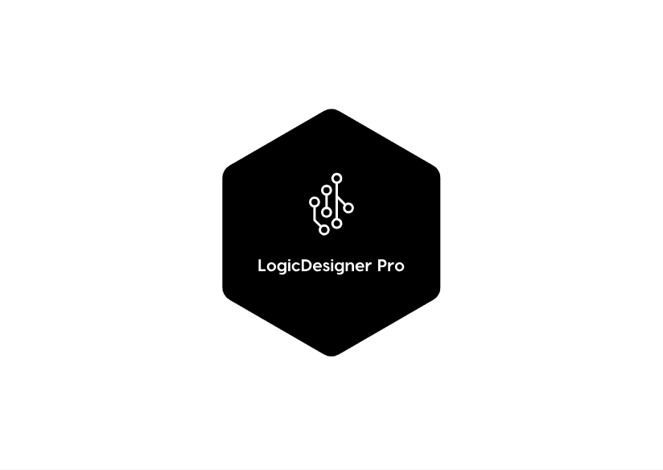

**Copyright © 2019 FH Wiener Neustadt**

**Thank you for using LogicDesigner Pro.**

LogicDesigner Pro was developed by Katja Lisyanskaya, Michael Moritz, Stephan Pillhofer and Fabian Weisser. It offers everything you need to design and test complex logic designs. LogicDesigner Pro’s main focus is its expandability and simple UI which makes the program very easy to use for beginners but also offers lots of potential for more experienced users.

**Copyright**

LogicDesigner Pro was developed at FH Wiener Neustadt. FH Wiener Neustadt also holds the copyright for this program.

Table of content

Introduction 4

Getting Started 4

Adding components to the program 4

Loading a component 4

Using the program 5

The component grid 5

The info panel 5

Connecting components 6

Starting a simulation 6

Toolbar 7

Shortcuts 8

# Introduction

In order to use this program it is necessary that your computer has .NET installed. After the installation process you can start the application by executing its exe.

# Getting Started

After starting the application you are greeted with the user interface.

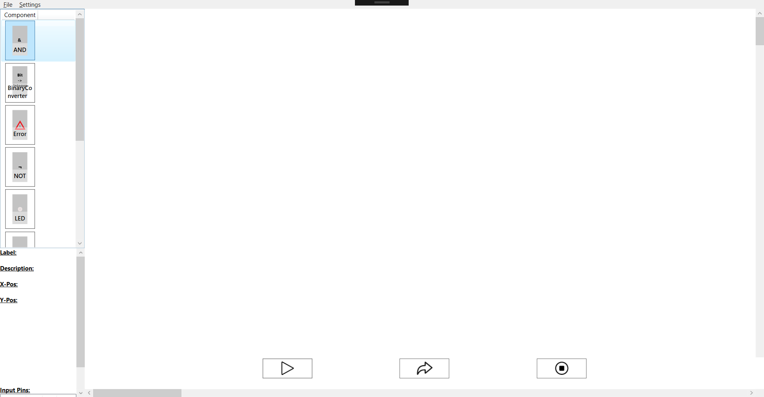

**4.**

**3.**

**2.**

**1.**

1. Available components
2. Info panel
3. Component grid
4. Simulation controls

# Adding components to the program

LogicDesigner Pro was created to support all sorts of components to offer a wide variety of features. Users can use the provided interfaces to develop their own components and directly test them afterwards.

## Loading a component

In order to load a component you need to copy your built .dll or .exe to the programs component directory. You can find and define the component directory within the configuration file of this program. The file is called “*config.json*” and can be found in the applications root directory or by opening it from within the program (See “Toolbar”).

After you copied the file it should automatically appear in the list of all available components.  
  
Note: If your component doesn’t show up immediately it is very likely that you didn’t implement the interfaces correctly. Please make sure that your component is error free and try it again.

# Using the program

## The component grid

In order to add a component to your component grid simply scroll through the list of available components until you find the component of your desire. Afterwards double click on the wanted component. The element will be spawned in the top left corner of the grid.

A spawned element can be drag and dropped by left clicking it and moving it to any place you want. You can let go of it by releasing the mouse button again.

You can spawn an unlimited amount of elements in your grid and distribute them wherever you want. If your workspace gets too small you can zoom in and out to change the size of your working space (See “Shortcuts”). You can also use the scrollbars on the bottom and right side to navigate through the grid. Elements can even be stacked over each other if you wish to do so.

## The info panel

The info panel is used to show you more information about one panel. In order to make it display some content simply select a spawned component by left clicking it. As you can see various information can now be seen.

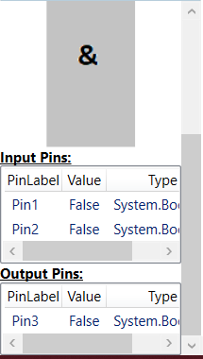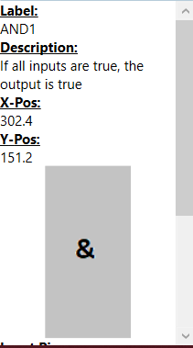

The info panel shows the following items:

* Label: The label/name of the component.
* Description: The description of the component.
* X-Pos: The current x position of the element in the grid.
* Y-Pos: The current y position of the element in the grid.
* Picture: How the component is currently displayed.
* Input Pins: The components input pins and their state/type.
* Output Pins: The components output pins and their state/type.

## Connecting components

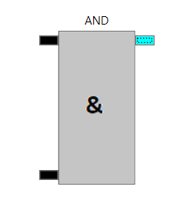  
LogicDesigner Pro offers a very easy and intuitive way to connect pins with each other. All pins of a component are drawn on its right and left side. All input pins are located on the left side while all output pins are located on its right side.

In order to select a pin make a left click on it. The pin now should be highlighted in a different color which is also configurable in the *config.json*.   
  
After you selected the first pin you now can select a second pin to which you want to make a connection to. A connection line should now be visible.   
  
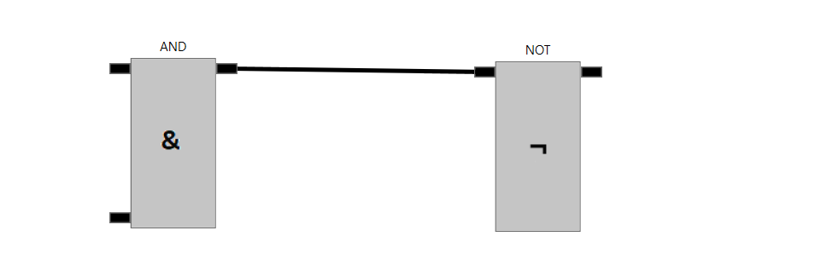

The connection now has been established and will stay until you decide to remove it. In order to remove a connection or a component simply make a right click on it and it will disappear. If you delete a component all connections connected to it will also disappear.

It is possible to establish multiple lines from one output pin to other input pins but it is NOT possible to connect multiple lines to one input line.

If you hover your mouse over a pin you will get more information about the pin itsef. The first value shows you the pin lable and afterwards the global pin id is shown.

## Starting a simulation

Once you are satisfied with your components and their connections you can start to simulate your circuit. The “Simulation Controls” are located on the bottom of the program and allow you to start an endless simulation or to make one simulation step at a time.

The following graphic shows a simple circuit after the play button has been pressed.

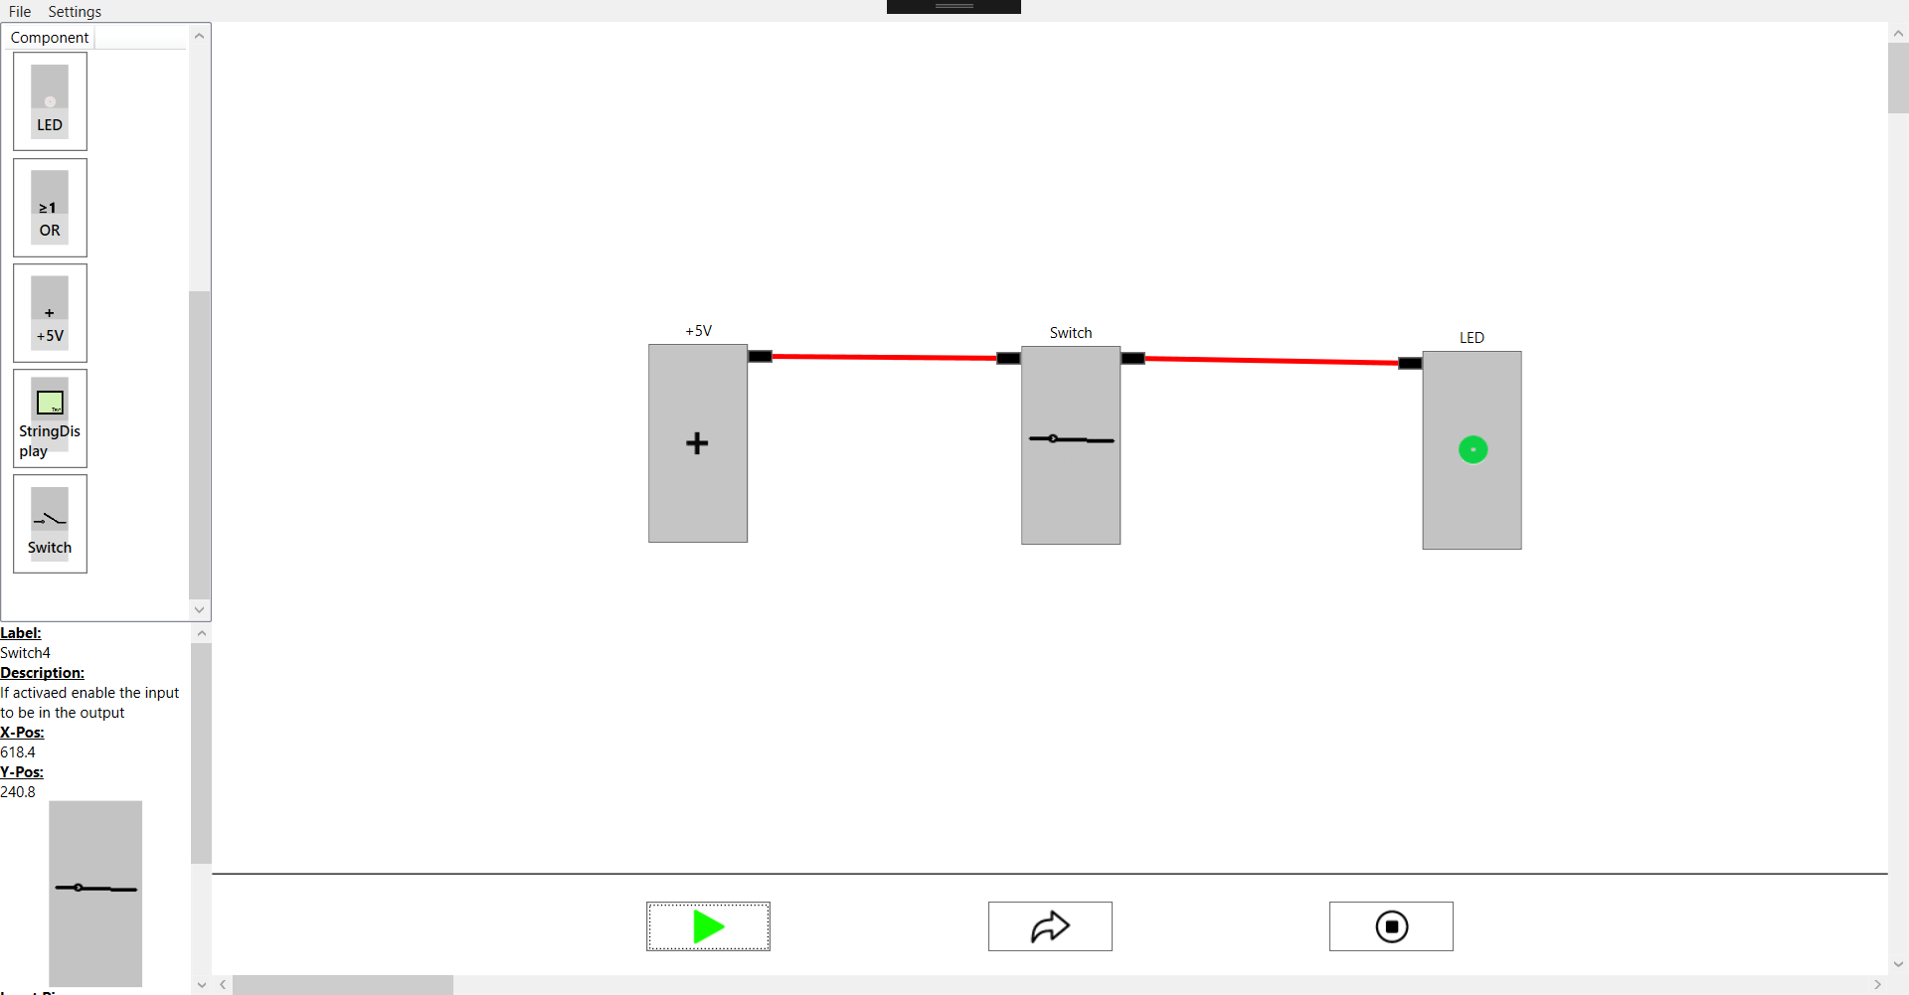

The play button turned green to indicate that the simulation is running. The graphics shows the +5V power source delivering an input for the switch which lets the signal through to the led. As soon as the pause button is pressed the simulation is ended and the LED turns of again. Active lines are colored in a different color than passive lines. Those colors are also configurable.

The button in the middle makes a so called animation step as it runs the simulation exactly one time. This is very useful if you want to do some debugging.

NOTE: Sometimes multiple simulation steps are necessary to retrieve the expected result. This is completely normal and expected.

## Toolbar

The toolbar is located at the very top of the program and offers various different options.

* Load: Loads a specific save file.
* Save: Saves the current working environment.
* Clear Workspace: Deletes all elements in the grid.
* Activate grid: Activates the grid.
* Open config: Opens the configuration file.

## Shortcuts

LogicDesigner Pro offers various different shortcuts to make your workflow even smoother. Use these shortcuts to get things done more quickly.

* Ctrl + S = Save
* Ctrl + L = Load
* Ctrl + Y = Redo
* Ctrl + Z = Undo
* Ctrl + G = Toggle grid
* Ctrl + + = Zoom in
* Ctrl + - = Zoom out

It’s also possible to zoom in and out using the mouse wheel if you wish to do so.