Student Management System
Final Assessment Project | UFCFK1-15-0 | Fundamentals of Data Science | 2025/2026

Module Code | UFCFK1-15-0
Module Title | Fundamentals of Data Science
Module Tutor | Saurav Gautam
Submission | 19 April 2026 | 23:59 | Blackboard
Weighting | 40% (Portfolio Component)

1. Introduction
This report documents the design, implementation, and testing of a Student Profile Management System built in Python. The system was developed as the final assessment for the Fundamentals of Data Science module (UFCFK1-15-0). It demonstrates core programming concepts including Object-Oriented Programming (OOP), file handling, modular design, and data analytics using industry-standard libraries.
The system manages student personal information, examination grades across five subjects, and extracurricular activity (ECA) records. Two distinct user roles — Admin and Student — interact with the system through role-based menus. An optional Analytics Dashboard (Task 2 bonus) provides data visualisations and performance insights for administrators.
2. System Overview
The application is composed of six Python modules, each with a clear responsibility:
Module | Responsibility
main.py | Entry point. Orchestrates login and routes the user to the correct role menu.
auth.py | Handles login/logout logic and defines the User, Student, and Admin classes.
file_handler.py | Centralised file I/O for all four text files (users, passwords, grades, ECA).
admin.py | Full-featured admin panel built with pandas and a rich ASCII box UI.
student.py | Student-facing features: view profile, grades, ECA, and update profile.
analytics.py | Analytics dashboard with four data insights and optional matplotlib charts.

2.1 Data Files
All persistent data is stored in four comma-separated text files:
- users.txt: Stores id, name, role (admin/student), and username for every account.
- passwords.txt: Stores username–password pairs (plaintext, appropriate for a learning context).
- grades.txt: Stores marks for five subjects: Math, Science, English, CS, and Statistics.
- eca.txt: Stores extracurricular activity entries; one row per activity per student.
3. Object-Oriented Design
The system applies OOP principles throughout. A base User class encapsulates shared attributes (user_id, name, role, username) and role-query methods. Two subclasses extend it:
- Student: Inherits User and adds a get_grades() method that fetches the student's marks from file_handler.
- Admin: Inherits User and adds a greet() method; admin-specific operations live in admin.py to keep classes lean.
The admin.py module defines a local Learner class with name-mangled private attributes (__ID, __Name, __Role, __Username) to demonstrate encapsulation, and displays user details through a dedicated DisplayDetails() method. This satisfies the OOP requirement for encapsulation via private attributes.
4. Features
4.1 Login System
The login() function in auth.py validates credentials against passwords.txt and grants up to three attempts before locking out the session. On success it instantiates either a Student or Admin object and routes the user to their respective menu. Empty-field input is caught before the password check.
4.2 Admin Panel
- Add User: Creates a new user with a unique ID, assigns a role, and writes to users.txt and passwords.txt.
- Display Users: Renders a formatted table of all registered accounts using pandas.
- Search User: Looks up any user by their numeric ID.
- Update User: Allows updating name, role, username, or all fields at once.
- Delete User: Removes a user record after explicit confirmation.
- Manage Grades: Add or update marks for any student across all five subjects.
- Manage ECA: Add a new ECA activity or delete all ECA entries for a given student.
- Analytics: Launches the Analytics Dashboard (see Section 4.4).
4.3 Student Panel
- View Profile: Displays the student's ID, name, and role.
- View Grades: Shows marks per subject, computes the average, and prints PASS / AT RISK status.
- View ECA: Lists all extracurricular activities linked to the student.
- Update Profile: Allows the student to change their name, username, or both; username change propagates to passwords.txt.
4.4 Analytics Dashboard (Task 2 Bonus)
The analytics module provides four insights accessible from the admin panel. Where matplotlib is installed, each insight also renders a chart:
- Average Grades Per Subject: Computes and displays the class mean for each subject, with ASCII bar and optional bar chart.
- Grade Trends Per Student: Displays each student's marks side-by-side, with a grouped bar chart.
- ECA Impact: Compares average academic performance of students with ECA against those without.
- Performance Alerts: Flags students scoring below a configurable threshold and suggests targeted tutoring.
5. System Flowcharts
The following three flowcharts illustrate the complete program flow, from login through to each role's available actions.
5.1 Login System
Covers credential validation, empty-field checking, the 3-attempt lockout, and role-based routing to Admin or Student menus.

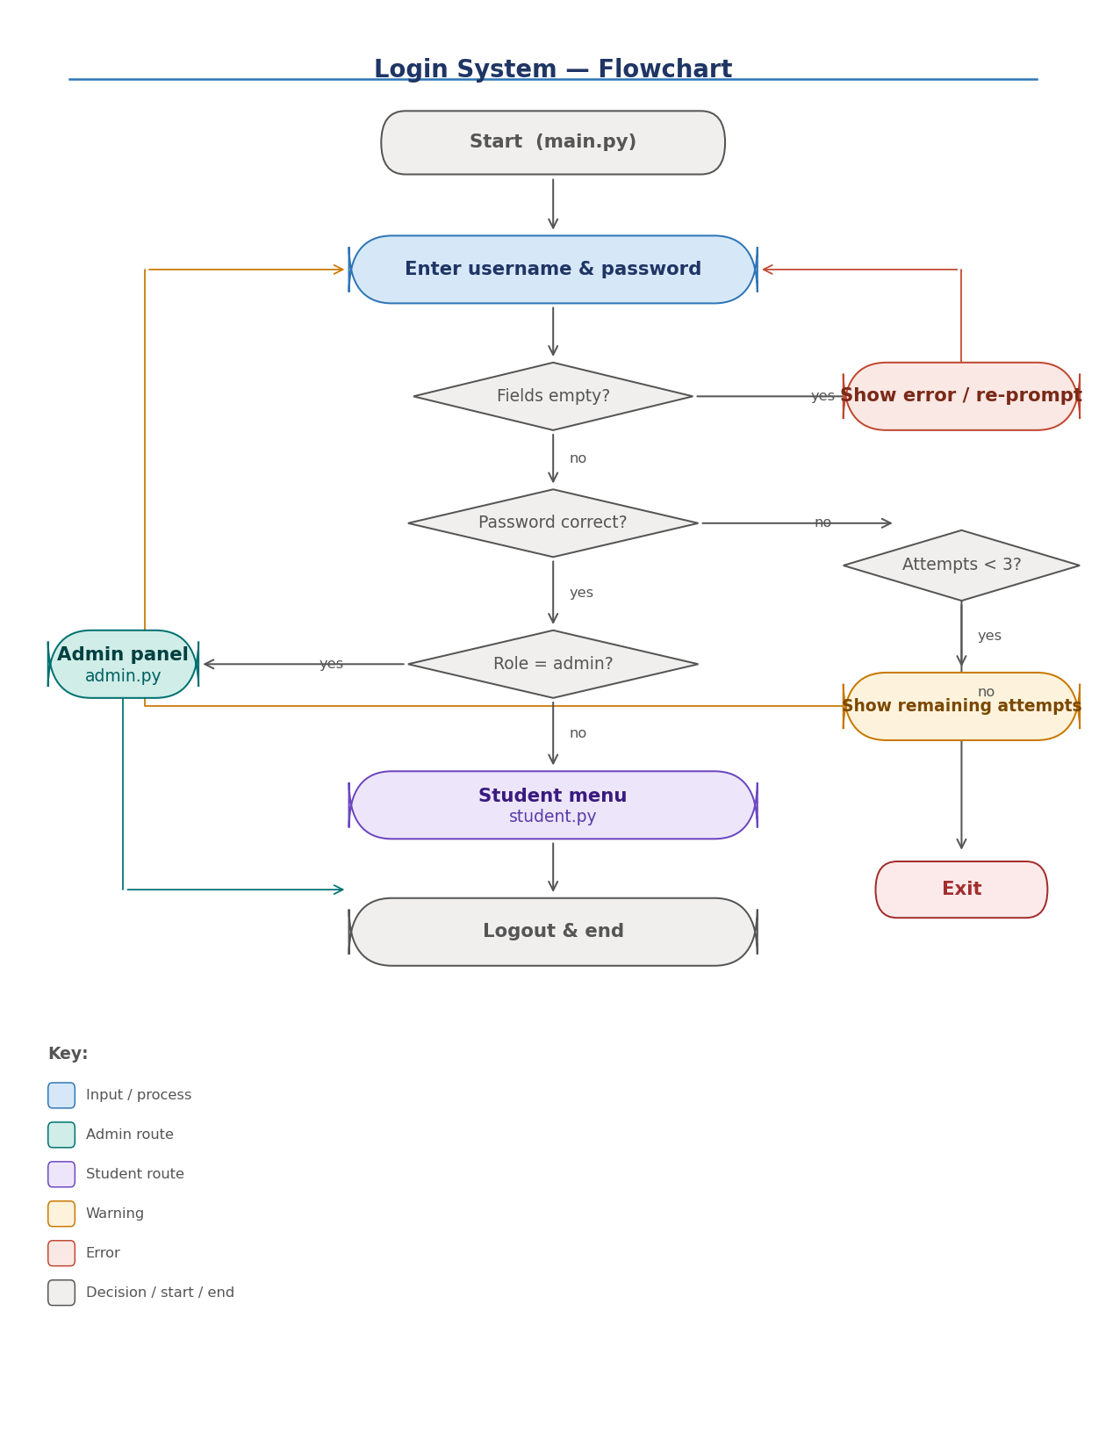
Figure 1 — Login system flowchart

5.2 Admin Panel
Shows all eight admin menu options (Add, Display, Search, Update, Delete, Grades, ECA, Analytics), the loop-back mechanism, and the exit path.

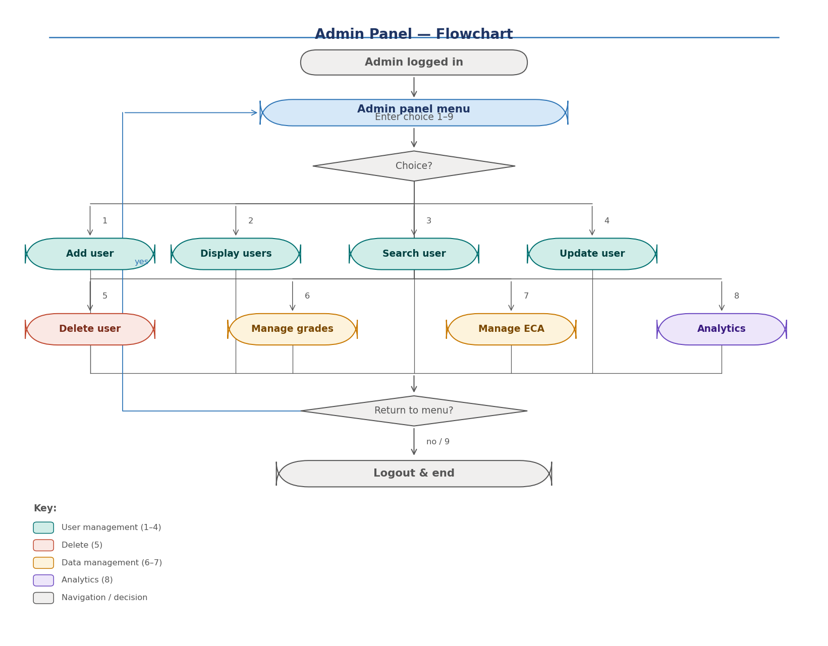
Figure 2 — Admin panel flowchart

5.3 Student Panel & Analytics Dashboard
Left side shows the four student features and logout loop. Right side shows the Analytics Dashboard with its four insight options, result display, and return path.

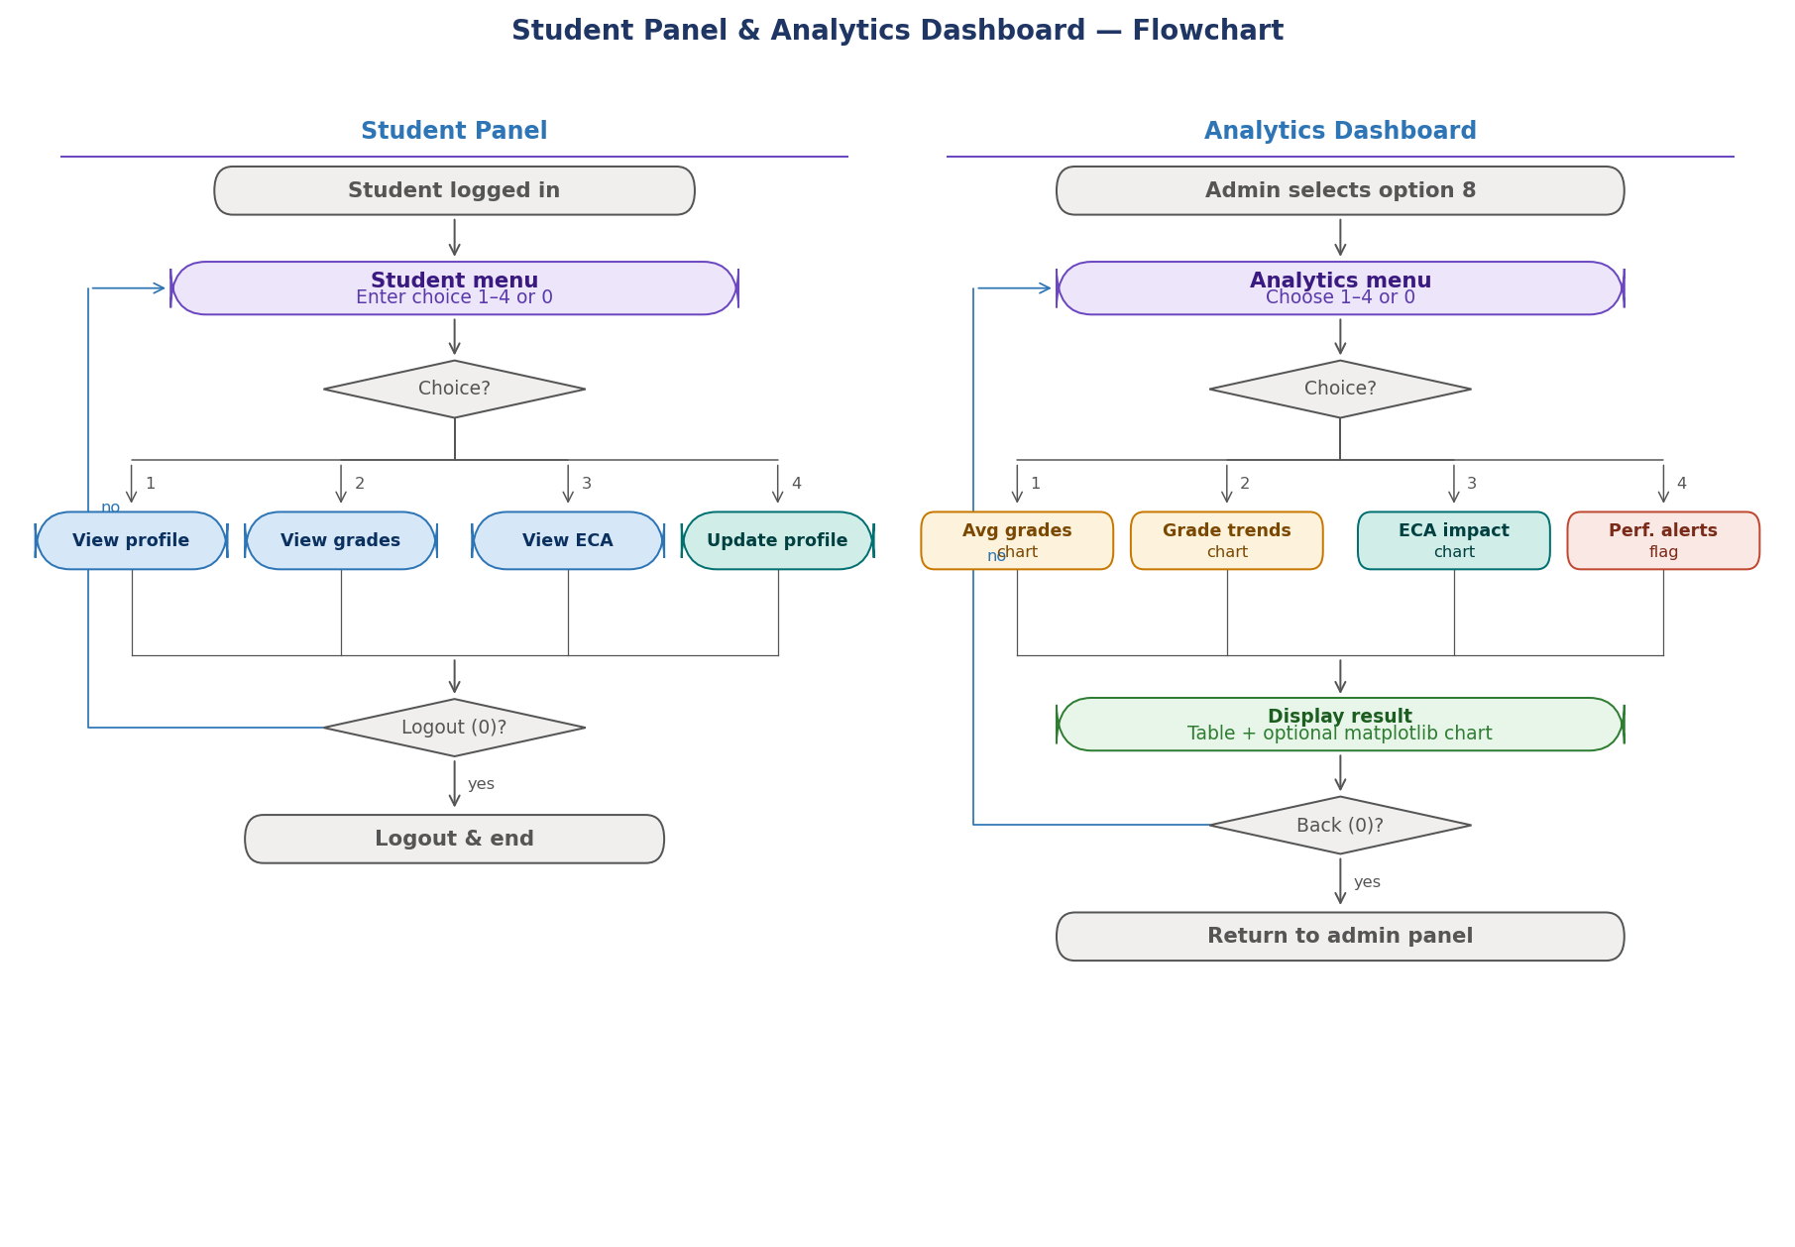
Figure 3 — Student panel (left) and Analytics dashboard (right) flowcharts

6. File Handling & Exception Handling
All file operations are centralised in file_handler.py. Each read function wraps the open() call in a try/except FileNotFoundError block and prints a user-friendly error message. Write functions catch generic exceptions to prevent silent data loss.
Input validation uses try/except ValueError blocks wherever the user enters numeric values (menu choices, marks). Invalid inputs are rejected with a clear prompt to retry, preventing crashes from non-numeric entries. The admin update/delete flows use bare except clauses to catch all input errors robustly.
7. Sample Input / Output
The following scenarios demonstrate key system interactions with actual terminal output.
7.1 Successful student login
INPUT
Username: ZENITH_G
Password: 1719
OUTPUT
Welcome, Zenith!
── Student Menu ───────────────
1. View profile
2. View grades
3. View ECA activities
4. Update profile
0. Logout
Choose:
7.2 Failed login — 3 attempts exceeded
INPUT
Username: wrong
Password: bad
OUTPUT
Incorrect username or password. 2 attempt(s) left.
...
Too many failed attempts. Exiting.
7.3 Student views grades
INPUT
Choose: 2
OUTPUT
--- GRADES ---
Math: 70
Science: 80
English: 75
CS: 90
Stats: 85
Average: 80.00
Status: PASS
7.4 Admin adds a new user
INPUT
Enter ID: 102
Enter Name: Sara
Enter Username: sara_x
Enter Password: pass123
Enter Role (1 or 2) >> 1
OUTPUT
User added successfully.
──────────────────────────────
ID 102
Name Sara
Role student
Username sara_x
7.5 Admin duplicate ID rejected
INPUT
Enter ID: 101
OUTPUT
Error: ID already exists.
Enter a unique ID:
7.6 Analytics — performance alerts (no failures)
INPUT
Analytics >> 4
Enter failing threshold (default 50) >> 50
OUTPUT
✓ No students are currently below the threshold. Great work!
7.7 Invalid menu input handled
INPUT
Enter your choice (1-9) >> abc
OUTPUT
Invalid input. Please enter a number.
Enter your choice (1-9) >>
8. Testing
Test ID | Description | Expected Resul | Status

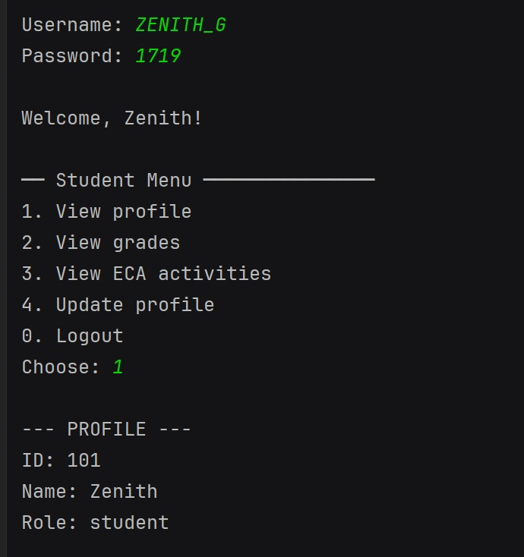
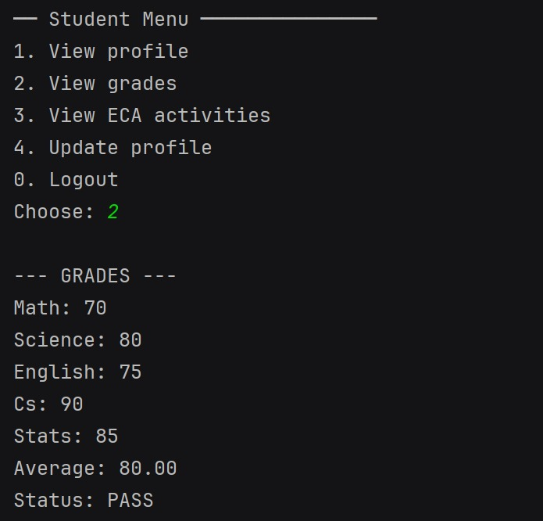
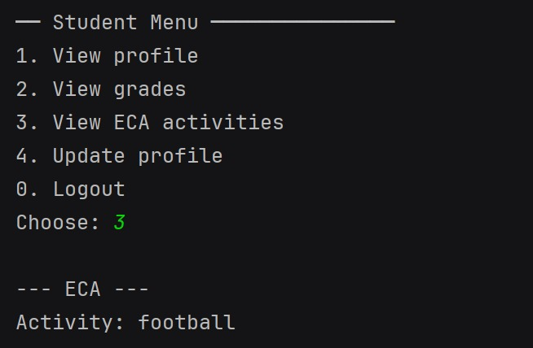
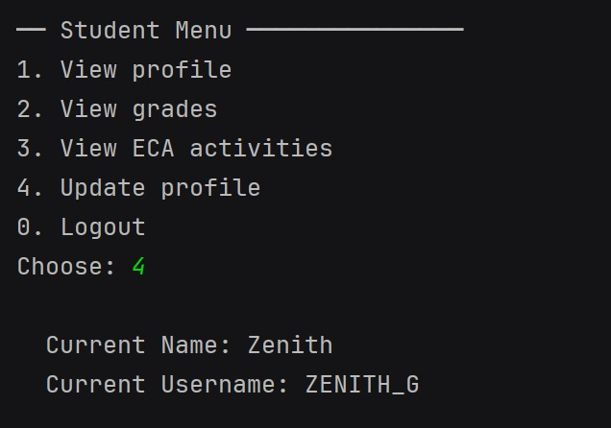
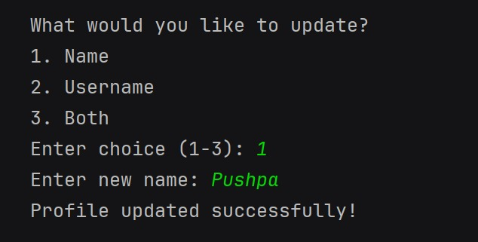
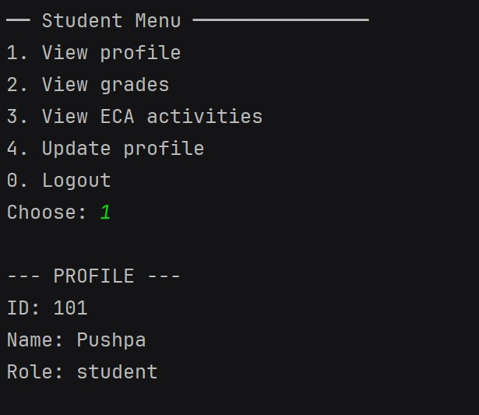
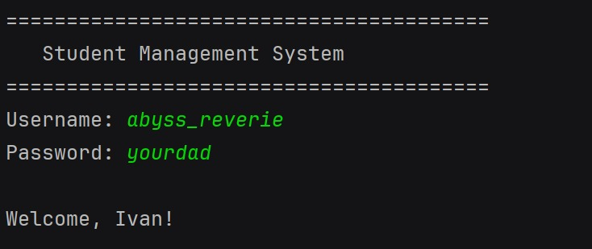
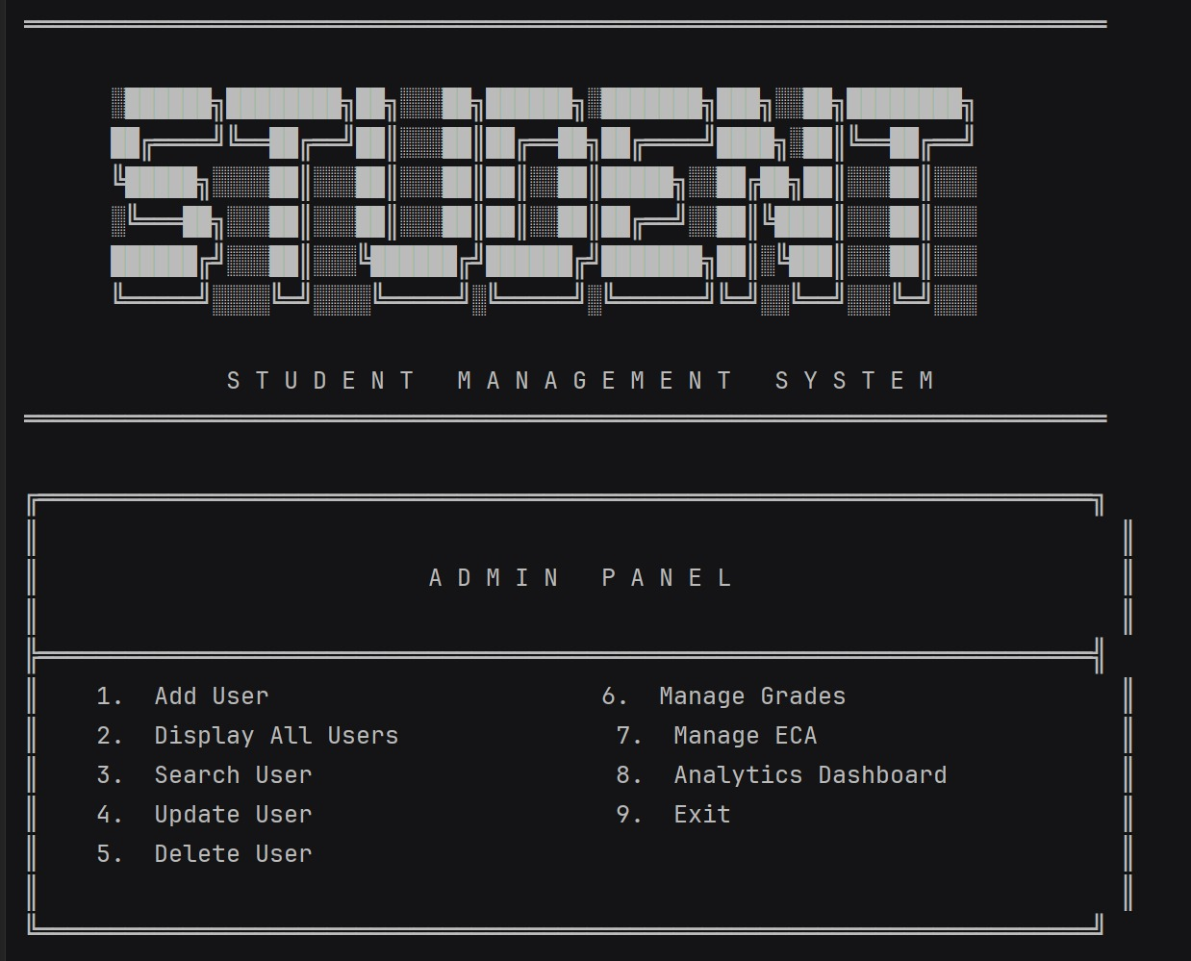
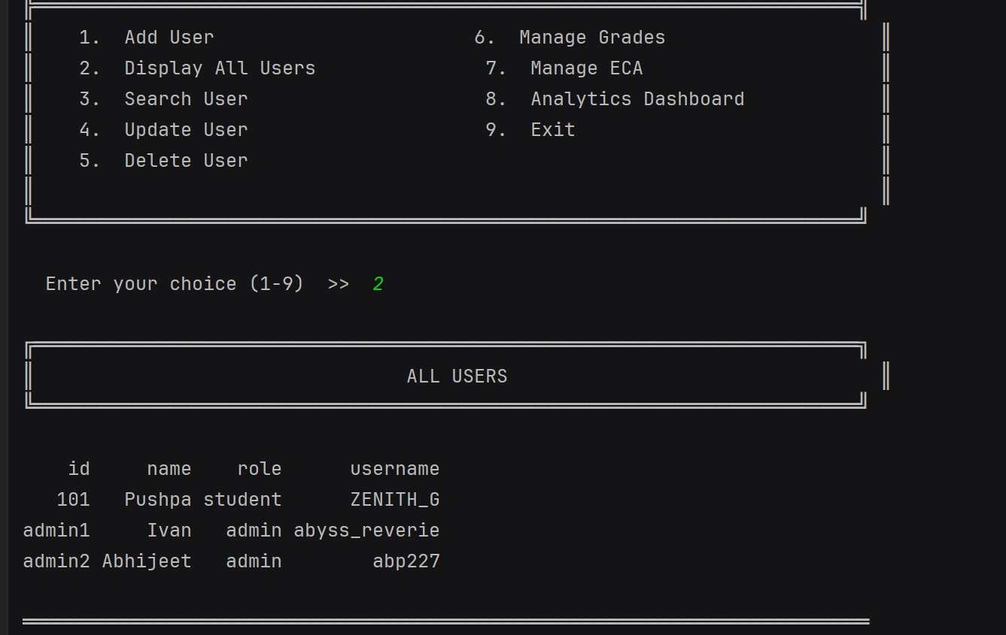
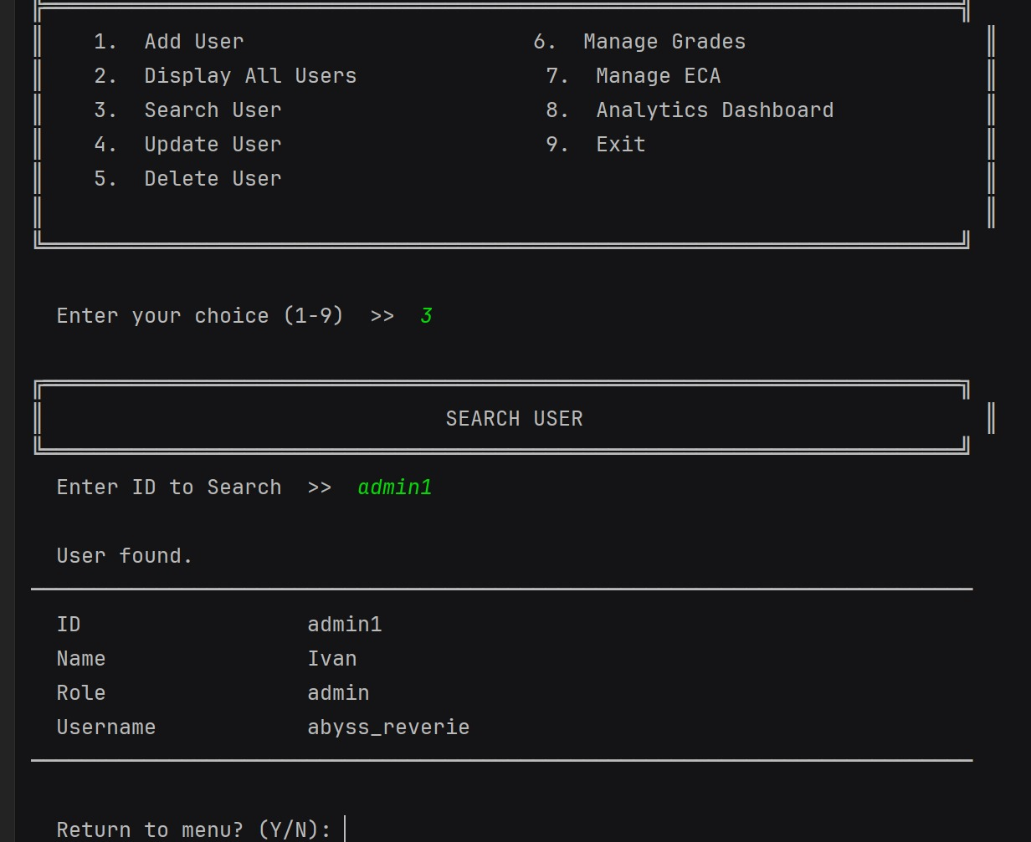
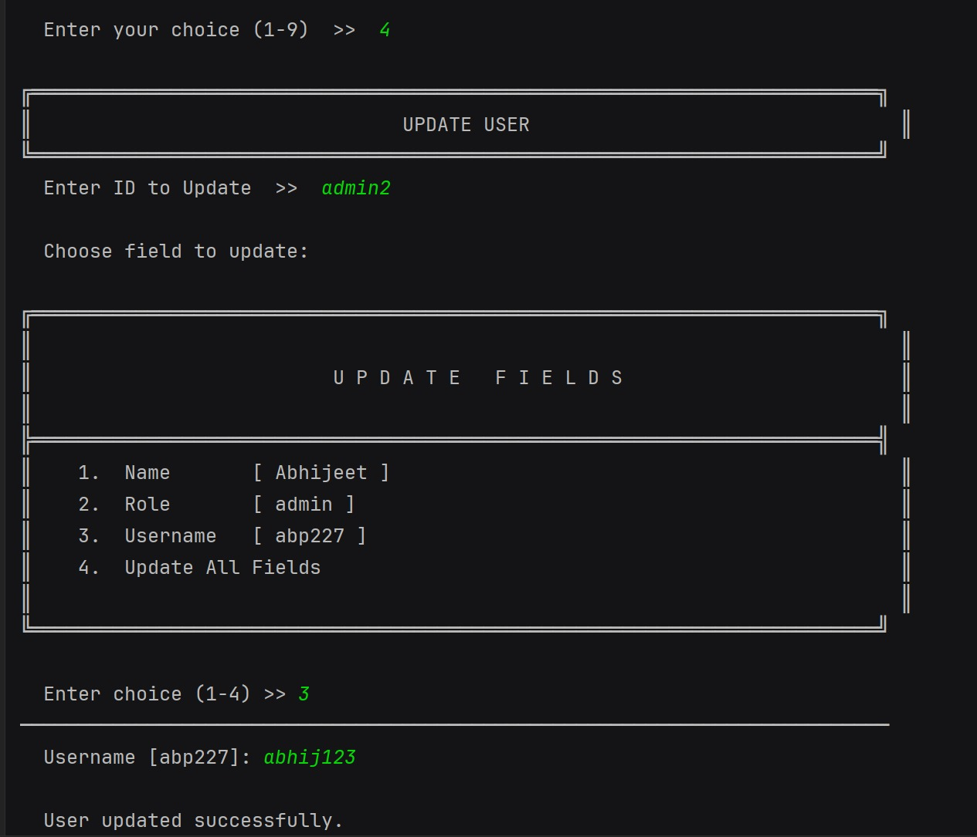
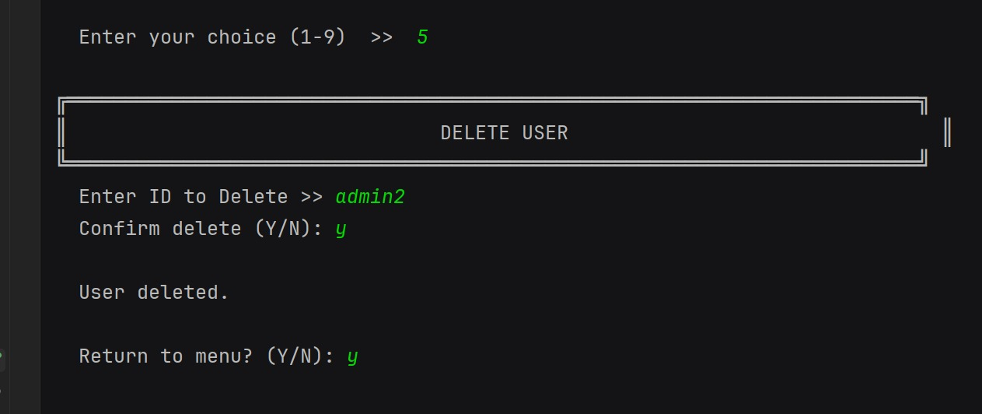
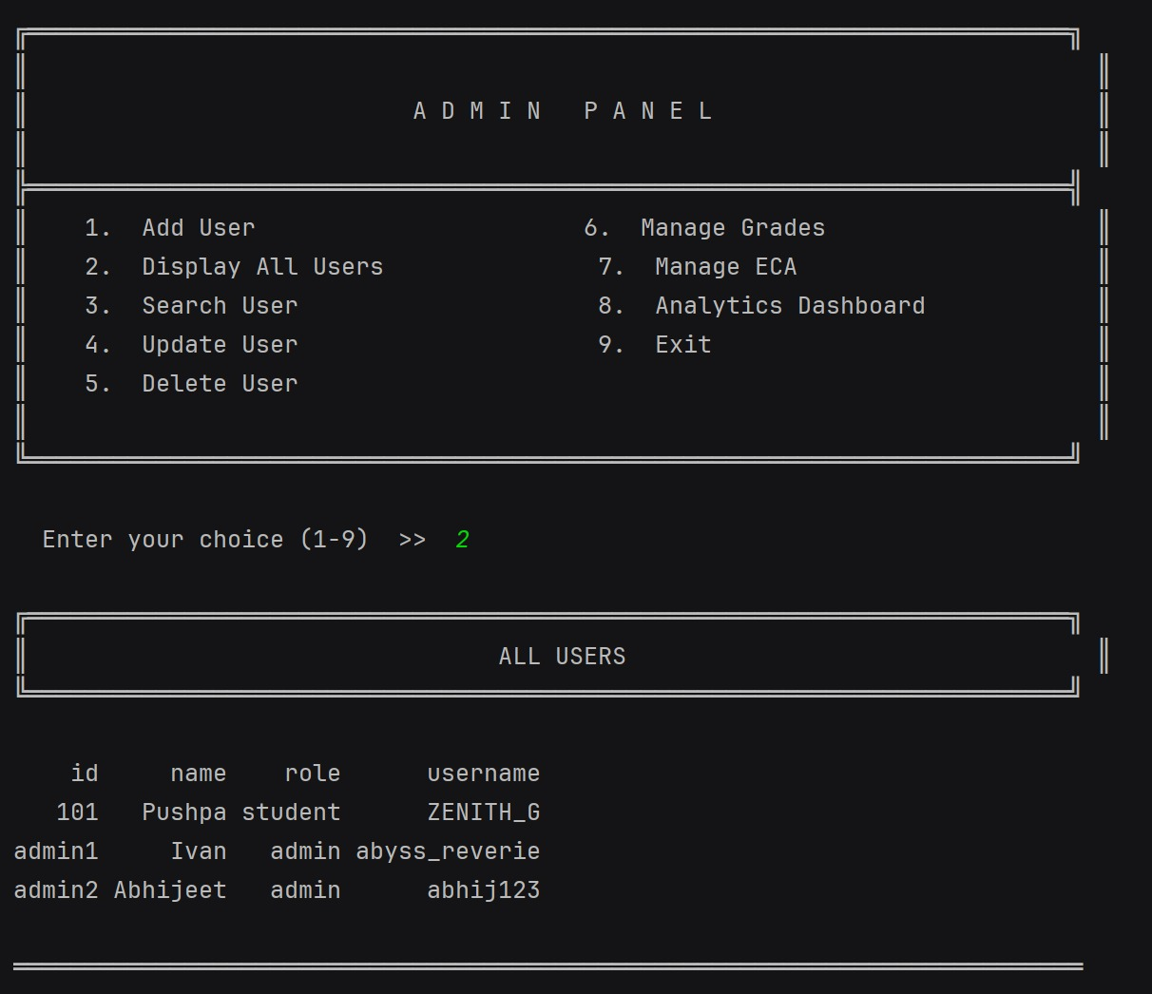
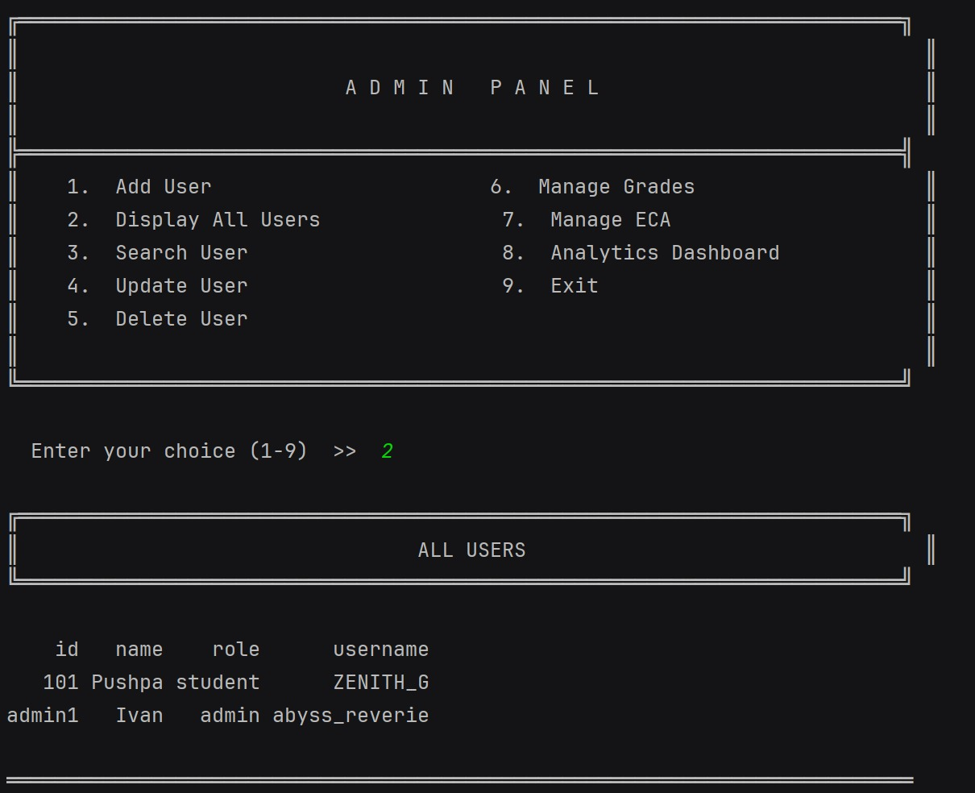
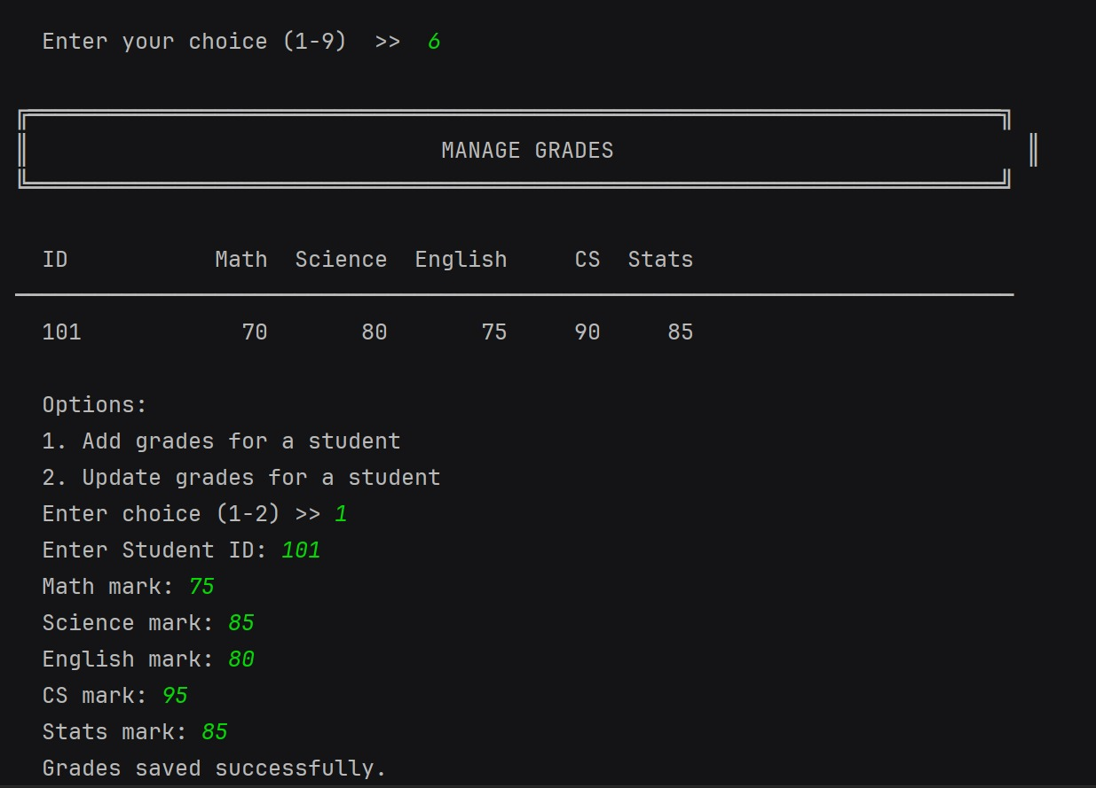
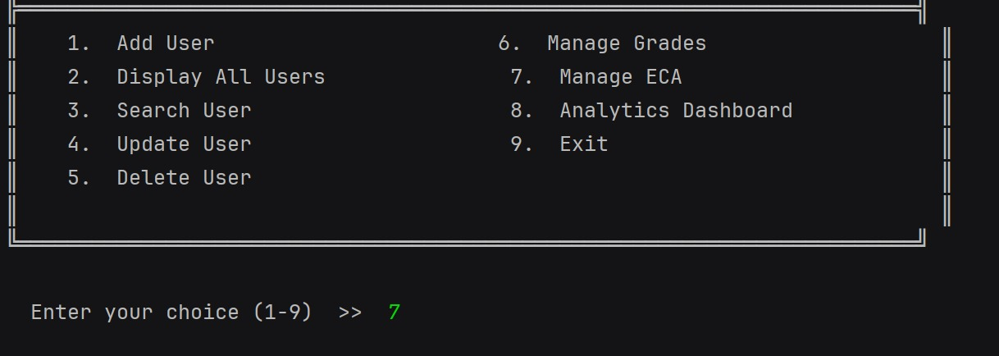
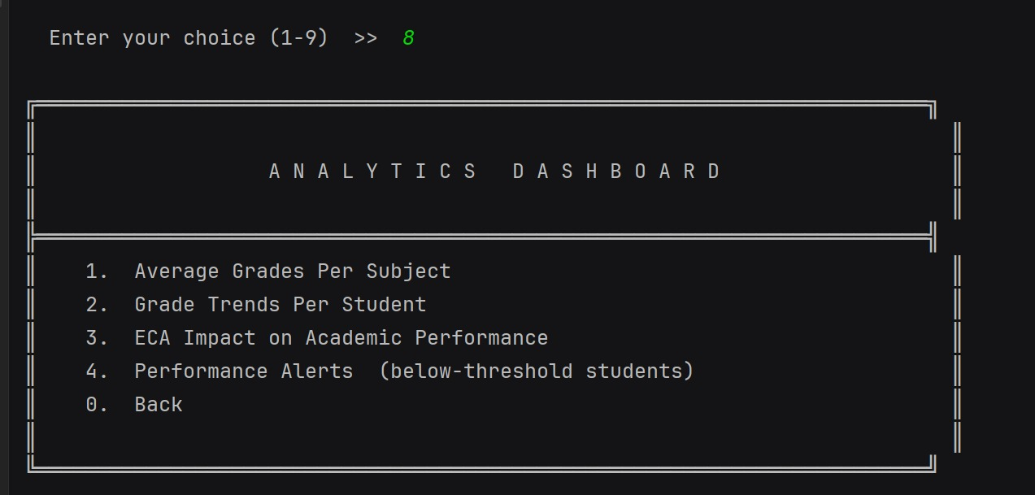
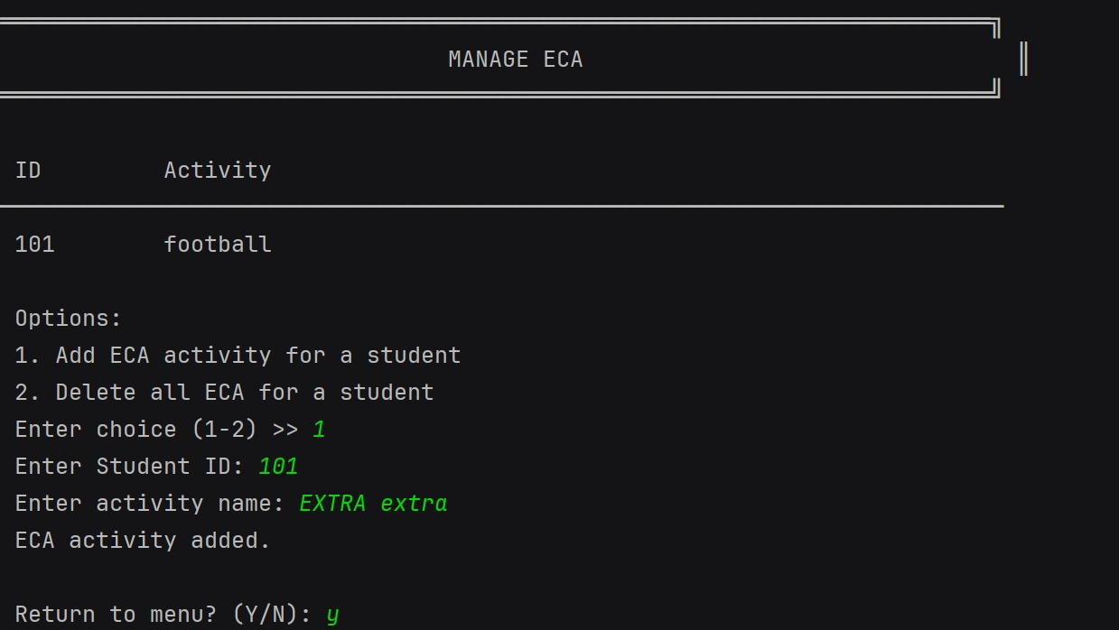
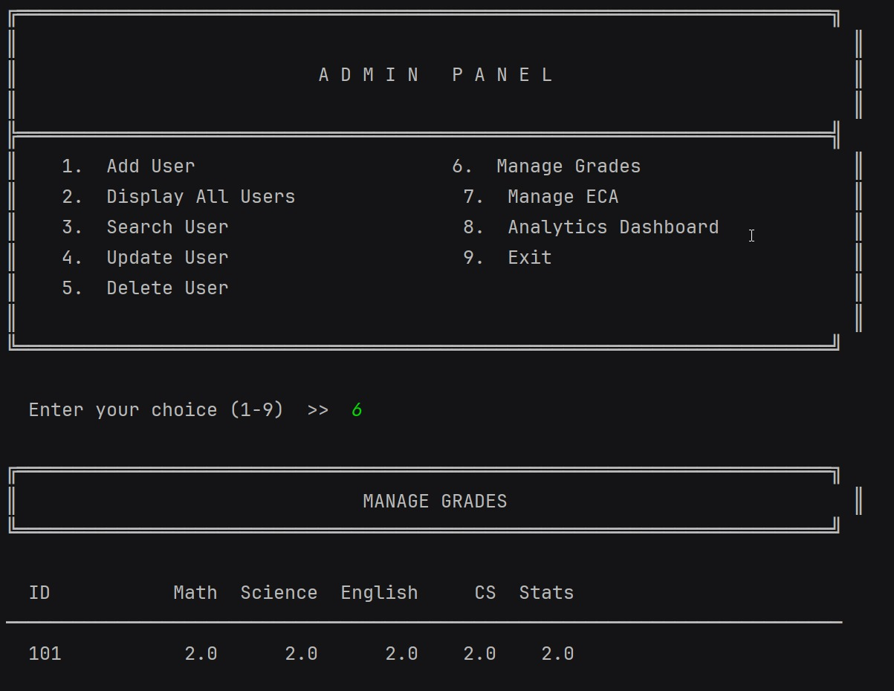
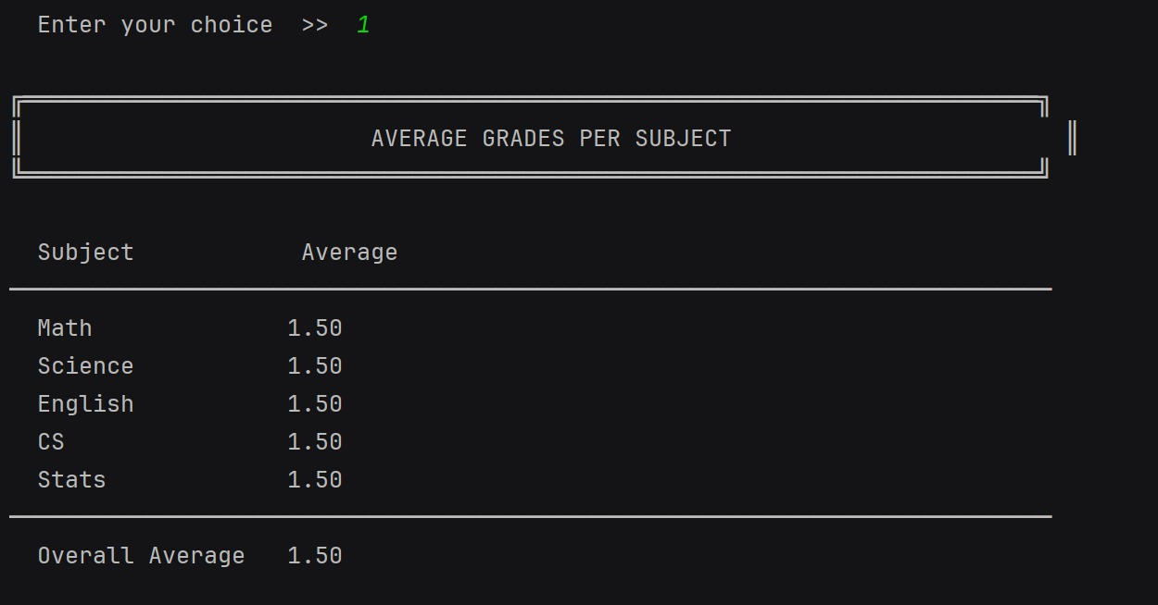
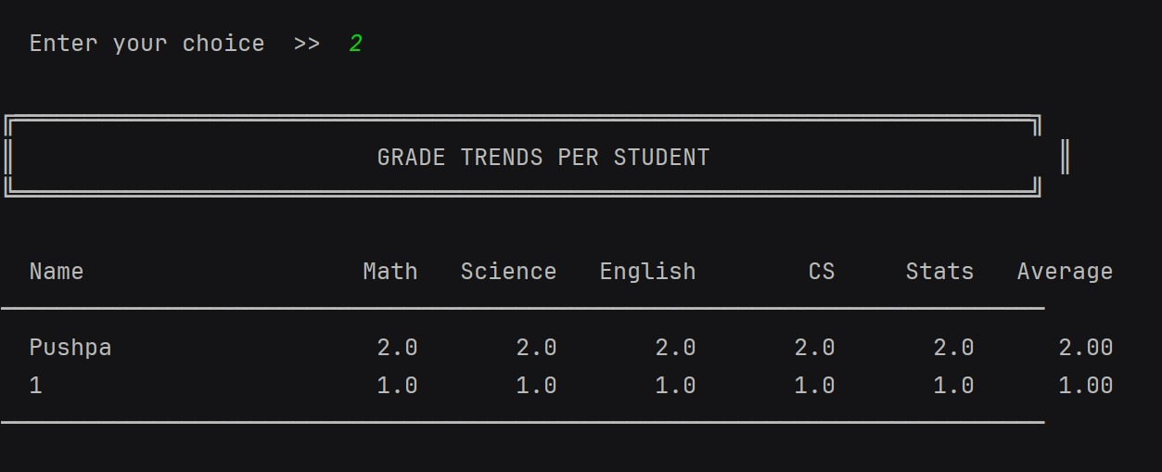
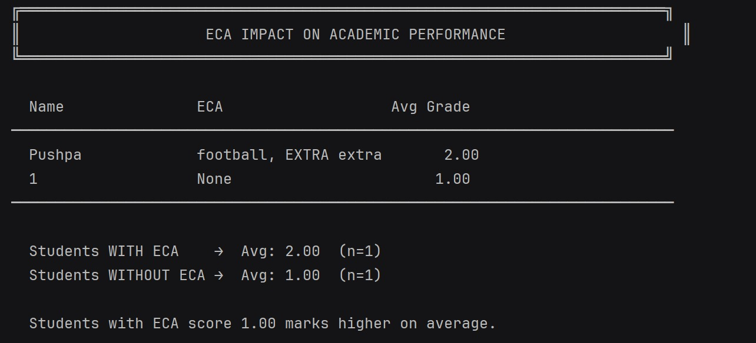
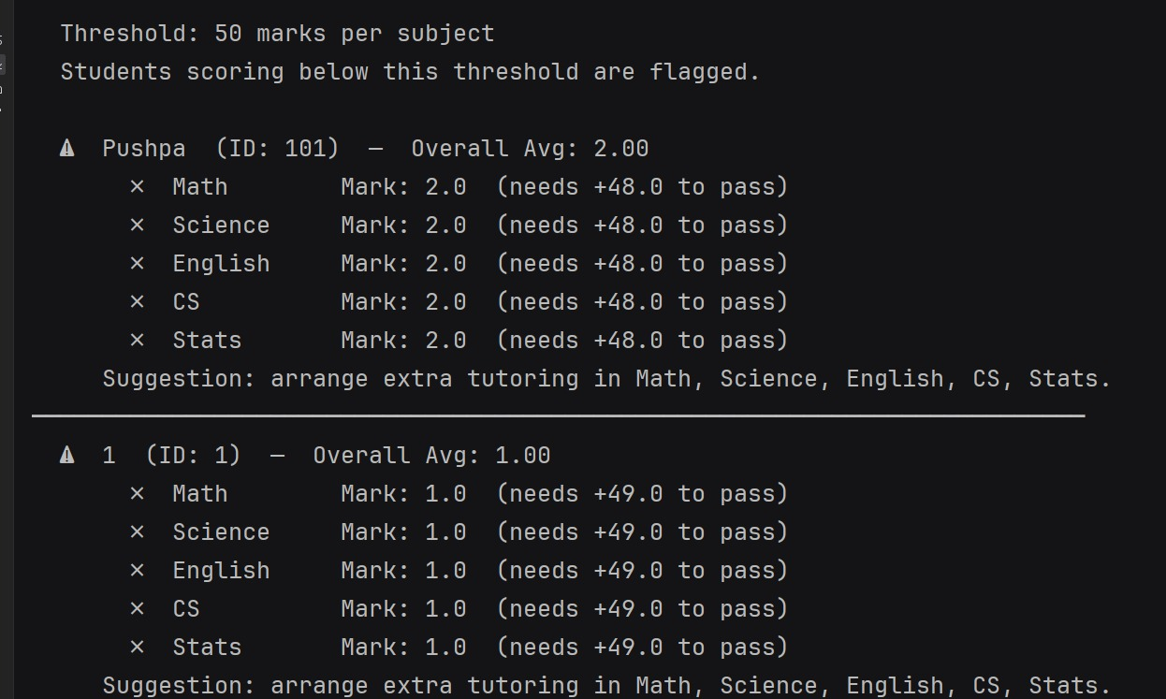
9. Limitations & Future Improvements
While the system satisfies all task requirements, several enhancements would improve it in a production setting:
- Password security: Passwords are stored as plaintext. Hashing (e.g., bcrypt) should be used in any real deployment.
- Database backend: Text files work well for small datasets but should be replaced with SQLite or PostgreSQL for scalability.
- GUI: A graphical interface (tkinter or a web front-end) would improve usability.
- Unit tests: Automated tests using pytest would improve maintainability and catch regressions.
- Password change: Students currently cannot change their own password from the student menu.
- Username sync: Deleting a user from users.txt does not automatically remove their entry from passwords.txt.
10. Conclusion
The Student Profile Management System successfully meets all basic requirements of Task 1 and implements the full Analytics Dashboard bonus of Task 2. The codebase demonstrates OOP inheritance, encapsulation, modular functions, robust file handling, and exception handling throughout. The analytics module additionally showcases data processing with pandas and visualisation with matplotlib.
The project provided valuable hands-on experience in structuring a multi-module Python application, handling persistent data without a database, and designing a clean terminal-based user interface. The three system flowcharts (Section 5) provide a clear visual reference for the program logic and data flow.

