Project Design Phase-II
Technology Stack (Architecture & Stack)

Date | 30 September 2026
Team ID | SWTID-2026-4475
Project Name | Implement Client Script & UI Policy (Incident)
Maximum Marks | 4 Marks

Technical Architecture:
The Deliverable shall include the architectural diagram as below and the information as per the table1 & table 2
Example: Implement Client Script & UI Policy (Incident) in ServiceNow
Reference: https://developer.servicenow.com/
Guidelines:
Include all the processes (As an application logic / Technology Block)
Provide infrastructural demarcation (Local / Cloud)
Indicate external interfaces (third party API’s etc.)
Indicate Data Storage components / services
Indicate interface to machine learning models (if applicable)
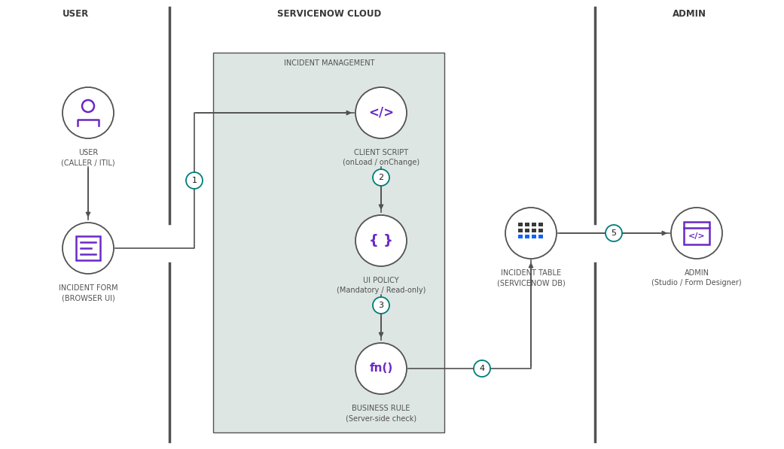

Table-1 : Components & Technologies:
S.No | Component | Description | Technology
 | User Interface | How user interacts with the Incident form e.g.  ServiceNow Web UI, Service Portal, Mobile App | ServiceNow UI (Next Experience / UI16), HTML, CSS, JavaScript
 | Application Logic-1 | Client Script (onLoad, onChange, onSubmit) validates Incident fields in the browser | JavaScript (client-side, g_form API)
 | Application Logic-2 | UI Policy makes Incident fields mandatory, read-only or visible | ServiceNow UI Policy & UI Policy Actions
 | Application Logic-3 | UI Policy Script and server-side Business Rule enforce the rules | JavaScript, Business Rule (GlideRecord)
 | Database | Incident table fields (State, Priority, Category, etc.) | ServiceNow relational database (Incident table, extends Task)
 | Cloud Database | Database service on ServiceNow Cloud | ServiceNow Cloud (Personal Developer Instance)
 | File Storage | Attachments added to Incident records | ServiceNow attachment storage (sys_attachment)
 | External API-1 | Purpose: read / create Incident records for testing | ServiceNow REST Table API
 | External API-2 | Not applicable for this project | Not applicable
 | Machine Learning Model | Not applicable - no machine learning model is used | Not applicable
 | Infrastructure (Server / Cloud) | Application Deployment on Cloud  Local Server Configuration: N/A  Cloud Server Configuration : ServiceNow PDI | ServiceNow Cloud (PDI)

Table-2: Application Characteristics:
S.No | Characteristics | Description | Technology
 | Open-Source Frameworks | Client-side JavaScript / platform APIs (g_form, g_user) used to implement form behaviour | JavaScript, HTML, CSS
 | Security Implementations | Role-based access (ACLs, itil role), HTTPS; Business Rules back up client checks | ACLs, Role-based access control, HTTPS / TLS
 | Scalable Architecture | Multi-instance cloud; client-side logic reduces server round trips | ServiceNow multi-instance cloud architecture
 | Availability | Redundant data centers and load balancers keep Incident available | ServiceNow data center failover & load balancers
 | Performance | Prefer UI Policy over Client Script; use async GlideAjax for server data | UI Policy, Client Script, GlideAjax (async)

References:
https://c4model.com/
https://docs.servicenow.com/
https://www.ibm.com/cloud/architecture
https://aws.amazon.com/architecture
https://medium.com/the-internal-startup/how-to-draw-useful-technical-architecture-diagrams-2d20c9fda90d

