CREDIT CARD FRAUD DETECTION
End-to-End Data Analytics Project Report
SQL • Python • EDA • Power BI
Submitted by:
Karan Bisht
Practical Data Analytics Final Assignment

2. Introduction
Credit card fraud is one of the most common and costly problems faced by banks and payment companies today. Every day, millions of transactions happen, and even a very small percentage of fraud can cause huge financial losses. This project takes a real-world credit card transactions dataset and analyzes it end-to-end — starting from a relational database, moving through Python-based cleaning and exploratory analysis, and finishing with an interactive Power BI dashboard — to understand fraud patterns and suggest ways to catch fraud faster.
The goal of this project is to demonstrate a complete analytics workflow: storing raw transaction data in a MySQL database, writing SQL queries to pull out business-relevant numbers, using Python (Pandas, NumPy, Matplotlib, Seaborn) to clean the data and explore it further, and finally building a Power BI dashboard that a non-technical stakeholder (like a bank's risk team) could actually use.
3. Business Problem
Banks and card issuers need to detect fraudulent transactions as quickly and accurately as possible, without blocking too many genuine transactions (which frustrates customers). The key business questions this project tries to answer are:
- At what times of day does fraud happen the most?
- Are small transactions or large transactions more likely to be fraudulent?
- Is there a meaningful difference between night-time and day-time fraud activity?
- Which transaction amount ranges carry the highest fraud risk, and should get extra verification?
- Can a simple risk-scoring approach (based on time and amount) help flag suspicious transactions faster?
Answering these questions helps a fraud/risk team decide where to focus manual review effort and where to add automated checks like OTP or two-factor authentication.
4. Dataset Description
The project uses the well-known Credit Card Fraud Detection dataset, which contains transactions made by European cardholders over two days in September 2013.
Property | Details
Total transactions | 284,807
Genuine transactions (class 0) | 284,315 (99.83%)
Fraudulent transactions (class 1) | 492 (0.17%)
Time span | 2 days (Day 1 & Day 2)
Features | V1–V28 (PCA-anonymized), Time, Amount, Class
Target column | class (0 = Genuine, 1 = Fraud)

Because the original numeric features (V1 to V28) come from a PCA transformation for privacy reasons, they don't have real-world names — only Time (seconds since the first transaction) and Amount are in their original, interpretable form. This is why the analysis leans heavily on Time and Amount-based patterns rather than the anonymized V-columns.
This dataset is extremely imbalanced — fraud makes up only about 0.17% of all transactions — which is itself an important finding and is treated as a core theme throughout the analysis, rather than a limitation to fix.
5. Database Structure
A MySQL database named credit_card_fraud was created to hold the raw data before any Python processing. The structure was kept simple but realistic, including a lookup table so that amount-band analysis could be practiced with a SQL JOIN.
transactions table
Loaded with all 284,807 rows using LOAD DATA LOCAL INFILE in HeidiSQL. Columns: transaction_id (PK), time_sec, v1–v28, amount, class, plus hour_of_day and day_num derived directly in SQL from time_sec.
amount_bands table (lookup)
A small 5-row lookup table (Very Low, Low, Medium, High, Very High) with min/max amount ranges, created purely so the amount-band analysis could be done with a proper SQL JOIN instead of a CASE statement.
Analysis_Queries.sql
A separate script holding all 10 business SQL queries used for analysis (hourly fraud rate, day comparison, amount statistics, amount-band JOIN, top-fraud RANK, running total window function, LAG gap-between-frauds, and a CTE + DENSE_RANK risk ranking) — the same queries are reproduced and computed in the SQL Analysis section below.
6. Data Cleaning
Cleaning was done in two stages — a quick check in SQL after loading, and a more thorough pass in Python before analysis.
SQL-side checks
- Row count verified: exactly 284,807 rows loaded, matching the source file
- Class distribution confirmed: 284,315 genuine vs 492 fraud
Python-side cleaning (extract_and_clean.py)
- Checked for missing values across all 40 columns — none found
- Checked for duplicate rows — none found
- Re-confirmed class distribution (99.83% vs 0.17%) directly in Pandas
- Scaled the amount column using StandardScaler → amount_scaled
- Applied a log transform using NumPy’s np.log1p() → amount_log, since Amount is heavily right-skewed and log1p() safely handles the zero-amount transactions that a plain log() would break on
- Derived hour_of_day_py and day_num_py from time_sec for time-based analysis
- Used NumPy vectorized array conditions (np.where / np.select) on the amount and hour_of_day_py arrays to build the is_night flag and amount_band buckets directly, avoiding slow row-by-row Python loops over 284,807 rows
- Added an is_night flag (1 if hour is between 12am–6am, else 0)
- Bucketed every transaction into an amount_band (Very Low / Low / Medium / High / Very High), mirroring the SQL lookup table
The cleaned, feature-engineered dataset was saved as transactions_cleaned.csv, which was used for all further EDA, visualization, and the SQL-equivalent business queries below.
7. SQL Analysis
Ten business queries were written against the credit_card_fraud database to answer the core business questions. The results below are reproduced from those queries (computed on the cleaned dataset, which is a direct export of the SQL table).
Query 1 — Fraud Rate by Hour of Day
Hour | Total Txns | Frauds | Fraud Rate %
0 | 7,695 | 6 | 0.078
2 | 3,328 | 57 | 1.713
4 | 2,209 | 23 | 1.041
11 | 16,856 | 53 | 0.314
18 | 17,039 | 33 | 0.194
22 | 15,441 | 9 | 0.058

Fraud clearly spikes around 2 AM–4 AM — the full 24-hour breakdown is graphed below.
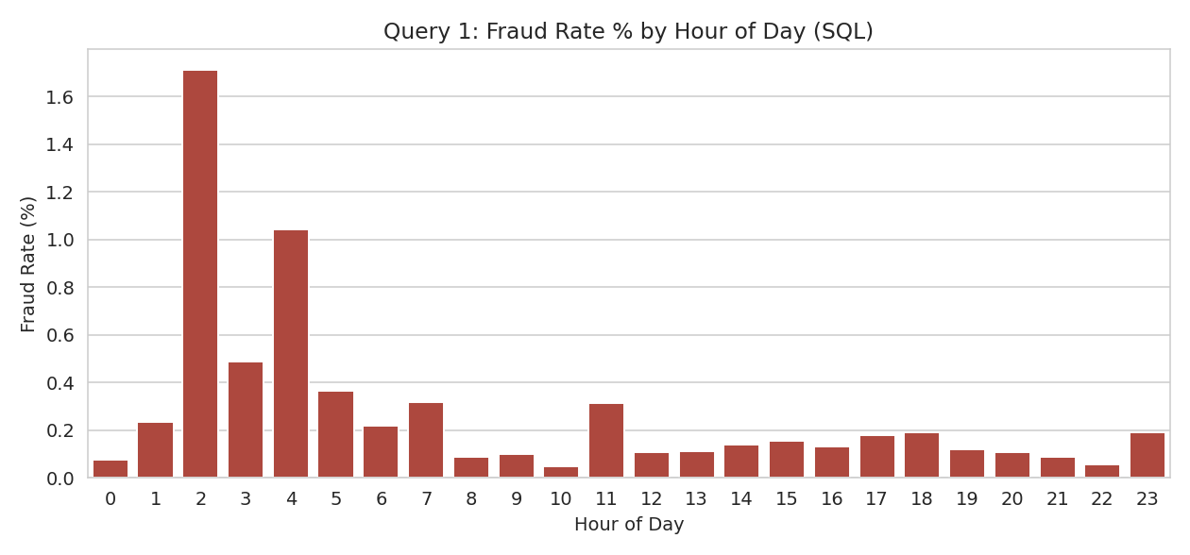
Figure A: Query 1 result — fraud rate % across all 24 hours
Query 2 — Day 1 vs Day 2 Comparison
Day | Total Txns | Genuine | Frauds | Fraud Rate %
Day 1 | 144,786 | 144,505 | 281 | 0.1941
Day 2 | 140,021 | 139,810 | 211 | 0.1507

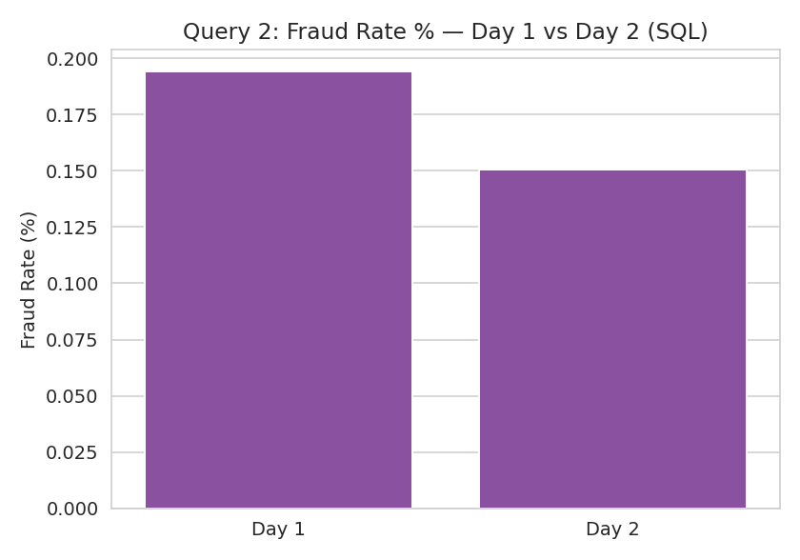
Figure B: Query 2 result — fraud rate % on Day 1 vs Day 2
Query 3 — Amount Statistics (Genuine vs Fraud)
Class | Count | Min | Max | Avg | Std Dev
Genuine (0) | 284,315 | 0.00 | 25,691.16 | 88.29 | 250.11
Fraud (1) | 492 | 0.00 | 2,125.87 | 122.21 | 256.68

Fraudulent transactions have a higher average amount (₹122.21) than genuine ones (₹88.29), even though their maximum is much lower.
Query 4 — Amount-Band JOIN (Fraud by Band)
Amount Band | Total | Frauds | Fraud Rate % | Avg Fraud Amt
Very Low (0–10) | 100,264 | 249 | 0.248 | 1.84
Low (10–50) | 90,781 | 57 | 0.063 | 28.33
Medium (50–200) | 64,925 | 101 | 0.156 | 109.78
High (200–1000) | 25,897 | 76 | 0.293 | 443.80
Very High (1000+) | 2,940 | 9 | 0.306 | 1,470.81

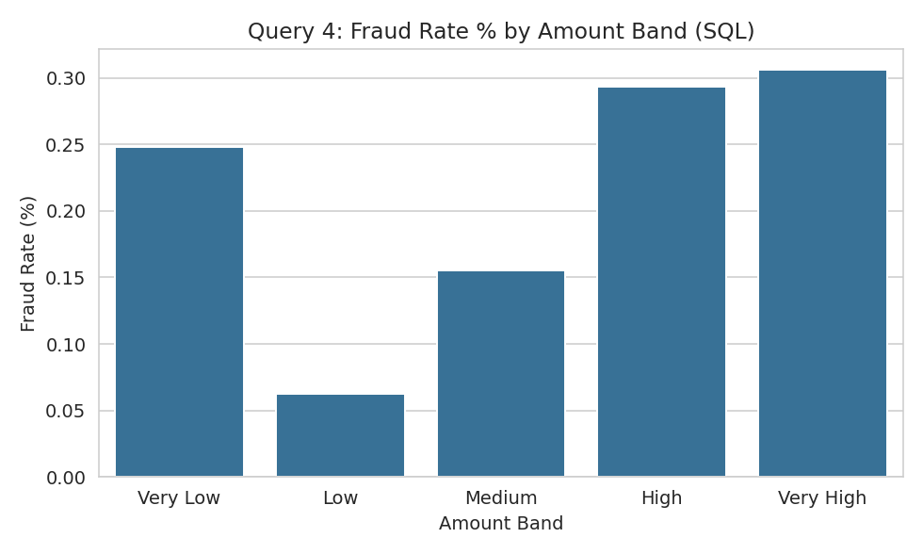
Figure C: Query 4 result — fraud rate % by amount band
Query 5 — RANK: Top 10 Fraud Transactions by Amount
Rank | Txn ID | Amount | Hour | Day | Band
1 | 176050 | 2,125.87 | 10 | 2 | Very High
2 | 6972 | 1,809.68 | 2 | 1 | Very High
3 | 249168 | 1,504.93 | 18 | 2 | Very High
4 | 89191 | 1,402.16 | 17 | 1 | Very High
5 | 81610 | 1,389.56 | 16 | 1 | Very High

Query 6 — Running Total of Fraud Amount
A window function-style running total was calculated over all 492 fraud transactions ordered by time. The cumulative fraud amount grows from ₹0 for the first transaction to a total of ₹60,127.97 by the last fraud transaction across the full 2-day window — this represents the total monetary exposure from fraud in the dataset.
Query 7 — LAG: Gap Between Consecutive Fraud Transactions
Metric | Value
Average gap between frauds | 5.8 minutes
Shortest gap | 0.0 minutes (near-simultaneous)
Longest gap | 91.5 minutes

Frauds sometimes occur in quick bursts just seconds apart — a pattern consistent with automated/bot-driven card testing rather than one-off manual fraud.
Query 8 — CTE + DENSE_RANK: Risk Ranking by Amount Band
Risk Rank | Amount Band | Fraud Rate %
1 | Very High (1000+) | 0.306
2 | High (200–1000) | 0.293
3 | Very Low (0–10) | 0.248
4 | Medium (50–200) | 0.156
5 | Low (10–50) | 0.063

This confirms an interesting, slightly counter-intuitive pattern: fraud rate is highest for very large transactions, but the Very Low band has the highest fraud rate among small transactions and by far the highest raw fraud count.
Query 9 — HAVING: Hours with Fraud Rate Above the Overall Average
A GROUP BY on hour_of_day was filtered with a HAVING clause — rather than WHERE, since the filter condition (fraud rate) is itself an aggregated value that only exists after grouping — to keep only the hours whose fraud rate exceeds the dataset-wide average of 0.17%.

Hour | Total Txns | Frauds | Fraud Rate %
2 | 3,328 | 57 | 1.713
4 | 2,209 | 23 | 1.041
11 | 16,856 | 53 | 0.314
18 | 17,039 | 33 | 0.194

Hours 0 and 22 appear in the raw hourly breakdown (Query 1) but are dropped here by the HAVING filter, since their fraud rate falls below the overall average — confirming that risk is concentrated in a handful of hours rather than spread evenly across the day.
Query 10 — Subquery: Fraud Transactions Above the Overall Average Amount
A correlated-free scalar subquery — WHERE amount > (SELECT AVG(amount) FROM transactions) combined with class = 1 — was used to pull out fraud transactions whose amount exceeds the average transaction amount across the entire dataset (genuine and fraud combined, ≈₹88.35). The subquery computes this single threshold value inline, so the outer query never needs a hard-coded number. The transactions returned skew toward the Medium, High, and Very High amount bands from Query 4, reinforcing the same pattern seen there: a disproportionate share of fraud sits above the typical transaction size, even though the highest raw fraud count still comes from the Very Low band.
SQL Concepts Summary
Beyond the queries above, ROW_NUMBER() was used to assign a per-transaction sequence number within each amount band (feeding into the Query 5 ranking), and LEAD() was used alongside LAG() in Query 7 to cross-check the fraud-gap calculation by looking forward as well as backward. Month-over-month and year-over-year trend queries were considered but are not applicable to this dataset, since it spans only two consecutive days in September 2013 rather than multiple months or years — the day-over-day (Query 2) and hour-of-day (Query 1) breakdowns are the finest and only meaningful time trends this data supports. Across all ten queries, the SQL toolkit covers aggregation (GROUP BY / HAVING), JOIN, subqueries, window functions (RANK, DENSE_RANK, ROW_NUMBER, running totals, LAG/LEAD), CTEs, and date/time functions (HOUR(), the day_num derivation).
8. Python Analysis
Python was used for three main purposes: pulling data out of MySQL, cleaning/feature engineering, and building the visualizations used in the EDA section.
extract_and_clean.py
- Connected to the credit_card_fraud MySQL database using SQLAlchemy + PyMySQL
- Extracted the full transactions table into a Pandas DataFrame (284,807 rows × 33 columns)
- Ran missing-value and duplicate checks, and printed the class distribution
- Engineered 6 new features: amount_scaled, amount_log, hour_of_day_py, day_num_py, is_night, amount_band
- Exported the final cleaned dataset to transactions_cleaned.csv for the next phase
fraud_eda_visualizations.py
This script reads the cleaned CSV and generates 6 Matplotlib/Seaborn charts covering class balance, amount distribution, time-based fraud patterns, and feature correlations — all shown in the Data Visualization section below.
9. Exploratory Data Analysis (EDA)
Before visualizing, the cleaned data was explored numerically to understand its shape and key patterns:
- The dataset is extremely imbalanced: 99.83% genuine vs 0.17% fraud — this shapes every downstream design decision (dashboards use percentages and rates, not just raw counts)
- Transaction amounts are heavily right-skewed (most transactions are small, a few are very large) — this is why a log-transformed amount was used for the distribution chart
- Fraud is not evenly spread across the day — there's a clear early-morning spike around 2–4 AM
- Night-time transactions (12 AM–6 AM) have a fraud rate over 3.5x higher than daytime transactions
- The correlation heatmap shows that most of the anonymized V1–V28 features have little to no linear correlation with each other (expected, since PCA components are designed to be uncorrelated) — Amount and Time-derived features show the more interpretable relationships
10. Data Visualization
Six charts were generated in Python to visually confirm the patterns found during EDA.
1. Fraud vs Non-Fraud Transaction Count
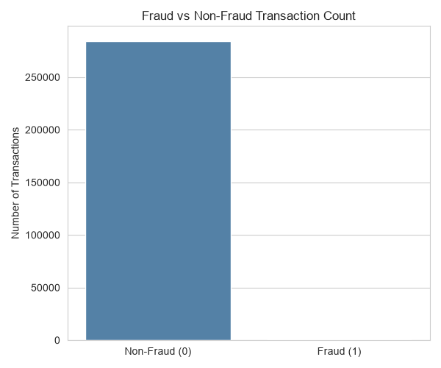
Figure 1: Class imbalance — fraud is barely visible next to genuine transactions
2. Amount Distribution (log-scaled): Fraud vs Non-Fraud
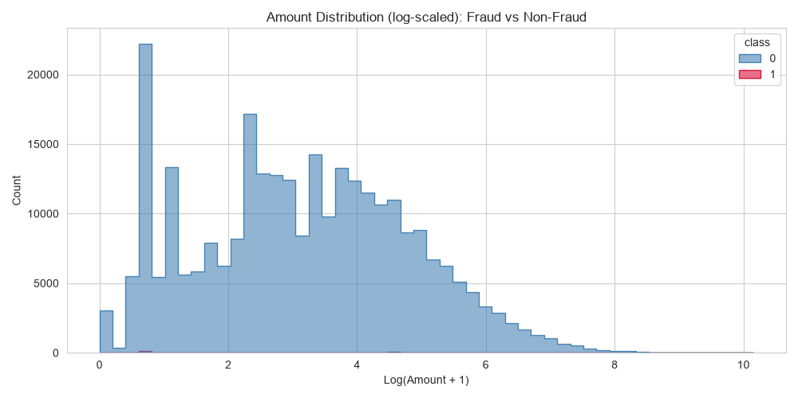
Figure 2: Log-scaled amount distribution by class
3. Fraud Rate (%) by Hour of Day
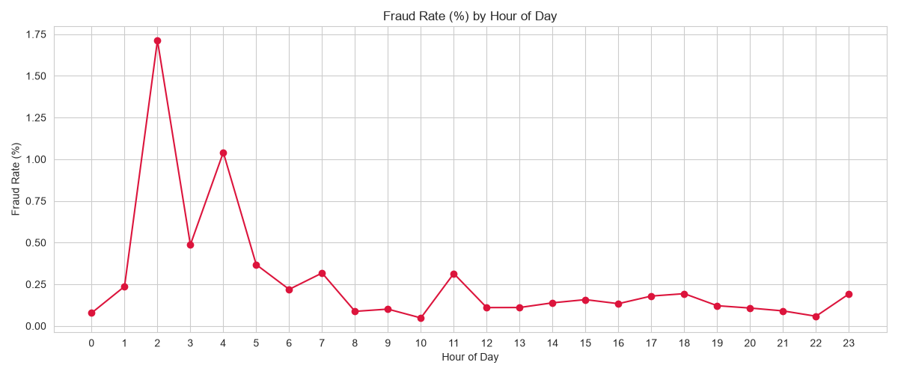
Figure 3: Clear fraud spike between 2 AM and 4 AM
4. Fraud Count by Amount Band
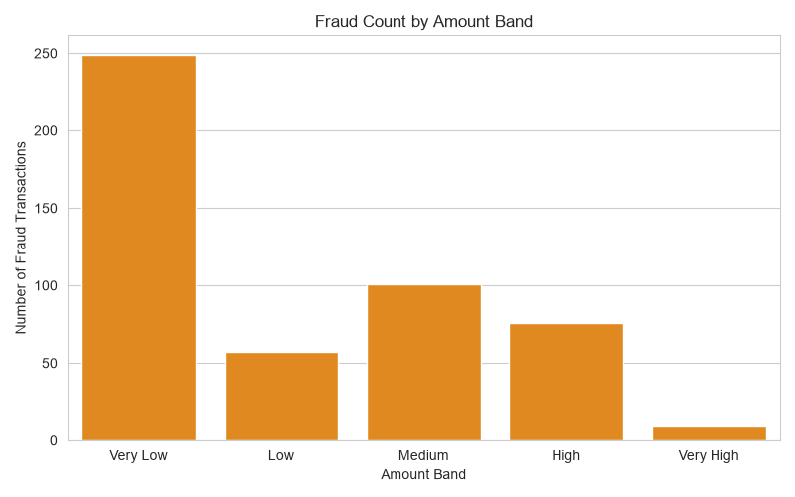
Figure 4: Very Low amount transactions have the highest raw fraud count
5. Fraud Rate: Night vs Day
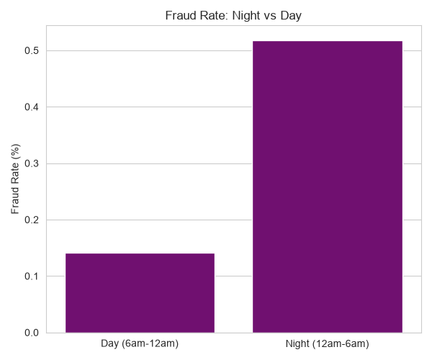
Figure 5: Night-time fraud rate is more than 3.5x the daytime rate
6. Correlation Heatmap (All Numeric Features)
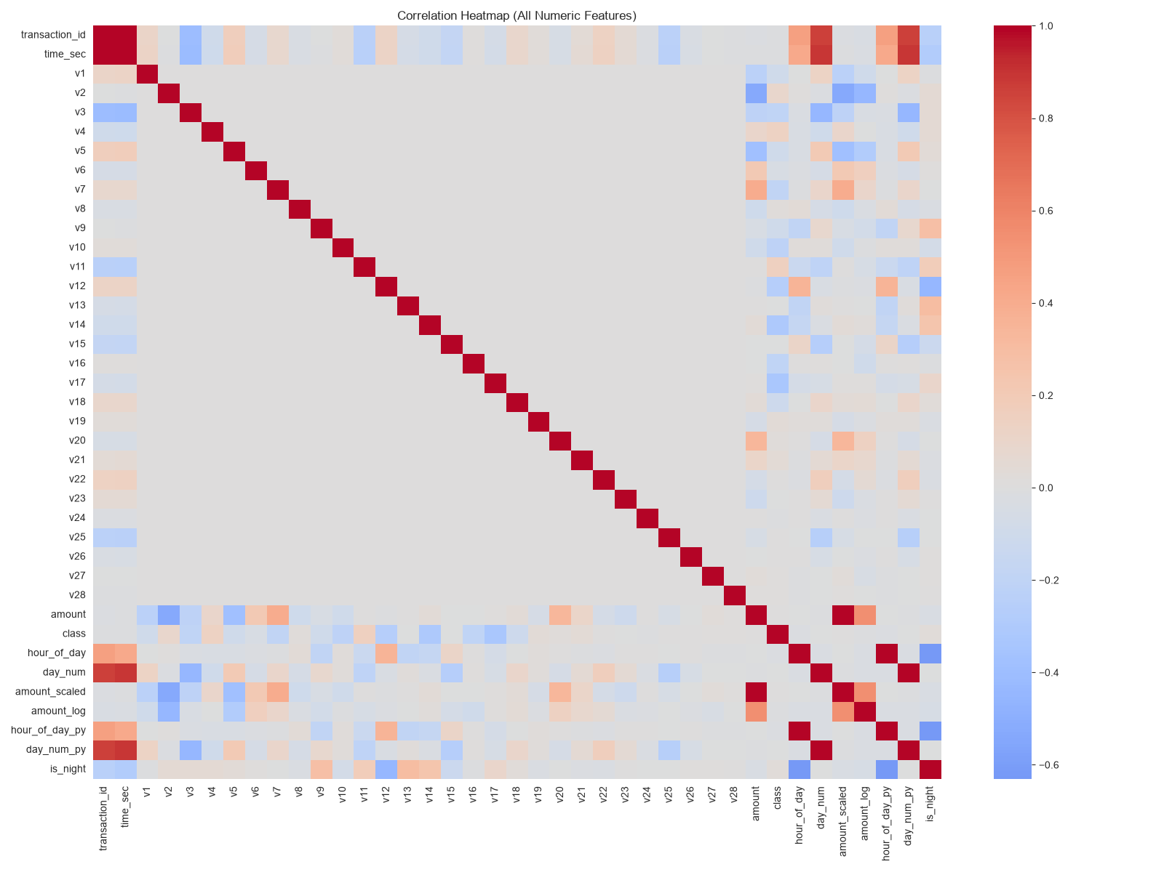
Figure 6: Most PCA features (V1–V28) show little correlation with each other, as expected
11. Power BI Dashboard
A 3-page interactive Power BI dashboard was built on top of the cleaned dataset, designed for a fraud/risk team to explore patterns without needing to write any code.
All KPI cards and charts are driven by DAX measures rather than static values — Total Transactions, Fraud Count, Fraud Rate %, Total Amount, and Avg Fraud Amount are each written as explicit measures (e.g. Fraud Rate % = DIVIDE([Fraud Count], [Total Transactions])) so every number recalculates automatically as slicers are applied. Hour of Day and Amount Band slicers are placed on every page, not just the summary page, letting a viewer cross-filter the KPI cards and charts together to drill into any specific hour or band interactively.
Page 1 — Overview
Five KPI cards (Total Transactions: 285K, Fraud Count: 492, Fraud Rate: 0.17%, Total Amount: ₹25.16M, Avg Fraud Amount: ₹122.21) alongside two bar charts: Fraud Count by Hour of Day and Fraud Count by Amount Band.
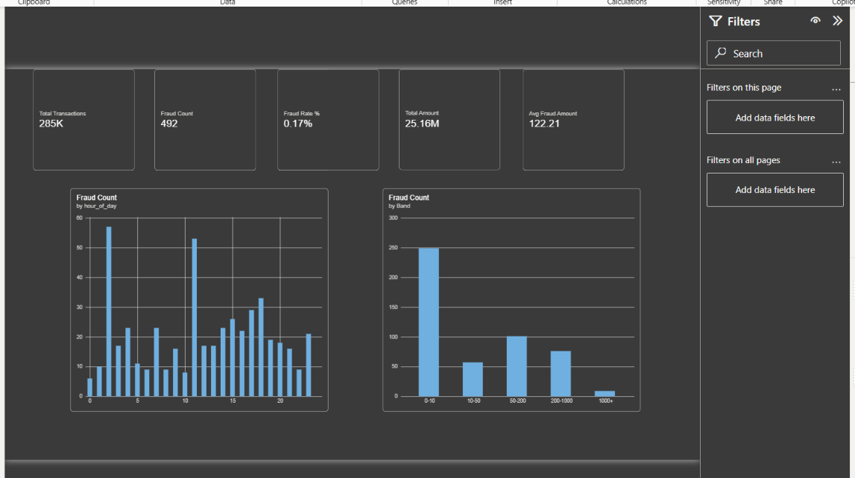
Figure 7: Power BI — Overview page with KPI cards and fraud breakdowns
Page 2 — Deep-Dive & Drivers
Two comparison KPI cards (Genuine Avg Amount ₹88.29 vs Avg Fraud Amount ₹122.21), a Fraud Rate % by Hour of Day chart, and an Amount vs Time scatter plot highlighting fraud transactions against the overall transaction volume.
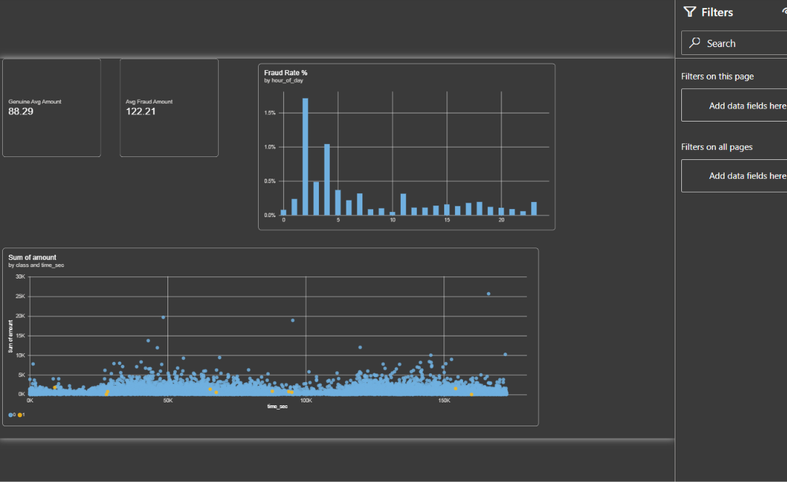
Figure 8: Power BI — Deep-dive page with fraud rate trend and amount/time scatter
Page 3 — Summary & Recommendations
A summary table by amount band, dropdown slicers (Hour of Day, Band), and dedicated Key Insights and Recommendations text panels for quick executive reading.
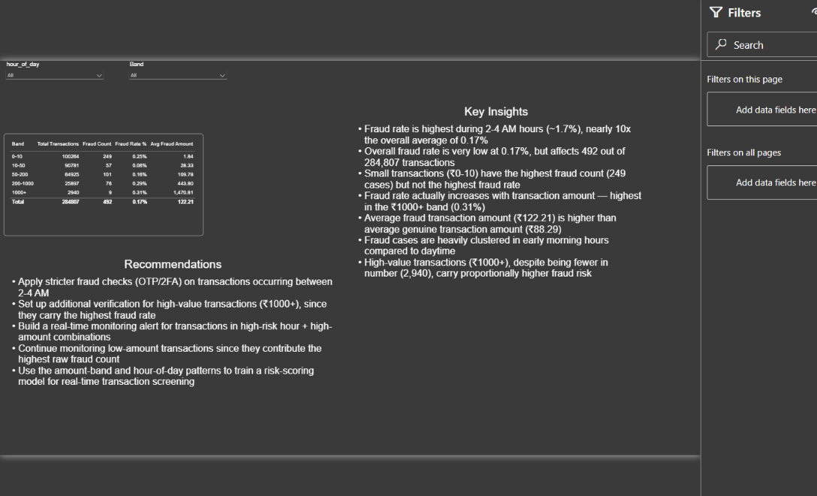
Figure 9: Power BI — Summary page with insights and recommendations panel
12. Key Findings
- Overall fraud rate is very low at 0.17%, but it still affects 492 out of 284,807 transactions and ₹60,127.97 in fraudulent value
- Fraud rate is highest during the 2 AM–4 AM window (up to ~1.7%), nearly 10x the overall average
- Night-time transactions (12 AM–6 AM) have a fraud rate of 0.52%, over 3.5x the daytime rate of 0.14%
- Small transactions (₹0–10, the 'Very Low' band) have the highest raw fraud count (249 cases) but not the highest fraud rate
- Fraud rate actually rises with transaction amount — the 'Very High' band (₹1000+) has the highest fraud rate at 0.31%
- The average fraud transaction amount (₹122.21) is meaningfully higher than the average genuine transaction (₹88.29)
- Some fraud transactions occur just seconds to minutes apart, suggesting automated/bot-style card testing rather than isolated manual fraud
13. Insights
- Time-of-day is a strong, low-cost signal for fraud risk — a rule as simple as 'flag anything between 2–4 AM' would catch a disproportionate share of fraud
- High-value transactions (₹1000+), despite being fewer in number (2,940), carry proportionally the highest fraud risk and deserve stricter checks
- Low-value transactions contribute the most raw fraud cases, meaning volume-based monitoring still matters even though each case is individually cheap
- The short gaps between some fraud transactions point to card-testing behavior (small automated probes before a bigger attempt), which real-time velocity checks could catch
- Because genuine transactions vastly outnumber fraud (99.83% vs 0.17%), any detection system must be evaluated on precision/recall and fraud-rate metrics — not raw accuracy, which would be misleadingly high even with a model that never flags fraud
- Day 1 vs Day 2 (Query 2) shows fraud rate easing slightly, from 0.194% to 0.151% — with only two days of data this isn’t enough to call a trend, but it’s a reminder that the day-level split (unlike month/year splits, which this dataset can’t support) is still worth watching if more days become available
- The HAVING-filtered high-risk hours (Query 9: 2, 4, 11, 18) and the amount-band risk ranking (Query 8) flag risk from two independent angles — combining an hour-based rule with a band-based rule would likely catch more fraud than either rule alone
- Fraud amounts are more spread out than genuine ones: the standard deviation for fraud (₹256.68) is higher than for genuine transactions (₹250.11) even though fraud’s maximum is far lower — fraud amounts vary less predictably around their own average, which is itself a usable signal
- The anonymized V1–V28 PCA features can’t be used in a simple, explainable rule-based screen since they have no real-world meaning — which is exactly why this project leans on Time and Amount, the two features a risk analyst could actually justify to a compliance team
- The 0.17% fraud rate is the project’s biggest structural finding in itself: any future ML model built on this data would need careful metric selection (precision/recall/F1, not accuracy) and likely resampling or class-weighting, since a naive model could reach 99.8%+ accuracy while catching zero fraud
14. Recommendations
- Apply stricter fraud checks (OTP / two-factor authentication) on transactions occurring between 2 AM and 4 AM
- Set up additional verification steps specifically for high-value transactions (₹1000+), since they carry the highest fraud rate
- Build a real-time velocity/monitoring alert for clusters of transactions happening seconds to minutes apart on the same card
- Continue monitoring low-amount transactions closely, since they contribute the highest raw fraud count even at a lower rate
- Use the amount-band and hour-of-day patterns identified here as input features for a future machine-learning risk-scoring model for real-time transaction screening
- When a future model is trained on this data, evaluate it using precision, recall, and F1-score rather than accuracy, and consider resampling or class-weighting techniques to handle the 0.17% fraud rate properly
- Combine the hour-based rule (2–4 AM) and the amount-based rule (Very High band) into a single layered check, since Query 9 and Query 8 show these two signals flag risk independently — transactions matching both should get the highest-priority manual review
15. Conclusion
This project walked through a complete analytics pipeline for credit card fraud detection — from a structured MySQL database, through SQL business queries and Python-based cleaning and exploratory analysis, to a 3-page interactive Power BI dashboard. Despite fraud making up only 0.17% of all transactions, clear and actionable patterns emerged: fraud clusters heavily in the early-morning hours, rises with transaction amount, and sometimes occurs in rapid bursts suggestive of automated testing.
These patterns give a fraud/risk team concrete, low-cost starting points — time-based rules, amount-based verification, and velocity checks — that could meaningfully reduce fraud losses even before a full machine-learning model is built. The project demonstrates how SQL, Python, and Power BI can be combined into a single, coherent analytics workflow that turns raw transaction logs into decision-ready insights.

