RETAIL SUPERSTORE SALES ANALYSIS
Power BI Dashboard Project Report
Prepared by: Karan Bisht
Tool: Microsoft Power BI Desktop | Data Source: MySQL (superstore database)
Date: August 2026

A Data Analytics Project — End-to-End Power BI Dashboard Development
MySQL → Power Query → Data Modeling → DAX → Visualization → Insights

2. Introduction
This project uses the Superstore dataset, a simulated retail business dataset containing order-level transactional records across multiple years. The business scenario represents a mid-sized retail company selling products across categories such as Furniture, Office Supplies, and Technology, operating through multiple regions and serving a broad customer base.
As a Data Analyst, the goal of this project was to take raw transactional order data and turn it into a decision-ready Power BI dashboard that helps management understand sales performance, profitability, customer behavior, and growth trends over time.

3. Problem Statement / Objective
The Superstore business generates a large volume of order data, but without a consolidated reporting system, it is difficult for management to answer basic performance questions quickly — which regions and categories drive the most revenue, which customers are most valuable, whether the business is growing year over year, and how actual sales compare against targets.
The objective of this dashboard is to solve that problem by providing:
- A clear, real-time view of overall sales, profit, and order KPIs.
- Region-, category-, and product-level performance breakdowns.
- Customer-level analysis to identify top contributors and sales-vs-profit relationships.
- Time-intelligence tracking (YTD, YoY growth) to monitor business trajectory.
- A Sales vs Target gauge to monitor progress against a defined sales goal.

4. Dataset Description
Source: MySQL database named 'superstore', accessed via MySQL Connector/NET and managed through HeidiSQL, connected live to Power BI Desktop.
Main Table: orders — one row per order line item.
Important columns:
- order_id, order_date, ship_date, ship_mode — order and shipping identifiers/dates
- customer_id, customer_name, segment — customer attributes
- product_id, product_name, category, sub_category — product attributes
- region, state, city, postal_code — geographic attributes
- sales, profit, discount, quantity — transactional metrics
Supporting Table: DateTable — a dedicated calendar/date dimension table created for time-intelligence analysis, containing Date, Year, Month, MonthNumber, and Quarter columns.
Relationships: A one-to-many relationship exists between DateTable[Date] (one side) and orders[order_date] (many side), enabling accurate time-based filtering and calculations across all visuals.
The dashboard's Total Orders KPI shows approximately 5,000 order records in the cleaned dataset, spanning the years 2014 to 2017.

5. Data Cleaning & Preparation
The following data-cleaning steps were performed in Power Query before building the data model:
- Removed duplicate order records to prevent double-counting of sales and profit.
- Converted order_date and ship_date fields to proper Date data types to support time-intelligence functions.
- Standardized number formats for sales, profit, discount, and quantity columns (ensuring consistent decimal handling).
- Identified and handled null/blank values in relevant columns to prevent calculation errors in measures.
- Trimmed extra whitespace from text fields such as customer_name and product_name to avoid duplicate groupings caused by formatting inconsistencies.
- Reviewed category and sub-category values for consistent, correctly spelled labels.

6. Data Modeling
A star-schema-style model was used, with the orders table acting as the fact table and DateTable acting as a dimension table for time intelligence.
- DateTable[Date] → orders[order_date]: one-to-many relationship, single filter direction (DateTable filters orders).
- The DateTable spans the complete date range covered by the order data, ensuring no gaps in time-based calculations.
- Year, Month (with a numeric sort column), and Quarter columns in DateTable allow correct chronological sorting in all time-based visuals.
Data Model Screenshot:
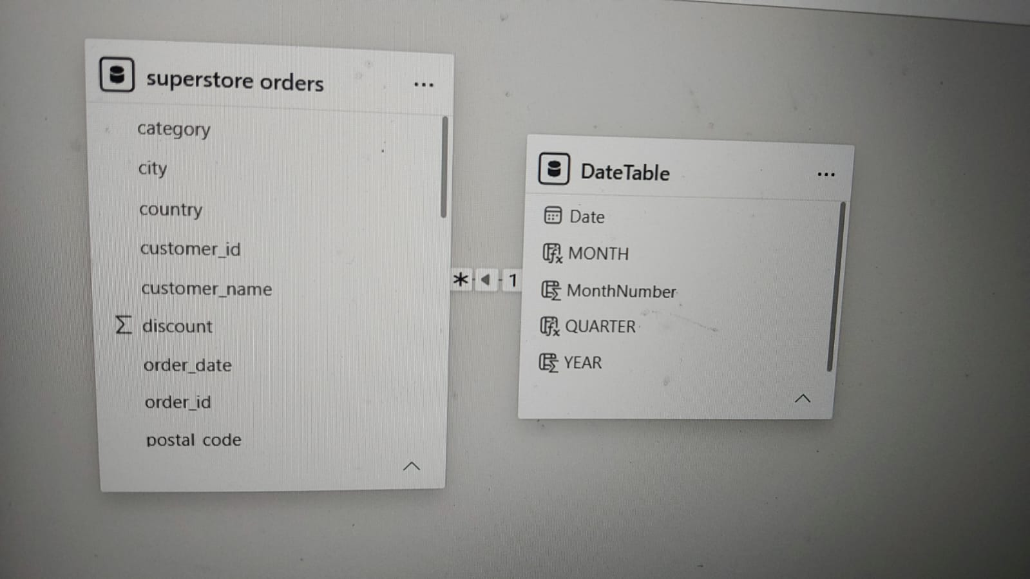
Figure: Power BI Model View — one-to-many relationship between superstore orders and DateTable, joined on order_date ↔ Date.

7. DAX Calculations
The following measures were created to support the dashboard's KPIs, trend analysis, and rankings:
Measure | DAX Logic / Purpose
Total Sales | SUM of order sales values
Total Profit | SUM of order profit values
Profit Margin % | DIVIDE(Total Profit, Total Sales)
Total Orders | DISTINCTCOUNT of order_id
Avg Order Value | DIVIDE(Total Sales, Total Orders)
Sales PY | Prior-year sales using SAMEPERIODLASTYEAR
YoY Growth % | DIVIDE(Total Sales − Sales PY, Sales PY)
Rank by Sales | RANKX over customers by Total Sales, descending
Sales YTD | TOTALYTD(Total Sales, DateTable[Date])
Sales Target | Defined sales goal used as the gauge benchmark
Max Gauge | Sales Target × multiplier, used as the gauge's maximum axis value
These measures demonstrate the use of aggregation functions (SUM, DIVIDE), iterator functions (RANKX), and time-intelligence functions (TOTALYTD, SAMEPERIODLASTYEAR) as required by the course.

8. Dashboard Design

Page 1 — Overview
Purpose: Give management a single-glance view of overall business health.
- Four KPI cards: Total Sales, Total Profit, Profit Margin %, Total Orders.
- Sales Trend line chart across Year/Month, chronologically sorted.
- Region and State bar charts to identify geographic performance.
- Category/Sub-category bar chart and treemap for product-line performance.
- Top 10 Customers and Top 10 Products tables.
- Region, Category, and Date Range slicers for interactive filtering.
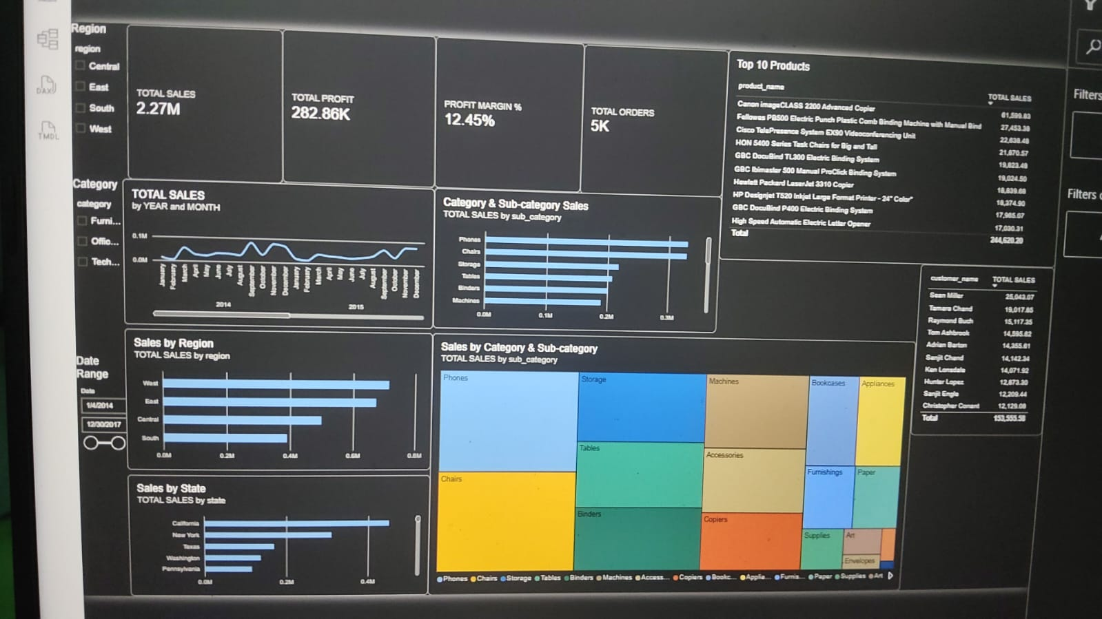
Figure: Page 1 — Overview, showing KPI cards, Sales Trend, Sales by Region/State, Category & Sub-category treemap, Top Products, and Top Customers.

Page 2 — Customer & Product Deep-Dive
Purpose: Allow deeper exploration of how regions, categories, and individual customers relate to sales and profit.
- Region vs Category matrix for cross-tabulated performance.
- Sales decomposition tree for root-cause/driver exploration.
- Customer-level scatter chart comparing Sales vs Profit, useful for spotting high-sales/low-profit outliers.
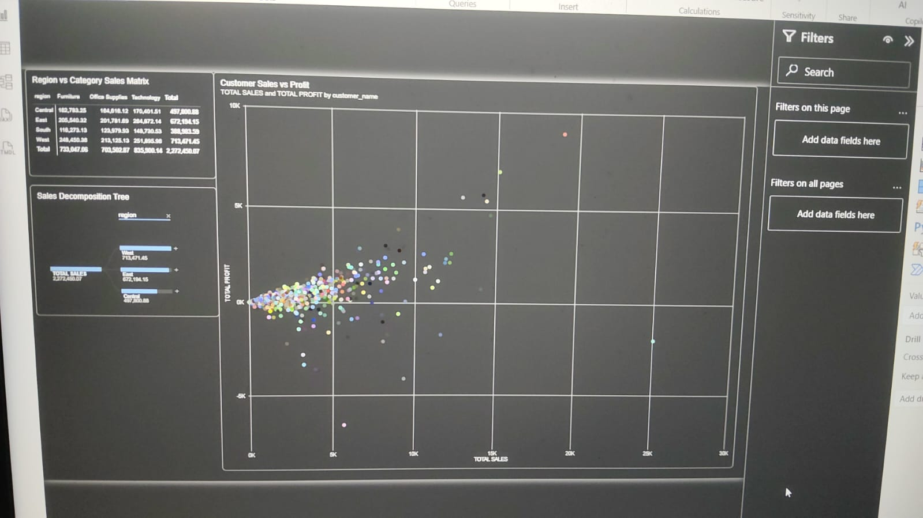
Figure: Page 2 — Customer & Product Deep-Dive, showing the Region vs Category matrix, Sales Decomposition Tree, and Customer Sales vs Profit scatter chart.

Page 3 — Time Intelligence & Insights
Purpose: Track the business's performance trajectory over time and monitor progress against targets.
- Combined Total Sales vs Sales YTD line chart, expanded to Year-Month granularity to show both monthly and cumulative trends.
- YoY Growth % card with conditional green/red formatting for immediate visual feedback.
- Top 5 Customers by Rank table, filtered using the Rank by Sales measure.
- Gauge visual comparing Total Sales against the defined Sales Target.
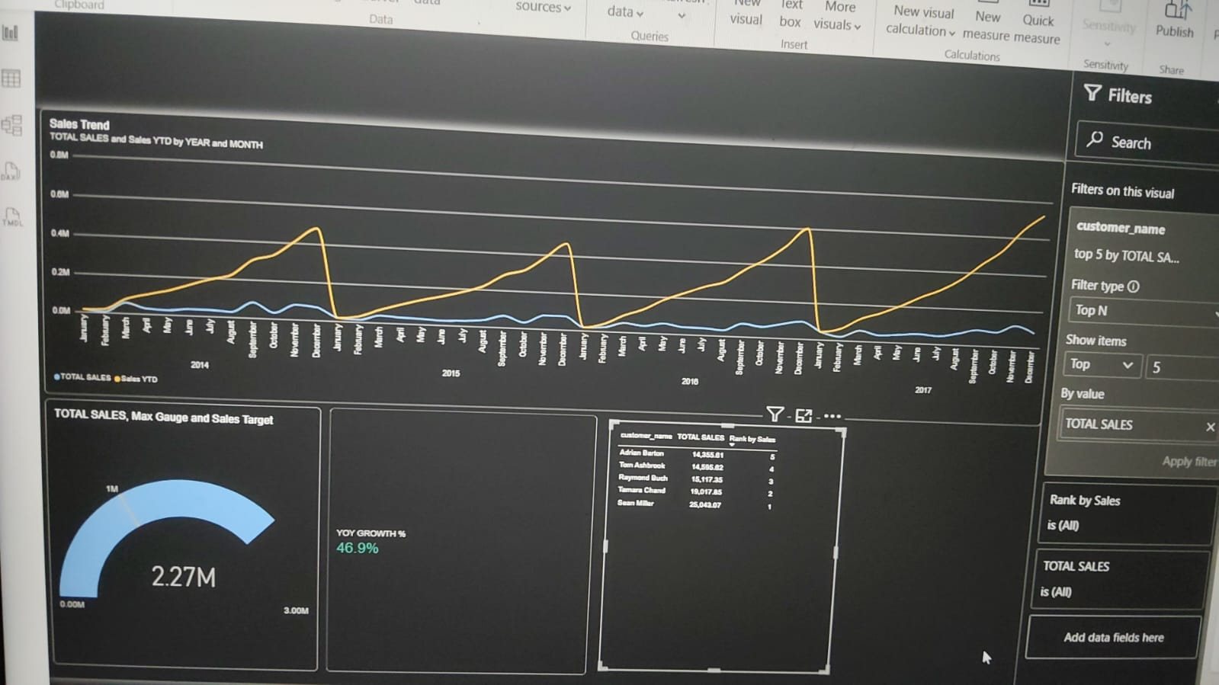
Figure: Page 3 — Time Intelligence & Insights, showing the Sales Trend chart, Sales-vs-Target gauge, YoY Growth % card, and Top 5 Customers table.

9. Key Findings
- Overall year-over-year sales growth is 46.9%, indicating strong positive momentum in the business.
- Sean Miller is the top-performing customer by sales value (approx. ₹25,043), the highest among the top-5 customer segment.
- 2016 recorded the strongest cumulative (YTD) sales performance among the years analyzed.
- Monthly (non-cumulative) sales remain relatively stable throughout each year, while the YTD line rises steadily until it resets at each new year.
- The combined sales of the top 5 customers form a significant share of total revenue.
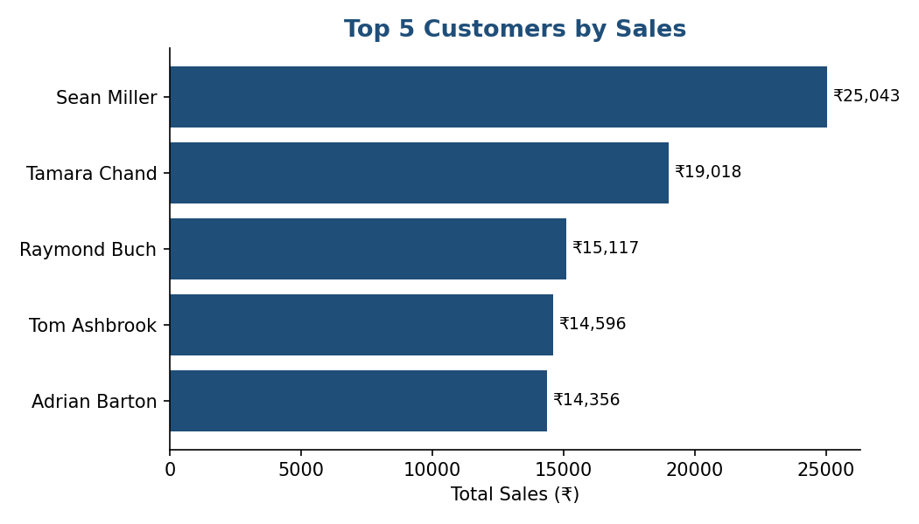
Figure: Top 5 Customers by Sales
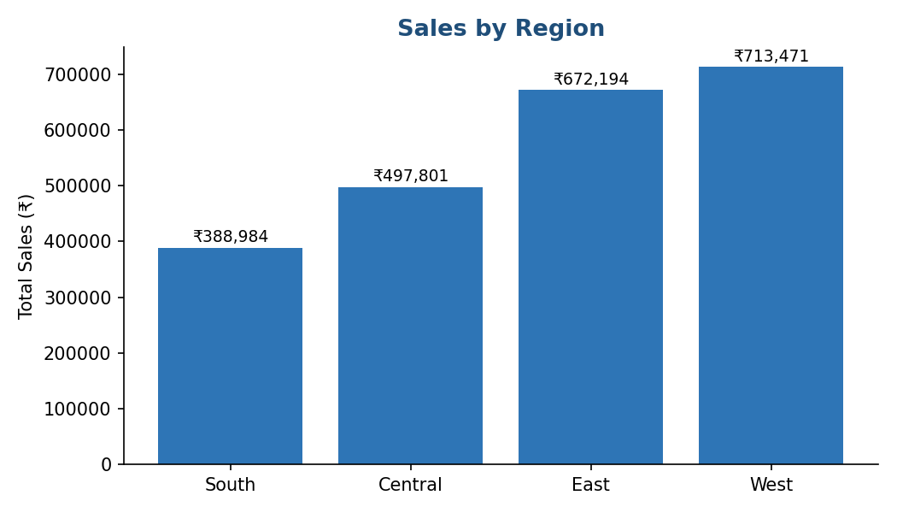
Figure: Sales by Region
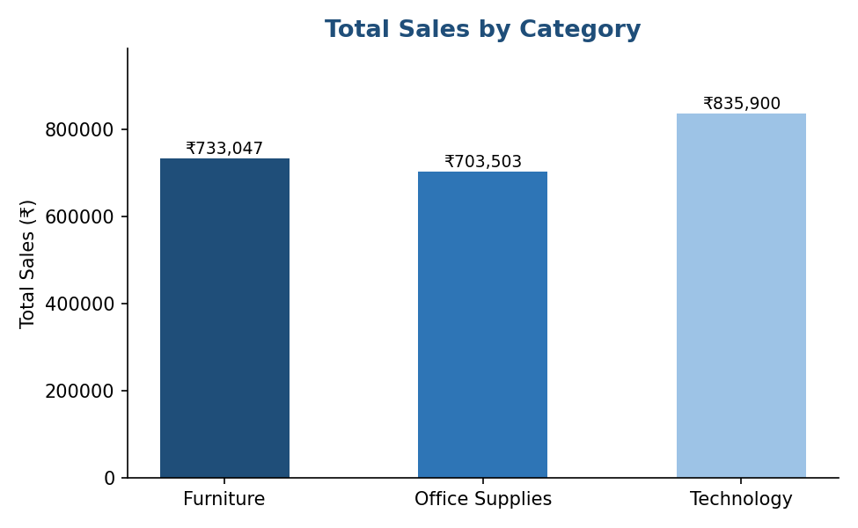
Figure: Total Sales by Category

10. Insights
- Strong YoY growth (46.9%) suggests the business's overall strategy and market positioning are working, but this growth is not evenly distributed — it appears concentrated in specific years and customers.
- A small number of top customers contribute disproportionately to revenue, which signals meaningful customer-concentration risk if any of them were to churn.
- The consistent YTD reset pattern each January suggests seasonality tied to the calendar year rather than gradual organic growth — the business may benefit from smoothing this cycle.
- 2016 outperforming other years suggests specific factors (marketing, pricing, product mix) were more effective that year and are worth investigating and replicating.
- The relative stability of monthly sales indicates operational consistency, but also suggests limited use of seasonal promotions or campaigns to drive spikes in demand.

11. Recommendations
- Introduce a loyalty or retention program targeted at top-value customers such as Sean Miller and Tamara Chand, given their outsized contribution to total revenue, to reduce customer-concentration risk.
- Launch proactive marketing campaigns ahead of the Q4-to-Q1 transition, since cumulative YTD sales consistently reset at the start of each new year — early promotions could smooth this seasonal dip and improve the following year's start.
- Analyze and replicate the operational and marketing strategies used in 2016, the strongest-performing year, to inform future sales planning and target-setting.

12. Conclusion
This project successfully transformed raw MySQL transactional data into a fully interactive, insight-driven Power BI dashboard. Through a clean star-schema data model and a comprehensive set of DAX measures, the dashboard delivers reliable KPI tracking, time-intelligence analysis, and customer/product-level insights.
The findings demonstrate healthy overall sales growth alongside clear opportunities for improving customer retention and smoothing seasonal performance dips. This report, together with the accompanying Power BI (.pbix) file, forms the complete deliverable for the Superstore Sales Analysis project.

Report prepared by: Karan Bisht

