HR ATTRITION ANALYTICS
Power BI Dashboard Project Report
Project 2 — HR Analytics (IBM Employee Attrition Dataset)
Prepared by: Karan Bisht
Submission Date: 25 August 2026
Tool Used: Microsoft Power BI Desktop

2. Introduction
Employee attrition — the rate at which employees leave an organisation — is one of the most closely tracked people-metrics in Human Resources. Every employee who leaves represents lost institutional knowledge, recruitment and training cost, and disruption to team productivity. Understanding who is leaving, and why, allows an organisation to move from reacting to attrition after the fact to actively preventing it.
This project uses Power BI to build an interactive HR analytics dashboard on an employee attrition dataset (based on the well-known IBM HR Analytics Employee Attrition sample). The dashboard is designed for an HR/People Analytics audience — HR Business Partners, department heads, and senior leadership — who need a quick, filterable view of where attrition is concentrated and what factors are associated with it.

3. Problem Statement / Objective
The organisation wants to understand its attrition problem in data-driven terms rather than anecdotally. Specifically, the dashboard is built to answer the following business questions:
- What is the company's overall attrition rate, and how many employees does it represent?
- Which departments experience the highest attrition, in both absolute and percentage terms?
- Does an employee's age or tenure with the company influence their likelihood of leaving?
- Does job satisfaction, or marital status, correlate with attrition?
- Which specific combination of factors (department, satisfaction, tenure) represents the highest-risk employee segment?
The objective is to convert these questions into a self-service, interactive dashboard so that HR stakeholders can filter and drill into the data themselves, rather than requesting a new static report each time a question comes up.

4. Dataset Description
Source: A trimmed version of the IBM HR Analytics Employee Attrition & Performance dataset (a widely-used, publicly available HR analytics sample), supplied as a single CSV file (IBM.csv).
Structure: The dataset consists of a single flat table with 1,470 records (one row per employee) and 13 original columns. There is no separate dimension table, unique employee identifier, or date/hire-date field in the source file — an EmployeeID surrogate key was added during data preparation (see Section 5).
Data quality: The dataset was found to have zero missing (null) values across all 1,470 rows and all 13 columns on initial inspection — a rare and welcome starting point that meant cleaning could focus on structuring and enriching the data rather than repairing it.

Column Overview
Column | Description
Age | Employee's age in years
Attrition | Whether the employee left the company (Yes/No) — the target variable
Department | Human Resources, Research & Development, or Sales
DistanceFromHome | Distance between home and office (miles)
Education | Education level, coded 1 (Below College) to 5 (Doctor)
EducationField | Field of study, e.g. Life Sciences, Medical, Marketing
EnvironmentSatisfaction | Satisfaction with work environment, coded 1 (Low) to 4 (Very High)
JobSatisfaction | Satisfaction with the job, coded 1 (Low) to 4 (Very High)
MaritalStatus | Single, Married, or Divorced
MonthlyIncome | Employee's monthly salary
NumCompaniesWorked | Number of companies the employee has worked at previously
WorkLifeBalance | Rating of work-life balance, coded 1 (Bad) to 4 (Best)
YearsAtCompany | Tenure with the company, in years

Because the dataset has no date column and no natural key, no relationships or star schema were required — the data model is a single, well-typed, enriched table (detailed in Section 6).

5. Data Cleaning & Preparation
All cleaning and preparation was performed in Power Query, using a single M-code script applied through the Advanced Editor. The following steps were carried out:
- Data type correction — all numeric columns (Age, DistanceFromHome, Education, EnvironmentSatisfaction, JobSatisfaction, MonthlyIncome, NumCompaniesWorked, WorkLifeBalance, YearsAtCompany) were explicitly set to Whole Number, and all categorical columns (Attrition, Department, EducationField, MaritalStatus) were set to Text, to prevent incorrect aggregation or type-mismatch errors downstream.
- Surrogate key creation — since the source data had no unique identifier, an Index Column was added and renamed EmployeeID, giving every row a unique key.
- Label decoding for readability — several columns in the raw data are numerically coded (e.g. JobSatisfaction: 1–4). Four new descriptive columns were added using conditional logic: EducationLabel, JobSatisfactionLabel, EnvironmentSatisfactionLabel, and WorkLifeBalanceLabel, so that dashboard visuals show "Low / Medium / High / Very High" instead of bare numbers.
- Binning for analysis — two new banding columns were created to support trend analysis: AgeBand (Under 25, 25-34, 35-44, 45-54, 55+) and TenureBand (0-2 yrs, 3-5 yrs, 6-10 yrs, 10+ yrs).
- Custom sort ordering — because AgeBand, TenureBand, and JobSatisfactionLabel are text categories, Power BI would sort them alphabetically by default (a misleading order for bands). Three additional helper columns — AgeBandSort, TenureBandSort, and JobSatSort — were created and linked to their respective label columns using the "Sort by Column" feature, so that charts display bands in their correct logical order.
No duplicate records, invalid categories, or formatting inconsistencies were found during review, so no rows were removed. The result is a clean, fully-typed, analysis-ready table of 1,470 rows and 20 columns (13 original + 7 derived).

6. Data Modeling
Given the structure of the source data — a single table with no date column and no foreign keys to other entities — a star schema or multi-table model was not applicable to this dataset. The data model therefore consists of one flat, well-structured table that acts as both fact and dimension data: quantitative measures (MonthlyIncome, YearsAtCompany, Age) and categorical attributes (Department, MaritalStatus, JobSatisfactionLabel) live side by side in the same table.
This is an intentional and appropriate modelling decision for this dataset's grain (one row per employee, no repeating transactions or time series), rather than a limitation — introducing artificial dimension tables would have added complexity without analytical benefit.
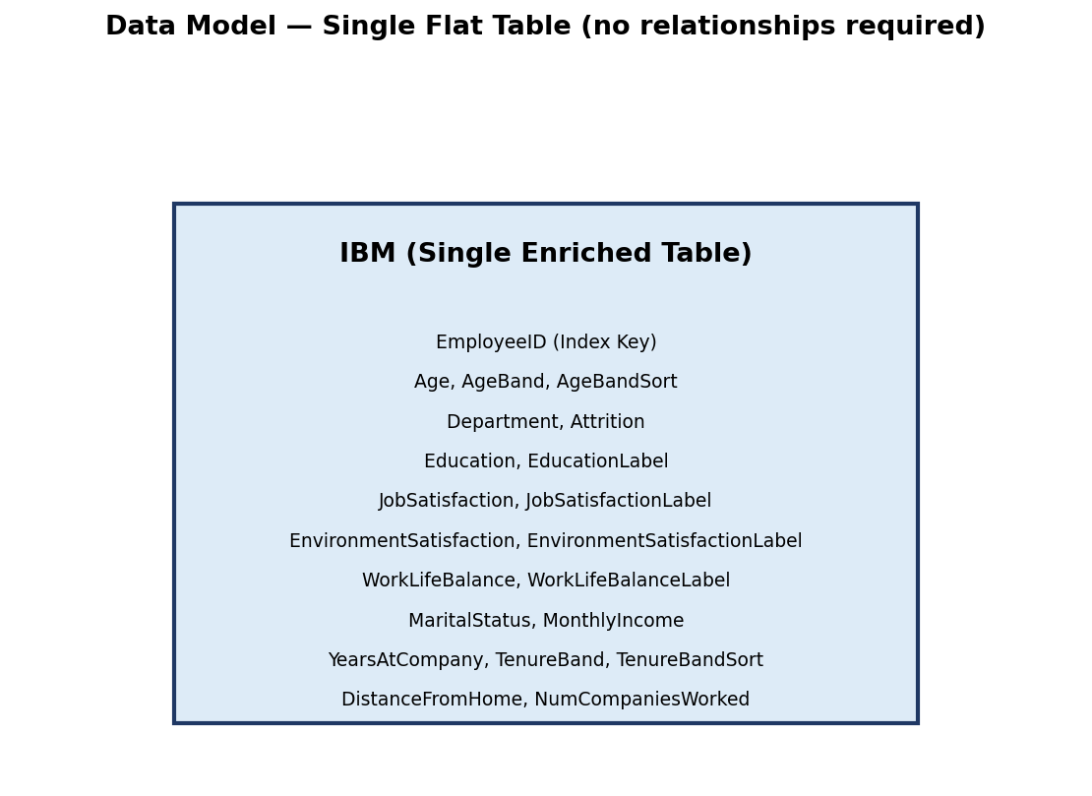
Figure 1: Data model — single enriched table, no relationships required

7. DAX Calculations
Seven DAX measures were created to support the KPI cards and analytical visuals across the dashboard. Measures were used throughout (rather than calculated columns) for all aggregations, since they compute dynamically based on the current filter/slicer context — essential for the dashboard's interactivity.
Measure | DAX Formula | Purpose
Total Employees | COUNTROWS('IBM') | Headcount base for the workforce
Attrited Employees | CALCULATE(COUNTROWS('IBM'), 'IBM'[Attrition]="Yes") | Count of employees who left
Attrition Rate % | DIVIDE([Attrited Employees],[Total Employees],0) | Core KPI — % of workforce lost
Avg Tenure (Years) | AVERAGE('IBM'[YearsAtCompany]) | Average length of service
Avg Monthly Income | AVERAGE('IBM'[MonthlyIncome]) | Average pay level
Avg Age | AVERAGE('IBM'[Age]) | Average workforce age
Avg Distance From Home | AVERAGE('IBM'[DistanceFromHome]) | Average commute distance

DIVIDE() was used instead of the "/" operator for Attrition Rate % to safely handle any potential divide-by-zero scenario when filters return an empty result set. CALCULATE() with a Boolean filter argument was used to compute Attrited Employees within the current filter context, allowing the measure to respond correctly to slicers on Department, Marital Status, and Tenure Band.

8. Dashboard Design
The dashboard is organised into three pages, each with a distinct analytical purpose, following a top-down narrative: start broad (Overview), go deep (Drivers), then summarise for action (Summary & Recommendations).

Page 1 — Overview
Purpose: give a at-a-glance health check of workforce attrition. Contains five KPI cards (Total Employees, Attrited Employees, Attrition Rate %, Avg Tenure, Avg Monthly Income) followed by three charts: Total Employees by Department and Attrition, Attrition Rate by Age Band, and Total Employees by Job Satisfaction and Attrition.
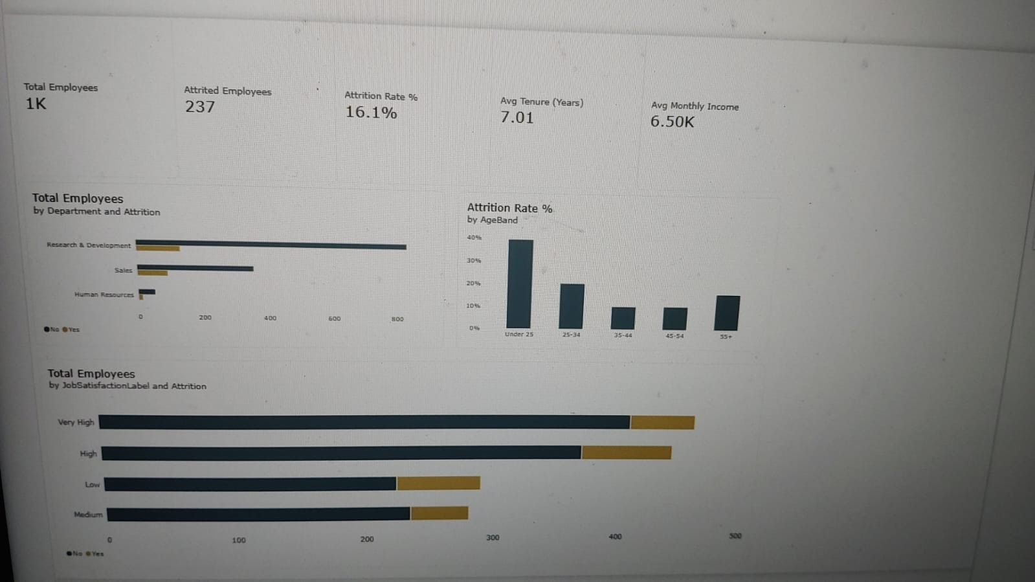
Figure 2: Dashboard Page 1 — Overview

Page 2 — Deep-Dive & Drivers
Purpose: let the user explore why attrition happens, not just how much. Contains a Matrix (Marital Status × Attrition), a Decomposition Tree (Attrited Employees explained by Department → Job Satisfaction → Tenure Band) that supports free-form, click-driven exploration, a Scatter Chart (Monthly Income vs. Years at Company, coloured by Attrition), and a column chart of Attrition Rate by Tenure Band.
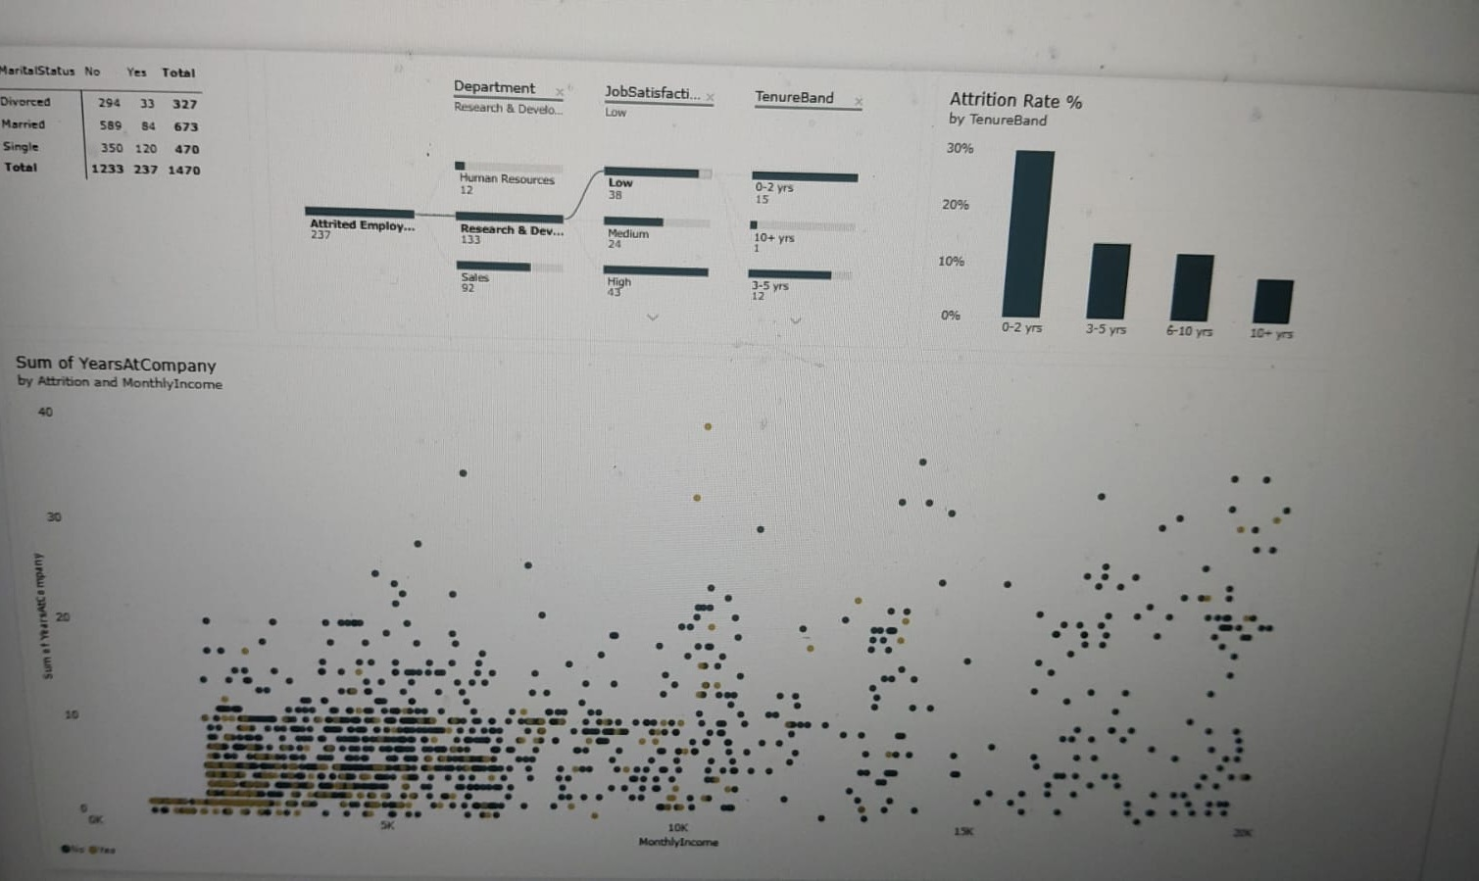
Figure 3: Dashboard Page 2 — Deep-Dive & Drivers

Page 3 — Summary & Recommendations
Purpose: turn analysis into decisions. Contains three slicers (Department, Marital Status, Tenure Band) that cross-filter every visual on the page and, by design intent, could be extended to filter the whole report; a department-level summary table (Total Employees, Attrited Employees, Attrition Rate %, Avg Monthly Income, Avg Tenure); and two text panels presenting the Key Insights and Recommendations in plain business language.
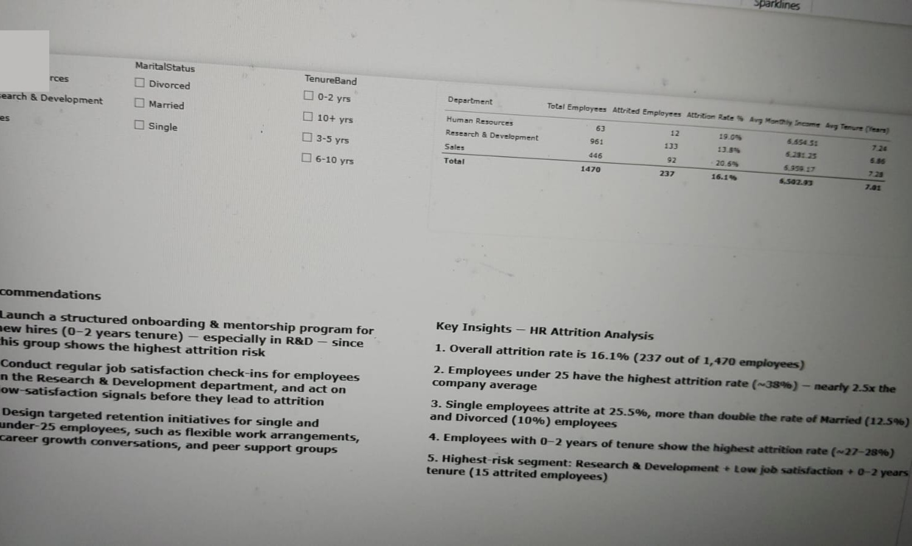
Figure 4: Dashboard Page 3 — Summary & Recommendations

Interactivity
- Slicers (Department, Marital Status, Tenure Band) on Page 3 for self-service filtering
- Cross-filtering / visual interactions between all charts on a page (clicking one bar filters the others)
- Drill-down / free exploration via the Decomposition Tree on Page 2
- Legends acting as implicit filters (Attrition Yes/No) on stacked and clustered charts
- Custom sort ordering ensures category axes (age bands, tenure bands, satisfaction levels) read in a logical, not alphabetical, sequence

9. Key Findings
The department-level summary produced by the dashboard is reproduced below, as it underpins several of the findings and recommendations that follow.
Department | Total Emp. | Attrited | Attrition % | Avg Income | Avg Tenure
Human Resources | 63 | 12 | 19.0% | 6,654.51 | 7.24
Research & Development | 961 | 133 | 13.8% | 6,281.25 | 6.86
Sales | 446 | 92 | 20.6% | 6,959.17 | 7.28
Total | 1,470 | 237 | 16.1% | 6,502.93 | 7.01

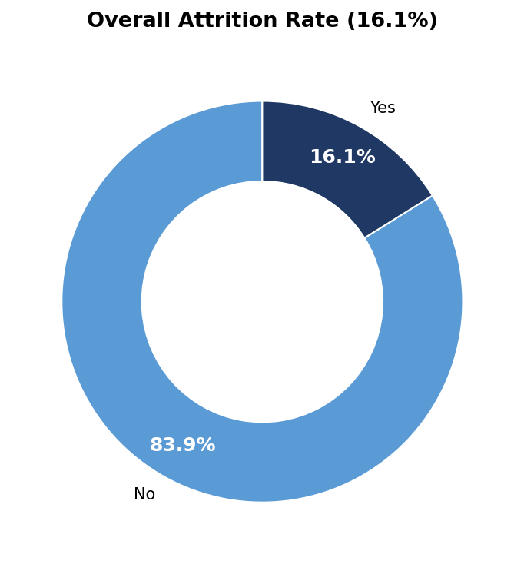
Figure 5: Overall attrition split — 237 of 1,470 employees (16.1%) have left
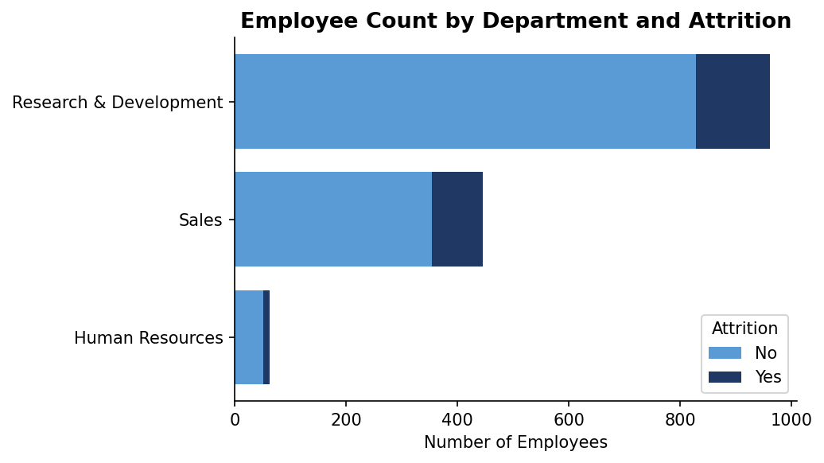
Figure 6: Employee count by department, split by attrition
Sales has the highest attrition rate by percentage (20.6%), followed by Human Resources (19.0%) and Research & Development (13.8%) — but because R&D is by far the largest department (961 employees), it contributes the largest absolute number of leavers (133, or 56% of all attrition).

10. Insights
Combining the KPI cards, charts, matrix, and decomposition tree from all three dashboard pages, five key business insights emerge:
- Overall attrition stands at 16.1% (237 of 1,470 employees) — a level worth monitoring, as it sits above the commonly-cited healthy benchmark of 10–15% for many industries.
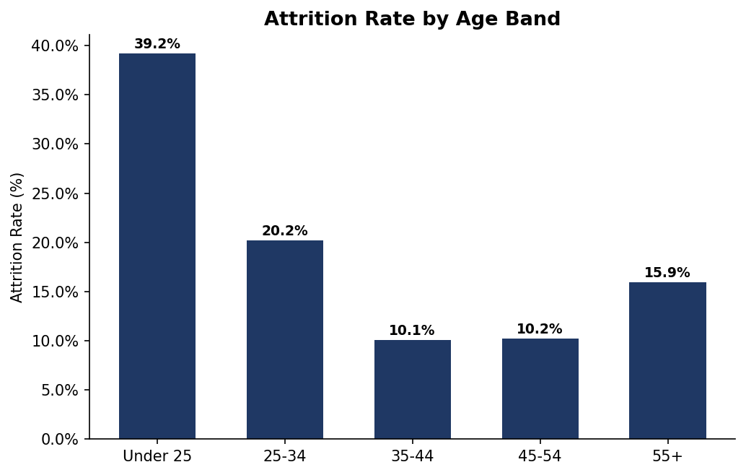
Figure 7: Attrition rate by age band
- Age is the single strongest driver visible in the data: employees under 25 attrite at 39.2% — roughly 2.4× the company average — and the rate falls steadily through each older age band before ticking back up slightly at 55+ (likely retirement-related, rather than dissatisfaction-related, departures).
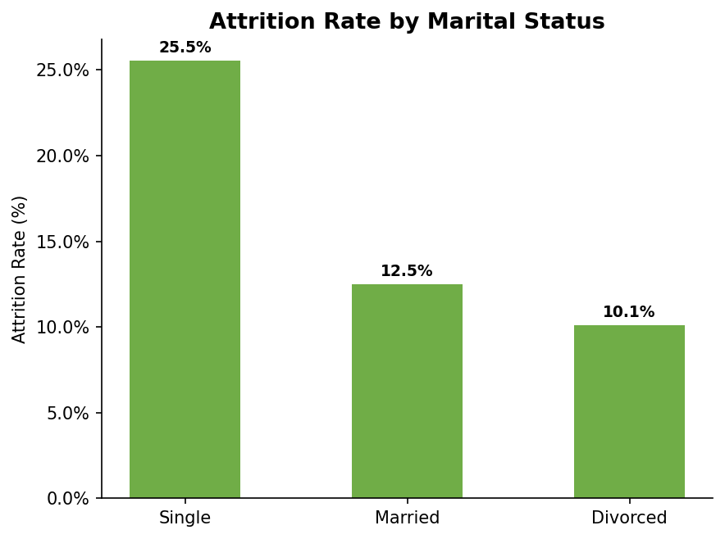
Figure 8: Attrition rate by marital status
- Marital status shows a clear gradient: Single employees attrite at roughly double the rate of Married employees, and well above Divorced employees, consistent with single/younger employees having fewer location or family ties keeping them at the company.
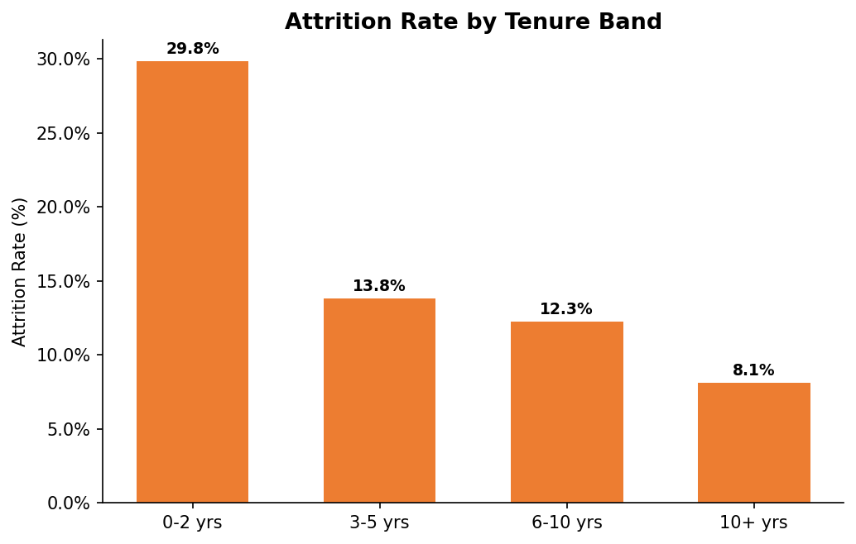
Figure 9: Attrition rate by tenure band
- Tenure follows an early-exit pattern: employees with 0–2 years at the company attrite at roughly 2.5–3× the rate of employees with 6+ years of service — the classic "early-tenure flight risk" window that most retention programmes are built around.
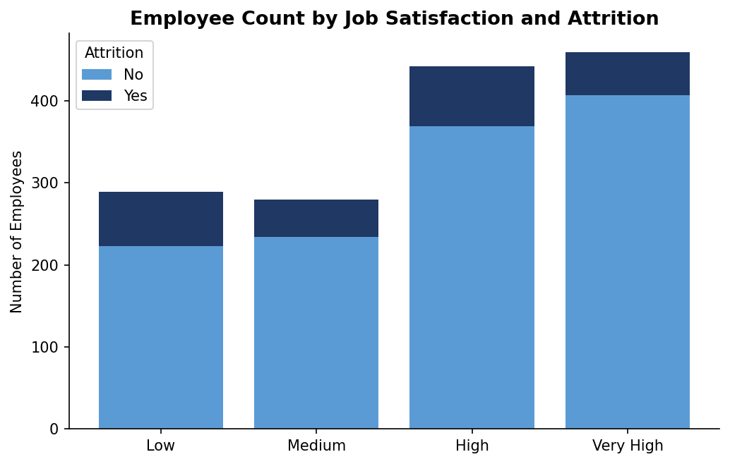
Figure 10: Employee count by job satisfaction level and attrition
- The Decomposition Tree pinpoints a specific compound risk segment: Research & Development department → Low job satisfaction → 0–2 years tenure accounts for 15 attrited employees on its own — a small, addressable group rather than an abstract company-wide problem.
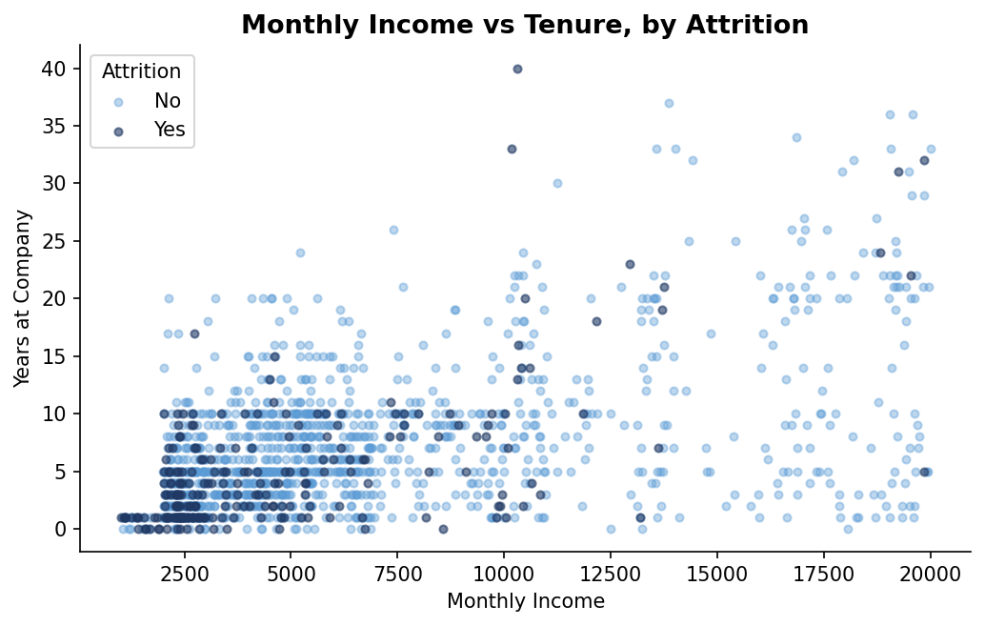
Figure 11: Monthly income vs. tenure, coloured by attrition — leavers (dark) cluster toward the lower-income, lower-tenure region

11. Recommendations
The following recommendations are derived directly from the patterns above, rather than being generic HR advice:
- Strengthen early-tenure retention: since employees in their first two years drive a disproportionate share of attrition, introduce a structured onboarding and mentorship programme for new hires, with a formal 30/60/90-day check-in cadence — prioritising Research & Development, where the largest volume of at-risk new hires sits.
- Make job satisfaction an actively monitored metric, not a one-off survey: since the Decomposition Tree shows Low satisfaction as a compounding factor with department and tenure, HR should run regular (e.g. quarterly) satisfaction pulse-checks in the Research & Development department specifically, with a defined escalation path when scores are Low, rather than waiting for exit interviews.
- Build a targeted retention track for young, single employees: since Under-25 and Single employees are the two highest-risk demographic segments, design initiatives that speak directly to their stage of life — flexible working arrangements, visible career-progression paths, and peer/social support groups — rather than a one-size-fits-all retention policy.
Together, these three actions target the intersection identified by the dashboard (new, dissatisfied, R&D employees) while also addressing the two broader demographic patterns (age and marital status) that cut across departments.

12. Conclusion
This project applied a complete Power BI dashboard-development workflow — understanding the business problem, cleaning and enriching the data in Power Query, building DAX measures, and designing an interactive three-page dashboard — to a real-world HR attrition dataset.
The resulting dashboard moves the organisation from a single top-line number ("16.1% attrition") to an actionable, segmented understanding of who is leaving and why: predominantly young, single, newly-hired employees, concentrated in Research & Development, and correlated with low job satisfaction. Because every finding in this report is filterable and drillable within the live dashboard, HR stakeholders can independently verify these patterns, explore other cross-sections (e.g. by education field or distance from home), and track whether the recommended interventions move the Attrition Rate % KPI over time.

