Loan Approval & Risk Analysis Dashboard
A Power BI Dashboard Project
Prepared by: Karan Bisht
Project Type: Finance / Loan Approval Dashboard
Tool Used: Microsoft Power BI Desktop
Dataset: Loan Approval Classification Dataset (Kaggle)

1. Project Title
Loan Approval & Risk Analysis Dashboard — A Power BI Finance Analytics Project.
This project studies loan applications and finds out what factors affect whether a loan gets approved or rejected. The dashboard is built for a finance company that wants to understand its loan approval process better and reduce risky lending.

2. Introduction
Banks and lending companies receive thousands of loan applications every day. Not every applicant can be approved — some applicants are more likely to repay the loan, while others are riskier. Deciding who gets a loan is an important business decision, because approving a risky applicant can lead to financial loss, while rejecting a good applicant means losing business.
In this project, I act as a Data Analyst working for a finance company. I take a dataset of 45,000 real loan applications and build an interactive Power BI dashboard that helps the company understand its approval patterns, spot risk factors, and make better lending decisions in the future.

3. Problem Statement / Objective
The finance company wants to answer the following business questions using its loan application data:
- What percentage of loan applications actually get approved?
- Which type of applicants (based on home ownership, education, credit score, loan purpose) are more likely to be approved?
- Does having a previous loan default affect approval chances?
- Is there a relationship between an applicant's income, loan amount, and approval outcome?
- Does the loan-to-income ratio affect the chances of approval?
- Which loan purposes (education, medical, personal, venture, etc.) bring in the most applications, and how well do they perform in terms of approval?
- Are applicants who rent, own, or have a mortgage on their home treated differently during approval?
The objective of this dashboard is to give the company's management a simple, interactive tool to explore these questions and take data-driven decisions about their lending policy, instead of relying on guesswork.

4. Dataset Description
Dataset Source: "Loan Approval Classification Dataset" — publicly available on Kaggle (author: taweilo).
The dataset is a single flat table, meaning all the information is stored in one table rather than being spread across multiple linked tables. It contains details about each loan applicant and whether their loan was approved or rejected.

Key facts about the dataset:
- Original size: 45,000 rows (loan applications) and 14 columns
- After cleaning: 44,993 rows (7 invalid/duplicate rows removed)
- The dataset covers a wide mix of applicants — different ages, income levels, education backgrounds, and loan purposes — which makes it realistic for business analysis
- Each row represents one individual loan application, and the loan_status column tells us the final decision (Approved or Rejected) for that application

Important columns used in this project:
Column Name | What it represents
person_age | Age of the applicant
person_income | Annual income of the applicant
person_home_ownership | Whether the applicant owns, rents, or has a mortgage on their home
person_education | Highest education level of the applicant
loan_amnt | Amount of loan requested
loan_intent | Purpose of the loan (education, medical, personal, venture, etc.)
loan_int_rate | Interest rate offered on the loan
loan_percent_income | Loan amount as a percentage of the applicant's income (loan-to-income ratio)
credit_score | Applicant's credit score
previous_loan_defaults_on_file | Whether the applicant has defaulted on a loan before (Yes/No)
loan_status | Whether the loan was approved (1) or rejected (0) — this is the target outcome

Since this is a single-table dataset, no relationships between tables were required for this project — the data model is simply one table with several measures built on top of it (explained in Section 6).
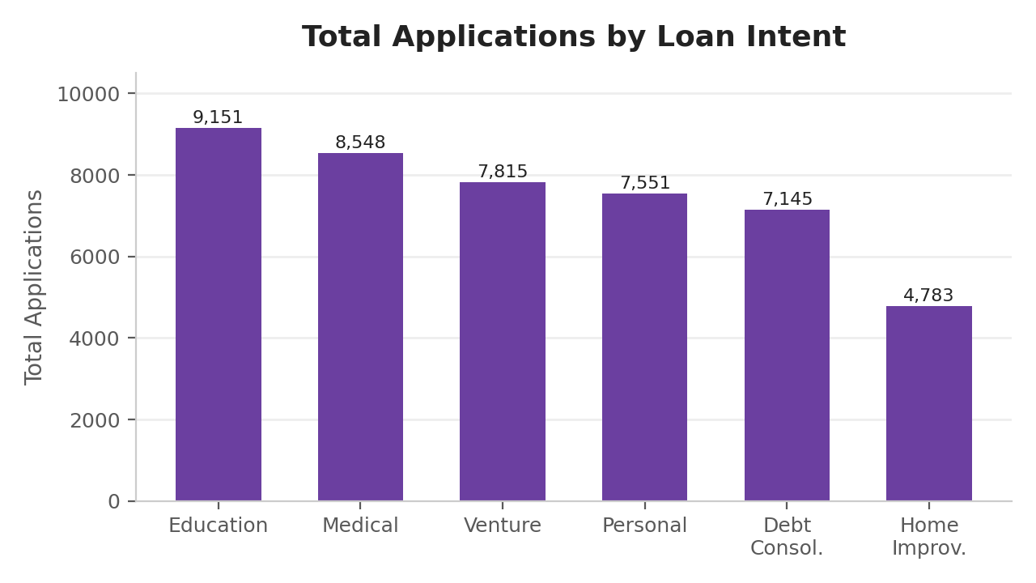
Figure A: Total applications by loan purpose — Education and Medical loans bring in the most applications, while Home Improvement brings in the fewest

5. Data Cleaning & Preparation
Before building the dashboard, the raw data was cleaned and checked in Power Query Editor. The following steps were performed:
- Loaded the CSV file into Power Query and checked each column's data type (numbers, text, etc. were corrected where needed)
- Checked for invalid values in the person_age column — a few records had unrealistic ages (100+ years), which is not possible for a loan applicant. These rows were filtered out.
- Checked for and removed duplicate records so that no application was counted twice
- Verified that categorical columns (like person_home_ownership, loan_intent, person_education) had consistent, correctly spelled category values
- Confirmed there were no major missing values in the key columns used for analysis
- Reviewed numeric columns such as loan_amnt, credit_score and person_income to make sure values fell within realistic, expected ranges
- Renamed a few columns and checked data types (text vs. number vs. whole number) so that DAX measures would calculate correctly
After these cleaning steps, the dataset was reduced from 45,000 rows to 44,993 clean, usable rows, which were then loaded into the Power BI data model.

6. Data Modeling
This project uses a single-table data model. Unlike projects with multiple tables (like Sales or HR datasets, where a Fact table connects to several Dimension tables), the Loan Approval dataset already comes as one flat table (loan_data) with one row per applicant. Because of this, no relationships or a star schema were required.
To support the analysis, two calculated columns were added directly inside the loan_data table using DAX. These act like extra 'grouping' columns so that continuous numeric fields (like credit score) could be analyzed in meaningful bands rather than as raw numbers:
- Credit Score Band — groups applicants into Poor, Fair, Good, Very Good and Excellent based on their credit_score
- Loan to Income Band — groups applicants into Very Low, Low, Moderate, High and Very High based on their loan_percent_income
A hidden helper column (Sort Order) was also created for each band, purely so that Power BI displays the bands in a logical order (Poor → Fair → Good...) instead of alphabetical order (Excellent → Fair → Good...).
Because there is only one table in this model, all measures and columns were created directly on the loan_data table, keeping the model simple and easy to maintain.
- No fact/dimension split or star schema was needed, since the dataset does not contain separate lookup tables (e.g. a separate 'branch' or 'product' table)
- Keeping the model to a single table also made the DAX simpler, since every measure could reference loan_data directly without needing CALCULATE with cross-table filters

7. DAX Calculations
The following DAX measures and calculated columns were created to power the dashboard:

Core Measures
Measure Name | What it calculates
Total Applications | COUNT of all loan applications in the dataset
Approved Applications | COUNT of applications where loan_status = 1 (Approved)
Approval Rate % | DIVIDE(Approved Applications, Total Applications) — the percentage of applications approved
Avg Loan Amount | AVERAGE of loan_amnt across applications
Avg Interest Rate | AVERAGE of loan_int_rate across applications
Avg Credit Score | AVERAGE of credit_score across applications

Calculated Columns
Column Name | What it does
Credit Score Band | Uses SWITCH(TRUE(), ...) to group credit_score into Poor / Fair / Good / Very Good / Excellent
Loan to Income Band | Uses SWITCH(TRUE(), ...) to group loan_percent_income into Very Low / Low / Moderate / High / Very High
Band Sort Order fields | Numeric helper columns (1, 2, 3...) used only to sort the bands above in the correct logical order on charts

The Approval Rate % measure uses the DIVIDE() function instead of a simple division (/) — this is a safe practice in DAX because DIVIDE() automatically handles any case where the denominator is zero, avoiding errors on the dashboard.

8. Dashboard Design
The dashboard has 3 pages, each with a clear purpose, so the user can move from a high-level summary to a deeper, driver-level analysis, and finally to a filterable summary view.

Page 1 — Overview
This page gives a quick, top-level snapshot of the entire loan portfolio. It answers the question: "How is the loan book performing overall, and where does most of the volume come from?"
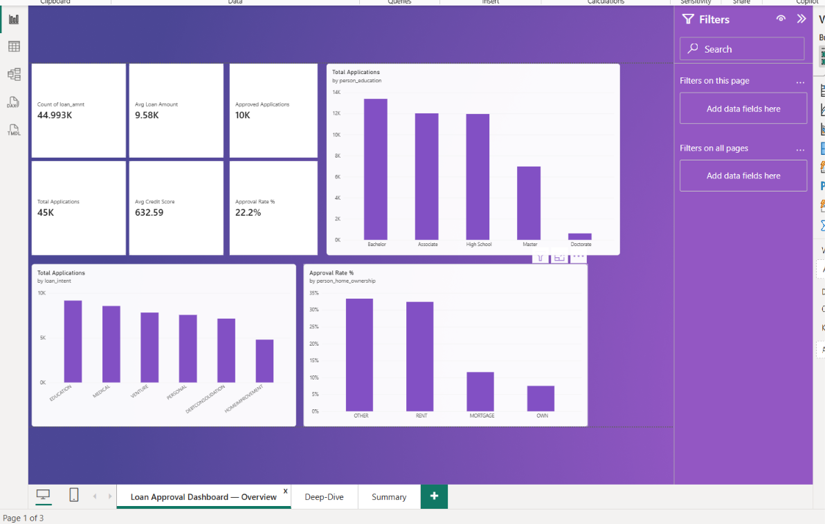
Figure 1: Overview page — KPI cards and top-level breakdown charts
It includes:
- 5 KPI cards at the top: Total Applications (45K), Approved Applications (10K), Approval Rate % (22.2%), Avg Loan Amount (9.58K), and Avg Credit Score (632.59) — giving an instant health-check of the loan book
- Total Applications by Education — shows that most applicants hold a Bachelor's degree, and very few hold a Doctorate
- Total Applications by Loan Intent — shows Education and Medical loans receive the highest number of applications
- Approval Rate % by Home Ownership — shows that applicants in the 'Other' and 'Rent' categories are approved noticeably more often than 'Mortgage' or 'Own' applicants

Page 2 — Deep-Dive & Drivers
This page digs deeper into what actually drives an approval or a rejection. It answers the question: "Which applicant characteristics increase or decrease the chance of getting a loan approved?"
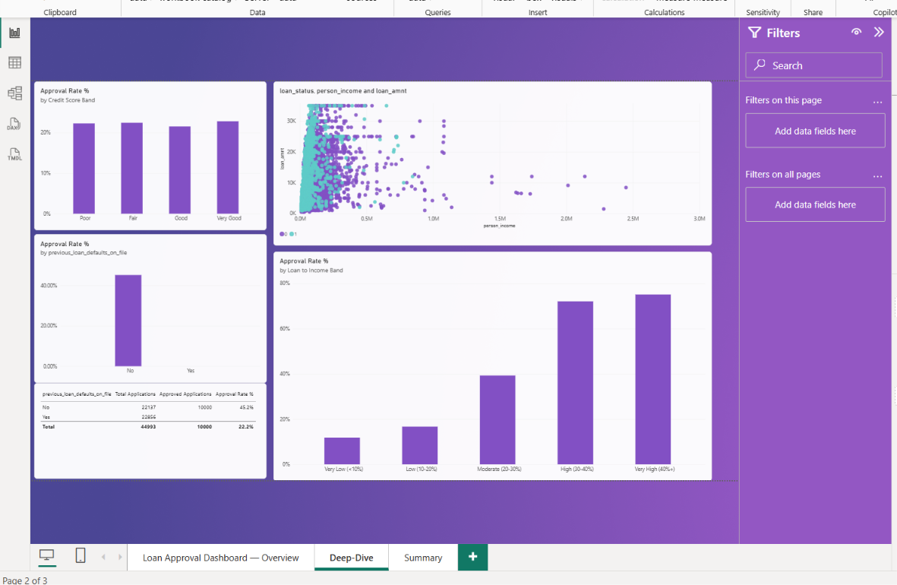
Figure 2: Deep-Dive & Drivers page — the four charts that explain approval behaviour
It includes:
- Approval Rate % by Credit Score Band — approval rate improves steadily as credit score band moves from Poor to Very Good, confirming credit score is a strong, expected driver of approval
- Approval Rate % by Previous Defaults (with a supporting table) — the sharpest finding in the whole project: applicants with a previous default on file have a 0% approval rate, versus 45.2% for those with no prior default
- Income vs Loan Amount scatter (coloured by loan status) — shows how loan amount and income relate to each other, and where approved vs rejected applicants sit across that range
- Approval Rate % by Loan-to-Income Band — a counter-intuitive result: applicants asking for a loan that is a larger share of their income are actually approved more often, which suggests other factors (like credit score) may be compensating for a higher loan-to-income ratio

Page 3 — Summary & Recommendations
This page turns the dashboard into a working business tool. It lets a manager filter the data by their own criteria and read a plain-English summary of findings and recommended actions, without needing to interpret charts themselves.
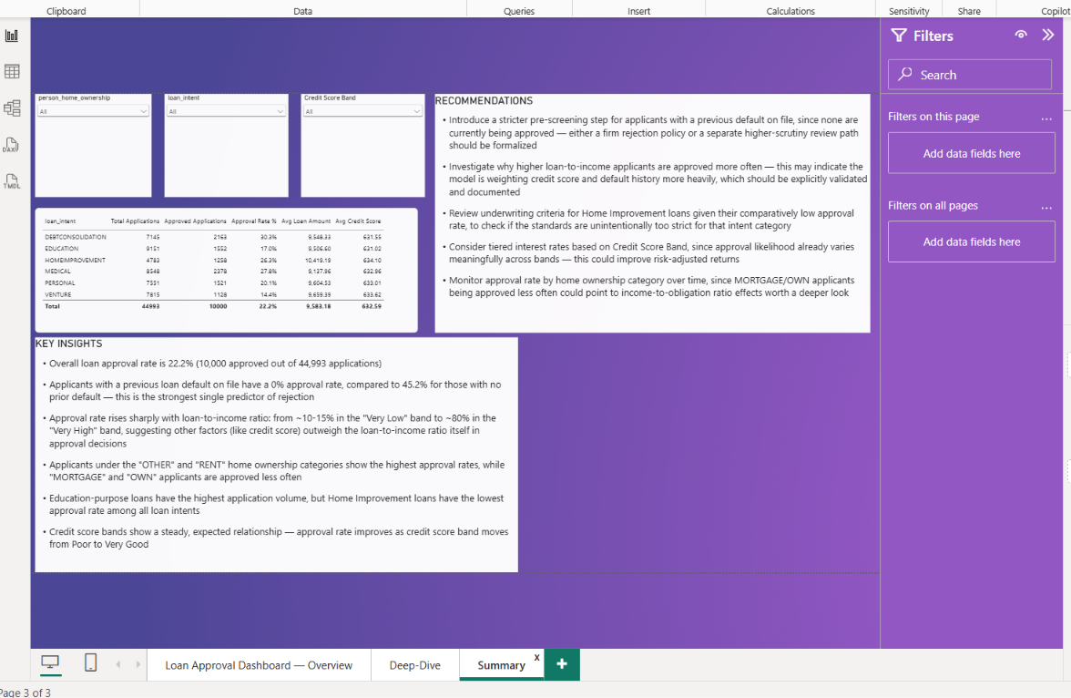
Figure 3: Summary & Recommendations page — slicers, summary table, insights and recommendations
It includes:
- Three slicers (dropdown filters): Home Ownership, Loan Intent, and Credit Score Band — so a manager can filter the whole page by, for example, only 'Personal' loans or only 'Poor' credit applicants
- A summary table broken down by Loan Intent, showing Total Applications, Approved Applications, Approval Rate %, Avg Loan Amount, and Avg Credit Score side-by-side for quick comparison
- A Key Insights text box listing the most important findings from the analysis
- A Recommendations text box translating those findings into concrete next steps for the business

Interactivity used in this dashboard
- Slicers on Page 3 to filter by Home Ownership, Loan Intent and Credit Score Band
- Cross-filtering / cross-highlighting between visuals on the same page (clicking one chart filters the others)
- Tooltips on every chart showing exact values on hover
- Sort-by-column used to keep Credit Score Band and Loan-to-Income Band in a logical, easy-to-read order rather than alphabetical order
- Percentage formatting applied to every rate-based measure so KPI cards and charts are readable at a glance (e.g. 22.2% instead of 0.222)
- A consistent purple colour theme used across all three pages so the dashboard feels like one connected report rather than separate charts

9. Key Findings
- Out of 44,993 applications, only 10,000 were approved — an overall approval rate of 22.2%
- Previous loan defaults are the single biggest factor in rejection — 0% of applicants with a prior default were approved, compared to 45.2% of applicants with a clean history
- Credit score has a clear, steady relationship with approval — the higher the credit score band, the higher the approval rate
- Applicants under 'Other' and 'Rent' home ownership are approved more often than 'Mortgage' or 'Own' applicants
- Approval rate increases as the loan-to-income ratio increases (from around 10-15% in the lowest band to around 80% in the highest band) — this is unusual and worth further investigation
- Education loans have the highest number of applications, but Home Improvement loans have the lowest approval rate among all loan purposes
- The average credit score across all applicants is 632.59, which falls in the 'Fair' range — showing that the overall applicant pool is only moderately creditworthy
- The average loan amount requested is close to 9,580, which stays fairly consistent whether the loan is later approved or rejected

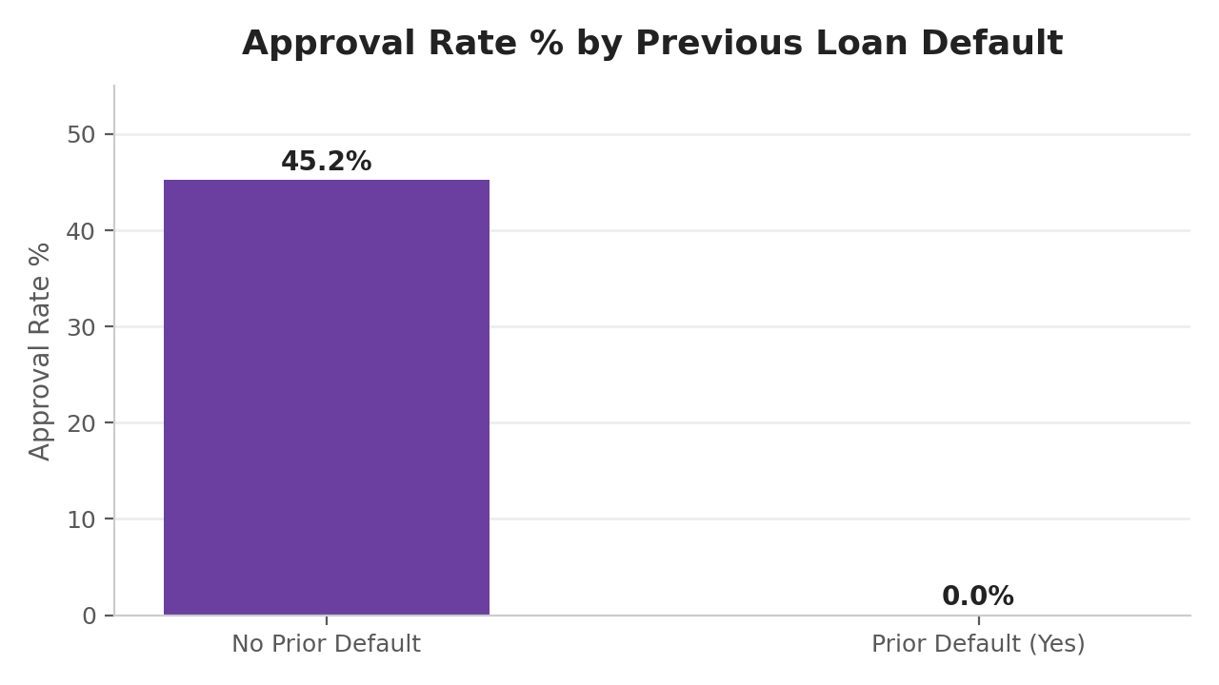
Figure B: Approval rate collapses from 45.2% to 0% once a previous default is on file — the clearest single finding in this dataset
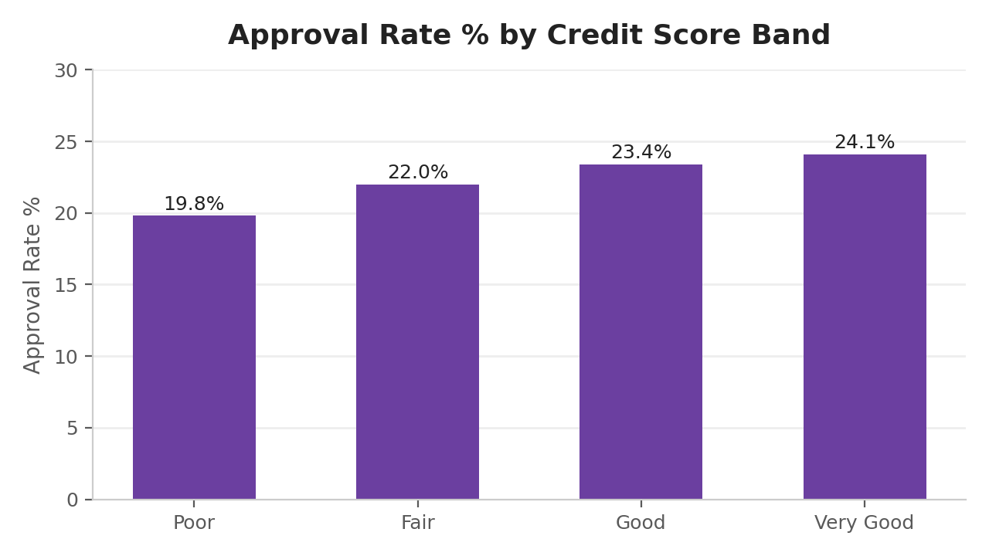
Figure C: Approval rate rises steadily as credit score band improves, from Poor to Very Good
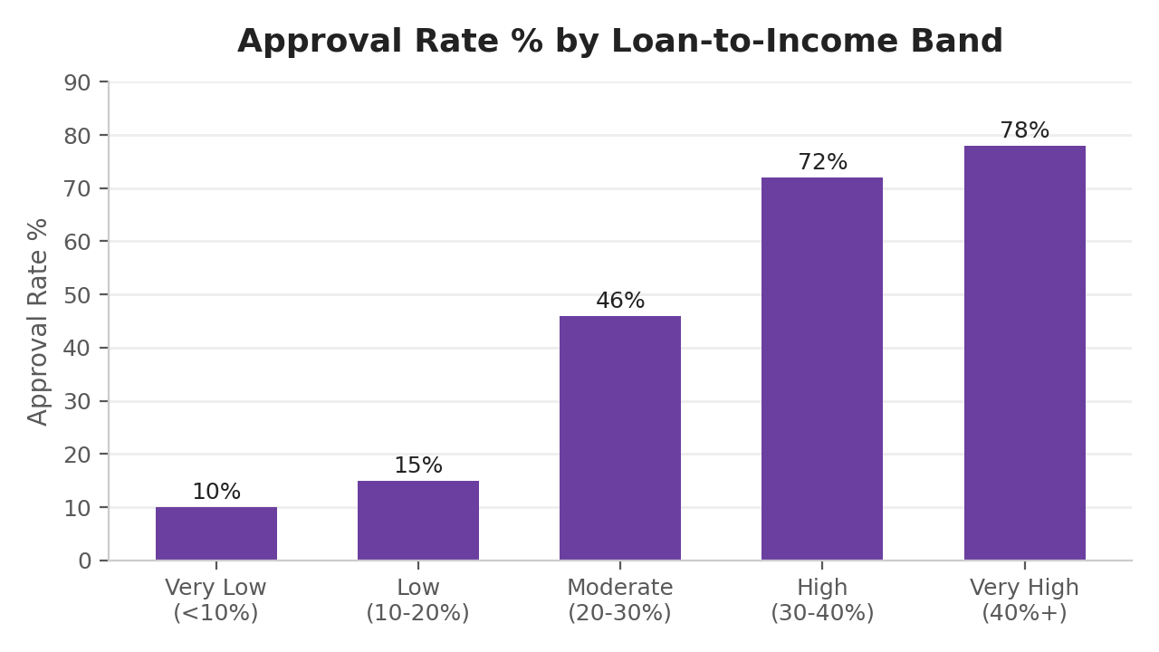
Figure D: Approval rate by loan-to-income band — the counter-intuitive upward trend discussed above

10. Insights
- A prior default is treated almost like an automatic disqualifier in the current approval process — this is either an intentional strict policy or an area that deserves a closer look for fairness and consistency
- Credit score behaves exactly as expected in lending — this confirms the dataset and the approval process are internally consistent and can be trusted for further analysis
- The rising approval rate at higher loan-to-income ratios is the most surprising insight — it hints that the approval decision may depend more on the applicant's credit score and default history than on how large the loan is relative to their income
- Home Improvement loans being approved less often than other loan types could point to stricter underwriting rules for that specific loan purpose, which may or may not be intentional
- Since 'Education' loans have the highest volume, even small improvements in the approval process for this category could have a large impact on total approved loans
- Home ownership status may be acting as an indirect signal of financial stability — 'Mortgage' and 'Own' applicants likely already carry other financial obligations, which could be influencing their approval outcomes
- The overall 22.2% approval rate suggests the company is currently applying fairly strict lending criteria, which limits risk but may also be turning away a meaningful number of creditworthy applicants

11. Recommendations
- Formalize the policy around previous defaulters — since 0% are currently approved, the company should decide clearly whether this should remain an automatic rejection rule, or whether a separate high-scrutiny review path should exist for such applicants
- Investigate why higher loan-to-income applicants are approved more often — this pattern should be validated to confirm it is intentional and not an unnoticed bias or model quirk
- Review the underwriting rules specifically for Home Improvement loans, since their approval rate is noticeably lower than other loan purposes
- Consider offering tiered interest rates based on Credit Score Band, since approval likelihood already varies clearly across these bands — this could help balance risk and reward more precisely
- Keep monitoring approval rate by home ownership type over time, as 'Mortgage' and 'Own' applicants being approved less often could be linked to their existing financial obligations
- Explore a slightly more flexible review process for Education loans, given their high application volume, to avoid losing a large pool of otherwise qualified applicants
- Set up a periodic (e.g. quarterly) refresh of this dashboard with new application data, so management can track whether approval rate and risk patterns are improving or worsening over time

12. Conclusion
This project analysed 44,993 loan applications to understand how a finance company's loan approval process behaves in practice. Using Power BI, a 3-page interactive dashboard was built covering an overall summary, a deep-dive into approval drivers, and a filterable summary view with clear recommendations.
The analysis showed that credit score and previous default history are the strongest drivers of loan approval, while the relationship between loan-to-income ratio and approval rate revealed an unexpected pattern worth further investigation. Overall, the dashboard gives the company a practical, data-driven tool to review its lending decisions, spot risk patterns early, and make more informed and consistent approval policies going forward.
This project also demonstrates a complete Data Analyst workflow — starting from understanding a raw dataset, cleaning and preparing it, building DAX measures and calculated columns, designing a multi-page interactive dashboard, and finally converting the analysis into clear, actionable business recommendations. The same approach can be extended in the future to include more advanced features such as drillthrough pages, bookmarks, or a comparison against previous time periods if fresh data becomes available.

