END-TO-END DATA ANALYTICS PROJECT
Marketing Campaign Performance & Customer Analytics Dashboard
A Power BI Dashboard Project
Dataset: Marketing Campaign Dataset (Kaggle)
Tool Used: Microsoft Power BI Desktop
Prepared by
Karan Bisht

Table of Contents
1. Introduction & Project Objective
2. Dataset Description
3. Data Cleaning & Preparation
4. Data Modeling
5. DAX Measures
6. Dashboard Design — Page 1: Overview
7. Dashboard Design — Page 2: Deep-Dive & Drivers
8. Dashboard Design — Page 3: Summary & Recommendations
9. Interactivity & User Experience
10. Key Insights
11. Recommendations
12. Conclusion & Future Scope

1. Introduction & Project Objective
In today's competitive business environment, marketing teams run multiple campaigns to acquire and retain customers, but not every campaign performs equally well across every customer segment. Organizations that can identify which customers respond, why they respond, and how their spending behavior changes over time gain a significant edge in designing future marketing strategies.
This project analyzes a Marketing Campaign dataset containing 2,240 customer records with demographic information, purchasing behavior, and responses across six marketing campaigns. The goal is to build a complete, interactive Power BI dashboard that transforms raw transactional data into clear, actionable business insights for marketing decision-makers.

Project Objectives
- Clean and prepare raw customer data to ensure accuracy and consistency.
- Build a single-table data model suitable for analysis in Power BI.
- Design DAX measures that quantify campaign performance, customer value, and conversion behavior.
- Develop a three-page interactive dashboard covering overview KPIs, deep-dive segmentation analysis, and an executive summary with recommendations.
- Translate the analysis into concrete, actionable business recommendations.

Tools Used
- Microsoft Power BI Desktop — data cleaning (Power Query), data modeling, DAX measures, and dashboard design.
- Source data format: CSV (semicolon-delimited), sourced from Kaggle.

2. Dataset Description
The dataset used for this project is the "Marketing Campaign Dataset" from Kaggle, containing 2,240 rows and 29 columns of customer-level marketing data. It is a single, denormalized table — no relationships or joins were required.

Key Column Groups
- Demographics: ID, Year_Birth, Education, Marital_Status, Income, Kidhome, Teenhome, Dt_Customer.
- Spending (last 2 years): MntWines, MntFruits, MntMeatProducts, MntFishProducts, MntSweetProducts, MntGoldProds.
- Purchase Channels: NumDealsPurchases, NumWebPurchases, NumCatalogPurchases, NumStorePurchases, NumWebVisitsMonth.
- Campaign Responses: AcceptedCmp1 through AcceptedCmp5, Response (most recent campaign), Complain.

Customer Demographic Distribution
The charts below summarize the customer base composition after data cleaning, providing context for the segmentation analysis carried out later in this report.
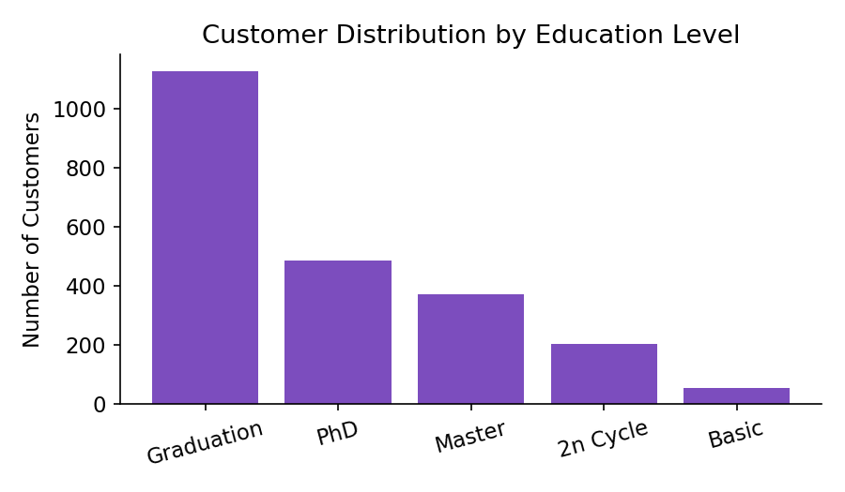
Figure 1: Customer distribution by education level. Graduation is the most common qualification among customers, followed by PhD and Master's degree holders.
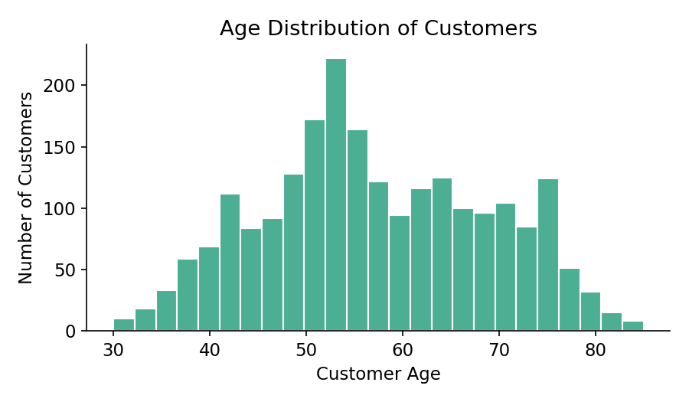
Figure 2: Age distribution of customers, ranging roughly from the early 30s to early 80s, with the bulk of customers concentrated between 40 and 65 years.
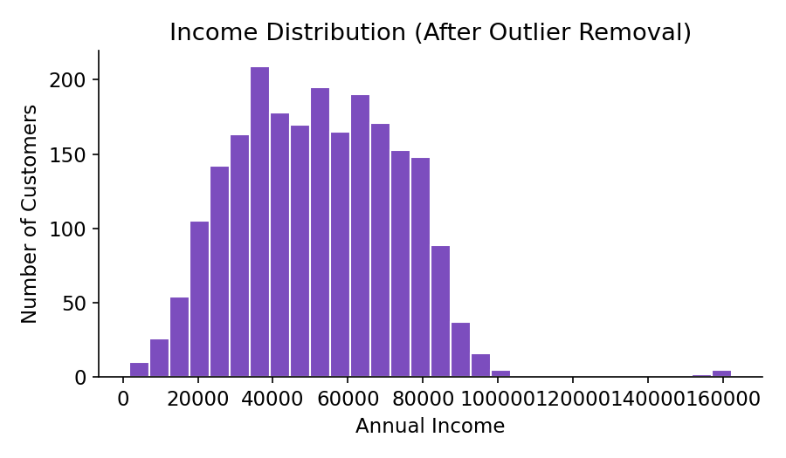
Figure 3: Income distribution after removing the extreme outlier, showing that most customers earn between ₹20,000 and ₹80,000 annually, with a long tail toward higher incomes.
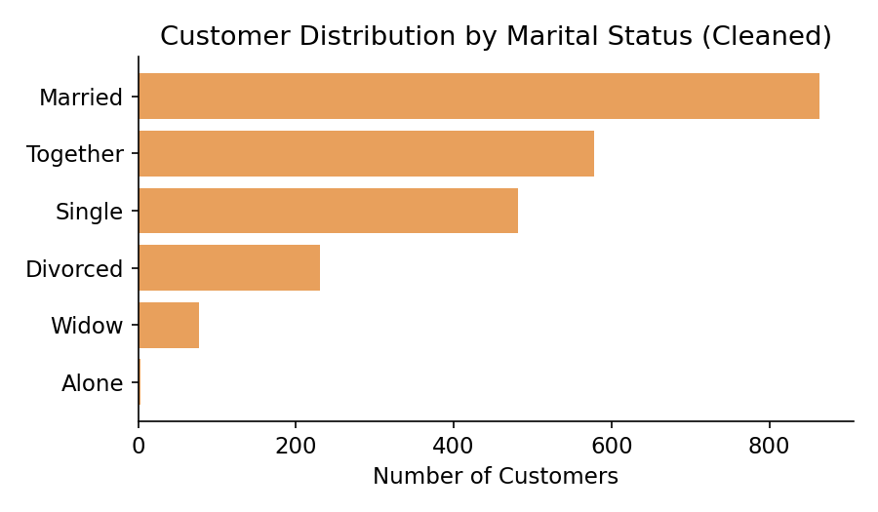
Figure 4: Customer distribution by marital status after cleaning invalid entries ("Absurd" and "YOLO" reclassified as "Single").

3. Data Cleaning & Preparation
Before any analysis or modeling could take place, the raw dataset was audited and cleaned inside Power Query Editor to ensure data quality and reliability. The following issues were identified and resolved:

Issues Identified
- Missing Values: The Income column contained 24 missing (null) values.
- Invalid Categorical Entries: The Marital_Status column contained two nonsensical categories, "Absurd" and "YOLO".
- Outlier: One customer record had an Income of ₹6,66,666 — an extreme, unrealistic outlier compared to the rest of the dataset (max otherwise ~₹1,62,000).
- Invalid Age Entries: A small number of customers had Year_Birth values as early as 1893, implying ages above 120 years — clearly data entry errors.
- Redundant Columns: Z_CostContact and Z_Revenue contained a single constant value across all rows and carried no analytical value.
- Incorrect Data Type: The Dt_Customer column was stored as text and needed to be converted to a proper Date type.

Cleaning Steps Applied
- Replaced the 24 missing Income values with the column median (₹51,381.50) to avoid skewing the distribution — a more robust choice than the mean given the presence of high-income outliers.
- Reclassified "Absurd" and "YOLO" marital status entries as "Single".
- Removed the single record with an Income above ₹2,00,000 as a data-entry outlier.
- Removed records where Year_Birth was earlier than 1940 (unrealistic age).
- Removed the Z_CostContact and Z_Revenue columns.
- Converted Dt_Customer to Date type.
- Verified there were zero duplicate rows and zero duplicate Customer IDs in the dataset.
After cleaning, the dataset was reduced from 2,240 to 2,235 valid customer records, ready for modeling and analysis.
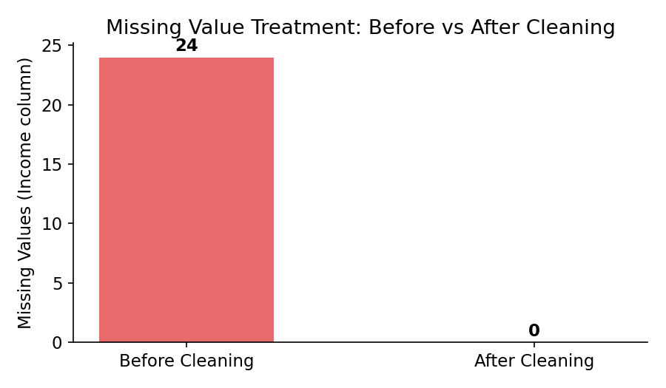
Figure 5: Missing values in the Income column before and after the cleaning process — reduced from 24 to 0.
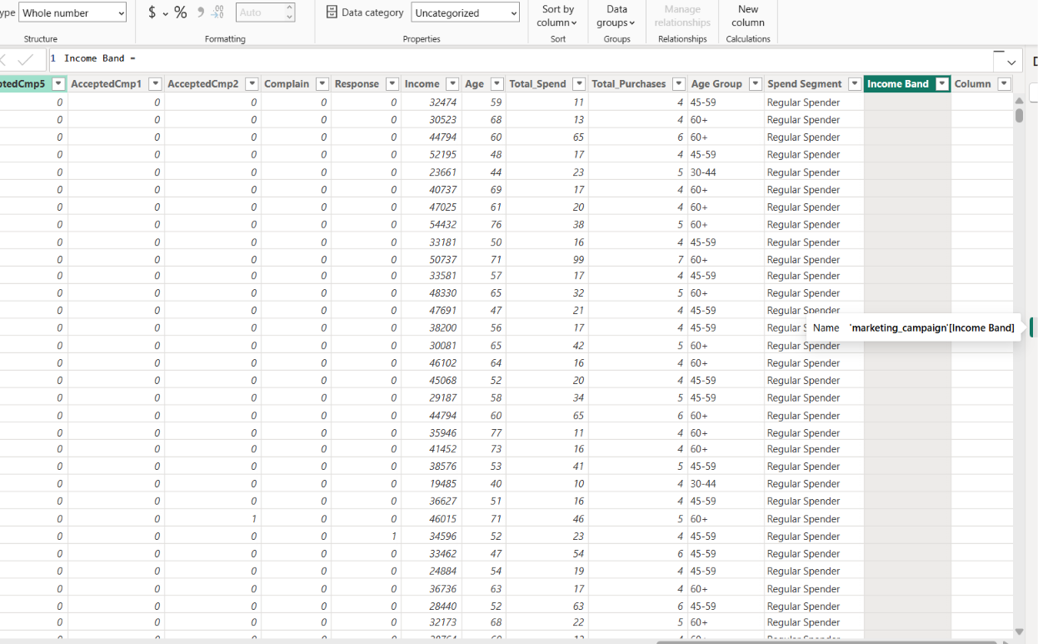
Figure 6: Cleaned dataset as viewed in Power BI's Data view, showing the Income, Age, Total_Spend, Age Group, and Income Band columns after all transformations were applied.

4. Data Modeling
This project uses a single flat table (marketing_campaign) rather than a multi-table relational model. Since every attribute — demographics, spending, and campaign responses — exists at the individual customer level within one file, there was no need to build relationships between multiple tables.
This decision was made deliberately after reviewing the dataset structure: all 29 columns describe the same grain of data (one row per customer), so introducing artificial joins or a star schema would have added unnecessary complexity without any analytical benefit.

Calculated Columns Added
To support richer segmentation and analysis, the following calculated columns were added directly to the table using DAX:
Age = 2026 - marketing_campaign[Year_Birth]
Total_Spend = marketing_campaign[MntWines] + marketing_campaign[MntFruits] +
marketing_campaign[MntMeatProducts] + marketing_campaign[MntFishProducts] +
marketing_campaign[MntSweetProducts] + marketing_campaign[MntGoldProds]
Total_Purchases = marketing_campaign[NumDealsPurchases] + marketing_campaign[NumWebPurchases] +
marketing_campaign[NumCatalogPurchases] + marketing_campaign[NumStorePurchases]
Age Group = SWITCH(TRUE(),
marketing_campaign[Age] < 30, "18-29",
marketing_campaign[Age] < 45, "30-44",
marketing_campaign[Age] < 60, "45-59",
marketing_campaign[Age] >= 60, "60+", "Unknown")
Income Band = SWITCH(TRUE(),
marketing_campaign[Income] < 30000, "Low (<30K)",
marketing_campaign[Income] < 60000, "Mid (30-60K)",
marketing_campaign[Income] < 90000, "High (60-90K)",
marketing_campaign[Income] >= 90000, "Very High (90K+)", "Unknown")
Spend Segment = IF(marketing_campaign[Total_Spend] > [Avg Customer Spend],
"High Spender", "Regular Spender")
These calculated columns transformed continuous numeric fields (Age, Income) into meaningful categorical bands, which became the primary dimensions used across the segmentation charts in Page 2 of the dashboard.

5. DAX Measures
A set of DAX measures was created to power every KPI card, chart, and table across the dashboard. Measures were preferred over calculated columns wherever the value needed to respond dynamically to filters and slicers.

Core Measures
Total Customers = DISTINCTCOUNT(marketing_campaign[ID])
Total Campaigns Accepted = SUM(marketing_campaign[AcceptedCmp1]) + SUM(marketing_campaign[AcceptedCmp2]) +
SUM(marketing_campaign[AcceptedCmp3]) + SUM(marketing_campaign[AcceptedCmp4]) + SUM(marketing_campaign[AcceptedCmp5])
Total Responses = SUM(marketing_campaign[Response])
Conversion Rate % = DIVIDE([Total Responses], [Total Customers], 0)
Avg Customer Spend = AVERAGE(marketing_campaign[Total_Spend])
Total Revenue = SUM(marketing_campaign[Total_Spend])
Response Rate by Segment = DIVIDE([Total Responses], [Total Customers], 0)
The "Response Rate by Segment" measure is a single, reusable measure — when placed against any dimension (Education, Age Group, Income Band, Marital Status) in a chart, Power BI automatically recalculates the response rate for each category, eliminating the need for separate measures per segment.

Supporting Measures
High Value Customers = CALCULATE([Total Customers],
FILTER(marketing_campaign, marketing_campaign[Total_Spend] > [Avg Customer Spend]))
Web Purchases = SUM(marketing_campaign[NumWebPurchases])
Catalog Purchases = SUM(marketing_campaign[NumCatalogPurchases])
Store Purchases = SUM(marketing_campaign[NumStorePurchases])
Deal Purchases = SUM(marketing_campaign[NumDealsPurchases])
Total Purchases Sum = SUM(marketing_campaign[Total_Purchases])
Web Purchase % = DIVIDE(SUM(marketing_campaign[NumWebPurchases]), [Total Purchases Sum], 0)
All measures were validated inside Power BI's formula bar and Data view before being used in visuals, ensuring each returned the expected values against the cleaned dataset.

6. Dashboard Design — Page 1: Overview
The Overview page is designed to answer one question at a glance: "How is the business performing overall?" It presents five headline KPI cards followed by three supporting visuals summarizing performance across education, purchase channels, and marital status.
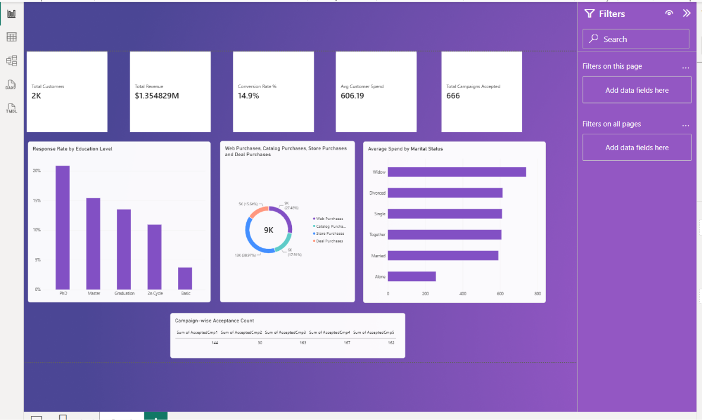
Figure 7: Page 1 — Overview, showing five KPI cards (Total Customers, Total Revenue, Conversion Rate %, Avg Customer Spend, Total Campaigns Accepted), a Response Rate by Education Level chart, a Purchase Channel donut chart, an Average Spend by Marital Status chart, and a Campaign-wise Acceptance Count table.

KPI Card Summary
Metric | Value
Total Customers | 2,235
Total Revenue | $1,354,829
Conversion Rate % | 14.9%
Avg Customer Spend | 606.19
Total Campaigns Accepted | 666

Page Explanation
- Response Rate by Education Level: PhD holders show the highest response rate (~21%), while customers with only Basic education respond least (~4%) — suggesting education level correlates strongly with campaign receptiveness.
- Purchase Channel Distribution: Store purchases account for the largest share of transactions (~39%), followed by web purchases (~28%), catalog purchases (~16%), and deal-driven purchases (~17%).
- Average Spend by Marital Status: Widowed customers show the highest average spend, followed by Divorced and Single customers.
- Campaign-wise Acceptance Count: Campaign 4 (167) and Campaign 5 (162) were the most successful individual campaigns, while Campaign 2 (30) significantly underperformed relative to the others.

7. Dashboard Design — Page 2: Deep-Dive & Drivers
The Deep-Dive & Drivers page moves from "what happened" to "why it happened." It examines how response rate varies across demographic segments and explores the relationship between customer behavior variables using scatter and trend visuals.
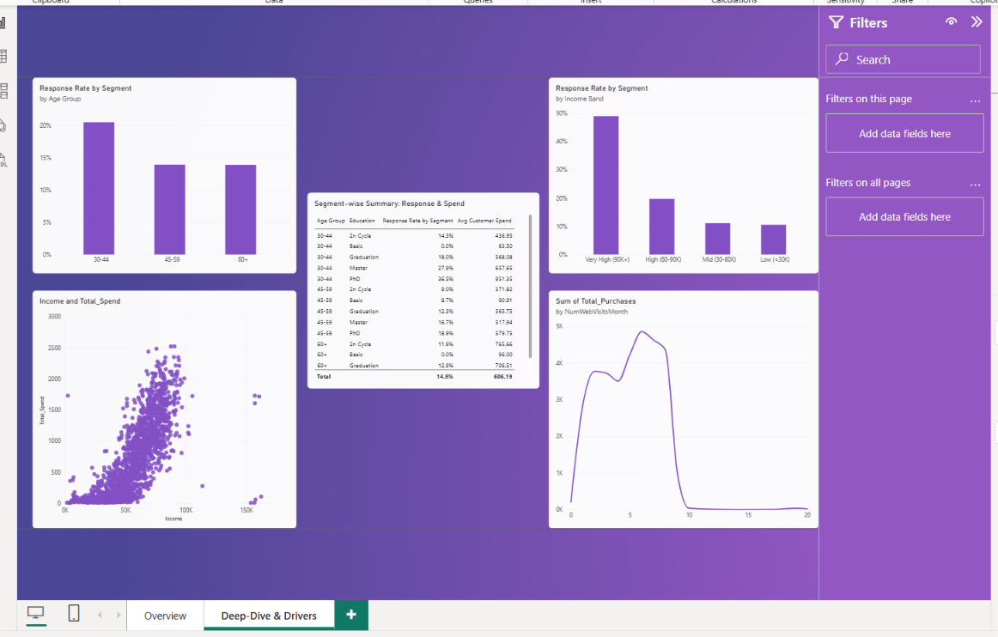
Figure 8: Page 2 — Deep-Dive & Drivers, showing Response Rate by Age Group, Response Rate by Income Band, an Income vs Total Spend scatter plot, a Web Visits vs Purchases trend line, and a segment-wise summary table.

Page Explanation
- Response Rate by Age Group: The 30-44 age group is the most responsive segment at approximately 20.5%, notably higher than the 45-59 and 60+ groups (both around 14%).
- Response Rate by Income Band: A strong, almost linear relationship exists between income and response rate — Very High income customers (₹90K+) respond at nearly 49%, compared to just 10.5% for Low income customers.
- Income vs Total Spend (Scatter): A clear positive correlation is visible — as customer income increases, total spend rises consistently, with a small cluster of high-spend outliers even at moderate income levels, suggesting a secondary "high-engagement" customer type worth investigating separately.
- Web Visits vs Purchases: Purchases peak when customers visit the website 5-8 times per month; beyond 10 visits, purchase volume drops sharply. This suggests that excessive browsing without conversion may indicate friction in the purchase journey rather than genuine high interest.
- Segment-wise Summary Table: Cross-tabulating Age Group and Education reveals that customers aged 30-44 with a PhD have the single highest response rate (27.9%) of any combination in the dataset.

8. Dashboard Design — Page 3: Summary & Recommendations
The final page is built for decision-makers who need a filtered, at-a-glance summary along with clear, written takeaways. It combines three interactive slicers, a compact business summary table, and two curated text panels covering insights and recommendations.
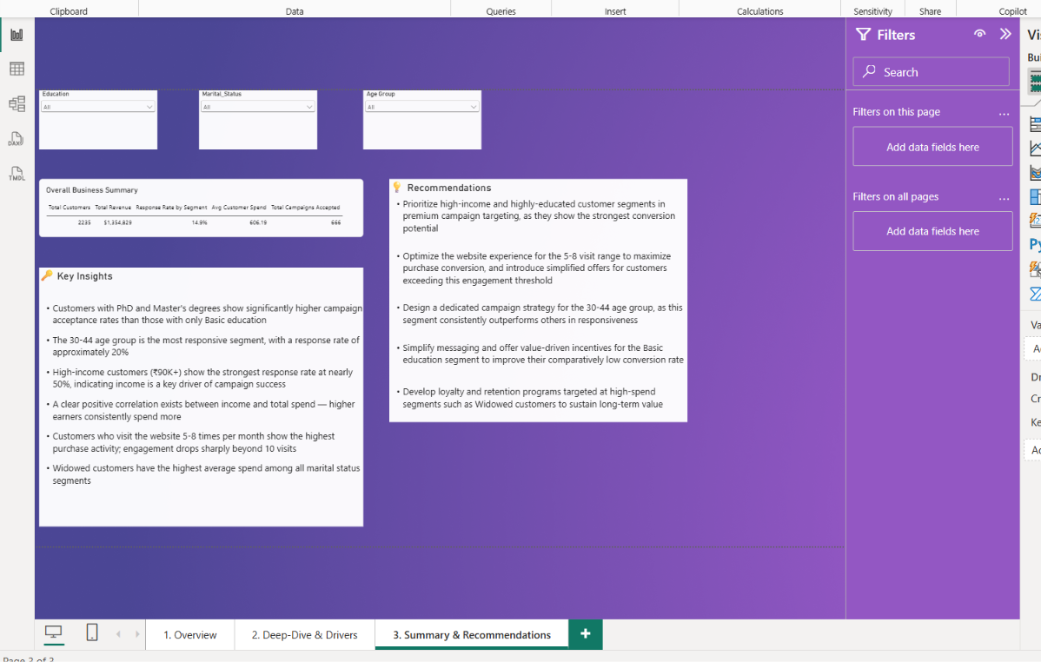
Figure 9: Page 3 — Summary & Recommendations, with slicers for Education, Marital Status, and Age Group, an Overall Business Summary table, and Key Insights and Recommendations panels.

Page Explanation
- Slicers (Education, Marital Status, Age Group): Allow any stakeholder to instantly filter the summary table and re-examine business performance for a specific customer segment, without needing to touch the underlying data or write a query.
- Overall Business Summary Table: Displays Total Customers, Total Revenue, Response Rate, Avg Customer Spend, and Total Campaigns Accepted in a single row — updating live as slicers are applied.
- Key Insights Panel: Summarizes the most important patterns discovered across Pages 1 and 2 in plain business language.
- Recommendations Panel: Converts each insight into a specific, actionable next step for the marketing team.

9. Interactivity & User Experience
Interactivity was a core design priority throughout the dashboard so that stakeholders could explore the data themselves rather than relying solely on static charts.
- Cross-filtering: Every chart on Pages 1 and 2 is cross-filterable by default in Power BI — clicking any bar, slice, or point filters all other visuals on the same page to that selection.
- Slicers: Three slicers (Education, Marital Status, Age Group) were added on Page 3, giving users direct control over which customer segment the summary reflects.
- Tooltips: Default Power BI tooltips were retained on all charts, showing exact values (counts, percentages, currency) on hover, which supports precise reading of the visuals beyond what is visible at a glance.
- Consistent Visual Language: A single purple-based color theme was used consistently across all three pages so that the dashboard reads as one cohesive report rather than three disconnected pages.
Together, these features allow a marketing manager to move from a high-level KPI view (Page 1), into a segment-level investigation (Page 2), and finally into a filtered executive summary (Page 3) — all within the same report, without needing any additional tools.

10. Key Insights
Bringing together the analysis from all three dashboard pages, the following insights represent the most significant, decision-relevant findings from this project:
- Education strongly predicts campaign response. Customers with PhD (20.9%) and Master's (15.4%) degrees respond at roughly 4-6x the rate of customers with only Basic education (3.7%).
- The 30-44 age group is the single most responsive age segment (20.5% response rate), making it a priority audience for future campaigns.
- Income is the strongest single driver of conversion observed in this dataset. Response rate rises from 10.5% (Low income) to 49.1% (Very High income) — a near five-fold increase.
- Income and spending move together. Higher-income customers consistently spend more, though a small group of moderate-income, high-spend customers stands out as a distinct high-engagement segment.
- Website engagement has a "sweet spot." Customers visiting 5-8 times per month purchase the most; beyond 10 visits, purchases fall sharply, suggesting a possible browsing-without-converting pattern.
- Campaign performance varies significantly. Campaigns 4 and 5 drove the highest acceptance (167 and 162 customers respectively), while Campaign 2 substantially underperformed (only 30 customers).
- Widowed customers show the highest average spend among marital status groups, despite likely being a smaller segment — indicating strong per-customer value.
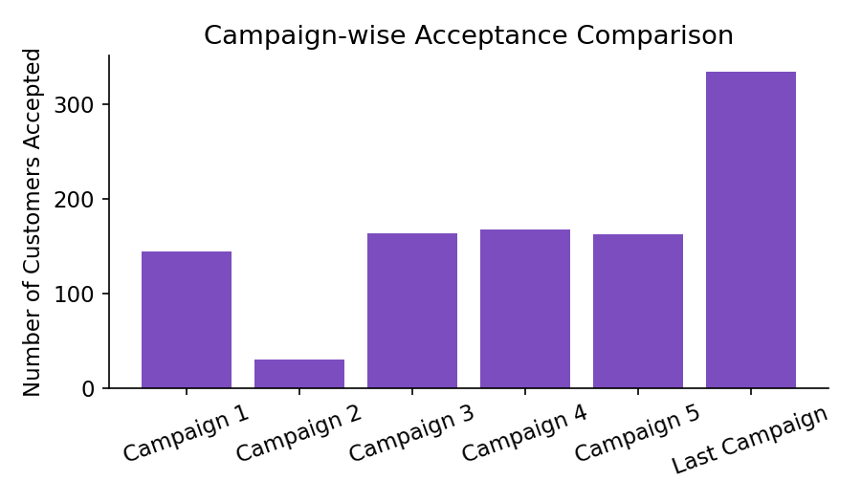
Figure 10: Comparison of customer acceptance counts across all six marketing campaigns, highlighting the strong performance of Campaigns 4 and 5 against the underperformance of Campaign 2.

11. Recommendations
Based on the insights above, the following recommendations are proposed to improve future campaign performance and overall marketing ROI:
- Prioritize high-income and highly-educated customer segments in premium campaign targeting, as they consistently show the strongest conversion potential across every metric analyzed.
- Design a dedicated campaign strategy for the 30-44 age group, since this segment consistently outperforms all others in responsiveness and represents an efficient use of marketing spend.
- Investigate and replicate the design of Campaigns 4 and 5, and conduct a root-cause review of Campaign 2 to understand why its acceptance rate was significantly lower than the others.
- Optimize the website experience around the 5-8 visit engagement window — for customers exceeding this range without converting, consider simplified offers, live chat support, or exit-intent promotions to reduce drop-off.
- Simplify messaging and offer value-driven incentives for the Basic education segment to improve their comparatively low conversion rate, rather than using the same messaging strategy across all education levels.
- Develop loyalty and retention programs targeted at high-spend segments such as Widowed customers, to protect and grow an already high-value relationship.
- Use the Income Band and Age Group segmentation built into this dashboard as a standing framework for evaluating all future campaigns, rather than assessing performance in aggregate alone.

12. Conclusion & Future Scope
This project successfully transformed a raw, unclean marketing dataset into a fully interactive three-page Power BI dashboard that supports both high-level monitoring and detailed diagnostic analysis. The data cleaning process resolved missing values, invalid categories, and outliers, ensuring the reliability of every downstream metric. A carefully designed set of DAX measures and calculated columns enabled flexible, segment-aware analysis without requiring a complex data model, since the dataset's single-table structure was sufficient for this use case.
The resulting dashboard demonstrates a clear, consistent narrative: income and education are the two strongest predictors of campaign response in this customer base, the 30-44 age group is the most valuable segment to target, and website engagement shows a measurable optimum range that marketing teams can act on directly. These findings, translated into concrete recommendations, give a marketing team a practical, data-backed starting point for planning future campaigns.

Future Scope
- Incorporate a time dimension (campaign dates) if made available, to analyze seasonality and campaign timing effects.
- Apply clustering (e.g., RFM or k-means segmentation) in Python to formally define customer personas beyond the manual Age/Income bands used here.
- Extend the model with a predictive component (e.g., a logistic regression or classification model) to score the likelihood of a customer accepting a future campaign.
- Integrate real campaign cost data to calculate true ROI per campaign, rather than acceptance counts alone.

— End of Report —
Prepared by Karan Bisht

