FastSpeech 2 TTS for English and Telugu — Technical Report (DRAFT, English part)
Name / roll no.: [TODO] GitHub: [TODO]

1. Implementation approach
[TODO] Describe FastSpeech 2 (encoder FFT blocks, variance adaptor = duration / pitch / energy predictors + length regulator, mel decoder, PostNet), the reference repo (ming024/FastSpeech2), MFA for durations, HiFi-GAN universal vocoder, and the modifications listed in English/CHANGES.md and Telugu/CHANGES.md.

2. Data and preprocessing

English
Train: 3594 utts / 4.60 h; validation: 771 utts / 1.02 h; 114 speaker(s); 1 utterances dropped after alignment. Utterance-disjoint split, seed 1234.
[TODO] Selection/sub-sampling strategy (config.yaml > data), filters (1.5-12 s, word counts), resampling to 22.05 kHz, peak-normalisation, text normalisation, phone set, MFA settings, pitch/energy (phoneme-level, normalised with train statistics).

3. Training configuration
Batch 16, Adam (0.9, 0.98), warm-up 4000, 30000 steps, LR annealing at 65% and 85% of training, grad-clip 1.0, hidden 256, 4 encoder / 6 decoder FFT layers. [TODO: add GPU, wall-clock time]

4. Loss curves
English: 30000 steps, best validation total loss 3.4678 at step 2000 (last val 3.7065, last train 0.9998). [TODO: convergence, instability, over-fitting (val vs train gap)]
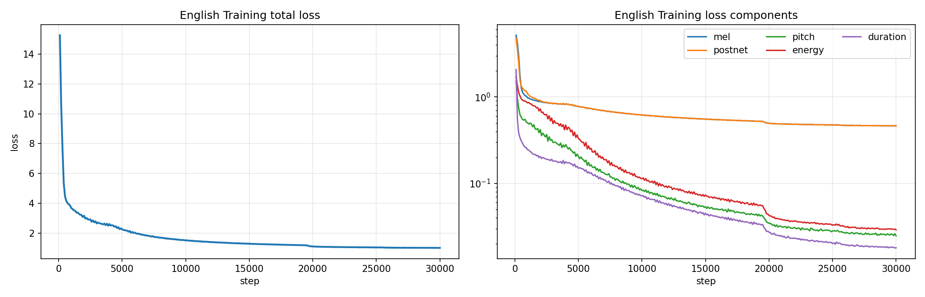
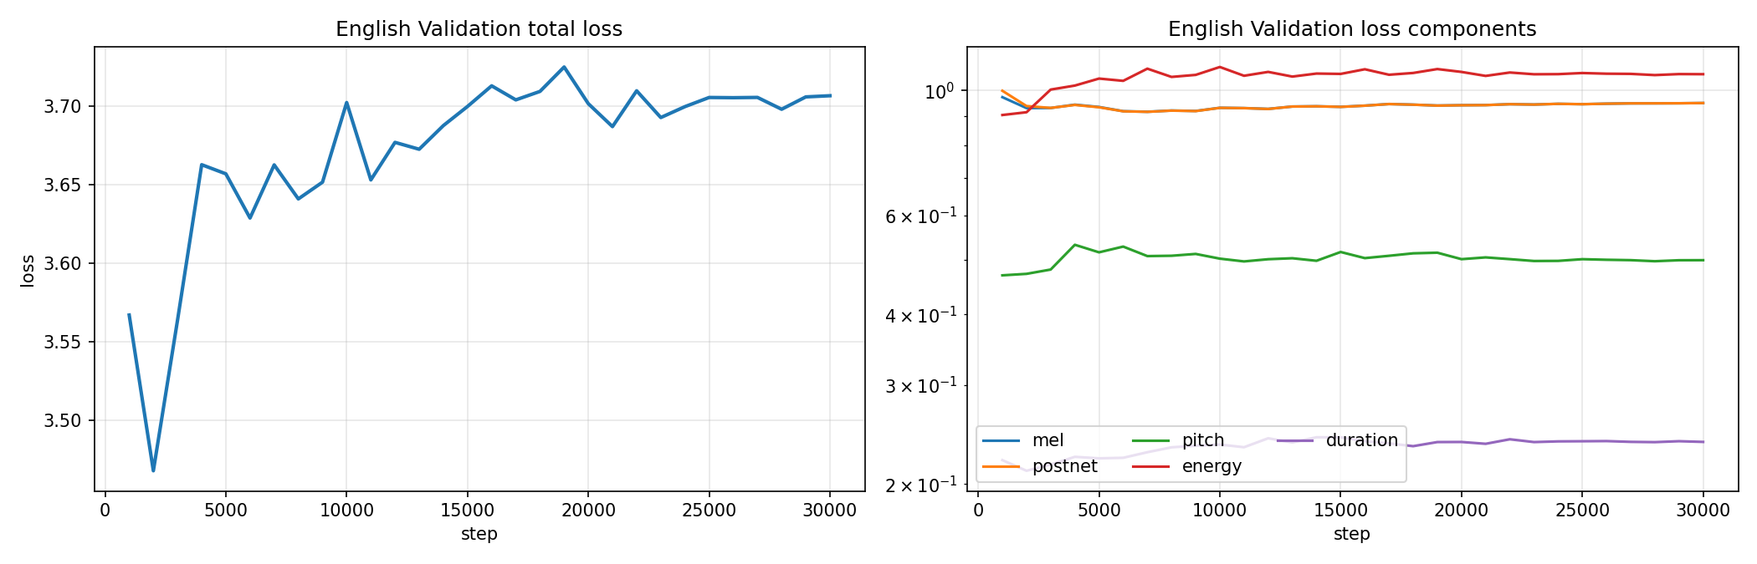
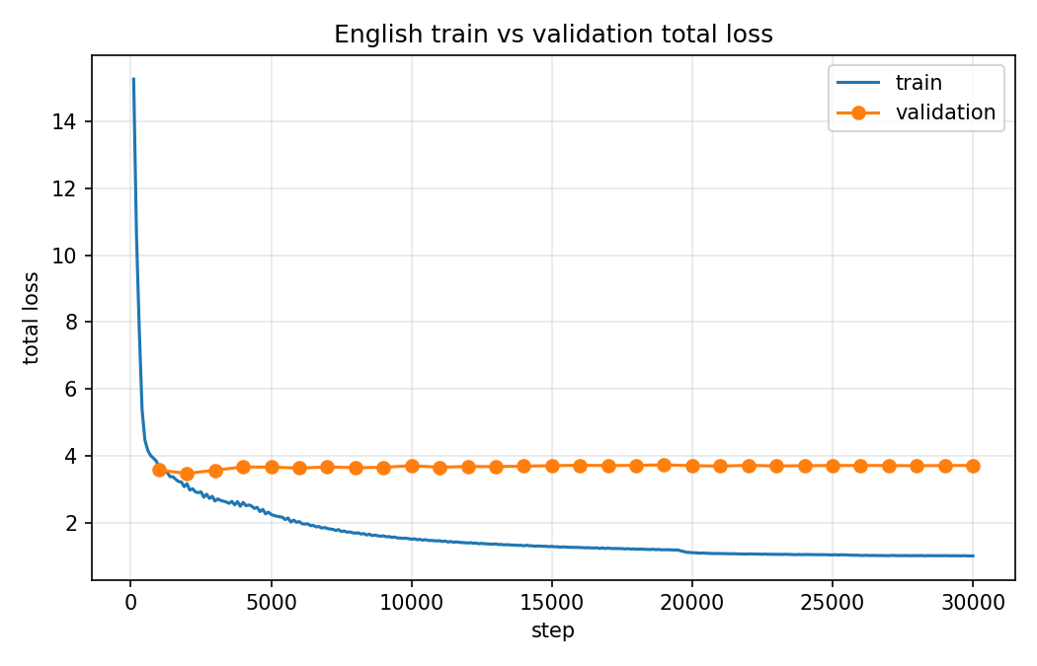

5. Generated speech and variance-adaptor analysis (per test sentence)

English

E1: The antidisestablishmentarianism movement gained considerable momentum during the parliamentary proceedings.
Duration 5.41 s, 85 phones + 0 pauses; F0 136-170 Hz (mean 148); energy 5.06-30.67; longest: SH (104 ms), NG (104 ms), Z (104 ms)
[TODO] Pronunciation / quality observations (listen!). Duration / pitch / energy pattern explanation.
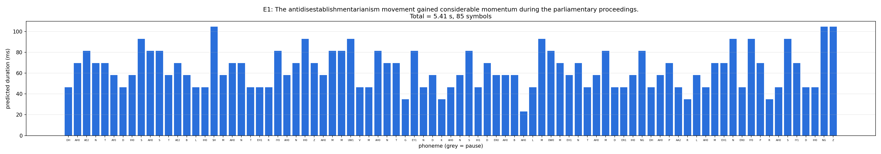
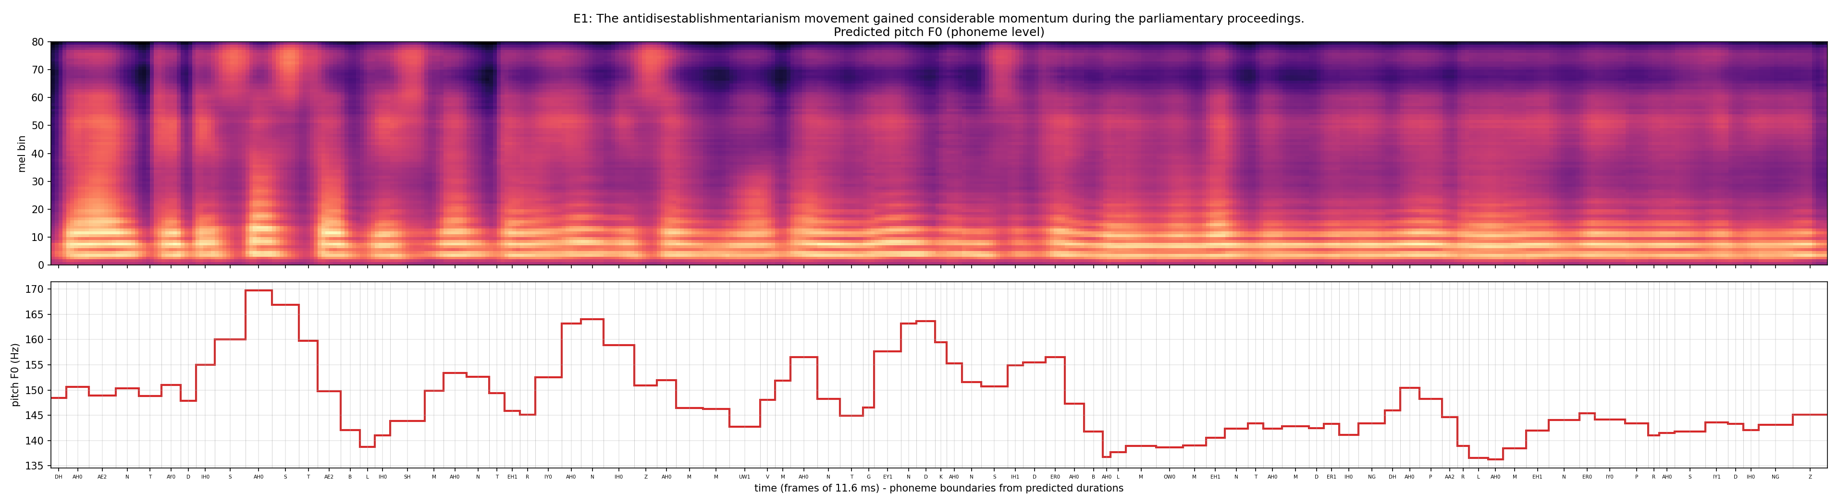
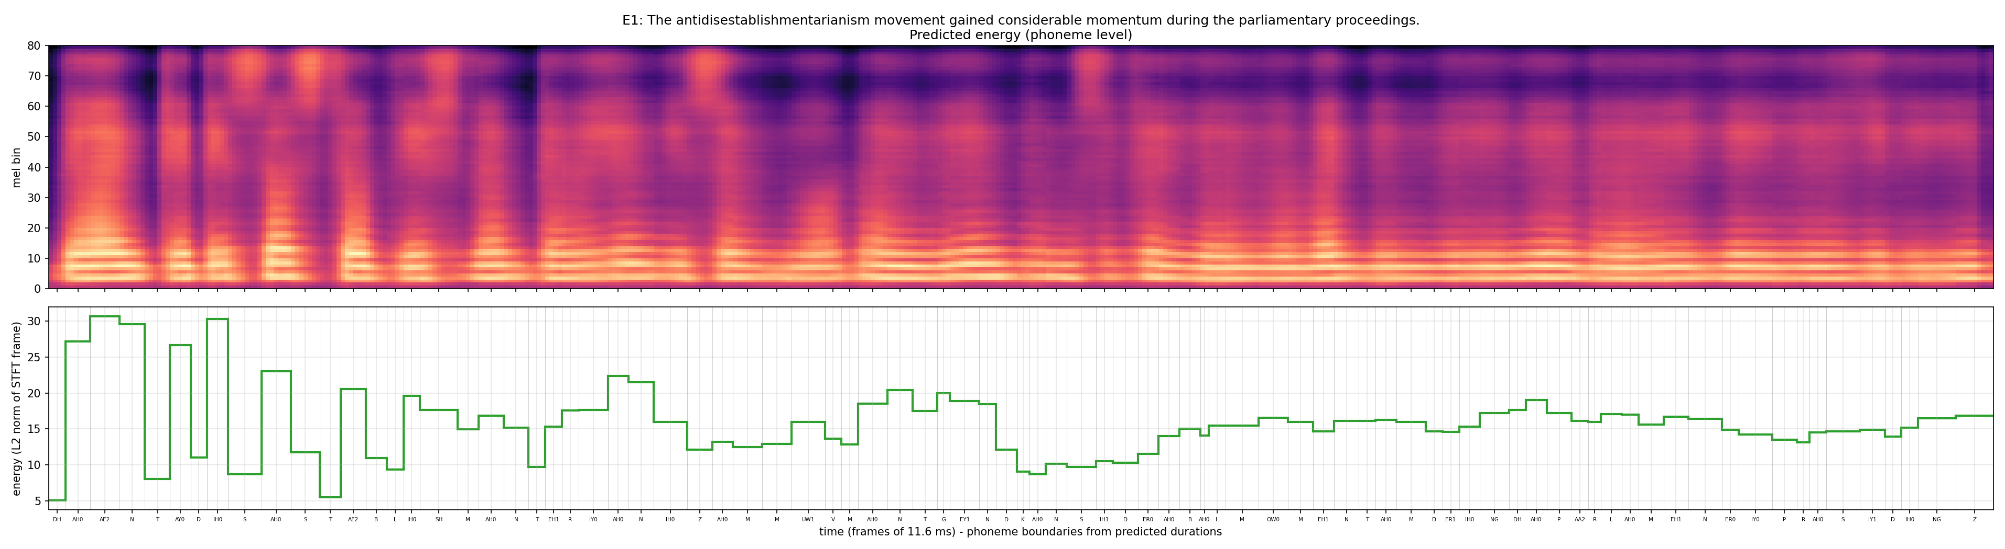

E2a: The orchestra's conduct during the ceremony was praised by the audience.
Duration 3.48 s, 50 phones + 0 pauses; F0 131-182 Hz (mean 146); energy 4.33-31.69; longest: EY1 (128 ms), S (128 ms), Z (116 ms)
[TODO] Pronunciation / quality observations (listen!). Duration / pitch / energy pattern explanation.
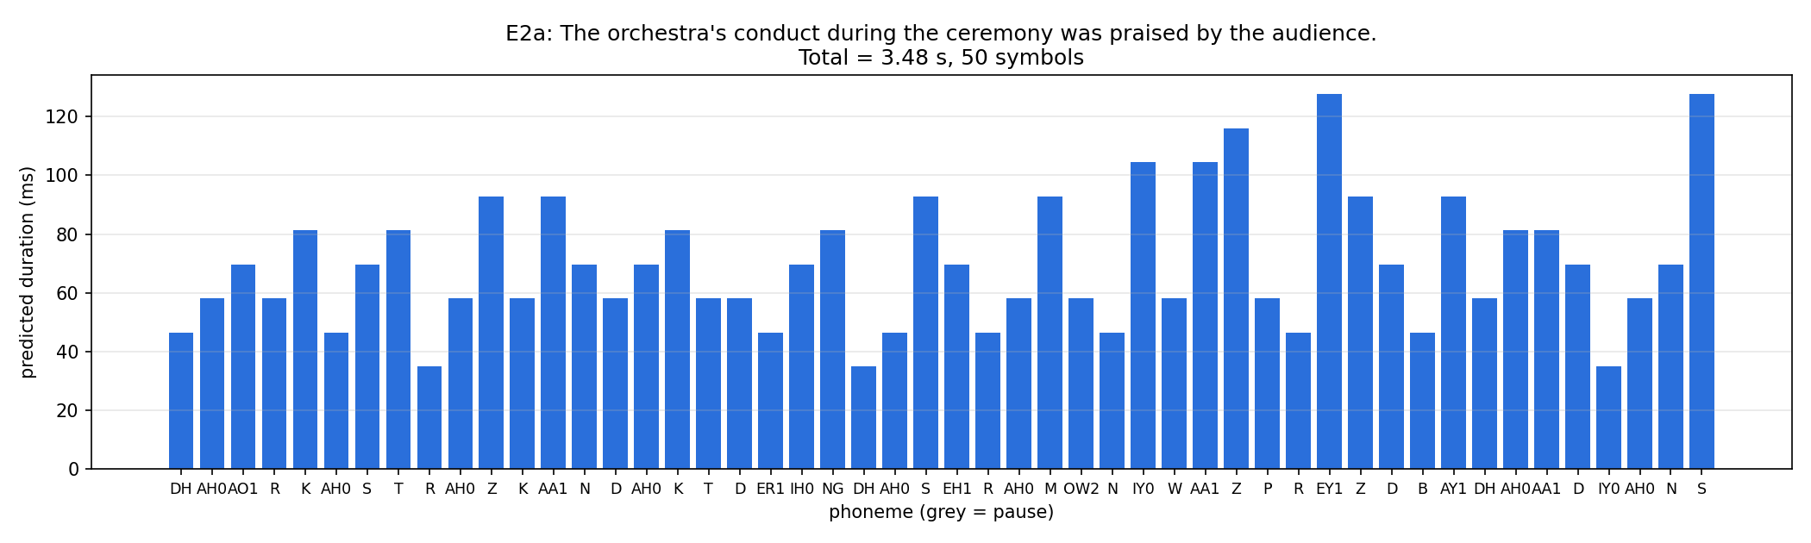
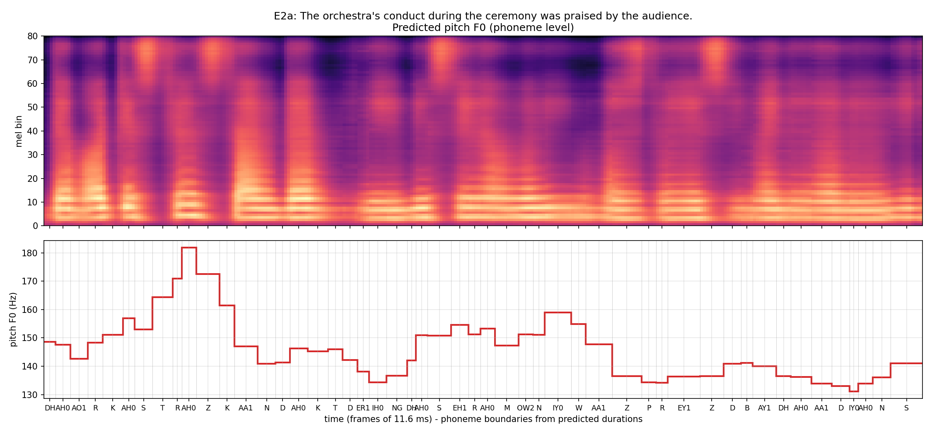
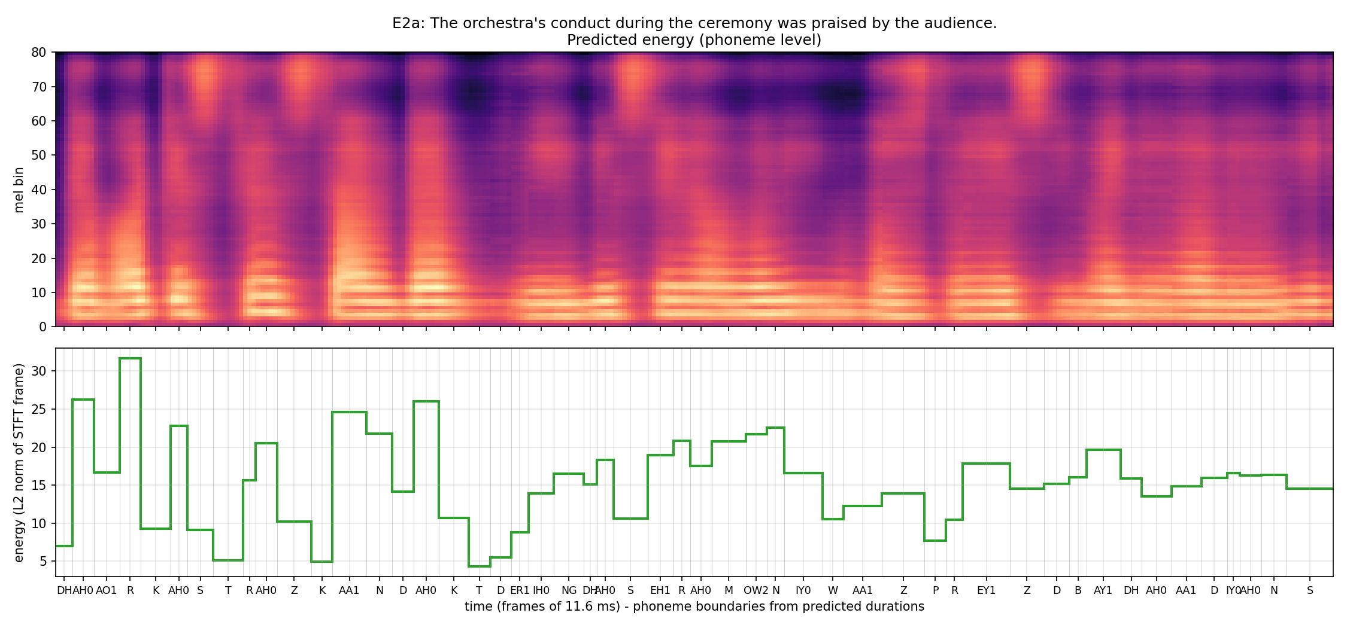

E2b: The researchers will conduct an experiment to evaluate the proposed method.
Duration 3.82 s, 56 phones + 0 pauses; F0 131-159 Hz (mean 142); energy 4.03-34.17; longest: ER0 (128 ms), CH (116 ms), TH (116 ms)
[TODO] Pronunciation / quality observations (listen!). Duration / pitch / energy pattern explanation.
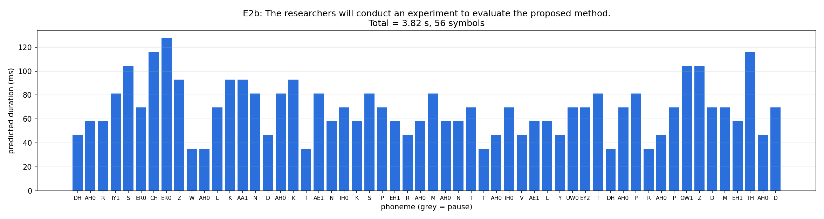
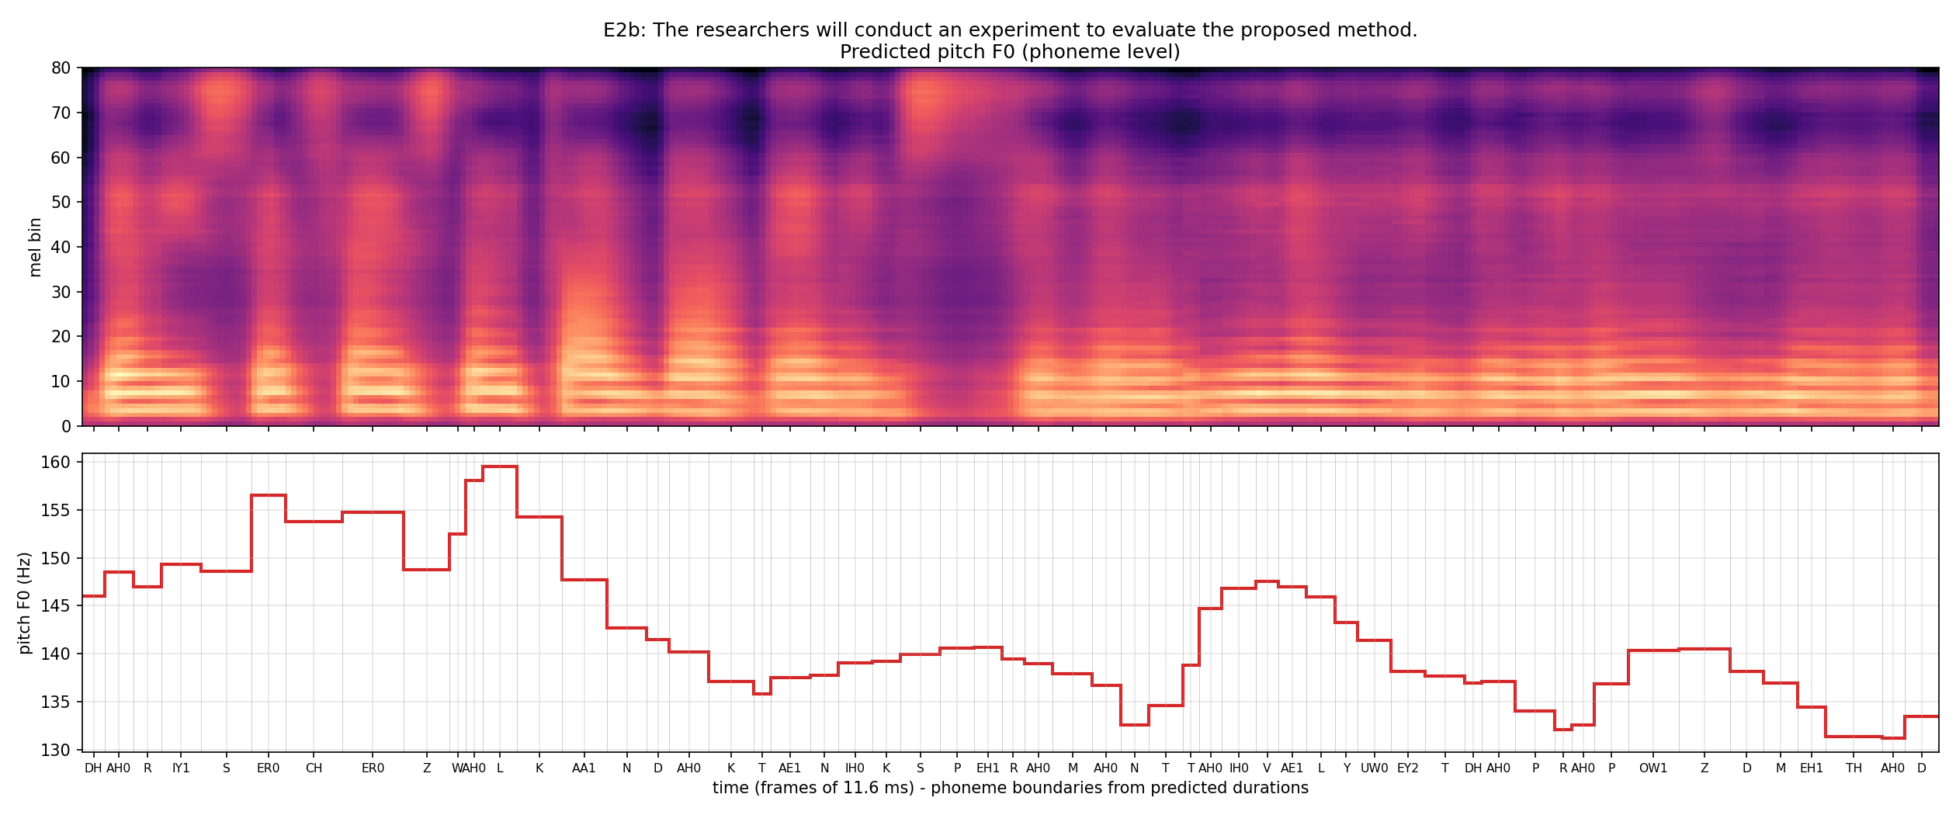
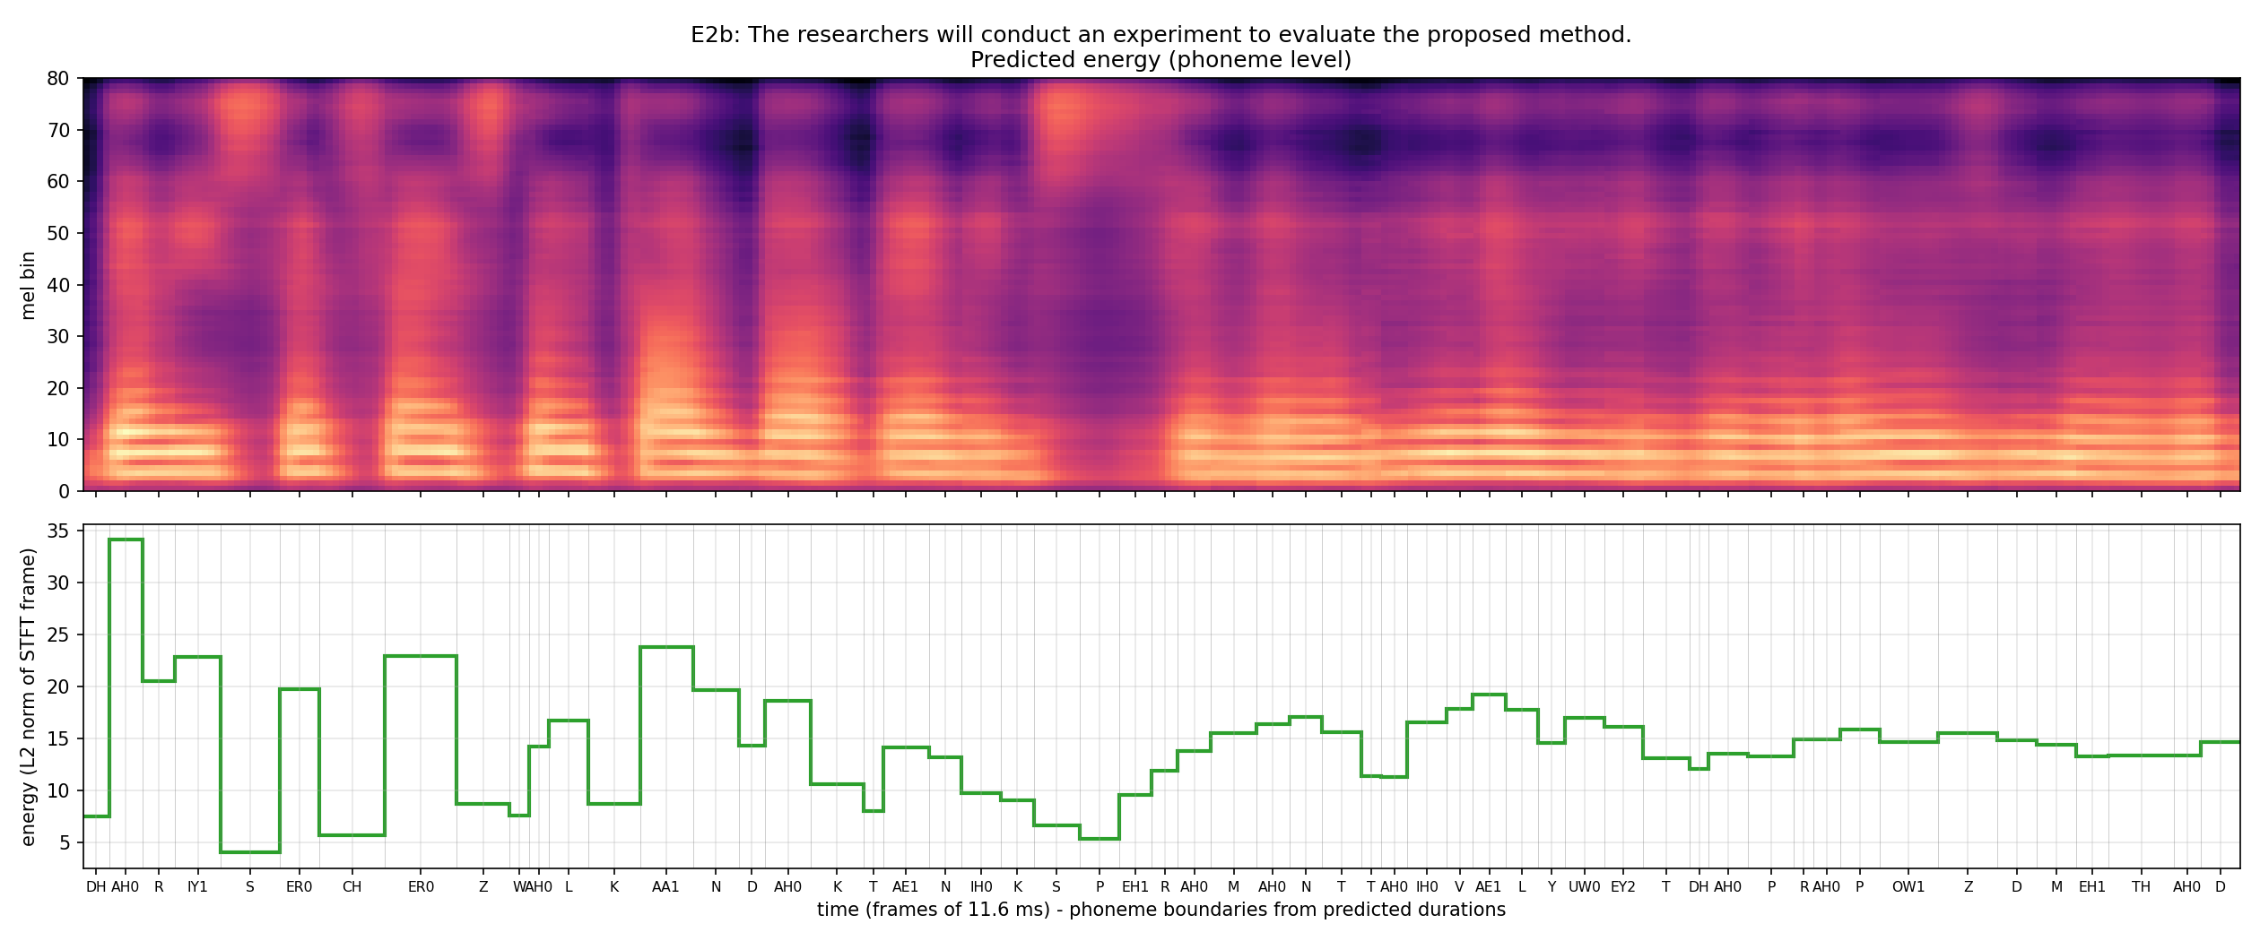

E3: The rhyth m of the orchestra changed unexpectedly.
Duration 2.57 s, 37 phones + 0 pauses; F0 134-156 Hz (mean 142); energy 6.26-39.70; longest: AY1 (139 ms), EY1 (128 ms), IY0 (116 ms)
[TODO] Pronunciation / quality observations (listen!). Duration / pitch / energy pattern explanation.
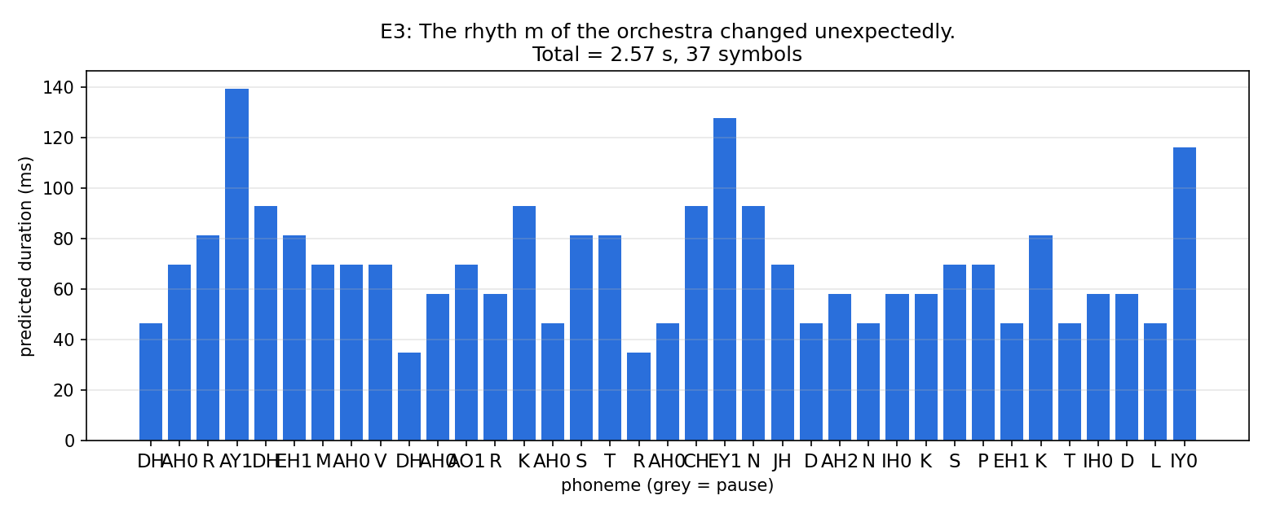
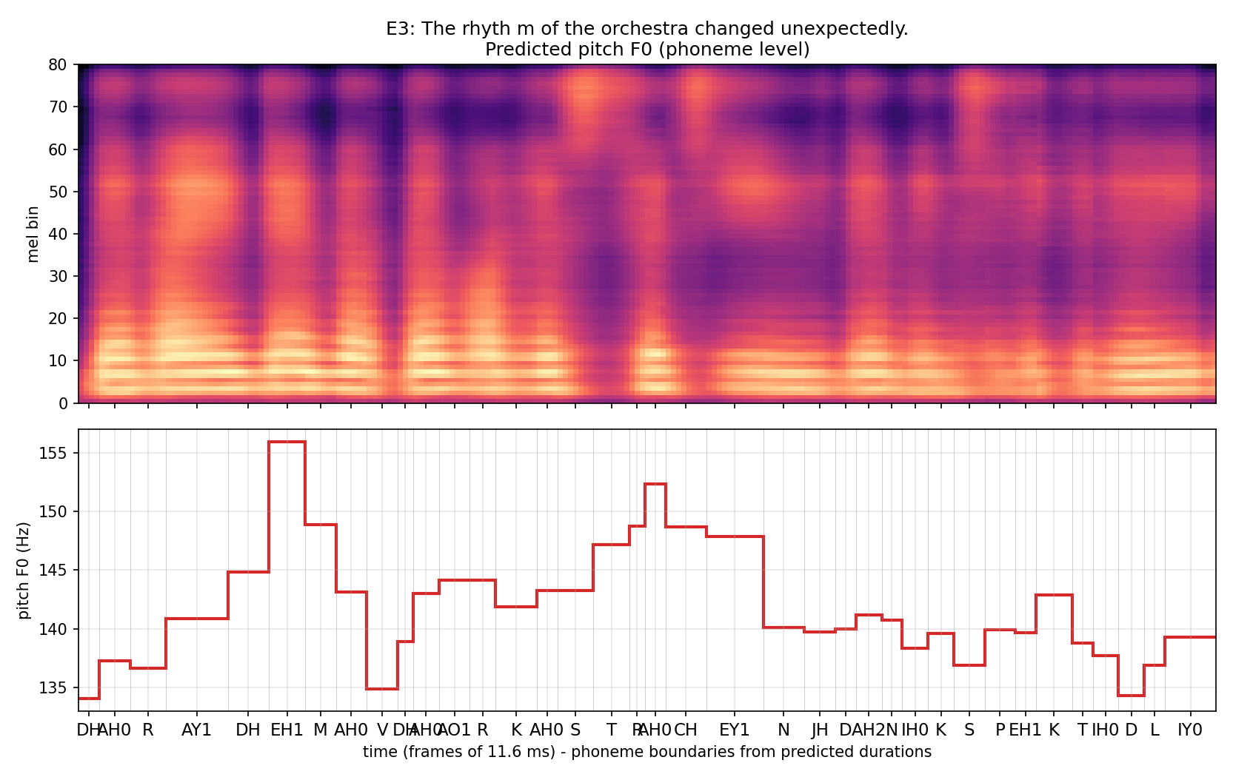
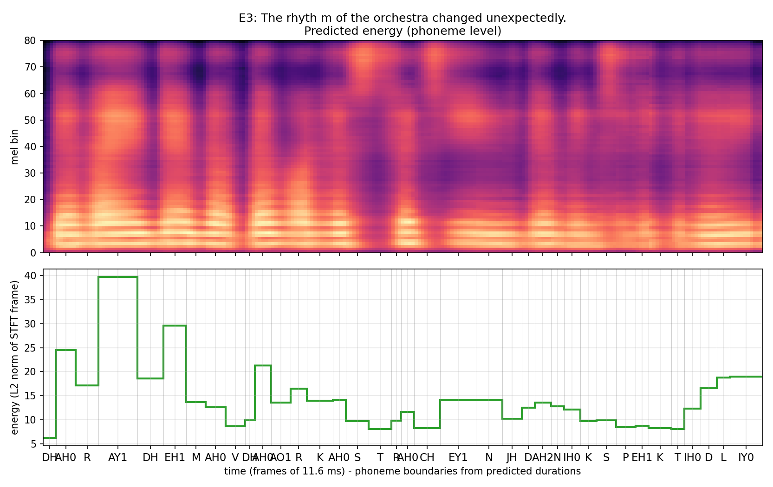

E4: The meeting will start at 10:45 AM on 12 November 2026, so andaroo should arrive on time.
Duration 5.55 s, 78 phones + 1 pauses; F0 135-162 Hz (mean 147); energy 4.17-30.73; longest: AY1 (139 ms), F (116 ms), AY1 (116 ms)
[TODO] Pronunciation / quality observations (listen!). Duration / pitch / energy pattern explanation.
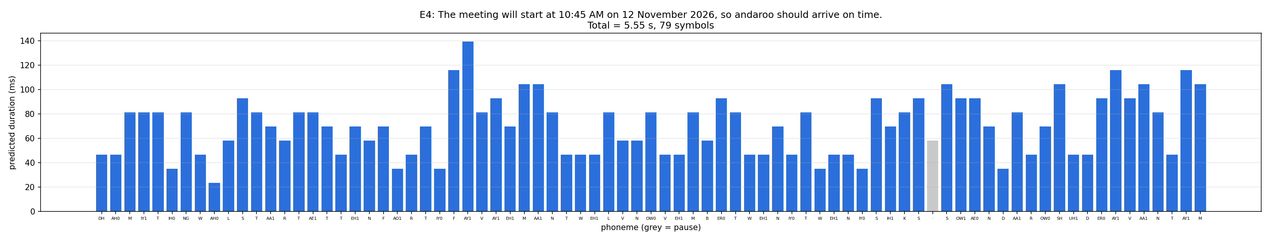
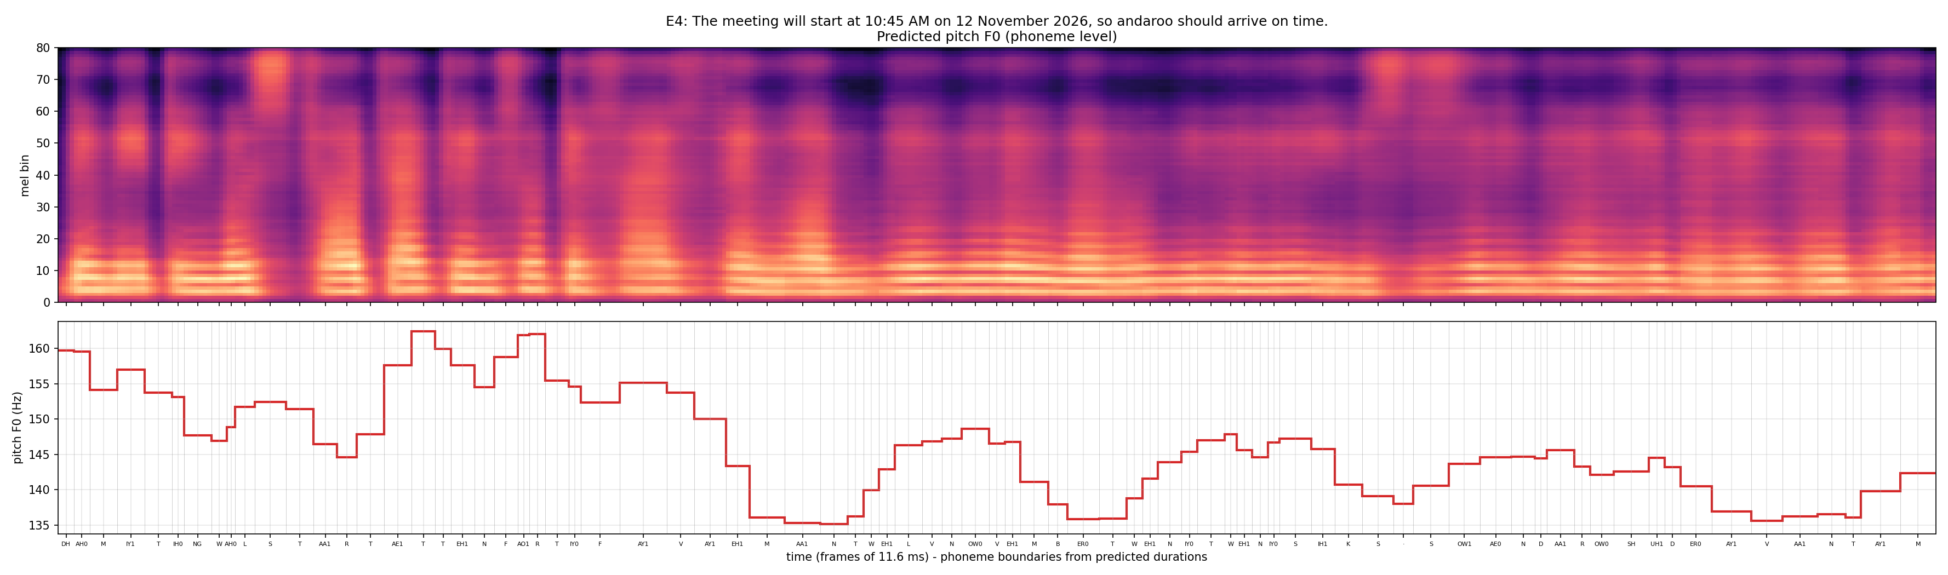
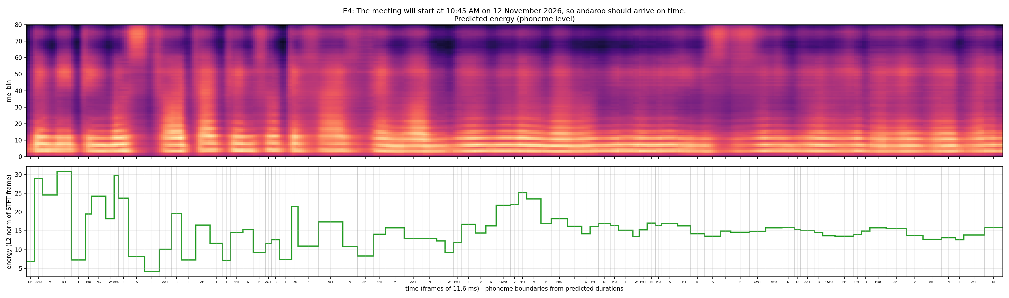

6. English vs Telugu: comparison, limitations, improvements
[TODO] Svarah is multi-speaker / accented / partly spontaneous with varying channels vs. clean studio IndicTTS; rule-based Telugu phones vs. ARPAbet+G2P; homographs (conduct, పట్టు); OOV words; number/date handling; alignment quality; vocoder mismatch (universal HiFi-GAN); more data / better G2P / speaker-disjoint evaluation / MOS or CER evaluation as improvements.

7. Reproducibility
See README.md: requirements.txt, config.yaml per language and the commands: preprocess.py --stage all; train.py; inference.py.

