FastSpeech 2 TTS for English and Telugu — Technical Report (DRAFT, Telugu part)
Name / roll no.: [TODO] GitHub: [TODO]

1. Implementation approach
[TODO] Describe FastSpeech 2 (encoder FFT blocks, variance adaptor = duration / pitch / energy predictors + length regulator, mel decoder, PostNet), the reference repo (ming024/FastSpeech2), MFA for durations, HiFi-GAN universal vocoder, and the modifications listed in English/CHANGES.md and Telugu/CHANGES.md.

2. Data and preprocessing

Telugu
Train: 2063 utts / 2.96 h; validation: 479 utts / 0.69 h; 2 speaker(s); 42 utterances dropped after alignment. Utterance-disjoint split, seed 1234.
[TODO] Selection/sub-sampling strategy (config.yaml > data), filters (1.5-12 s, word counts), resampling to 22.05 kHz, peak-normalisation, text normalisation, phone set, MFA settings, pitch/energy (phoneme-level, normalised with train statistics).

3. Training configuration
Batch 16, Adam (0.9, 0.98), warm-up 4000, 30000 steps, LR annealing at 65% and 85% of training, grad-clip 1.0, hidden 256, 4 encoder / 6 decoder FFT layers. [TODO: add GPU, wall-clock time]

4. Loss curves
Telugu: 30000 steps, best validation total loss 3.7463 at step 1000 (last val 3.9657, last train 0.7655). [TODO: convergence, instability, over-fitting (val vs train gap)]
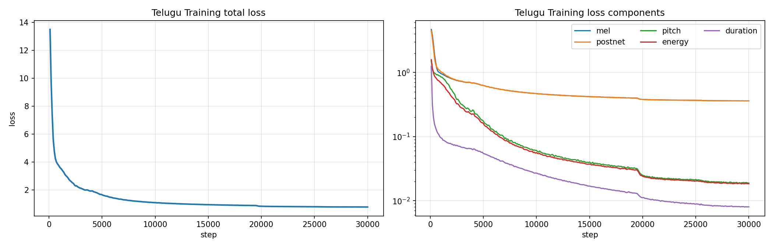
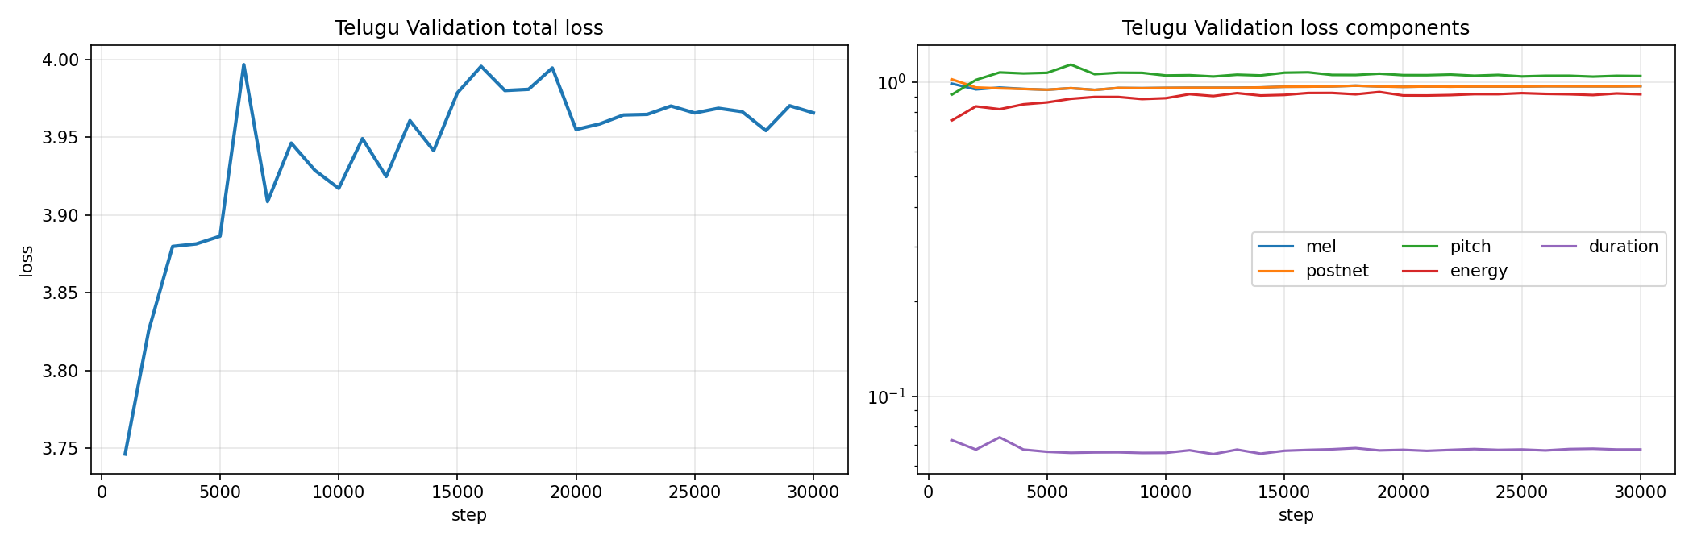
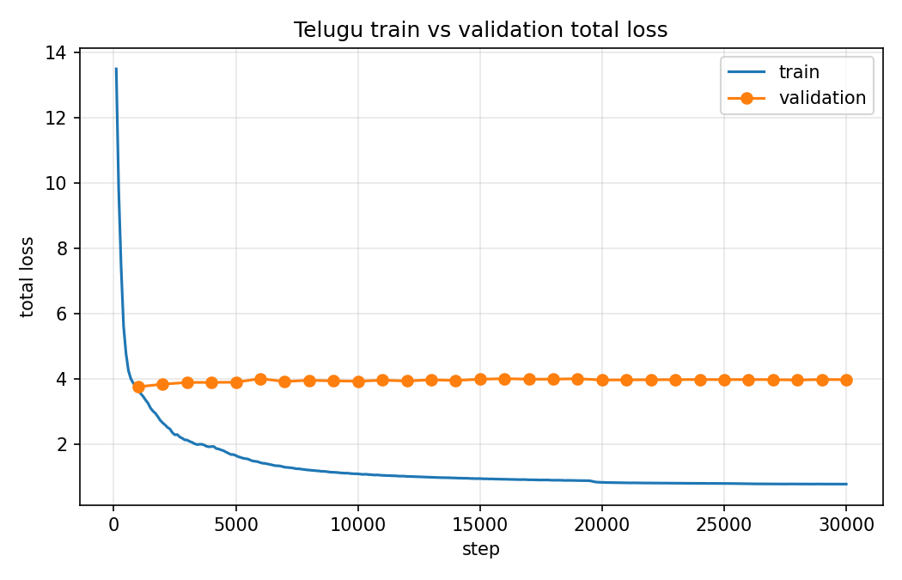

5. Generated speech and variance-adaptor analysis (per test sentence)

Telugu

T1: న్యూరోఫార్మకోలాజికల్ పరిశోధనలో నూతన ఔషధాల ప్రభావాన్ని విశ్లేషించారు.
Duration 4.93 s, 66 phones + 5 pauses; F0 147-282 Hz (mean 204); energy 13.57-117.94; longest: ఓ (128 ms), శ (116 ms), ఓ (116 ms)
[TODO] Pronunciation / quality observations (listen!). Duration / pitch / energy pattern explanation.
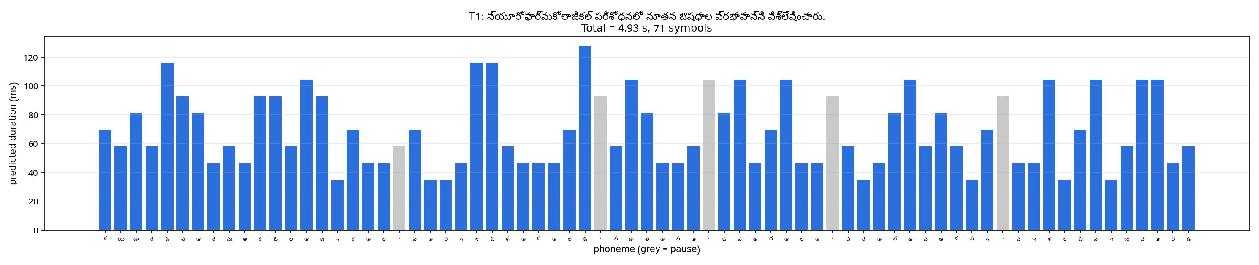
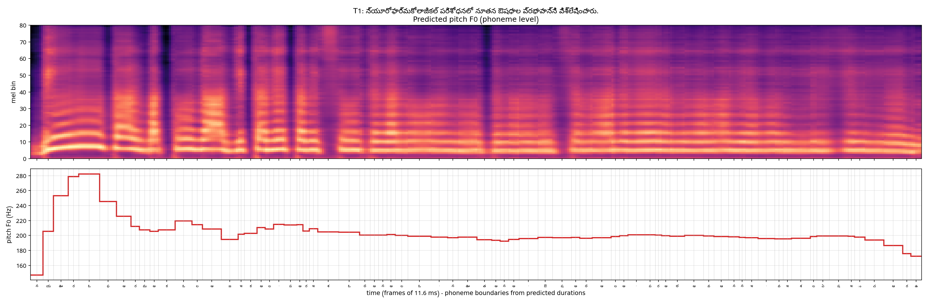
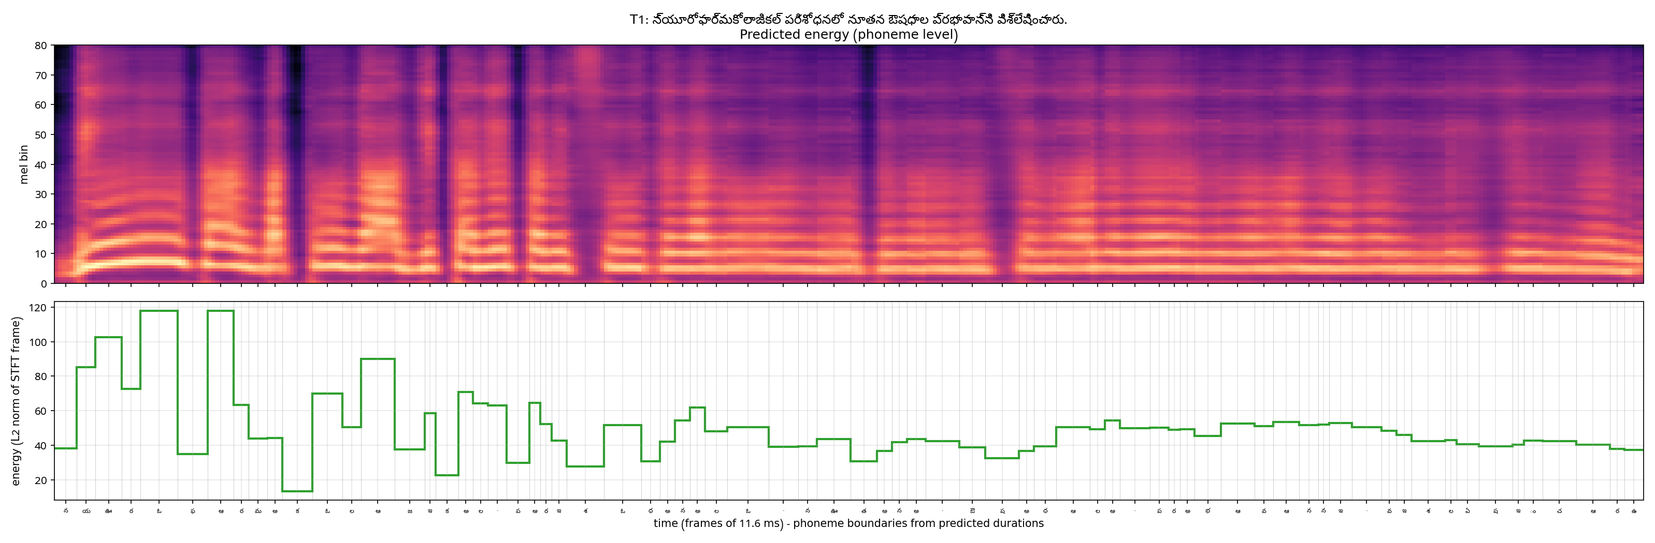

T2a: తాడుపై అతని పట్టు చాలా బలంగా ఉంది.
Duration 2.54 s, 31 phones + 5 pauses; F0 150-240 Hz (mean 195); energy 4.94-113.61; longest: ఆ (128 ms), ఆ (116 ms), ఆ (116 ms)
[TODO] Pronunciation / quality observations (listen!). Duration / pitch / energy pattern explanation.
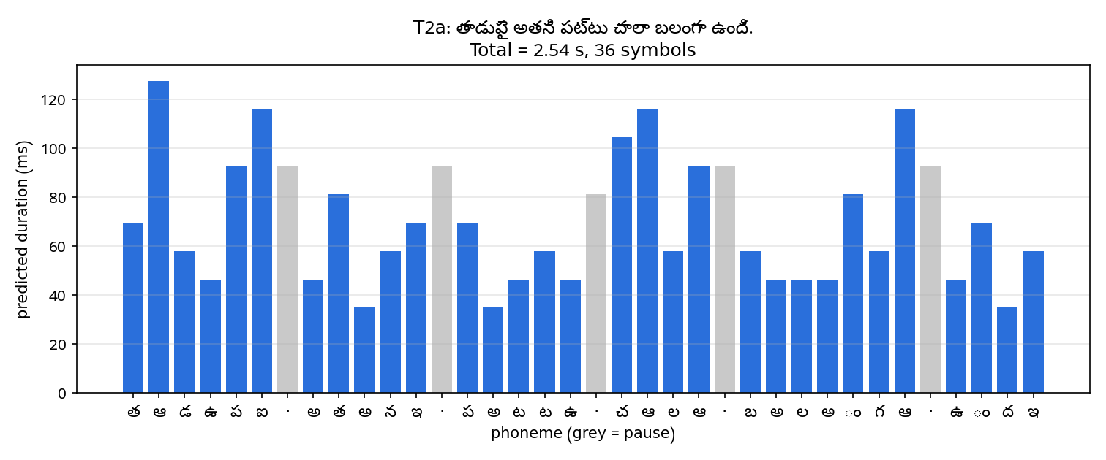
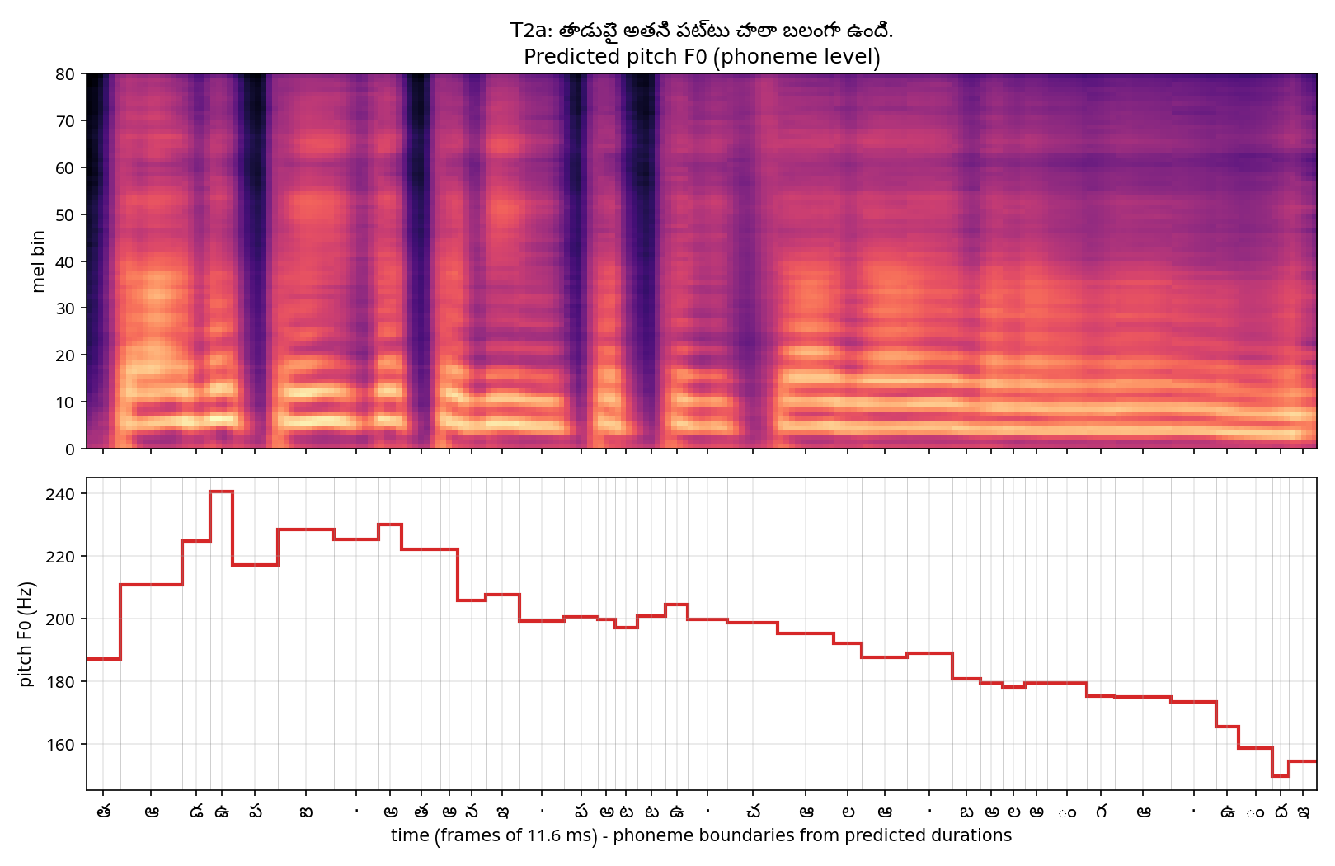
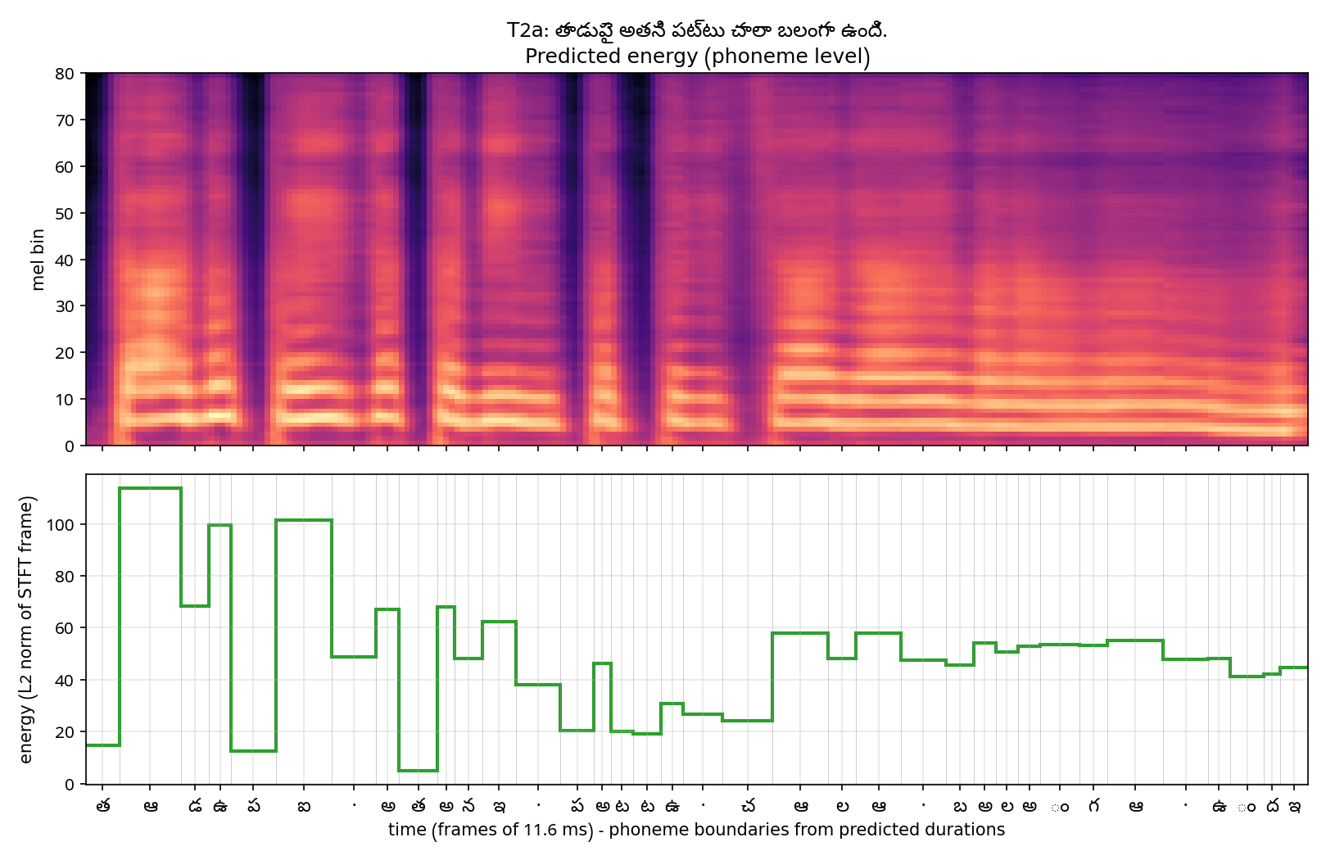

T2b: ఆమె పట్టుచీరను ధరించి వేడుకకు వచ్చింది.
Duration 2.81 s, 37 phones + 4 pauses; F0 164-261 Hz (mean 203); energy 12.33-110.35; longest: ఆ (151 ms), చ (116 ms), sp (104 ms)
[TODO] Pronunciation / quality observations (listen!). Duration / pitch / energy pattern explanation.
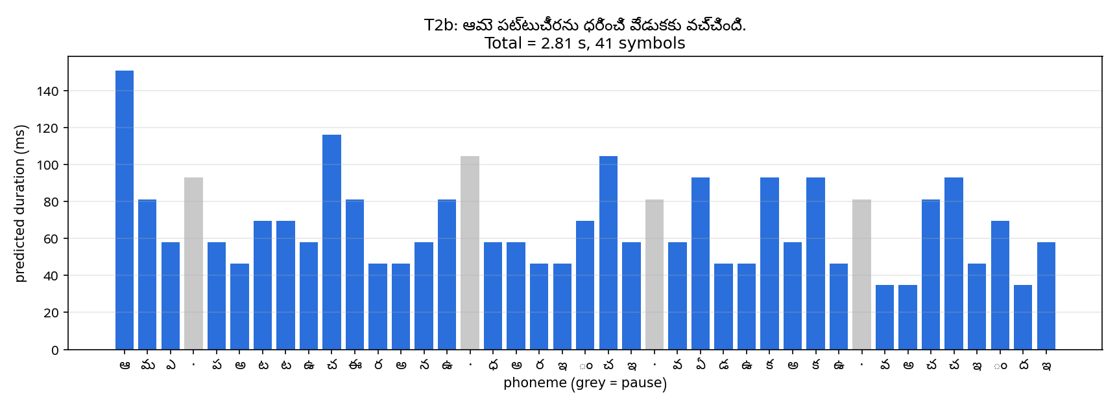
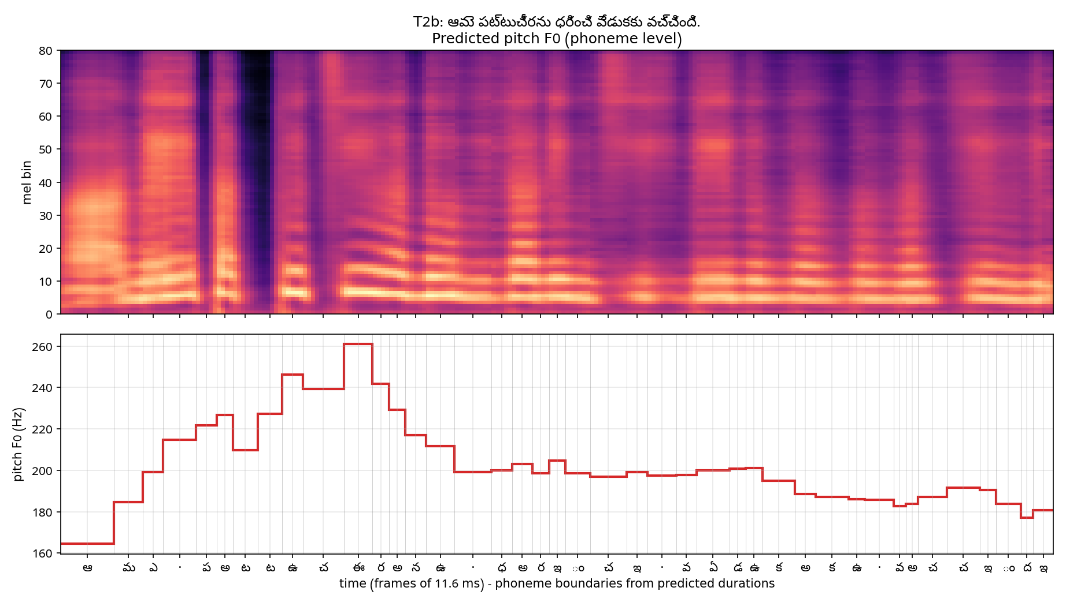
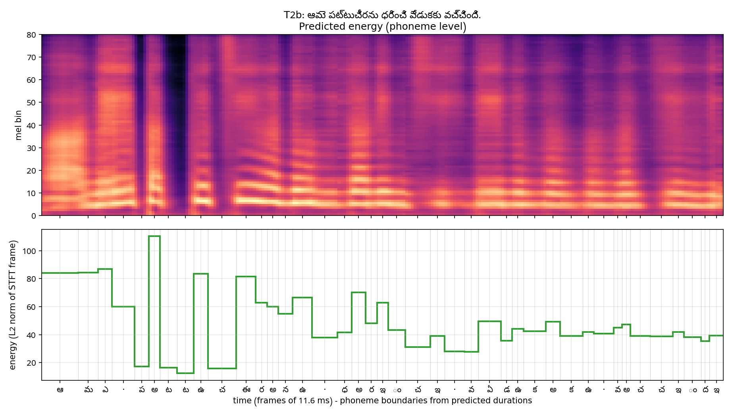

T3: పులి అడవిలో నిశ్శబ్దంగా నడిచింది.
Duration 2.16 s, 31 phones + 3 pauses; F0 166-284 Hz (mean 202); energy 13.66-117.50; longest: శ (139 ms), చ (116 ms), ఆ (104 ms)
[TODO] Pronunciation / quality observations (listen!). Duration / pitch / energy pattern explanation.
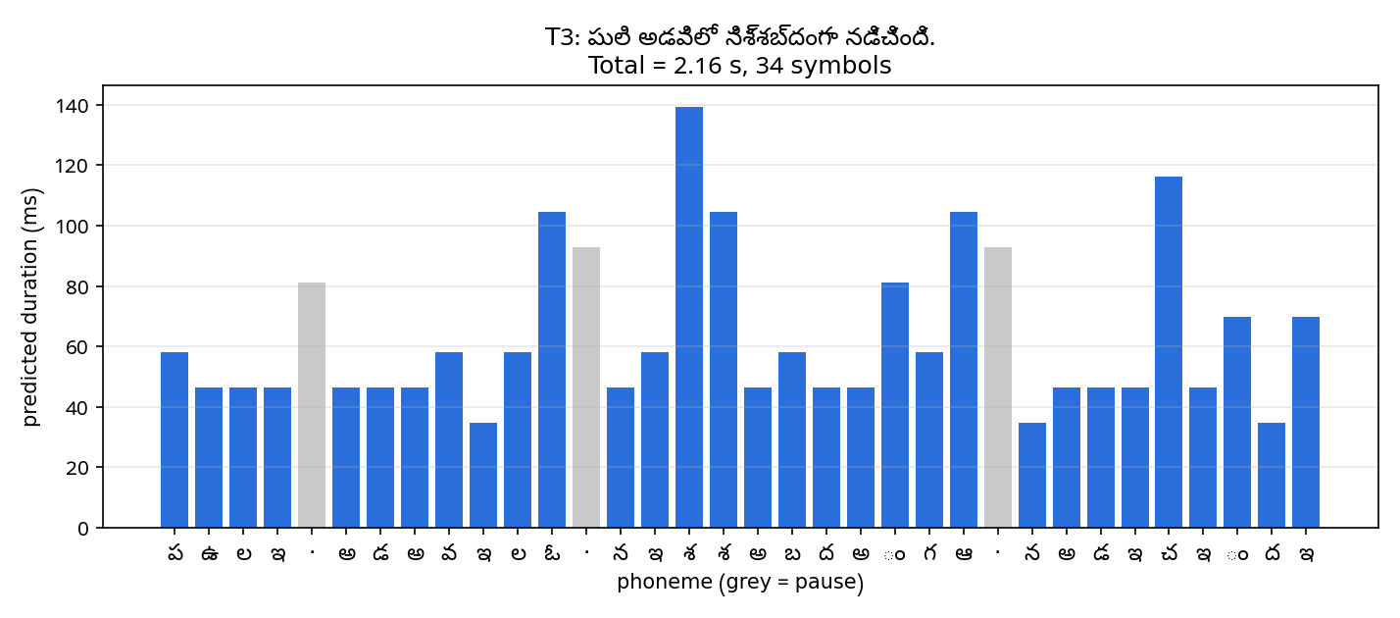
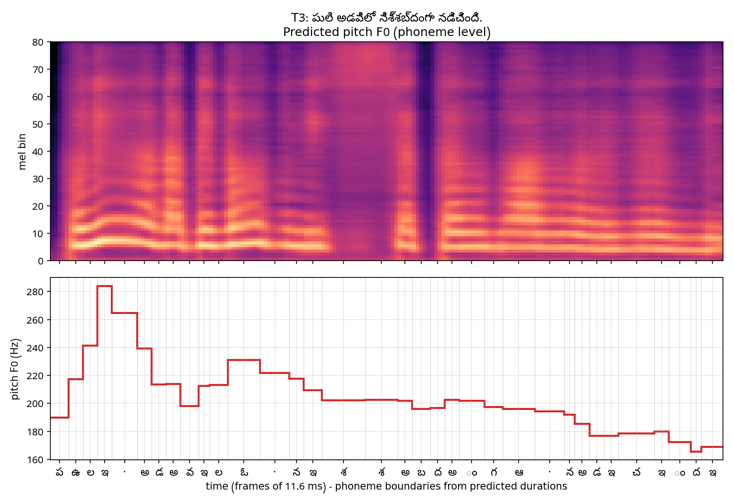
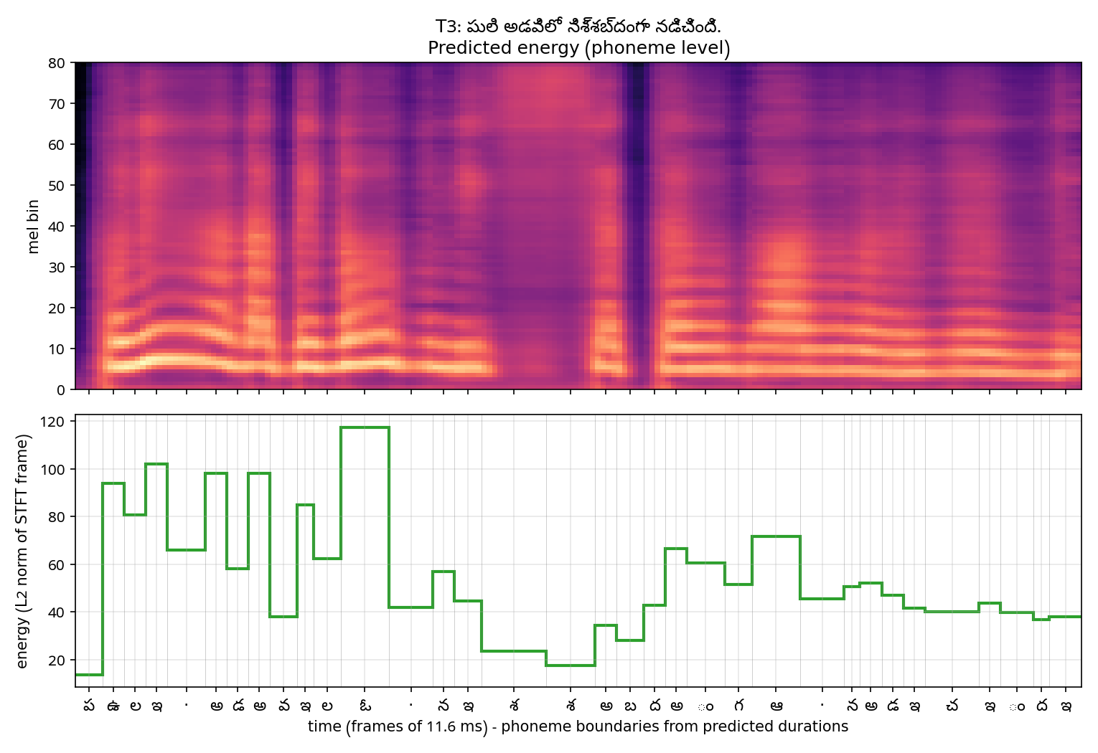

T4: ఈ సమావేశం 2026 నవంబర్ 12వ తేదీ ఉదయం 10:45 గంటలకు ప్రారంభమవుతుంది, సమయానికి సిద్ధంగా ఉంచండి.
Duration 8.42 s, 119 phones + 17 pauses; F0 188-246 Hz (mean 202); energy 14.67-93.79; longest: ఈ (151 ms), ఐ (139 ms), ఐ (104 ms)
[TODO] Pronunciation / quality observations (listen!). Duration / pitch / energy pattern explanation.
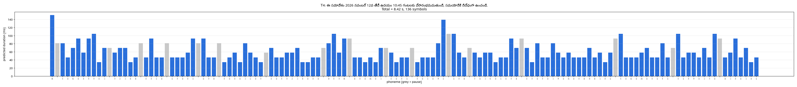
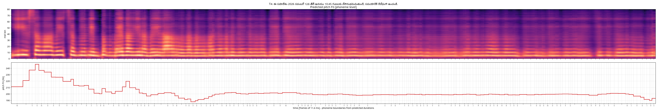
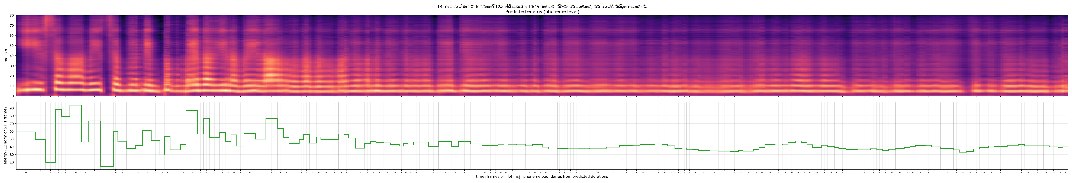

6. English vs Telugu: comparison, limitations, improvements
[TODO] Svarah is multi-speaker / accented / partly spontaneous with varying channels vs. clean studio IndicTTS; rule-based Telugu phones vs. ARPAbet+G2P; homographs (conduct, పట్టు); OOV words; number/date handling; alignment quality; vocoder mismatch (universal HiFi-GAN); more data / better G2P / speaker-disjoint evaluation / MOS or CER evaluation as improvements.

7. Reproducibility
See README.md: requirements.txt, config.yaml per language and the commands: preprocess.py --stage all; train.py; inference.py.

