SUMMER TRAINING
VLSI DESIGN AND FPGAIMPLEMENTATION
PROJECT -
4-BIT MICROPROCESSOR
USING VHDL

LAKHWINDER UNDER THE GUIDANCE OF
ROLL NO. 101406094 MANJIT KAUR
ECE-3rd year ENGINEER,ASCD
THAPAR UNIVERSITY ,PATIALA CDAC,MOHALI

TABLES OF CONTENTS

CHAPTER-1 …………………………………………………………………………………………..5 INTRODUCTION AND ORGANIZATION OF THE PROJECT……………………………………………………………………………………………….5-7
- INTRODUCTION…………………………………………………………………………….6
- PROJECT OBJECTIVE……………………………………………………………………..6

- SCOPE OF WORK…………………………………………………………………………….6
- ORGANIZATION OF PROJECT.…………………………………………………………7

CHAPTER-2………………………………………………………………………………………………….8
BRIEF INTRODUCTION TO MICROPROCESSOR AND VHDL……………….………8-11
- INTRODUCTION……………………………………………………………………………9
- ORIGIN OF MICROPROCESSOR……………………………………….………………9
- MICROPROCESSORS TODAY………………………………………….……………….9

- INTRODUCTION TO VHDL……………………………………………………………..10
- ADVANTAGES OF VHDL…………………………………………..……………………10
- BENEFITS OF USING VHDL…………………………………………………………….10

CHAPTER-3……………………………………………………………………………………………….12
DESIGN OF 4 BIT MICROPROCESSOR USING VHDL……..………………………..12-18
- INTRODUCTION TO THE PROJECT………………….………………………………13

- BLOCK DIAGRAM OF CPU………………………….………………………………….13
- DESCRIPTION OF DIFFERENT BLOCK……….……………………………………..14

CHAPTER-4…………………………………………….………………………….................19
SIMULATION AND VERIFICATION…………………………………………………..19-25
4.1 INTRODUCTION……………………………………………………………………………20

- CPU SIMULATION…………………………………………………….......................20
  - RTL SCHEMETIC….……………………………………………………………………..….22
  - CODE……………………………………………………….......................................23

CHAPTER-5…………………………………………………………………………………………..26 EDA TOOLS AND FPGA……………………………………………………………….......26-31
- XILINX 14.7…………………………………………………………………………….……..27

- SIMULATION……………………………………………………………………….………..27
  - ISIM KEY FEATURE…………………………………………………………….…………..28
  - SYNTHESIS……………………………………………….…………………….……………..29
5.5 FPGA…………………………………………......................................................29

LIST OF FIGURES

Figure 3.1 CPU Block Diagram…………………………………………….13
Figure 3.2 ALU Interface.…………………….…………………………..…14
Figure 3.3 multiplexer …………………….………………………………..15
Figure 3.4 register interface…………………………………….…………16
Figure 3.5 accumulator…………………………………………………….…16
Figure 3.6 counter and rom………………………………………..………17
Figure 3.7 instruction decoder……………………………………………18 Figure 4.1 implemention of project….…………………....…….……21
Figure 4.2 simulation of project……..………………………………….22 Figure 4.3 RTL schemetic……………………….……………………………23 Figure 5.1 xillinexe logo..……………………………………….…………..27
Figure 5.2 Spartan 3………………………………….....……………………31

Chapter 1

INTRODUCTION

1.1 INTRODUCTION

Microprocessor is basically an electronic device that consists of arithmetic and logic unit (ALU) and control circuitry which is required to function as computer’s CPU. Microprocessor is integrated circuit that interprets and executes the program instructions and behaves intelligently. The processor operates at a speed of the internal clock and the speed of the clock depends upon the no. of pulses per second. With each clock pulse, the processor performs the function that corresponds to the instruction. Thus the power of the processor can be calculated by no. of instructions executed per second. During the execution of instructions, data are stored temporarily in memory units called registers. The control signal is the electronic signals used for communication between various processor units during the execution of the instruction. fourbit microprocessor contains a number of basic modules which together completes the processor. The processor uses 4 bit data bus to communicate through different sections like General purpose registers, Arithmetic logic unit, CU (control unit), memory,programcounter,alu register, instruction decoder and shift register. With the advancement in integrated circuit technology the power of the processor has increased tremendously. Microprocessors are widely used in the embedded sector based on general purpose application and special purpose application. Microprocessors are used in instruments to make it intelligent using behavioral coding. All the modules in the design are coded in VHDL, as it is very useful tool with its concept of concurrency to cope with the parallelism of digital hardware.

1.2 PROJECT OBJECTIVE
The objective of this project is to design a small 4 bit microprocessor by using VHDL (Very High Speed Integrated Circuit Hardware Description Language). This microprocessor has the basic instruction that student has been learned in microprocessor subject. This design use VHDL as a hardware description language.

1.3 SCOPES OF WORK
Based on available resources, limited time frame and expertise, this research project is narrowed down to the following scope of work
- This project includes the design of 4 bit microprocessor and its components using VHDL and collecting the simulation result
- Analysis of the simulated result of 4 bit microprocessor.

1.4 ORGANIZATION OF REPORT
This report is organized into five chapters. The first chapter will cover the introduction , project objectives and scopes of work.

In chapter 2 we mainly are giving brief introduction of microprocessor, a brief discussion about its origin, historical overview. It also outlines the different micropropessorchips,and todays microprocessor. At the end of this chapter there is a brief discussion about VHDL (very high speed integrated circuit hardware description language) , its features, advantages and benefits of using VHDL.

In chapter 3, we have discussed about the design of 4 bit microprocessor. It outlines the block diagram of 4 bit microprocessor, its different components

Chapter 4 begins with a discussion of VHDL testbenches and how they are to verify functionality. Chapter 4 finishes the discussion by describing the simulation of the CPU design. We have mentioned the VHDL coading for each component in our appendix Section.In chapter 5 we have discussed how we can interface the verified design with a synthesis tool. Here we have provided the introduction of our implementation platform, that is XILINX SPARTAN 3EFPGA kit. .

Chapter 2

BRIEF INTRODUCTION TO MICROPROCESSOR AND VHDL

2.1 INTRODUCTION
A microprocessor is a multipurpose, programmable, clock-driven, register-based electronic device that reads binary instructions from a storage device called memory, accepts binary data as input and processes data according to those instructions and provides results as output. It is also called that a microprocessor is a programmable integrated device that has computing and decision –making capability similar to that of the central processing unit of a computer.

2.2 ORIGIN OF MICROPROCESSOR

Early Computers
Machines that take in data, perform computations and then provide an output have been around since at least the 1300s. The early machines were analog, or manually controlled. Explorers used a device called an astrolabe to determine time and their geographical location using the position of the sun and stars. In 1645, French mathematician Blaise Pascal created a simple calculator using wheels and gears, a technology later adopted into clock-making and watch making.

2.3 Microprocessors Today
Today's microprocessors are hugely powerful, capable of executing complex instructions at a faster rate than ever before. As computers grow ever more sophisticated, engineering science begins to run up against puzzling challenges. The continued forward march of microprocessor technology depends as much on pure computing research as it does on cutting edge developments in other fields of science. The engine of microprocessor development in the 21st century may well be the creation of new forms of miniaturization or new semi conductive alloys that permit ever more transistors to be placed on a microchip. Though it is not known if Moore's Law can stand up against these unprecedented technical challenges, it is indisputable that today's microprocessors are more powerful than anything that could have been imagined at the dawn of the computing age over half a century ago. As increasingly globalized societies demand better computing technology, more great advances are sure to be made

2.4 VERY HIGH SPEED INTEGRATED CIRCUIT HARDWARE DESCRIPTION LANGUAGE (VHDL)

Introduction to VHDL
VHDL is a hardware description language. It is a language specifically developed to describe digital electronic hardware and its attributes. It is a flexible language and can be applied to many different design situations. Digital circuits captured using VHDL can be easily simulated are more likely to be synthesizable into multiple target technologies and can be archived for later modification and reuse. VHDL is commonly used to write text models that describe a logic circuit. Such a model is processed by a synthesis program, only if it is part of the logic design. A simulation program is used to test the logic design using simulation models to represent the logic circuits that interface to the design. This collection of simulation models is commonly called a test bench
We have already mentioned that, we have used VHDL for our project. VHDL was first developed in 1980 at US, to describe structure and function of an IC. Then it was adopted and developed by IEEE. We are following VHDL-93 standard in our work. VHDL has mainly four styles for coding:-
VHDL has mainly four styles for coding:-i> Dataflow
ii> Behavioral
iii> Structural
iv> Mixed

2.5 ADVANTAGES
i>The key advantage of VHDL, when used for systems design, is that it allows the behavior of the required system to be described (modeled) and verified (simulated) before synthesis tools can translate the design into hardware.
ii> Another benefit is that VHDL allows the description of a concurrent system. VHDL is a dataflow language, unlike procedural computing languages such as BASIC, C, and assembly code, which all run sequentially, one instruction at a time.
iii> VHDL project is multipurpose. Being created once, a calculation block can be used in many other projects. Also, many formational and functional block parameters can be tuned (capacity parameters, memory size, element base, block composition and interconnection structure).
iv> VHDL project is portable. Being created for one element base, a computing device project can be ported on another element base, for example VLSI with various technologies.

2.6 BENEFITS OF USING VHDL

VHDL is a general-purpose programming language optimized for electronic circuit design. As such, there are many points in the overall design process at which VHDL can help.

For design specification
This is particularly useful for large projects involving many team members. Using a top-down approach to design, a system designer may define the interface to each component in the system, and describe the acceptance requirements of those components in the form of a high-level test bench. The interface definition (typically expressed as a VHDL entity declaration) and high-level performance specification (the test bench) can then be passed on to other team members for completion or refinement.

For design capture
Design capture is that phase in which the details of the system are entered (captured) in a computer-based design system. In this phase, design may be expressed as schematics (either board-level or purely functional) or using VHDL descriptions.

The design capture phase may include tools and design entry methods other than VHDL. In many cases, design descriptions written in VHDL are combined with other representations, such as schematics, to form the complete system.

For design simulation
Once entered into a computer-based design system, if someone want to simulate the operation of the circuit to find out if it will meet the functional and timing requirements developed during the specification process. If one or more test benches are created as a part of the design specification, then a simulator is used to apply the test bench to the design as it is written for synthesis (a functional simulation) and possibly using the post-synthesis version of the design as well.

For design documentation

The structured programming features of VHDL, coupled with its configuration management features, make VHDL a natural form in which to document a large and complex circuit. The value of using a high-level language such as VHDL for design documentation is pointed out by the fact that the U.S. Department of Defense now requires VHDL as the standard format for communicating design requirements between government subcontractors.

As an alternative to schematics
Schematics have long been a part of electronic system design, and it is unlikely that they will become extinct anytime soon. Schematics have their advantages, particularly when used to depict circuitry in block diagram form. For this reason many VHDL design tools now offer ability to combine schematic and VHDL representations in a design.

Chapter 3

4 BIT MICROPROCESSOR DESIGN
USING VHDL

3.1 Introduction
A microprocessor is programmable device that accepts digital data as input, processes it according to the instruction stored in its memory and provides results as output. It can be viewed as a programmable logic device that can be used to control processes or to turn on/off devices. The Microprocessor can be viewed as a data processing unit or a computing unit of a computer. It has computing and decision-making capability similar to that of the central processing unit of a computer.
Nowadays, the microprocessor is being used in a wide range of products called microprocessor-based products or systems. The goal of my project was to design a 4 bit microprocessor using VHDL language. This is a very interesting project. VHDL language is a general purpose language and this language has various features. The main aim of these project is to tie all of these features together to design a small CPU, verify its functionality that it can be synthesized.

3.2 BLOCK DIAGRAM OF CPU

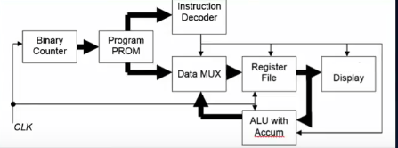

Figure 3.1 CPU Block Diagram

This is the block diagram of a simple 4 bit microprocessor. The processor hold a number of basic pieces. There are two registers of 4 bit each. There is an arithmatic and logic unit, a programmable ROM, a program counter, a decoder which read the instruction from ROM, AND a register(accmulator) after alu,four 2:1 mux,and a decoder in the end to display data on seven segment.

3.3 BRIEF DESCRIPTION OF VARIOUS COMPONENTS OF CPU

ARITHMETIC AND LOGIC UNIT (ALU)
The first VHDL component is the Arithmetic and logic unit or ALU. The ALU is the fundamental building block of the central processing unit of a computer. Depending on how the ALU is designed it can make the CPU more powerful. It performs a number of arithmetic and logical operations such as add and subtract and some logical operations such as AND, OR,NOT,XNOR and XOR .
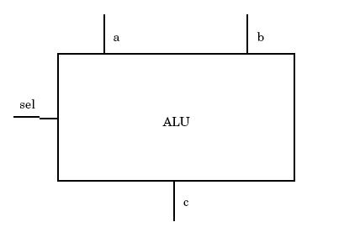

Figure 3.2 ALU Interface

This is the symbol of an ALU. Inputs a and b are the two input busses upon which the ALU opertions are performed. Output bus c returns the result of the ALU operation. Input select (sel.) determines which of the arithmetic or logical operations operation is performed.

Select line | Operation
000 | A+B
001 | A-B
010 | A & B
011 | A | B
100 | A xor B
101 | A xnor B
110 | A !& B
111 | !A

This is the function table of the ALU. Here a and b are the two input and c is the output and input sel to determine which of the arithmetic or logical operations to perform. After a new value for output c is calculated, all of the resulting values are assigned with a 1 nanosecond time delay to eliminate delta delay problems during simulation.

MULTIPLEXERS
This is another component of microprocessor. Here we are using four mux of type 2:1 so we have total 8 inputs. Four from ROM as a input and four from accumulator which store the result of alu so depending upon the instruction given by the ROM it will pass alu result or our input.

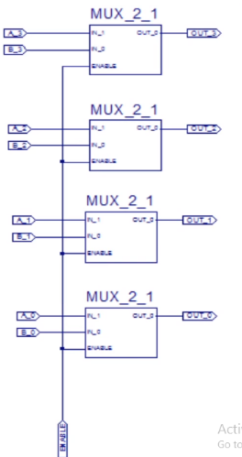

Fig. 3.3 multiplexer

here A’s are inputs from ROM as a input and B’s are inputs from the accumulator so one of them will be passed depending upon the enable. Enable signal will be taken from the insurction decoder. And these outputs O’s will be sent to the register. There are two registers of four bit each.

REGISTERS
Four bit microprocessor contain two four bit shift registers. Here they are sharing the common input from the multiplexer. But at the same clock pulse both will not be active one of them will be enable or both will be disable. Ouput of registers will be sent to the alu or output of second register will be sent to the another decoder for seven segment display. This will be depend on the commond set by our microprocessor

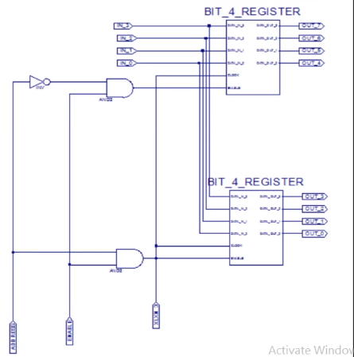

Fig3.4 Registers

Here in the IN’s are the input from multiplexers and add and enable e are the two input from insurction decoder as we can see from the fig.
Both register can not be enable at the same clock pulse so one will store the value at one clock pulse and other at another clock pulse and there is clock common to both. And output of both send to alu and output of second one is send to another decoder for seven segment display. So depending upon the command by our processor desired operation will be performed.

ACCUMULATOR
Accumulator is 4 bit shift register which stores the output of alu. Input of accumulator is output of alu and output of accumulator is connected to the one of the inputs of muxs through four data buses. Clock,reset and enable are the other input to the accumulator.

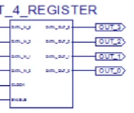
Fig 3.5 Accumulator
Here first upper four lines are input from the alu and 5th line is the enable from the insurction decoder and 6th line is clock. And out’s are the outputs which is connected to the mux’s.when we make accumulator enable its outputs is send to mux. And from mux’s its output to the lower register and from where we can show it to the seven segment display.

SEVEN SEGMENT DISPLAY
Seven segment display the data which is stored on the lowest register It may be output of accumulator or any data which we want to display on the display it consist of decode which take 4 input and 7 outputs and 7 output is lcd display across seven segment.

COUNTER AND ROM
Counter is the first and intial component of our microprocessor we are using 8 bit counter so it can count upto 256. And output o component is fed to the ROM so total 256 value can be passed to the ROM so we can store 256 instruction in our ROM with each count we can perform our instruction.
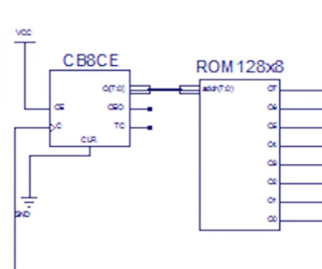
Fig 3.6 counter and rom
Rom is of size 128*8 and upper four output is fed to the instruction decoder and lower four inputs is fed to the mux. And theses are the number on which we are going to perform the operation.

Decoder
Decoder is the instruction interpreter it has four input and we are taking 8 outputs. It takes input from the rom and its output is given to the various component it may be mux’s, registers etc. so it perform the action according to the instruction

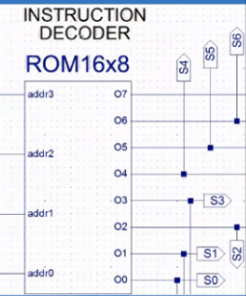
Fig 3.7 instruction decoder

Chapter 4

SIMULATION AND VERIFICATION

4.1 INTRODUCTION
After the programming have done in VHDL, a VHDL simulator is used to verify the functionality of the CPU. The VHDL RTL description of the CPU is simulated with a standard VHDL simulator. Here we have used ModelSimISE simulator

4.2 CPU SIMULATION
Simulating the microprocessor design is different from most other entities because the microprocessor design doesn’t need much outside stimulus. The memory device provides the input data for the processor much as a stimulus file would for other entities. The processor reads its program from the memory device. The processor need only have the clk signal and reset signal stimulated properly, and the processor reads and executes instructions from that point forward.

STEPS FOR SIMULATION
After writing VHDL code (which I have mentioned in appendix) for each component , now processor is simulated.

The complied format is loaded into the simulator, and the simulator is executed. The ise simulator from Model Technology is used for the simulation process.
Here we use ISE simulator for our project. The files are
eightbitcounter.vhd
romnew.vhd
decoder.vhd
muxp.vhd
alup.vhd
registerp.vhd

muxregisterp.vhd

we have placed all these files in the projectsummer.vhd file so to compile these file we have to set top module to the projectsummer file and compile it after compiling this main file we get the resukt as shown

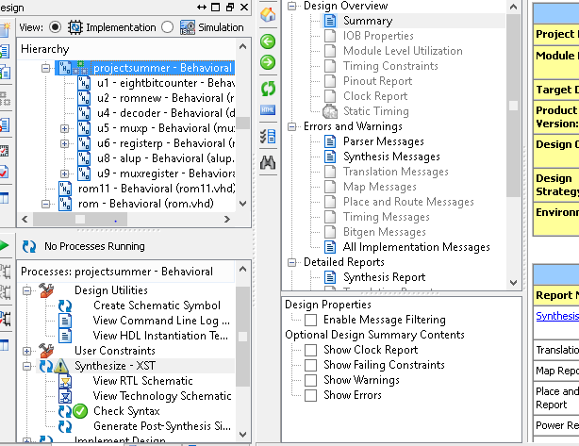

Fig 4.1 imlemention of project

SIMULATION RESULT
After check syntax we simulate the our code and result of our simulation is observed here there is outputs of signal also which is not required for us . here the output of simulation. Here clock and rst Are the inputs and fo is the output of two registers t4 is the decoder output.

.

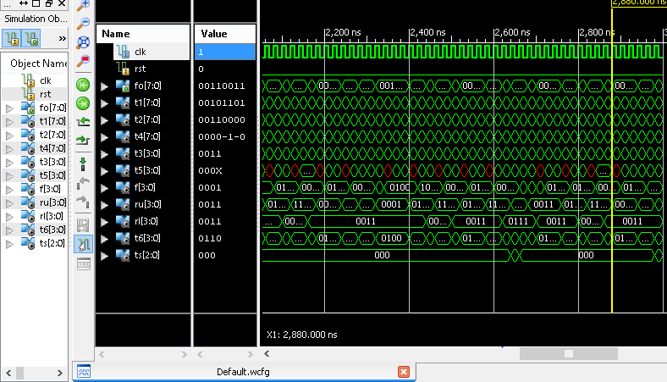

Fig 4.2 simulation result

4.3 RTL SCHEMETIC

RTL is the resistor transfer logic which tells the what will be structure of our program. It is in the part of synthesis. From synthesis we can get the rtlschemetic of our code.

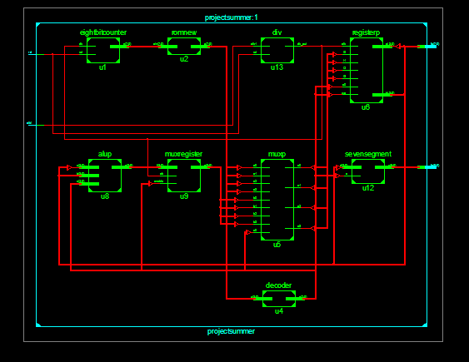

Fig 4.3 RTL Schemetic

4.3 CODE
library IEEE;
use IEEE.STD_LOGIC_1164.ALL;
entityprojectsummer is
Port ( clk1,rst : in STD_LOGIC;
fz :inoutSTD_LOGIC_vector(7 downto 0);
fo :inoutSTD_LOGIC_vector(6 downto 0));
endprojectsummer;
architecture Behavioral of projectsummer is
componenteightbitcounter is
Port ( clk : in STD_LOGIC;
rst : in STD_LOGIC;
q :inoutSTD_LOGIC_vector(7 downto 0));
end component;
componentromnew is
Port ( cin : in STD_LOGIC_vector(7 downto 0);
z :inoutSTD_LOGIC_vector(7 downto 0));
end component;
component decoder is
port(x: in std_logic_vector(3 downto 0);
o: inoutstd_logic_vector(7 downto 0));
end component;
componentmuxp is
Port ( a0,a1,a2,a3,b0,b1,b2,b3,s0 : in STD_LOGIC;
o0,o1,o2,o3: inout STD_LOGIC);
end component;
componentregisterp is
Port ( i0,i1,i2,i3,we,s0,clk: in STD_LOGIC;
a,b : inoutSTD_LOGIC_vector(3 downto 0));
end component;
componentalup is
Port ( a : in STD_LOGIC_vector(3 downto 0);
b : in STD_LOGIC_vector(3 downto 0);

s : in STD_LOGIC_vector(2 downto 0);
z :inoutSTD_LOGIC_vector(3 downto 0));
end component;
componentmuxregister is
port(l: in std_logic_vector(3 downto 0);
clk: in std_logic;
enable: in std_logic;
o: inoutstd_logic_vector(3 downto 0));
end component;
componentsevensegment is
Port ( d : in STD_LOGIC_vector(3 downto 0);
e:in std_logic;
y : out STD_LOGIC_vector(6 downto 0));
end component;
component div is
Port ( clk1,rst : in STD_LOGIC;
clk_out : out STD_LOGIC);
end component;

signal t1,t2,t4:std_logic_vector(7 downto 0);
signal t3,t5,f,ru,rl,t6,t7:std_logic_vector(3 downto 0);
signalts:std_logic_vector(2 downto 0);
signal c:std_logic;
begin

u1:eightbitcounter port map(c,rst,t1);
u2:romnew port map(t1,t2);
u3:t3<=t2(7)&t2(6)&t2(5)&t2(4);
u4:decoder port map(t3,t4);
u5:muxp port map(t2(3),t2(2),t2(1),t2(0),f(3),f(2),f(1),f(0),t4(3),t5(3),t5(2),t5(1),t5(0));
u6:registerp port map(t5(3),t5(2),t5(1),t5(0),t4(0),t4(1),c,ru,rl);
u7:ts<=t4(7)&t4(6)&t4(5);
u8:alup port map(ru,rl,ts,t6);
u9: muxregister port map(t6,c,t4(4),f);
u10:fz<=rl&ru;
u11: t7<=fz(3)&fz(2)&fz(1)&fz(0);
u12:sevensegment port map(t7,t4(2),fo);
u13:div port map(clk1,rst,c);
end Behavioral;

Chapter 5

EDA TOOLS AND FPGA KIT

Electronic design automation (EDA) is a category of software tools for designing electronic systems such as printed circuit boards and integrated circuits. The tools work together in a design flow that chip designers use to design and analyze entire semiconductor chips.
COMMONLY USED EDA TOOLS
- ALTERA
- CADENCE DESIGN SYSTEMS
- XILINX
- UCAMCO
- UPVERTER
- SYNOPSYS
5.1 XILINX 14.7
Xilinx ISE (Integrated Synthesis Environment) is a software tool produced by Xilinx for synthesis and analysis of HDL designs, enabling the developer to synthesize (“compile”) their designs, perform timing analysis, examine RTL diagrams, simulate a design’s reaction to different stimuli, and configure the target device with the programmer.

FIIGURE 5.1 XILINX LOGO
Xilinx ISE is a design environment for FPGA products from Xilinx, and is tightly-coupled to the architecture of such chips, and cannot be used with FPGA products from other vendors. The Xilinx ISE is primarily used for circuit synthesis and design, while ISIM or the ModelSim logic simulator is used for system-level testing. Other components shipped with the Xilinx ISE include the Embedded Development Kit (EDK), a Software Development Kit (SDK) and ChipScope Pro.
5.2 Simulation
System-level testing may be performed with ISIM , and such test programs must also be written in HDL languages. Test bench programs may include simulated input signal waveforms, or monitors which observe and verify the outputs of the device under test.ISIM may be used to perform the following types of simulations:
1.Logical verification, to ensure the module produces expected results.
2.Behavioural verification, to verify logical and timing issues.
3.Post-place & route simulation, to verify behaviour after placement of the module within the reconfigurable logic of the FPGA.
5.3 ISim Key Features:
-Mixed language support
-Supports VHDL-93 and Verilog 2001
-Native support for all HardIP blocks
-PPC, MGT, PCIe, etc.
-No special license requirements
-Supports AXI Bus Functional Model (BFM)
-Multi-Threaded compilation
-Post-Processing capabilities
-Tcl scriptable GUI and batch mode simulation run
-Standalone Waveform viewing capabilities
-Debug capabilities
-Waveform tracing, waveform viewing, HDL source debugging
-Power Analysis and optimization using SAIF
-Memory Editor for viewing and debugging memory elements
-Single click re-compile and re-launch of simulation
-Integrated with ISE Design Suite and PlanAhead application
-Easy to use - One-click compilation and simulation
-Hardware Cosimulation capability
-Offload a design or a portion of the design to hardware
-Accelerate RTL simulation by up to 50x
-Xilinx simulation libraries “built-in”

5.4 Synthesis
Xilinx's patented algorithms for synthesis allow designs to run up to 30% faster than competing programs, and allows greater logic density which reduces project time and costs.Also, due to the increasing complexity of FPGA fabric, including memory blocks and I/O blocks, more complex synthesis algorithms were developed that separate unrelated modules into slices, reducing post-placement errors.IP Cores are offered by Xilinx and other third-party vendors, to implement system-level functions such as digital signal processing (DSP), bus interfaces, networking protocols, image processing, embedded processors, and peripherals. Xilinx has been instrumental in shifting designs from ASIC-based implementation to FPGA-based implementation.
5.5.FPGA
A field-programmable gate array (FPGA) is an integrated circuit designed to be configured by a customer or a designer after manufacturing – hence "field-programmable". The FPGA configuration is generally specified using a hardware description language (HDL), similar to that used for an application-specific integrated circuit (ASIC). (Circuit diagrams were previously used to specify the configuration, as they were for ASICs, but this is increasingly rare.)A Spartan FPGA from XilinxFPGAscontain an array of programmable logic blocks, and a hierarchy of reconfigurable interconnects that allow the blocks to be "wired together", like many logic gates that can be inter-wired in different configurations. Logic blocks can be configured to perform complex combinational functions, or merely simple logic gates like AND and XOR. In most FPGAs, logic blocks also include memory elements, which may be simple flip-flops or more complete blocks of memory.
Introduction
The Spartan®-3 family of Field-Programmable Gate Arrays is specifically designed to meet the needs of high volume, cost-sensitive consumer electronic applications. The eight-member family offers densities ranging from 50,000 to 5,000,000 system gates. The Spartan-3 family builds on the success of the earlier Spartan-IIE family by increasing the amount of logicresources, the capacity of internal RAM, the total number ofI/Os, and the overall level of performance as well as by improving clock management functions. Numerous enhancements derive from the Virtex®-II platform technology. These Spartan-3 FPGA enhancements, combined with advanced process technology, deliver more functionality and bandwidth per dollar than was previously possible, setting new standards in the programmable logicindustry. Because of their exceptionally low cost, Spartan-3 FPGAs are ideally suited to a wide range of consumer electronics applications, including broadband access, home networking, display/projection and digital television equipment.The Spartan-3 family is a superior alternative to mask programmed ASICs. FPGAs avoid the high initial cost, the lengthy development cycles, and the inherent inflexibility of conventional ASICs.Also, FPGA programmability permits design upgrades in the field with no hardware replacementnecessary, an impossibility with ASICs.
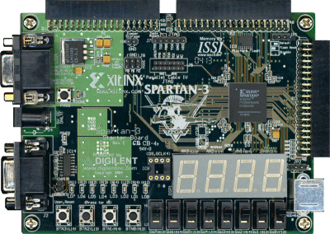
FIGURE 8:SPARTAN 3
Features
• Low-cost, high-performance logic solution for high-volume, consumer-oriented applications
• Densities up to 74,880 logic cells
• SelectIO™ interface signaling
• Up to 633 I/O pins
• 622+ Mb/s data transfer rate per I/O
• 18 single-ended signal standards
• 8 differential I/O standards including LVDS, RSDS
• Termination by Digitally Controlled Impedance
• Signal swing ranging from 1.14V to 3.465V
• Double Data Rate (DDR) support
• DDR, DDR2 SDRAM support up to 333 Mb/s
• Logic resources
• Abundant logic cells with shift register capability
• Wide, fast multiplexers
• Fast look-ahead carry logic
• Dedicated 18 x 18 multipliers
• JTAG logic compatible with IEEE 1149.1/1532
• SelectRAM™ hierarchical memory
• Up to 1,872 Kbits of total block RAM
• Up to 520 Kbits of total distributed RAM
• Digital Clock Manager (up to four DCMs)
• Clock skew elimination
• Frequency synthesis
• High resolution phase shifting
• Eight global clock lines and abundant routing
• Fully supported by Xilinx ISE® and WebPACK™ software development systems
• MicroBlaze™ and PicoBlaze™ processor, PCI®, PCI Express® PIPE Endpoint, and other IP cores
• Pb-free packaging options
• Automotive Spartan-3 XA Family variant
• Common footprints support easy density migration
• Pb-free packaging options

6

16

17

.

33

