DATA 266 Lab 1
Combined Team Report - Team 15
Anshika Goel | Viraat Chaudhary
Repository: https://github.com/99GoelAnshika/data266-lab1-team15

Team ownership statement
Team 15 consists of Anshika Goel and Viraat Chaudhary. For each of the three lab tasks, each member independently trained and evaluated a meaningfully different model configuration while preserving member-scoped code, checkpoints, logs, metrics, and failure/error evidence. Anshika built the five-block pre-layer-normalized character GPT for Task 1, the mean-pool/TextCNN/BiGRU-attention sentiment suite for Task 2, and the nine-block CycleGAN whose final selected checkpoint is epoch 125 for Task 3. Viraat built a four-block post-layer-normalized character GPT for Task 1, an RNN/LSTM/TCN sentiment suite for Task 2, and a six-block resize-convolution CycleGAN for Task 3. Cross-member conclusions in this report are descriptive comparisons of frozen evidence; where preprocessing, hardware, training definitions, or multiple architectural factors differ.

Report organization and evidence policy
- Task 1: character-level GPT-style language modeling from scratch on TinyStories.
- Task 2: Yelp Polarity binary sentiment classification with three from-scratch models per member.
- Task 3: CycleGAN unpaired Monet/photo translation with two generators and two discriminators per member.
- All metrics are reported from committed result artifacts; raw logs are treated as immutable provenance.

Contents
- Task 1 - GPT-style character language modeling
- Task 2 - Yelp Polarity sentiment classification
- Task 3 - CycleGAN image-to-image translation
- Overall conclusions and remaining submission checks
- References

1. Task 1 - GPT-style character language modeling from scratch
Task 1 trains decoder-only autoregressive character language models from scratch on TinyStories. The shared objective is next-character prediction under a causal mask, followed by quantitative evaluation and qualitative generation analysis. The member implementations deliberately differ in normalization placement, depth, width, attention-head count, activation, dropout, output-weight tying, and training batch size, allowing a practical comparison of two compact GPT-style designs without using pretrained weights or prebuilt Transformer blocks.

1.1 Shared data and evaluation protocol
Item | Protocol
Dataset | roneneldan/TinyStories
Frozen revision | f54c09fd23315a6f9c86f9dc80f725de7d8f9c64
Training sequences | 100,000 fixed-length sequences
Validation sequences | 10,000 fixed-length sequences
Context length | 256 characters
Split boundary | Story-record groups split before sequence construction
Vocabulary boundary | Built from training text only
Generation evaluation | Greedy plus temperature sampling; saved continuations and diversity metrics

1.2 Anshika Goel - five-block pre-LN character GPT
Anshika implemented a compact pre-layer-normalized decoder-only Transformer at character granularity. Attention, causal masking, residual connections, normalization, feed-forward layers, and learned positional embeddings are implemented directly rather than delegated to a prebuilt Transformer or multi-head-attention layer. The output projection is tied to the token-embedding matrix, reducing parameters and enforcing a shared input/output representation.
Figure 1. Anshika Task 1 architecture: five pre-LN causal Transformer blocks with tied token/output weights.

Architecture and hyperparameters
Setting | Value
Tokenization / vocabulary | Character / 101
Context length | 256
Model width | 240
Transformer blocks | 5
Attention heads | 6 (40 dimensions/head)
Feed-forward width | 960
Activation | GELU
Normalization | Pre-LayerNorm
Position encoding | Learned embeddings
Dropout | 0.10
Output head | Tied to token embedding
Trainable parameters | 3,557,861
Epochs / batch size | 10 / 32
Optimizer | AdamW
Peak LR / minimum LR | 3e-4 / 3e-5
Warm-up / schedule | 5% / cosine decay
Weight decay | 0.10

Performance and measured metrics
Metric | Value
Training cross-entropy | 0.729267
Validation cross-entropy | 0.693730
Validation perplexity | 2.001166
Bits per character | 1.000841
Generalization gap (val - train) | -0.035537
Validation top-1 next-character accuracy | 78.03%
Distinct-1 / Distinct-2 / Distinct-3 | 0.004370 / 0.039709 / 0.158188
Repeated 4-gram rate | 0.222371
Gradient norm mean / max | 0.767176 / 11.639734
Loss spikes / nonfinite losses | 0 / 0
AMP-skipped nonfinite-gradient updates | 10
Training throughput | 80,067.67 characters/s
Validation throughput | 257,370.58 characters/s
Generation throughput | 518.08 characters/s
Peak GPU allocated / reserved | 1,586.03 / 1,754.00 MB
Total training time | 55.09 minutes

Interpretation: The low validation CE and 78.03% next-character accuracy are the strongest Task 1 quality results in the member comparison. The negative saved gap uses Anshika's epoch-average training-loss convention, so it should not be numerically equated with Viraat's dropout-off full-training-set inference gap.
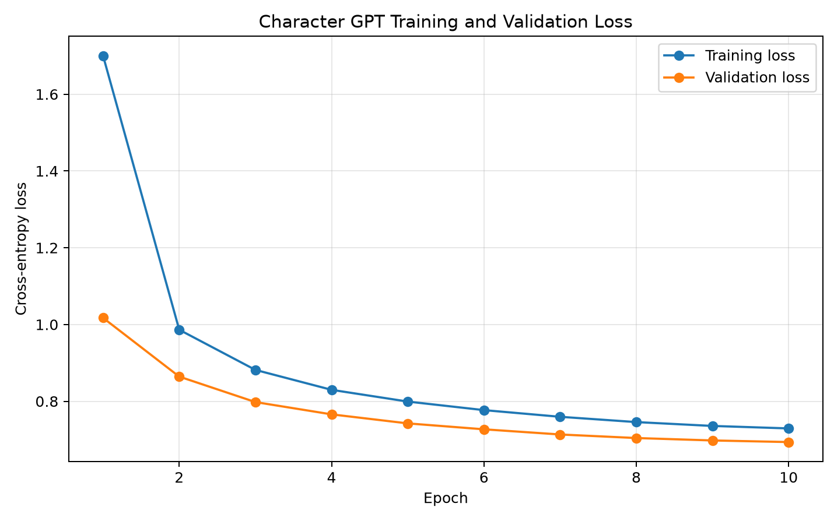
Figure 2. Anshika Task 1 training and validation loss across ten epochs.
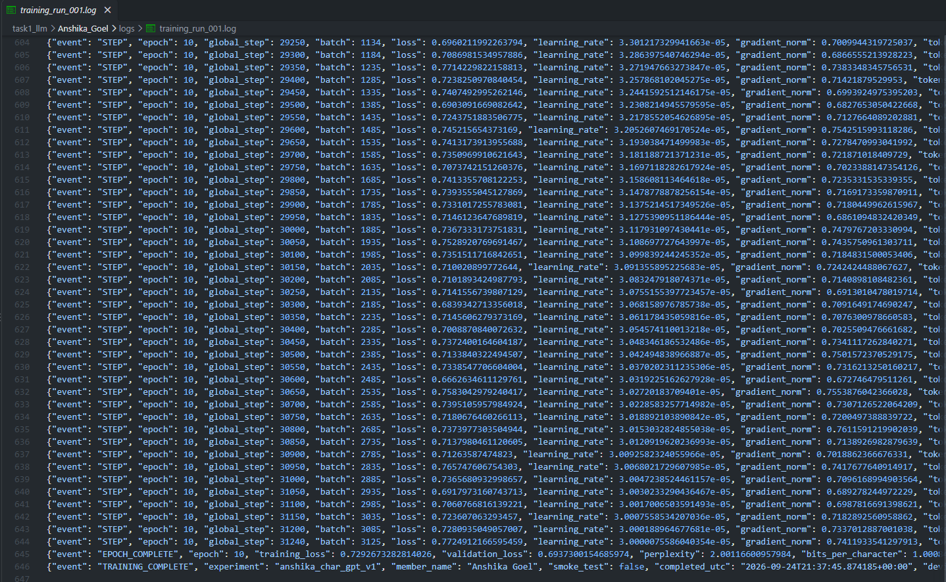
Figure 3. Final training-log evidence.
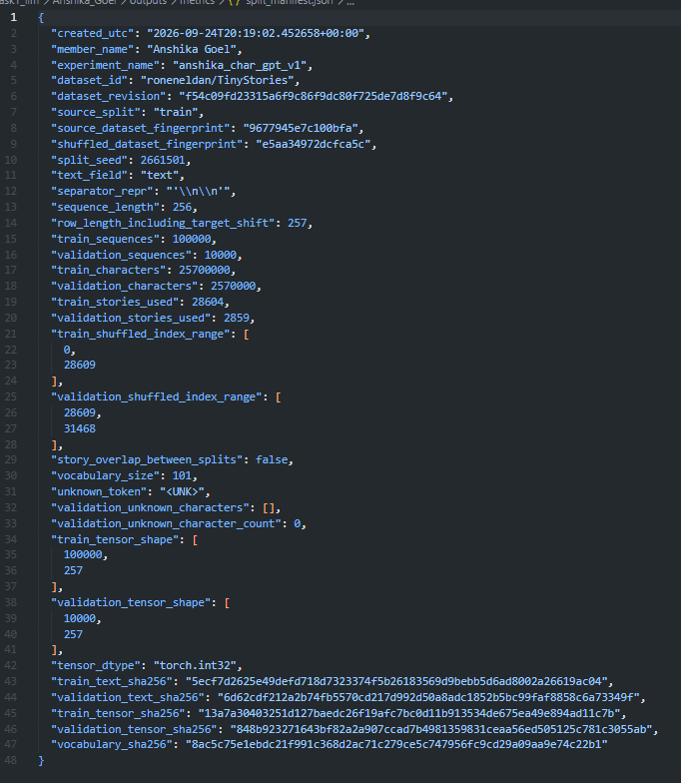
Figure 4. Split and dataset provenance.
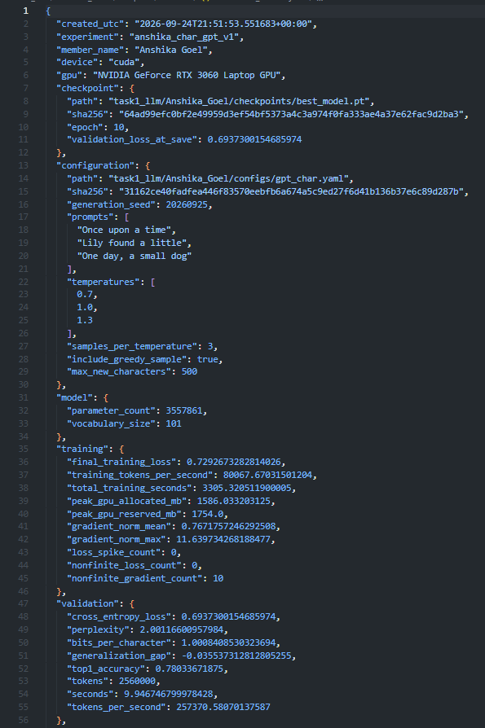
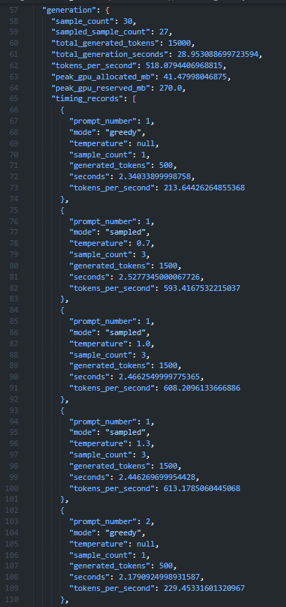
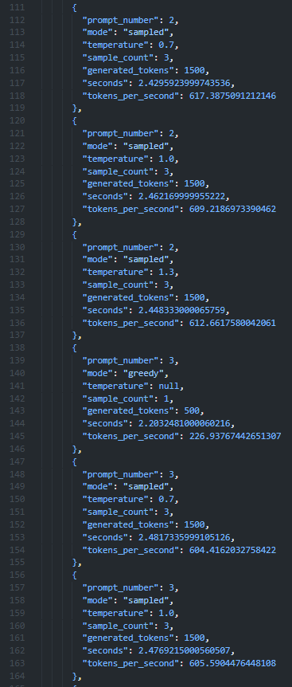
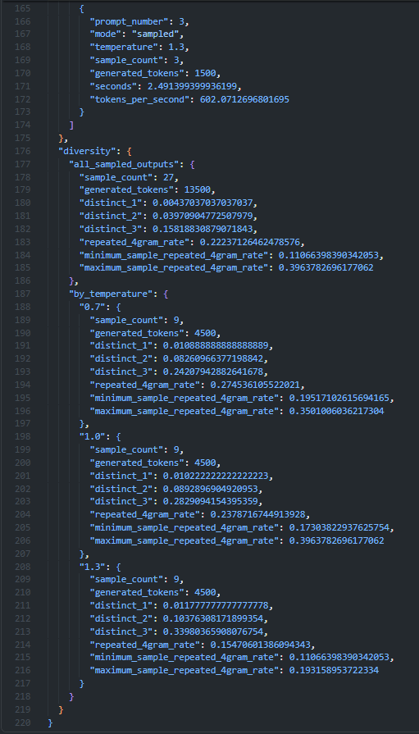
Figure 5. Machine-readable evaluation evidence.

Strengths, weaknesses, limitations, and design rationale
- Strengths: best observed common-validation CE and next-character accuracy; tied output weights; stable ten-epoch optimization; compact 3.56M-parameter scale.
- Weaknesses: greedy generation can collapse into exact repetition; sampled text can repeat words or become grammatically incoherent at higher temperature.
- Limitations: character-level modeling lacks explicit word-level semantics; a 256-character context constrains long-range story planning; diversity metrics do not directly measure narrative coherence.
- Why this design: pre-LN is a stability-oriented Transformer layout, GELU provides a smooth nonlinear feed-forward transform, and weight tying reduces parameters while keeping input/output character representations aligned.

Failure analysis - exact observed cases

Case 1 - Sentence-level repetition loop
sample_001 | greedy | repeated 4-gram rate 0.543260
She said they were going to the park to play with it. She said they were going to the park to play with it. She said they were going to the park to play with it. She said they were going to the park to play with it.
The continuation initially remains plausible but becomes trapped in an exact sentence loop. Greedy decoding offers no randomness or explicit repetition control once a locally probable sequence dominates the recent 256-character context.

Case 2 - Pathological word repetition
sample_005 | temperature 1.0 | repeated 4-gram rate 0.396378
she found a box of blue blue blue blue blue balls. She brought it to the blue blue blue blue blue blue blanket! The blue blue blue blue blue blue, near a tree and carrots.
Repeated emission of the word blue prevents narrative progression even under temperature sampling. A future test could compare an n-gram repetition penalty or unlikelihood objective using the same prompt/seed.

Case 3 - Grammar and semantic coherence breakdown
sample_008 | temperature 1.3 | repeated 4-gram rate 0.171026
The nlight was nothing happened, hugged and ran off for bed. Moral. Joey was so happy to have opened a bowl very year of.
Malformed tokens and broken clause structure make the story difficult to interpret. A controlled temperature comparison can test whether lower sampling temperature improves grammar without increasing repetition.

1.3 Viraat Chaudhary - four-block post-LN character GPT
Viraat implemented a four-block post-layer-normalized character GPT with a wider 256-dimensional state, eight attention heads, ReLU feed-forward activation, and an untied output projection. The design uses explicit tensor-level attention, causal masking, and normalization. It therefore remains from-scratch while providing a materially different architecture from Anshika's pre-LN/GELU/tied-head model.
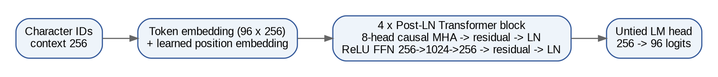
Figure 6. Viraat Task 1 architecture: four post-LN causal Transformer blocks with an untied language-model head.

Architecture and hyperparameters
Setting | Value
Tokenization / vocabulary | Character / 96
Context length | 256
Model width | 256
Transformer blocks | 4
Attention heads | 8
Feed-forward width | 1024
Activation | ReLU
Normalization | Post-LayerNorm
Dropout | 0.15
Output head | Untied
Trainable parameters | 3,273,824
Epochs / batch size | 10 / 64
Optimizer | AdamW
Peak LR / minimum LR | 3e-4 / 3e-5
Warm-up / schedule | 10% / cosine decay
Precision | BF16

Performance and measured metrics
Metric | Value
Training CE, selected checkpoint FP32/dropout off | 0.85758417
Final-epoch online training CE | 0.93269972
Validation CE, FP32/dropout off | 0.86370217
Validation perplexity | 2.3719257
Bits per character | 1.2460588
Generalization gap | 0.0061180
Validation top-1 next-character accuracy | 72.7812%
Distinct-1 / Distinct-2 / Distinct-3 | 0.004593 / 0.042158 / 0.166592
Repeated 4-gram rate, sampled outputs | 0.174678
Gradient norm mean / max | 0.624755 / 3.309997
Loss spikes / nonfinite loss / nonfinite grad | 0 / 0 / 0
Training throughput | 590,870.73 target characters/s
Generation throughput | 696.01 characters/s
Peak GPU allocated / reserved | 1,758.95 / 2,034 MiB
Total training time | 451.62 s (7.53 min)
Hardware | NVIDIA A100-SXM4-40GB

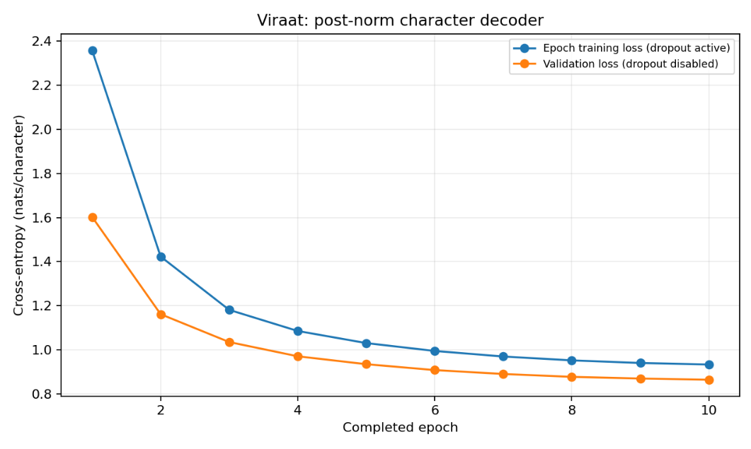
Figure 7. Viraat Task 1 training and validation loss across ten epochs.
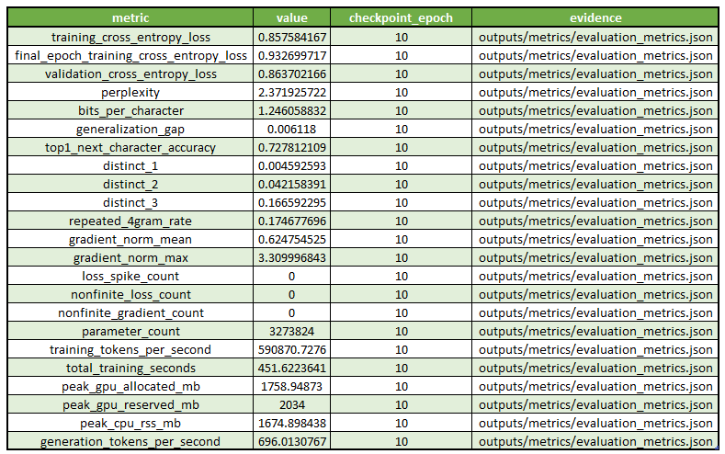
Figure 8. Viraat Task 1 full metric table.

Strengths, weaknesses, limitations, and design rationale
- Strengths: substantially faster recorded training and generation throughput; slightly smaller parameter count; lower sampled repeated-4-gram rate than Anshika.
- Weaknesses: higher common CE and lower next-character accuracy; greedy output still shows severe repetition; sampled output can switch character identity and create malformed words.
- Limitations: the post-LN/ReLU/untied design differs in several factors simultaneously, so quality differences cannot be attributed to one architectural choice; character-level context remains limited to 256 characters.
- Why this design: fewer blocks with greater width and eight heads trade depth for parallel representation capacity, while the untied head provides a separate learned output mapping. BF16 and batch 64 prioritize training efficiency.

Failure analysis - exact observed cases

Case 1 - Repetitive generation loop
sample_001 | greedy | full greedy repeated 4-gram rate 0.748491
You are very sad. You are a good friend. You are very sad. You are a good friend. You are very sad. You are a good friend.
The same sentence pair repeats without developing the story. The aggregate 0.174678 repeated-4-gram metric applies to the 27 sampled continuations and excludes greedy output, so this greedy-case rate must be interpreted separately.

Case 2 - Unexplained character-name change
sample_006 | temperature 1.0
, there was a little girl called Jelie, "Zoomp! I love you. Thank you, Grandma!" Lily said.
The continuation introduces Jelie and immediately attributes speech to Lily without establishing Lily as another character. A controlled continuation-consistency test would be needed to evaluate whether further training improves name stability.

Case 3 - Malformed words and grammar
sample_018 | temperature 1.3
Lily noticed down the tib legs. She splashed the stame. She's notice and kicked some chone flowersh.
Nonstandard forms such as stame, chone, and flowersh plus malformed grammar reduce readability. A matched-seed temperature study can test readability/repetition tradeoffs.

1.4 Task 1 team comparison
Property / metric | Anshika | Viraat
Architecture | 5-block pre-LN, d=240, 6 heads, GELU, tied head | 4-block post-LN, d=256, 8 heads, ReLU, untied head
Parameters | 3,557,861 | 3,273,824
Validation CE | 0.693730 | 0.863702
Validation top-1 accuracy | 78.03% | 72.7812%
Perplexity | 2.001166 | 2.371926
Sampled repeated 4-gram rate | 0.222371 | 0.174678
Training throughput | 80,067.67 chars/s | 590,870.73 chars/s
Training time | 55.09 min | 7.53 min
Generation throughput | 518.08 chars/s | 696.01 chars/s

Common held-out metric | Anshika | Viraat
Common validation CE | 0.69440728 | 0.86098925
Common next-character accuracy | 78.1023% | 72.9764%

Interpretation: Under the shared held-out comparison, Anshika is the stronger quality model because it achieves lower CE and higher next-character accuracy. Viraat is the stronger efficiency model because it trains much faster, uses slightly fewer parameters, and generates faster. Because normalization, depth, width, heads, activation, dropout, weight tying, batch size, precision, and split seed differ together, the comparison supports a practical model choice rather than a causal architectural ablation.
Figure 9. Common-validation comparison evidence.
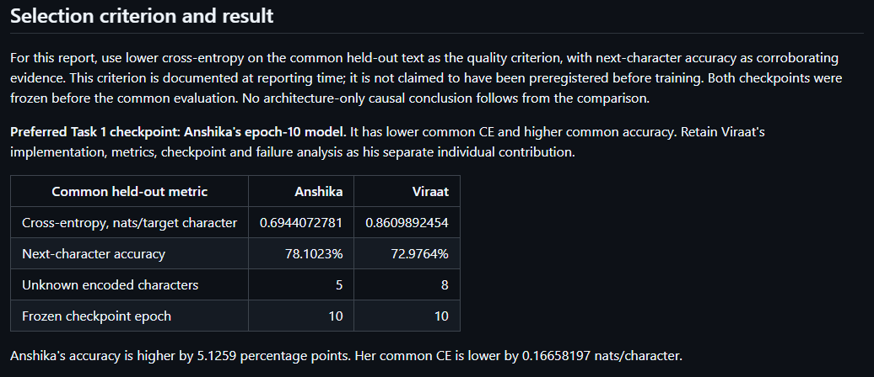
Figure 10. Team selection rationale.
1.4.1 Complete Task 1 team comparison matrix
The matrix below consolidates the architecture, hyperparameters, and every required Task 1 evaluation metric already reported in Sections 1.2-1.4. Training-CE conventions differ: Anshika reports the epoch-average training CE, while Viraat also preserves a selected-checkpoint FP32/dropout-off CE; those values are therefore shown with their original definitions rather than treated as directly interchangeable.
Property / metric | Anshika | Viraat
Architecture | 5-block pre-LN decoder-only GPT; d=240; 6 heads; GELU; tied LM head | 4-block post-LN decoder-only GPT; d=256; 8 heads; ReLU; untied LM head
Vocabulary / context | 101 characters / 256 | 96 characters / 256
Feed-forward width | 960 | 1024
Dropout | 0.10 | 0.15
Epochs / batch | 10 / 32 | 10 / 64
Optimizer | AdamW | AdamW
Peak LR / minimum LR | 3e-4 / 3e-5 | 3e-4 / 3e-5
Warm-up / schedule | 5% / cosine decay | 10% / cosine decay
Precision | FP32 training path reported | BF16
Parameters | 3,557,861 | 3,273,824
Training CE (reported convention) | 0.729267 (epoch-average) | 0.85758417 (selected checkpoint FP32/dropout off); 0.93269972 final-epoch online
Validation CE | 0.693730 | 0.86370217
Perplexity | 2.001166 | 2.3719257
Bits per character | 1.000841 | 1.2460588
Generalization gap | -0.035537 | 0.0061180
Top-1 next-character accuracy | 78.03% | 72.7812%
Distinct-1 / 2 / 3 | 0.004370 / 0.039709 / 0.158188 | 0.004593 / 0.042158 / 0.166592
Repeated 4-gram rate | 0.222371 | 0.174678
Gradient norm mean / max | 0.767176 / 11.639734 | 0.624755 / 3.309997
Stability events | Loss spikes 0; nonfinite losses 0; AMP-skipped nonfinite-gradient updates 10 | Loss spikes 0; nonfinite loss 0; nonfinite grad 0
Training throughput | 80,067.67 chars/s | 590,870.73 target chars/s
Generation throughput | 518.08 chars/s | 696.01 chars/s
Peak GPU allocated / reserved | 1,586.03 / 1,754.00 MB | 1,758.95 / 2,034 MiB
Total training time | 55.09 min | 451.62 s (7.53 min)
Common held-out CE | 0.69440728 | 0.86098925
Common held-out next-char accuracy | 78.1023% | 72.9764%

1.4.2 What we would try next
- Run a controlled one-factor-at-a-time ablation on the same frozen 100,000/10,000 sequence protocol: match width, batch size, precision, learning-rate schedule and context length, then vary pre-LN versus post-LN, GELU versus ReLU, and tied versus untied output weights separately. This is needed because Anshika wins the common held-out comparison (CE 0.69440728; accuracy 78.1023%) while Viraat is much faster (590,870.73 vs 80,067.67 chars/s), but several design factors currently change together.
- Repeat the existing generation protocol with matched prompts/seeds across greedy and sampled decoding and evaluate repeated 4-gram rate together with malformed-word/name-consistency failures. Viraat has the lower sampled repeated-4-gram rate (0.174678 vs 0.222371), yet its greedy failure reaches 0.748491 on sample_001; Anshika also shows grammar/coherence failures at higher temperature, so the next experiment should quantify the quality-repetition trade-off rather than rely on isolated samples.

2. Task 2 - Yelp Polarity sentiment classification
Task 2 evaluates from-scratch neural text classifiers on Yelp Polarity. Each member trained a baseline plus two meaningfully different experimental models without pretrained embeddings or pretrained language models. Model selection was performed on validation data before official-test evaluation. The final report emphasizes not only accuracy and macro-F1 but also ranking quality, calibration, robustness slices, statistical confidence, efficiency, and a frozen 20-error qualitative review.

2.1 Shared task protocol
Item | Value
Dataset | fancyzhx/yelp_polarity
Official train / test | 560,000 / 38,000
Frozen train / validation | 504,000 / 56,000
Maximum sequence length | 256 tokens
Training vocabulary | 50,000 tokens
Decision threshold | 0.50
Official-test boundary | Test accessed only after checkpoints/model choices were frozen
Required manual review | 20 errors: 5 confident FP, 5 confident FN, 5 near-threshold, 5 slice-specific

2.1.1 Exploratory data analysis summary
The raw-data audit was run on the pinned Yelp Polarity revision before model training. The official train and test splits are exactly balanced, contain no missing/malformed-label rows, and show no exact stripped-text overlap across splits. Negative reviews are materially longer than positive reviews, which is relevant to the fixed 256-token input boundary used by both members.
EDA metric | Official train |  | Official test
Official split size | 560,000 |  | 38,000
Negative / positive | 280,000 / 280,000 |  | 19,000 / 19,000
Positive fraction | 50.00% |  | 50.00%
Null / non-string / blank text | 0 / 0 / 0 |  | 0 / 0 / 0
Invalid labels / duplicate rows | 0 / 0 |  | 0 / 0
Raw words: mean / median | 136.21 / 99 |  | 135.75 / 99
Raw words: p95 / p99 / max | 382 / 625 / 1046 |  | 377 / 617 / 1005
Negative mean raw words | 154.92 |  | 154.77
Positive mean raw words | 117.51 |  | 116.73
Processed-data metric |  | Recorded value
Frozen train / validation / test |  | 504,000 / 56,000 / 38,000
Vocabulary / max sequence length |  | 50,000 / 256 tokens
Processed train length mean / median / p95 / p99 |  | 66.15 / 48 / 185 / 302
Train truncated |  | 8,983 (1.782%)
Validation truncated |  | 949 (1.695%)
Test truncated |  | 651 (1.713%)
Empty after preprocessing (train / val / test) |  | 37 / 3 / 1
OOV fraction before truncation (train / val / test) |  | 0.459% / 0.566% / 0.543%
Cross-split exact-text digest overlap |  | 0

2.2 Anshika Goel - Mean Pool, TextCNN, and BiGRU-Attention
Anshika used a shared learned 128-dimensional word embedding and compared three representations of increasing contextual capacity. The baseline discards token order through masked mean pooling, TextCNN captures local n-gram patterns through three convolution widths, and BiGRU-Attention models bidirectional sequential context before learning a weighted document representation.
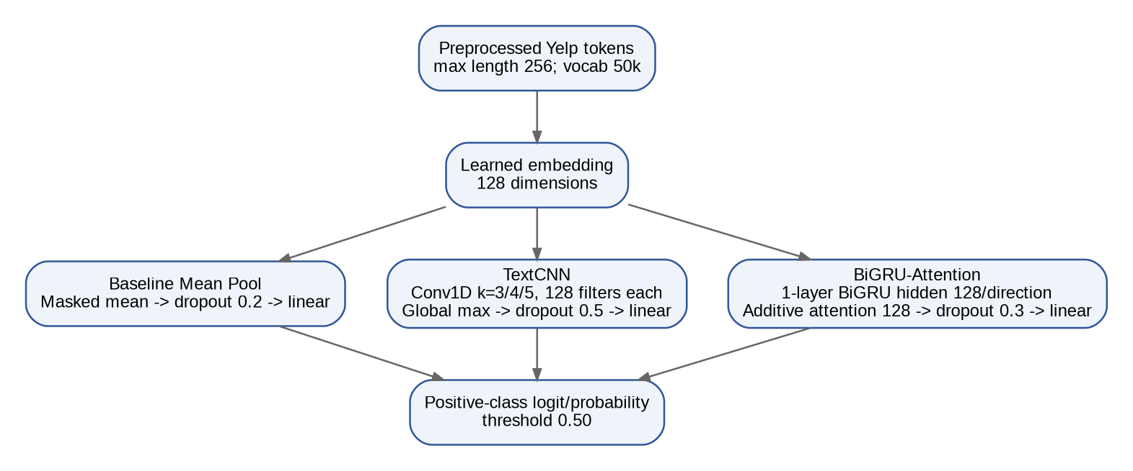
Figure 11. Anshika Task 2 model lineup: mean pooling, multikernel TextCNN, and BiGRU with additive attention.

Preprocessing and shared training controls
- Lowercase, normalize HTML/whitespace, expand negation contractions, remove punctuation and special characters, remove stopwords while preserving no/nor/not/never, apply Porter stemming, and tokenize with regex word tokens.
- Training seed 20260924; AMP enabled; gradient clip norm 1.0; 5% warm-up; minimum LR 1e-5; early-stopping patience 2; fixed decision threshold 0.50.

Model | Architecture | Dropout | Batch | Max epochs | LR | Parameters
Mean Pool | Embedding 128 -> masked mean -> linear | 0.20 | 512 | 5 | 0.001 | 6,400,129
TextCNN | Embedding 128 -> Conv k=3/4/5 (128 each) -> global max -> linear | 0.50 | 256 | 5 | 0.001 | 6,597,377
BiGRU-Attention | Embedding 128 -> 1-layer BiGRU h=128/dir -> additive attention 128 -> linear | 0.30 | 128 | 5 | 0.0005 | 6,631,425

Final official-test classification metrics
Model | Accuracy | Macro-F1 | MCC | ROC-AUC | PR-AUC | Brier | ECE
Mean Pool | 0.929474 | 0.929474 | 0.858947 | 0.977648 | 0.977576 | 0.053777 | 0.008339
TextCNN | 0.941737 | 0.941736 | 0.883491 | 0.985671 | 0.986079 | 0.044814 | 0.017341
BiGRU-Attn | 0.944868 | 0.944864 | 0.889869 | 0.988415 | 0.988652 | 0.040506 | 0.007061

Model | Confusion matrix [[TN,FP],[FN,TP]] | Training s | Mean train ex/s | Peak GPU alloc MB | Final-test ex/s
Mean Pool | [[17661,1339],[1341,17659]] | 72.678 | 36,636.53 | 269.09 | 37,655.44
TextCNN | [[17833,1167],[1047,17953]] | 358.845 | 7,310.55 | 308.88 | 15,632.27
BiGRU-Attn | [[17789,1211],[884,18116]] | 1545.914 | 1,401.12 | 223.45 | 6,407.57

Interpretation: BiGRU-Attention has the best observed accuracy, macro-F1, MCC, ROC-AUC, PR-AUC, Brier score, and ECE among Anshika's three models, but it is dramatically slower than the mean-pool baseline and TextCNN. TextCNN provides a middle ground: a sizable accuracy gain over mean pooling at much lower cost than BiGRU-Attention.
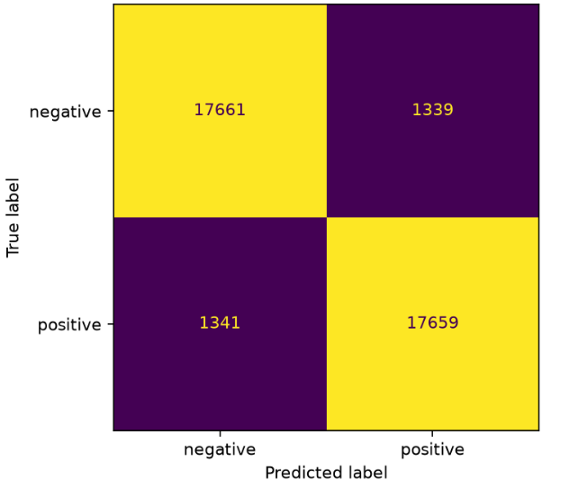
Figure 12. Anshika Mean Pool official-test confusion matrix.
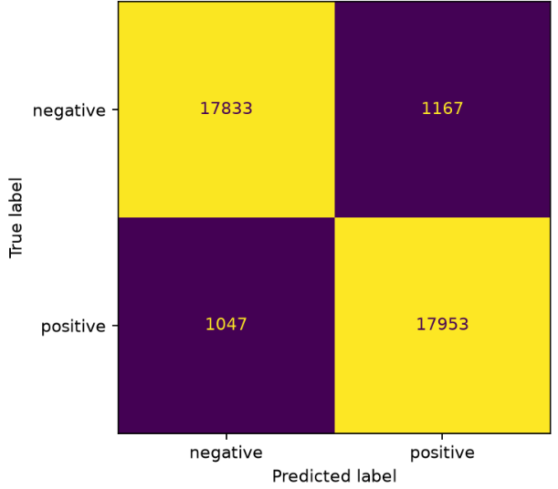
Figure 13. Anshika TextCNN official-test confusion matrix.
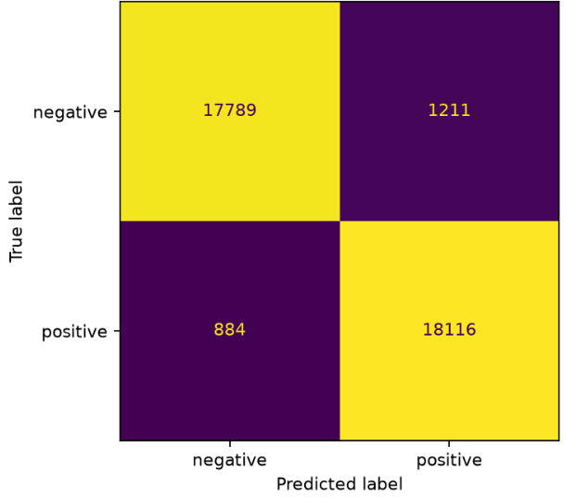
Figure 14. Anshika BiGRU-Attention official-test confusion matrix.
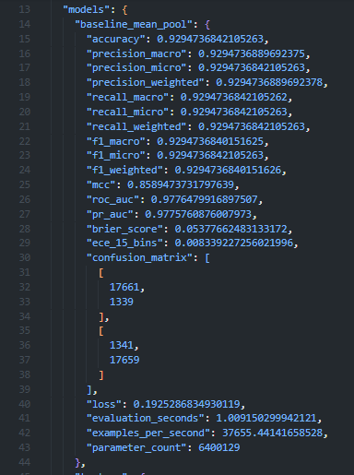
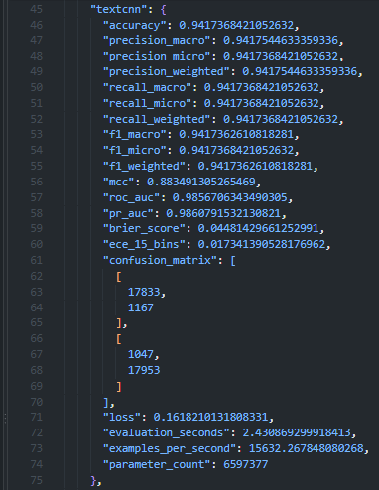
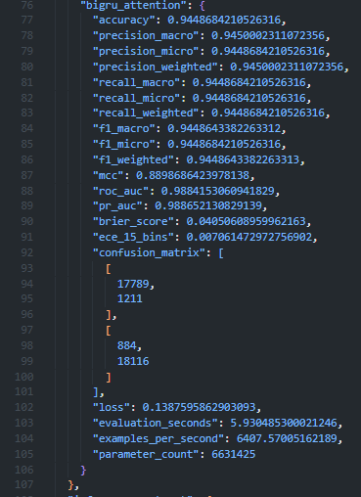
Figure 15. Final official-test metric record.
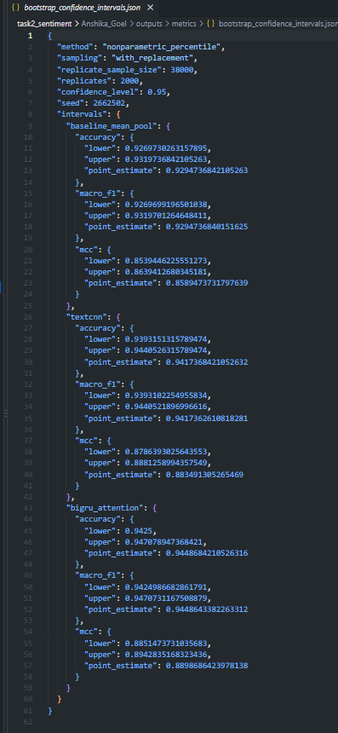
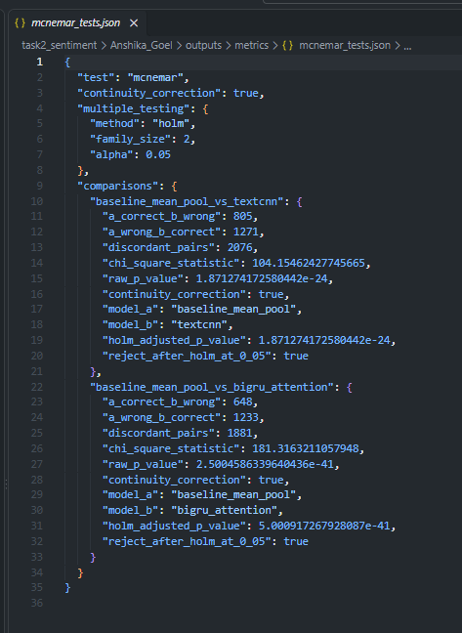
Figure 16. Bootstrap and paired-test evidence

Strengths, weaknesses, limitations, and design rationale
- Mean Pool is fastest and easiest to interpret, but it discards word order and interaction structure.
- TextCNN efficiently captures short local phrases and improves accuracy substantially, but global max pooling can overemphasize isolated phrases and miss long discourse reversals.
- BiGRU-Attention has the strongest observed classification and calibration metrics, but recurrent computation makes it by far the slowest model in Anshika's suite.
- The 256-token limit is a concrete representation limitation for long reviews; preprocessing can also remove punctuation/discourse cues relevant to sarcasm and mixed sentiment.
- The three-model progression was chosen to compare order-independent lexical aggregation, local n-gram modeling, and full bidirectional sequence modeling under the same dataset/evaluation protocol.

Failure/error analysis - 20 frozen official-test errors
The focal model is BiGRU-Attention. The review IDs were frozen before raw review text was accessed. The 20 cases are exactly balanced across four required categories. The following compact table preserves each frozen case identity and a verbatim excerpt from the committed failure-analysis table; ellipses already present in the source artifact remain ellipses. Full raw review text is preserved separately in the snapshot artifact.

# | Category | Row | True -> Pred | P+ | Error type | Verbatim source excerpt
1 | confident false positive | 29330 | negative -> positive | 1.000000 | Possible label-text disagreement | Wow love the place and everything is very clean and new! Great place to come and relax worth a try! Cheers, Eric Van Nguyen Visited April 2012
2 | confident false positive | 14825 | negative -> positive | 0.998535 | Sarcasm / pragmatic polarity | Do you believe in Yin and Yang? The ancient Asian philosophy suggesting polar opposites are interrelated? If you don't, then you best start believi...
3 | confident false positive | 21331 | negative -> positive | 0.998047 | Sentiment scope / entity confusion | This place is only awesome if you are one of three things: 1. an Ohio State fan, 2. a metrosexual, or 3. someone trying to hook up with an Ohio Sta...
4 | confident false positive | 5752 | negative -> positive | 0.997559 | Temporal update / review-history conflict | NOTE: This was a 4-star review, but the food quality and ESPECIALLY customer service have gone down the tubes. See update below. Complaining I can'...
5 | confident false positive | 8426 | negative -> positive | 0.997559 | Mixed-aspect sentiment | Saturday / Sunday AYCE brunch In true las vegas fashion, you get a flat rate to eat your heart out. For Strip food, main menu items seem reasonably...
6 | confident false negative | 22807 | positive -> negative | 0.000229 | Temporal update / possible label-text disagreement | EDIT: They really did change the service up since I last posted this. Horrible service. Used to be my favorite pizza in the city (at a reasonable p...
7 | confident false negative | 30793 | positive -> negative | 0.000782 | Temporal reversal / contrast | This place is so much better since they changed owners. My wife and I went when it was the old owners, it was terrible. We waited forever and the f...
8 | confident false negative | 30958 | positive -> negative | 0.001561 | Long complaint with positive final resolution | Look, we all know Cox sucks. In fact they are a terrible business and their practices are laughable. However they are a necessary evil if you want ...
9 | confident false negative | 22451 | positive -> negative | 0.001782 | Aspect conflict / overall-rating mismatch | The food is crap. I'm not trying to be mean, but it really is horrible. I'd rather eat one of those Tornado things from Circle K for dinner. Also, ...
10 | confident false negative | 25329 | positive -> negative | 0.002132 | Compositional stance with negative lexical density | Im with Kimberly B...this is a card for people rebuilding credit. Mine got tanked due to a divorce. I have been rebuilding, and started with a $300...
11 | near threshold error | 12415 | negative -> positive | 0.500000 | Mixed sentiment / threshold uncertainty | My friends and I were in the mood for some cheap sushi..and since I was with 5 guy friends, I was not surprised they chose an all-you-can-eat place...
12 | near threshold error | 16620 | negative -> positive | 0.500000 | Informal ambivalence / lexical variation | blush is a cool place to hang out.. idk if it's a lounge. felt like it.. but with a club crowd? there's not enough places to chill and a million pp...
13 | near threshold error | 31278 | negative -> positive | 0.500000 | Short-context pragmatic criticism | How hard is it to get a 2 donut order right?? One chocolate glazed and one strawberry glazed donut. That's IT. Apparently pretty hard.
14 | near threshold error | 37323 | negative -> positive | 0.500000 | Mild mixed sentiment / aspect balance | They have a good space but I don't think their using it wisely... The food is okay for a bar but my martini was very good. Adding a bit more seatin...
15 | near threshold error | 18639 | positive -> negative | 0.499756 | Extremely short positive context | You really need a whole day to see this centre. The gardens are spectacular, as are the views.
16 | slice specific error | 12480 | negative -> positive | 0.997070 | Short-review ambiguity / possible label-text disagreement | my husband had an omelette that was good. i had a blt, a little on the small side for $10, but bacon was great. Our server was awesome!
17 | slice specific error | 20203 | negative -> positive | 0.997559 | Contrast with misleading positive cues | Not all that. This joint has some of the best reviews short of Joel Robuchon but the fact is it's not much more than a glorified protein-buffet. Th...
18 | slice specific error | 6611 | positive -> negative | 0.003111 | Negative lexical density with positive final stance | Harlow's gives me diarrhea. Every time. Every single time. You know what, though? I don't care because Harlow's cuts my hangover directly in half a...
19 | slice specific error | 37771 | negative -> positive | 0.997559 | Negation / location-specific reversal | I have to say I love cafe rio! Their food is simple yet delicious, the service is great as well as consistent, and my appetite and tummy are always...
20 | slice specific error | 26587 | negative -> positive | 0.990723 | Sequence truncation with late decisive evidence | On the whole, this restaurant does give a new patron a great slice of European cuisine and it is worth noting that if you've never been here before...

Representative exact text and interpretation
Wow love the place and everything is very clean and new! Great place to come and relax worth a try! Cheers, Eric Van Nguyen Visited April 2012
Confident false positive, source row 29330, P(positive)=1.000000. The visible text is strongly positive despite the frozen negative label, so this is documented as a possible label-text disagreement rather than automatically re-labeled.
This place is so much better since they changed owners. My wife and I went when it was the old owners, it was terrible. We waited forever and the food never came before we walked out...
Confident false negative, source row 30793. The review begins with positive current sentiment but contains a strongly negative historical narrative, illustrating temporal reversal and discourse weighting.
How hard is it to get a 2 donut order right?? One chocolate glazed and one strawberry glazed donut. That's IT. Apparently pretty hard.
Near-threshold negative review, source row 31278, where very short context and pragmatic criticism provide a difficult signal around the fixed 0.50 threshold.
Harlow's gives me diarrhea. Every time. Every single time. You know what, though? I don't care because Harlow's cuts my hangover directly in half and I feel twice as good when I leave...
Slice-specific false negative, source row 6611. Dense negative lexical content coexists with an ultimately positive stance, a recurring failure pattern in the frozen review.

2.3 Viraat Chaudhary - RNN, LSTM, and residual causal TCN
Viraat compared three sequence-model families with a common 128-dimensional learned embedding and masked mean-plus-maximum pooling. The baseline is a vanilla RNN, experiment 1 is an LSTM, and experiment 2 is a residual causal temporal convolutional network with exponentially increasing dilations. This contrasts recurrent memory gating against a parallel convolutional receptive field while holding many training settings fixed.
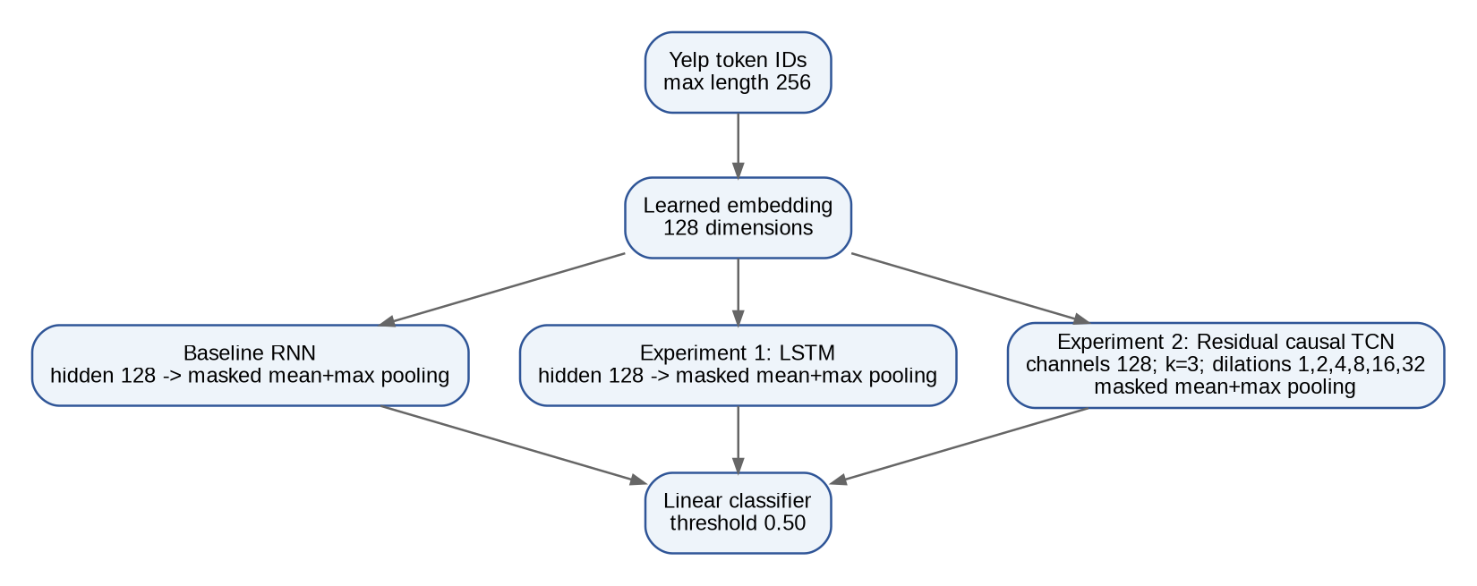
Figure 17. Viraat Task 2 lineup: RNN baseline, LSTM, and residual causal TCN.

Hyperparameters
Setting | RNN | LSTM | TCN
Embedding / hidden | 128 / 128 | 128 / 128 | 128 / 128 channels
Embedding dropout / dropout | 0.10 / 0.25 | 0.10 / 0.25 | 0.10 / 0.25
Batch / max epochs | 512 / 5 | 512 / 5 | 512 / 5
Learning rate / weight decay | 0.001 / 0.0001 | 0.001 / 0.0001 | 0.001 / 0.0001
Gradient clip / patience | 1.0 / 2 | 1.0 / 2 | 1.0 / 2
Special architecture | Vanilla RNN | LSTM gates | k=3; dilations 1,2,4,8,16,32
Parameters | 6,450,049 | 6,549,121 | 7,027,969

Final official-test performance
Model | Accuracy | Macro-F1 | MCC | ROC-AUC | PR-AUC | Brier | ECE
RNN | 0.942658 | 0.942657 | 0.885343 | 0.986512 | 0.986900 | 0.042879 | 0.002350
LSTM | 0.948474 | 0.948472 | 0.897019 | 0.989121 | 0.989355 | 0.038735 | 0.008854
TCN | 0.948026 | 0.948021 | 0.896242 | 0.989122 | 0.989492 | 0.039448 | 0.011682

Model | TN | FP | FN | TP | Train s | Train ex/s | Peak CUDA MiB
RNN | 17836 | 1164 | 1015 | 17985 | 46.984 | 58,008 | 581.15
LSTM | 18141 | 859 | 1099 | 17901 | 57.146 | 48,179 | 712.03
TCN | 18208 | 792 | 1183 | 17817 | 280.528 | 9,414 | 2,738.23

Interpretation: LSTM has the highest observed accuracy, macro-F1, and MCC and offers the strongest accuracy/time balance in Viraat's suite. TCN is nearly tied in accuracy and has marginally higher ROC-AUC/average precision plus the best long-review macro-F1, but it costs roughly 4.9x the LSTM training time and much more GPU memory. RNN has the lowest ECE and the highest speed.
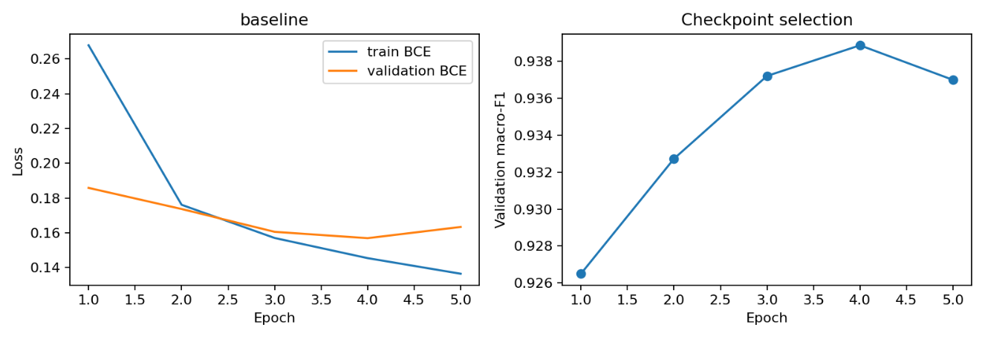
Figure 18. RNN training curves.
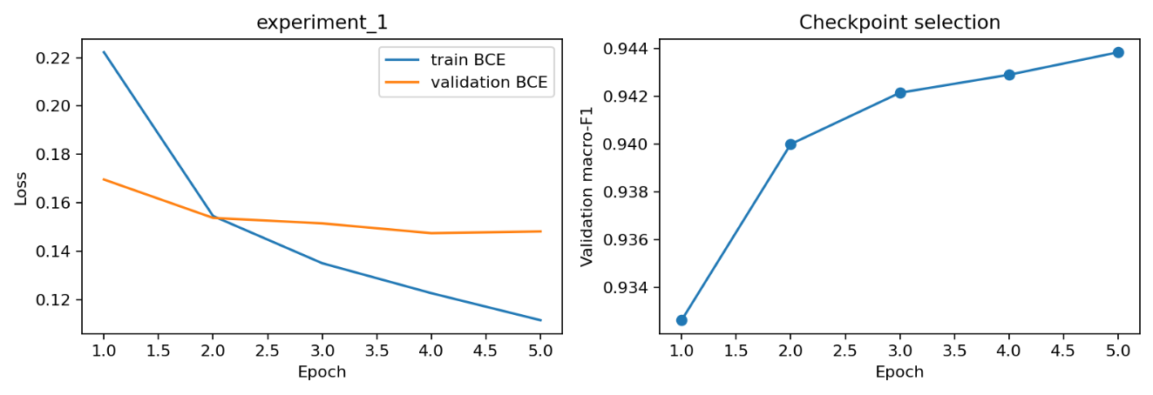
Figure 19. LSTM training curves.
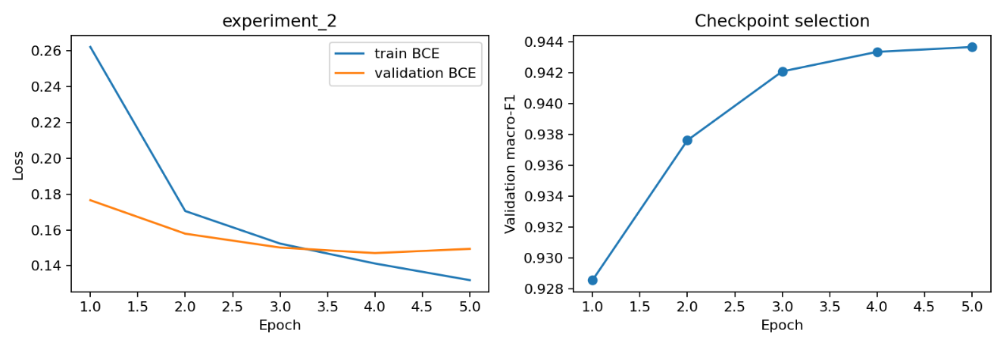
Figure 20. TCN training curves.
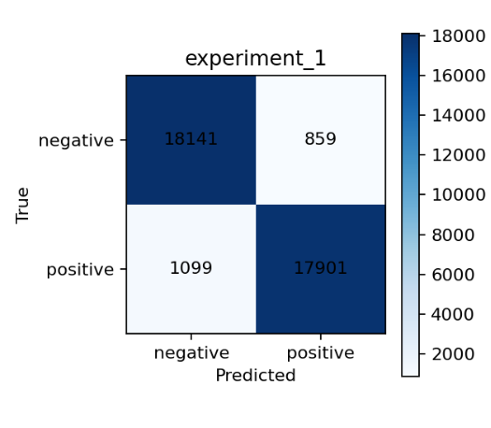
Figure 21. LSTM confusion matrix.
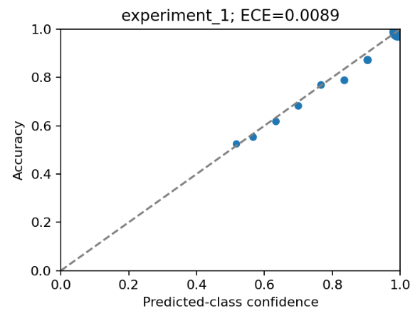
Figure 22. Viraat LSTM reliability diagram.
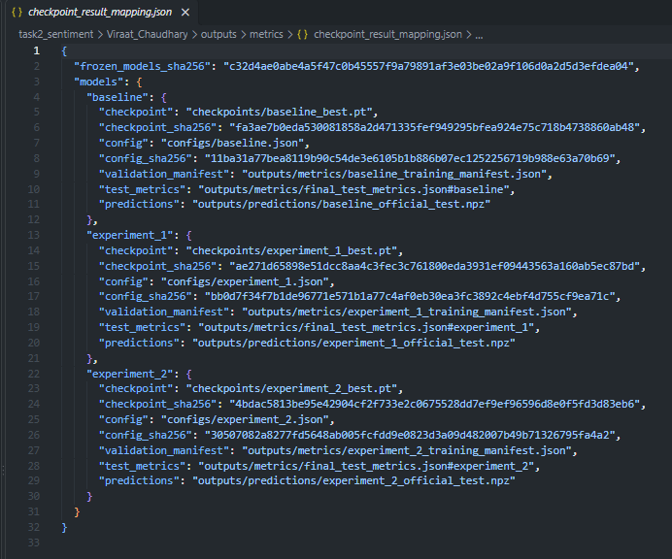
Figure 23. Checkpoint-to-result provenance.
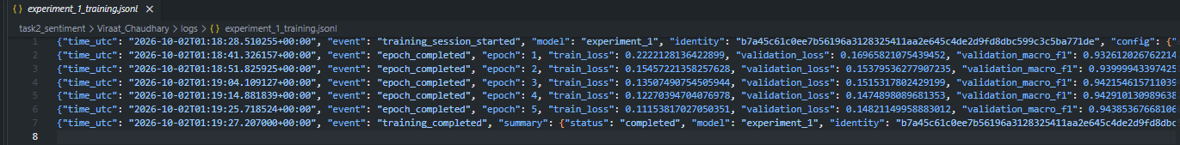
Figure 24. LSTM raw training log.

Strengths, weaknesses, limitations, and design rationale
- RNN provides a fast recurrent baseline with strong calibration but lower classification quality than LSTM/TCN.
- LSTM gates improve long-range sequential modeling with only a modest runtime increase over RNN, producing the strongest overall observed Task 2 score.
- TCN offers parallel dilated context and the strongest long-review slice result, but its compute/memory cost is much higher in this implementation.
- All three are single-seed, five-epoch runs; parameter counts differ and no LSTM-vs-TCN significance test was reported, so the small 0.0447-point accuracy gap does not prove superiority.
- The same 256-token limit, preprocessing choices, high-OOV slice difficulty, and mixed-sentiment/discourse-reversal issues remain important limitations.

Failure/error analysis - 20 frozen LSTM errors
Viraat selected the LSTM using validation macro-F1 before official-test access. The committed failure analysis contains 20 unique official-test errors, five in each required group. The compact table below retains case identity, prediction metadata, error type, and an exact leading excerpt of the saved review; the complete review text and full explanation remain in the cited failure-analysis artifact.
# | Category | Row | True -> Pred | P+ | Error type | Verbatim leading excerpt
1 | confident false positive | 29330 | 0 -> 1 | 0.999996 | Possible label-text mismatch | Wow love the place and everything is very clean and new! Great place to come and relax worth a try! Cheers, Eric Van Nguyen Visited April 2012
2 | confident false positive | 12480 | 0 -> 1 | 0.999910 | Mixed aspects with a value complaint | my husband had an omelette that was good. i had a blt, a little on the small side for $10, but bacon was great. Our server was awesome!
3 | confident false positive | 34454 | 0 -> 1 | 0.999690 | Contrast and authenticity criticism | It's a really good concept but the execution in authentic flavors for each region falls a little short. Every dish we tried was a bit off. We had t...
4 | confident false positive | 20008 | 0 -> 1 | 0.999381 | Mixed sentiment and audience suitability | Fun place but when you're in your early-mid 30s and have a tad bit of style other than local carny then you will stick out like sore thumb. We're r...
5 | confident false positive | 27375 | 0 -> 1 | 0.999366 | Unmet expectations despite positive aspects | We had dinner here for four. Had an artichoke appetizer with pita chips, club sandwich and shared a huge sundae for dessert. The service was awesom...
6 | confident false negative | 36001 | 1 -> 0 | 0.000089 | Mixed aspects and return intention | Good food, decent beer, terrible bar service. Girl with short blond hair behind bar was awful. I'm sure this places gets better with time. I'd come...
7 | confident false negative | 22807 | 1 -> 0 | 0.000099 | Updated opinion with historical complaint | EDIT: They really did change the service up since I last posted this. Horrible service. Used to be my favorite pizza in the city (at a reasonable p...
8 | confident false negative | 3223 | 1 -> 0 | 0.000102 | Conflicting visits and willingness to return | I've been here two times. The first time was really good, but the second was very boring flavored. I had some lemon chicken that was mediocre. For ...
9 | confident false negative | 30793 | 1 -> 0 | 0.000191 | Temporal reversal after ownership change | This place is so much better since they changed owners. My wife and I went when it was the old owners, it was terrible. We waited forever and the f...
10 | confident false negative | 3485 | 1 -> 0 | 0.000229 | Resolved complaint in a final update | Update: Emailed 2 weeks ago, did not get a reply or call. . Did receive a message from Chris H and asked me to resend my email which I did today. W...
11 | near threshold error | 29664 | 0 -> 1 | 0.500223 | Little sentiment evidence | I'm looking for comedians to start a comedy night in Glendale if your interested email me cutty20s@yahoo.com
12 | near threshold error | 15540 | 1 -> 0 | 0.499713 | Positive review near the threshold | First impressions are the most important. I am so glad I stopped by this location. The lady that runs the front counter is so freaking funny. I did...
13 | near threshold error | 18014 | 1 -> 0 | 0.499658 | Mixed rating and double negation | Honestly the quality of food is about a 3 star but because I support the mom and pop shops and used to go here almost every day during my breaks fr...
14 | near threshold error | 21051 | 1 -> 0 | 0.499618 | Positive evaluation with incidental negation | I usually don't write reviews but reading the ones on this site helped me decide where to go, so I'm paying it forward. I haven't been to a traditi...
15 | near threshold error | 19979 | 0 -> 1 | 0.500658 | Positive food but negative safety and management | My wife thought of a great idea to grab some carb legs for my birthday so she found Finz. Upon arriving we knew it was an old Vinnie's which at tim...
16 | slice specific failure | 37451 | 0 -> 1 | 0.998225 | Price-value criticism in the high-OOV slice | Decor and atmosphere really good. Actually a bit upscale for its Eastowne Mall location. Food was good, but not inexpensive. See photo. Ordered rib...
17 | slice specific failure | 30086 | 1 -> 0 | 0.000364 | Business closure with ambiguous evaluative target | Went there yesterday and found that the place has just CLOSED. Another victim of a good chef with a bad location and business planning. Hint for fu...
18 | slice specific failure | 29494 | 1 -> 0 | 0.001016 | Long review with a positive resolution | UPDATED. My initial very frustrated and dramatic review read as follows: Bililng practices are at best negligent and at worst fraudulent. I started...
19 | slice specific failure | 21215 | 1 -> 0 | 0.000612 | Sentiment directed at customers rather than staff | Last night several parents came in with over 15 children to celebrate their 9 year olds 4th grade graduation at 9:15 pm. The bartender expressed th...
20 | slice specific failure | 34919 | 1 -> 0 | 0.000856 | Qualified praise after criticism | These burgers taste like they're made with high end Big Mac patties! Not a lot of variety, and really nothing all that special, but what they do, t...

Representative case 1 - Possible label-text mismatch
Wow love the place and everything is very clean and new! Great place to come and relax worth a try! Cheers, Eric Van Nguyen Visited April 2012
The text is entirely positive: it praises the clean venue and recommends visiting. The prediction agrees with the visible text but conflicts with the recorded negative label. This is a possible label-text mismatch, not proof that the official label is wrong.

Representative case 2 - Mixed aspects with a value complaint
my husband had an omelette that was good. i had a blt, a little on the small side for $10, but bacon was great. Our server was awesome!
The food and server receive praise, but the BLT is described as small for its price. The positive prediction may reflect stronger positive wording than the value complaint. The binary rating label does not reveal how the reviewer weighted these aspects.

Representative case 18 - Long review with a positive resolution
UPDATED. My initial very frustrated and dramatic review read as follows: Bililng practices are at best negligent and at worst fraudulent. I started going to the studio per a groupon. I enjoyed the experience so much that I purchased a discounted 20 pack of classes. When I purchased the classes, my credit card was charged. However, the purchase didn't show up in my online account so I couldn't schedule classes. I called The Studio and they told me that they'd credited the classes to another student but they did remedy the situation. Fast forward about 6 months and I am reviewing my credit card statement. Lo and behold a mysterious charge from the Studio shows up for $130. I have not even been back there in months and certainly have not authorized any transactions to this business. I am now disputing the charge via my credit card. The yoga is great but all these terrible billing practices ...
An earlier section alleges billing problems, but a later update says the owner resolved the issue beyond expectations and explicitly updates the rating to four stars. The negative prediction misses that current resolution. Long-review membership does not establish that the positive update was truncated.

Representative case 20 - Qualified praise after criticism
These burgers taste like they're made with high end Big Mac patties! Not a lot of variety, and really nothing all that special, but what they do, they do well.
The review criticizes limited variety and ordinary burgers, but concludes that the restaurant does what it offers well. The negative prediction does not match the positive label. The closing concession carries praise despite negative wording earlier in this short review.

2.4 Task 2 team comparison
Member | Model | Accuracy | Macro-F1 | MCC | ROC-AUC | PR-AUC | Brier | ECE
Anshika | Mean Pool | 0.929474 | 0.929474 | 0.858947 | 0.977648 | 0.977576 | 0.053777 | 0.008339
Anshika | TextCNN | 0.941737 | 0.941736 | 0.883491 | 0.985671 | 0.986079 | 0.044814 | 0.017341
Anshika | BiGRU-Attn | 0.944868 | 0.944864 | 0.889869 | 0.988415 | 0.988652 | 0.040506 | 0.007061
Viraat | RNN | 0.942658 | 0.942657 | 0.885343 | 0.986512 | 0.986900 | 0.042879 | 0.002350
Viraat | LSTM | 0.948474 | 0.948472 | 0.897019 | 0.989121 | 0.989355 | 0.038735 | 0.008854
Viraat | TCN | 0.948026 | 0.948021 | 0.896242 | 0.989122 | 0.989492 | 0.039448 | 0.011682

Interpretation: Descriptively, Viraat's LSTM is the strongest overall model on accuracy, macro-F1, and MCC; the TCN is almost tied and slightly leads on ROC-AUC/average precision. Anshika's BiGRU-Attention is the strongest of her three and has lower ECE than Viraat's LSTM/TCN. Cross-member architecture effects should not be over-interpreted because preprocessing, vocabulary, hardware, training settings, and slice memberships are member-specific, and cross-member paired significance was not established.

2.4.1 Complete Task 2 team comparison matrix
The following tables consolidate the six from-scratch models using the frozen official-test predictions. Precision, recall and F1 are reported under macro, micro and weighted averaging; confidence intervals use 2,000 nonparametric bootstrap replicates; McNemar tests compare each member baseline with that member's two experiments; robustness slices retain each member's training-derived tokenizer-specific slice definitions.
Property | A: Mean Pool | A: TextCNN | A: BiGRU-Attn | V: RNN |  | V: LSTM | V: TCN
Architecture | Embedding 128 -> masked mean -> linear | Embedding 128 -> Conv k=3/4/5 (128 each) -> global max -> linear | Embedding 128 -> 1-layer BiGRU h=128/dir -> additive attention 128 -> linear | Embedding 128 -> vanilla RNN h=128 -> masked mean+max pooling -> classifier |  | Embedding 128 -> LSTM h=128 -> masked mean+max pooling -> classifier | Embedding 128 -> residual causal TCN, k=3, dilations 1/2/4/8/16/32 -> classifier
Dropout | 0.20 | 0.50 | 0.30 | embed 0.10 / model 0.25 |  | embed 0.10 / model 0.25 | embed 0.10 / model 0.25
Batch size | 512 | 256 | 128 | 512 |  | 512 | 512
Max epochs | 5 | 5 | 5 | 5 |  | 5 | 5
Learning rate | 0.001 | 0.001 | 0.0005 | 0.001 |  | 0.001 | 0.001
Weight decay | reported shared control | reported shared control | reported shared control | 0.0001 |  | 0.0001 | 0.0001
Gradient clip | 1.0 | 1.0 | 1.0 | 1.0 |  | 1.0 | 1.0
Parameters | 6,400,129 | 6,597,377 | 6,631,425 | 6,450,049 |  | 6,549,121 | 7,027,969
Property | A: Mean Pool | A: TextCNN | A: BiGRU-Attn | V: RNN |  | V: LSTM | V: TCN
Accuracy | 0.929474 | 0.941737 | 0.944868 | 0.942658 |  | 0.948474 | 0.948026
Precision macro | 0.929474 | 0.941754 | 0.945000 | 0.942685 |  | 0.948545 | 0.948216
Recall macro | 0.929474 | 0.941737 | 0.944868 | 0.942658 |  | 0.948474 | 0.948026
F1 macro | 0.929474 | 0.941736 | 0.944864 | 0.942657 |  | 0.948472 | 0.948021
Precision micro | 0.929474 | 0.941737 | 0.944868 | 0.942658 |  | 0.948474 | 0.948026
Recall micro | 0.929474 | 0.941737 | 0.944868 | 0.942658 |  | 0.948474 | 0.948026
F1 micro | 0.929474 | 0.941737 | 0.944868 | 0.942658 |  | 0.948474 | 0.948026
Precision weighted | 0.929474 | 0.941754 | 0.945000 | 0.942685 |  | 0.948545 | 0.948216
Recall weighted | 0.929474 | 0.941737 | 0.944868 | 0.942658 |  | 0.948474 | 0.948026
F1 weighted | 0.929474 | 0.941736 | 0.944864 | 0.942657 |  | 0.948472 | 0.948021
MCC | 0.858947 | 0.883491 | 0.889869 | 0.885343 |  | 0.897019 | 0.896242
ROC-AUC | 0.977648 | 0.985671 | 0.988415 | 0.986512 |  | 0.989121 | 0.989122
PR-AUC | 0.977576 | 0.986079 | 0.988652 | 0.986900 |  | 0.989355 | 0.989492
Brier score | 0.053777 | 0.044814 | 0.040506 | 0.042879 |  | 0.038735 | 0.039448
ECE (15 bins) | 0.008339 | 0.017341 | 0.007061 | 0.002350 |  | 0.008854 | 0.011682
Confusion TN/FP/FN/TP | 17661/1339/1341/17659 | 17833/1167/1047/17953 | 17789/1211/884/18116 | 17836/1164/1015/17985 |  | 18141/859/1099/17901 | 18208/792/1183/17817
Property | A: Mean Pool | A: TextCNN | A: BiGRU-Attn | V: RNN |  | V: LSTM | V: TCN
Training time (s) | 72.678 | 358.845 | 1545.914 | 46.984 |  | 57.146 | 280.528
Train examples/s | 36636.53 | 7310.55 | 1401.12 | 58008.29 |  | 48179.36 | 9414.18
Peak GPU allocated (MiB) | 269.09 | 308.88 | 223.45 | 581.15 |  | 712.03 | 2738.23
Final-test examples/s | 37655.44 | 15632.27 | 6407.57 | 22669.21 |  | 178045.15 | 19204.01
Member / scope |  | Exact CPU |  |  | Exact GPU
Anshika - all three models |  | 12th Gen Intel(R) Core(TM) i7-12650H (10 physical / 16 logical cores) |  |  | NVIDIA GeForce RTX 3060 Laptop GPU (6144 MiB)
Viraat - all three models |  | Intel(R) Xeon(R) CPU @ 2.20GHz |  |  | NVIDIA A100-SXM4-40GB (39.49 GiB)
Model | 95% CI accuracy |  | 95% CI macro-F1 |  |  | 95% CI MCC
Anshika Mean Pool | [0.926973, 0.931974] |  | [0.926970, 0.931970] |  |  | [0.853945, 0.863941]
Anshika TextCNN | [0.939315, 0.944053] |  | [0.939310, 0.944052] |  |  | [0.878639, 0.888126]
Anshika BiGRU-Attn | [0.942500, 0.947079] |  | [0.942499, 0.947073] |  |  | [0.885147, 0.894284]
Viraat RNN | [0.940211, 0.944947] |  | [0.940209, 0.944947] |  |  | [0.880427, 0.889931]
Viraat LSTM | [0.946263, 0.950606] |  | [0.946252, 0.950602] |  |  | [0.892601, 0.901297]
Viraat TCN | [0.945841, 0.950184] |  | [0.945826, 0.950177] |  |  | [0.891877, 0.900556]
McNemar comparison | A correct/B wrong | A wrong/B correct | Discordant | Chi-square |  | Holm p | Reject 0.05
Anshika Mean Pool vs TextCNN | 805 | 1271 | 2076 | 104.1546 |  | 1.871e-24 | Yes
Anshika Mean Pool vs BiGRU-Attn | 648 | 1233 | 1881 | 181.3163 |  | 5.001e-41 | Yes
Viraat RNN vs LSTM | 601 | 822 | 1423 | 34.0126 |  | 1.095e-08 | Yes
Viraat RNN vs TCN | 530 | 734 | 1264 | 32.6021 |  | 1.131e-08 | Yes

Robustness slices - Anshika (macro-F1 / error rate)
Slice | Mean Pool F1 | Mean Pool err | TextCNN F1 | TextCNN err | BiGRU F1 | BiGRU err
Short Reviews | 0.9224 | 7.50% | 0.9342 | 6.35% | 0.9385 | 5.93%
Medium Reviews | 0.9316 | 6.84% | 0.9453 | 5.47% | 0.9474 | 5.26%
Long Reviews | 0.9277 | 6.99% | 0.9384 | 5.97% | 0.9427 | 5.57%
Contains Negation | 0.9219 | 7.55% | 0.9384 | 5.97% | 0.9420 | 5.63%
High Oov Rate | 0.9138 | 8.22% | 0.9244 | 7.19% | 0.9253 | 7.11%

Robustness slices - Viraat (macro-F1 / error rate)
Slice | RNN F1 | RNN err | LSTM F1 | LSTM err | TCN F1 | TCN err
Short Reviews | 0.9420 | 5.59% | 0.9425 | 5.57% | 0.9435 | 5.48%
Medium Reviews | 0.9431 | 5.69% | 0.9518 | 4.82% | 0.9484 | 5.16%
Long Reviews | 0.9379 | 5.98% | 0.9438 | 5.39% | 0.9480 | 4.98%
Contains Negation | 0.9379 | 6.02% | 0.9462 | 5.19% | 0.9449 | 5.31%
High Oov Rate | 0.9225 | 7.38% | 0.9273 | 6.96% | 0.9265 | 7.05%

2.4.2 What we would try next
- Evaluate a scratch-trained chunked or hierarchical long-review model on a new validation/test protocol rather than retuning against the consumed official test set. The 256-token representation truncates 8,983/504,000 training reviews (1.782%), and the frozen qualitative review contains late-resolution errors where decisive evidence appears after long negative setup.
- Target discourse reversal, temporal updates and aspect conflict with an order-sensitive scratch encoder and predefined future slices. These error types recur in both members' 20-case reviews, while the high-OOV slice remains the weakest robustness slice for the strongest models (Anshika BiGRU-Attn macro-F1 0.9253; Viraat LSTM 0.9273).
- Compare a character/subword representation learned from scratch against the current word-level vocabulary while keeping the 0.50 threshold, training split and model-selection protocol frozen. This directly tests informal spelling/OOV failure modes without violating the no-pretrained-embedding/no-pretrained-LM constraint.

3. Task 3 - CycleGAN unpaired Monet/photo translation
Task 3 trains CycleGAN models for unpaired bidirectional translation between Monet paintings and photographs. Each system contains two generators and two discriminators and combines least-squares adversarial loss with cycle-consistency and identity losses. Evaluation uses frozen predictions in both directions plus the unchanged instructor FID/MiFID evaluator.

3.1 Anshika Goel - nine-block ResNet CycleGAN, selected epoch 125
Anshika's final selected configuration is epoch 125 of run cyclegan_baseline_rtx4090_run001. It uses two nine-block ResNet generators and two 70x70 PatchGAN discriminators. Instance normalization and tanh outputs are used in the generators, while least-squares GAN loss, cycle L1, identity L1, and a replay pool support unpaired training. The selected checkpoint followed deterministic comparison of later checkpoints with epoch 50 retained as a reproduction control.
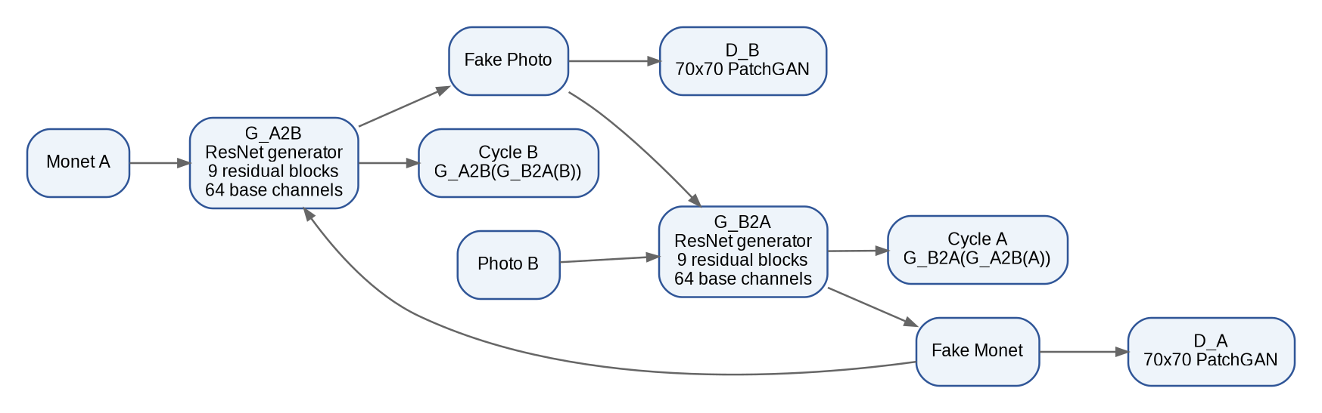
Figure 25. Anshika Task 3 CycleGAN architecture with nine residual blocks per generator and two PatchGAN discriminators.

Architecture and training configuration
Setting | Value
Generators | 2 ResNet generators, 9 residual blocks each, 64 base channels
Discriminators | 2 x 70x70 PatchGAN, 64 base channels
Normalization / output | InstanceNorm / tanh
Trainable parameters | 28,285,832
Image transform | Resize 286 -> random crop 256; horizontal flip p=0.5
Batch / precision | 1 / FP32
Optimizer | Adam, LR 0.0002, betas (0.5, 0.999), weight decay 0
Cycle L1 weight | 10 per direction
Identity effective weight | 5 per direction
Replay pool | 50 images/domain
Configured schedule | 200 epochs; 100 constant + 100 linear decay
Selected checkpoint | Epoch 125, global step 879,750
Final-epoch LR | 0.00015
Training hardware | NVIDIA GeForce RTX 4090

Final automatic metrics and leaderboard evidence
Metric | Monet -> Photo | Photo -> Monet | Mean / official
FID | 96.068450 | 98.864013 | Official avg 97.466148498
MiFID | 0.413548 | 0.400183 | Official avg 0.406865570
KID | 0.017190 | 0.007900 | 0.012545
Generative precision | 0.7800 | 0.4333 | 0.6067
Generative recall | 0.3333 | 0.6300 | 0.4817
Cycle L1 | 0.032256 | 0.034622 | 0.033439
Cycle LPIPS (AlexNet) | 0.182873 | 0.134368 | 0.158620
Content cosine | 0.783451 | 0.754759 | 0.769105

Training/resource metric | Value
Completed epochs / final step | 125 / 879,750
Training duration | 27.8685 hours
Weighted throughput | 17.5377 domain images/s
Nonfinite gradient events | 0
Final generator gradient norm | 34.309808
Final discriminator A / B gradient norms | 4.317097 / 6.441369
Final cycle loss A / B | 0.543312 / 0.627509
Final identity loss A / B | 0.147671 / 0.203830
Final discriminator loss A / B | 0.055120 / 0.157722
Final total generator loss | 2.811135
Kaggle score | -48.9365
Final selected checkpoint SHA256 | 3216b4997ed51962590251170ca5cbd6d00fb444479a8b5cd9480f0cfbeab7ec
Peak CUDA memory for final epoch-125 continuation | Not retained in final training_run_summary (historical epoch-50 run recorded approx. 2542 MiB)

Interpretation: Epoch 125 improves the instructor FID/MiFID and Kaggle score relative to the earlier epoch-75 evaluation. The final model has strong cycle-reconstruction metrics but direction-specific tradeoffs: Monet->Photo has the lower and higher precision; Photo->Monet has lower MiFID and KID and higher recall. Content cosine is a proxy, not a complete semantic-content measure.
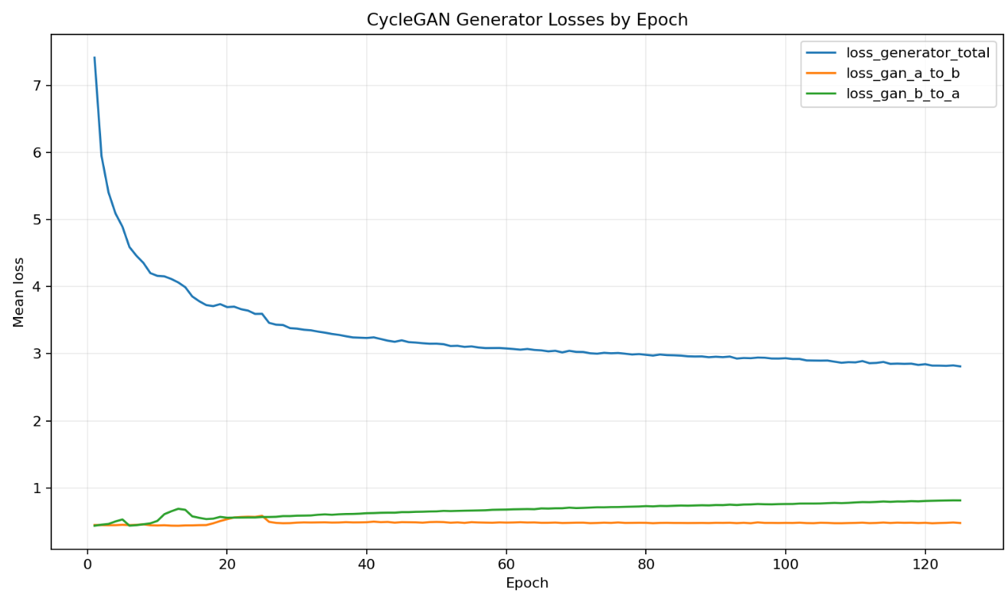
Figure 26. Generator losses for Anshika Task 3.
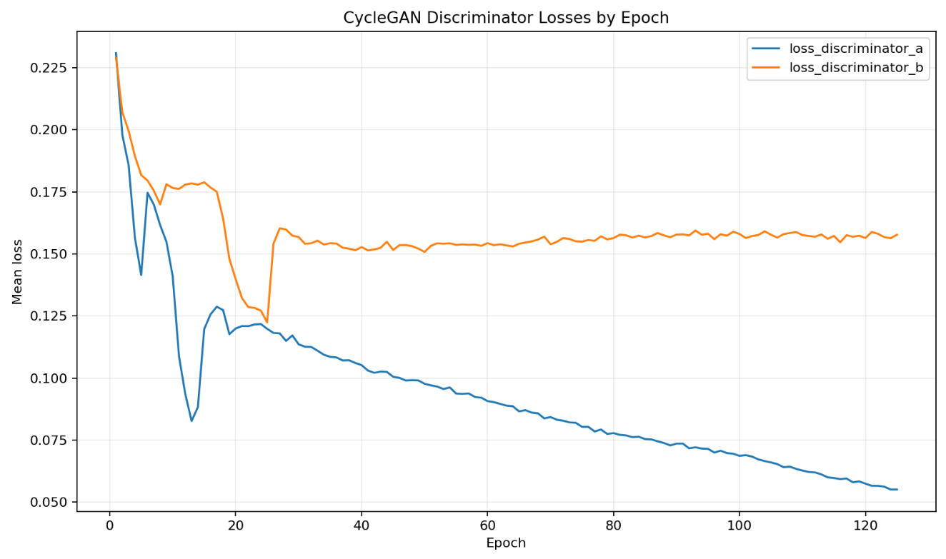
Figure 27. Discriminator losses for Anshika Task 3.
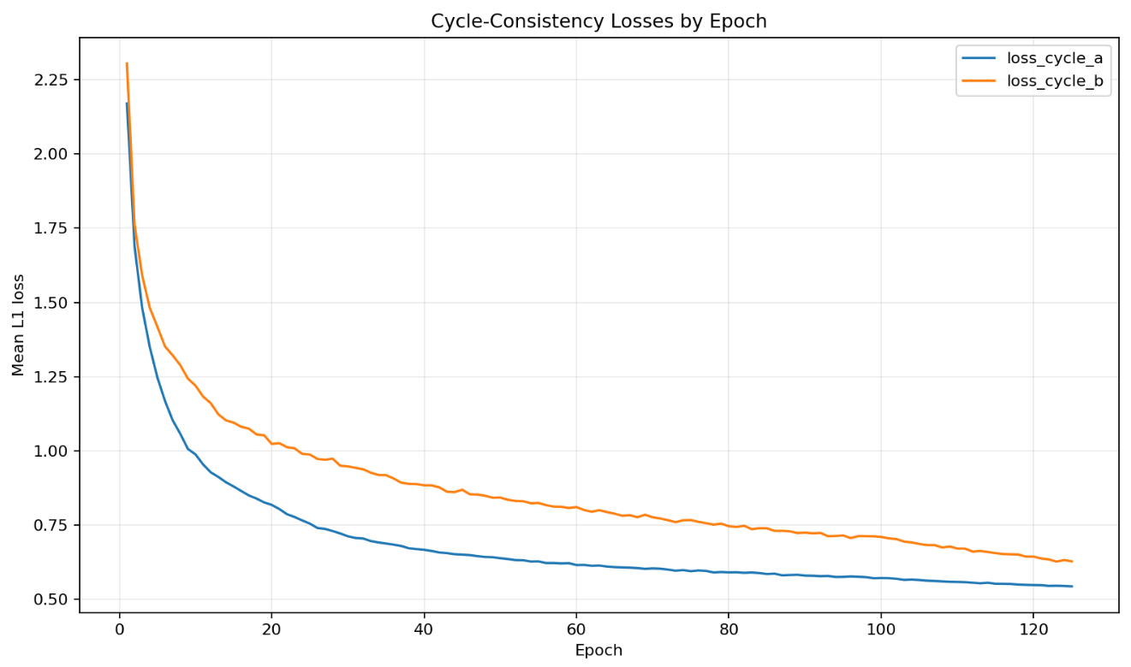
Figure 28. Cycle-consistency losses for Anshika Task 3.
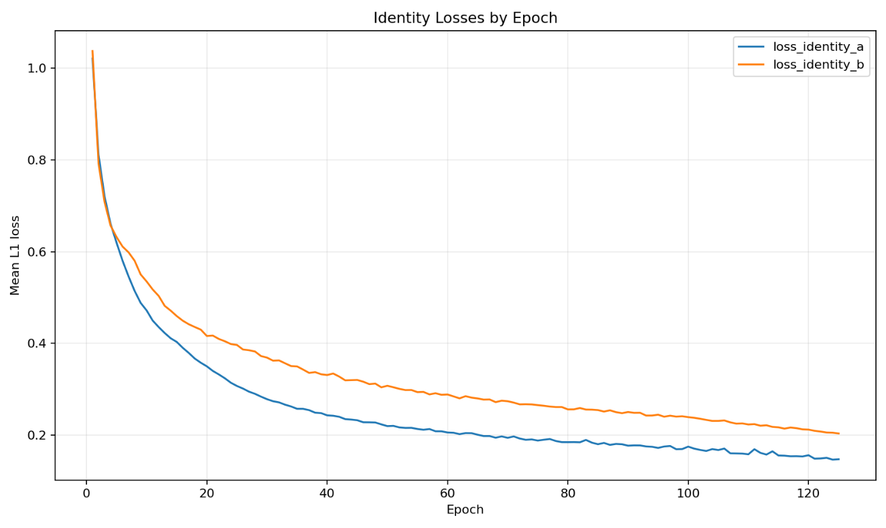
Figure 29. Identity losses for Anshika Task 3.
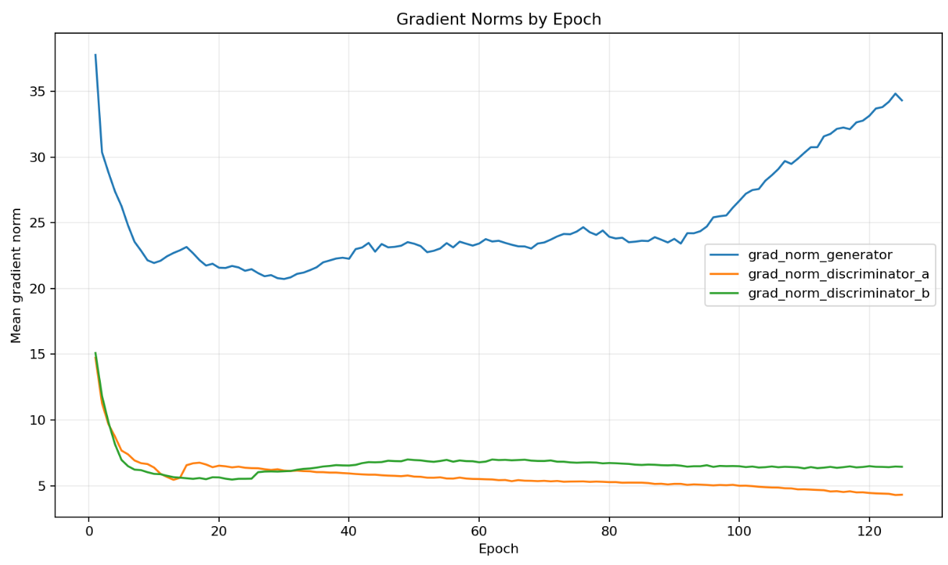
Figure 30. Gradient norms for Anshika Task 3.
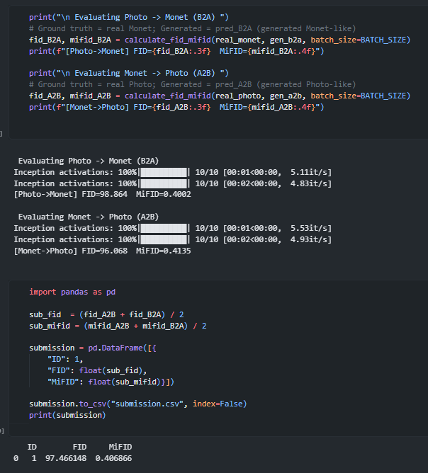
Figure 31. Executed instructor evaluator evidence
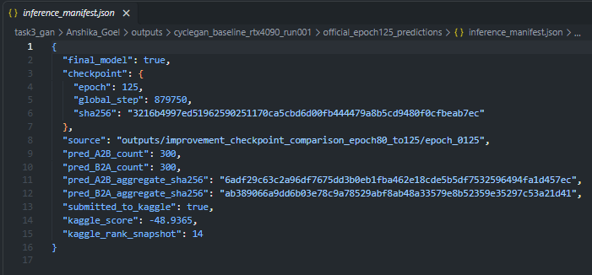
Figure 32. Final prediction provenance

Evaluation analysis - grounded evidence
Anshika's selected epoch-125 CycleGAN is supported by three independent evidence layers: the unchanged instructor evaluator, the deterministic directional metric pipeline, and the preserved training/inference provenance. The unchanged instructor notebook reports an official average FID of 97.466148498 and MiFID of 0.406865570. On the same frozen 300-image subset per direction, the directional pipeline gives Monet -> Photo FID 96.068450, MiFID 0.413548, KID 0.017190, precision 0.7800, recall 0.3333; and Photo -> Monet FID 98.864013, MiFID 0.400183, KID 0.007900, precision 0.4333, recall 0.6300. The model is therefore asymmetric by direction: Monet -> Photo is stronger on FID and precision, while Photo -> Monet is stronger on MiFID/KID and recall.
The reconstruction metrics provide a second view of quality. Cycle L1 is 0.032256 for A2B2A and 0.034622 for B2A2B (mean 0.033439), while AlexNet LPIPS is 0.182873 and 0.134368 (mean 0.158620). These values indicate that the round-trip mappings reconstruct the source relatively closely in pixel and perceptual feature space. Direct source-to-translation content cosine, however, is lower: 0.783451 for Monet -> Photo and 0.754759 for Photo -> Monet, with a mean of 0.769105. Because cycle consistency is a round-trip measure while content cosine compares the source with the direct translation, the two together show why low reconstruction error cannot by itself prove that all source semantics are preserved in the intermediate translated image.
From epoch 75 to epoch 125, mean FID improved from 98.170107 to 97.466231 and mean MiFID from 0.410627 to 0.406866; mean cycle L1 also improved from 0.038552 to 0.033439. At the same time, KID moved from 0.011541 to 0.012545, recall from 0.5000 to 0.4817, and content cosine from 0.795510 to 0.769105. Precision changed only slightly, from 0.6050 to 0.6067. Thus epoch 125 is the best retained checkpoint, but it is not uniformly superior on every auxiliary metric.
Metric | Epoch 75 | Epoch 125 | Observed change
FID mean | 98.170107 | 97.466231 | Improved
MiFID mean | 0.410627 | 0.406866 | Improved
KID mean | 0.011541 | 0.012545 | Worsened
Precision mean | 0.6050 | 0.6067 | Slightly improved
Recall mean | 0.5000 | 0.4817 | Worsened
Content cosine | 0.795510 | 0.769105 | Worsened
Cycle L1 | 0.038552 | 0.033439 | Improved
The durable event record also supports training stability rather than merely final image quality. The selected run completed 125 epochs and global step 879,750, recorded 27.8685 training hours at a weighted throughput of 17.5377 domain images/s, and logged zero non-finite gradient events. The final prediction bundle contains exactly 300 Monet -> Photo and 300 Photo -> Monet translations tied to the selected epoch-125 checkpoint through its inference manifest.

Failure analysis - final epoch-125 model
The final epoch-125 failure analysis is primarily a trade-off analysis rather than a numerical-instability diagnosis: the run has zero logged non-finite gradient events, yet the auxiliary metrics show that stronger target-domain alignment was obtained with weaker source/translation feature similarity. Mean content cosine at epoch 125 is 0.769105, compared with the epoch-50 reproduction-control value of 0.806853. This does not prove semantic content loss for every image, but it is direct evidence that continued style/adversarial optimization changed the feature-space relationship between source and direct translation even while the official FID/MiFID improved.
A second failure mode is direction-dependent coverage. Monet -> Photo has high generative precision (0.7800) but low recall (0.3333), indicating that its generated outputs are concentrated in regions judged to resemble the target photo distribution but cover less of that distribution. Photo -> Monet shows the opposite tendency: lower precision (0.4333) but higher recall (0.6300). The mean precision/recall pair of 0.6067/0.4817 therefore hides substantial directional asymmetry.
A third limitation is metric disagreement. Relative to epoch 75, epoch 125 improves FID, MiFID, and cycle L1, while KID becomes slightly worse, recall declines, and content cosine declines. The selected checkpoint should therefore be described as better under the official evaluator and competition criterion, not as universally better on every property of the translations. Cycle L1/LPIPS quantify round-trip reconstruction, whereas FID/MiFID/KID quantify distributional behavior and content cosine is only a feature-space proxy; no one metric is sufficient to characterize translation quality.
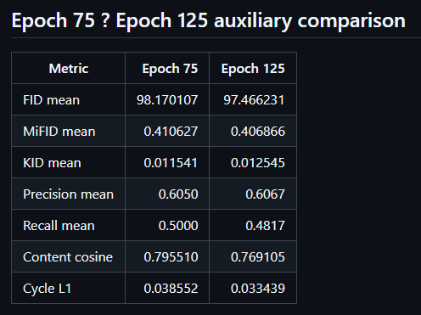
Figure 33. Anshika Task 3 final-model failure/limitation evidence.

Strengths, weaknesses, limitations, and design rationale
- Strengths: best team official average FID and MiFID; better cycle L1/LPIPS reconstruction; improved Kaggle score at epoch 125; stable long training with no nonfinite-gradient events.
- Weaknesses: larger model and much longer training than Viraat; lower content cosine; direction-specific recall/precision tradeoffs; final continuation summary does not preserve a peak-memory value.
- Limitations: metrics are based on 300 fixed images per direction; FID/KID/LPIPS are estimator/proxy metrics; historical simulated ratings are retained only as provenance; the required blinded two-rater audit of the final models is reported in Section 3.4.
- Why this design: nine ResNet blocks follow the high-capacity CycleGAN pattern for 256x256 translation, cycle weight 10 constrains content consistency, and identity weight 5 discourages unnecessary changes when an image is already in the target domain.

3.2 Viraat Chaudhary - six-block resize-convolution CycleGAN
Viraat adapted the shared CycleGAN training infrastructure but changed the generator design to six residual blocks and nearest-neighbor resize followed by reflection-padded convolution. This reduces capacity and changes the upsampling operator. The final run completed all 60 configured epochs with BF16 autocast while retaining FP32 model and optimizer state.
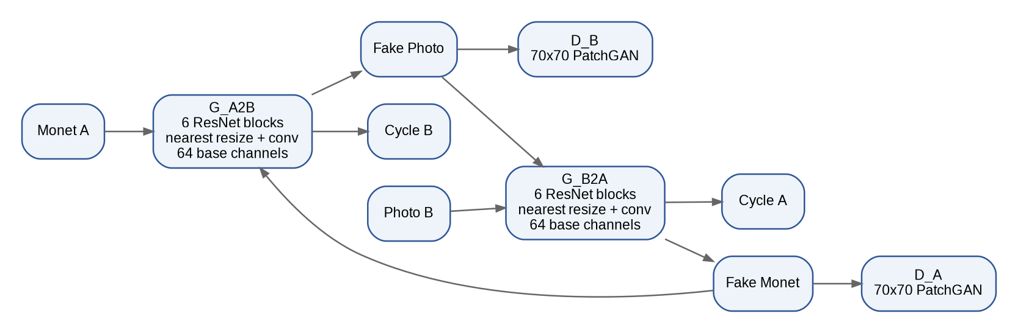
Figure 34. Viraat Task 3 CycleGAN architecture: six-block ResNet generators with nearest-resize convolution upsampling.

Architecture and training configuration
Setting | Value
Generators | 2 RGB ResNet generators, 6 residual blocks, 64 base channels, nearest resize + reflection-padded convolution
Discriminators | 2 three-layer 70x70 PatchGANs, 64 base channels
Trainable parameters | 21,204,872
Training domains | 300 Monet / 7,038 photos, unpaired
Seed | 2661510
Transform | Resize 286; random crop 256; flip p=0.5; normalize to [-1,1]
Batch / precision | 2 / BF16 autocast; FP32 model and Adam states
Optimizer | Adam; LR 0.0002; betas (0.5,0.999)
Schedule | 20 constant epochs + 40 linear-decay epochs
Cycle weight | 10
Identity ratio / effective weight | 0.25 / 2.5
Replay pool | 50
Final epoch | 60; global step 211,140
Hardware | NVIDIA GeForce RTX 4090

Final automatic metrics
Metric | Monet -> Photo | Photo -> Monet | Mean / official
FID | 103.036489 | 95.615238 | Official avg 99.328525404
MiFID | 0.416142 | 0.405585 | Official avg 0.410869756
KID | 0.024615 | 0.007861 | -
Generative precision | 0.623333 | 0.546667 | -
Generative recall | 0.426667 | 0.596667 | -
Cycle L1 | 0.043438 | 0.046902 | 0.045170
Cycle LPIPS | 0.420099 | 0.309908 | 0.365004
Content cosine | 0.789136 | 0.793367 | 0.791252

Training/resource metric | Value
Completed epochs / steps | 60 / 211,140
Recorded training time | 18,960.139 s (5.2667 h)
Throughput | 44.544 domain images/s
Peak allocated CUDA memory | 2,587.737 MiB
Nonfinite gradient count | 0
Final generator grad norm | 32.479166
Final discriminator A / B grad norm | 4.104792 / 5.933052
Final cycle loss A / B | 0.743626 / 0.822668
Final identity loss A / B | 0.155582 / 0.202499
Final discriminator loss A / B | 0.038158 / 0.042537
Production checkpoint SHA256 | 138f9ae9edef412125ddfad643d2fc672c3de2d609819caf0b623979d3765252

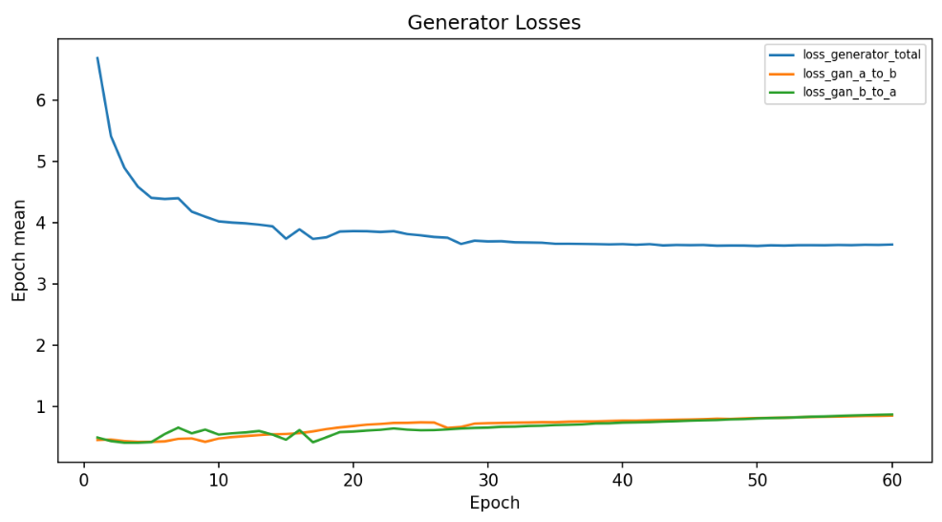
Figure 35. Generator losses for Viraat Task 3.
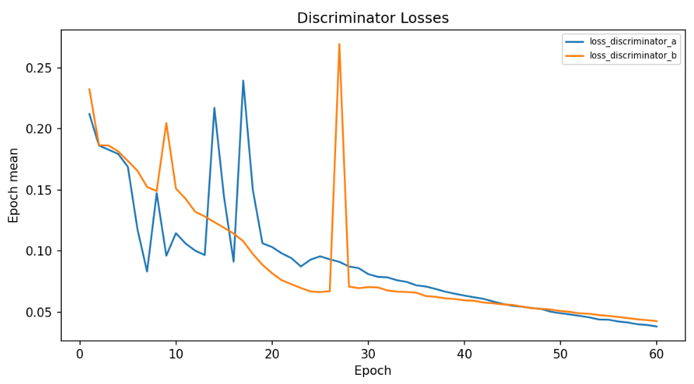
Figure 36. Discriminator losses for Viraat Task 3.
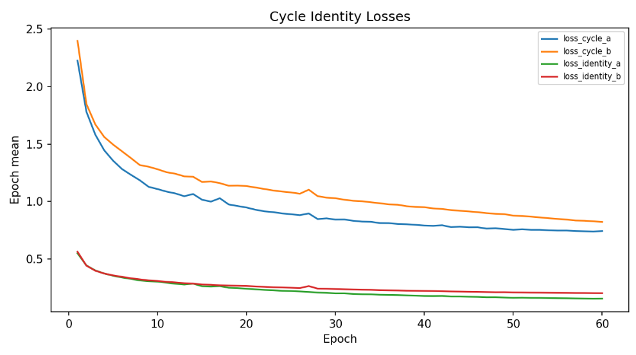
Figure 37. Cycle and identity losses for Viraat Task 3.
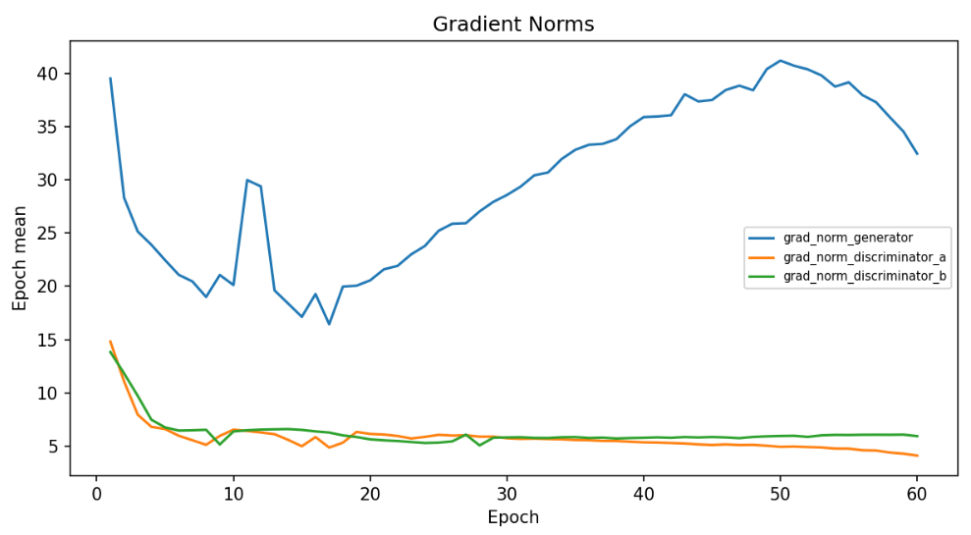
Figure 38. Gradient norms for Viraat Task 3.
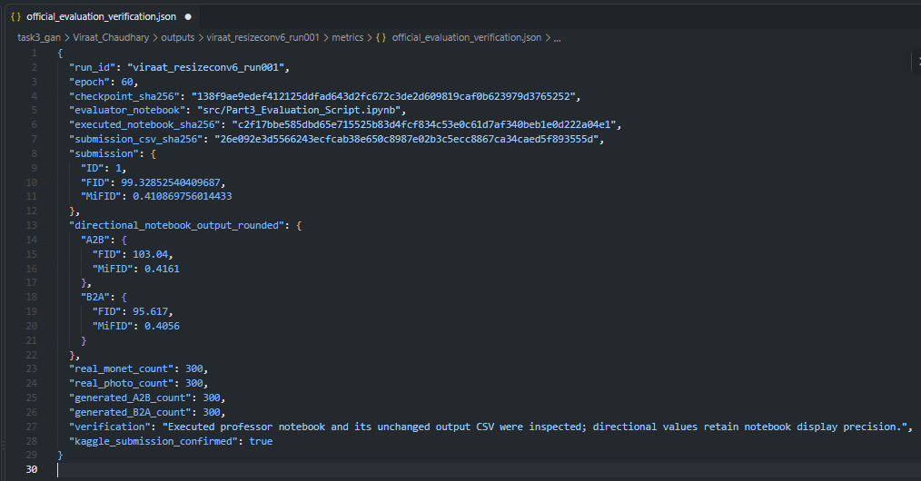
Figure 39. Official evaluator verification.
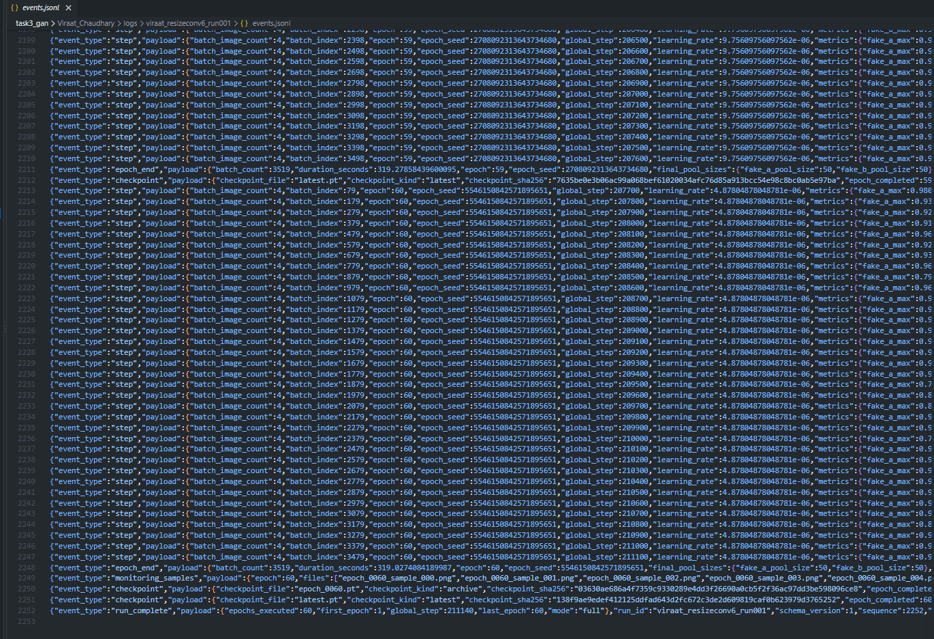
Figure 40. Completed run log.

Evaluation analysis - grounded evidence
Viraat's epoch-60 resize-convolution CycleGAN is supported by the saved professor-evaluator verification, the member-level full metric report, and the preserved epoch-by-epoch training record. The official evaluator average is FID 99.32852540409687 and MiFID 0.410869756014433. Directionally, Monet -> Photo is the weaker distributional direction: FID 103.036489, MiFID 0.416142 and KID 0.024615, compared with Photo -> Monet FID 95.615238, MiFID 0.405585 and KID 0.007861. This directional gap is important because the overall average alone would hide that the B2A direction is substantially stronger than A2B on FID and KID.
Generative precision/recall shows a related asymmetry. Monet -> Photo precision/recall is 0.623333/0.426667, while Photo -> Monet is 0.546667/0.596667. Content cosine is comparatively balanced at 0.789136 and 0.793367. The cycle metrics are less favorable than Anshika's selected checkpoint: Viraat records cycle L1 0.043438/0.046902 and AlexNet LPIPS 0.420099/0.309908 for A2B2A/B2A2B. Thus, Viraat preserves source-to-translation feature similarity relatively well, especially in B2A, but its round-trip perceptual reconstruction is weaker.
Training evidence supports numerical stability and efficiency rather than a claim of universal visual superiority. The run completed all 60 configured epochs and global step 211,140 in 5.2667 hours at 44.544 domain images/s, with 2,587.737 MiB peak allocated CUDA memory and zero logged non-finite gradient events. Across training, cycle losses fell from 2.227211/2.399329 at epoch 1 to 0.743626/0.822668 at epoch 60; identity losses fell from 0.549718/0.563311 to 0.155582/0.202499; and total generator loss fell from 6.683079 to 3.640399. These trends show that the optimization remained finite and that reconstruction/identity objectives improved substantially, while the distributional evaluation metrics still expose an A2B weakness.
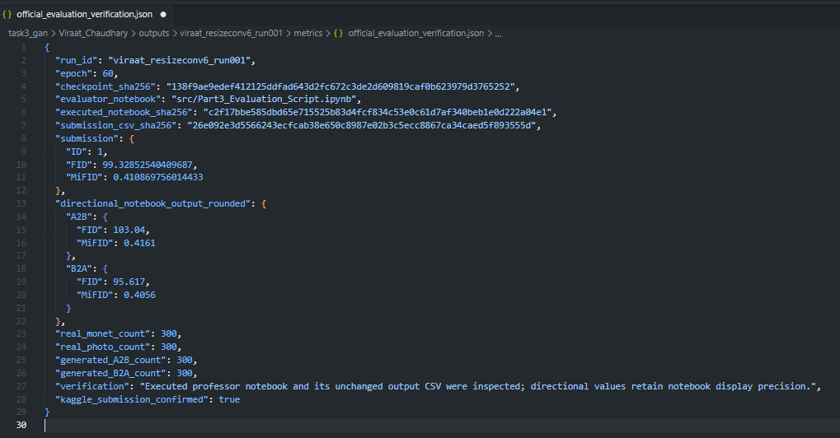
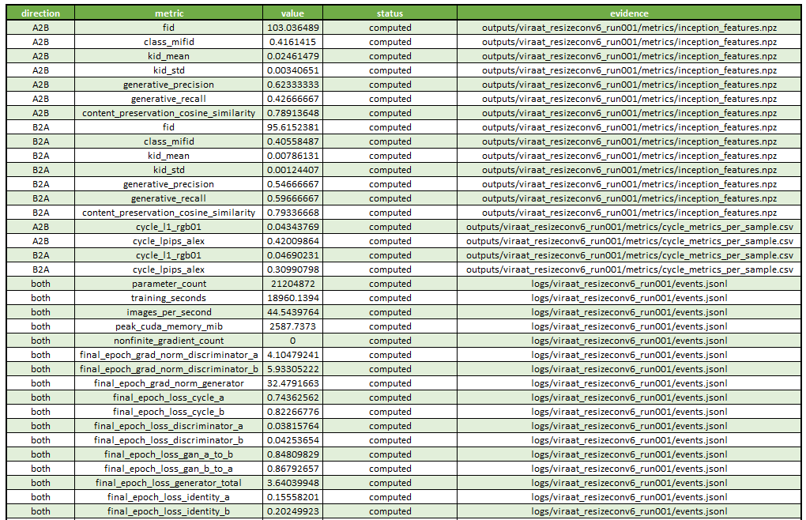
Figure 41. Grounded automatic-evaluation evidence for Viraat's completed epoch-60 CycleGAN.

Failure analysis - six fixed high-LPIPS cases
Viraat's failure analysis uses a fixed, reproducible selection rule rather than hand-picking visually poor images. The saved per-sample cycle CSV was used to identify the three highest cycle-LPIPS cases in each translation direction, after which those six fixed panels were visually reviewed. The six retained IDs and round-trip reconstruction metrics are listed below.
Case | Panel path | Cycle L1 | Cycle LPIPS
AUDIT_004 | .../human_audit/AUDIT_004.png | 0.034307 | 0.540362
AUDIT_001 | .../human_audit/AUDIT_001.png | 0.052304 | 0.519985
AUDIT_012 | .../human_audit/AUDIT_012.png | 0.055689 | 0.483064
AUDIT_002 | .../human_audit/AUDIT_002.png | 0.057657 | 0.463376
AUDIT_015 | .../human_audit/AUDIT_015.png | 0.071630 | 0.401893
AUDIT_023 | .../human_audit/AUDIT_023.png | 0.064907 | 0.394317
The highest cycle-LPIPS case, AUDIT_004, has cycle L1 0.034307 and LPIPS 0.540362. Its relatively modest L1 but very high perceptual distance demonstrates why pixel error and perceptual error cannot be treated as interchangeable measures. AUDIT_001 (L1 0.052304, LPIPS 0.519985) is explicitly documented as darkening with residual brush-like texture, showing exposure/color drift even when the broad scene remains recognizable.
AUDIT_012 (L1 0.055689, LPIPS 0.483064) shows flowering vegetation becoming darker with dense repeated bright strokes; the sky shifts to a much darker gradient and fine flower/leaf detail is replaced by coarse texture, although the broad horizon remains. AUDIT_002 (L1 0.057657, LPIPS 0.463376) retains the lake/tree skyline and reflection layout but softens thin trunks and cloud boundaries and introduces strong blue-green color in some tree regions. These cases show a concrete style/content trade-off rather than complete scene destruction.
AUDIT_015 has the largest cycle L1 among the six selected cases (0.071630; LPIPS 0.401893), identifying it as the strongest pixel-space round-trip reconstruction failure in the fixed panel. AUDIT_023 (L1 0.064907, LPIPS 0.394317) preserves the approximate horizon and shoreline, but changes an orange/black sunset into a bright blue-green textured scene; small foreground figures/objects become less distinct and the sun/reflection contrast changes substantially. This is direct evidence that broad geometry can survive while local color, contrast, and fine content are altered.
The failure-analysis document also places an important boundary on interpretation: cycle metrics measure round-trip reconstruction, not direct translation correctness. A small cycle L1 does not establish good photographic or Monet style, and a large LPIPS value does not by itself identify where the direct translation failed. For follow-up work, the repository proposes controlled tests of six versus nine residual blocks, identity ratio 0.25 versus 0.5, and cycle weight 10 versus 12.5 while keeping the remaining configuration fixed; these are proposed experiments, not demonstrated improvements.
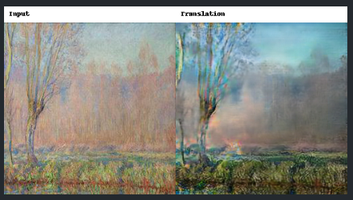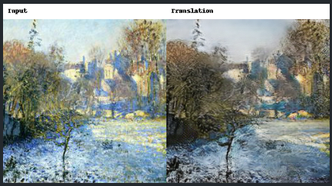
AUDIT_004.png AUDIT_001.png
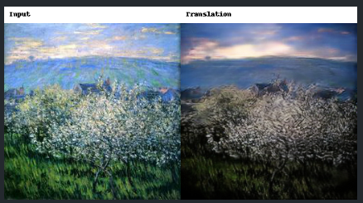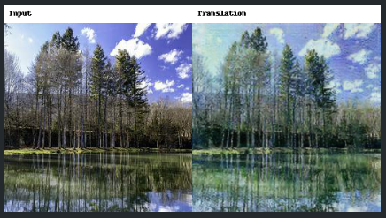
AUDIT_012.png AUDIT_002.png
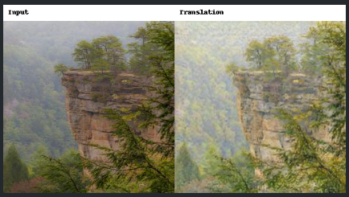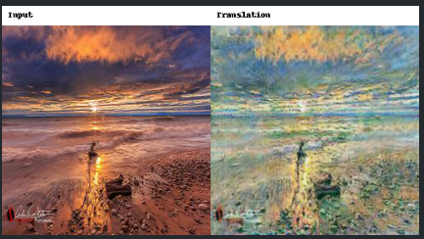
AUDIT_015.png AUDIT_023.png
Figure 42. Viraat Task 3 fixed failure panel: three highest cycle-LPIPS cases per translation direction, selected from the saved per-sample metric CSV before visual interpretation.

Strengths, weaknesses, limitations, and design rationale
- Strengths: approximately 25% fewer parameters than Anshika; over 2.5x recorded throughput; much shorter total training; better Photo->Monet FID/KID; higher mean content cosine.
- Weaknesses: worse official average FID/MiFID and substantially worse cycle LPIPS; A2B FID is notably higher; lower capacity may limit fine reconstruction detail.
- Limitations: six-block generator, resize-convolution, identity weight, batch size/precision, and training schedule differ simultaneously; therefore the result does not isolate the effect of a single design choice.
- Why this design: six residual blocks and resize-convolution reduce compute/capacity and avoid relying on transposed-convolution upsampling, while BF16 and batch 2 prioritize throughput on the same RTX 4090 class of serious training hardware.

3.3 Task 3 team comparison
Property / metric | Anshika epoch 125 | Viraat epoch 60 | Observed advantage
Residual blocks | 9 | 6 | Viraat efficiency
Parameters | 28.286 M | 21.205 M | Viraat
Training time | 27.868 h | 5.267 h | Viraat
Throughput | 17.538 img/s | 44.544 img/s | Viraat
Official average FID | 97.466148 | 99.328525 | Anshika
Official average MiFID | 0.406866 | 0.410870 | Anshika
Monet -> Photo FID | 96.068450 | 103.036489 | Anshika
Photo -> Monet FID | 98.864013 | 95.615238 | Viraat
Monet -> Photo KID | 0.017190 | 0.024615 | Anshika
Photo -> Monet KID | 0.007900 | 0.007861 | Near tie / Viraat
Mean cycle L1 | 0.033439 | 0.045170 | Anshika
Mean cycle LPIPS | 0.158620 | 0.365004 | Anshika
Mean content cosine | 0.769105 | 0.791252 | Viraat

Interpretation: If the primary criterion is the course official evaluator plus cycle-reconstruction quality, Anshika's epoch-125 model is the stronger final configuration. Viraat offers a compelling efficiency/content-preservation tradeoff: far lower training cost, fewer parameters, better Photo->Monet FID, and higher content cosine. Neither model dominates every direction or every metric.
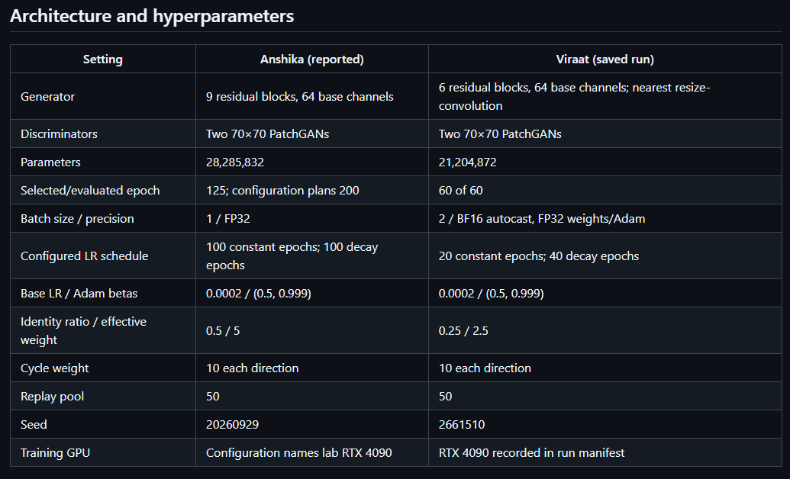
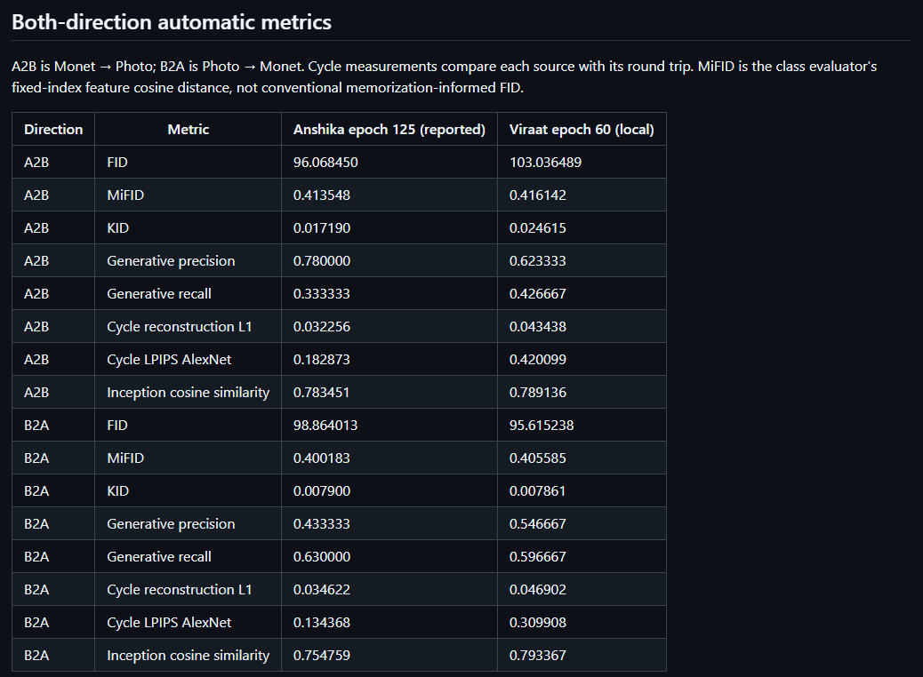
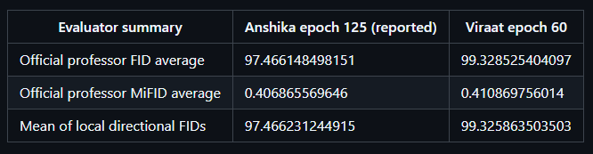
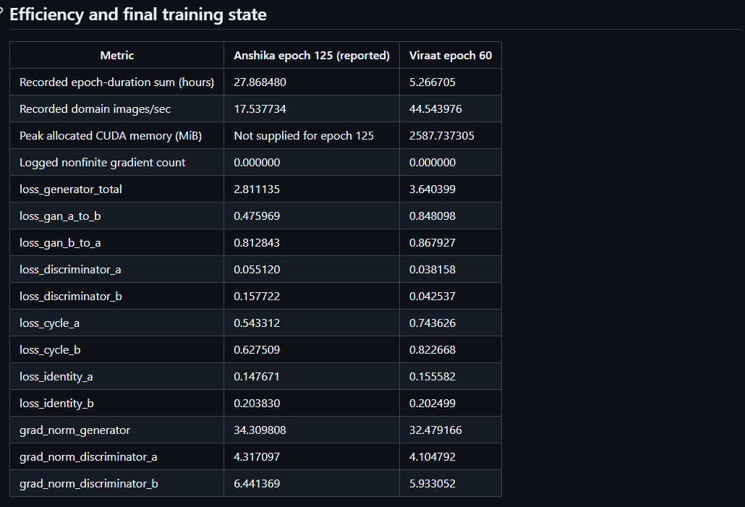
Figure 43. Task 3 side-by-side comparison.
3.3.1 Complete Task 3 team comparison matrix
This matrix consolidates the final selected CycleGAN configurations and every required Task 3 metric. Direction labels follow the report convention Monet -> Photo and Photo -> Monet.
Property / metric | Anshika epoch 125 | Viraat epoch 60 | Comparison
Generator architecture | 2 x 9-block ResNet generators, 64 base channels | 2 x 6-block ResNet generators, 64 base channels; nearest-resize + reflection-padded convolution | Capacity / upsampling differ
Discriminators | 2 x 70x70 PatchGAN, 64 base channels | 2 x three-layer 70x70 PatchGAN, 64 base channels | Both PatchGAN
Parameters | 28,285,832 | 21,204,872 | Viraat smaller
Batch / precision | 1 / FP32 | 2 / BF16 autocast; FP32 states | Viraat efficiency
Optimizer | Adam; LR 0.0002; betas (0.5,0.999); wd 0 | Adam; LR 0.0002; betas (0.5,0.999) | Matched LR/betas
Schedule | 200 configured: 100 constant + 100 decay; selected epoch 125 | 60: 20 constant + 40 decay | Different budgets
Cycle weight | 10 per direction | 10 | Matched
Identity effective weight | 5 per direction | 2.5 | Anshika stronger identity penalty
Replay pool | 50/domain | 50 | Matched
Training hardware | NVIDIA GeForce RTX 4090 | NVIDIA GeForce RTX 4090 | Same GPU class
FID Monet -> Photo | 96.068450 | 103.036489 | Anshika lower
FID Photo -> Monet | 98.864013 | 95.615238 | Viraat lower
Official average FID | 97.466148498 | 99.328525404 | Anshika lower
MiFID Monet -> Photo | 0.413548 | 0.416142 | Anshika lower
MiFID Photo -> Monet | 0.400183 | 0.405585 | Anshika lower
Official average MiFID | 0.406865570 | 0.410869756 | Anshika lower
KID Monet -> Photo | 0.017190 | 0.024615 | Anshika lower
KID Photo -> Monet | 0.007900 | 0.007861 | Near tie; Viraat lower
Generative precision Monet -> Photo | 0.7800 | 0.623333 | Anshika
Generative precision Photo -> Monet | 0.4333 | 0.546667 | Viraat
Generative recall Monet -> Photo | 0.3333 | 0.426667 | Viraat
Generative recall Photo -> Monet | 0.6300 | 0.596667 | Anshika
Cycle L1 Monet -> Photo | 0.032256 | 0.043438 | Anshika lower
Cycle L1 Photo -> Monet | 0.034622 | 0.046902 | Anshika lower
Cycle LPIPS Monet -> Photo | 0.182873 | 0.420099 | Anshika lower
Cycle LPIPS Photo -> Monet | 0.134368 | 0.309908 | Anshika lower
Content cosine Monet -> Photo | 0.783451 | 0.789136 | Viraat higher
Content cosine Photo -> Monet | 0.754759 | 0.793367 | Viraat higher
Final cycle loss A / B | 0.543312 / 0.627509 | 0.743626 / 0.822668 | Anshika lower
Final identity loss A / B | 0.147671 / 0.203830 | 0.155582 / 0.202499 | Mixed / close
Final discriminator loss A / B | 0.055120 / 0.157722 | 0.038158 / 0.042537 | Different adversarial balance
Final generator grad norm | 34.309808 | 32.479166 | Both finite
Final discriminator grad norm A / B | 4.317097 / 6.441369 | 4.104792 / 5.933052 | Both finite
Nonfinite gradient events | 0 | 0 | Stable
Training time | 27.8685 h | 5.2667 h | Viraat
Throughput | 17.5377 domain img/s | 44.544 domain img/s | Viraat
Human style mean | 3.2000 | 3.2500 | Viraat +0.0500
Human content-preservation mean | 3.4833 | 3.7500 | Viraat +0.2667
Human artifact-free mean | 3.4500 | 3.6833 | Viraat +0.2333
Pooled exact agreement | 27.78% | 40.00% | Viraat raters agreed more often
Pooled Cohen's kappa | 0.0782 | 0.2357 | Both modest; Viraat higher

3.3.2 What we would try next
- Run a matched-budget multi-seed ablation that changes one factor at a time: six versus nine residual blocks, identity effective weight 2.5 versus 5, and batch/precision settings, while holding the image transform, optimizer, cycle weight, replay pool and training schedule fixed. The current comparison cannot isolate one architectural cause because these factors and total training duration differ together.
- Target the Monet -> Photo direction specifically. Anshika reaches high precision 0.7800 but low recall 0.3333, while Viraat has FID 103.036489 in the same direction; the next model should test whether coverage can be improved without sacrificing Anshika's lower FID/cycle error or Viraat's throughput advantage.
- Repeat the blinded visual evaluation with a larger fixed panel and additional independent raters while preserving the same anonymous protocol. The current pooled kappa is 0.0782 for Anshika and 0.2357 for Viraat, so a larger audit would quantify whether the small mean-rating advantage for Viraat is stable despite modest inter-rater agreement.

3.4 Blinded real-human audit
To complement the automatic Task 3 metrics, the final selected models were evaluated in a blinded real-human audit. For each model, 30 fixed panels were rated: 15 Monet -> Photo and 15 Photo -> Monet. The same two independent human raters scored every panel on three integer 1-5 scales: style quality, content preservation, and artifact-free quality; higher scores indicate better perceived quality. The raters received anonymous Set_A / Set_B packages, and model identity was revealed only after both completed responses were returned and validated. Historical simulated/AI-assisted ratings were not used in these final real-human calculations.

Overall human-rating results
Criterion | Anshika epoch 125 | Viraat epoch 60 | Viraat - Anshika
Style quality mean | 3.2000 | 3.2500 | +0.0500
Content preservation mean | 3.4833 | 3.7500 | +0.2667
Artifact-free quality mean | 3.4500 | 3.6833 | +0.2333
Interpretation: Viraat receives the higher two-rater mean on all three perceptual criteria. The style difference is only 0.05 on a five-point scale, so style quality is effectively very close. The larger gaps are content preservation (+0.2667) and artifact-free quality (+0.2333), which descriptively favor Viraat. These differences are descriptive human-audit results, not inferential significance tests: no p-value or confidence interval was computed for the human ratings, so they should not be presented as statistically significant differences.

Inter-rater agreement
Agreement metric | Anshika epoch 125 | Viraat epoch 60 | Meaning
Style exact agreement | 16.67% | 40.00% | Identical 1-5 score
Style Cohen's kappa | -0.0190 | 0.2275 | Chance-adjusted agreement
Content exact agreement | 26.67% | 43.33% | Identical 1-5 score
Content Cohen's kappa | 0.0517 | 0.2630 | Chance-adjusted agreement
Artifact exact agreement | 40.00% | 36.67% | Identical 1-5 score
Artifact Cohen's kappa | 0.2405 | 0.1775 | Chance-adjusted agreement
Pooled exact agreement | 27.78% | 40.00% | All three criteria pooled
Pooled Cohen's kappa | 0.0782 | 0.2357 | All three criteria pooled
Significance of agreement metrics: Exact agreement is the percentage of samples for which the two raters chose the same integer score. Cohen's kappa adjusts that agreement for chance. Anshika's pooled kappa of 0.0782 shows very limited beyond-chance agreement overall, with style particularly subjective (kappa -0.0190). Viraat's pooled kappa is higher at 0.2357, but agreement is still modest rather than strong. Therefore, the human audit is useful as perceptual evidence, but the low-to-moderate rater consistency means it should corroborate, not replace, the automatic metrics.

Direction-specific human ratings
Model / direction | Style | Content | Artifact-free
Anshika Monet -> Photo | 2.6000 | 3.3667 | 3.0333
Anshika Photo -> Monet | 3.8000 | 3.6000 | 3.8667
Viraat Monet -> Photo | 2.8667 | 3.5000 | 3.5000
Viraat Photo -> Monet | 3.6333 | 4.0000 | 3.8667
Directional significance: Both models were rated higher for Photo -> Monet than for Monet -> Photo on all three human criteria. For Anshika, the largest directional gaps are in style (3.8000 vs 2.6000) and artifact-free quality (3.8667 vs 3.0333). Viraat shows the same pattern, with Photo -> Monet reaching 4.0000 for content preservation. This human preference is consistent with Viraat's stronger Photo -> Monet FID/KID and, for Anshika, with the stronger Photo -> Monet MiFID/KID and recall reported earlier, even though not every automatic metric moves in the same direction.

Human audit versus automatic metrics
Combined interpretation: The human audit does not overturn the automatic comparison; instead, it exposes a complementary trade-off. Anshika remains stronger on the course official average FID/MiFID and on cycle-reconstruction quality, while Viraat receives slightly higher mean human ratings for style, content preservation, and artifact-free quality. This disagreement is important because FID/MiFID/KID measure distributional behavior, cycle L1/LPIPS measure round-trip reconstruction, content cosine is a feature-space proxy, and human raters judge visible style/content/artifacts directly. The combined evidence therefore supports the report's existing conclusion that neither model is a universal winner across all evaluation dimensions.
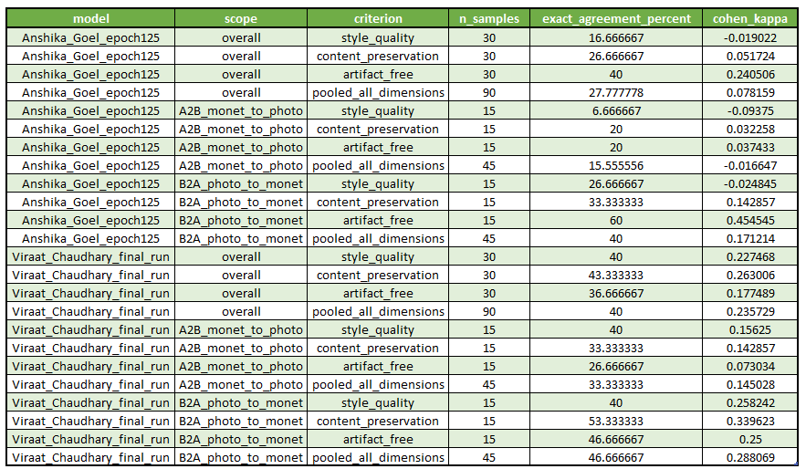
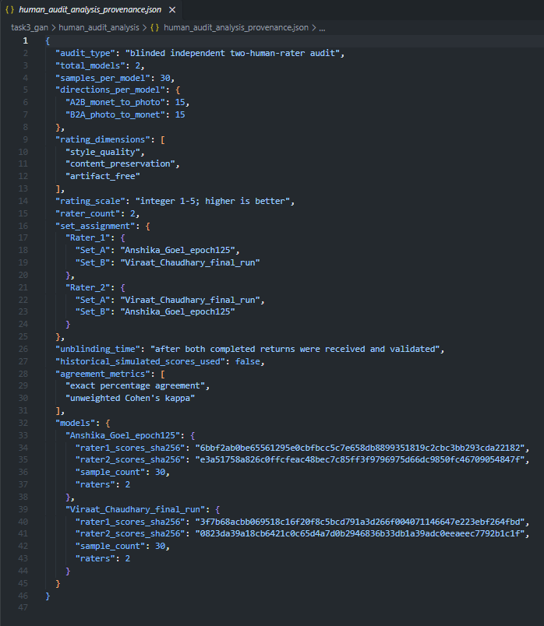
Figure 44. Final blinded two-rater human-audit summary and inter-rater agreement evidence.

4. Overall conclusions and remaining submission checks
Across the three tasks, the strongest model depends on the evaluation objective rather than a universal architecture rule. Anshika's Task 1 GPT is the clear quality winner under the common held-out evaluation, while Viraat's Task 1 model is substantially more efficient. In Task 2, Viraat's LSTM has the highest observed accuracy/macro-F1/MCC across the six-model table, with the TCN almost tied and Anshika's BiGRU-Attention the strongest of her three. In Task 3, Anshika's epoch-125 CycleGAN wins on the official FID/MiFID averages and reconstruction metrics, whereas Viraat's six-block resize-convolution model provides much better training efficiency and stronger Photo->Monet/content-cosine results.

5. References
- Vaswani, A., et al. (2017). Attention Is All You Need. Advances in Neural Information Processing Systems 30.
- Eldan, R., & Li, Y. (2023). TinyStories: How Small Can Language Models Be and Still Speak Coherent English? arXiv:2305.07759.
- Zhang, X., Zhao, J., & LeCun, Y. (2015). Character-level Convolutional Networks for Text Classification. Advances in Neural Information Processing Systems 28. Yelp Review Polarity dataset.
- Bai, S., Kolter, J. Z., & Koltun, V. (2018). An Empirical Evaluation of Generic Convolutional and Recurrent Networks for Sequence Modeling. arXiv:1803.01271.
- Zhu, J.-Y., Park, T., Isola, P., & Efros, A. A. (2017). Unpaired Image-to-Image Translation using Cycle-Consistent Adversarial Networks. ICCV.
- Heusel, M., et al. (2017). GANs Trained by a Two Time-Scale Update Rule Converge to a Local Nash Equilibrium. NeurIPS. (FID).
- Zhang, R., Isola, P., Efros, A. A., Shechtman, E., & Wang, O. (2018). The Unreasonable Effectiveness of Deep Features as a Perceptual Metric. CVPR. (LPIPS).

