
AMERICAN INTERNATIONAL UNIVERSITY-BANGLADESH
Faculty of Science and Technology
Department of Computer Science
CSC 3215: Web Technologies
Semester: Summer 2025-26 Group No: 04 Section: AA
Group Members:
SL. | Student ID | Name | Role | Signature
1 | 23-53049-3 | MD. Minhazul Hassan | Group Leader | Minhaz
2 | 22-47724-2 | Alrazi Hosen Rizvy | Member | Rizvy
3 | 22-46682-1 | Khandaker Sadman Saif | Member | Saif
4 | 23-53014-3 | Yeasin Ahmed | Member | Yeasin

Project Title
E-Medicine Shop — Online Medicine Ordering & Pharmacy Management System

Short Description
E-Medicine Shop is a web-based online pharmacy platform that connects customers, medicine vendors, store administrators, and delivery personnel in a single system. Customers can browse and search medicines by category, vendor, or name, place orders, and pay online. Vendors independently manage the medicines they supply, admins oversee the catalog and order pipeline, and delivery personnel handle the final step of getting the order to the customer's doorstep.
Introduction
Buying medicine from a physical pharmacy can be time-consuming and inconvenient, particularly for elderly or unwell patients who need quick access to essential medicines. E-Medicine Shop addresses this problem by providing a browser-based platform where customers can search for medicines, compare vendors, and place orders from home. The system is built using a lightweight, custom PHP MVC architecture with a MySQL database, and follows a role-based design so that each type of user only sees the features relevant to them.
To ensure clear task independence among the four group members, the system was designed around four distinct user roles — Customer, Admin, Vendor, and Delivery — each with its own controller, views, and set of responsibilities that do not overlap with the others.
Background Study
Before designing E-Medicine Shop, the group studied the browsing, cart, and checkout flow of existing online pharmacy services available in Bangladesh, as well as common patterns used in typical PHP MVC e-commerce applications. This helped identify the core features a medicine ordering platform needs (category-based browsing, cart management, order tracking) and informed the decision to extend the usual customer/admin structure with two additional roles, Vendor and Delivery, so that medicine supply and order fulfilment could be modeled as independent, assignable responsibilities rather than being bundled entirely under Admin.
ER Diagram
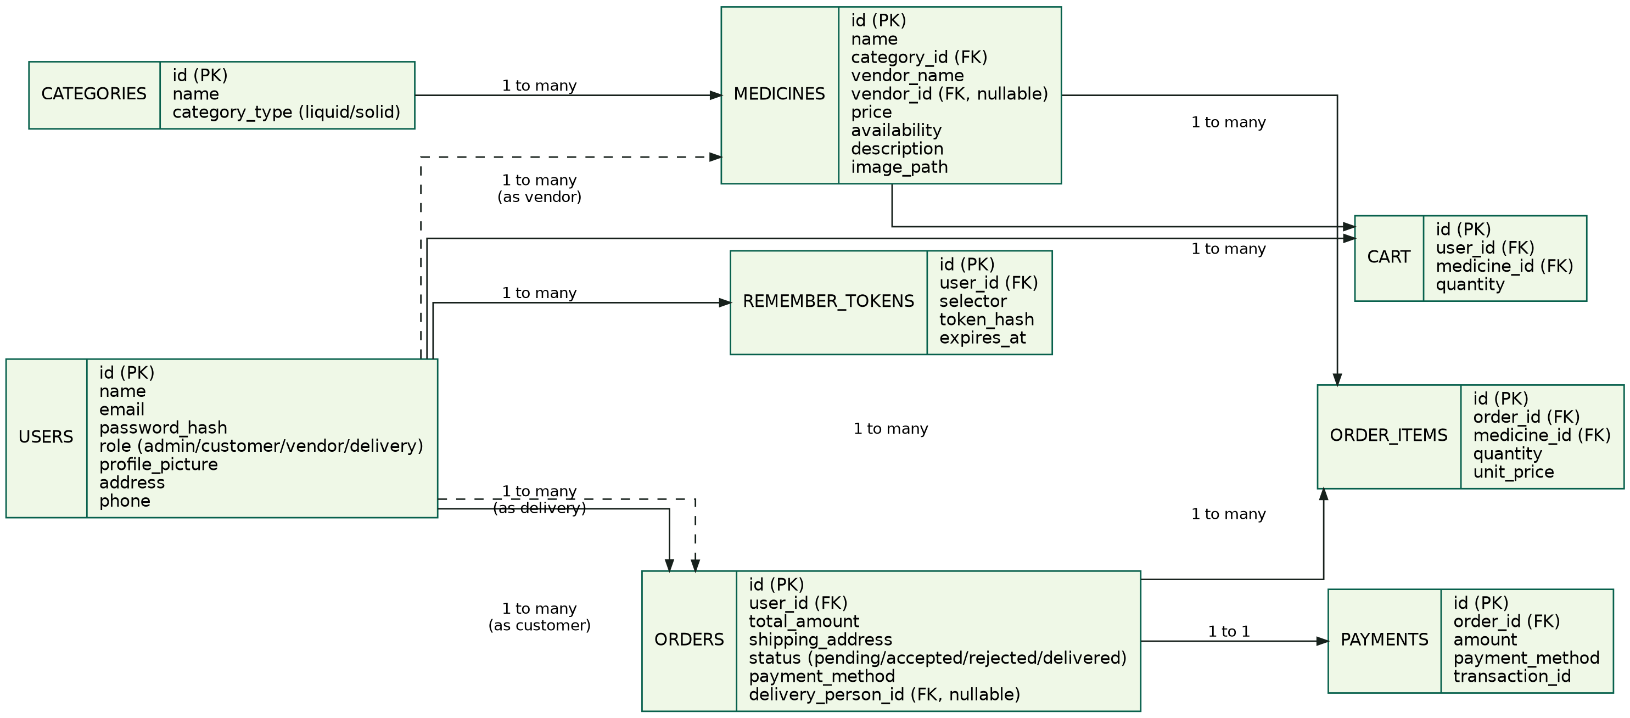
Use Case Diagram
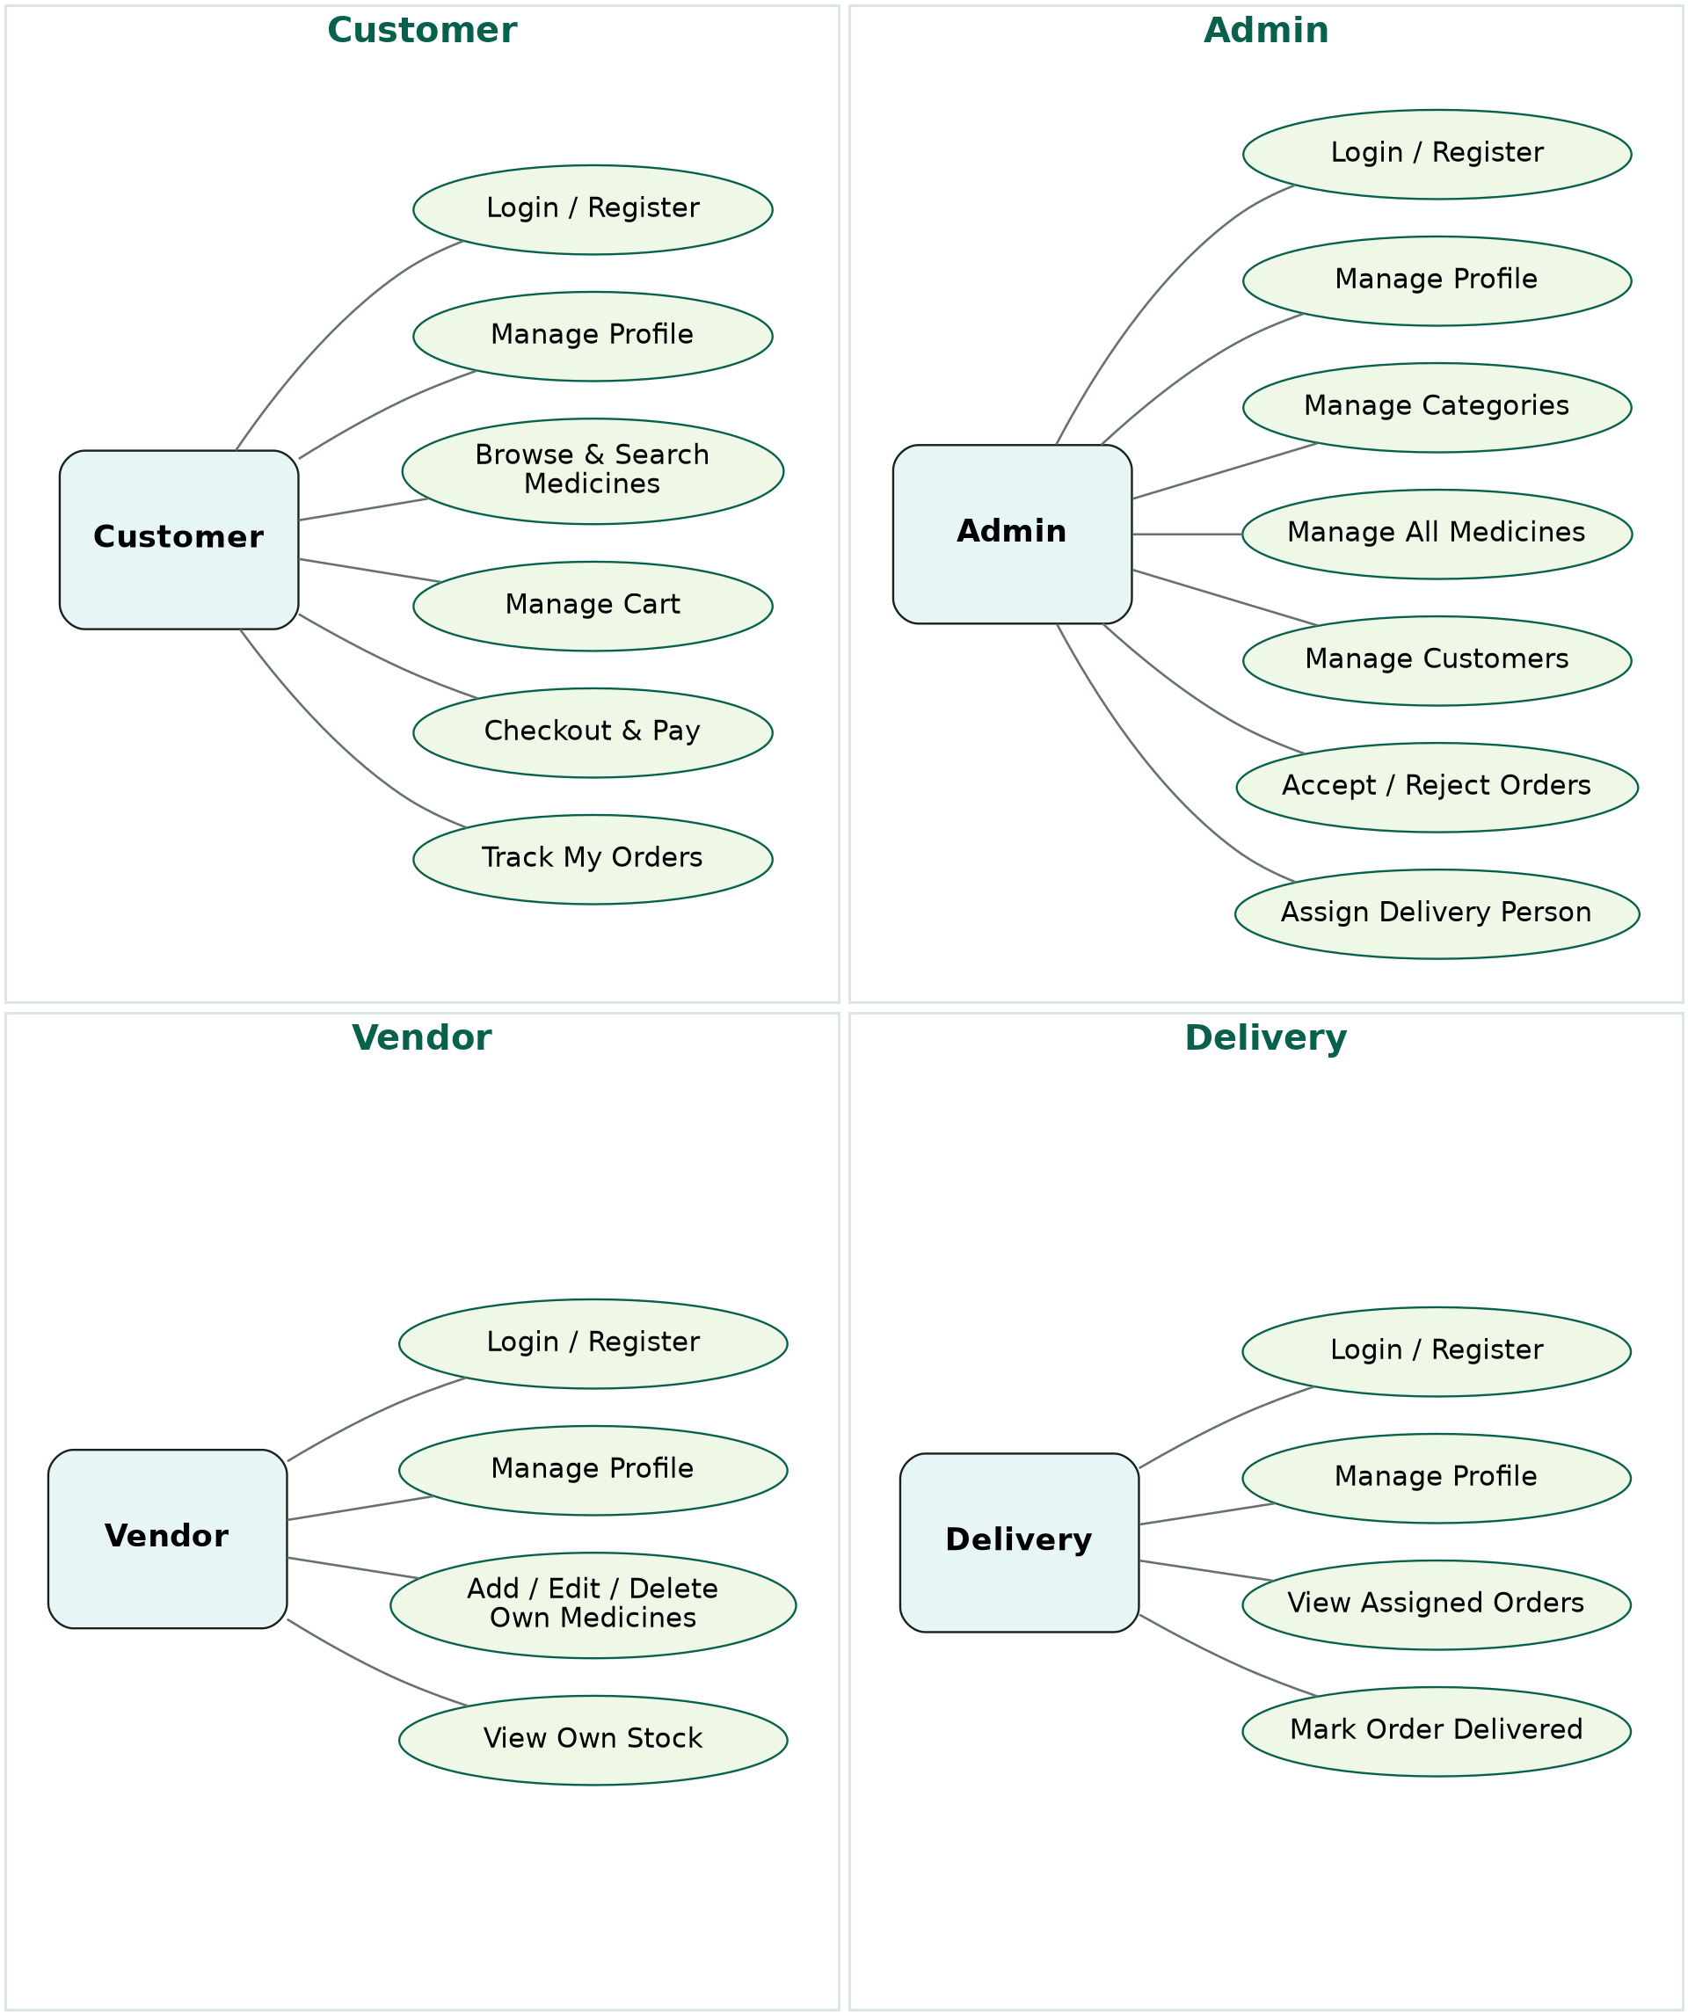
UI (Figma/Sketch)
The interface follows a clean, minimal pharmacy-style theme (soft mint/green accents on a light background) across all roles. Key screens include: a customer-facing Home page with category filters and live search, a Cart & Checkout flow with payment method selection, an Admin Dashboard with catalog, order, and customer management panels, a Vendor Dashboard for managing personally supplied medicines, and a Delivery Dashboard listing assigned orders with a one-click “Mark Delivered” action. Wireframes for each of these screens were sketched before implementation to agree on layout and navigation across the group.
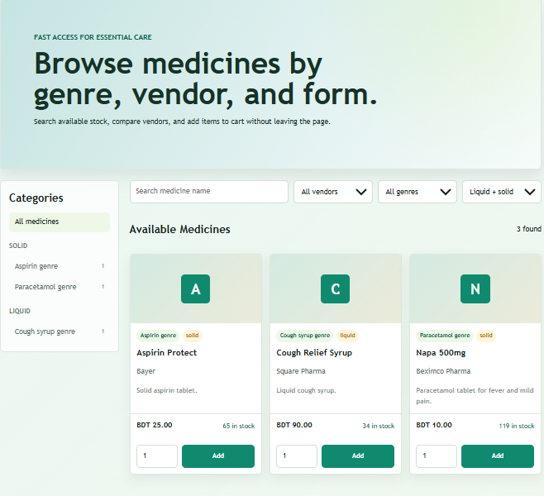
Customer part:
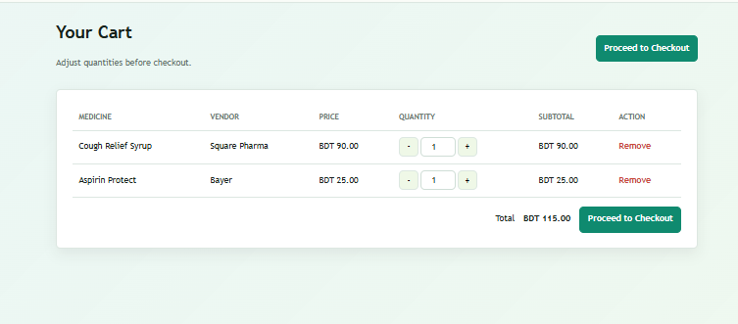
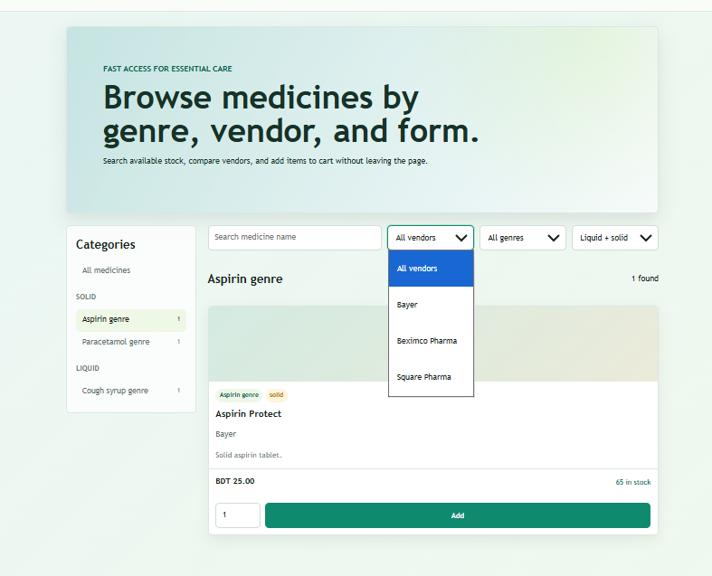
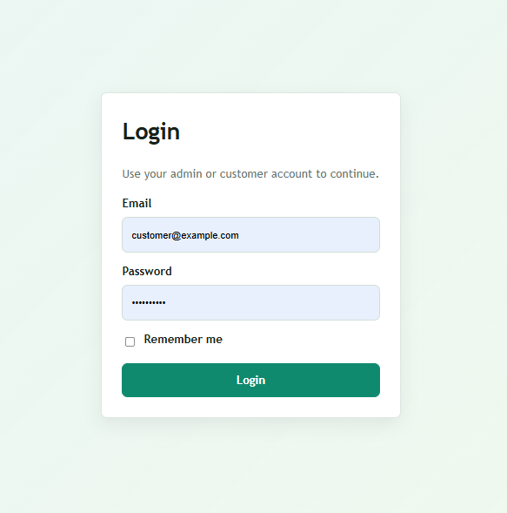
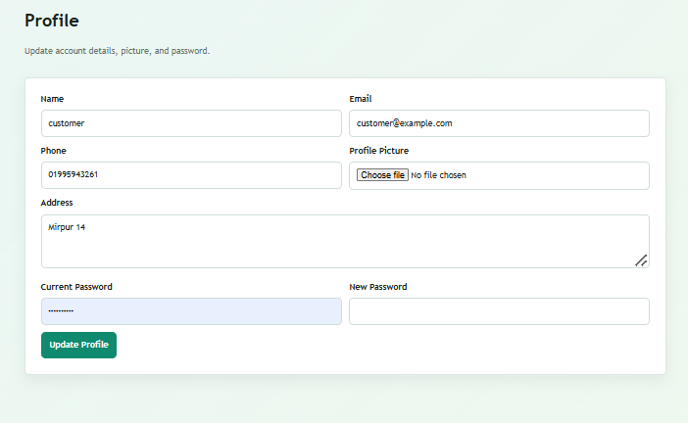
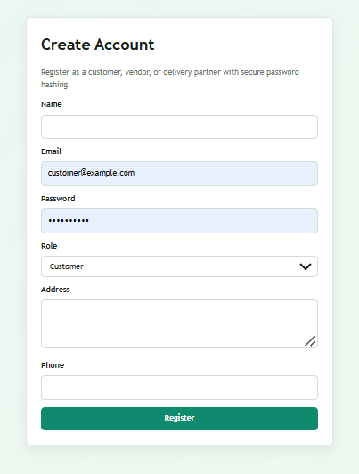
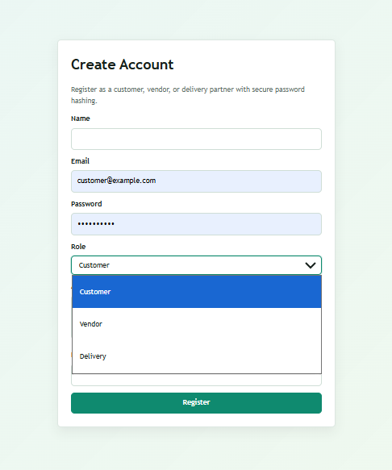

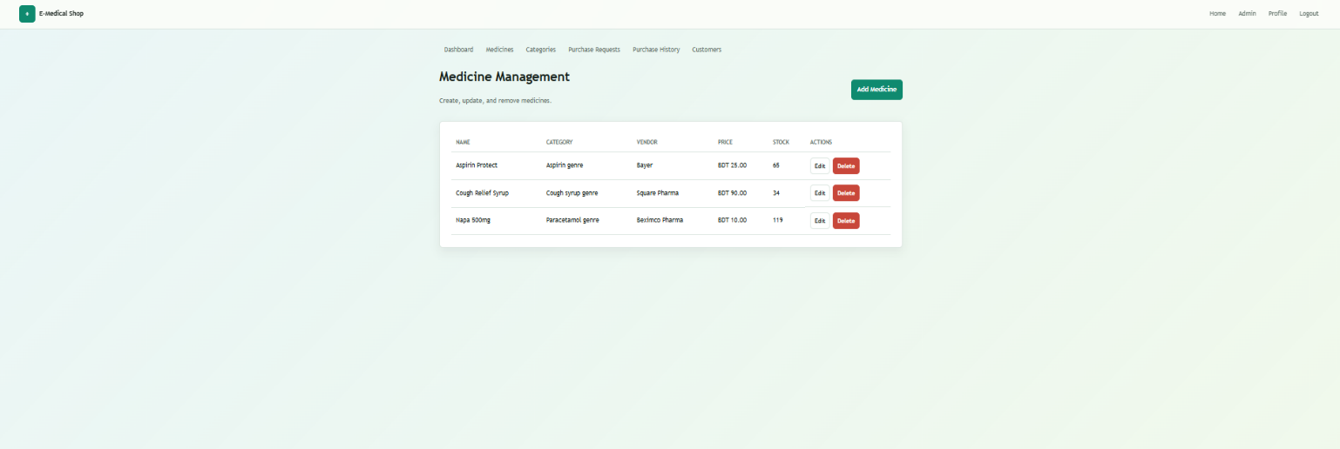
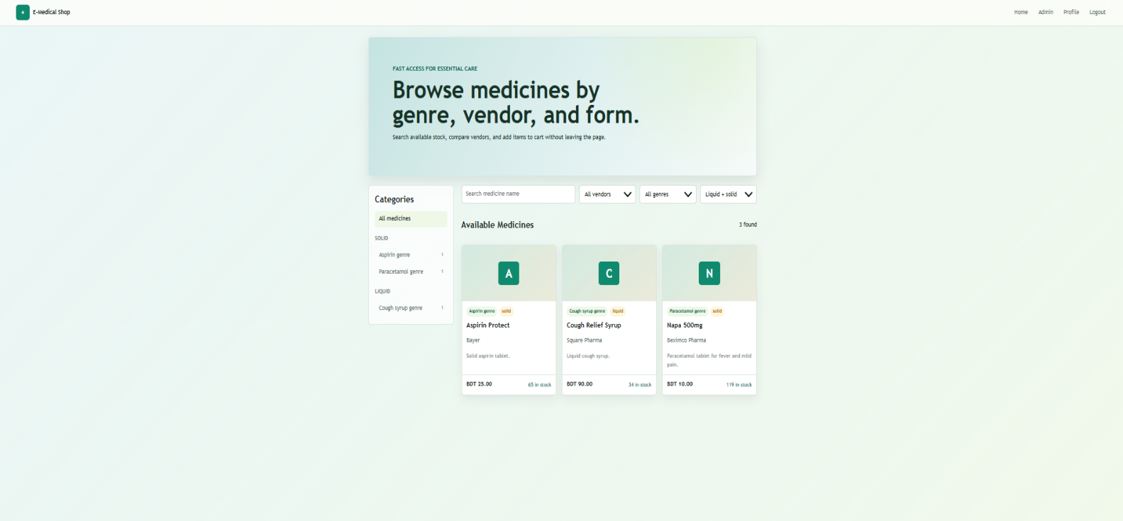
ADMIN PART:

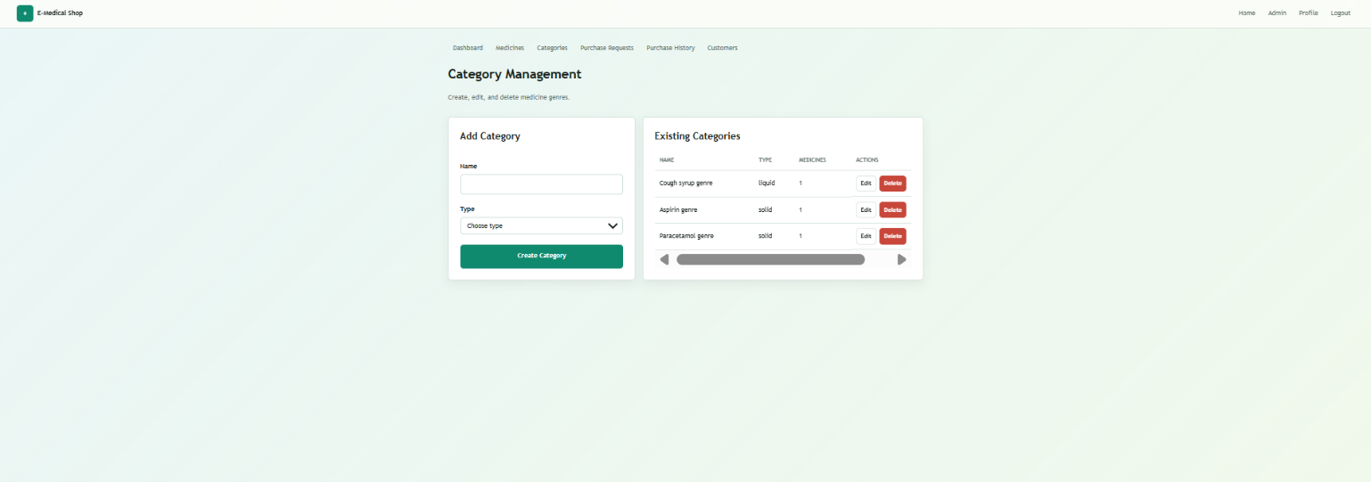
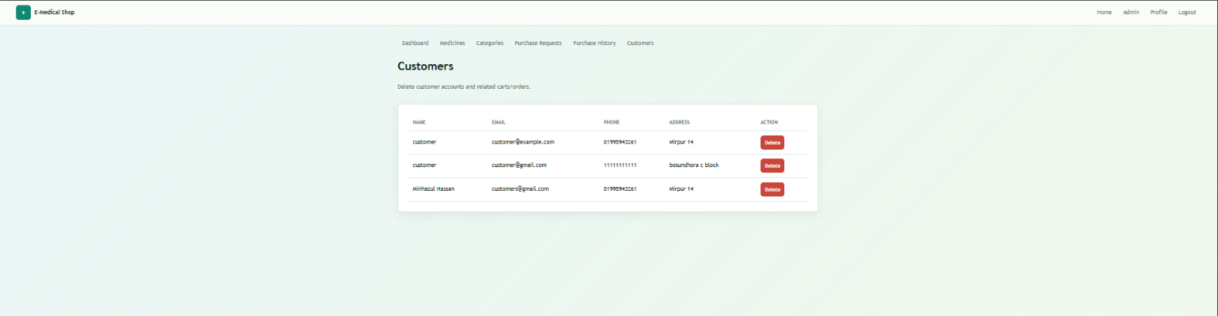




VENDOR PART:





DELIVERY PART:
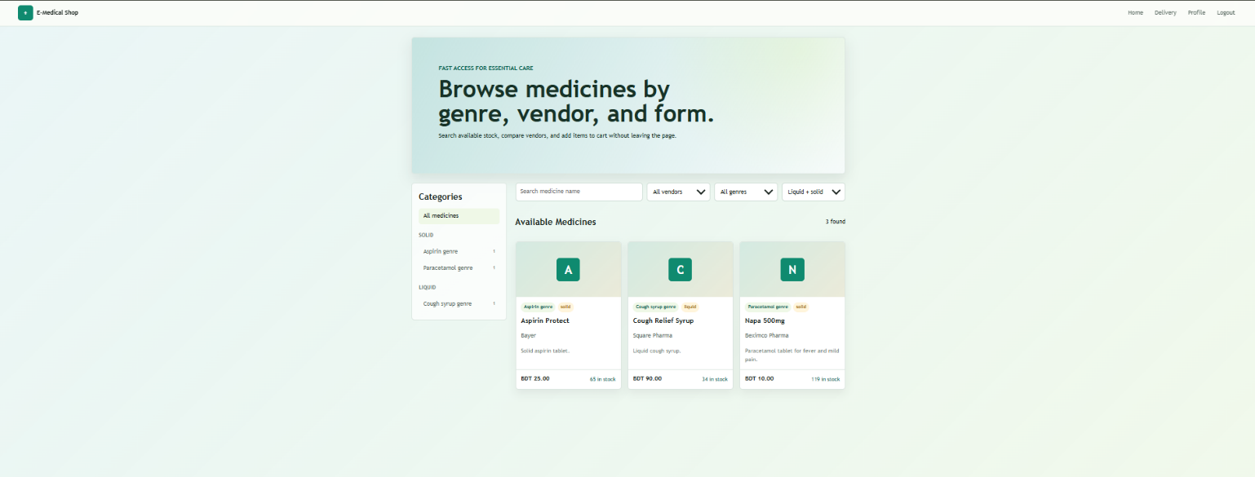


Types of Users
Types of Users: 1. Customer 2. Admin 3. Vendor 4. Delivery
Common Features (Available to All Users)
● Authentication
1. Login to the system
2. Logout from the system
3. User registration (Customer, Vendor, and Delivery only — Admin accounts are pre-provisioned, not self-registered)
● Account Management
1. Change or reset password
2. Manage profile information (view, edit, delete)
● Dashboard
1. Access a personalized dashboard after login
Specific Features by User Type
● Features of User1 (Customer)
1. Browse and search medicines by name, vendor, or category (liquid/solid)
2. Add medicines to the cart and check out with a chosen payment method
3. Track the status and history of personal orders
● Features of User2 (Admin)
1. Manage medicine categories and the complete medicine catalog
2. Accept or reject incoming customer orders and assign a delivery person
3. Manage registered customer accounts and view store-wide dashboard statistics, powered by MySQL stored procedures
● Features of User3 (Vendor)
1. Add, edit, and delete the medicines they personally supply
2. View and update the stock level of their own medicines
3. Supplied medicines automatically appear in the public catalog once approved
● Features of User4 (Delivery)
1. View the list of orders assigned by the Admin
2. See customer address and contact details for assigned orders
3. Mark an assigned order as delivered once completed

N.B: Each user type must have at least 3 distinct features different from the others. Additional features may be added if desired. Proposals with generic, incomplete, or duplicated features across user types will receive reduced marks under the criteria below.

