B.Tech. Major Project (CS499) – Weekly Progress Report 11
Student Details:
- Name: Vicky Prasad and Shivansh
- Roll No.: 22CSE1040 and 22CSE1034
- Supervisor's Name: Dr. Pravati Swain
Reporting Period: [31st October 2025 – 7th November 2025]
1. Progress Summary*
The Fed-Audit-GAN repository is nearing completion, with most of the core functionality, tests, documentation, and CI in place. However, a few final changes and improvements are still required to fully finalize the project. We're in the process of addressing these last details to ensure everything works smoothly and efficiently. After that, we shall conduct a few unit tests to compare and verify the effect of this framework on the fairness of the ecosystem.
2. Tasks Completed This Week*
We’ve made significant progress in finalizing the project. We completed the main codebase and successfully merged the final feature branch into the main branch. As part of our efforts to ensure the code is robust and reliable, we added both unit and integration tests for key modules, addressing any test failures that came up during this process. The training and evaluation scripts for the GAN and federated components have been fully developed and are now working seamlessly. In terms of data, we collected and cleaned a set of example data (MNIST, CIFAR10 etc) that we’ll use in the experiments, ensuring it's ready for further analysis and testing. The README file has been updated with comprehensive setup instructions, usage details, and example commands to make it easier for anyone to get started with the project. To support continuous integration, we’ve set up a simple CI pipeline that runs tests and performs linting checks on every push to the repository.
For now, our folder structure is as follows:

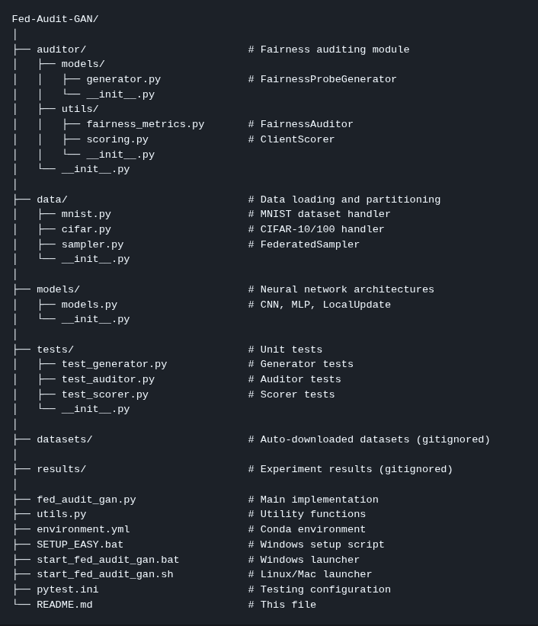
3. Plan for the Upcoming Week*
The plan is to complete the remaining portions of the code and start testing the framework and compare the results of fairness. Then, we’re working to expand our test coverage by adding more end-to-end tests to ensure that all critical workflows are fully covered, and addressing any gaps that remain in the testing suite.

4. Additional Notes*

N/A
Student’s Signature: ___________________
Supervisor’s Remarks: The research progress report is satisfactory / not-satisfactory (if not satisfactory, specific reasons must be furnished separately)
__________________________________________________________________________
Supervisor’s Signature: ___________________

