PS1 Linear Feedback Shift Register

In this assignment, I had to encrypt an image using the LFSR generate command and save that image, then decrypt that image to get the original image using the same LFSR generate command. OO designs that were central to this assignment were classes. An additional implementation that I added to this assignment was that the esc key would close the window.

There was only serious problem I encountered was that I copied and pasted p.r ^ lfsr.generate(5)

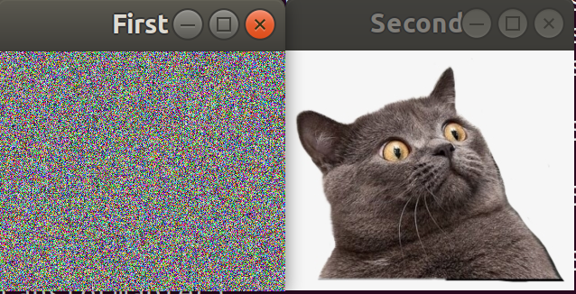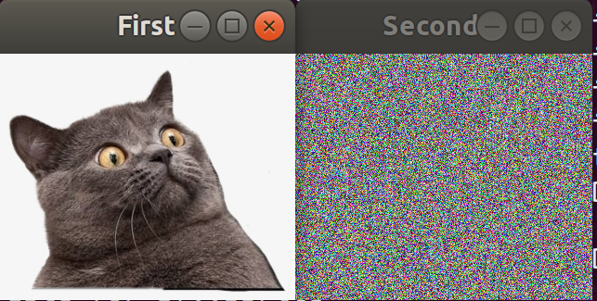for the p.g and p.b and it took me forever to find out what was wrong with it, and the make file.