PS2 Recursive Graphics (Pythagoras tree)

In this assignment, I coded the Pythagoras tree using the SFML library and recursion. A key algorithm I used to design the tree was to set the origin of the left square to the bottom left and the position of the origin to the top left of the previously drawn square, then rotated +45 deg. The right side

was similar which was that I set the origin of the right square to the bottom right and the positon to the top right of the previously drawn square, then rotated -45 deg. Anohter OO design that was central to this assignment were classes. I also implemented an additional functionality where the user could use the right arrow key to step through each recursive step of drawing the tree.

In this assignment I learned how to use recursion to draw recursive objects. The majority of the time I spent on this assignment was figuring out the recursuve part of the assignment because I had a hard time setting the different origins and positions correctly. I also didn't include the drawable class because I do not understand how to implent it, but I just got the adress of the window, so I could

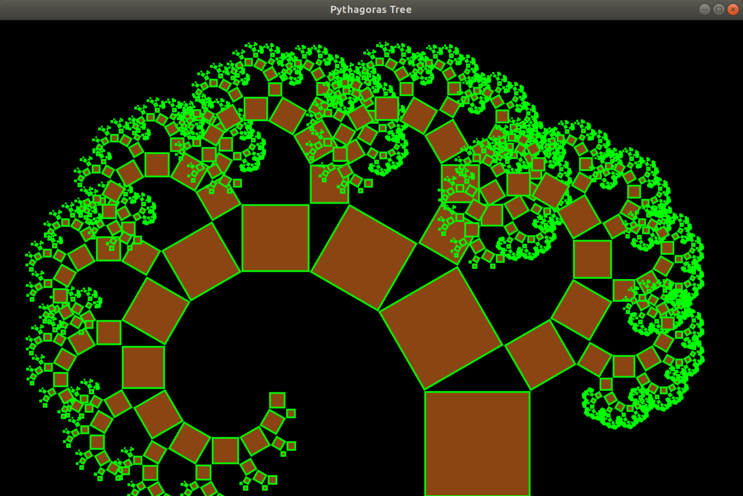draw the shape within the function, which worked fine.