PS3 N-Body Simulation

In this project, I used physics and the SFML library to simulate celestial bodies and gravity graphically. One key OO design that was central to this assignment was the use of classes to create different bodies. In addition to that, I also used unique pointers to be able to draw multiple different sprites for each different celestial body in the simulation. To print the state of the universe at the end of the simulation I just outputted the current x and y positions, and the x and y velocities at the time the window is closed. To make the planets rotate counter clockwise, I just -= for all acceleration and

velocities, because when it was +=, it was going clockwise. Used shared pointers from before. To play the song, I had to change the makefile to include -lsfml-audio in the LIBS, otherwise it didnt work. To display text I had to download a .ttf file to get text, and I also had to look online on how to do it. I also added music and a timer to the program as well.

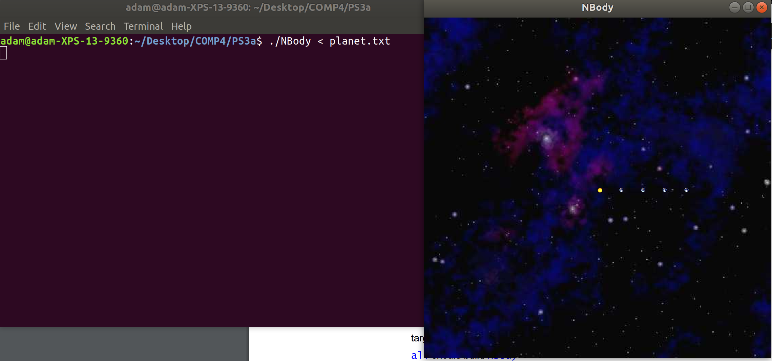 One difficulty was that it took me forever to figure out how to make the planets move reasonably, and I was stuck the majority of the time with the planets just going up, or just going in one direction, or disappearing.