PS4 DNA Sequence Alignment

In this project, I had to use the Needleman-Wunsch method to find the best allignment for two strings. In this assignment OO designs that were implemented were classes, and data structures used were arrays to create a 2d array in order to implement the Needlema-Wunsch method. In this assignment I learned different ways to use valgrind in order to find memory leaks, and the SFML library in order to determine the run time for different sequences.

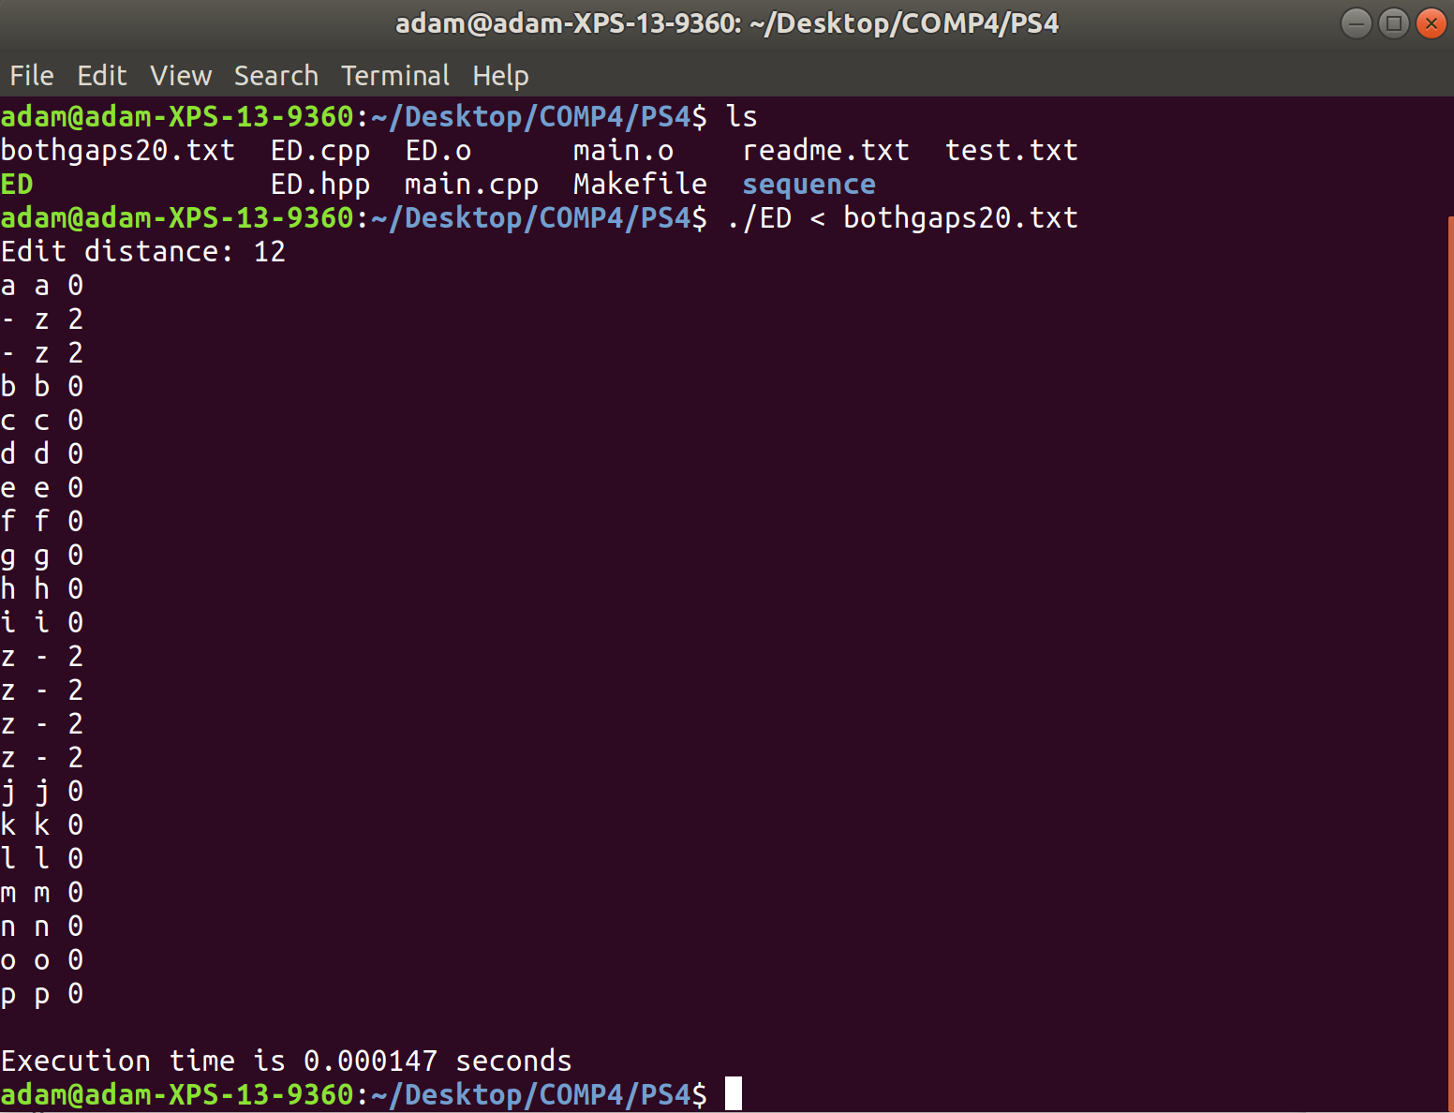 One problem that I ran into was that I got stuck on how to delete a 2d array to get rid of memory leaks, but to solve this problem I used google to help me with it.