PS5 Guitar Hero

In this assignment, I had to use the SFML library and a ring buffer to play different sounds when different keys were pressed. OO methods that were used in this assignment were classes, and data structures that were central to the assignment were vectors. Another key algorithm that was central to this assignment was queues. In this assignment I created a stack for queue, then implemented enqueue, dequeue, isfull, isempty, and peek for the queue stack. I also implemented a few other functions to help

me debug my code while I was writing it such as size, print, and get.

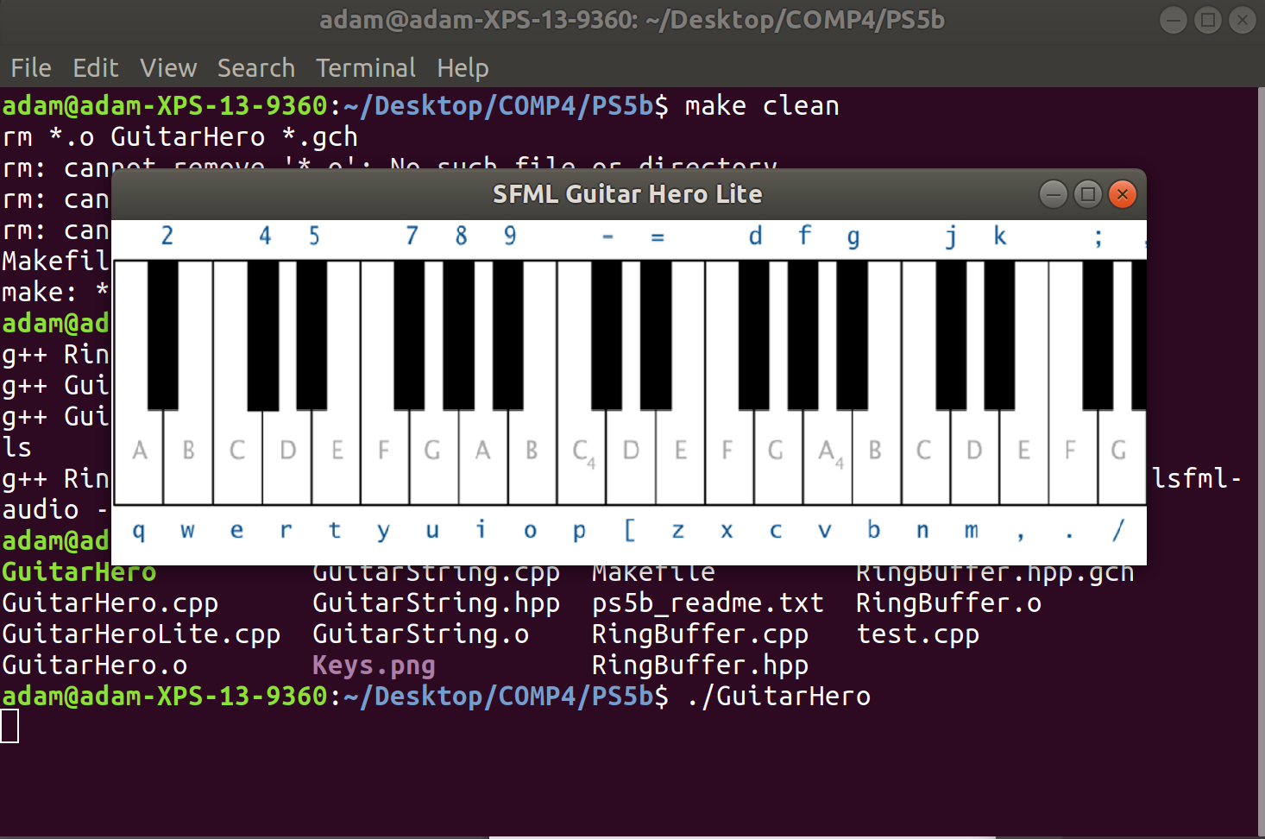 One issue I had with this assignment was that only two of the keys on the keyboard that were supposed to create sounds did not create any sound.