PS6 Airport Simulation (C++ Concurrency)

In this assignment, I had to simulate landings of multiple airplanes on multiple runways at Logan Airport. Use thread and mutex to run multiple threads of code at the same time, which simulated multiple landing lanes landing at the same time. OO design was mutex, and using switch statements to lock and unlock different runways when they were in use. In this assignment I implemented switch statement to check if lanes are being used by different planes.

I learned how to use thread and mutex libraries to run multiple different threads at the same time. One issue I had was that the first time I ran Airport_Sync the planes crashed after a few seconds,

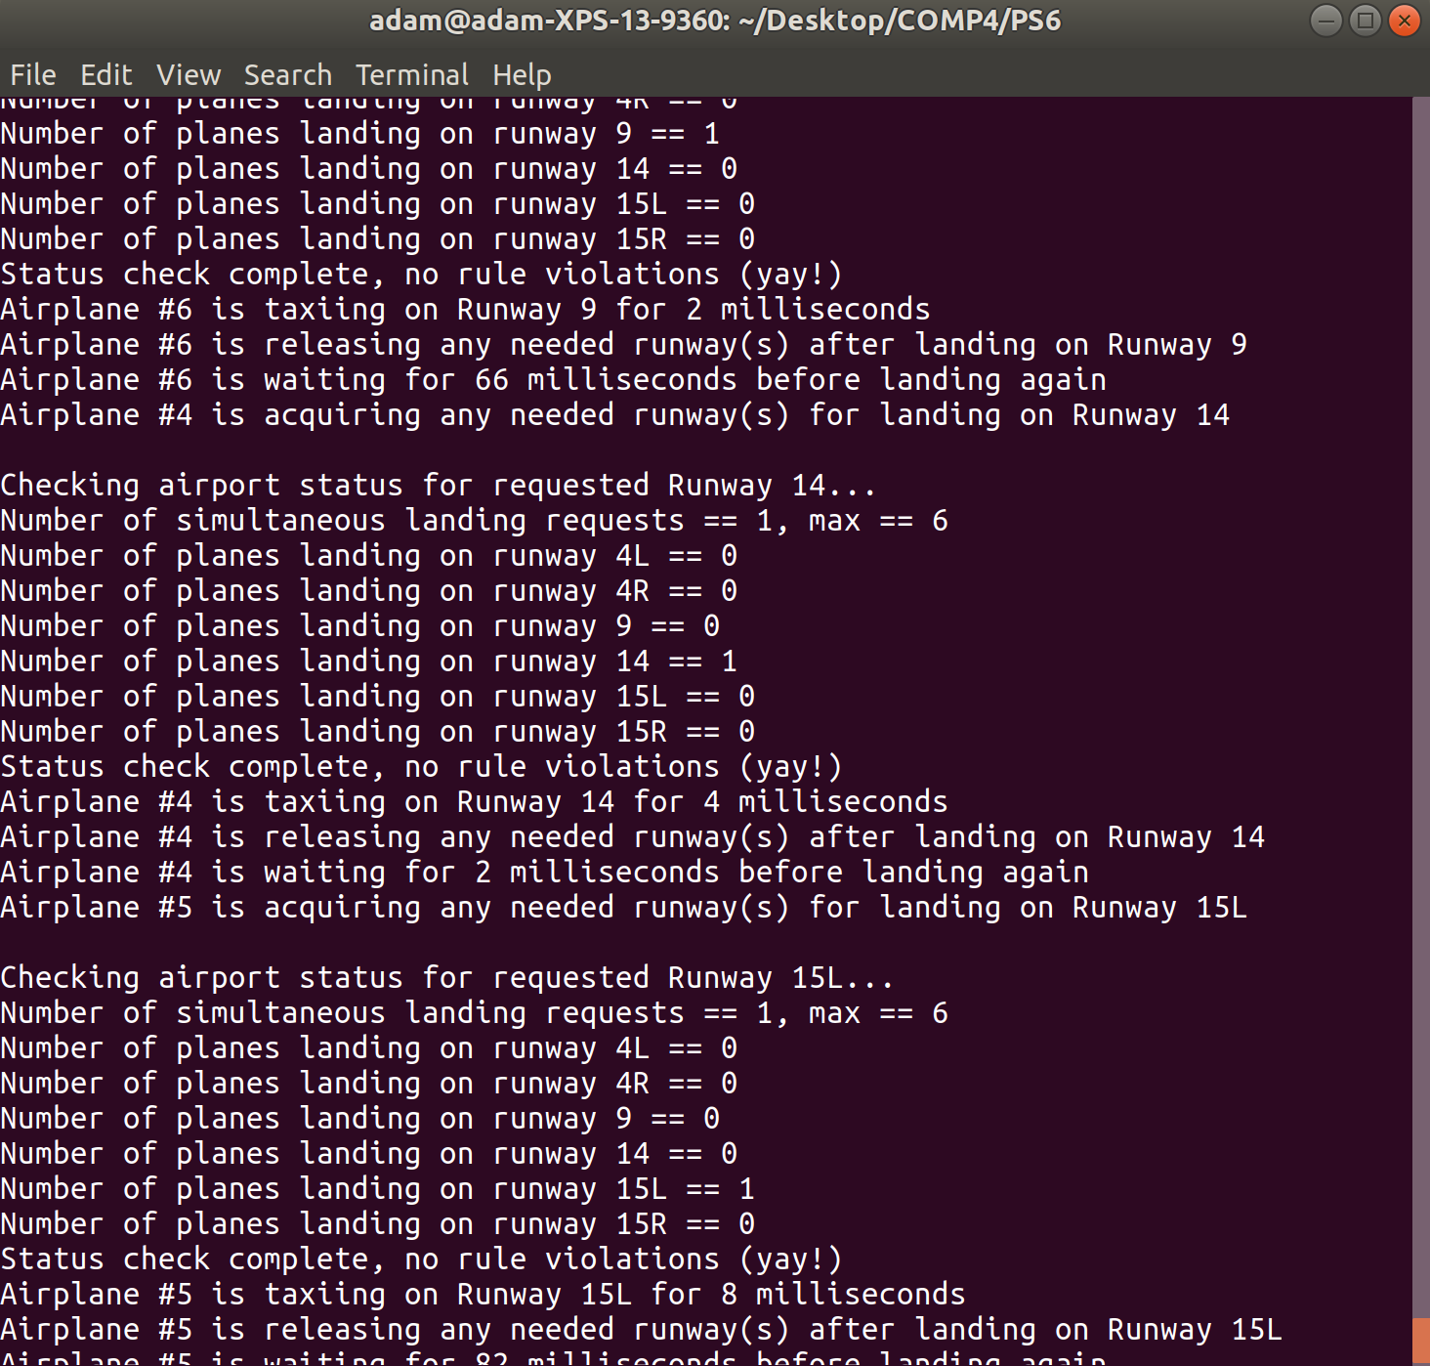but after that it ran fine, for 15 min. I do not know what caused this, so if this happens when you test it for the first time, try again and it might fix itself. Another problem I had was that my terminal only saves 10000 lines so my output.txt only has 10000 output lines.