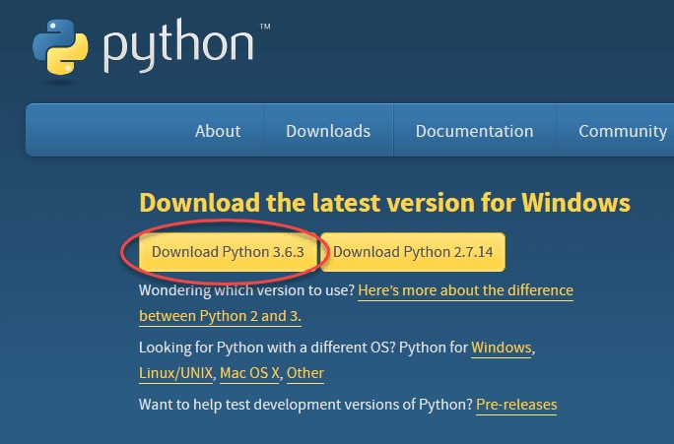

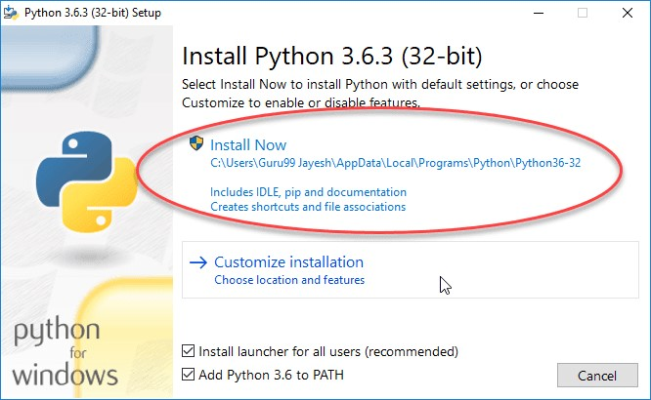

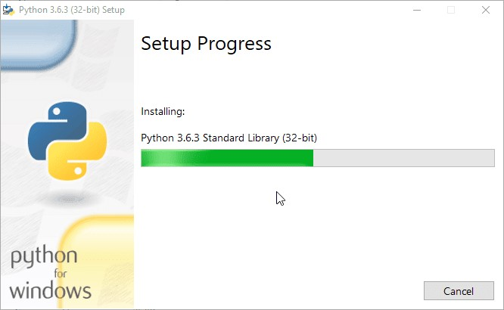

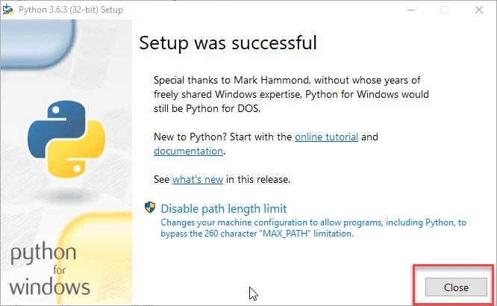



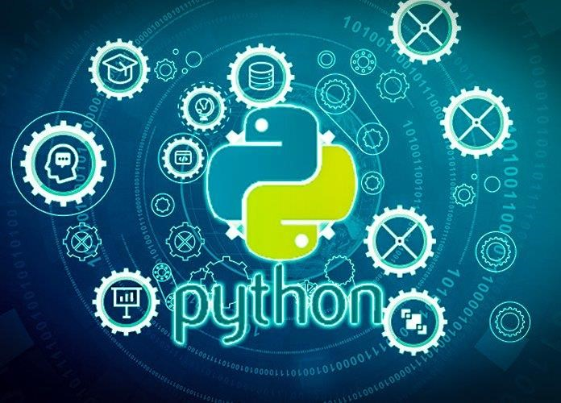

**KEY DIFFERENCE**

* Python 3 syntax is simpler and easily understandable whereas Python 2 syntax is comparatively difficult to understand.
* Python 3 default storing of strings is Unicode whereas Python 2 stores need to define Unicode string value with "u."
* Python 3 value of variables never changes whereas in Python 2 value of the global variable will be changed while using it inside forloop.
* Python 3 exceptions should be enclosed in parenthesis while Python 2 exceptions should be enclosed in notations.
* Python 3 rules of ordering comparisons are simplified whereas Python 2 rules of ordering comparison are complex.
* Python 3 offers Range() function to perform iterations whereas, In Python 2, the xrange() is used for iterations.

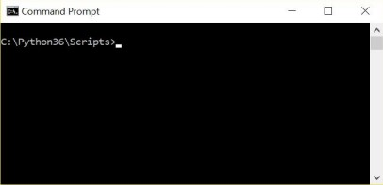

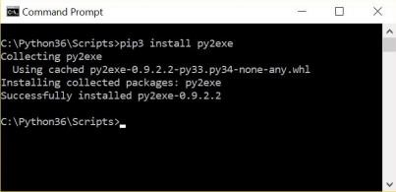

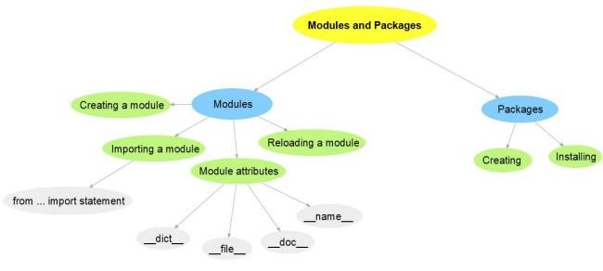

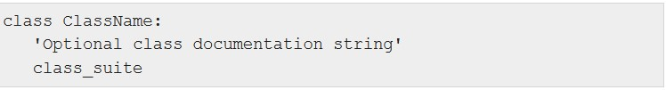

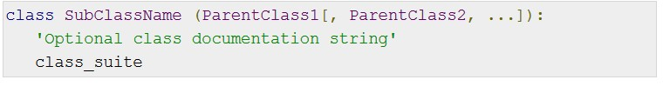

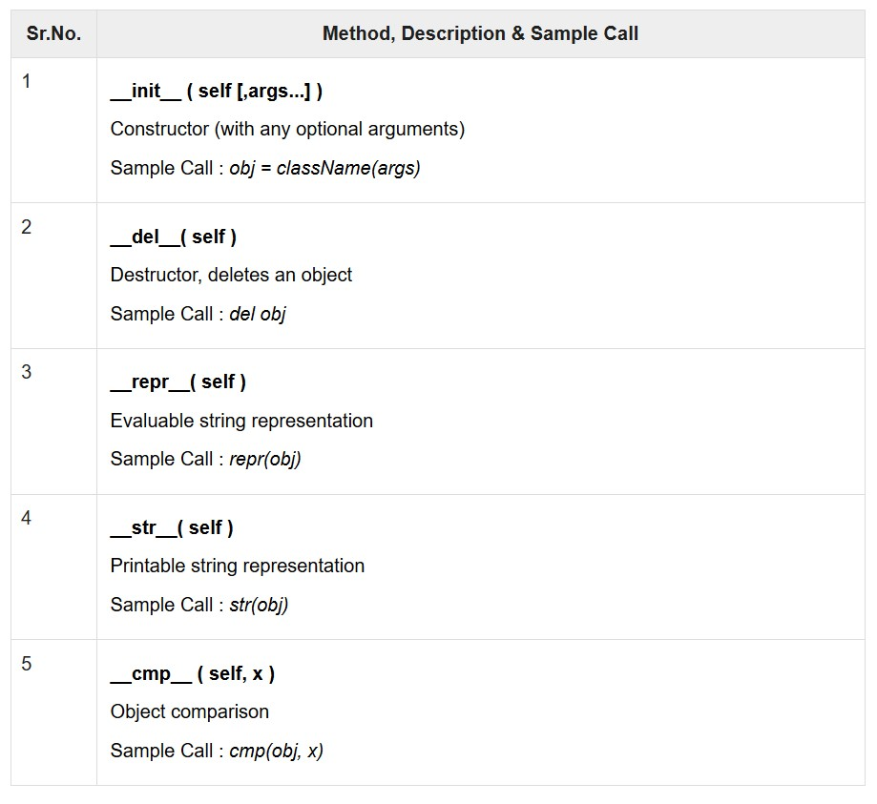

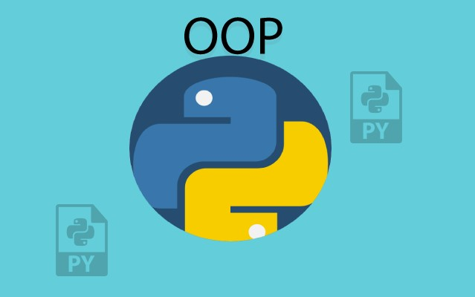

|  |  |
| --- | --- |
| Application window | A container widget inside which other elements are arranged |
| Button | An area on which a mouse click triggers some operation |
| Textbox | Reads text input from a keyboard |
| Radio button | Allows a user select one of several options |
| Checkbox | Allows a user to select one or more of several options |

