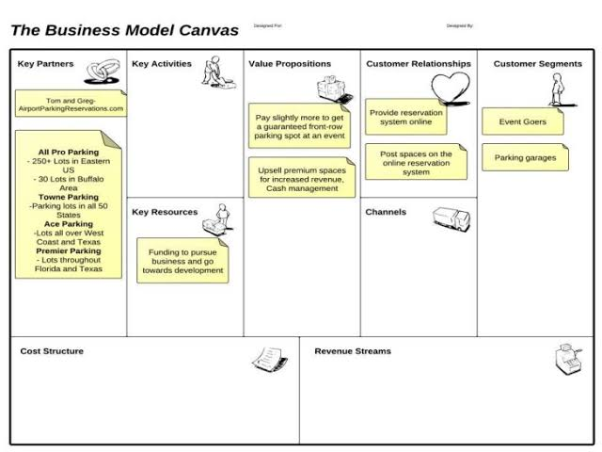

1. Gps-Rs200
2. Model car-Rs 100
3. Node-mcu -Rs 200
4. Total-Rs 500
5. Tota

Team members contribution

Wwww.google.com

https://github.com

Easy way to know empty parking area nearby

Especially in case of emergence

Friendly GUI

Easy to understand by people of all age group

Here we have chosen the strategy mainly inspired by “truecaller app” and have chosen to follow their marketing strategy.

Our strategy mainly consists of having tie-up with parking space owners for initial phase of the up.

Promotion of app through social media and digital marketing

It is both highly profitable yet very difficult situation that our target user is essentially anyone with a vehicle whether it is automobile such as car, scooter or bike aur non-automated vehicles such as bi-cycle basically anything that requires parking.

Parking space owners for initial phase.

Real-time database to inform location and availibility of parking slots.

about the vacant parking places

The Parking Problem