SYSTEM OVERVIEW
The main objective of this work is to reduce the human death rate in road accident. The paper proposed a system to give quick assistance to the people who got the accident. The fall detection and reporting system for the vehicle can gain the attention because the system will save the life and give medical treatment on time. The system consists of Nodemcu micro-controller unit, MEMS accelerometer,crash controller, GPS device, GSM module . An Accelerometer is used to detect the acceleration. It is the main sensor used to detect the accident.The crash sensor gets active too,measure this acceleration and relay it to the control unit as usable data.Once the accident is detected GPS collect the current position values which include latitude (N or S), longitude (E or W), date and time. The location values are given to microcontroller. Controller gives this information to GSM module. By using GSM module we can send the message to family members or EMS. The RS232 communication standard is used for the electrical signal characteristics such as voltage levels. This communication enables point to point data transfer. A high performance 16/32 bit microcontroller unit is used to process and store real time signal from the accelerometer and various sensor . All the data of these sensor and GPS data are stored in memory card for analysis of accident cause. The total system is placed inside a vehicle which is not visible to others. We can implement robust package design so that system is safe from water and dust.
Hardware
- Nodemcu
- MEMS accelerometer
- Crash sensor
- Vibration sensor
- Led
- Buzzer
- GSM modem
- GPS device
1.Nodemcu
Nodemcu is an open source IoT platform. It includes firmware which runs on the ESP8266
Wi-Fi SoC from Espressif Systems, and hardware which is based on the ESP-12 module. The term "NodeMCU" by default refers to the firmware rather than the development kits.
NODEMCU
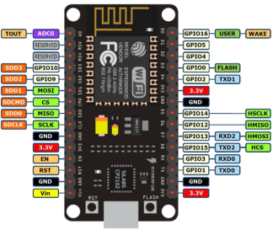

2.MEMS Accelerometer
An accelerometer is electromechanical device that measure acceleration forces. These forces may be static, like the constant force of gravity pulling at our feet, or they could be dynamic-caused by moving or vibrating the accelerometer. Accelerometers are sensor or transducers that generally measures acceleration forces applied to body by being mounted directly on to a surface of the accelerated body. Accelerometer in terms of ‘g’ (‘g’ is acceleration measurement for gravity which is equal to 9.81 m/s2). It is useful in detecting motion of the object. The MMA7361L is 3-axis accelerometer. It is low profile capacitive MEMS sensor featuring low pass filter, temperature compensation and g-Select which allows for the selection among two sensitivities (1.5g / 6g). MMA7361L mostly used for free fall detection, car crashes detection, tilt and motion sensing, text scroll, image stability etc.

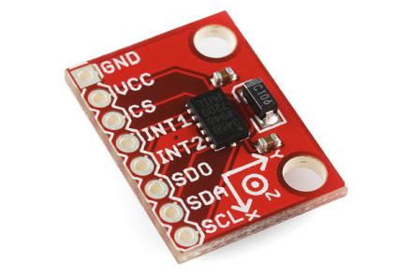
Accelerometer

3.Crash Sensor
Crash sensors need to detect a collision and convert it to usable signals within milliseconds. The accelerating forces acting on the sensors after a collision can be as high as 100g (100 times the earth's gravitational force). When a car is stopped abruptly by an impact, all bodies or objects that are not firmly fixed to the car will continue to move at the impact speed. The sensors measure this acceleration and relay it to the control unit as usable data.
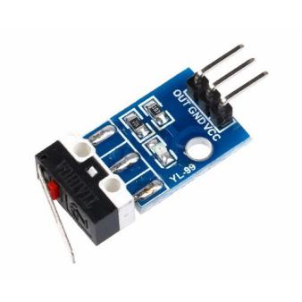
Crash Sensor

4.VIBRATION SENSOR
Vibration sensors, also known as piezoelectric sensors, are versatile tools for the measurement of various processes. These sensors use the piezoelectric effect, which measure changes in pressure, acceleration, temperature, strain or force by converting them to an electrical charge
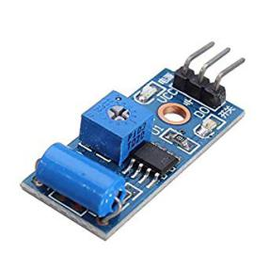
VIBRATION SENSOR

5.LED
A light-emitting diode is a semiconductor light source that emits light when current flows through it. Electrons in the semiconductor recombine with electron holes, releasing energy in the form of photons.Here will be using led to to gain attention of people towards accident spot of accident which will alert other vehicles and prevent further accidents.
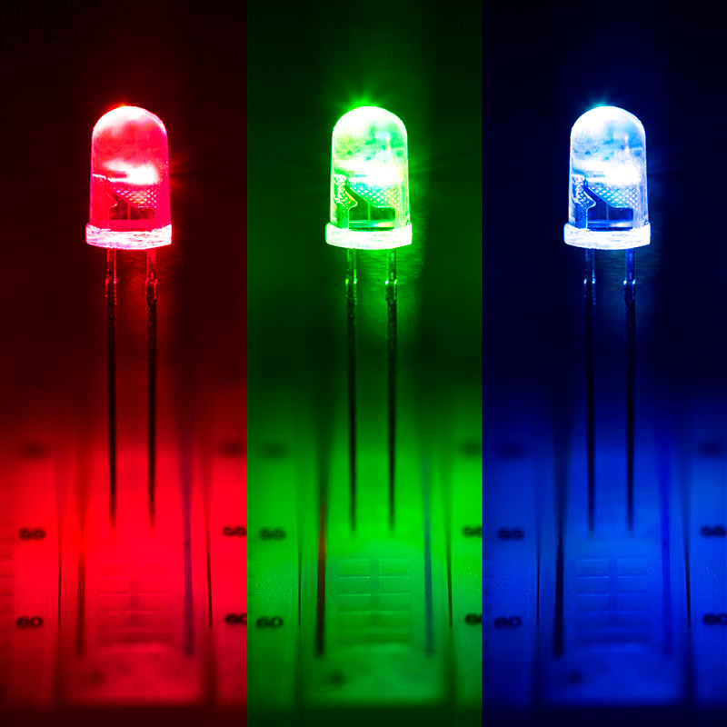
LED
6.BUZZER
A buzzer or beeper is a signalling device, usually electronic, typically used in automobiles, household appliances .It most commonly consists of a number of switches or sensors connected to a control unit that determines if and which button was pushed or a preset time has lapsed, and usually illuminates a light on the appropriate button or control panel, and sounds a warning in the form of a continuous or intermittent buzzing or beeping sound.Here we will use buzzer to alarm people and draw attention towards accident spot.
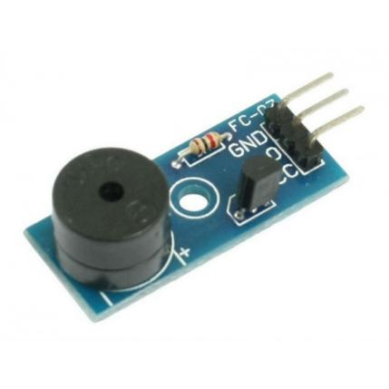
BUZZER

7.GSM MODEM
GSM is global system for mobile communication and used to send message to pre-programmed number. A GSM modem is a specialized type of modem which accepts a SIM card and operates over a subscription to a mobile operator just like a mobile phone. From the mobile operator perspective a GSM modem looks just like a mobile phone. A wireless modem behaves like a dial modem. The main difference between them is that a dial-up modem sends and receives data through a fixed telephone line while a wireless modem sends and receives data through radio waves. Advantages of using this modem will be that you can use its RS232 port to communicate and develop embedded applications. Application like SMS control, data transfer, remote control and logging can be developed easily. The SIM 900 is complete Quad- band GSM/GPRS solution in a SMT module which can be embedded in the customer applications. Featuring an industry standard interface, the SIM 900 delivers GSM/GPRS 850/900/1800/1900 MHz performance for voice, SMS, data and Fax in a small form factor and with low power consumption. With a tiny configuration of 24mm*24mm*3mm, SIM 900 can fit almost all the space requirement in your M2M application, especially for slim and compact demand of design. SIM900 features GPRS multi slot class 10/ class8 (optional) and supports the GPRS coding schemes CS-1, CS-2, CS-3 and CS-4. GSM modems support an extended set of AT commands.

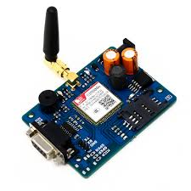
GSM MODEM

8.GPS SENSOR
(GNSS) that provides reliable location and time formation in all weather and times anywhere on the globe. When people talk about a GPS, they usually mean a GPS receiver. GPS used a constellation of 27 earth orbiting satellites (24 in operation and three extras in case one fails). These satellites, which are equipped with atomic clocks, transmit radio signal that contain their exact location, time and other information. The GPS satellites act as a reference point from which receivers on the ground detect their position. Ground station precisely monitor the orbit of every satellite and by measuring the travel time of the signal transmitted from the satellite four distances between receiver and satellites will yield accurate position, direction and speed. Though three-range measurements are sufficient, the fourth observation is essential for solving clock synchronization error between receiver and satellite. Whichever the modem is used it works based upon the NMEA 0183protocol. Basically, a GPS receiver determines four variables: longitude, latitude, height and time.
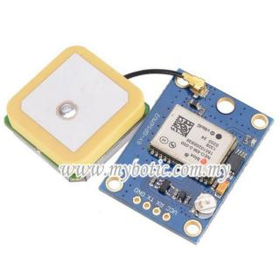
GPS SENSOR

METHODOLOGY
The system design for accident detection and reporting is based on ARM and GPS. When vehicle meets an accident, at that time the accident will be detected by accelerometer. MEMS accelerometer sensor can be used as a shock detector of vehicle during and after crash. At that time vibration sensor is used as alarm application to gain attention of people towards accident spot. According to this project when a vehicle meets with an accident, a Micro elector mechanical system (MEMS) sensor will detects the signal and sends it to ARM controller. Immediately micro-controller sends the signal to GPS module to collect the current position co-ordinates values which contains longitude (N or S), latitude (E or W), time and date. After that the micro-controller sends the alert message to family member or emergency medical service (EMS) through GSM modem which contains GPS parameter values. Due to this alert message we can provide immediate medical treatment at accident location and victim can get the treatment as fast as possible. If the vehicle meets with a small accident or no serious injuries to people then we can send a message only to the trusted contact “we are safe”in order to save the valuable time of emergency medical service.The mobile number of the user should be included in the software programming in order to receive the accident location values from the SIM card which we are using in GSM modem. Here one switch is provided to send a message we are safe, when there is no serious injury happen. Due to this we can save the valuable time of emergency medical services.

MEMS SENSORS
GSM

MICRO
CONTROLLER

CRASH SENSOR
GPS

LED
VIBRATION SENSOR
BUZZER

BLOCK DIAGRAM

Working of Automatic vehicle accident detection
Step1: Initially, the MEMS sensor is kept in one direction ie, indicating that the vehicle is safe.
Step2: The kit is powered up by the energy from engines located in the vehicles.
Step3: When an accident occurred, the angle or direction of the MEMS sensor changes. These changes are considered to be input and the process starts.
Step4: The crash sensor gets active,measure this acceleration and relay it to the control unit as usable data.
Step5: The vibration sensor and led gets active simultaneously ,alarming people nearby and drawing attention towards the accident spot.
Step6: The GPS locates the exact position of the vehicle by the latitude and longitude.
Step7: These values are initially read in0’s and 1’s by the circuit and then converted to normal value.
Step8: Here we use GSM that sends the emergency message to the medical assistance and trusted contact and in case of small accident only to the trusted contact in order to save the valuable time of emergency medical service.
Step9: The SIM is fitted and an emergency message consisting of the location (google map link) is been sent to the family and rescue team.

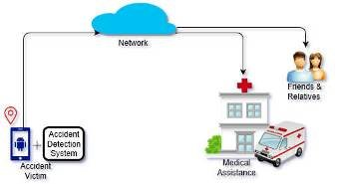

DESIGN OF ACCIDENT DETECTION SYSTEM

