9/10/15

**PID: Service-Oriented Systems Modelling**

**Module: SE3IP13 Project ID:223**

**Stefan manning**

# Supervisor Checklist

|  |  |  |  |
| --- | --- | --- | --- |
| Primary Supervisor | Lilly Sun | | |
| Secondary supervisor |  | | |
| Supervisor’s check: For each item below the supervisor should circle ✓ if it is satisfactory for this stage of the project; if it is not satisfactory then the supervisor should circle 🗶 and add a suitable comment to indicate the deficiency. The supervisor should then sign below to confirm the ✓,🗶 and comments. | | | |
| **CHECKLIST** |  | Comments, concerns and recommendations | |
| Background | **✓ 🗶** |  | |
| Problem statement | **✓ 🗶** |  | |
| Technical Products | **✓ 🗶** |  | |
| Crosscheck | **✓ 🗶** |  | |
| Purchases | **✓ 🗶** |  | |
| Health & Safety | **✓ 🗶** |  | |
| Social, Legal & Ethical | **✓ 🗶** |  | |
| References | **✓ 🗶** |  | |
| Project Plan | **✓ 🗶** |  | |
| **Supervisor’s Signature** |  | | **Date:** |
| **Submission rules: The PID, with this form completed and signed by the supervisor, must be handed in to the student information centre (G47) AND submitted online on Blackboard by Friday 9th October 2015. If the deadline is not met, the student will face a penalty of 5 marks being deducted from their overall module mark. It is expected that students will address any comments noted by their supervisor on this form in due course.** | | | |

Contents

1 Supervisor Checklist 1

2 Introduction 2

3 Background 2

4 Problem Statement 2

4.1 Objectives 2

4.2 Constraints 3

4.3 Assumptions 3

5 Technical Products 3

6 Crosscheck of Approach 8

7 Purchases 8

8 Health and Safety 8

9 Legal and Ethical Issues 8

10 Examination Products 8

11 References 10

12 Project Plan 10

12.1 Work Breakdown Structure 10

12.2 Time Plan 11

13 Appendix 15

# Introduction

This document specifics what and how Service Oriented Architecture (SOA) project is to be delivered. As in any project there are many uncertainties and they are identified where possible using the term TDB (to be decided) or are in the risk assessment.

The motivation for this project is summarised in section 3, with objectives and assumptions present in section 4. The products that are going to be developed to meet these objectives are presented in section 5.

This project will be undertaken as part of the final year project module (SE3IP13), this has its own requirements which are listed in section 12 and be delivered as part of this project.

Project plan (section 12) and cross check of products (section 6) will show that this project is feasible within the given time frame and that all objectives will be met. This ensures a successful project.

Legal, health, ethical and safety issues are addressed in sections 8 and 9. All references, terms, guides and research in this document are listed in section 11.

# Background

# Problem Statement

## Objectives

## Constraints

## Assumptions

# Technical Products

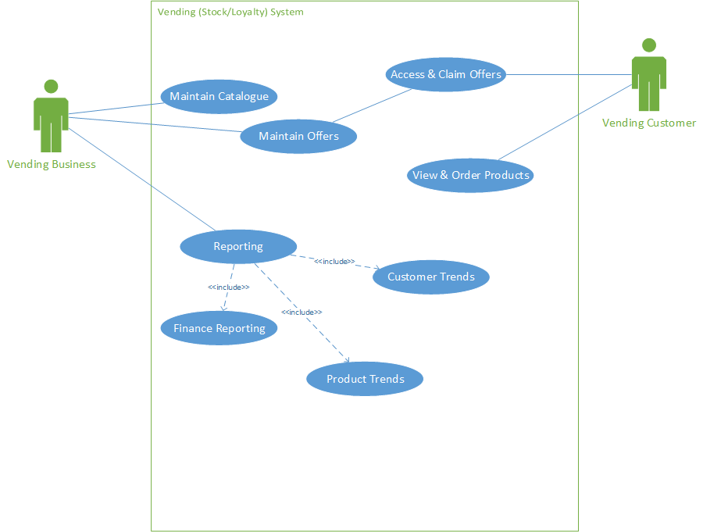

Figure : UML Use case Diagram

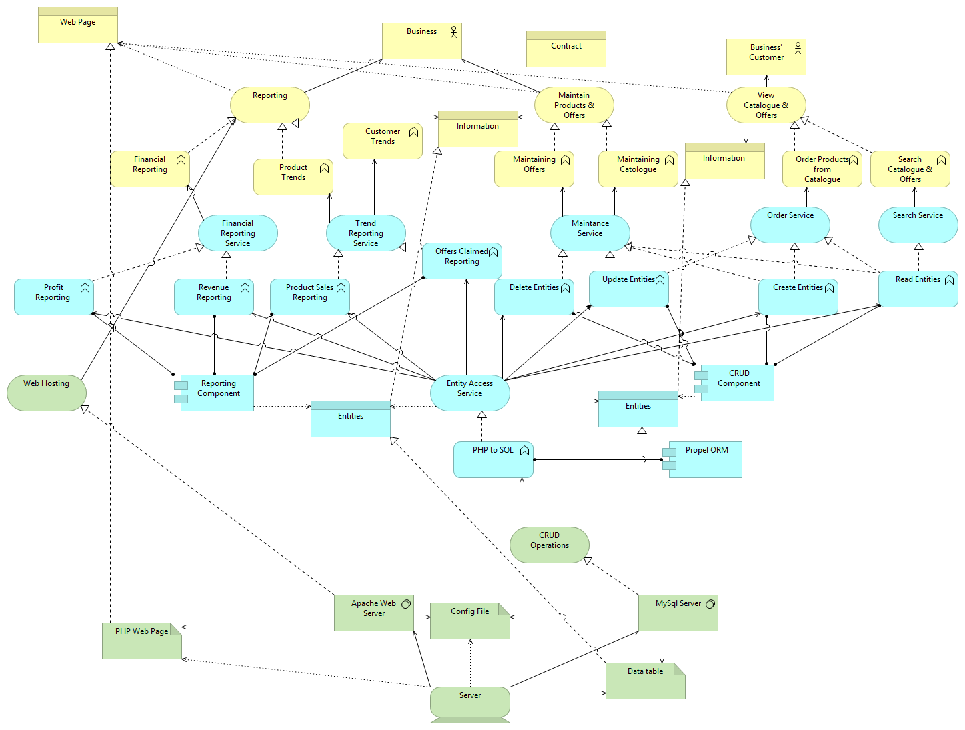

Figure 3 Tier systems architecture

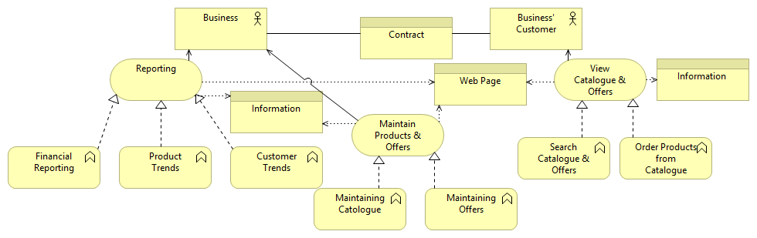

Figure Business system architecture

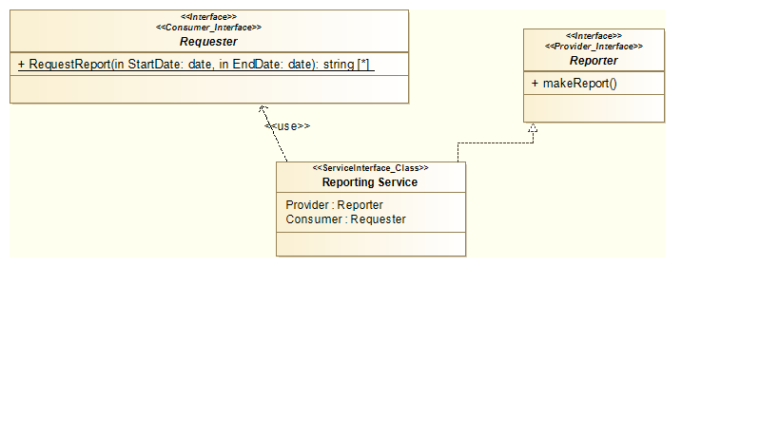

Figure SOAML Reporting Service Interface Diagram

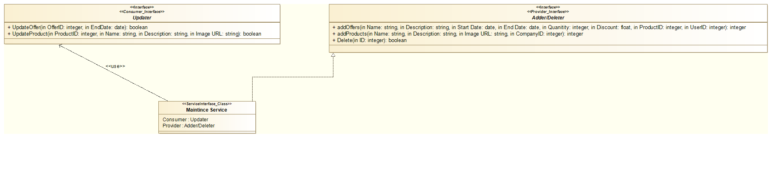

Figure SOAML Maintenance Service Interface Diagram

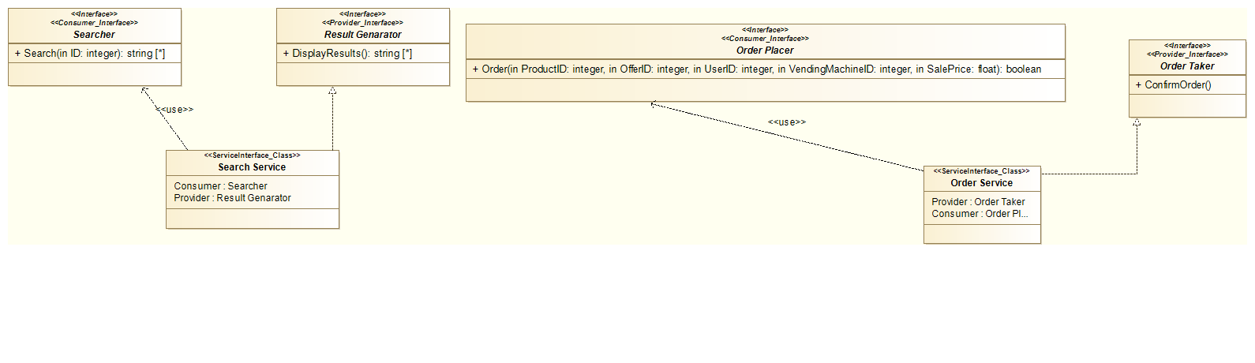

Figure SOAML Search & Order Service Interface Diagram

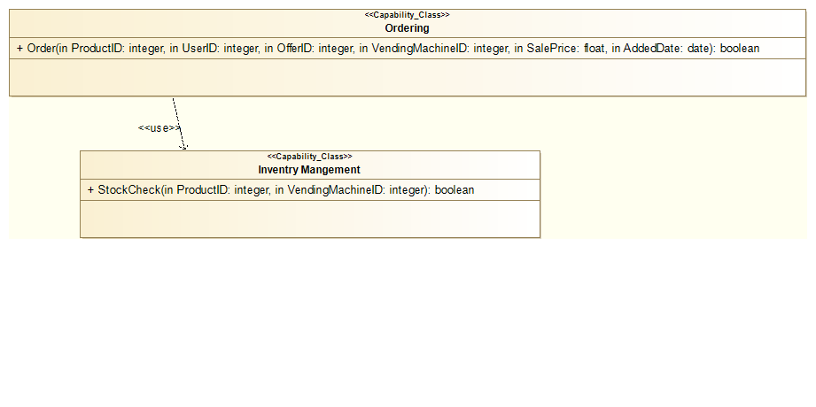

Figure SOAML Ordering Capability Diagram

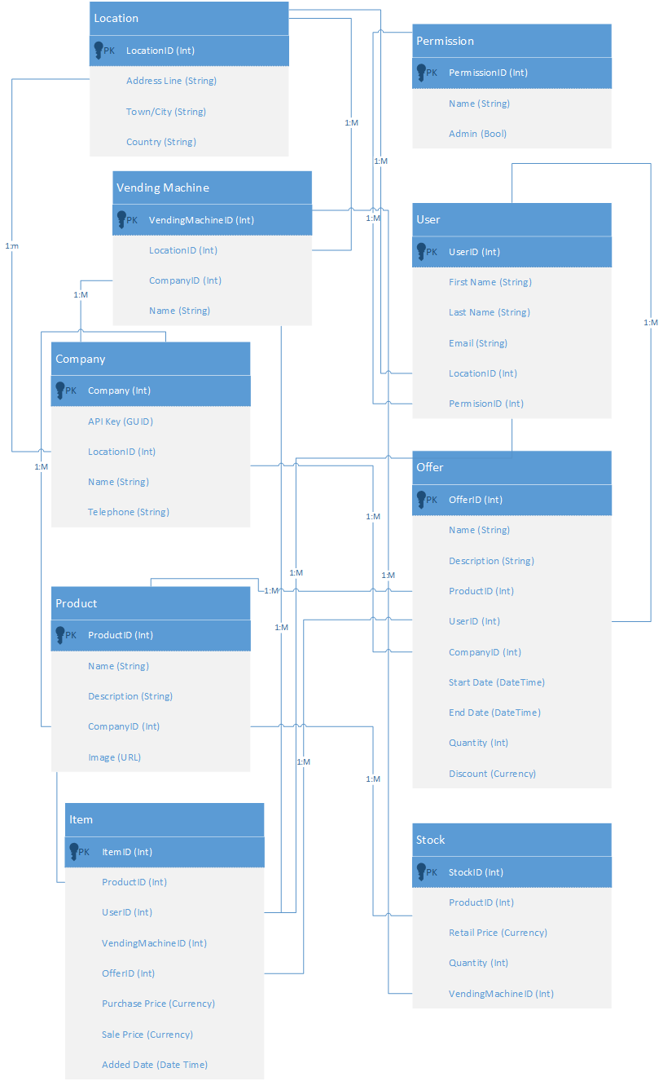

Figure UML Database ER Diagram

# Crosscheck of Approach

# Purchases

There will be no purchases need for this project as any and all libraries or 3rd party APIs will be open source or have MIT, Apache or Creative commons licences.

# Health and Safety

# Legal and Ethical Issues

# Examination Products

The products that need to be delivered in order to meet the examination criteria are as follows. However some criteria may change during this project affecting the resulting products, as well as some criteria still to be decided (TBC).

**EX1. Name**: PID

* **Short Description**: The document that initiates this project and guides it thereafter.
* **Acceptance Criteria**: The PID must be written as a Microsoft Word or PDF document in compliance with the format and content instructions indicated in this document (the PID Master). All sections should be complete to a reasonable depth and quality, consistent with the stage of the project, that satisfies the technical judgement of the project supervisor and, if appropriate, the Company Partner. The sign offs on the cover page will be completed.

**EX2. Name**: Autumn Term Week 6 Logbook Check

* **Short Description**: A formal check of project progress based on the logbook.
* **Acceptance Criteria**: The Student Information Centre staff, and Project Co-Ordinator if necessary, must be convinced the project progress has been sufficient to date and that this progress has been adequately recorded in the logbook. The logbook must include a sign-off sheet that indicates that the logbook has been assessed by the supervisor on a weekly basis.

**EX3. Name:** Project Progress Review

* **Short Description**: A formal check of project progress based on a checklist form.
* **Acceptance Criteria**: The ‘Project Progress Review Individual Form’ must be completed by the student and supervisor and signed and submitted by the appropriate deadline.

**EX4. Name**: Spring Term Week 6 Demonstration

* **Short Description**: A formal presentation of the executable technical products of the project to the project supervisor and internal moderator.
* **Acceptance Criteria**: During Week 6 of Spring Term, the student must demonstrate their project to their supervisor and internal moderator. The demonstration should show that the project’s technical products are on track to be completed by the end of the project.

**EX5. Name**: Poster

* **Short Description**: A poster summarising a significant aspect of your work.
* **Acceptance Criteria**: A poster is constructed based on the template (TBD). It will be of a quality typical of an academic conference poster presentation. The content will introduce and explain some aspect, claim of other facet of the project that the student deems most interesting and which is agreed by the supervisor.

**EX6. Name**: SCARP Abstract

* **Short Description**: An abstract in a form typical of an academic conference.
* **Acceptance Criteria**: The abstract is written according to the academic template (TBD). It will summarise the project with a focus on its achievements with respect to the objectives and technical products and what was learned.

**EX7. Name**: SCARP Paper

* **Short Description**: A short paper in a form typical of an academic conference.
* **Acceptance Criteria**: The paper is written according to the academic template (TBD). It will describe the project with a focus on its achievements with respect to the objectives and technical products and what was learned.

**EX8. Name**: Final Report

* **Short Description**: The academic write up of the work achieved by the project in addressing the technical problem.
* **Acceptance Criteria**: The report shall be formatted according to provided rules (TBD). It shall have content assessable according to the criteria (TBD). It will include sections such as Introduction, Literature Survey, Problem Analysis, Solution Analysis, Implementation, Evaluation (detail TBD).

**EX9. Name**: Demonstration to Internal Examiners

* **Short Description**: A formal presentation of the executable technical products of the project.
* **Acceptance Criteria**: The working demonstration must be convincing to the examiners in terms of: showing a significant satisfaction of the objectives through the operation of the developed technical products; showing that the work is substantially the product of the student’s efforts.

**EX10. Name**: SCARP Presentation

* **Short Description**: A 10 minute presentation of your work in a conference setting.
* **Acceptance Criteria**: The paper is presented in a clear, coherent manner in the allotted time and plausible answers are given to such questions that are possible in the conference schedule (typically two or three questions).

**EX11. Name**: Project Archive

* **Short Description**: A CD containing all project documents.
* **Acceptance Criteria**: The CD must contain all the files and folders specified in the guidelines (TBD).

# References

223: Service-Oriented Systems Modelling. (2015).Project Digest 2014-2015, Blackboard .

Coreymaynard.com, (2015). *Creating a RESTful API with PHP*. [online] Available at: http://coreymaynard.com/blog/creating-a-restful-api-with-php/ [Accessed 3 Aug. 2015].

Docs.oracle.com, (2015). *What Are RESTful Web Services? - The Java EE 6 Tutorial*. [online] Available at: https://docs.oracle.com/javaee/6/tutorial/doc/gijqy.html [Accessed 3 Aug. 2015].

Getmdl.io, (2015). *Material Design Lite*. [online] Available at: http://www.getmdl.io/ [Accessed 3 Aug. 2015].

Modelio.org, (2015). *Modelio Open Source Community*. [online] Available at: https://www.modelio.org/ [Accessed 3 Aug. 2015].

Kanbanblog.com, (2015). *Kanban Blog*. [online] Available at: http://kanbanblog.com/ [Accessed 3 Aug. 2015].

manning, S. (2015). *RA1 Risk Assessment Form*. Undergrad. Reading University.

Omg.org, (2015). *SoaML*. [online] Available at: http://www.omg.org/spec/SoaML/1.0.1/PDF/ [Accessed 3 Aug. 2015].

Opengroup.org, (2015). *ArchiMate® | The Open Group*. [online] Available at: http://www.opengroup.org/subjectareas/enterprise/archimate [Accessed 3 Aug. 2015].

Opengroup.org, (2015). *What Is SOA?*. [online] Available at: https://www.opengroup.org/soa/source-book/soa/soa.htm [Accessed 3 Aug. 2015].

PRINCE2.com, (2015). *What is PRINCE2?*. [online] Available at: https://www.prince2.com/what-is-prince2 [Accessed 3 Aug. 2015].

Propelorm.org, (2015). *Installing Propel - Propel, The Blazing Fast Open-Source PHP 5.4 ORM*. [online] Available at: http://propelorm.org/documentation/01-installation.html [Accessed 3 Aug. 2015].

SearchSOA, (2015). *What is service-oriented architecture (SOA)? - Definition from WhatIs.com*. [online] Available at: http://searchsoa.techtarget.com/definition/service-oriented-architecture [Accessed 3 Aug. 2015].

Uml.org, (2015). *Unified Modeling Language (UML)*. [online] Available at: http://www.uml.org/ [Accessed 3 Aug. 2015].

Wbstool.com, (2015). *WBS Tool.com - A free web software for WBS Charts, Organograms and Hierarchies*. [online] Available at: http://www.wbstool.com/WBSEditor.php [Accessed 3 Aug. 2015].

# Project Plan

## Work Breakdown Structure

The following products and their tasks have been identified in figure 9. All the task need to be completed to ensure the project is a success.

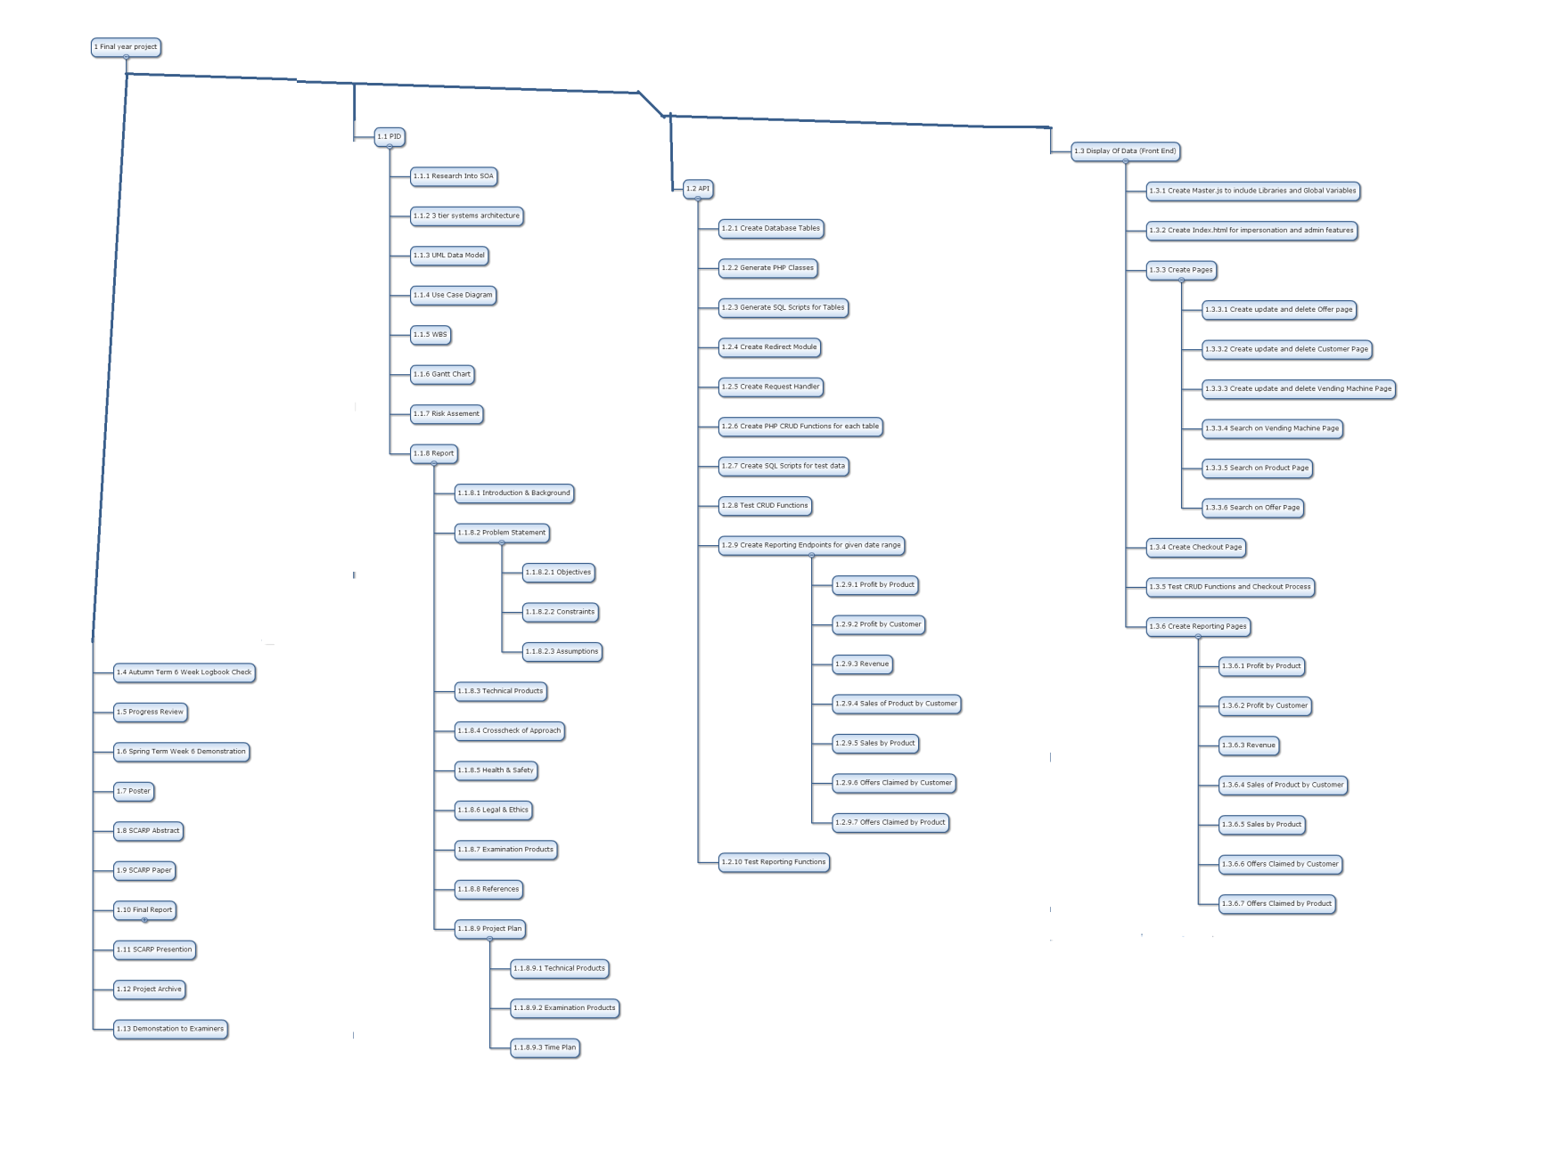

Figure WBS

## Time Plan

Figure 10 shows the task & how long each will take as well as their WBS number.

|  |  |  |  |  |  |
| --- | --- | --- | --- | --- | --- |
| Task Name | Duration | Start | Finish | Predecessors | WBS |
| **Final year project** | **43.75 days** | **Mon 03/08/15** | **Mon 02/05/16** |  | **4** |
| **PID** | **13.38 days** | **Mon 03/08/15** | **Wed 14/10/15** |  | **4.1** |
| Research Into SOA | 10 hrs | Mon 03/08/15 | Thu 06/08/15 |  | 4.1.9 |
| 3 tier systems architecture | 10 hrs | Mon 10/08/15 | Thu 13/08/15 | 3 | 4.1.10 |
| UML Data Model | 3 hrs | Mon 17/08/15 | Tue 18/08/15 | 4 | 4.1.11 |
| Use Case Diagram | 2 hrs | Tue 18/08/15 | Tue 18/08/15 | 5 | 4.1.12 |
| WBS | 3 hrs | Wed 19/08/15 | Wed 19/08/15 | 6 | 4.1.13 |
| Gantt Chart | 10 hrs | Thu 20/08/15 | Wed 26/08/15 | 7 | 4.1.14 |
| Risk Assement | 3 hrs | Thu 27/08/15 | Mon 31/08/15 | 8 | 4.1.15 |
| **Report** | **8.25 days** | **Mon 31/08/15** | **Wed 14/10/15** | **9** | **4.1.16** |
| Introduction & Background | 2 hrs | Mon 31/08/15 | Tue 01/09/15 |  | 4.1.16.10 |
| **Problem Statement** | **0.38 days** | **Tue 01/09/15** | **Wed 02/09/15** |  | **4.1.16.11** |
| Objectives | 1 hr | Tue 01/09/15 | Tue 01/09/15 | 11 | 4.1.16.11.4 |
| Constraints | 1 hr | Tue 01/09/15 | Tue 01/09/15 | 13 | 4.1.16.11.5 |
| Assumptions | 1 hr | Wed 02/09/15 | Wed 02/09/15 | 14 | 4.1.16.11.6 |
| Technical Products | 5 hrs | Wed 02/09/15 | Mon 07/09/15 | 15 | 4.1.16.12 |
| Crosscheck of Approach | 1 hr | Mon 07/09/15 | Mon 07/09/15 | 16 | 4.1.16.13 |
| Health & Safety | 2.5 hrs | Tue 08/09/15 | Tue 08/09/15 | 17 | 4.1.16.14 |
| Legal & Ethics | 2.5 hrs | Tue 08/09/15 | Wed 09/09/15 | 18 | 4.1.16.15 |
| Examination Products | 1 hr | Wed 09/09/15 | Wed 09/09/15 | 19 | 4.1.16.16 |
| References | 2 hrs | Thu 10/09/15 | Thu 10/09/15 | 20 | 4.1.16.17 |
| **Project Plan** | **5.88 days** | **Mon 14/09/15** | **Wed 14/10/15** | **21** | **4.1.16.18** |
| Technical Products | 16 hrs | Mon 14/09/15 | Wed 23/09/15 |  | 4.1.16.18.4 |
| Examination Products | 1 hr | Wed 23/09/15 | Wed 23/09/15 | 23 | 4.1.16.18.5 |
| Time Plan | 30 hrs | Wed 23/09/15 | Wed 14/10/15 | 24 | 4.1.16.18.6 |
| **API** | **11.25 days** | **Wed 14/10/15** | **Wed 13/01/16** |  | **4.2** |
| Create Database Tables | 4 hrs | Wed 14/10/15 | Mon 19/10/15 | 25 | 4.2.11 |
| Generate PHP Classes | 10 hrs | Mon 19/10/15 | Mon 26/10/15 | 27 | 4.2.12 |
| Generate SQL Scripts for Tables | 2 hrs | Mon 26/10/15 | Tue 27/10/15 | 28 | 4.2.13 |
| Create Redirect Module | 3 hrs | Tue 27/10/15 | Wed 28/10/15 | 29 | 4.2.14 |
| Create Request Handler | 5 hrs | Wed 28/10/15 | Mon 02/11/15 | 30 | 4.2.15 |
| Create PHP CRUD Functions for each table | 7 hrs | Mon 02/11/15 | Wed 04/11/15 | 31 | 4.2.16 |
| Create SQL Scripts for test data | 3 hrs | Thu 05/11/15 | Mon 09/11/15 | 32 | 4.2.17 |
| Test CRUD Functions | 20 hrs | Mon 09/11/15 | Mon 23/11/15 | 33 | 4.2.18 |
| **Create Reporting Endpoints for given date range** | **2 days** | **Mon 23/11/15** | **Wed 02/12/15** |  | **4.2.19** |
| Profit by Product | 3 hrs | Mon 23/11/15 | Tue 24/11/15 | 34 | 4.2.19.8 |
| Profit by Customer | 2 hrs | Tue 24/11/15 | Wed 25/11/15 | 36 | 4.2.19.9 |
| Revenue | 2 hrs | Wed 25/11/15 | Wed 25/11/15 | 37 | 4.2.19.10 |
| Sales of Product by Customer | 3 hrs | Thu 26/11/15 | Mon 30/11/15 | 38 | 4.2.19.11 |
| Sales by Product | 2 hrs | Mon 30/11/15 | Tue 01/12/15 | 39 | 4.2.19.12 |
| Offers Claimed by Customer | 3 hrs | Tue 01/12/15 | Wed 02/12/15 | 40 | 4.2.19.13 |
| Offers Claimed by Product | 1 hr | Wed 02/12/15 | Wed 02/12/15 | 41 | 4.2.19.14 |
| Test Reporting Functions | 20 hrs | Wed 02/12/15 | Wed 13/01/16 | 42 | 4.2.20 |
| **Display Of Data (Front End)** | **9.25 days** | **Wed 13/01/16** | **Mon 07/03/16** |  | **4.3** |
| Create Master.js to include Libraries and Global Variables | 3 hrs | Wed 13/01/16 | Thu 14/01/16 | 43 | 4.3.7 |
| Create Index.html for impersonation and admin features | 3 hrs | Mon 18/01/16 | Tue 19/01/16 | 45 | 4.3.8 |
| **Create Pages** | **2.5 days** | **Tue 19/01/16** | **Tue 02/02/16** |  | **4.3.9** |
| Create update and delete Offer page | 3 hrs | Tue 19/01/16 | Wed 20/01/16 | 46 | 4.3.9.7 |
| Create update and delete Customer Page | 3 hrs | Wed 20/01/16 | Thu 21/01/16 | 48 | 4.3.9.8 |
| Create update and delete Vending Machine Page | 4 hrs | Thu 21/01/16 | Tue 26/01/16 | 49 | 4.3.9.9 |
| Search on Vending Machine Page | 3 hrs | Tue 26/01/16 | Wed 27/01/16 | 50 | 4.3.9.10 |
| Search on Product Page | 3 hrs | Wed 27/01/16 | Thu 28/01/16 | 51 | 4.3.9.11 |
| Search on Offer Page | 4 hrs | Thu 28/01/16 | Tue 02/02/16 | 52 | 4.3.9.12 |
| Create Checkout Page | 12 hrs | Tue 02/02/16 | Tue 09/02/16 | 53 | 4.3.10 |
| Test CRUD Functions and Checkout Process | 20 hrs | Wed 10/02/16 | Tue 23/02/16 | 54 | 4.3.11 |
| **Create Reporting Pages** | **2 days** | **Wed 24/02/16** | **Mon 07/03/16** |  | **4.3.12** |
| Profit by Product | 3 hrs | Wed 24/02/16 | Wed 24/02/16 | 55 | 4.3.12.8 |
| Profit by Customer | 2 hrs | Thu 25/02/16 | Thu 25/02/16 | 57 | 4.3.12.9 |
| Revenue | 2 hrs | Mon 29/02/16 | Mon 29/02/16 | 58 | 4.3.12.10 |
| Sales of Product by Customer | 3 hrs | Tue 01/03/16 | Tue 01/03/16 | 59 | 4.3.12.11 |
| Sales by Product | 2 hrs | Wed 02/03/16 | Wed 02/03/16 | 60 | 4.3.12.12 |
| Offers Claimed by Customer | 3 hrs | Wed 02/03/16 | Thu 03/03/16 | 61 | 4.3.12.13 |
| Offers Claimed by Product | 1 hr | Mon 07/03/16 | Mon 07/03/16 | 62 | 4.3.12.14 |
| Autumn Term 6 Week Logbook Check | 0 days | Mon 19/10/15 | Mon 19/10/15 |  | 4.6 |
| Progress Review | 0 days | Mon 07/12/15 | Mon 07/12/15 |  | 4.8 |
| Spring Term Week 6 Demonstration | 0 days | Mon 29/02/16 | Mon 29/02/16 |  | 4.9 |
| Poster | 4 hrs | Mon 07/03/16 | Tue 08/03/16 | 63 | 4.10 |
| SCARP Abstract | 4 hrs | Wed 09/03/16 | Thu 10/03/16 | 67 | 4.11 |
| SCARP Paper | 5 hrs | Thu 10/03/16 | Tue 15/03/16 | 68 | 4.12 |
| **Final Report** | **1.5 days** | **Tue 15/03/16** | **Wed 23/03/16** |  | **4.13** |
| Indroduction | 1 hr | Tue 15/03/16 | Tue 15/03/16 | 69 | 4.13.1 |
| Literature Survey | 3 hrs | Wed 16/03/16 | Wed 16/03/16 | 71 | 4.13.2 |
| Problem Analysis | 1 hr | Thu 17/03/16 | Thu 17/03/16 | 72 | 4.13.3 |
| Solution Analysis | 2 hrs | Thu 17/03/16 | Mon 21/03/16 | 73 | 4.13.4 |
| Implementation | 3 hrs | Mon 21/03/16 | Tue 22/03/16 | 74 | 4.13.5 |
| Evaluation | 2 hrs | Tue 22/03/16 | Wed 23/03/16 | 75 | 4.13.6 |
| SCARP Presention | 2 hrs | Wed 23/03/16 | Wed 23/03/16 | 76 | 4.20 |
| Project Archive | 1 hr | Thu 24/03/16 | Thu 24/03/16 | 77 | 4.21 |
| Demonstation to Examiners | 0 days | Mon 02/05/16 | Mon 02/05/16 |  | 4.22 |

Figure Time Plan

# Appendix

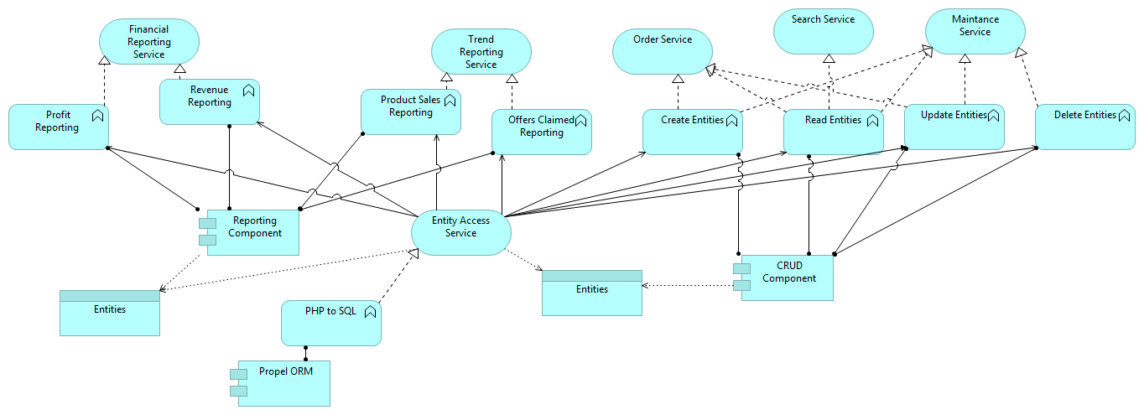

Figure Application Architecture

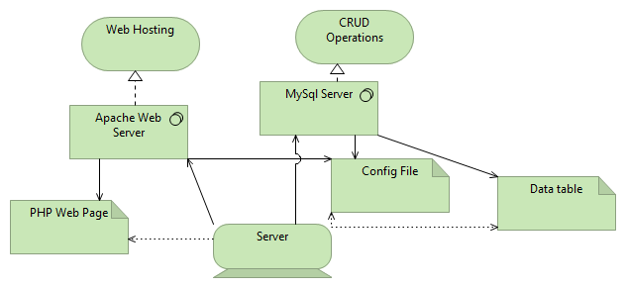

Figure Technology Architecture