RBI Major Failures Report
Executive Summary
As part of the regulators recommendations on maintaining BCP/DR plan, RBI recommends that the bank should submit an annual statement capturing failures encountered by critical applications. This report is tailor made to address these requirement and several important sections of the report are auto generated through a DR Management tool for improved information accuracy. This failure report, documents failures from start date of 16 Feb, 2017 00:00:00 to end date of 16 Feb, 2017 23:59:59.
DR Setup Description

Failure Details by Application

App_pfr_106_76_Remote
PR DR
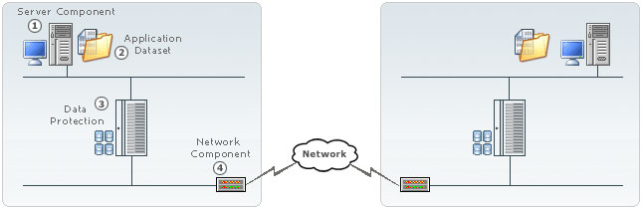

DR Solution Signature
ApplicationSubSystem-with-PFR

Server Component
Primary Component 1: Linux_192.168.2.106 [ Linux ]
Remote Component 1: Linux_172.168.20.76 [ Linux ]

Dataset Details
Primary Dataset 1: DS_Primary_106 [ ApplicationSubSystem ]
Remote Dataset 1: DS_Secondary_76 [ ApplicationSubSystem ]

Replication Details
Primary Service : PFR_Primary_106 [ PFR ]
Remote Service: : PFR_Secondary_76 [ PFR ]
App_pfr_106_76_Remote is a Application SubSystem running on Linux servers and protected by Log/Full replication using PFR. There were 9 major failures on this application during Feb 16, 2017 12:00:00 AM to Feb 16, 2017 11:59:59 PM
Failure Type | Occurred at | Corrected at | Comments
Replication stopped due to PFR Failure. | 16 Feb, 2017 09:13:57 | N/A
Replication stopped due to PFR Failure. | 16 Feb, 2017 09:16:18 | N/A
Replication has stopped for a long time. | 16 Feb, 2017 11:58:20 | N/A
System is awaiting input | 16 Feb, 2017 12:00:17 | 16 Feb, 2017 12:25:54
System is awaiting input | 16 Feb, 2017 12:27:45 | 16 Feb, 2017 12:28:13
System is awaiting input | 16 Feb, 2017 12:40:29 | 16 Feb, 2017 12:47:41
System is awaiting input | 16 Feb, 2017 12:50:59 | 16 Feb, 2017 12:59:25
System is awaiting input | 16 Feb, 2017 13:02:44 | 16 Feb, 2017 13:03:35
System is awaiting input | 16 Feb, 2017 13:21:49 | 16 Feb, 2017 13:22:32

