Jonathan Fazzari Sprint 1, Week 2
Deliverables
- Github
  - Set up github repo
  - Establish branch structure
  - Add client as admin
  - Acknowledge previous team
  - Set up for team collaboration
This was largely completed by the last sprint submission, but it can be summarised here.
The github repo can be found here, https://github.com/99pancakez/Group62-StudyPlanner/, and the branch structure while functionality exists in github, conventions are followed by developers. For example, dev 2’s contributions have added features under the initial descriptor “feature/…”
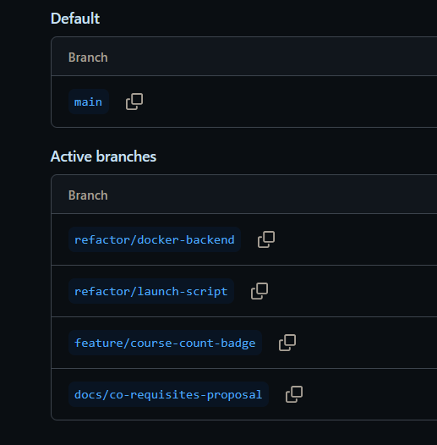
The key members of the group (members, supervisors, admins) were invited to the github repo.
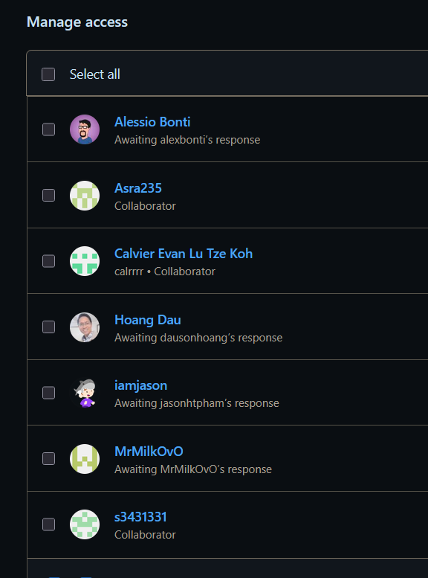
And finally, the acknowledgement of the original creator was documented in the readme.md file.
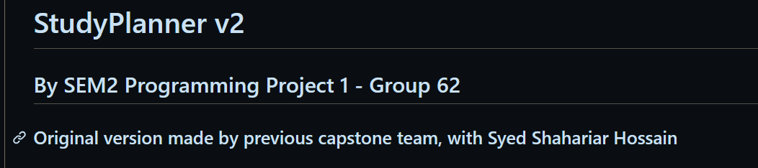
This was added with this commit to the main branch.

- Table Documentation
The source code uses a variety of SQL tables to enable the program to run, and store all these courses. These can be found in both the source code, and by directly exploring the MySQL terminal while the program is running, and in the source code as the JavaScript files that make the values actually mean something
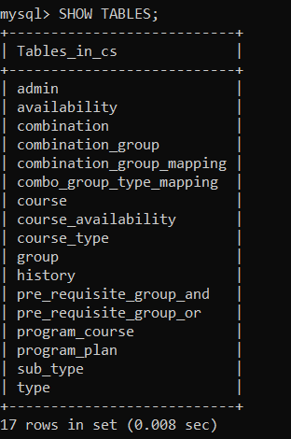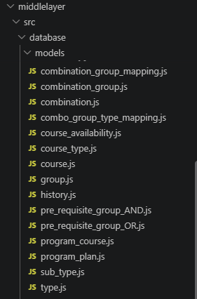
Each one of these 17 tables were explored, and briefly summarised in a spreadsheet along with the relevant columns for each table, with the first column (mostly) being the relevant primary key
Spreadsheet Link: table_documentation.xlsx

- Technical Requirements
The task of technical requirements is what changes to the system are required to be able to support the tasks we have planned for, right now the ability to support a course in a summer term, and to handle flex terms.
There is currently zero existing allowance for the summer semester to happen, and the way classes are allowed to be in semester 1 or 2, is not as simple as changing a number in the database. However, there is a small truth to this. The semester can easily be created by editing the availability table. And when the database is created on launch, it allows for the existence of a third value representing summer term.
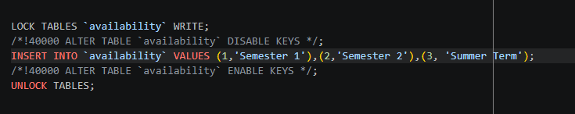
Here is the SQL code for when the availability table is created, note the option to create a third value for the summer term, this is what allows it to be attached in course_availability.

When the middle layer parses each class into what semester it is allowed in. This code in the SemesterComponent, restricts it to either 1 or 2 as a value.
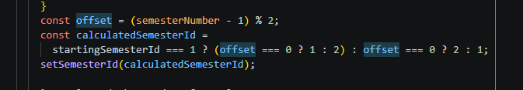

Regardless on how the summer term is implemented, as part of its specified design, there is no limit on the amount of courses that can be added to that semester, unlike other semesters that warn you when you are overloading outside of the university recommended 48 credit points. This might not be necessary when developing the frontend.
When it comes to the flex Term mentions within the code, while it's not functional in practice. It is the aim of the program to scrub mentions and remnants of its existence. This would require going through the all the JavaScript handling files and removing each remaining functionality
Most of this week’s discussion and the documentation of this week is largely related to the database functionality and the schema, but there are some more tech requirements that need to be addressed.
As mentioned previously, regarding the summer term, another key requirement is that a new frontend segment is needed to be created for the summer term, this was an explicit requirement from the client that is a top priority, this would likely be in the form of another column on the page, and a restyling of the webpage entirely. This alongside the feature implementations would also be a big task.

Future developments that require code related changes, are that of streamlining the launching process; to not require multiple command runs to launch. These are not what the common user would like to do to access this tool.

- Summer Semester Mapped
As mentioned earlier, there are two ways that these could be represented in the database, by either a “3” tacked onto the course availability, and changing the code to work around that. Or the second option below.
For the summer semester to be explicitly outlined into the ER diagram, this type of change would be made to the ER diagram.
This summer availability table will be similar to the course availability table, given that both take in the same thing, the course_id, and the semester_id. From here, the new column made to the frontend would be easier to implement a list based off this table explicitly.

- Modified ER Diagram
As mentioned, the ER diagram for the pre-existing version was provided within the documentation, however with the implementation of the summer term, there is a proposed simple extension to the model, changed highlighted in red.

