**CS5346 Information Visualisation**

**Task B Week 6 Visualisation**

By Lee Yu Cong A0171334M

**Comparison of Singapore Imports of Financial Services from Asia and Europe**

In this visualisation, I aim to find out the direction of trade. Singapore is a country heavily dependent on imports due to the lack of resources, hence we need to look at trade and deduce if we are too reliant on one source. I was inspired by this visualisation of traffic of cargo ships passing the Straits of Malacca. As Singapore is situated at the Straits of Malacca where cargo ships must pass through from Asia to Europe, it is the source of economic prosperity in the founding years and I find it important to learn the trading partners of Singapore.

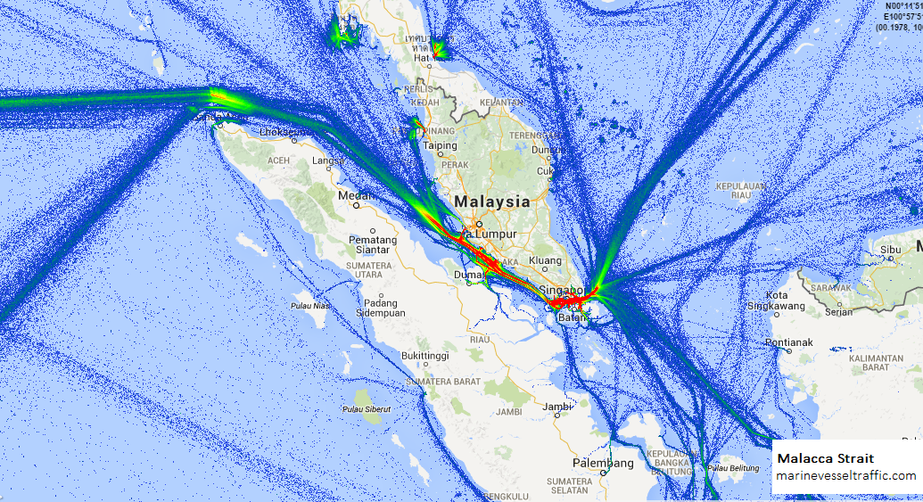

Figure 1: Cargo ships traffic, from <http://www.shiptraffic.net/2001/04/Malacca-Strait-Ship-Traffic.html>

The dataset was obtained from the Department of Statistics Singapore website. There were 3 types of variables: the partner country, the type of industry and the year of the export. There was no need to integrate the data as it was in one single sheet in an excel file. As there are too much data, I decided to concentrate on Asia and Europe since using continents consist of more countries. The financial sector was chosen as it has more variations. There are times when Europe exported more than Asia and vice versa.

For the visual encoding, two lines graphs are used to indicate the amount of trade per continent. The different colour represented different continent. The area in between the lines represents the difference in trade volume of the two continents. When Asia exported more than Europe to Singapore it shows a green area and a red area for the other situation. The colour saturation also shows the trade difference in conjunction to the length in between the two lines.

I have referred to this YouTube channel for guides on using Tableau to make more complicated charts: <https://www.youtube.com/c/TheInformationLabCoUK/featured>. The website for the dataset is <https://www.tablebuilder.singstat.gov.sg/publicfacing/createDataTable.action?refId=11938>.

Minor pre-processing was done. It involves mainly the deletion of extra information in the excel file and then a quick copy-paste of relevant data to a new excel file.