PLATFORM: PYTHON 3.5.2 :: ANACONDA CUSTOM (64 BIT)
PLOTLY '1.12.9'
Get plotly link: plotly
XGBOOST package for Predictive model.

SOURCE CODES: data_analysis.ipynb & pred_model.ipynb
Git-hub link to code: Solution_Code

DEPLOYMENT INSTRUCTIONs:

(1) Both codes and the data set should be in the same folder.
(2) Codes are ipython files, need to opend in ipython notebook with above mentioned platform requirements.
(3) Graphs and results will be displayed there only.

Solutions:

Q1. Analyze and list the platforms with the most "Editor's Choice" awards?

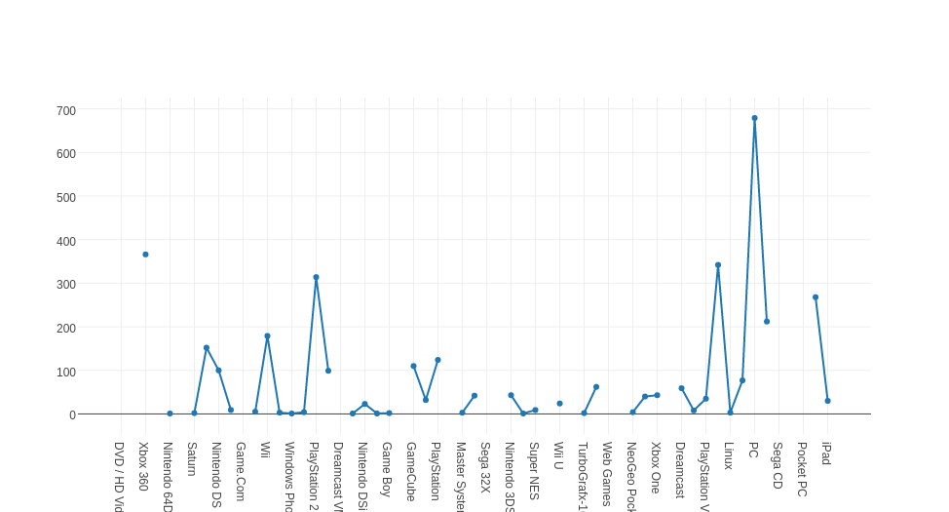

The above graph (data_analysis.ipynb)Depicts about different platforms editor choice award counts. And list is following in Decreasing order of editor choice appreciations:

list of platforms in decreasing order of editors choice award:
['DVD / HD Video Game', 'Atari 5200', 'Xbox 360', 'Vectrex', 'Nintendo 64DD', 'Commodore 64/128', 'Saturn', 'iPhone', 'Nintendo DS', 'NES', 'Game.Com', 'Genesis', 'Wii', 'iPod', 'Windows Phone', 'Android', 'PlayStation 2', 'Game Boy Advance', 'Dreamcast VMU', 'TurboGrafx-CD', 'Nintendo DSi', 'Arcade', 'Game Boy', 'Ouya', 'GameCube', 'Game Boy Color', 'PlayStation', 'WonderSwan Color', 'Master System', 'Nintendo 64', 'Sega 32X', 'WonderSwan', 'Nintendo 3DS', 'NeoGeo', 'Super NES', 'Windows Surface', 'Wii U', 'Lynx', 'TurboGrafx-16', 'PlayStation 4', 'Web Games', 'New Nintendo 3DS', 'NeoGeo Pocket Color', 'Macintosh', 'Xbox One', 'SteamOS', 'Dreamcast', 'N-Gage', 'PlayStation Vita', 'PlayStation 3', 'Linux', 'PlayStation Portable', 'PC', 'Xbox', 'Sega CD', 'Atari 2600', 'Pocket PC', 'Wireless', 'iPad'])

Q2. Does number of games by a platform in a given year have any effect on these awards?

Yes it does has effects. Have a look at the following graph.
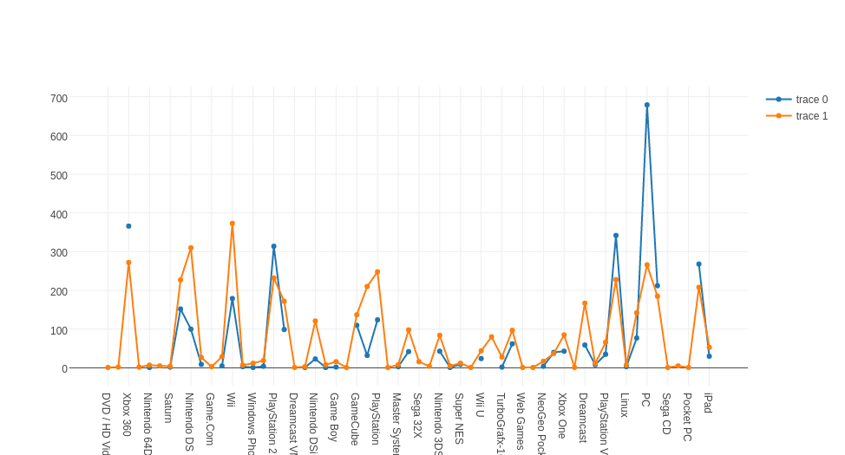
Trace 0 is for editor choice award count for different platforms and trace1 shows the maximum game developed on different platforms. Its clear from graph that which ever platform has launched the maximum of games got more editors choice award compared to others. So they kind of show a linear relation.

Q3. What is Macintosh's average award count?

Following is the release trend of macintosh:
release_year award count
2002 37
2013 18
2012 13
2014 6
2003 3
2015 3
2016 1

Average award count: 11.571428571428571

Q4. What is the optimal month for releasing a game?

Observe the follwing graph which shows in which month how much editors choice(Y) as been declared. MAXIMUM peak occurs in month 10 (1231).

Follwing are monthly acceptance number:
{ 0: 180, 1:1039, 2:288,3:1224, 4:49,5: 1050, 6:214,7:951,8: 192,9:1231,10:252,11:1004}

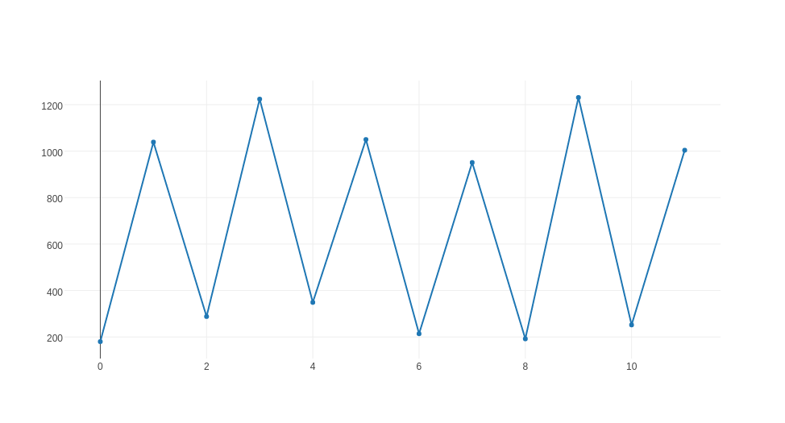
x-axis is the months. Y axis the editors choice yes count in that particular month.
So 10th month is the optimal choice.

Q5. Analyze the percentage growth in the gaming industry over the years.

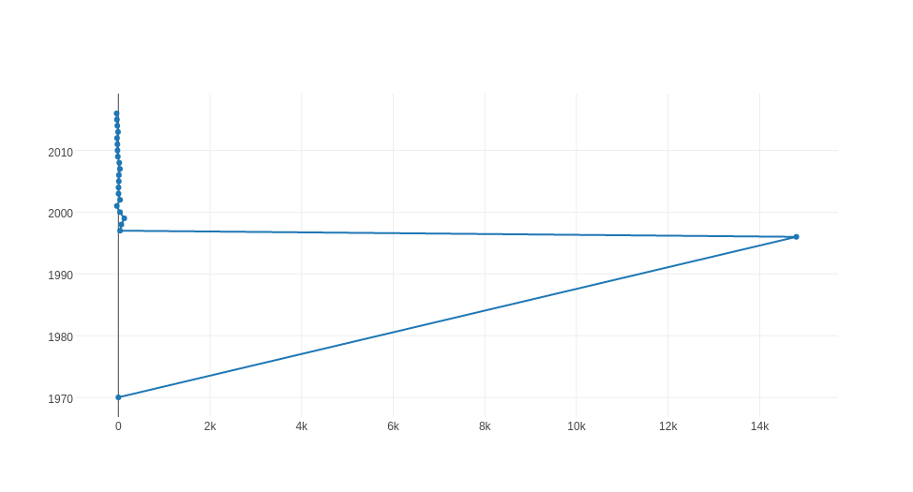

In this plot x axis is number of games launched under different platforms and y axis shows the year. In 1970s the pick up was quiet high the it almost stablized. But to get more insight about the variation i have plotted the graph excluding the first two years.

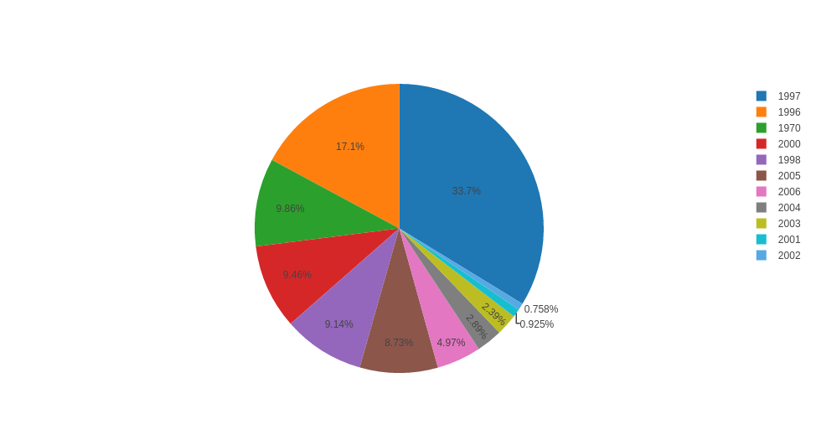
So this pie char depicts the contribution to the gaming industry year wise. 1997 shows growth of about 33.7% from previous year.
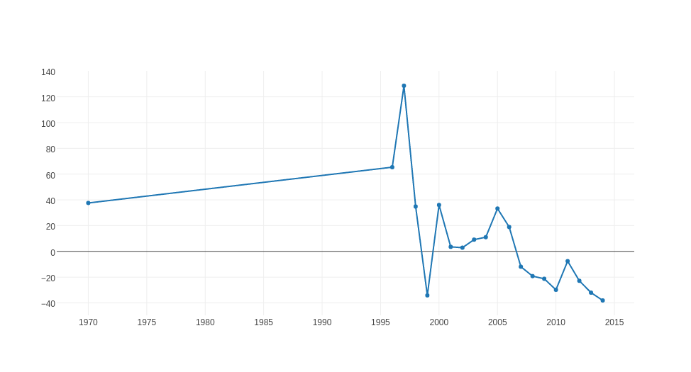

Follwing graph shows the clear trend of development year wise. As we can see the percentage growth of contribution in gaming industry has continuously decreased.

PREDICTIVE MODEL
using XGBOOst

1) Started my model with encoding categorical variables.
2) Then i created some count features which adds more of insight to data trend.
GetCountVar function computes the frequency of occureny of given feature contents.
3) First i performed a GRID-search over my data set for XGBclassifier which helps to find out optimum parameters(parameter tuning).

4) To avoid overfitting i train my model using Kfold.
5) I got the accuracy of 0.96.
6) But out of 18652 data rows only 3517 yes target values are there which is only 18%. Even if i predict all 'N' accuracy will be 82%. So accuracy is not a good mesure here.
0 15108
1 3517
7) So i found out confusion matrix

precision recall f1-score support

N 0.99 0.98 0.98 3039
Y 0.90 0.94 0.92 686

avg / total 0.97 0.97 0.97 3725
The result obtained was pretty good as precision and recall both are quiet high giving good f1 score.

8) Now i found out the feature importance score and the results are as follow:
Variable F-score (Importance)
score 144
release_year 126
platform 70
platform_count 69
genre 58
release day 52
release_month 42
release month count 16
score_phrase 2

