# Eclipse pring screens:

## Running all test cases expected behavior

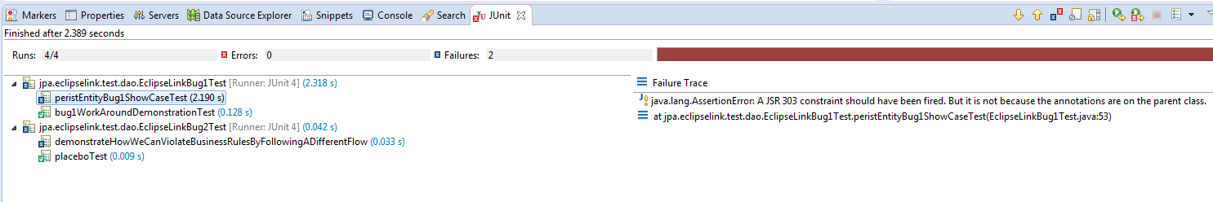

## Bug1:

### Test that fails:

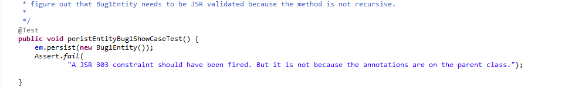

This test fails because the entity does not have any JSR annotation.

But its parent class does have JSR annotations and it should have blown up on the persist call.

### Bug1 workaround:

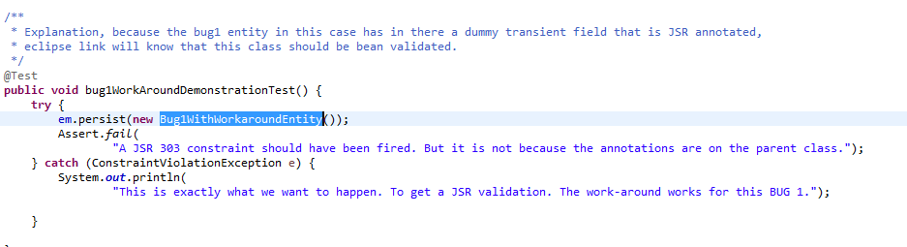

This test will pass.

It passes because the entity has been enriched with:



# Bug2:

Eclipse link does not trigger JSR 303 validations on preInsert.

This allows us to create an enityt A persist it.

Then modify the entity to have it violate business rules.

Finally commiting and no JSR validation blow up is triggered.

## Test that demonstrates bug:

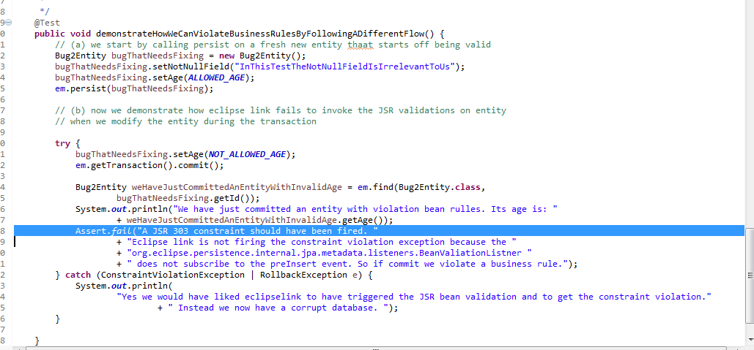

## Placebo test that proves JSR 303 violations should normally be triggered

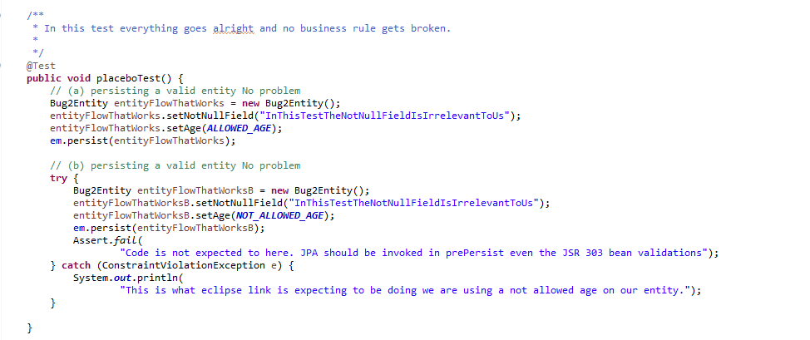

This test passes because the violation in step (b) is put into a new entity and then we call persist(). W e no longer have a the persist() and then break rules process execution.

This test demonstrates that the JSR violations that should be triggered are there and they can get evaluated.

But there is an execution path where the rules are not triggered.