# Left Join TREAT Bug

## Open the project importing as maven project into eclipse

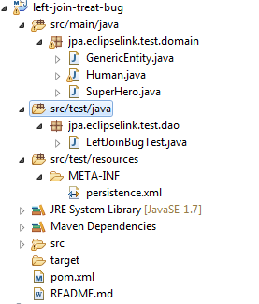

## Run the junit test

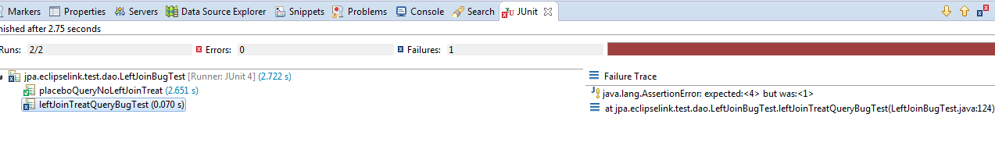

On test fails another passes.

The Test that fails uses left join TREAT.

The test that passes does not use it.

The test that uses LEAF JOIN TREAT demonstrates that doing a LEFT JOIN with a TREAT kills a left join, because the predicate of the generated native SQL is not correct.

The predicate is right now of the from **TREATTABLE.CLASS_TYPE = ‘SuperHero’**

**The Predicate of the native SQL should be of the form:**

1. ( TREATTABLE.CLASS_TYPE IS NULL or TREATTABLE.CLASS_TYPE IN (Hiearhcy Of SuperHeros) )

Where by hierarchy of SuperHeros, we mean that the predicate should be:

( TREATTABLE.CLASS_TYPE IS NULL or TREATTABLE.CLASS_TYPE IN (‘SuperHero’, ‘SuperHeroSmart’, ‘SuperHeroDumbAndStrong’, etc…) )

The full hierarchy.