# Image summarizing the problem

The immage shows several different ways of producing a graphic on the UI using p:graphic, however when working with view access scoped bean dynamic content seems not to be supported.

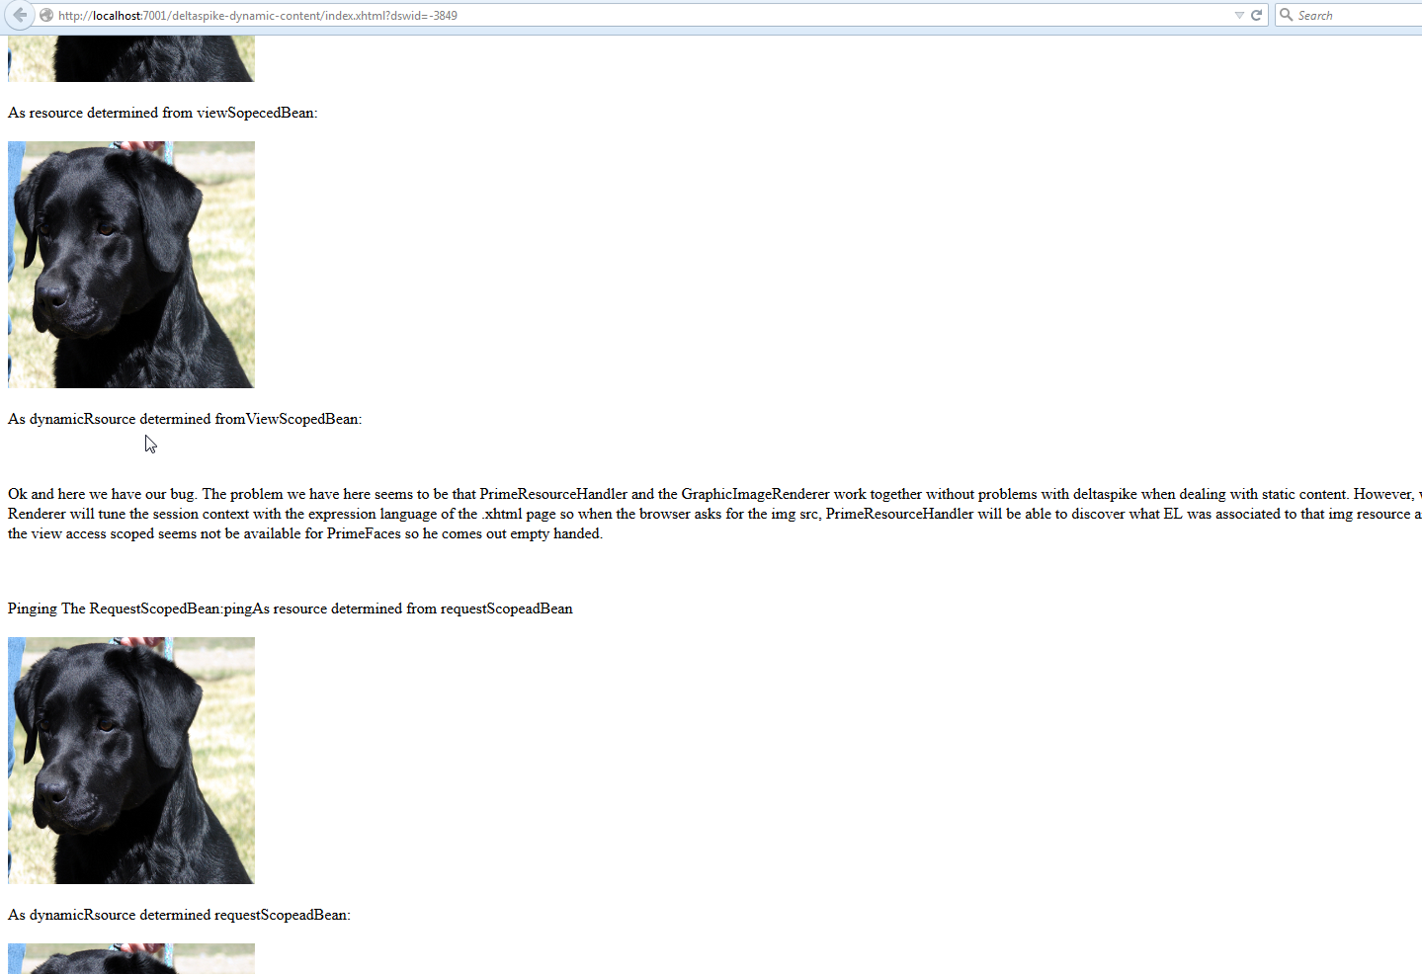

# PRoblematic line of code:

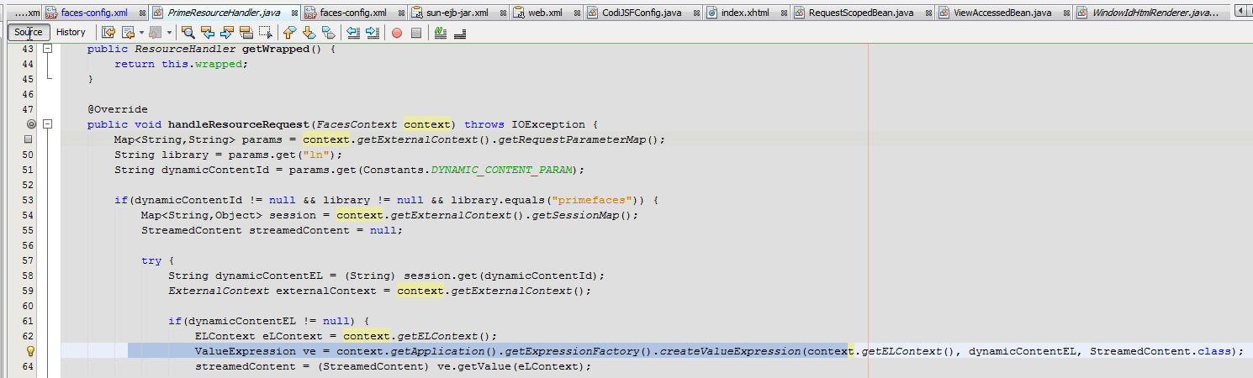

This ve.getValue() will not work well when we are faced with view access scoped beans.

# PGraphicImageRenderer

This render may be interesting for the analysis of the creation of th <img src=> that goes into the browser. But it is not the fundamental debug point.

