Name: Shweta Lal

NJIT UCID: srl29

Email Address: srl29@njit.edu

03/10/2024

Professor: Yasser Abduallah CS 634104 Data Mining

# Midterm Project Report

*Implementation and Code Usage*

# Apriori Algorithm Implementation

# Abstract:

In this project I came across Brute force, Apriori algorithm, and FP Tree algorithm, to generate various association rules for five datasets which consists of 20 transactions each. I have tried to implement the logic of brute force and used libraries to execute Apriori and FP Growth.

*S* *creenshots*

1. Import the following libraries:

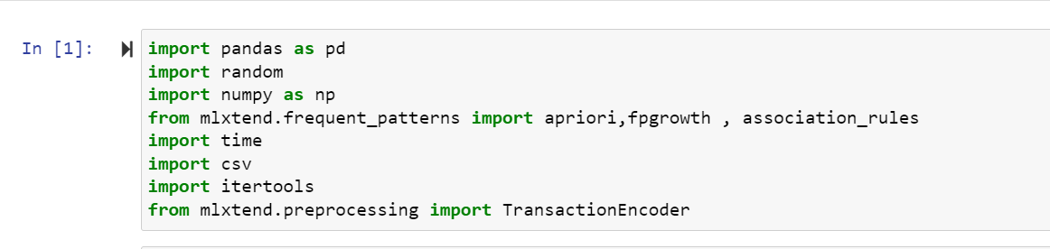

1. Below are the snippets of 5 datasets:

Amazon CSV file:

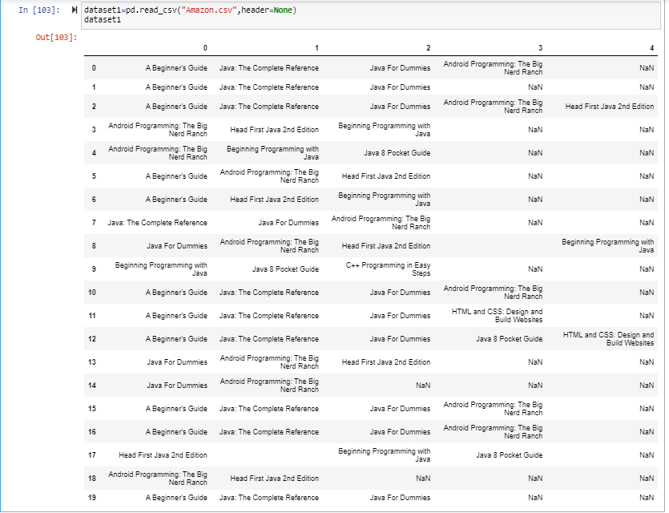

Bestbuy CSV file:

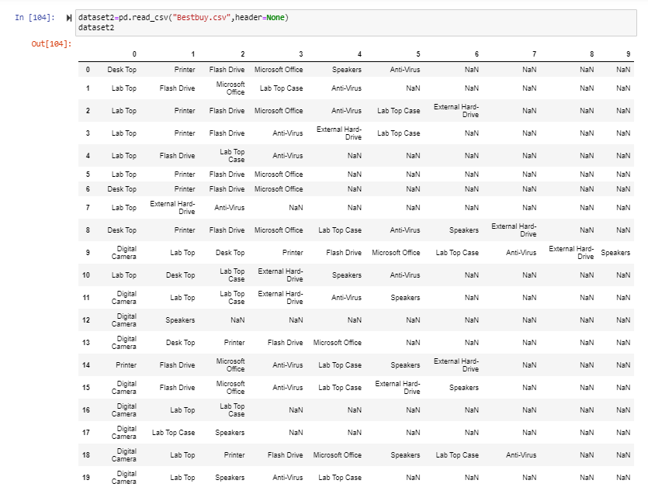

K-Mart CSV file:

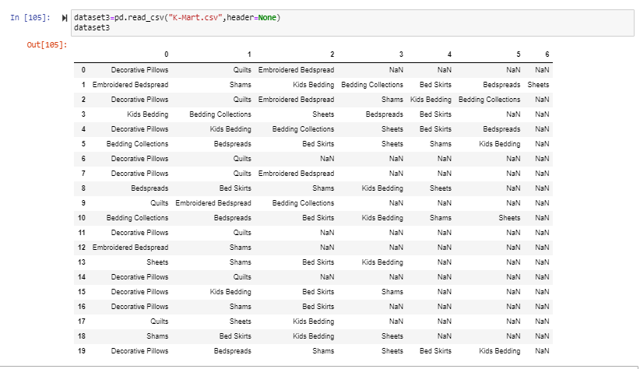

Nike CSV file:

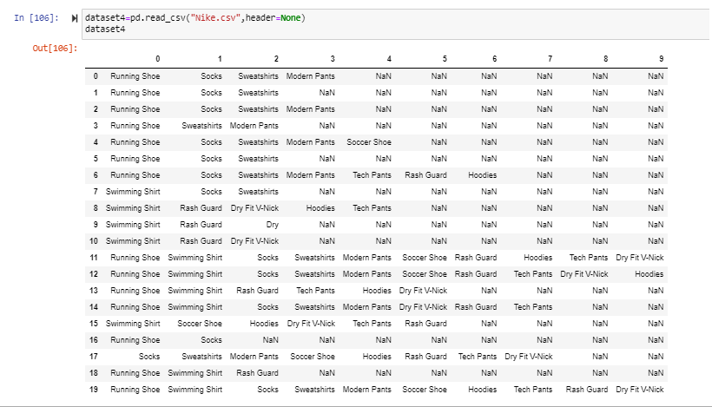

Walmart CSV file (made it by myself ):

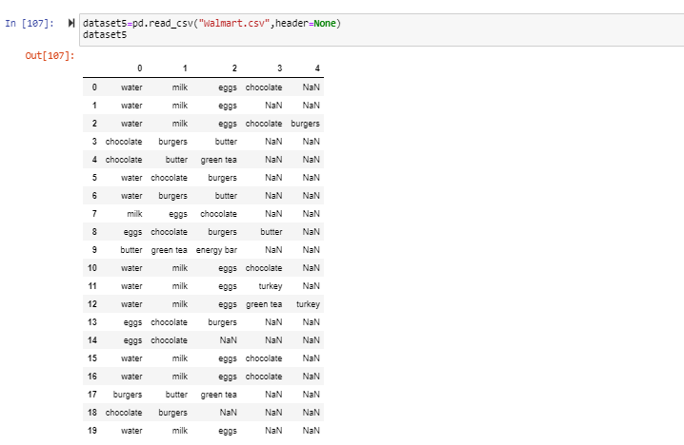

1. Code Snippets:

Give any input

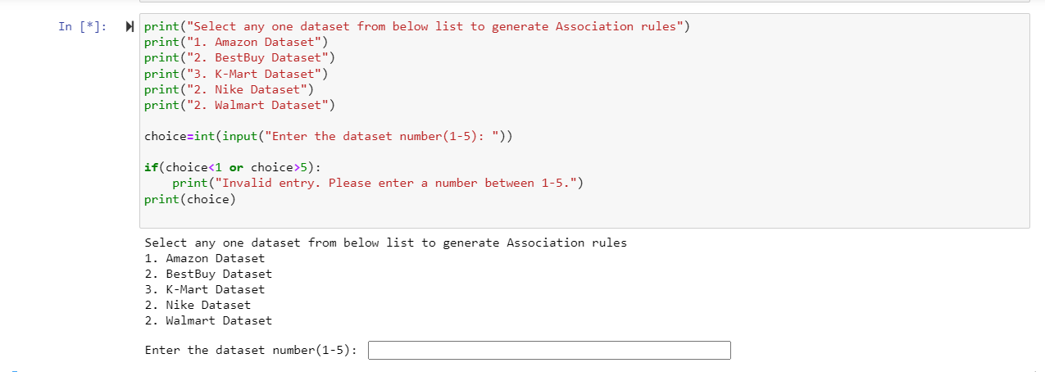

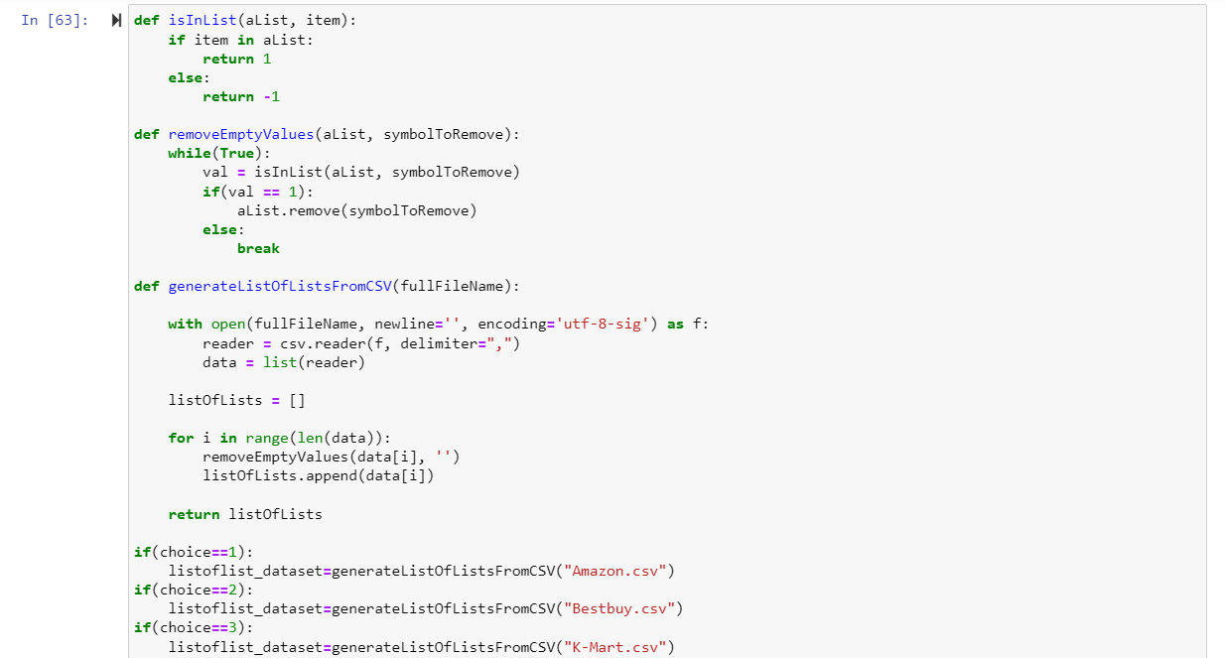

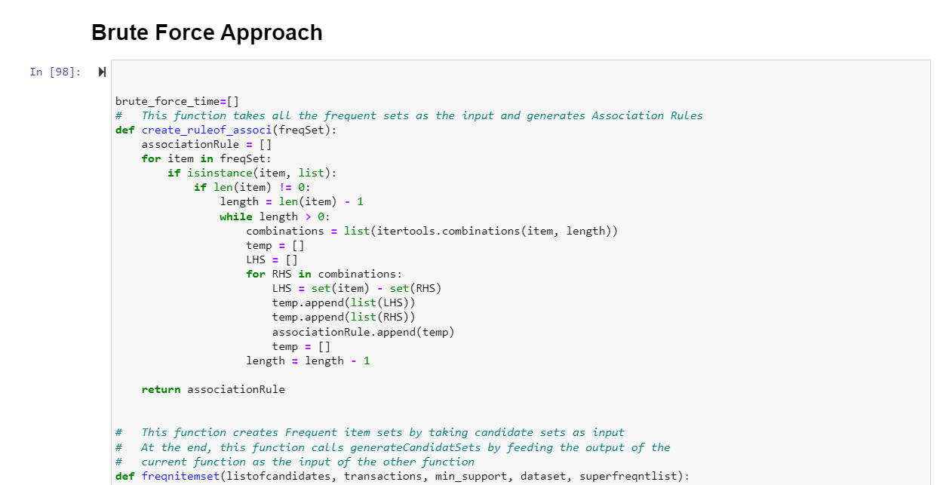

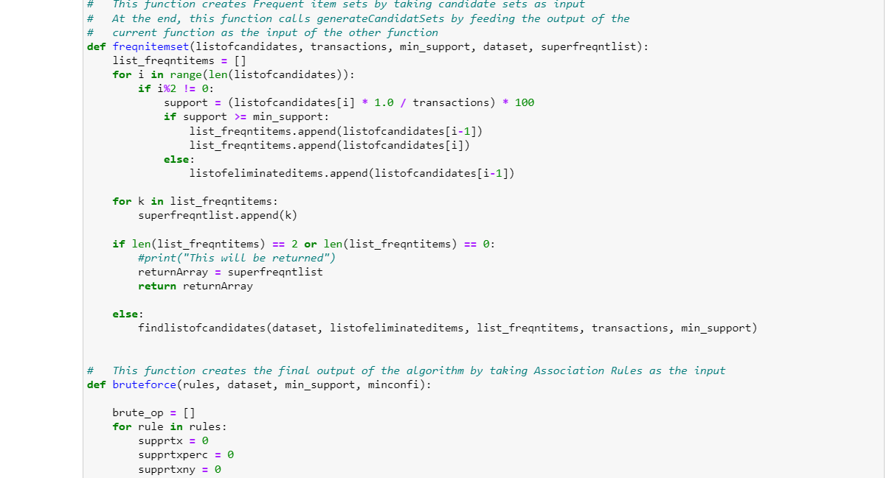

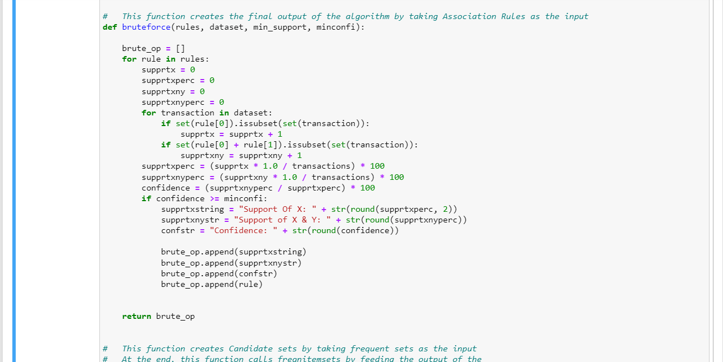

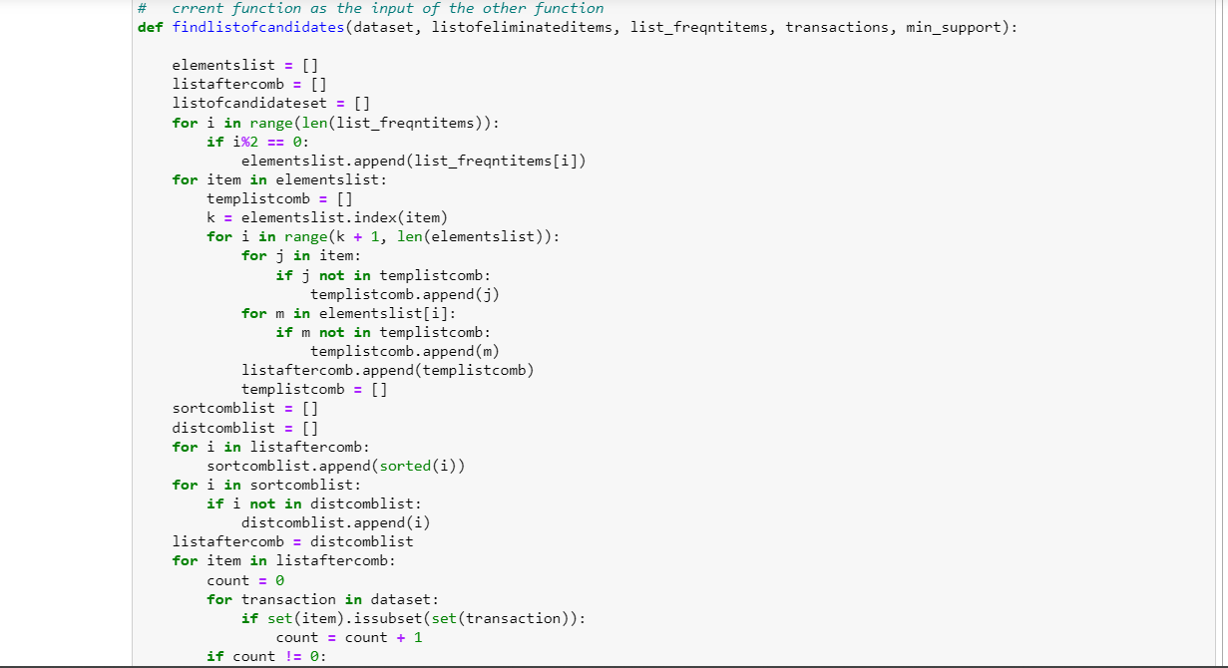

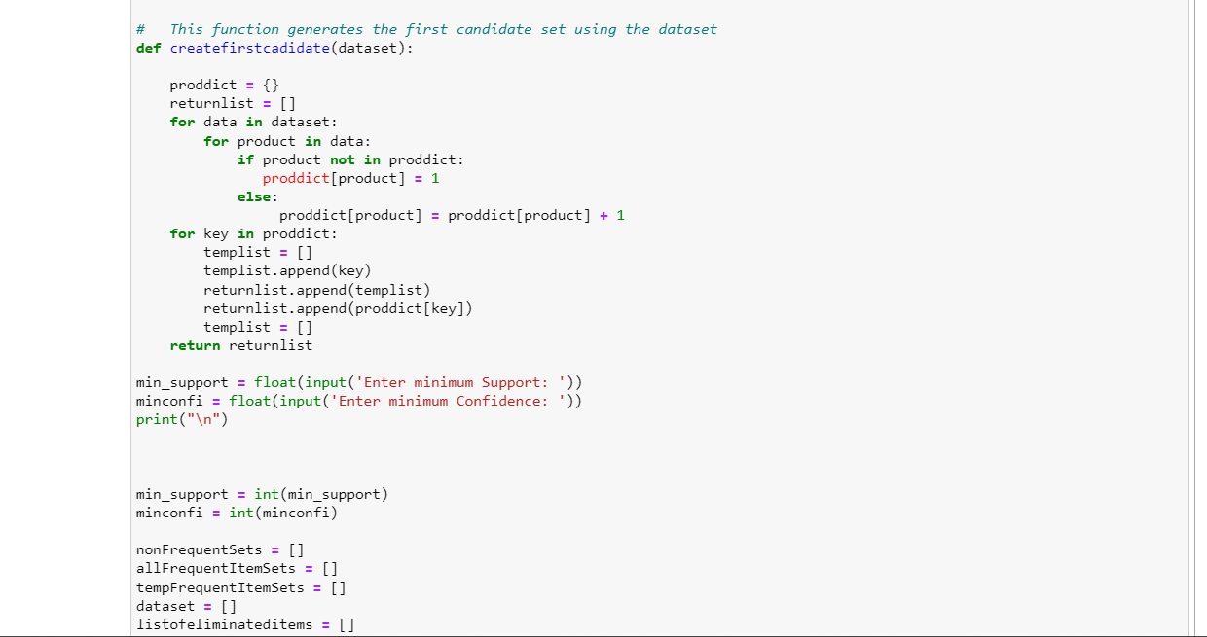

For Brute force: give integer values, even float will work, but for better computation input integer value

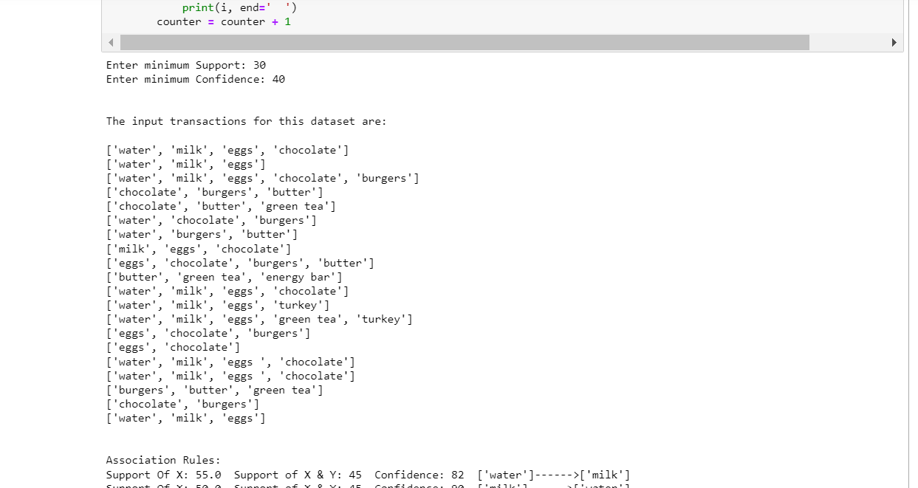

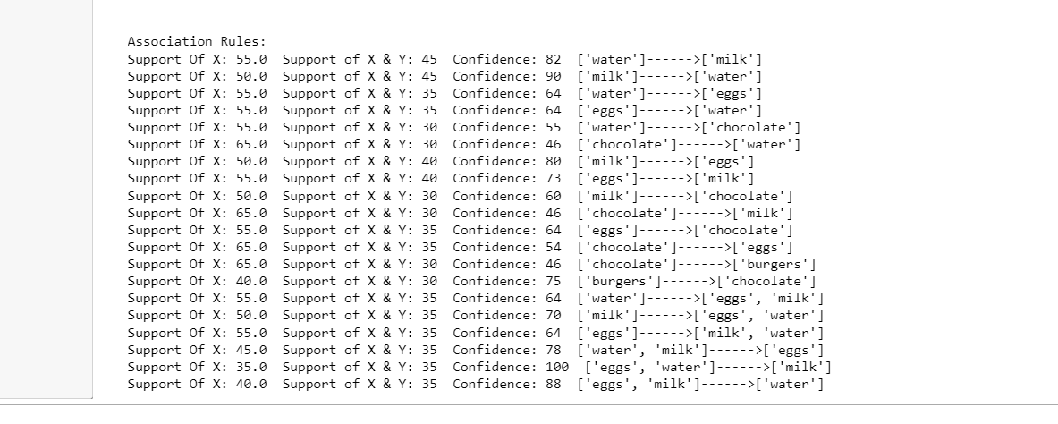

Enter decimal values when asked for min_support and confidence

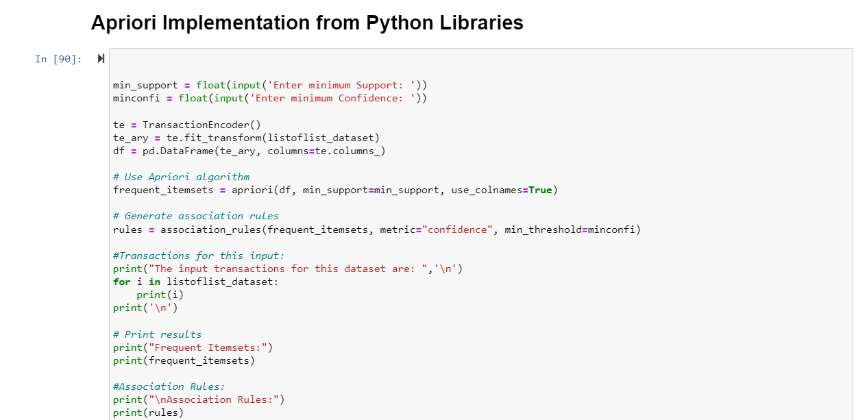

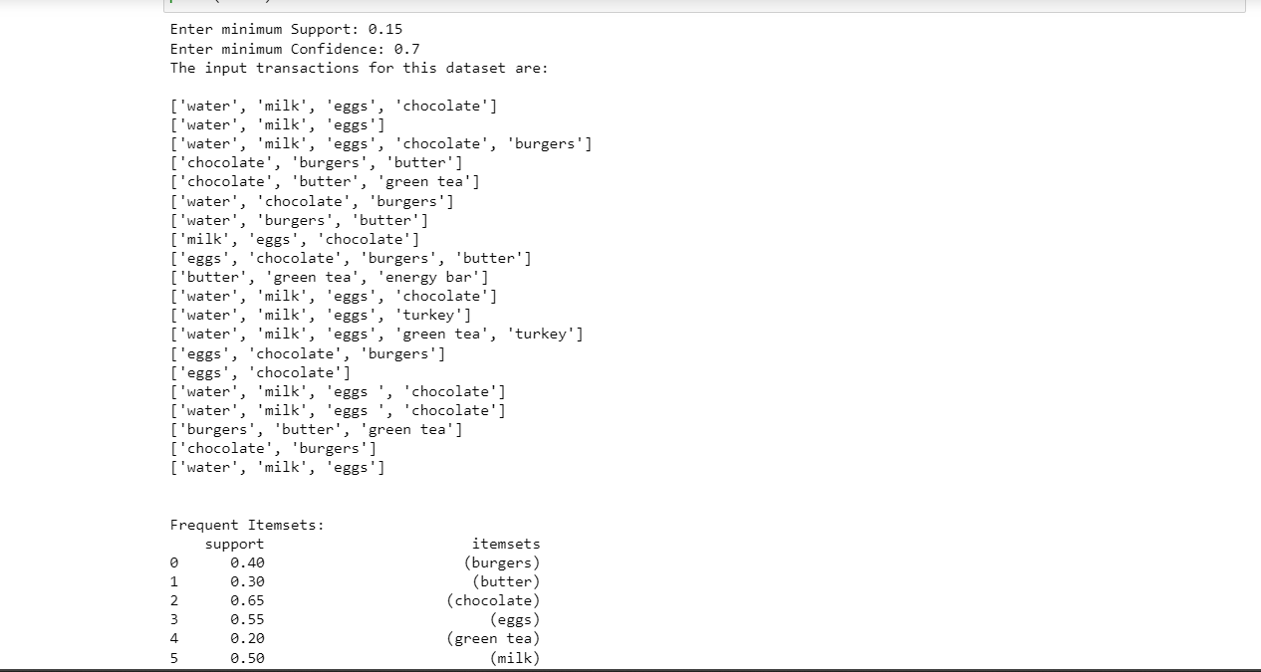

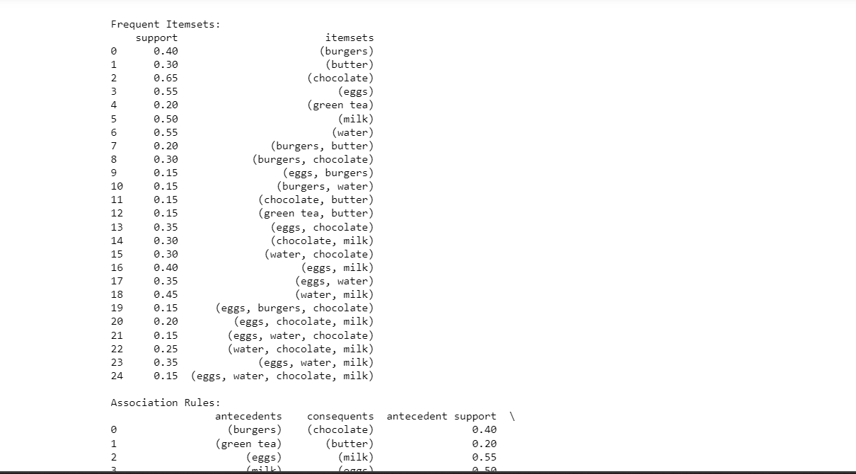

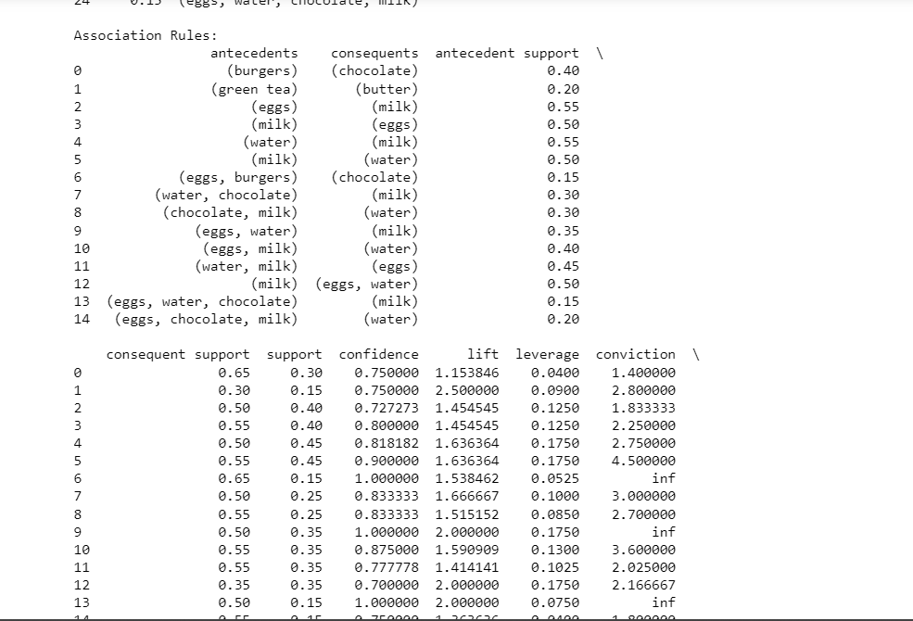

Enter decimal values when asked for min_support and confidence

