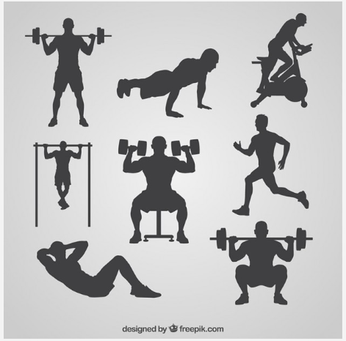

<https://www.freepik.com/free-vector/gym-silhouettes-collection_802591.htm>

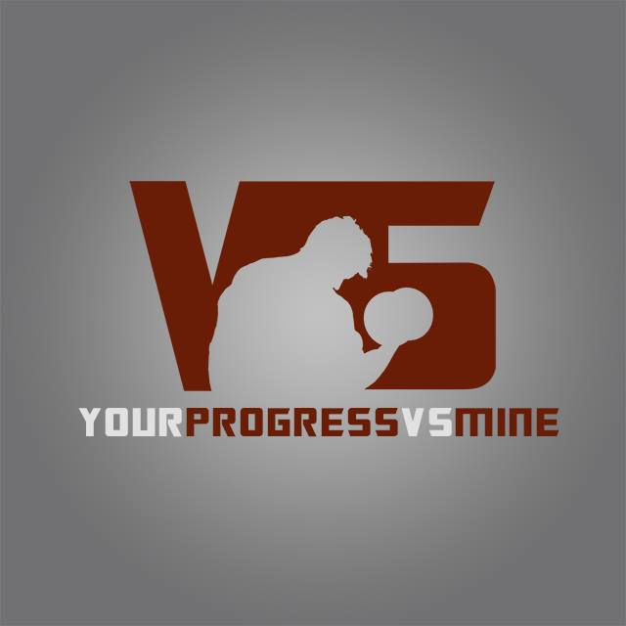

<https://celehomey.com/collections/brick-style-background-1/products/spotlight-brick-wall-photo-background-photography-studio-backdrop>

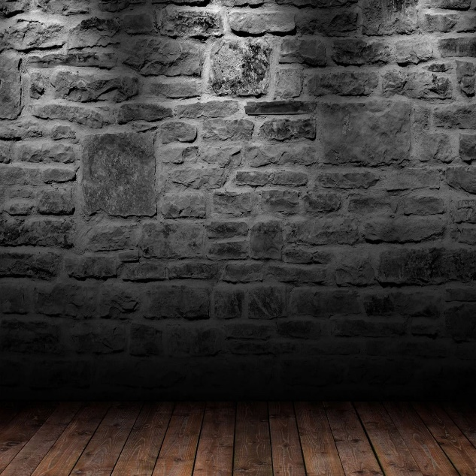

Logo created for me by Anthony Gustina

<https://www.facebook.com/gustinaphotography/>