STATISTICAL THEORY

APM1111

Finals - Item 26

BILLONES, Cristel Kaye P.

2021016541

A cognitive psychologist was interested in the impact of 2 - dimensional visual stimuli on the spontaneous exploration behavior in rats. Thirty-six (n = 36) rats were selected to participate and randomly assigned to three treatment conditions:

* Visual images of shapes
* Visual images of patterns
* Visual images that used pictures

Rats were released into a chamber and the number of seconds the rats spent exploring the experimental chamber with the images were recorded.

**1. Rationale for a hypothesis test.**

The researcher's interest lies in assessing whether different types of visual stimuli (shapes, patterns, and pictures) impact the spontaneous exploration behavior in rats. To scientifically test this, a hypothesis test can be formulated.

Certainly! Here's a concise rationale for the hypothesis test:

Rationale for the hypothesis test:

1. Population and Sample: The study includes observations on rats' exploration behavior when exposed to different visual stimuli—shapes, patterns, and pictures. The sample consists of 36 rats, assumed to represent the larger population of rats in this specific experimental setting.

2. Variable of Interest: The key variable under investigation is the time spent exploring visual stimuli. This quantitative variable is measured in seconds.

3. Test Statistic: An Analysis of Variance (ANOVA) test will be utilized to compare the means of multiple independent groups (shapes, patterns, and pictures). This will determine if there's a statistically significant difference in exploration time across these visual stimuli conditions.

4. Assumptions: The assumptions for the ANOVA include:

- Independence: Each rat's exploration time is independent of others in the group.

- Normality: The exploration times within each visual stimuli condition should approximately follow a normal distribution.

- Homogeneity of Variances: The variance of exploration times should be consistent across the different visual stimuli conditions.

5. Level of Significance: A preselected significance level, typically 0.05, will be used to determine the decision criteria.

6. Test Decision: Based on the ANOVA results, if the p-value is less than the chosen significance level, the null hypothesis will be rejected. This implies that there is a statistically significant difference in exploration times among the different visual stimuli—shapes, patterns, and pictures—for rats in the experimental setting.

**2. Analyze the data to provide the hypothesis testing conclusion. What is the p-value for your test? What is your recommendation for the researcher?**



With a p-value of 0.000, the test result indicates a statistically significant difference in the exploration times among the different visual stimuli—shapes, patterns, and pictures—for rats in the experiment. This extremely low p-value (0.000) suggests strong evidence against the null hypothesis, indicating that there's a substantial difference in how rats interact with these distinct visual stimuli.

The recommendation for the researcher would be to accept the alternative hypothesis, acknowledging that the type of visual stimuli significantly influences the exploration behavior of the rats. Further investigation or follow-up studies might be necessary to understand the nuances and specific impacts of each type of visual stimulus on the rats' behavior. Moreover, exploring potential reasons behind these differences and the potential implications of these findings could be an area for further research.

> Data Set/Data Frame

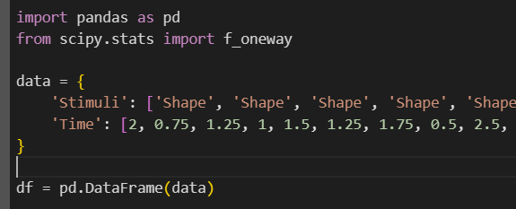

> Separate the time data by each stimulus type  
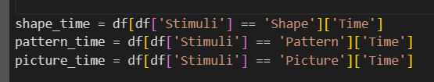

> ONE-way ANOVA  


> Result  


**Assumptions underlying the chosen ANOVA type:**  
1. Independence  
The significant F-statistic infers that there's a difference in exploration time between at least two of the treatment conditions.

2. Normality

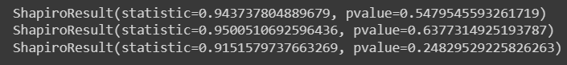

The normality assumption seems to be reasonably met based on the Shapiro-Wilk test, as the p-values are above 0.05.

3. Homogeneity of Variances



The Levene's test suggests that the assumption of homogeneity of variances is supported as there isn’t substantial evidence of variance differences between the treatment conditions.