STATISTICAL THEORY

APM1111

Finals - Item 27

BILLONES, Cristel Kaye P.

2021016541

Github link: https://github.com/9Cipher12/Finals_BILLONES_CristelKaye_Item27.git

Researchers are curious to know if four different engine oils lead to different mileage of cars. To test this, they measured the mileage of 5 cars using four different engine oils. Since each car’s mileage is measured by applying each of the four-engine oils one by one they use a repeated-measures ANOVA to check if the mean reaction time differs between engine oils.

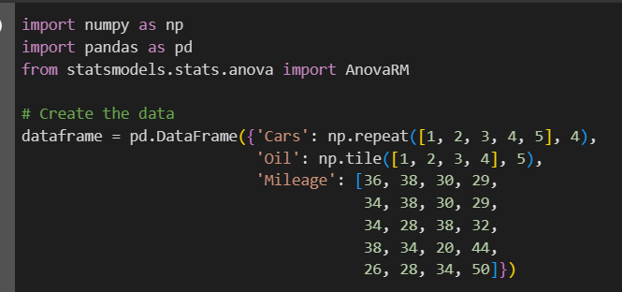

1. Provide a full analysis using repeated-measures ANOVA to determine if there is a difference in mileage of cars between four engine oils.

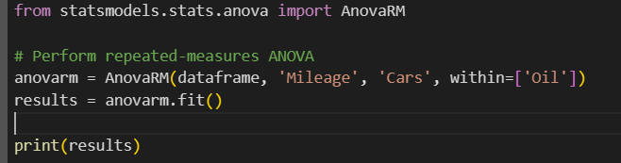

Results:

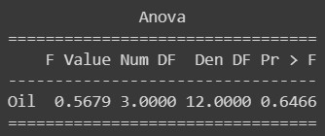

The F-value associated with the engine oil variable is 0.5679, with 3 degrees of freedom (Num DF) in the numerator and 12 degrees of freedom (Den DF) in the denominator. The p-value associated with this F-value is 0.6466

The F-value measures the ratio of variance between groups to variance within groups. A smaller F-value suggests that the variation between the different engine oils is relatively small compared to the variation within the groups.

With a p-value of 0.6466, which is greater than the typical significance level of 0.05, there is no significant evidence to reject the null hypothesis. Therefore, based on this analysis, it appears that the different engine oils do not have a statistically significant impact on the mileage of the cars.

In simpler terms, the type of engine oil used does not seem to lead to significantly different mileages in cars based on the data analysis performed.

2. Check the assumptions underlying the said ANOVA type.

* Sphericity

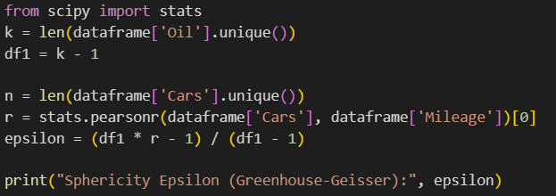

Result:  


- Sphericity Epsilon (Greenhouse-Geisser): -0.377

Sphericity epsilon values in repeated-measures ANOVA show the departure from sphericity (the assumption of equality between variances of the differences between all possible pairs of within-subject conditions). A negative value indicates that the assumption of sphericity is not met. Adjustments in degrees of freedom are necessary in the analysis, such as using the Greenhouse-Geisser correction.

* Normality

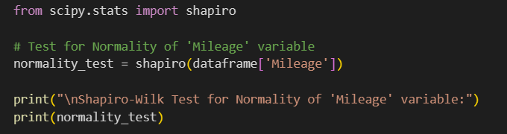

Result:  


The Shapiro-Wilk test assesses normality in the 'Mileage' variable. With a p-value of 0.52 (> 0.05), there is no significant evidence to suggest a departure from normality. Thus, it's reasonable to assume that the 'Mileage' variable approximately follows a normal distribution.

* Homogeneity of Variances

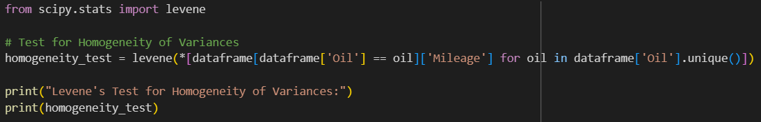

Result:



Levene's test evaluates whether variances across different engine oils (groups) are approximately equal. The obtained p-value of 0.55 (> 0.05) suggests no significant evidence against the assumption of homogeneity of variances. Thus, based on this test, the variances among the groups are reasonably similar.

* CONCLUSION

These results indicate that while there might be a departure from sphericity, the 'Mileage' variable appears to meet the assumptions of normality and homogeneity of variances for the ANOVA analysis. However, considering the negative epsilon value, corrections for violations of sphericity might be necessary in the interpretation of the ANOVA results.