STATISTICAL THEORY

APM1111

Finals - Item 27

BILLONES, Cristel Kaye P.

2021016541

Github link: https://github.com/9Cipher12/Finals_BILLONES_CristelKaye_Item28.git

Mice are used in an experiment to test drugs that may prevent Alzheimer’s disease. Half the mice are transgenic – have been genetically modified to have Alzheimer’s disease. The other half of the mice are “wild type” – they have not been modified in any way, and are considered free of Alzheimer’s disease. The mice are assigned to treatment conditions and given one of four drugs, then tested on memory using a maze. The number of errors made in the maze is recorded for the Training Day and the Memory Day.

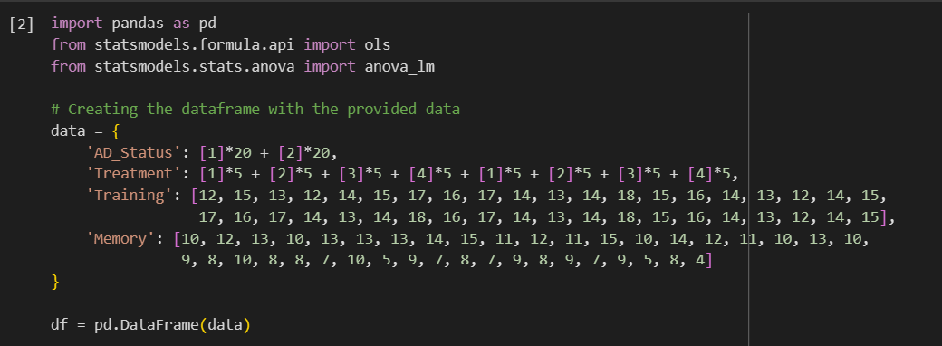

1. Analyze data using a 2-Factor (2B) ANOVA. (Just choose one of the two below. If you choose two, the other one will be considered a bonus item wit a maximum of 15 points.)

* Compare the training day errors based on drug treatments and AD status.
* Compare the memory day errors based on drug treatments and AD status.

**Training Day Errors Analysis:**

For training day errors, considering drug treatments and AD status:

* Null Hypothesis (H0): There is no interaction between drug treatments and AD status on training day errors.
* Alternative Hypothesis (H1): There is a significant interaction between drug treatments and AD status on training day errors.

**Memory Day Errors Analysis:**

For memory day errors, considering drug treatments and AD status:

* Null Hypothesis (H0): There is no interaction between drug treatments and AD status on memory day errors.
* Alternative Hypothesis (H1): There is a significant interaction between drug treatments and AD status on memory day errors.

(Performing 2-Factor ANOVA for Training Day errors based on Treatment and AD_Status)



(Performing 2-Factor ANOVA for Memory Day errors based on Treatment and AD_Status)



Result:

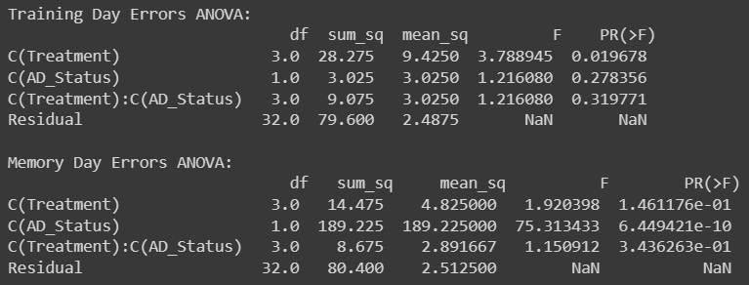

2. Check the assumptions underlying the said ANOVA type.

* Random Sampling:

This is ensured during the data collection process, making sure that each mouse has an equal chance of being selected for the experiment.

* Independence:

This assumption generally relates to how the observations are gathered. Ensure that the conditions within groups are independent and not influenced by each other.

* Normality:

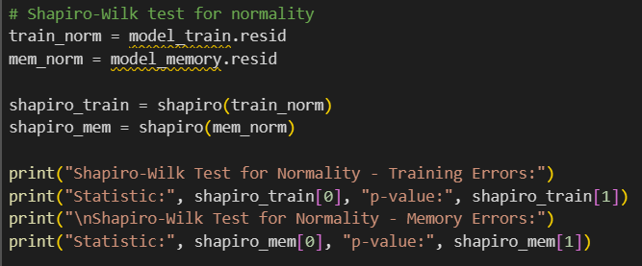

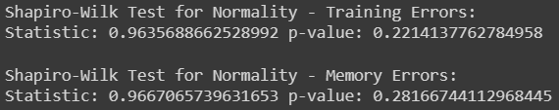

For both the Training and Memory Day errors:

The Shapiro-Wilk test assesses whether the data significantly deviate from a normal distribution. In this case, both tests yielded p-values of 0.22 and 0.28, respectively, at a significance level of 0.05.

Given these results, there's no significant evidence to suggest that the errors in either the Training or Memory Day data significantly deviate from a normal distribution. Therefore, based on the Shapiro-Wilk tests, the assumption of normality for ANOVA seems reasonable for both datasets.

* Homogeneity of Variances:

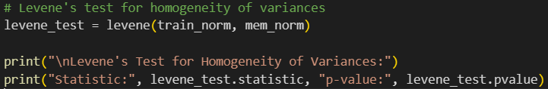



The Levene's test is used to assess whether the variances across groups are approximately equal. In this case, the test yielded a p-value of 0.911, well above the conventional significance level of 0.05.

With a high p-value, there's no significant evidence to suggest that the variances across different groups (treatments or AD status) are significantly different. Therefore, based on Levene's test, the assumption of homogeneity of variances seems to be met.

* Conclusion:

Considering the ANOVA assumptions are reasonably met—random sampling, independence, normality, and homogeneity of variances—it seems appropriate to proceed with the interpretation of the interaction effect between drug treatments and AD status on both Training and Memory Day errors. Based on the analysis, the p-values for the interactions should be considered to determine if there's a significant influence of drug treatments and AD status on memory day errors.