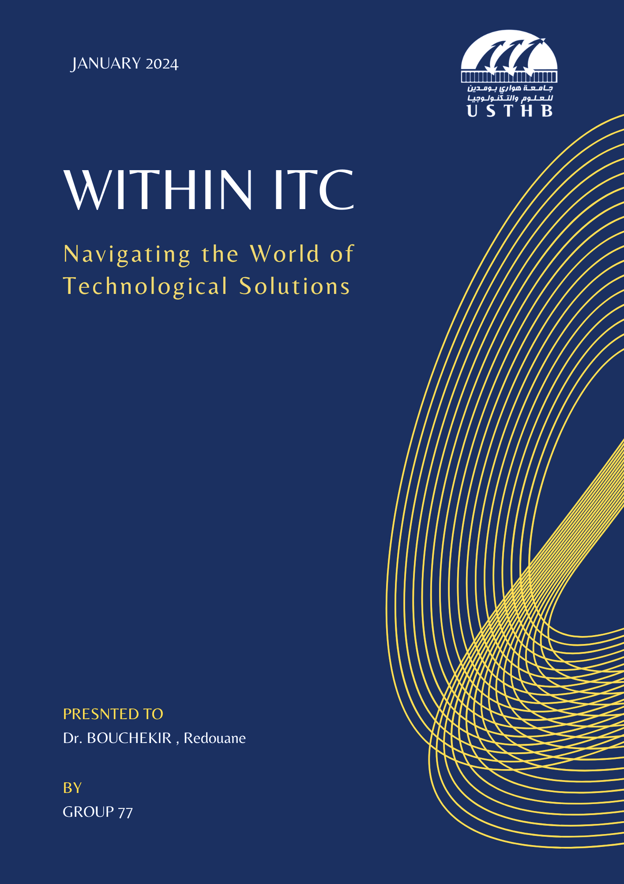

**Contents**

Introduction 2

Overview on ICT 3

Google Services 5

Microsoft tools 8

Git & Github 12

Conclusion 14

# **Introduction**

This report aims to offer a comprehensive overview of Information & Communication Technology (ICT). ICT is a constantly evolving technology that has significantly changed the way we live and work. It allows us to communicate, access information, and collaborate in ways we never could before. Throughout this document, readers will explore the importance and relevance of this field. We’ll also look at the tools and services provided by major players like Microsoft and Google.

# **Overview on ICT**

In our modern era, Information and Communication Technology (ICT) holds a crucial role in our daily lives. In 1800s, the era of technological advancements took its initial steps. Imagine the year 1837 when the telegraph made its debut, utilizing electricity to transmit messages across vast distances (encoded into Morse Code). This pioneering leap reshaped communication, setting the stage for forthcoming ICT advancements. Advancing to 1876, Alexander Graham Bell introduced the telephone, a breakthrough enabling vocal conversations across extensive distances, significantly enhancing global connectivity. Entering the 20th century marked the rise of computers as transformative tools proficient in storing vast information. The advent of ENIAC in 1946 revolutionized data handling, restructuring the ICT landscape. Another pivotal juncture unfolded in 1969 as interconnected computers laid the groundwork for the expansive internet we know today. This pivotal moment laid the foundation for monumental transformations in ICT. In 1991, Tim Berners-Lee’s creation of the World Wide Web (WWW) simplified global information exchange and communication through accessible ICT platforms worldwide. As the early 21st century emerged, smartphones, notably Apple’s iPhone in 2007, transformed our interactions with ICT. These devices became essential for accessing ICT resources, reshaping daily routines and communication methods. The visual below illustrates global internet usage, surpassing 5 billion users. It highlights the profound impact of ICT, particularly the internet in uniting people worldwide .

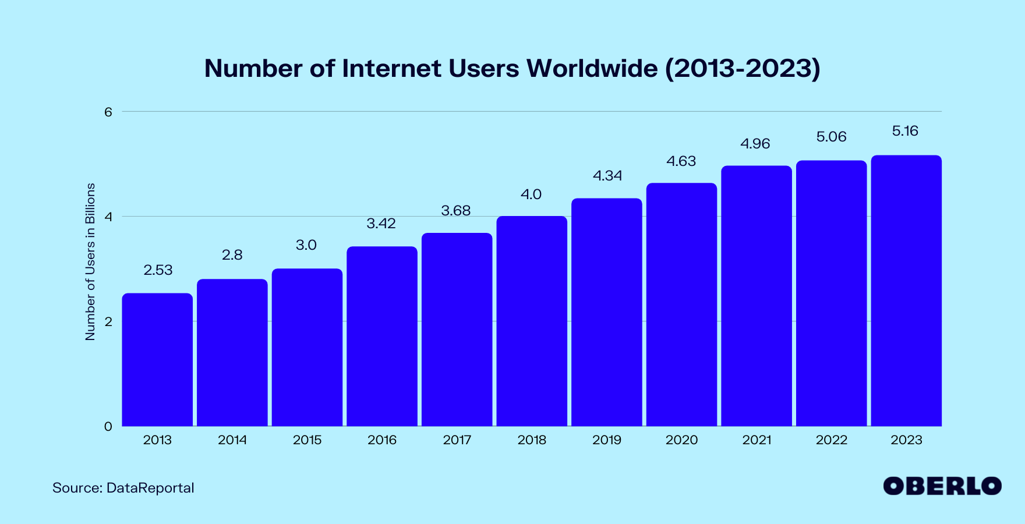Figure 2.1: Internet Usage between 2013 & 2023

[2]

In conclusion, ICT has significantly reshaped our society, impacting how we live, work, and connect. As technology advances, the future of ICT holds promise for further evolution and continued influence on generations to come. [3]

# **Google Services**

In this chapter, we will explore Google’s significant role in Information and Communication Technology (ICT). Specifically, we will delve into platforms like Gmail, Google Docs, and Google Drive, among others, that have greatly influenced this sphere.).

1. **Google Drive (2012)**

Google Drive serves as an extensive online storage solution for files and documents offered by Google. Its standout feature lies in its accessibility across various devices connected to the internet, providing seamless access to data for ICT professionals, irrespective of their location. This platform stands out due to its collaborative tools, enabling real-time file editing and easy sharing among team members in the field of ICT. Its versatility in handling diverse file types and smooth integration with other Google applications makes it a preferred choice for file management and collaborative work within the ICT domain.

1. **Google Docs** (2006)

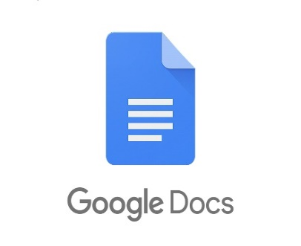Google Docs operates as a cloud-based document processing and collaboration tool offered by Google. Its primary appeal rests in its multi-device accessibility via the internet, delivering a streamlined document workflow for ICT practitioners, irrespective of their geographical dispersion. The platform distinguishes itself with its synchronous editing capabilities, which facilitate concurrent document modifications and hassle-free sharing among ICT team members. Its adaptability in handling diverse document formats and seamless integration with the Google Workspace suite positions it as a top-notch solution for collaborative document management within the ICT domain.

1. **Gmail** (2004)

Gmail, Google’s acclaimed email service, stands as a cornerstone for electronic correspondence. Its exceptional feature lies in its intuitive interface and universal accessibility across various internet connected devices, ensuring a hassle-free email experience for ICT professionals, irrespective of their geographical whereabouts.

|  |  |  |  |  |  |  |
| --- | --- | --- | --- | --- | --- | --- |
| Years | 2017 | 2018 | 2019 | 2020 | 2021 | 2022 |
| Nb. Emails sent daily | 98 | 102 | 105 | 110 | 115 | 121 |

Table 3.1: Number (Billions) of Emails Sent Daily Using gmail

[5]

The platform’s noteworthy integration with other Google Workspace tools provides a unified ecosystem for ICT professionals, streamlining workflow efficiency. Additionally, Gmail’s advanced security protocols, such as two-factor authentication and robust spam filtering, offer a shield against potential threats, ensuring secure communication channels for ICT practitioners. Its efficient labeling and categorization features further enhance organization, making it an ideal choice for managing extensive professional correspondence and information exchange within the ICT domain.

|  |  |  |  |  |  |  |  |
| --- | --- | --- | --- | --- | --- | --- | --- |
| Years | 2012 | 2014 | 2015 | 2016 | 2018 | 2019 | 2020 |
| Nb. Users | 98 | 102 | 105 | 110 | 115 | 121 | 1.8 |

Table 3.2: Number (Billions) of Gmail Users Recorded Over Years

[5]

1. Google Meet (2017)

Google Meet is an essential tool for ICT professionals, enabling effective video discussions for remote collaboration. Integrated with Google’s suite, it offers clear video calls and live features, making interactions highly efficient. Recently, it has introduced specialized tools for ICT, such as improved connections with project tools and AI helpers in meetings. These enhancements aid in better task management and meeting facilitation, boosting productivity for ICT teams.

# **Microsoft tools**

Microsoft is also well known for its huge contributions to the TIC field , it was on the forefront of the development of this field offering countless tools that we will see in this chapter.

1. **Microsoft Office**

Microsoft Office 365, including essential tools like Word, Excel, PowerPoint, Outlook, and Access, acts as a vital suite in modern work environments. It comprises various applications suitable for diverse tasks across industries. Its primary strength lies in aiding document creation, storage, and smooth collaboration, particularly helpful for professionals surfing the ITC.

*Microsoft Word* stands as an adaptable platform, empowering users with comprehensive tools for crafting and formatting documents. Offering an extensive array of formatting options, templates, and editing features, Word facilitates the creation of reports, academic papers, and diverse content with precision and ease.

*Microsoft Excel* emerges as a potent asset, specializing in data management and analysis. Its grid-based interface streamlines data organization, aiding in calculations and visual representations pivotal for financial modeling, statistics, and data-driven tasks. Advanced functions and data visualization tools empower users to delve into complex analysis and decision-making processes.

*Powerpoint* assumes the role of a creative ally, facilitating the development of visually captivating presentations. Boasting an extensive repertoire of templates, transitions, and multimedia embedding capabilities, PowerPoint enables users to craft engaging presentations essential for impactful communication in professional environments, aiding in conveying complex ideas with clarity.

*Outlook* serves as a centralized hub for streamlined communication and organization. It combines emails, calendars, tasks, and contacts into an integrated platform, simplifying coordination and fostering collaboration within teams. Its features, including shared calendars and task assignments, enhance teamwork efficiency.

*Microsoft Access* takes center stage as a robust database management system, crucial for organizing and analyzing structured information. Its user-friendly interface empowers users to design and manage databases efficiently, offering solutions for businesses and individuals seeking structured data management and analysis tools. Together, Microsoft Office’s tools work hand-in-hand. They cover diverse tasks and boost productivity, aiding collaboration across various industries and professions.

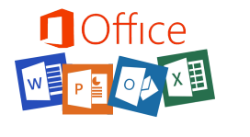

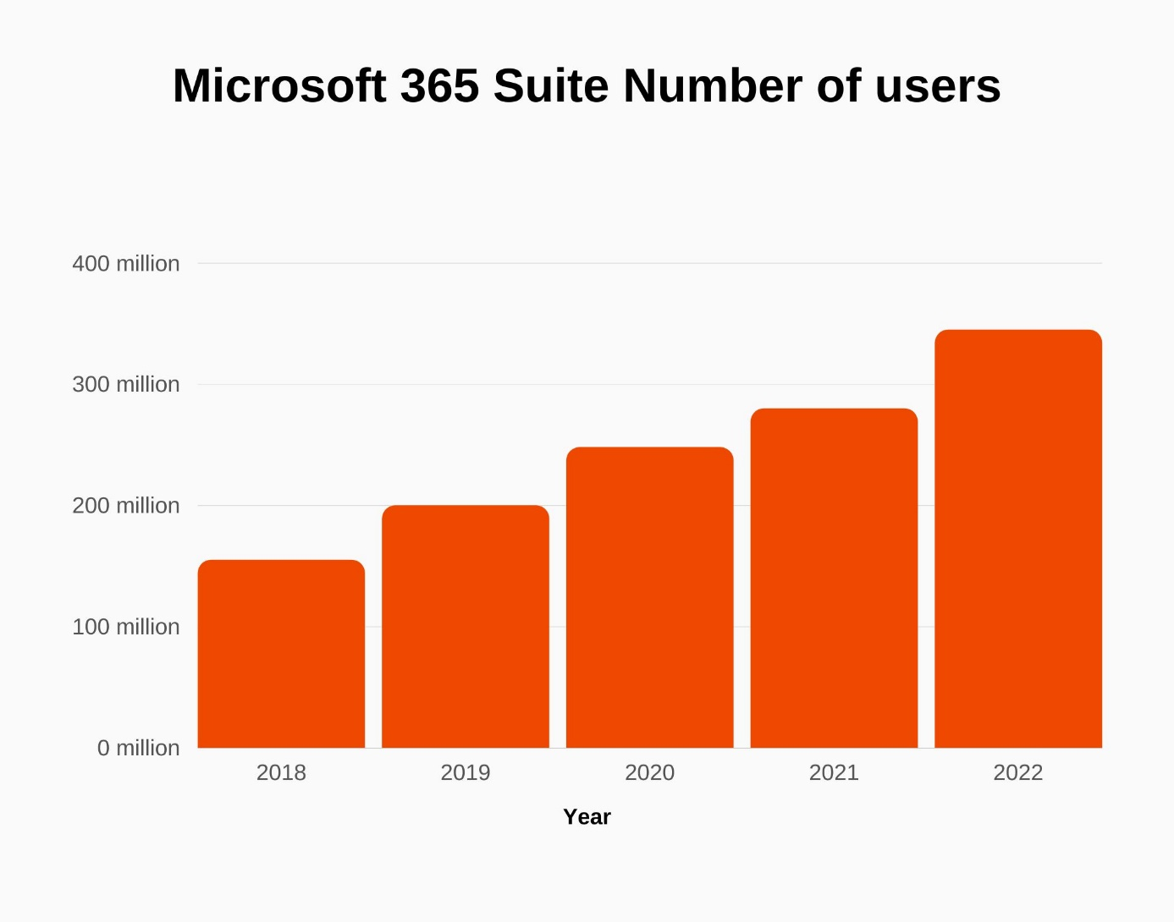

Figure 4.1: Microsoft 365 Suite Number of users.

[4]

1. **Microsoft teams**

Microsoft Teams was launched in 2017, marking a significant advancement in collaborative work platforms. This system efficiently categorizes discussions into channels and chats, simplifying communication among teams. Its video meeting functionalities, encompassing screen sharing and live captions, create a sophisticated virtual environment for interactive discussions and presentations, enabling smooth interaction regardless of team members’ locations. Microsoft Teams facilitates smooth file sharing and collaborative editing within channels or chats, smoothly integrating with Office 365 apps for streamlined document management. Its task management tools and compatibility with third-party applications con12 tribute to enhanced project coordination and workflow efficiency. Complemented by stringent security measures such as encryption and two-factor authentication, Teams prioritizes the security of shared information. It’s also accessible across a wide range of devices, Teams stands as a beacon of productivity, promoting collaboration and efficiency without geographical constraints.

|  |  |  |  |  |  |  |  |
| --- | --- | --- | --- | --- | --- | --- | --- |
| Years | 2012 | 2014 | 2015 | 2016 | 2018 | 2019 | 2020 |
| Nb. Microsoft Teams Users | 2 | 8 | 20 | 75 | 145 | 270 | 230 |

Table 4.1: Number of Microsoft Teams Users (Millions)

[6]

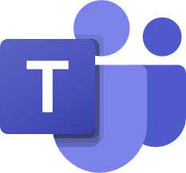

# **Git & Github**

Git emerged in 2005 as a version control system, revolutionizing how developers manage and track changes in code. It operates as a distributed version control system (DVCS), allowing developers to create repositories that store code histories and enabling seamless collaboration among teams. With Git’s decentralized structure, developers can create branches to work on specific features or fixes independently, merging their changes back into the main codebase effortlessly. This system grants unparalleled flexibility and control over project versions, enabling efficient tracking and management of code changes. GitHub, launched in 2008, is a cloud-based platform that amplifies the collaborative power of Git. It serves as a social coding platform, providing hosting services for Git repositories. GitHub’s userfriendly interface and comprehensive collaborative features have transformed the software development landscape. It functions as a centralized hub where developers can share, explore, and contribute to open-source projects. Beyond version control, GitHub integrates issue tracking, pull requests for code review, wikis for documentation, and project management tools, offering a holistic ecosystem for efficient collaboration.



GitHub’s influence transcends version control; it cultivates a global community where developers showcase, learn from, and contribute to diverse projects. Through features like stars, forks, and discussions, GitHub stimulates collaboration, knowledge exchange, and innovation within the developer community.

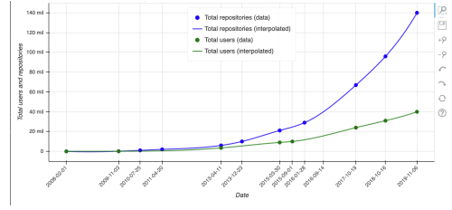

Figure 5.1: GitHub growth in users and repositories since 2008.

[1]

# **Conclusion**

In conclusion, information and communication technology (ICT) stands as an unparalleled force reshaping our world. This report highlights its profound impact on businesses and society, tracing its evolution from the internet’s inception to the dominance of social media platforms. ICT transcends borders, forging a global unity that compresses our world. Staying updated on ICT’s advancements becomes imperative, as the relentless technological progress demands unyielding adaptability from individuals and enterprises. Failing to evolve risks stagnation and missed opportunities. Mastery of emerging ICT domains is essential for navigating the digitized landscape and ensuring sustained progress. ICT redefines communication, work, and daily life, making proficiency in these technological leaps critical for those aspiring to lead in our evolving digital realm.

**THE END.**

**Bibliography**

1. History of GitHub — pslmodels.github.io.  
   <https://pslmodels.github.io/GitTutorial/content/background/GitHubHistory.html>.
2. How Many People Use the Internet in 2023? [May 2023 Update] — oberlo.com. <https://www.oberlo.com/statistics/how-many-people-use-internet>
3. Information and communications technology - Wikipedia — en.wikipedia.org. <https://en.wikipedia.org/wiki/Informationandcommunicationstechnology>.
4. Microsoft 365 Suite Revenue and Growth Statistics (2024) — SignHouse — usesignhouse.com. <https://www.usesignhouse.com/blog/microsoft365-suite-stats>.
5. R. Shewale. Gmail Statistics For 2024 (Users, Market, Revenue & More) — demandsage.com. <https://www.demandsage.com/gmail-statistics/>.
6. R. Shewale. Microsoft Teams Statistics - Users & Revenue (2024 Report) — demandsage.com. <https://www.demandsage.com/microsoftteams-statistics/>.