1.Basic Python

Follow the python tutorial in the following link (focus on the tutorials in the red box):

<https://www.w3schools.com/python/>

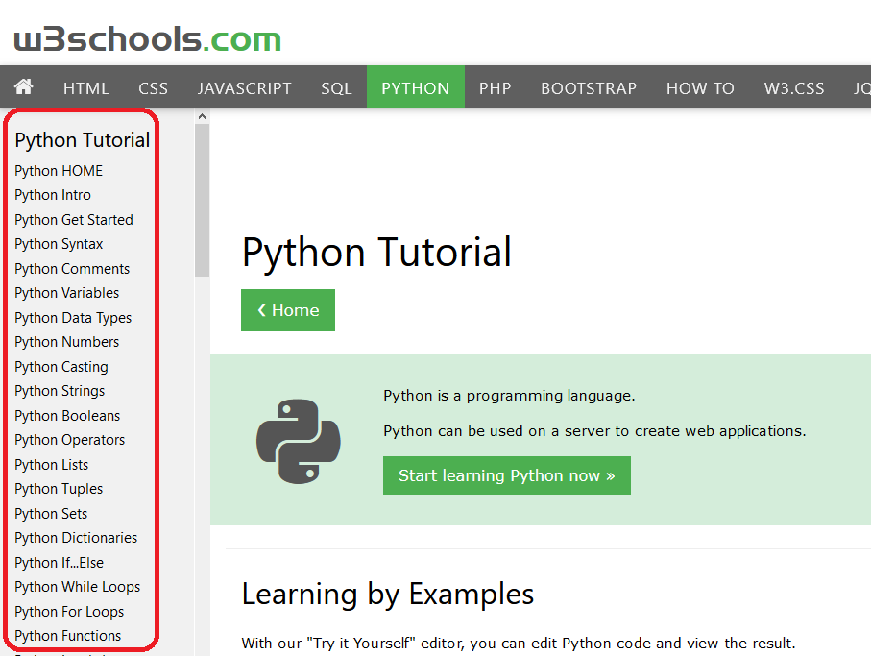

2. Linear Regression with scikit-learn library

Follow the linear regression tutorial in the file “Linear Regression in Python with Scikit-Learn.htm”