

Business Template

A DATABASE OF CLIMBS FOR A MOUNTAINEERING CLUB - Aibibi Nygymetolla
Logo / Image

Contents
1 Business Description 3
1.1 Business background 3
1.2 Problems. Current Situation 3
1.3 The benefits of implementing a database. Project Vision 3
2 Model description 3
2.1 Definitions & Acronyms 3
2.2 Logical Scheme 3
2.3 Objects 3

Business Description

Business background
The Mountaineering Club is a sports organisation whose members organise and participate in mountain climbing expeditions across different countries and regions. The club needs a centralised database to record all climbing activities and member information in a structured and reliable way.
The system must record the start and end dates of each climb, the names and home addresses of all participating climbers, the name and height of the mountain ascended, and the country and geographic area where the mountain is located. Each climb may involve multiple climbers in different roles (e.g. Leader, Member, Guide), and each climber may participate in many climbs over time.

Problems. Current Situation
Currently the club records climb information manually using spreadsheets and paper forms. This causes several problems: climber addresses are duplicated across multiple records; mountain and country data is entered inconsistently; there is no reliable way to prevent the same climber from being registered twice on the same climb; and running any analytical query requires significant manual effort.
Data redundancy is the core problem: storing all information in one flat structure means any change to a climber’s address or a mountain’s name must be updated in many rows, which is error-prone and time-consuming.

the Benefits of implementing a database. Project Vision
Implementing a relational database in 3rd Normal Form will eliminate data redundancy, ensure consistency of climber and mountain records, and enforce business rules (such as preventing duplicate participation) through keys and constraints.
The database will allow the club to: quickly look up all climbers who participated in a given climb; find all climbs on a specific mountain or in a specific country; maintain accurate emergency contact information per climber; and track climb routes with difficulty grades. The normalised structure is well suited to OLTP workloads such as registering new climbs and updating climber details.

Model description

Definitions & Acronyms
PK – Primary Key. Uniquely identifies each row in a table.
FK – Foreign Key. References the primary key of another table to establish a relationship.
3NF – Third Normal Form. A level of database normalisation that eliminates data redundancy and transitive dependencies.
OLTP – Online Transaction Processing. A database workload focused on frequent insert, update, and delete operations.
ER Diagram – Entity-Relationship Diagram. A visual representation of entities, their attributes, and the relationships between them.
UIAA – Union Internationale des Associations d’Alpinisme. International body that defines mountain climbing difficulty grades (I through VI+).

Logical Scheme
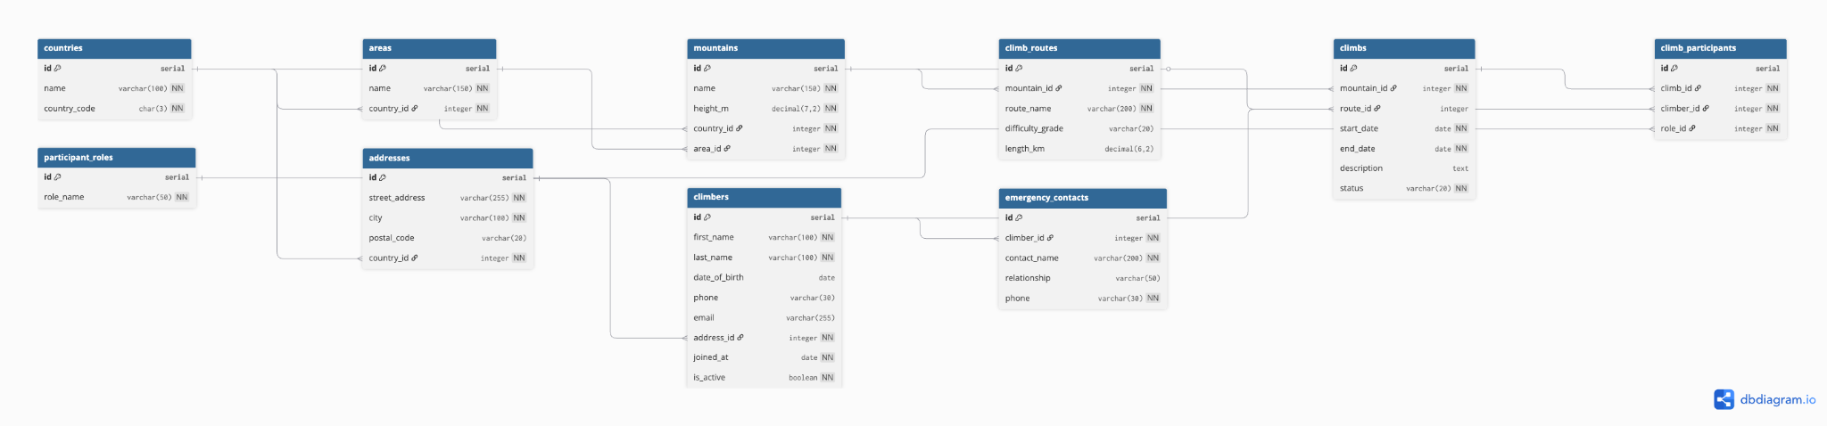

Objects

Table Description
The model contains 11 tables organised into four groups: Reference (countries, areas, participant_roles); Geographic (mountains, climb_routes); Climber data (addresses, climbers, emergency_contacts); and Climb events (climbs, climb_participants). The many-to-many relationship between climbers and climbs is resolved by the junction table climb_participants, which also records the role of each participant on that specific climb.

Table Name | Field name | Field Description | Data Type
countries | id | PK. Surrogate key. | serial
 | name | Country name, unique. | varchar(100)
 | country_code | ISO 3166-1 alpha-3 code, unique. | char(3)
areas | id | PK. Surrogate key. | serial
 | name | Area name. | varchar(150)
 | country_id | FK to countries.id, NOT NULL. | integer
mountains | id | PK. Surrogate key. | serial
 | name | Official mountain name. | varchar(150)
 | height_m | Height in metres, NOT NULL. | decimal(7,2)
 | country_id | FK to countries.id, NOT NULL. | integer
 | area_id | FK to areas.id, NOT NULL. | integer
climb_routes | id | PK. Surrogate key. | serial
 | mountain_id | FK to mountains.id, NOT NULL. | integer
 | route_name | Route name, NOT NULL. | varchar(200)
 | difficulty_grade | UIAA grade (I-VI+). | varchar(20)
addresses | id | PK. Surrogate key. | serial
 | street_address | Street and building number. | varchar(255)
 | city | City name, NOT NULL. | varchar(100)
 | country_id | FK to countries.id, NOT NULL. | integer
climbers | id | PK. Surrogate key. | serial
 | first_name | Given name, NOT NULL. | varchar(100)
 | last_name | Family name, NOT NULL. | varchar(100)
 | email | Contact email, UNIQUE. | varchar(255)
 | address_id | FK to addresses.id, NOT NULL. | integer
 | is_active | Soft-delete flag. Default true. | boolean
emergency_contacts | id | PK. Surrogate key. | serial
 | climber_id | FK to climbers.id, NOT NULL. | integer
 | contact_name | Full name of contact. | varchar(200)
 | phone | Contact phone, NOT NULL. | varchar(30)
participant_roles | id | PK. Surrogate key. | serial
 | role_name | Role label, UNIQUE. E.g. Leader. | varchar(50)
climbs | id | PK. Surrogate key. | serial
 | mountain_id | FK to mountains.id, NOT NULL. | integer
 | route_id | FK to climb_routes.id. Nullable. | integer
 | start_date | Climb start date, NOT NULL. | date
 | end_date | Climb end date, NOT NULL. | date
 | status | planned|ongoing|completed|cancelled. Default planned. | varchar(20)
climb_participants | id | PK. Surrogate key. | serial
 | climb_id | FK to climbs.id, NOT NULL. | integer
 | climber_id | FK to climbers.id, NOT NULL. | integer
 | role_id | FK to participant_roles.id. | integer
 | (climb_id, climber_id) | UNIQUE index — prevents duplicate participation. | —

Comments on table relationships
countries ← areas (N:1): each area belongs to one country. countries ← mountains (N:1): each mountain is located in one country. areas ← mountains (N:1): each mountain belongs to one geographic area. mountains ← climb_routes (N:1): routes belong to one mountain. countries ← addresses (N:1): each address has a country. addresses ← climbers (N:1): each climber has one home address. climbers ← emergency_contacts (1:N): a climber may have multiple emergency contacts. mountains ← climbs (N:1): each climb targets one mountain. climb_routes ← climbs (N:1, nullable): a climb may specify a route. climbs ↔ climbers (M:N via climb_participants): a climber participates in many climbs; each climb has many climbers. participant_roles ← climb_participants (N:1): each participation record has a role.

Example with data

climb_id | climber_id | role_id | joined_at
1 | 7 | 2 | 2025-06-15

