**NRF52840 BLE DONGLE**

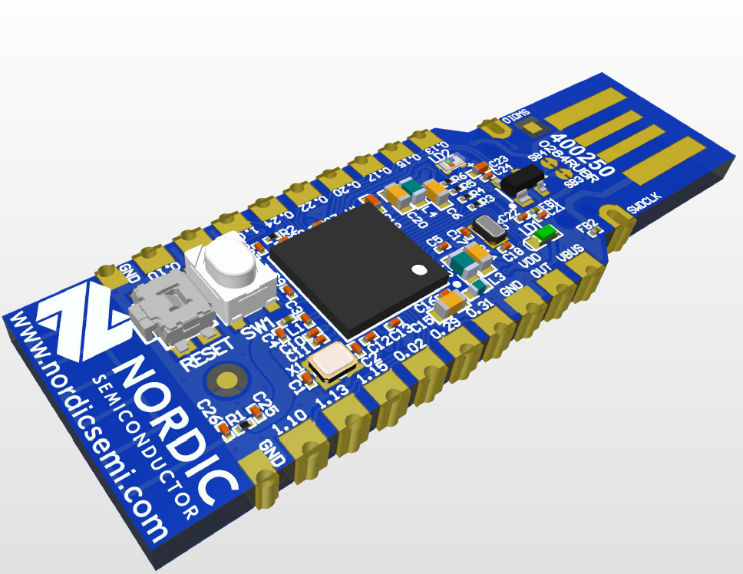 Atul kumar

1) Introduction about dongle

2) Physical overview

3) Nodic semiconductor website

4) NRF connect desktop application and mobile application

5) NRF52840 Software development kit

6) Where to write and how to program device

7) Blinking on board led

8) External pin configuration

Introduction about dongle 

The nRF52840 Dongle is a small, low-cost USB dongle for Bluetooth® Low Energy (LE), Bluetooth mesh, Thread, Zigbee, 802.15.4, ANT and 2.4 GHz proprietary applications using the nRF52840 SoC. The dongle is the perfect target hardware for use with nRF Connect for Desktop as it is low-cost but still support all the short range wireless standards used with Nordic devices. The dongle has been designed to be used as a wireless HW device together with nRF Connect for Desktop.

It can also be used to develop code for the nRF52840 SoC mounted on the dongle. Programming is supported through a USB enabled bootloader. Connectors for external debuggers are available.

**KEY FEATURES**

* Bluetooth 5 ready multiprotocol radio
* 2 Mbps
* Long Range
* Advertising Extensions
* Channel Selection Algorithm #2 (CSA #2)
* IEEE 802.15.4 radio support
* Thread
* Zigbee
* Arm® CortexTM-M4 with floating point support DSP instruction set
* Arm CryptoCell CC310 cryptographic accelerator
* 15 GPIO available via edge castellation
* USB interface direct to nRF52840 SoC
* Integrated 2.4 GHz PCB antenna
* 1 user-programmable button
* 1 user-programmable RGB LED
* 1 user-programmable LED
* 1.7-5.5 V operation from USB or external

Physical overview

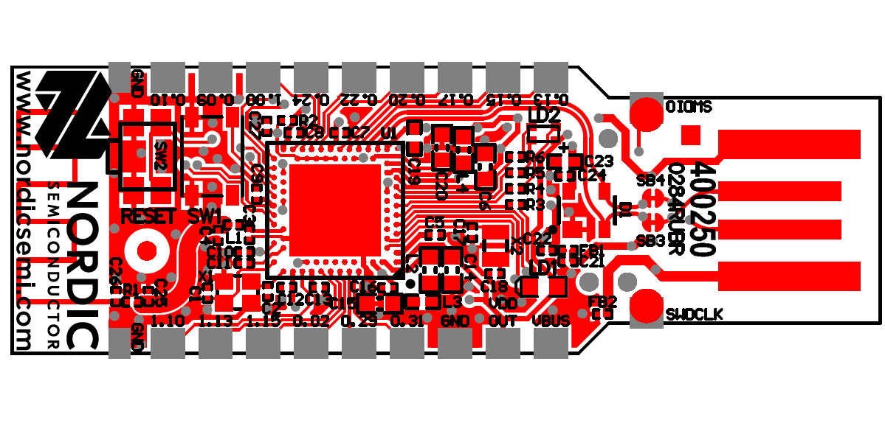

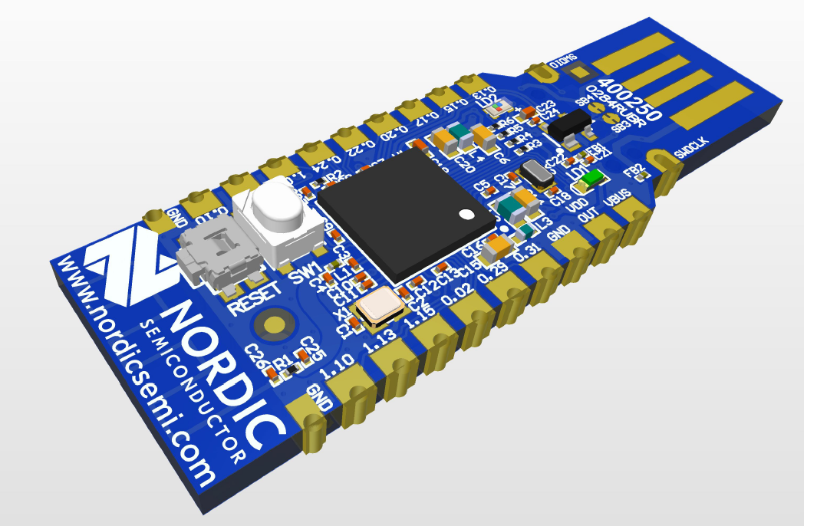

Nodic semiconductor website

Main website :

<https://www.nordicsemi.com/>

<https://infocenter.nordicsemi.com/index.jsp>

Downloads: To work on NRF52840 dongle you will require following:

* NRf connect desktop application

<https://www.nordicsemi.com/Software-and-tools/Development-Tools/nRF-Connect-for-desktop>

* NRF52840 Software development kit

<https://www.nordicsemi.com/Software-and-tools/Software/nRF5-SDK>

* Softdevice for NRF52840

<https://www.nordicsemi.com/Software-and-tools/Software/S140>

# Segger Embedded studio

# <https://www.segger.com/products/development-tools/embedded-studio/>

# NRF connect desktop application

# This application is specially designed for nodic boards which has many features like:

# 1)Bluetooth Low Energy

# 2)Direct test Mode

# 3)Getting Started Assistant

# 4)LTE link Monitor

# 5)Power Profiler

# 6)Programmer

# 7)RSSI viewer

# 8)Trace collector

# 

# NRF connect mobile application

# <https://play.google.com/store/apps/details?id=no.nordicsemi.android.mcp>

NRF52840 Software development kit

The nRF5 SDK is your first stop for building fully featured, reliable and secure applications with the nRF52 and nRF51 Series. It offers developers a wealth of varied modules and examples right across the spectrum including numerous Bluetooth Low Energy profiles, Device Firmware Upgrade (DFU), GATT serializer and driver support for all peripherals on all nRF5 Series devices. The nRF5 SDK will almost certainly have something for your needs in developing exciting yet robust wireless products.

**The SDK should contain following file after you download it from nodic semiconductor .**

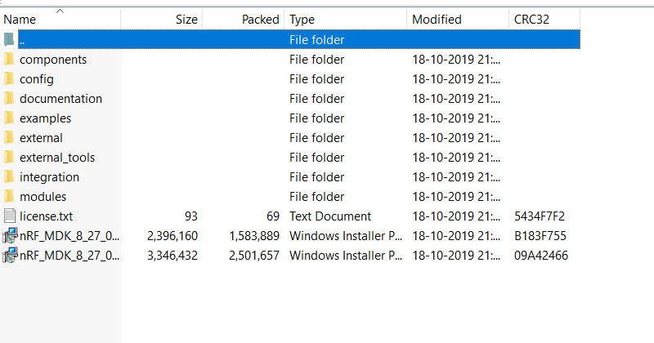

Where to write and how to program device

Program can be written using many applications like keil ,arm gcc for Ubuntu and best one is segger embedded studio.

Segger embedded studio has build in arm gcc compiler and it is free for nodic semiconductors boards just small procedure we have to follow to get free license and easy to build hex file and compile program.

For programming follow following steps:

Step 1) Plug dongle in laptop/pc in USB 3.0 port and press reset button after that red colour led will start blinking, that means dongle is in bootloader mode .

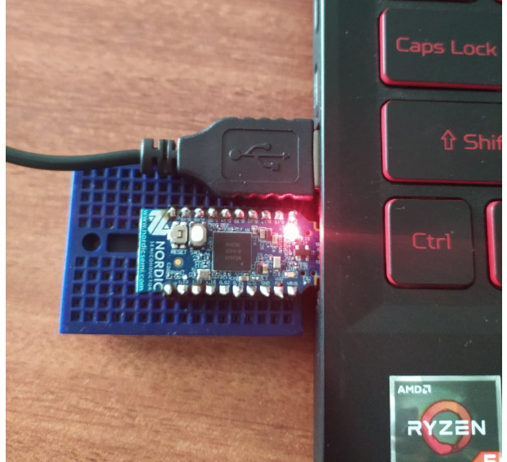

Step2)Open NRF connect application and open programmer



Select dongle from top left corner

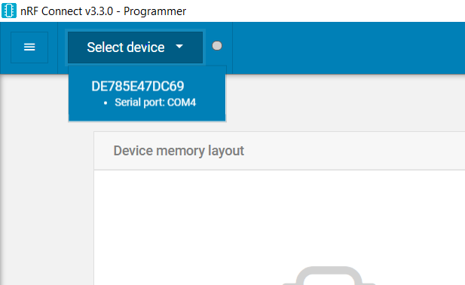

After this you will see following this means dongle is linked successfully.

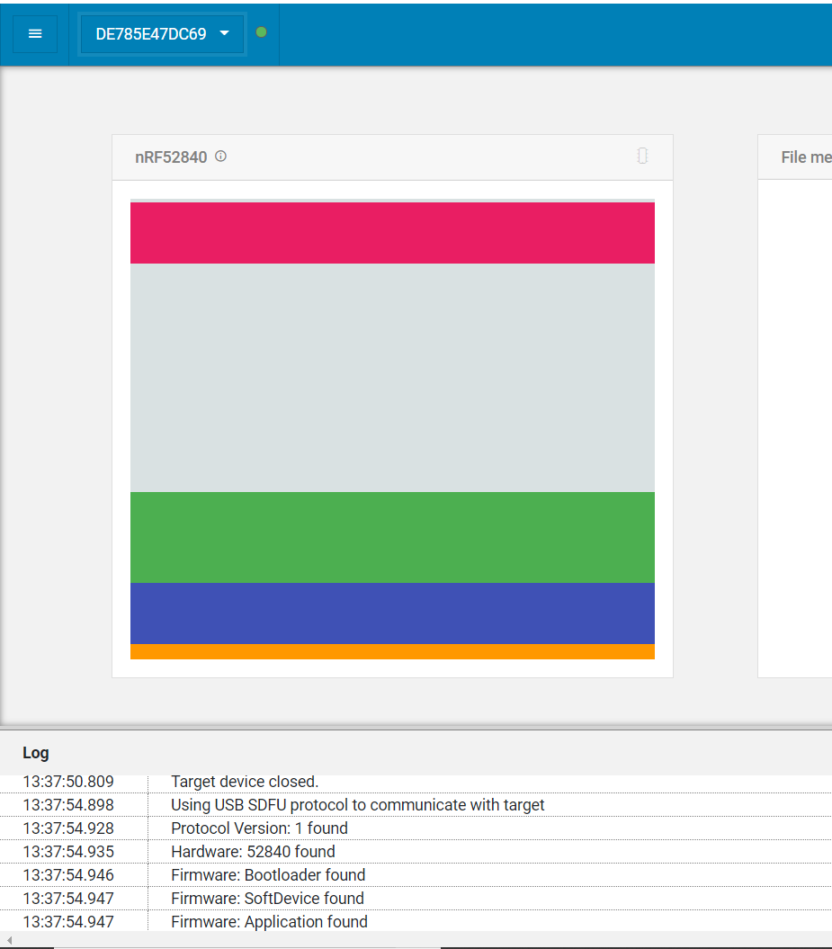

Step3) To add hex file

See at top right corner you will able see Add hex file,

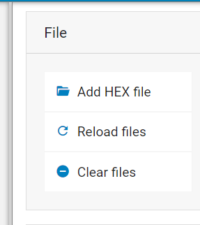

click on that and browse your specific hex file,

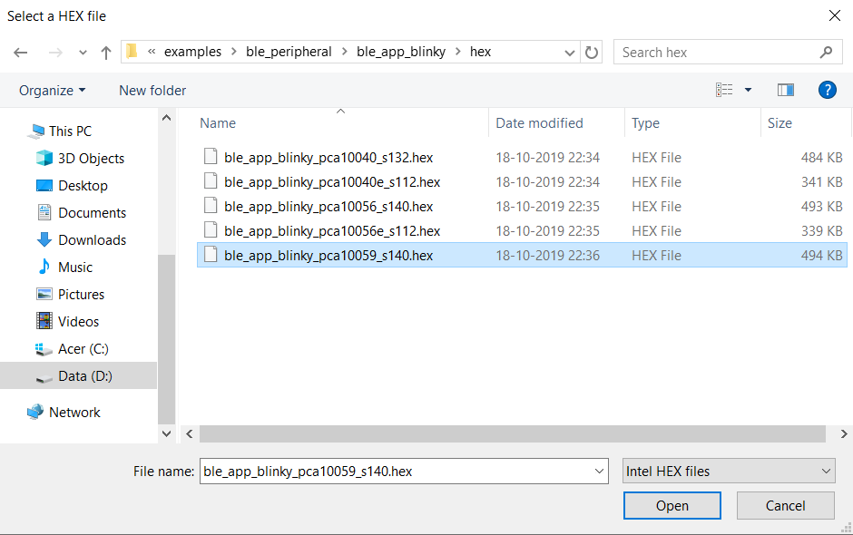

After selecting file click on open, initially file memory layout was empty now it will show like this, file is selected successfully.

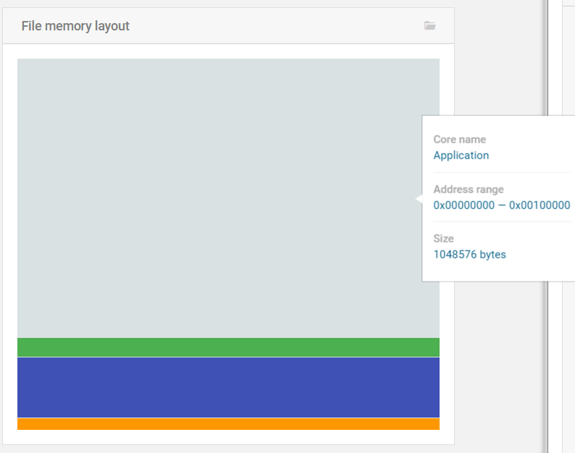

Now click on write which is just below under device

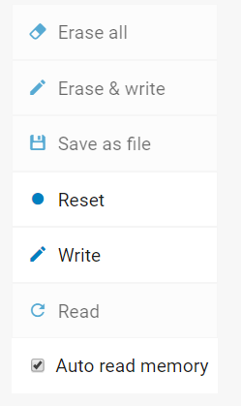

After clicking on write, programmer will take like 10 to 15 secs to upload program to the dongle .User can see progress in nRF log just below .If you see DFU for application completed successfully this means program is uploaded successfully.

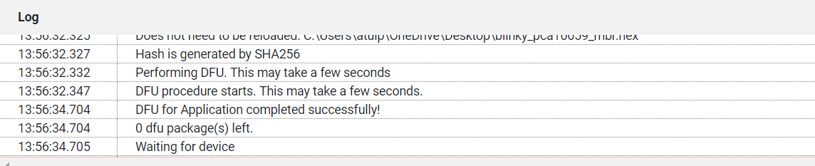

Blinking onboard led

Go to

**sdk\examples\peripheral\blinky\hex**

It has precompiled blinky hex file

our dongle is PCA10059

upload the program you will see following results

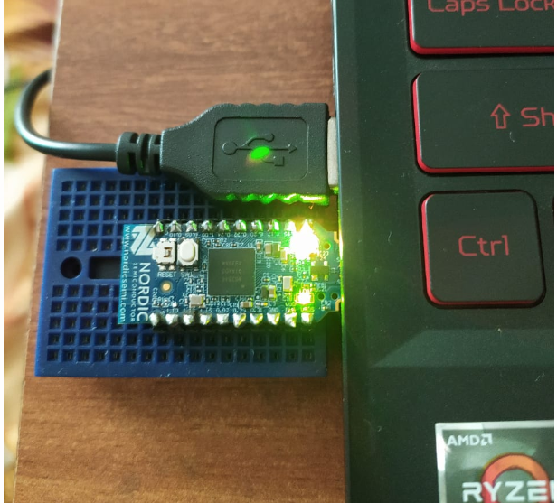

if user wants to edit the program like to change delay time to change blinking speed go to

**sdk\examples\peripheral\blinky\pca10059\mbr\ses**

**open project file in segger embbed studio you will see following program**

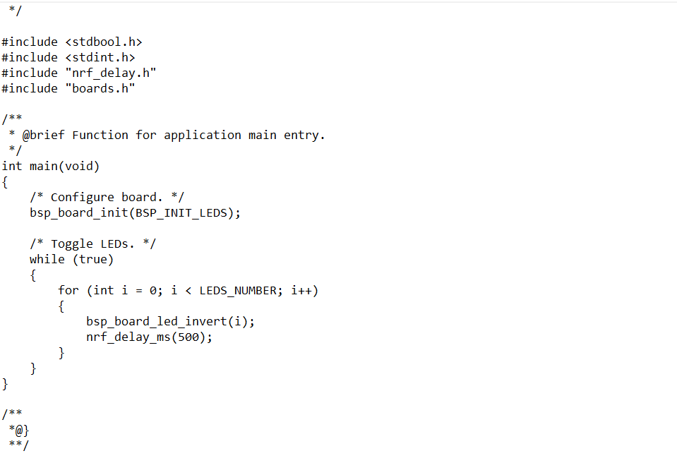

Change program as per requirement

Then at the top bar in segger, go to build then build solution after hex file created the location of hex will be **sdk\examples\peripheral\blinky\pca10059\mbr\ses\Output\Release\Exe**

**Upload the program**

External pin configuration

Following program is just a sample pin configuration to help user to understand how to drive external devices like motor, leds etc. Building solution ie hex file and uploading procedure will be same.

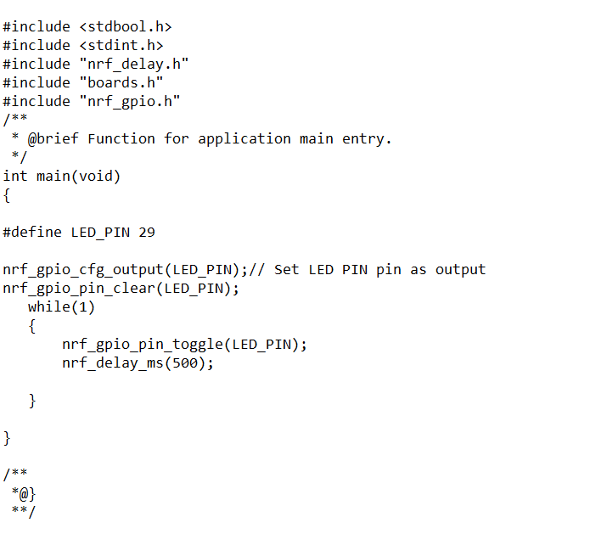

The end.