**ALIZE**

*Open Source platform for biometrics authentification*

### What's that ...

This is the new ALIZE website: this site is a collaborative website, so we are waiting for comments (bugs or improvments).   
old ALIZE website: not available all information should be there  
old Mistral website: not available all information should be there

ALIZE is an open-source plateform (distributed under LGPL licence) for biometric authentication. The ALIZE goal is to allow the development, by everybody, of niometric applications by providing a set of high-level and low-level tools. To allow everybody to use ALIZE according to his needs, ALIZE is composed of several sets:

* a low-level library (ALIZE): this library is composte of all needed functions to the use of Gaussian mixtures.
* an high-level toolkit (LIA_RAL): the toolkit is it-self sub-divided in several parts:
  + LIA_SpkTools : high-level library
  + LIA_Utils : tools needed to the manipulation of all formats used in ALIZE: GMM models, parameters, etc.
  + LIA_SpkDet : a set of tools to do all tasks recquired by a biometric authentication system: models (speaker/world) training, parameters normalisation, score normalisation, etc.
  + and soon LIA_SpkSeg : a new tool (soon avalaible) to speaker diarization.

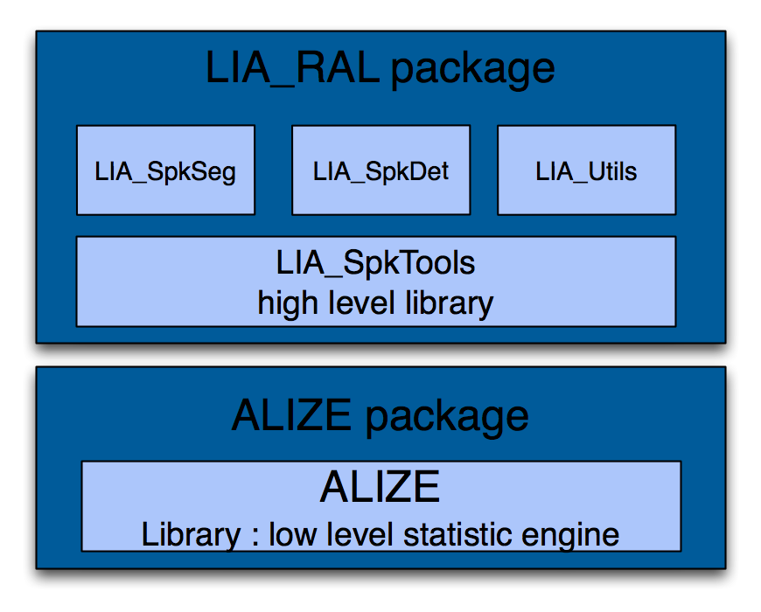

This software was developed with the aim to be multi-plateform, all main OS are supported:

* Windows
* Linux
* MacOSX

### Contacts

As described to about pages, ALIZE is not only an open-source software for biometric authentication ; it's also a huge community around this thematic. That's why there is two ways to contact "ALIZE" :

* the user/developper community of ALIZE
* responsibles of ALIZE project

##### ALIZE community

* Email list

This list could be used for every question or remarks around ALIZE.  
All actions allowed with ALIZE list is detailled below:

* + Send a email to the list: [dev-alize@listes.univ-avignon.fr](mailto:dev-alize@listes.univ-avignon.fr?subject=[ALIZE])
  + Subscribe to the list: [dev-alize-subscribe@listes.univ-avignon.fr](mailto:dev-alize-subscribe@listes.univ-avignon.fr)
  + Unsubscribe to the list: [dev-alize-unsubscribe@listes.univ-avignon.fr](mailto:dev-alize-unsubscribe@listes.univ-avignon.fr)
  + Contact the list administrator : [dev-alize-request@listes.univ-avignon.fr](mailto:dev-alize-request@listes.univ-avignon.fr)
* LinkedIn group

A group, named "ALIZE Biometry plateform", has been created on LinkedIn network. To join us: [ALIZE group on LinkedIn](http://www.linkedin.com/groups?mostPopular=&gid=2323703&trk=myg_ugrp_ovr).

##### ALIZE responsibles - LIA, Université d'Avignon

The best way to contact ALIZE responsibles is to send a email to [http://mistral.univ-avignon.fr/img/alize-adresse.png](mailto:alize@univ-avignon?subject=[ALIZE])

### Documentation

Here you can find the ALIZE documentation. How to use ALIZE, How to use LIA_RAL, how to use distant-server, ...

You can also contact us (with dev-alize list or alize email) if you don't find any solution into these docs.

##### Documentation

* ALIZE programming guide
  + Programming guide for ALIZE library
  + Version: a2.0
  + Refer to: [Documentation to program ALIZE](http://mistral.univ-avignon.fr/doc/userguide_alize.001.pdf)
* LIA_RAL programming guide
  + Programming guide for LIA_RAL
  + Version:1.0
  + Refer to: [Documentation to program LIA_RAL](http://mistral.univ-avignon.fr/doc/userguide_LIA_SpkDet.002.pdf)
* Doxygen documentation of ALIZE
  + Source code documentation of ALIZE
  + Version: 2.0
  + Refer to: [ALIZE doxygen](http://mistral.univ-avignon.fr/doc/doxygen_ALIZE_2.0/html/index.html)
* Doxygen documentation of LIA_RAL
  + Source code documentation of LIA_RAL
  + Version: 2.0
  + Refer to: [LIA_RAL doxygen](http://mistral.univ-avignon.fr/doc/doxygen_LIA_RAL_2.0/html/index.html)
* FAQ - ALIZE Wiki
  + Refer to: [ALIZE FAQ](http://mistral.univ-avignon.fr/mediawiki/index.php/Main_Page) (http://mistral.univ-avignon.fr/img/USA.png only)

### Download

Several solutions are avalaible to download ALIZE:

* download sources from the subversion server (**advised solution**)
* download a release version of library and high level programs
* download binaries:
  + Windows
  + Linux
  + Mac OS X

##### ALIZE svn server (advised solution)

Subversion (SVN) is an open-source revision control system, distributed under Apache et BSD licences. We use it for ALIZE:

Download:

* [trunk of ALIZE](http://alize.univ-avignon.fr/svn/ALIZE/trunk/): http://alize.univ-avignon.fr/svn/ALIZE/trunk/
* [trunk of LIA_RAL](http://alize.univ-avignon.fr/svn/LIA_RAL/trunk/): http://alize.univ-avignon.fr/svn/LIA_RAL/trunk/

##### Released versions

This solution is not advised. Indeed sources available here are not the latest. We advise to use the SVN server to download the latest sources.

Download;

* [ALIZE 2.0](http://mistral.univ-avignon.fr/src/ALIZE_2.0.zip)
* [LIA_RAL 2.0](http://mistral.univ-avignon.fr/src/LIA_RAL_2.0.zip)
* [ALIZE 1.4](http://mistral.univ-avignon.fr/src/ALIZE_1.4.zip)
* [LIA_RAL 1.4](http://mistral.univ-avignon.fr/src/LIA_RAL_1.4.zip)

##### ALIZE Binaries

soon available !!!

### Publications linked to ALIZE

This page contains a set of papers linked to ALIZE.   
If you made a paper linked to ALIZE but not refered here, don't hesitate to contact us (cf. [page contact](http://mistral.univ-avignon.fr/contact_en.html)).

#### 2012

["Variance-Spectra based Normalization for I-vector Standard and Probabilistic Linear Discriminant Analysis"](http://mistral.univ-avignon.fr/doc/publi/12_ODYSSEY_Bousquet.pdf), Bousquet P.M., Larcher A., Matrouf D., Bonastre J.F., Plchot O., Speaker Odyssey   
["I-vectors in the context of phonetically-constrained short utterances for speaker verification"](http://mistral.univ-avignon.fr/doc/publi/12_ICASSP_Larcher.pdf), Larcher A., Bousquet P.M., Lee K.A., Matrouf D, Li H., Bonastre J.F., ICASSP'12

#### 2011

["Intersession compensation and scoring methods in the I-vectors space for speaker recognition"](http://mistral.univ-avignon.fr/doc/publi/11_Interspeech_Bousquet.pdf), Bousquet P.M., Matrouf D., Bonastre J.F., Interspeech'11   
["Discriminant binary data representation for speaker recognition"](http://mistral.univ-avignon.fr/doc/publi/11_ICASSP_Bonastre.pdf), Bonastre J.F., Bousquet P.M., Matrouf D., Anguera X., ICASSP'11

#### 2010

["Data-driven background dataset selection for SVM-based speaker verification"](http://mistral.univ-avignon.fr/doc/publi/10_IEEE-TASP_Mclaren.pdf), McLaren M., Vogt R., Baker B., Sridharan S., IEEE Transactions on Audio, Speech and Language Processing.   
["Comparison of speaker adaptation methods as feature extraction for SVM-based speaker recognition"](http://mistral.univ-avignon.fr/doc/publi/10_IEEE-TASP_Ferras.pdf), Ferras M., Leung C-C, Barras C., Gauvain J.L., IEEE Transactions on Audio, Speech and Language Processing.   
["An integrated top-down/bottom-up approach to speaker diarization"](http://mistral.univ-avignon.fr/doc/publi/10_Interspeech_Bozonet.pdf), Bozonnet S., Evans N., Fredouille C., Wang D., Troncy R., Interspeech'10.   
["Topological representation of speech for speaker recognition"](http://mistral.univ-avignon.fr/doc/publi/10_Interspeech_Sierra.pdf), Sierra G., Bonastre J.F., Matrouf D., Calvo J.R., Interspeech'10.   
["Mistral: open source biometric platform"](http://mistral.univ-avignon.fr/doc/publi/10_ACM-SAC_Charton.pdf), Charton E., Larcher A., Lévy C., Bonastre J.F., ACM-SAC.

#### 2009

["Improved SVM speaker verification through data-driven background dataset selection"](http://mistral.univ-avignon.fr/doc/publi/09_ICASSP_McLarena.pdf), McLaren M, Baker B., Vogt R., Sridharan S., ICASSP'09   
["Improved GMM-based speaker verification using SVM-driven impostor dataset selection"](http://mistral.univ-avignon.fr/doc/publi/09_ICASSP_McLarenb.pdf), McLaren M, Vogt R., Baker B., Sridharan S., ICASSP'09   
["The SweDat project and Swedia database for phonetic and acoustic research"](http://mistral.univ-avignon.fr/doc/publi/09_IEEE_Lindh.pdf), Lindh J., Eriksson A., IEEE-e-science   
["A first step towards a text-independent speaker verification Praat plug-in using Mistral/Alize tools"](http://mistral.univ-avignon.fr/doc/publi/09_FONETIK_Lindh.pdf), Lindh J., FONETIK

#### 2008

["ALIZE/SpkDet: a state-of-the-art open source software for speaker recognition"](http://mistral.univ-avignon.fr/doc/publi/08_ODISSEY_Bonastre.pdf), Bonastre J.F., Scheffer N., Matrouf D., Fredouille C., Larcher A., Preti A., Pouchoulin G., Evans N., Fauve B. and Mason J., Speaker Odyssey  
["Combining continuous progressive model adaptation and Factor Analysis for speaker verification"](http://mistral.univ-avignon.fr/doc/publi/08_Interspeech_Mclaren.pdf), McLaren M., Matrouf D., Vogt R., Bonastre J.F., Interspeech'08  
["Improving the performance of text-independent short duration SVM-and GMM-based speaker verification"](http://mistral.univ-avignon.fr/doc/publi/08_ODISSEY_Fauve.pdf), Fauve B.G.B., Evans N., Mason J.S.D., Speaker Odyssey

#### 2007

["A Straightforward and Efficient Implementation of the Factor Analysis Model for Speaker Verification"](http://mistral.univ-avignon.fr/doc/publi/07_Interspeech_Matrouf.pdf), Matrouf D., Scheffer N., Fauve B., Bonastre J.F., Interspeech'07.  
["State-of-the-Art Performance in Text-Independent Speaker Verification Through Open-Source Software"](http://mistral.univ-avignon.fr/doc/publi/07_IEEE-TASP_Fauve.pdf), Fauve B.G.B., Matrouf, D., Scheffer, N., Bonastre J.-F., Mason J.S.D., IEEE Transactions on Audio, Speech and Language Processing.  
["Reliability-based decision fusion in multimodal biometric verification systems"](http://mistral.univ-avignon.fr/doc/publi/07_Eurasip_Kryszczuk.pdf), Kryszczuk K., Richiardi J., Prodanov P., Drygajlo A., EURASIP Journal on Applied Signal Processing  
["Frequency Study for the Characterization of the Dysphonic Voices"](http://mistral.univ-avignon.fr/doc/publi/07_Interspeech_Pouchoulin.pdf), Pouchoulin G., Fredouille C., Bonastre J.F., Ghio A., Giovanni A.,Interspeech'07  
["Confidence Measure Based Unsupervised Target Model Adaptation for Speaker Verification"](http://mistral.univ-avignon.fr/doc/publi/07_Interspeech_Preti.pdf), Preti A., Bonastre J.F., Matrouf D., Capman F., Ravera B.,Interspeech'07  
["Score calibrating for speaker recognition based on Support Vector Machiner and Gaussian Mixture Models"](http://mistral.univ-avignon.fr/doc/publi/07_SIP_Katz.pdf), Katz M., Schafföner M., Krüger S.E., Wendemuth A., SIP'07

#### 2006

["An overview of automatic speaker diarization systems"](http://mistral.univ-avignon.fr/doc/publi/06_IEEE-TASP_Tranter.pdf), Tranter S.E.,Reynolds D.A., IEEE Transactions on Audio, Speech and Language Processing.  
["Quality Dependent Fusion of Intramodal and Multimodal Biometric Experts"](http://mistral.univ-avignon.fr/doc/publi/06_SPIE_Kittler.pdf), Kittler J., Poh N., Fatukasi O., Messer K., Kryszczuk K., Richiardi J. and Drygajlo A., SPIE.  
["NIST RT'05S Evaluation: Pre-processing techniques and speaker diarization on multiple microphone meetings"](http://mistral.univ-avignon.fr/doc/publi/06_LNCS-NIST-RT05_Istrate.pdf), Istrate D., Fredouille C., Meignier S., Besacier L., Bonastre J.F., NIST-RT'05 .  
["Speaker Verification with Confidence and Reliability Measures"](http://mistral.univ-avignon.fr/doc/publi/06_ICASSP_Richiardi.pdf), Richiardi J., Prodanov P., Drygajlo A., ICASSP'06.  
["UBM-GMM driven discriminative approach for speaker verification"](http://mistral.univ-avignon.fr/doc/publi/06_ODISSEY_Scheffer.pdf), Scheffer N., Bonastre J.F., Speaker Odyssey.  
["Effect of speech transformation on impostor acceptance"](http://mistral.univ-avignon.fr/doc/publi/06_ICASSP_Matrouf.pdf), Matrouf D., Bonastre J.F., Fredouille C., ICASSP'06.

#### 2005

["Broadcast News Speaker Tracking for ESTER 2005 Campaign"](http://mistral.univ-avignon.fr/doc/publi/05_Interspeech_Istrate.pdf), Istrate D., Scheffer N., Fredouille C., Bonastre J.F., Interspeech'05  
["Application of automatic speaker recognition techniques to pathological voice assessment (dysphonia)"](http://mistral.univ-avignon.fr/doc/publi/05_Interspeech_Fredouille.pdf), Fredouille C., Pouchoulin G., Bonastre J.F., Azzarello M., Giovanni A., Ghio A., Interspeech'05  
["ALIZE, A FREE TOOLKIT FOR SPEAKER RECOGNITION"](http://mistral.univ-avignon.fr/doc/publi/05_Interspeech_Bonastre.pdf), Bonastre J.F., Wils F., Meignier S., Interspeech'05

PS: These information were copied from the following website, <http://mistral.univ-avignon.fr/index_en.html>

For more information, please refer to this main-page.

Edit by Bill Xia, All rights are reserved!

Contact me: [ibillxia@gmail.com](mailto:ibillxia@gmail.com)