Name: Jorge Blanco

Student Id: 24246948

Date of Submission: 2025-06-09

Module: IN5103

Assignment: 2

Title: **(Option B)**

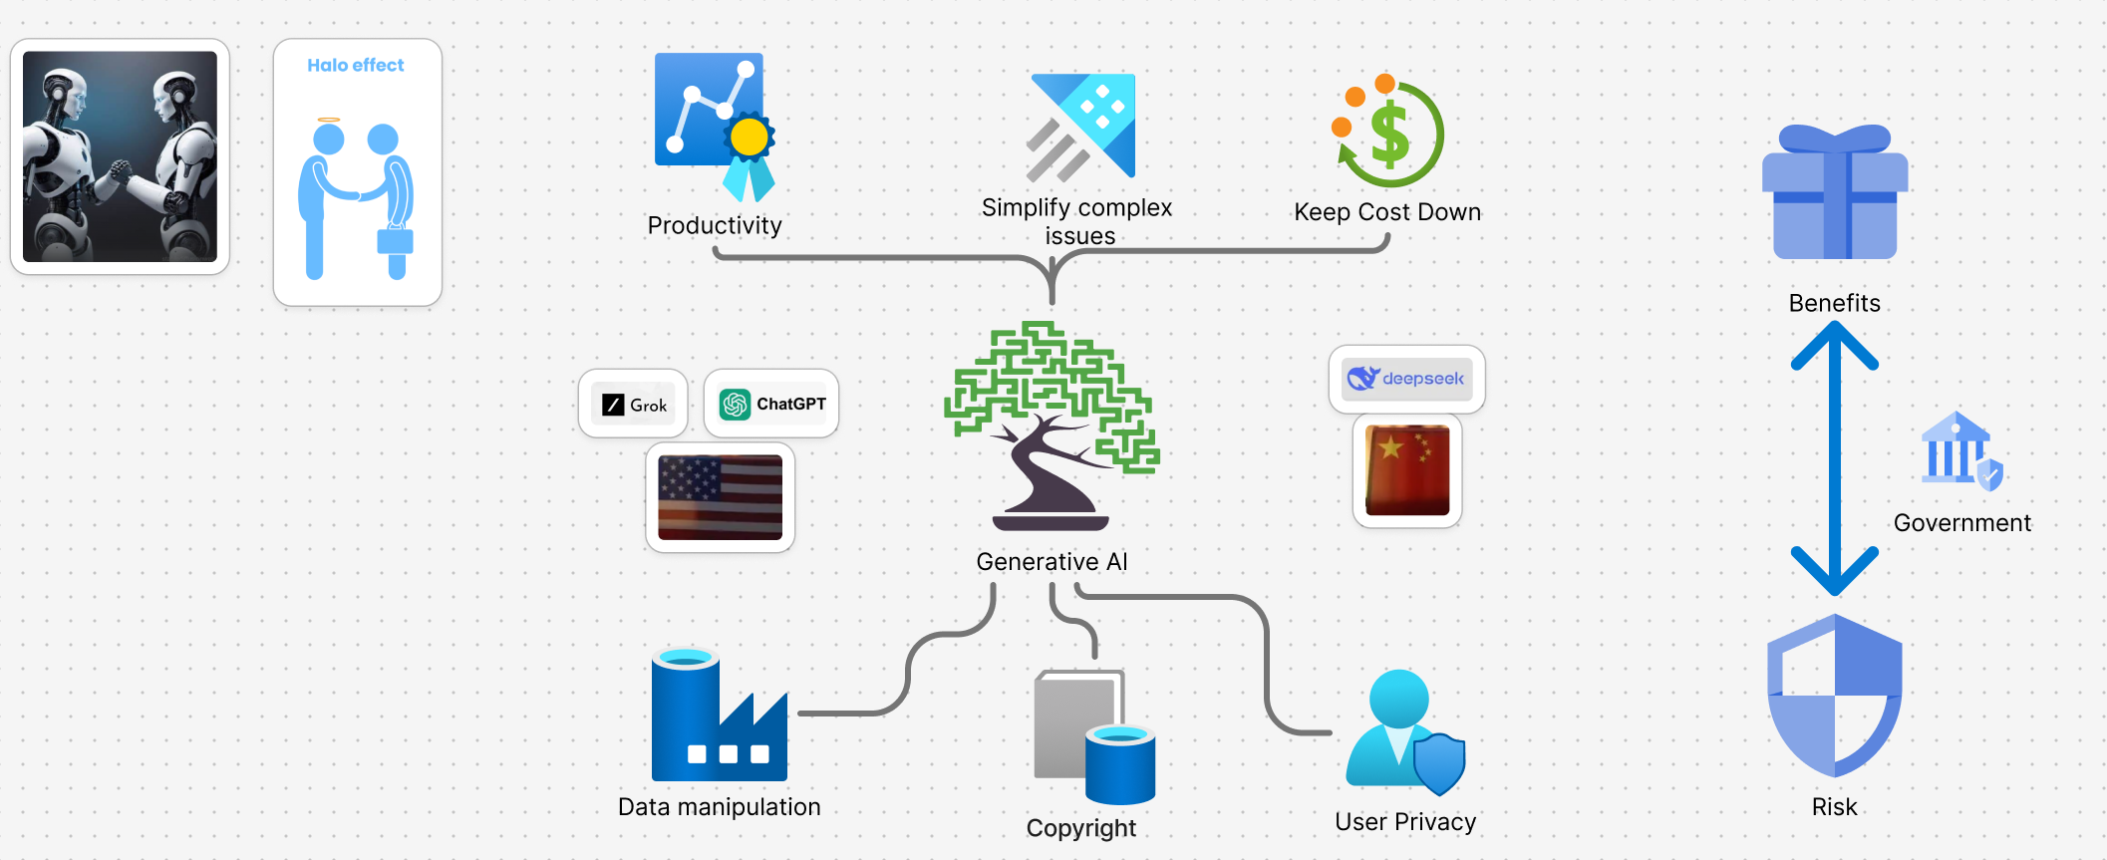

1 Introduction:

Generative AI platforms represent the next evolution in the Fourth Industrial Revolution, enabling machines to become more human-like by augmenting human intelligence. In the first Industrial Revolution, water was harnessed to power steam engines. The second used electricity and electronics to facilitate mass production. The widespread use of automation and robotics characterised the third revolution. The fourth focus is on Big Data, AI, and the Internet of Things (IoT) [10]. Remarkably, this era is no longer solely dominated by large corporations; independent third parties can also participate.

In 1998, Google Search was unleashed to the world, marking the beginning of a new era in social adaptation to the technology. Industries spin-off around the search engine universe. The result of the interaction depends on the keywords used, and the result is open to interpretation in some cases. It was all about instruction coding, and society had to learn how to interact with the new technology.

With ChatGPT and Grok, the goal is to facilitate a human-like conversation where the platform outputs a human-readable answer based on the context of the question. Each generative AI platform utilises a proprietary model to generate responses; for instance, Grok is better suited for technical interactions, while ChatGPT is more suitable for human-like conversations. The design of the model is intentionally crafted to stand out in a crowded market and serve the social interests of its creators, as well as the business model it supports. There's no such thing as a free lunch, especially when it comes to AI technology, which is resource-hungry [5] in an authoritarian environment.

This assignment examines the benefits and risks of utilising generative AI platforms in the field of AI ethics, drawing on Winner's paper as the basis for many of its arguments.

2 Benefits:

                2.1 Productivity

Generative AI platforms excel at repetitive tasks, but they often produce generic answers to posed questions. These types of platforms use data gathered from a wide range of internet sources; for instance, GPT-3 was trained on 500 billion tokens [6]. Recently, Chat GPT has begun to be more transparent about the sources used to generate its responses, addressing the five pillars of trust. Grok does output the rezoning process used to derive the answer.

As with all new technologies, early adopters tend to reap the rewards, while late adopters are penalised by society. We must also consider what we might be sacrificing in the name of productivity. Just like in the 1880s in Chicago [9], a mouldering machine was introduced in a manufacturing plant to prevent the union from getting a foothold. We are being tricked into creating a dependency on the technology, allowing monetisation to begin [4], and it has already started, without society having the option to opt out or directly ban U.S.-based generative AI platforms. Spilling over into the virtual world, the geopolitical tension.

                2.1.1 Halo effect

While generative AI can generate content, we should not underestimate the power of human creativity. Regarding comedy, if we analyse the question, "Can generative AI write a joke? "[1], the answer for now is "more work is required for a model to understand a joke". It can break it, it can digest the content, but it needs the human factor for the human audience to find a joke funny. Because of the Halo effect [1], humans like human jokes, and machines will probably like machine jokes.

                2.2 Simplify complex issues

Another significant advantage is the ability to shorten the learning curve for complex subjects, as it can process complex information and return a simplified version. This ability to simplify complex topics has made it an attractive tool for many individuals. We must not forget that if society loses the ability to think for itself, then the authoritarian generative AI platforms could tell us what to believe without society realising it is manipulated [3] [7]. While it is inevitable with each technological advance, skills that once seemed essential can become obsolete. Society should not collectively abandon its ability to reason and make independent decisions. However, this has become increasingly difficult each year due to the overwhelming presence of manipulated information.

                2.3 Keep running costs down

Due to the ability to generate content with generative AI, many view this as a step forward in the process of eliminating the middleman, i.e., writers, content generators, or developers, or reducing the cost [8], as highly skilled workers are expensive. Back to the mouldering machine in Chicago [9] at the manufacturing plant, highly skilled workers tended to unionise. In contrast, unskilled workers were just happy to have a job and could be left to supervise the mouldering machine. By pushing out highly skilled workers, the remaining ones would be more submissive.

3 Risks:

                3.1 Data manipulation

Generative AI excels at producing synthetic data based on its trained data. However, it poses a significant risk when it can manipulate data to achieve a desired statistical outcome, turning insignificant data into significant data or producing a propagandistic response based on the political views of the entity controlling the platform. Such capabilities enable generative AI platforms to create false content without any credible supporting data. Therefore, it is crucial to implement a deterrence protocol to prevent requests for data manipulation [7] and to validate the generated context, thereby preserving academic integrity, as a high percentage of users in society trust the results [12] without validating them.

3.2 Copyright

While generative AI platforms require a substantial amount of data to train, there exists a risk that copyrighted material may be inadvertently utilised; in other words, the model may incorporate data it is not permitted to use without compensating the original creator. Traditional legal frameworks often fall short of addressing all the complexities introduced by generative AI. To address these issues, governments must strike a balance between innovation and protecting the rights of individuals and society.

3.2 User privacy

Currently, generative AI platforms don't store any user-related data or use user data to train their models. However, the lack of transparency surrounding this issue may warrant further investigation. Given Meta's history in data privacy scandals, the topic of user privacy deserves scrutiny.

Conclusion:

Generative AI is integrated into our social workflows, boosting productivity, but it also poses significant risks. As a society, we must question everything and stop taking things for granted. While governments should legislate the usage of AI to safeguard data privacy, it should not penalise creativity.

**References:**

1. [**https://www.bbc.com/future/article/20240724-can-artificial-intelligence-be-genuinely-funny**](https://www.bbc.com/future/article/20240724-can-artificial-intelligence-be-genuinely-funny)
2. [**https://medium.com/@todasco/does-ai-get-the-joke-assessing-the-sense-of-humor-of-large-language-models-112b08508f25**](https://medium.com/@todasco/does-ai-get-the-joke-assessing-the-sense-of-humor-of-large-language-models-112b08508f25)
3. [**https://link.springer.com/article/10.1007/s10676-024-09745-x#article-info**](https://link.springer.com/article/10.1007/s10676-024-09745-x#article-info)
4. [**https://medium.com/@tfriehe_/5-proven-strategies-for-monetizing-open-source-software-cee173de6d04**](https://medium.com/@tfriehe_/5-proven-strategies-for-monetizing-open-source-software-cee173de6d04)
5. [**https://www.forbes.com/sites/bernardmarr/2025/06/03/mind-blowing-ai-statistics-everyone-must-know-about-now-in-2025/**](https://www.forbes.com/sites/bernardmarr/2025/06/03/mind-blowing-ai-statistics-everyone-must-know-about-now-in-2025/)
6. [**https://talkai.info/blog/how_does_chatgpt_work/**](https://talkai.info/blog/how_does_chatgpt_work/)
7. **<https://link.springer.com/article/10.1007/s43681-024-00546-y?fromPaywallRec=false>**
8. **<https://figures.hr/post/the-impact-of-ai-on-compensation-should-we-be-concerned>**
9. **Do Artifacts Have Politics? Langdon Winner**
10. [**https://sustainability-success.com/industry-1-0-to-4-0-2-3-revolution/**](https://sustainability-success.com/industry-1-0-to-4-0-2-3-revolution/)
11. [**https://link.springer.com/article/10.1007/s43681-024-00611-6**](https://link.springer.com/article/10.1007/s43681-024-00611-6)
12. **https://link.springer.com/article/10.1007/s43681-024-00611-6**