Contents

Code of Conduct (One stop shop): Part A 1

1 Courage: 2

2 Respect: 3

3 Honesty: 3

4 Zero discrimination: 3

5 Public interest: 4

6 The critical analysis: Part B 5

7 Q & A on the standards 5

7.1 Courage Q & A 5

7.2 Respect Q & A 5

7.3 Honesty Q & A 6

7.4 Zero discrimination Q & A 6

7.5 Public interest Q & A 6

### Code of Conduct (One stop shop): Part A

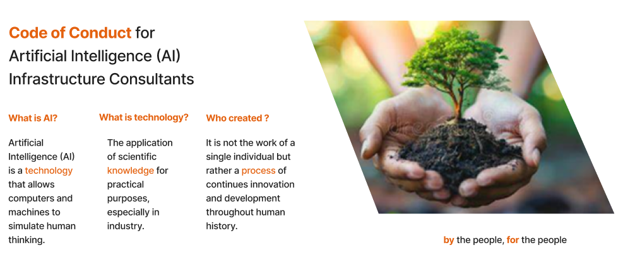

AI is here to stay and has become an integral part of our daily lives. While it is an excellent technology, the potential for enhancing our lives is boundless. There are some grey areas regarding the interaction between technology and humans, as well as its direct impact on our lives. This document aims to assist readers in navigating these grey areas and to offer a structured approach for effectively addressing unique situations within the organisation.

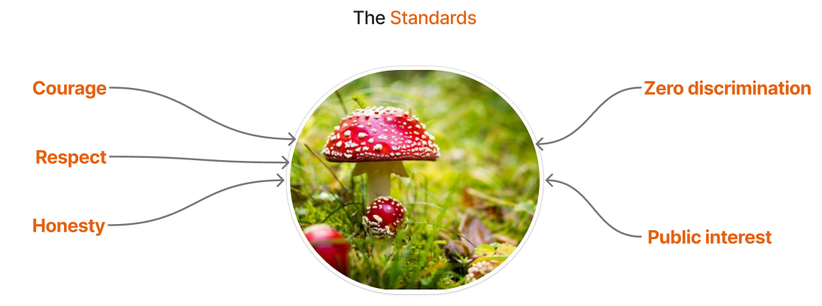

### 1 Courage:

All AI professionals are responsible for upholding the integrity of our profession and being accountable for decisions made throughout the life cycle of a model, from development to production. We also stand together against anything that could bring our profession into disrepute, whether it comes from internal or external forces. Deciding what to do is not always easy, and the best course of action may only become apparent after a decision is made.

We are all encouraged to speak out and work in an environment where positive disruptors are not oppressed. Mechanisms must be put in place to safeguard the anonymity of AI professionals who speak out against malicious AI models. With independent reviewers of the process and follow ups to increase confidence. Simply having the courage to speak out does not imply the end of one's professional career. Everyone deserves the freedom to express their views without fear of backlash.

Vital is the protection of the anonymity of professionals speaking out, even from their direct managers.

### 2 Respect:

### 

Professionalism lies at the core of each AI professional; we treat others with compassion and empathy. The same standards are expected of all AI models we create that engage with users of all ages. We must ensure they are designed with care and understanding, fostering positive interactions for everyone involved.



AI models need to be trained to de-escalate situations or detect when users are exhibiting aggressive behaviour. Abuse of AI models should not be tolerated and must be punished with the same gravity as the act. In the same way, medical professionals do not tolerate abuse; it should not be acceptable for human users to dish out abuse at AI models.

### 3 Honesty:

AI professionals hold a privileged position by working on a technology that has a significant impact on daily lives, whether it is for a medical app or an online psychological diagnosis app. We should always strive to be honest about the limitations of the AI model, including what it can and cannot do. Misrepresentation of the capabilities leads to a loss of trust in the technology and harms the collective brand of all AI professionals.



Because of the trust people are placing in Generative AI, the models should not function as a proxy decision-maker for users. The information must be presented in a way that enables users to make the final decision without promoting any special agenda.

The same applies to where the information was obtained and how the AI model arrived at the answer. In cases where a knowledge gap exists, the AI model should inform the user of its inability to provide an answer.

### 4 Zero discrimination:

In the same way, there is zero tolerance against unprofessional behaviour based on race, gender, nationality, and ethnical groups. It is essential to ensure that all AI models use diverse data that represents various segments of the population to prevent biases during the training process.

The above principle must be given priority throughout the life cycle of the AI model. Without proof of sufficient effort to eliminate biased decisions from the model, Product Owners cannot deploy the model to a live environment. By baking it into the QA validation cycle, we ensure it is constantly being practised, and it is not just another nice-to-have rule.

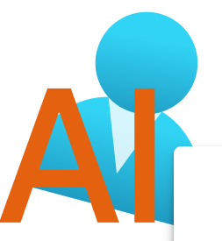

Remember, people are responsible for the decisions the AI model makes, not the machine.

### 5 Public interest:

While corporations are in the business of making money, we must not forget that employees build companies. With that in mind, the welfare and well-being of employees/clients and key stakeholders are now taking centre stage in how companies conduct their business. The use of disruptive technology should benefit the common good, general welfare, and security of all parties involved.



That is why key stakeholders and employees must be constantly on the lookout for services and vendors that may disrupt the inner company balance and report them through anonymous channels.

Due to the wide range of projects: from bridges to warehouses, to buildings, and traffic management infrastructure consultants can undertake. Public interest is defined by addressing the following three questions:

1) Are employees happy with the direction the company is going?

2) Are clients pleased with the type of clients being serviced by the company?

3) Investors: Are we generating profits while also creating a positive impact through investment opportunities?

### 6 The critical analysis: Part B

….

### 7 Q & A on the standards

### 7.1 Courage Q & A

**Question: What should I do if I suspect an AI model is biased?**

**Answer**: Report it to the local Quality Officer, who will investigate the concern further with the assistance of a third-party, independent investigator.

**Question: What should I do if I overhear some AI developer bragging about how biased their AI model is?**

***Answer***: Report it to the local Quality Officer, who will investigate the concern further with the assistance of a third-party, independent investigator.

### 7.2 Respect Q & A

**Question: *What should I do if the interaction with an AI model is unpleasant?***

***Answer***: If the interaction was not positive, report it to the Quality Officer. But all parties involved should try to de-escalate the situation. Maybe the best solution is to go for a walk and then try again later.

**Question: What if I see a user being abusive to an AI model?**

***Answer***: Contact a human customer service representative to try to de-escalate the situation and resolve the issue.

### 7.3 Honesty Q & A

**Question: A friend showed me a medical app that uses AI without adhering to local laws.**

**Answer:**Report it to the local Complaint Officer, as the app is selling a service under false pretences, it does not have all the required paperwork. It does not matter if the app uses AI; local laws and regulations must be respected.

**Question:  A financial report generated by the in-house AI portal looks unpolished and full of basic errors.**

**Answer:** Report it to the Product Owner and superiors, as spreading false information can lead to a loss of confidence in the product and trust in AI.

### 7.4 Zero discrimination Q & A

**Question: The QA manager is pushing for a feature in production ASAP**

**Answer: Without sufficient evidence, the data used to train the AI model may mitigate biases. One has the right to apply a show-stopper tag, as the feature is not compliant with the company's Code of Conduct.**

**Question: A new feature lacks data to mitigate biases.**

**Answer: Developers should not start work on a feature until the concerns have been addressed, regardless of the urgency or priority.**

### 7.5 Public interest Q & A

**Question: The company just signed a lucrative contract to provide a motorway service using AI in a remote location in Asia. One of the company's employees is from that area and has seen firsthand how discriminatory the service is from past vendors. What should the employee do?**

**Answer:**Report it to the AI Office, as the service is being used for discriminatory purposes and is contrary to the company's public interest.

**Question: A group of employees is unhappy that the company is in discussions with a military company to adopt existing AI models for use in a theatre of war. What should they do?**

**Answer:**Start a petition if the threshold number of employees is reached; management needs to reevaluate the relationship, as there is a risk of disrupting the harmony of public interest among key stakeholders within the company.

References:

1 <https://www.ibm.com/think/topics/artificial-intelligence>

2 Oxford Dictionary

3) <https://www.elysee.fr/en/emmanuel-macron/2025/02/11/the-paris-charter-on-artificial-intelligence-in-the-public-interest>

4) 2 Architects ( https://arb.org.uk/architect-information/architects-code-standards-of-conduct-and-practice/  )

5) Psychiatrists  ( https://www.europsy.net/epa-code-of-ethics/ )

6) Police (https://www.college.police.uk/ethics/code-of-ethics)

7) The Code of the U.S. fighting force - https://en.wikipedia.org/wiki/Code_of_the_United_States_Fighting_Force