Supplementary Figures for “An Ultra-Brief Acoustic–Lexical Framework for Detecting Depressive Symptoms From Five Daily Spoken Words in Active-Duty Police Officers”

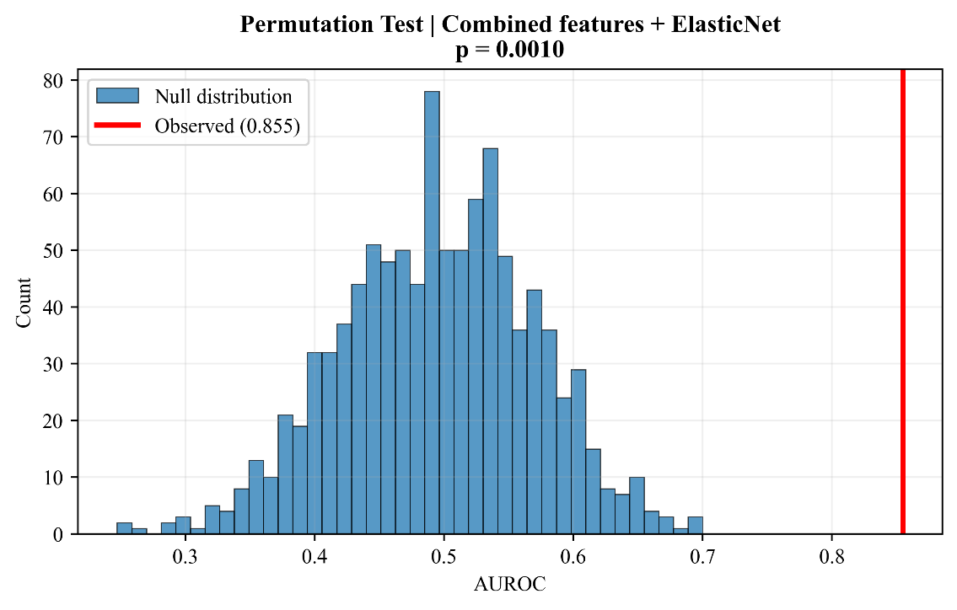
Fig. S1 Permutation-test null distribution for the combined-feature ElasticNet model. The red vertical line indicates the observed AUROC.

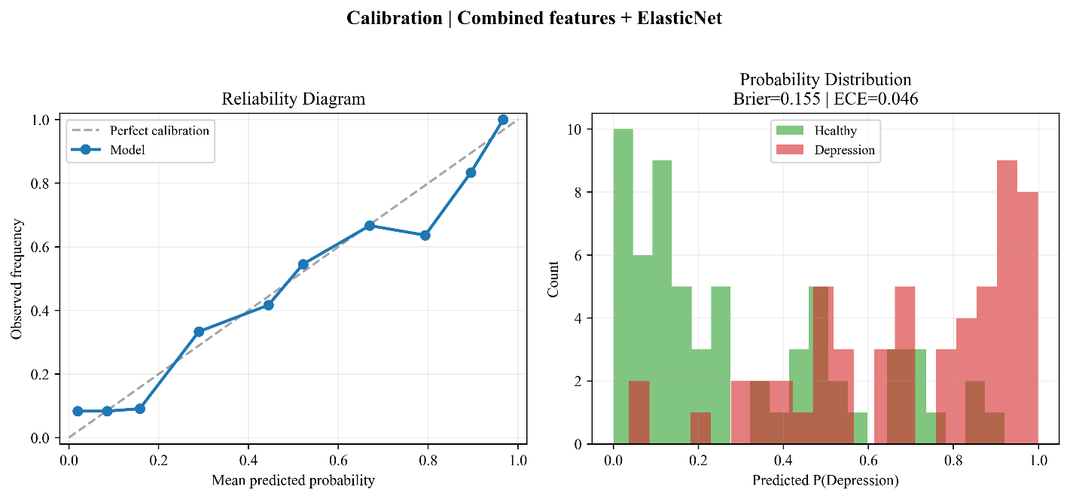
Fig. S2 Calibration analysis for the combined-feature ElasticNet model.
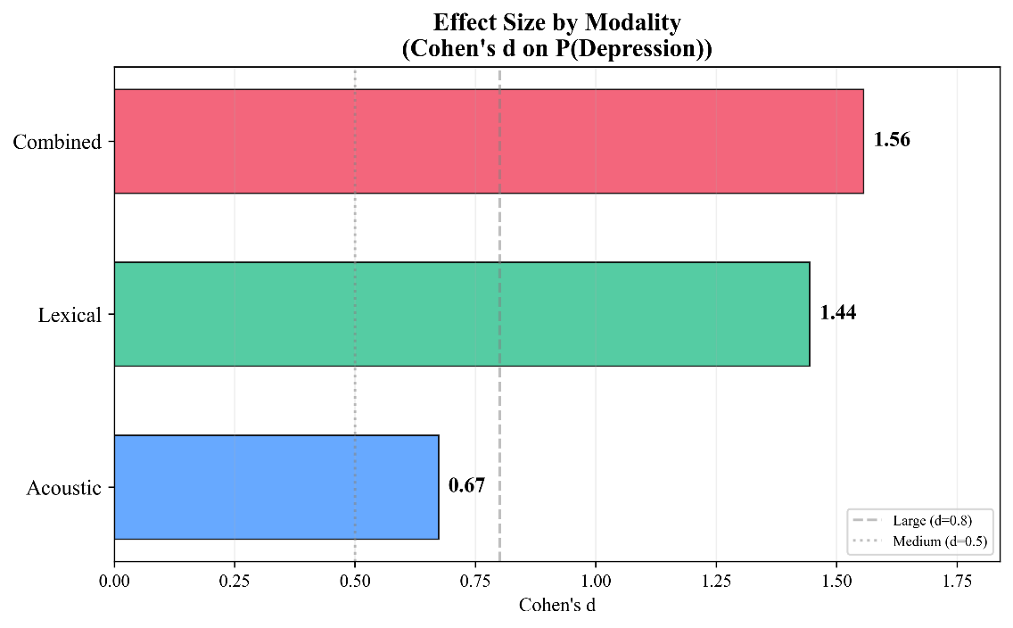
Fig. S3 Modality-level effect sizes measured as Cohen's d on out-of-fold predicted depression probabilities.

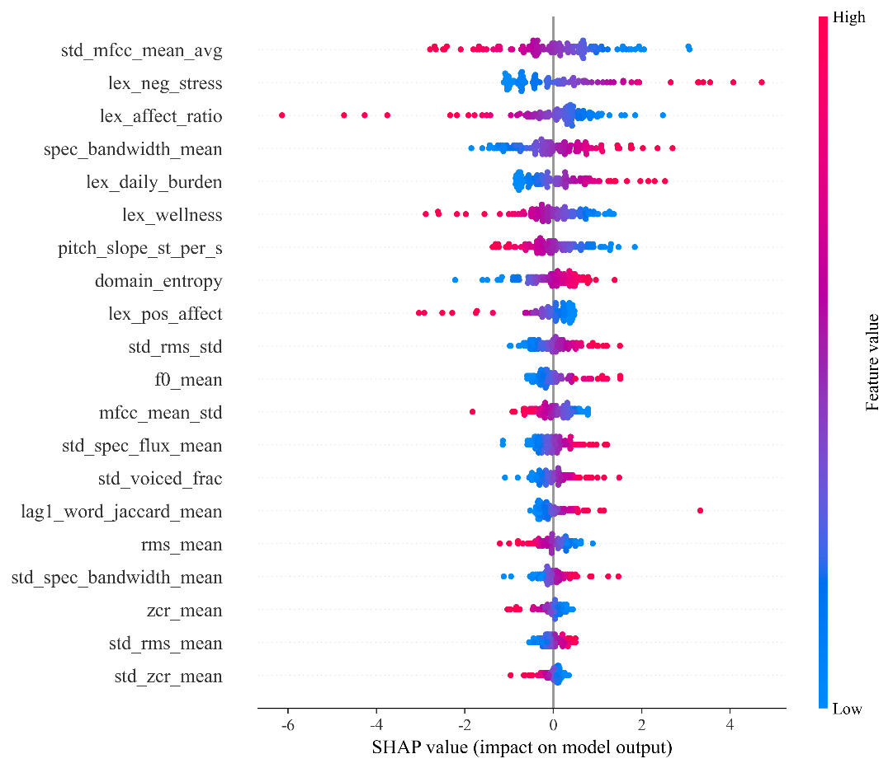
Fig. S4 SHAP summary plot for the combined-feature ElasticNet model, showing the direction and magnitude of feature contributions.
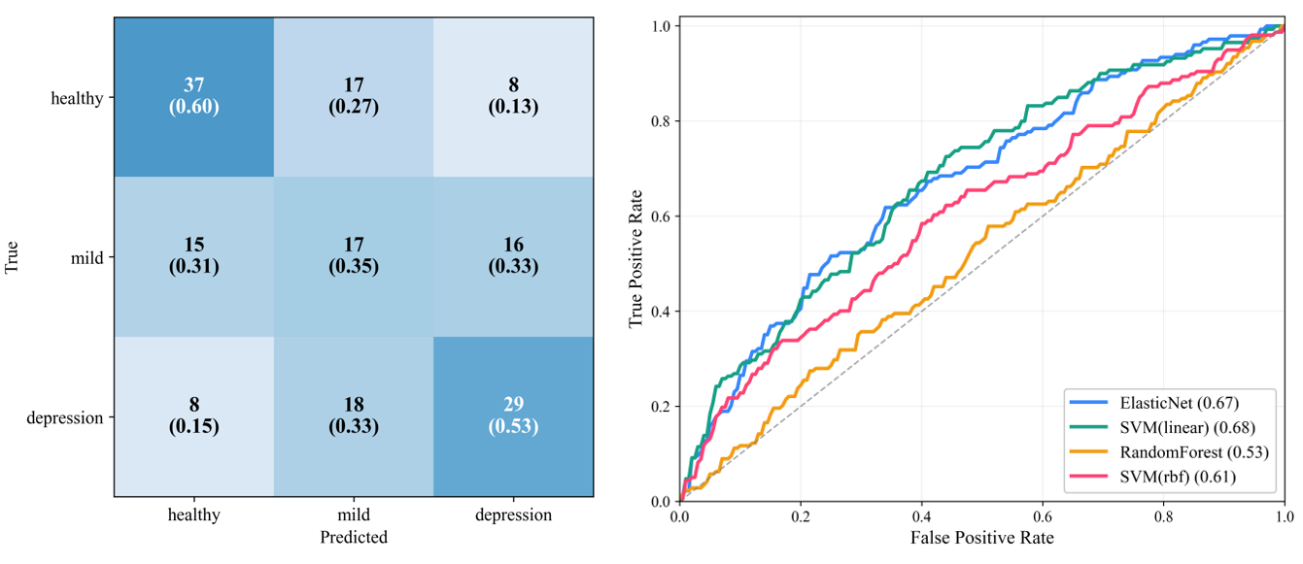
Fig. S 5 Three-class classification results using the combined feature set. Left: confusion matrix for ElasticNet (counts and row-wise proportions). Right: one-versus-rest ROC curves for the evaluated classifiers, with macro AUROC in parentheses.

Table S 1 Three-class classification performance using the combined features
Model | Macro AUROC | 95% CI | Macro F1 | Accuracy | Balanced Accuracy
ElasticNet | 0.671 | 0.616–0.733 | 0.495 | 0.503 | 0.493
Linear SVM | 0.678 | 0.627–0.732 | 0.413 | 0.527 | 0.493
Random Forest | 0.526 | 0.465–0.585 | 0.354 | 0.382 | 0.364
RBF SVM | 0.607 | 0.538–0.674 | 0.340 | 0.442 | 0.408

