Evaluation Warning : The document was created with Spire.Doc for .NET.

**Module 1: Programme Creation**

From the menu bar in the header (Figure 6.7), users can select the “Create Programme” link to navigate to the “Create New Programme” page (Figure 6.11). This page contains fields for entering the new programme’s code, name, duration (year), number of semesters (per year) and total credit hours respectively. There’s also a dropdown list which contains a list of faculties for users to choose the faculty that the new programme will be offered. The list of faculties from the drop down is retrieved from the database (“faculty” table) and then using the “ucwords_title” function in “function.php” file to do capitalization. The code for this is shown in Figure 6.12.

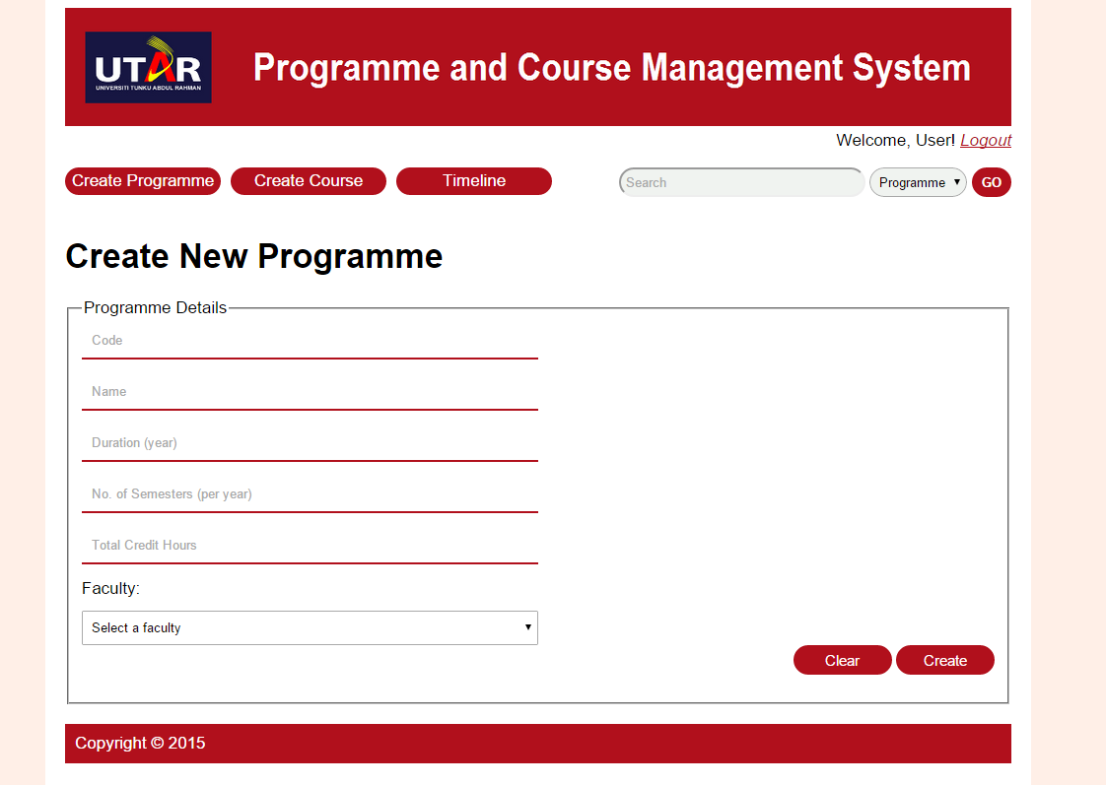

**Figure 6.11: “Create New Programme” Page**

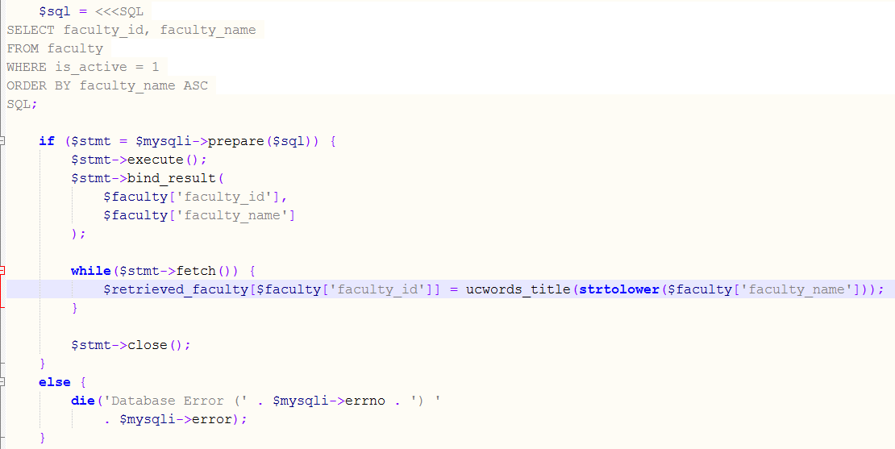

**Figure 6.12: Retrieving Faculty List from Database (createProgramme.php)**

There are two buttons, “Clear” and “Create” which allow users to clear the fields and create the programme respectively. Any errors upon clicking the “Create” button will also be displayed (Figure 6.13). Table 6.2 shows the list of possible errors for each field and their associated error messages. Figure 6.14 shows part of the PHP code of the error checking process and the HTML code for displaying the error message on one of the fields.

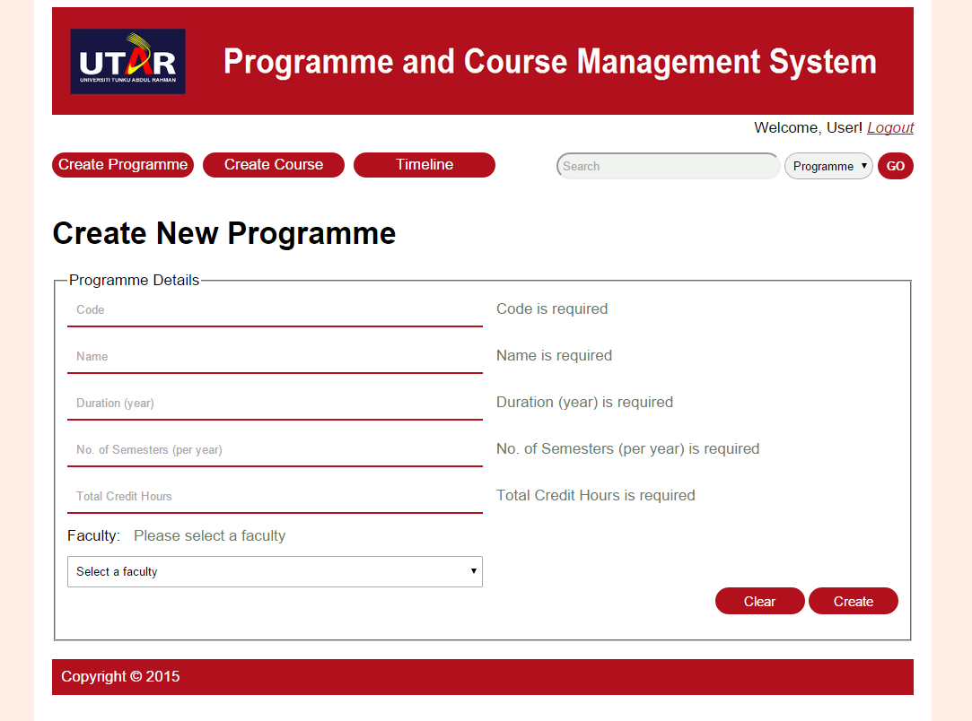

**Figure 6.13: “Create New Programme” Page – With Errors**

**Table 6.2: Error Checking for Create New Programme Form**

|  |  |  |
| --- | --- | --- |
| **Field Name** | **Error** | **Error Message** |
| Code | Empty field | Code is required |
| Existing code | [code entered] already exists |
| Contains invalid special characters | Code should only contain alphanumeric and ()/-&:' |
| Name | Empty field | Name is required |
| Contains invalid special characters | Name should only contain alphanumeric and ()/-&:' |
| Duration (year) | Empty field | Duration (year) is required |
| Contains non-digit | Please enter a number (digit) |
| No. of Semesters (per year) | Empty field | No. of Semesters (per year) is required |
| Contains non-digit | Please enter a number (digit) |
| Total Credit Hours | Empty field | Total Credit Hours is required |
| Contains non-digit | Please enter a number (digit) |
| Faculty | None selected | Please select a faculty |

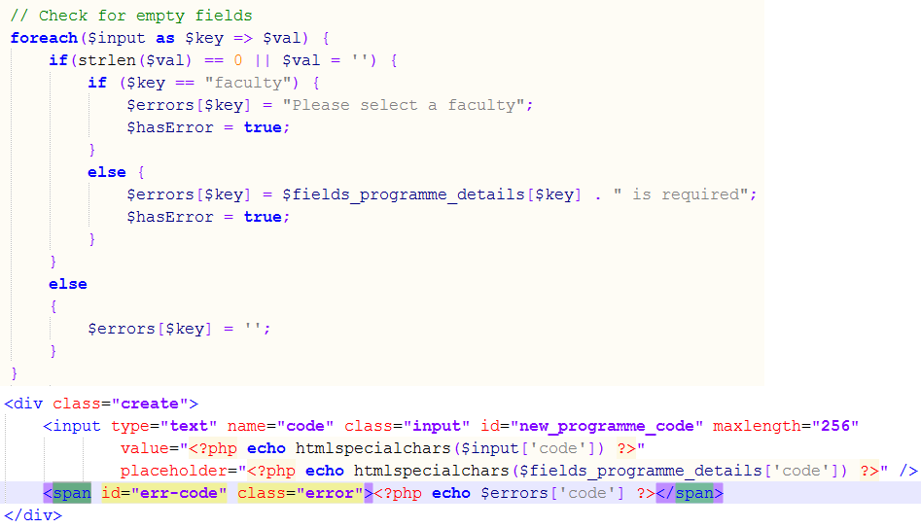

**Figure 6.14: Checking and Displaying Error (createProgramme.php)**

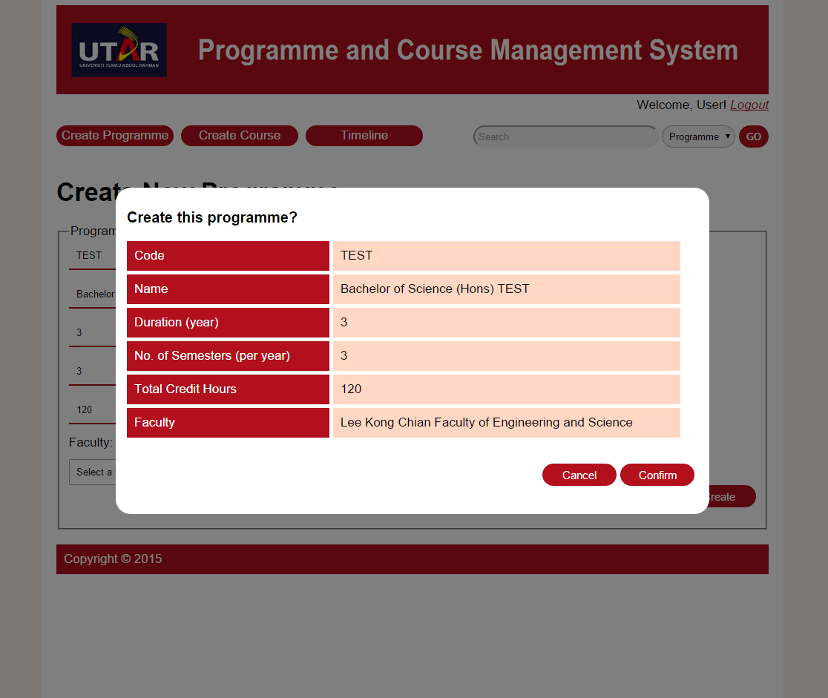

**Figure 6.15: “Create New Programme” Page – Confirmation Pop Up**

If all the details users entered are valid, then a pop-up will appear to ask to confirm the creation of the programme (Figure 6.15). The pop up will display the details entered by the user and contains two buttons, “Cancel” and “Confirm”. The “Cancel” button allows users to close the pop up and edit the details entered. The “Confirm” button allows users to confirm to create the programme (save to database).