CISP 360
Introduction to Structured Programming
Course Syllabus
Spring 2026

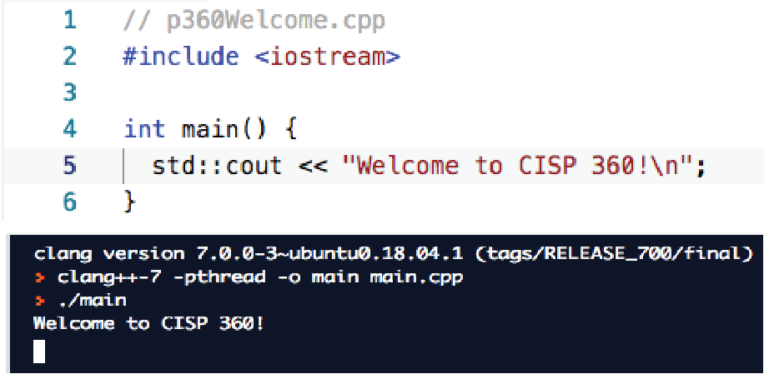
Course Description
This course is an introduction to structured programming using the C++ (see
plus plus) programming language. It will introduce you to the art and science of
capturing thoughts and making them real - programming! You will learn and
practice the syntax of the C++ programming language. Furthermore, you will
be exposed to other necessary skills of programming, such as debugging and
testing.
This course has a prerequisite. You must have taken and passed CISP 300 with
a grade "C" or higher. If you have other experience which you feel may count in
place of the prerequisite, come and see me immediately.
If FLC cannot verify your prerequisites, you will need to ﬁle a Prerequisite
Challenge Form immediately . You can ﬁnd this online and must be delivered
with the supporting documents to the Dean’s oﬃce. Copy me on your email so I
know you are in the process of challenging the prerequisite. You must start this process by the end of the ﬁrst Sunday before our ﬁrst face to face class meets. It
must be completed by the end of the ﬁrst week of the semester.
This class has a lab component. The lab is after class, on your own time. A lab
is an informal work time - you will be programming.
Where can I go for the latest course information?
The Folsom Lake College website has the most current information.
Main Catalog Page.
Class schedules.
Academic Calendar.
Final Schedule.
Prerequisite Challenge info - form link about half way down the page.
Does this class have a lab and what exactly does that mean?
This class has a lab component. The lab is after class, on your own time. You will be
involved in some classroom computer activities, but they will be structured and
not as free form as a lab would be. A lab is an informal work time - you will be
programming.
Contacting Me.
My oﬃce hours are Monday through Thursday at 12:00 (noon). You can use
Student Connect in Canvas to schedule a Zoom appointment. If these times
don’t work for you, send me an email and we can set something else up.
You can get in touch with me in the following ways:
1.My oﬃce (FL2 - 236) is the best way to contact me. Schedule an appoint-
ment and I guarantee I will be there. If you drop in, I will probably be
out and you will need to wait.
2.Call me at my oﬃce (916) 608-6595. If I am unavailable leave a voicemail -
they are emailed to me.
3.Send me an email. I do not check email past noon on Saturdays and not
at all on Sundays. It is not unusual for me respond in a few days - I have
lot’s of student inquiries. Pro-Tip: Put the class number in the subject of
your email (CISP 400 or p400) and my inbox will priority ﬂag it and move
it to the top of the list!
None of these methods are immediate. If you need to see me NOW, you will
need to come and ﬁnd me. Plan accordingly.
Student Learning Outcomes
The State Chancellor’s Oﬃce wants to know if we are measuring our student
success rates against the Student Learning Outcomes (SLOs) standard. Upon
completion of this course, the student will be able to:
1. Organize C/C++ code into modules.
2.Create C/C++ programs demonstrating ﬁle operations, pointers, and/or
structures.
3.Create programming problem solutions in C/C++ using selection state-
ments.
4. Create programming problem solutions in C/C++ using iteration.
5. Create programming problem solutions in C/C++ demonstrating the
appropriate use of single and multidimensional array data structures.
6. Create programming problem solutions in C/C++ demonstrating the
appropriate use of dynamic memory.
Text and Required Supplies. You will need access to a computer. I use Canvas to coordinate all classroom activities - even in my classroom courses. You will need to take notes – my lectures are insuﬃcient for learning the material. Finally, you will need to acquire and read the textbook.
Your client (me) will be using a Ubuntu Linux system to run you work on. It will
have the standard C++ libraries only. The gcc compiler will be used to check
your code. All the tools you need are installed with the Desktop installation
of Ubuntu - you will not need to install anything else. Also, the online compliers (replit.com, programiz, onlinegdb c++) compile in the Linux backend. That makes them suitable for working in this class as well. See the FAQ for more
detailed information on this.
Textbook
Gaddis, Walters, Muganda (2019). C++ Early Objects (10th ed.).
ISBN: 978-0135235003.
Upper Saddle River, NJ: Pearson Education.
When I refer to chapters, it is the chapters in this book I’m referring to. That’s changing as I update the material. You may want to simply look for the topics in whatever textbook you choose to use.
This is also a good online reference:
https://www.learncpp.com/
Course Schedule & Grade Plan.
These are now online, in Canvas.
Attendance. If you are in an online class, see the "I’m in an online class..." question below.
If your class is in a classroom on campus, keep reading. Classroom attendance
is mandatory. This class complies with the attendance policy speciﬁed under
the Folsom Lake College Academic Policy and the speciﬁcations in the FLC
Catalog. You are expected to attend allclasses. If you miss more than three
(3) classes I will either drop you from the class or you will receive a zero for
participation (depending upon where we are in relation to the withdraw date). I
no longer accept excuses. It is your responsibility to attend class and to track
your attendance. You should be very nervous when you reach 2 absences - you
have NO room for problems. You are also expected to be ready to start class
when the class is scheduled to begin. Even if you are one minute late, you are
late. I take roll in class and record who is absent and who is tardy. Canvas
records this as ’late’. Note: if you are more than 30 minutes late for class you
are absent, not late.
My expectation is you will attend class for the full meeting time. If you leave
early, I will record that as a ’left early’. Two ’left early’ are a full absence. Two
’lates’ are a full absence. If you come to class late and leave early, you are absent
from class.
Coming in and out of the room once class starts is disruptive. It also isn’t fair to
the other students who arrange their schedules so they can attend class. ’Late’
and ’left early’ attendance also reduces participation scores.
How can I track this? Keeping track of this is a great idea. While rare,
errors do occur in the roll. Canvas has a grade book built in, so you should
check that frequently. It is accessible online 24/7. You agree with the grade
book unless I hear otherwise.
I missed a test/quiz/project on the day I was absent. What can I do
about that?
Nothing, that’s part of the price of missing class. You should
expect a 0 for that assignment. No, you cannot make it up. I do give extra
credit and you can recover some of the points you missed.
What’s the big deal, why are you so focused on our attending class?
In study after study, there is one element which is consistently linked to high
grades - attendance. I want you to be successful and you need to attend class to
make that happen. Many times, winning is just a matter of showing up, and we
want to encourage that behavior at FLC.
I’m in an online class, does that mean attendance doesn’t matter?
Attendance is diﬀerent in an online class. Canvas tracks the dates you log on. If
you haven’t logged on to Canvas for this class within the last two (2) weeks, I
will assume you are no longer interested in the class and withdraw you.
First Week of Classes. It’s essential you attend the ﬁrst week of class. If you do not do this, I will drop you immediately. You will then need to get on the wait list to add. Perhaps
there will still be space, perhaps not. There are other students on the wait list
and those students show up. Seriously, think about the message you are sending
if you can’t be bothered to attend the ﬁrst week. Online folks you are not subject
to this.
Furthermore, you must turn in the ﬁrst assignment to avoid being dropped
from the class. Los Rios has had a huge problem with fake student’s registering
for classes to get .edu email addresses (they apply and receive student aid and
skip town). You too, online folks, must turn in your ﬁrst assignment on time.
Homework. This class has new homework assignments designed to put you ahead of the
ChatBots. After all, why should you be well paid when an organization can just
hire someone for minimum wage and have them use ChatGPT? The answer is
you are going to bring more value to your employer than a ChatBot. Therefore,
you should be paid more. That’s what we will work on here. That means the
homework is less about coding and more about understanding larger coding
concepts and how they ﬁt together in your program. We will discuss this in
greater detail in class.
All the homework assignments will be open and accessible from the ﬁrst day of
class. You can start on them whenever you wish. Do not get caught behind!
Homework is due on the due date. If you turn it in after the due date the grade
will suﬀer a 10% penalty per day it is late. That’s automatic and built into
Canvas. You have until the end of the semester to submit assignments, but the
early ones will not be worth much (if anything).
Evidence of Master (EoM) are the other assignments you will have. They ask
you to write code in a progression based upon the material the class has covered
so far. There is a time limit for how long you can work on this. It sounds like a
test, but you are graded for submitting work and not on how much you have
completed. You and I can use this to see how well you have masted the material
so far. These assignments cannot be turned in late. Online folks will have a
week to complete the assignment. I’m asking you to take no longer than an hour
with this.
Plagiarism Scores. A score higher than 50% is unacceptable. You will need to take steps to remedy this situation if you score greater than 50% on the plagiarism checker.
DSPS Students. It is my goal to create a learning experience that is as accessible as possible. If you anticipate any issues related to the format, materials, or requirements of this
course, please meet with me outside of class so we can explore potential options.
Students with veriﬁed disabilities may also wish to work with the Disability
Services and Programs for Students (DSPS) to discuss a range of options to
removing barriers in this course, including oﬃcial accommodations. Please
visit their website for contact and additional information. If you have already
been approved for accommodations through DSPS, please share with me your
letter of accommodations. The accommodation letter is just the beginning
of our conversation. It is your responsibility to let me know what speciﬁc
accommodations you will need, for example, if you need more time for a test,
you need to let me know how much more time you need.
Website: https://ﬂc.losrios.edu/dsps
Phone: (916) 608-6611
Email: dsps@ﬂc.losrios.edu
Social Media. Students frequently ask me to contact them with Linkedin,
Facebook and other forms of social media. I do not do that. Managing the
possible number of contacts would be a full time job. Bottom line: do not feel
slighted if I do not respond to your social media requests - I do not respond to
anybody. It’s not personal and it’s not you.
Code of Conduct. All students are expected to conform with the Code of Conduct found in the FLC Catalog. This class is a ’rehearsal space’. That means you have a place to
try out new ideas and concepts before you launch them into the public sphere.
This class is protected from the unending surveillance of the Internet and the
dark side of social media. To that end, the following rules also apply.
No unauthorized surveillance. This protects your privacy. You can’t be
sure what harm you may cause to others if you publicize classroom activities
(for example, the person in front of you may have a restraining order against
someone else). No video or audio recording without prior instructor approval. No
streaming of any kind. If you need to text or answer the phone, please go outside
so you do not disturb the rest of the class. You cannot take other student’s works,
comments, electronic material from Canvas and post it to electronic services like
YouTube.
Academic Honesty. I expect you to know the section on Academic Honesty
in the catalog. I will hold you to that standard. I consider isomorphic homework
to be plagiarism. Collaboration does not mean you get to copy each other’s work.
Expect an ’F’ for your ﬁrst oﬀense; removal from the class for a subsequent
oﬀense. I kick student’s out of my classes each semester for plagiarism. If you
have any questions on this, come and see me.
Your Ideas and Evaluations In general, your ideas, comments, suggestions,
questions, grade challenges, etc. are welcome. Your discretion in these matters
is expected, however. No part of your grade will be based on anything other
than your coursework and engagement activities. You are encouraged to take
advantage of instructor oﬃce hours for help with coursework or anything else
connected with the course and your progress.
Suggestions for Success. The key to succeeding in this course is to keep up
with the work. Assignments may start out simple, but they quickly build up
in number and complexity. It is critical you work steadily week in and week
out. Every class, my student’s say "I wish I had spent more time reading the
textbook". Success is built on many little things, not 1 big score. This is what
you need to do if you want to do well in here:
•Buy the textbook (you would think I wouldn’t have to say this).
•Read the textbook every week (nor this).
•Come to class every week.
•Keep up with the work.
Yes, it really is that simple. However, every semester, students try to prove
this advice wrong and fail. Students usually don’t implode spectacularly. They
usually get further and further behind and die an inch at a time. The key
to avoiding this is to stay out in front of your work. That’s what keeps it
manageable. You can do this!

