CISP 400
Object Oriented Programming in C++
Course Syllabus
Fall 2026
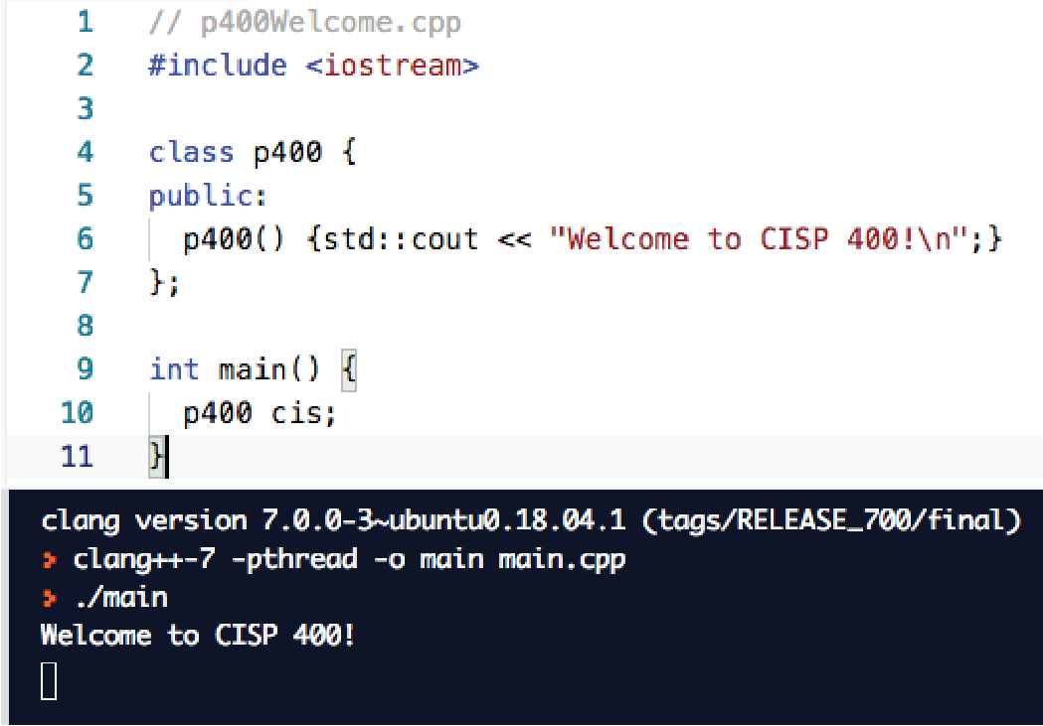
Course Description
This course is an introduction to object-oriented programming using the C++
programming language. This course is designed to enhance students’ abilities
to implement object-oriented programs and to further develop programming
proﬁciency. Detailedtopicsincludeclasses, storageclassandscope, encapsulation,
polymorphism, inheritance, functionoverloadingandoverriding, virtualfunctions,
operator overloading, templates, exception handling, stream I/O, ﬁle processing,
and the Standard Template Library.
Where can I go for the latest course information? The Folsom Lake
College website has the most current information.
Main Catalog Page.
Class schedules.
Academic Calendar.
Final Schedule.
Prerequisite Challenge info - form link about halfway down the page.
Does this class have a lab and what exactly does that mean?
This class has a lab component. The lab is after class, on your own time. You will be
involved in some classroom computer activities, but they will be structured and
not as free form as a lab would be. A lab is an informal work time - you will be
programming.
Contacting Me.
My oﬃce hours are Monday through Thursday at 12:00 (noon). You can use
Student Connect in Canvas to schedule a Zoom appointment. If these times
don’t work for you, send me an email and we can set something else up.
You can get in touch with me in the following ways:
1.My oﬃce (FL2 - 236) is the best way to contact me. Schedule an appoint-
ment and I guarantee I will be there. If you drop in, I will probably be
out and you will need to wait.
2.Call me at my oﬃce (916) 608-6595. If I am unavailable leave a voicemail -
they are emailed to me.
3.Send me an email. I do not check email past noon on Saturdays and not
at all on Sundays. It is not unusual for me respond in a few days - I have
lot’s of student inquiries. Pro-Tip: Put the class number in the subject of
your email (CISP 400 or p400) and my inbox will priority ﬂag it and move
it to the top of the list!
None of these methods are immediate. If you need to see me NOW, you will
need to come and ﬁnd me. Plan accordingly.
Prerequisites. If FLC cannot verify your prerequisites, you will need to ﬁle a
Prerequisite Challenge Form immediately . You can ﬁnd this online and must
be delivered with the supporting documents to the Dean’s oﬃce. Copy me on
your email so I know you are in the process of challenging the prerequisite. You
must start this process by the end of the ﬁrst Sunday before our ﬁrst face to face
class meets. It must be completed by the end of the ﬁrst week of the semester.
Student Learning Outcomes
The State Chancellor’s Oﬃce wants to know if we are measuring our student
success rates against the Student Learning Outcomes (SLOs) standard. Upon
completion of this course, the student will be able to:
1. Develop skills in object-oriented programming techniques using C++.
2.Use the programming language through coding, running, and testing
programs.
3.Demonstrate an understanding of programming vocabulary and concepts.
4.Apply appropriate coding format and documentation standards to written
programs.
Text and Required Supplies. You will need access to a computer. I use Canvas to coordinate all classroom activities - even in my classroom courses. You will need to take notes – my lectures are insuﬃcient for learning the material. Finally, you will need to acquire and read the textbook.
Your client (me) will be using a Ubuntu Linux system to run you work on. It will
have the standard C++ libraries only. The gcc compiler will be used to check
your code. All the tools you need are installed with the Desktop installation
of Ubuntu - you will not need to install anything else. Also, the online compliers (replit.com, programiz, onlinegdb c++) compile in the Linux backend. That makes them suitable for working in this class as well. See the FAQ for more
detailed information on this.
Textbook
Gaddis, Walters, Muganda (2019). C++ Early Objects (10th ed.).
ISBN: 978-0135235003.
Upper Saddle River, NJ: Pearson Education.
When I refer to chapters, it is the chapters in this book I’m referring to. That’s changing as I update the material. You may want to simply look for the topics in whatever textbook you choose to use.
This is also a good online reference:
https://www.learncpp.com/Course Schedule & Grade Plan.
These are now online, in Canvas.
Attendance
I teach face to face and online classes this semester. You can tell which class
type you have by looking at meeting time in the schedule. If the time is listed
as 1:00 - 1:00, you are in an asynchronous (100% online course). If you have any
other meeting times, you are in a face to face course and the time listed is the
actual time we will meet in the classroom. Note: ALL labs are online.
If you are in an online class, see the "I’m in an online class..." question below.
If your class is in a classroom on campus, keep reading. Classroom attendance
is mandatory. This class complies with the attendance policy speciﬁed under
the Folsom Lake College Academic Policy and the speciﬁcations in the FLC
Catalog. You are expected to attend allclasses. If you miss more than three
(3) classes I will either drop you from the class or you will receive a zero for
attendance (depending upon where we are in relation to the withdraw date). I
no longer accept excuses. It is your responsibility to attend class and to track
your attendance. You should be very nervous when you reach 2 absences - you
have NO room for problems. You are also expected to be ready to start class
when the class is scheduled to begin. Even if you are one minute late, you are
late. I take roll in class and record who is absent and who is tardy. Canvas
records this as ’late’. Note: if you are more than 30 minutes late for class you
are absent, not late.
My expectation is you will attend class for the full meeting time. If you leave
early, I will record that as a ’left early’. Two ’left early’ are a full absence. Two
’lates’ are a full absence. If you come to class late and leave early, you are absent
from class. Coming in and out of the room once class starts is disruptive. It also isn’t fair
to the other students who arrange their schedules so they can attend class.
Attendance and Extra Credit Attendance is counted as extra credit. The
amount is listed in the grade plan. Each attendance blemish reduces the amount
of extra credit I’ll give you at the end of the semester. Divide the total extra
credit by 6. A late or left early reduces it by 1/6. An absence reduces the
extra credit by 2/6. When you have 3 absences, you will no longer receive
attendance extra credit. You can still receive extra credit by completing the
extra credit assignments. Online folks, you are not eligible for attendance extra
credit because weekly attendance is not mandatory for you.
I missed a test/quiz/project on the day I was absent. What can I do
about that? Nothing, that’s part of the price of missing class. You should
expect a 0 for that assignment. No, you cannot make it up. I do give extra
credit and you can recover some of the points you missed.
What’s the big deal, why are you so focused on our attending class?
In study after study, there is one element which is consistently linked to high
grades - attendance. I want you to be successful and you need to attend class to
make that happen. Many times, winning is just a matter of showing up, and we
want to encourage that behavior at FLC.
I’m in an online class, does that mean attendance doesn’t matter?
Attendance is diﬀerent in an online class. Canvas tracks the dates you log on. If
you haven’t logged on to Canvas for this class within the last two (2) weeks, I
will assume you are no longer interested in the class and withdraw you.
Bottom line with attendance - come and talk to me about it. Don’t
just disappear.
First Week of Classes.
It’s essential you attend the ﬁrst week of class. If you do not do this, I will
drop you immediately. You will then need to get on the wait list to add. Perhaps
there will still be space, perhaps not. There are other students on the wait list
and those students show up. Seriously, think about the message you are sending
if you can’t be bothered to attend the ﬁrst week. Online folks you are not subject
to this.
Furthermore, you must turn in the ﬁrst assignment to avoid being dropped
from the class. Los Rios has had a huge problem with fake student’s registering
for classes to get .edu email addresses (they apply and receive student aid and
skip town). You too, online folks, must turn in your ﬁrst assignment on time.

Homework
This class has new homework assignments designed to put you ahead of the
ChatBots. After all, why should you be well paid when an organization can just
hire someone for minimum wage and have them use ChatGPT? The answer is
you are going to bring more value to your employer than a ChatBot. Therefore,
you should be paid more. That’s what we will work on here. That means the
homework is less about coding and more about understanding larger coding
concepts and how they ﬁt together in your program. We will discuss this in
greater detail in class.
All the homework assignments will be open and accessible from the ﬁrst day of
class. You can start on them whenever you wish. Do not get caught behind!
Homework is due on the due date. If you turn it in after the due date the grade
will suﬀer a 10% penalty per day it is late. That’s automatic and built into
Canvas. You have about five days to turn in late work – to prevent people from falling too far behind. I will record a 0 for missing assignments when I grade the class. I will revise this grade if you later turn in your work. Do not let the 0 dissuade you from completing the assignment. I do this because leaving work ungraded gives students an inaccurate (overly favorable) picture of how they are performing in the class.
Plagiarism Scores. A score higher than 50% is unacceptable. You will need to take steps to remedy this situation if you score greater than 50% on the plagiarism checker.
DSPS Students
It is my goal to create a learning experience that is as accessible as possible. If
you anticipate any issues related to the format, materials, or requirements of this
course, please meet with me outside of class so we can explore potential options.
Students with veriﬁed disabilities may also wish to work with the Disability
Services and Programs for Students (DSPS) to discuss a range of options to
removing barriers in this course, including oﬃcial accommodations. Please
visit their website for contact and additional information. If you have already
been approved for accommodations through DSPS, please share with me your letter of accommodations. The accommodation letter is just the beginning
of our conversation. It is your responsibility to let me know what speciﬁc
accommodations you will need, for example, if you need more time for a test,
you need to let me know how much more time you need.
Website: https://ﬂc.losrios.edu/dsps
Phone: (916) 608-6611
Email: dsps@ﬂc.losrios.edu
Social Media. Students frequently ask me to contact them with Linkedin,
Facebook and other forms of social media. I do not do that. Managing the
possible number of contacts would be a full time job. Bottom line: do not feel
slighted if I do not respond to your social media requests - I do not respond to
anybody. It’s not personal and it’s not you.
Code of Conduct
All students are expected to conform with the Code of Conduct found in the
FLC Catalog. This class is a ’rehearsal space’. That means you have a place to
try out new ideas and concepts before you launch them into the public sphere.
This class is protected from the unending surveillance of the Internet and the
dark side of social media. To that end, the following rules also apply.
No unauthorized surveillance. This protects your privacy. You can’t be
sure what harm you may cause to others if you publicize classroom activities
(for example, the person in front of you may have a restraining order against
someone else). No video or audio recording without prior instructor approval. No
streaming of any kind. If you need to text or answer the phone, please go outside
so you do not disturb the rest of the class. You cannot take other student’s works,
comments, electronic material from Canvas and post it to electronic services like
YouTube.
Academic Honesty. I expect you to know the section on Academic Honesty
in the catalog. I will hold you to that standard. I consider isomorphic homework
to be plagiarism. Collaboration does not mean you get to copy each other’s work.
Expect an ’F’ for your ﬁrst oﬀense; removal from the class for a subsequent
oﬀense. I kick student’s out of my classes each semester for plagiarism. If you
have any questions on this, come and see me.
Your Ideas and Evaluations In general, your ideas, comments, suggestions,
questions, grade challenges, etc. are welcome. Your discretion in these matters
is expected, however. No part of your grade will be based on anything other
than your coursework and engagement activities. You are encouraged to take advantage of instructor oﬃce hours for help with coursework or anything else
connected with the course and your progress.
Suggestions for Success
The key to succeeding in this course is to keep up with the work. Assignments may start out simple, but they quickly build up in number and complexity. It is critical you work steadily week in and week out. Every class, my student’s say "I wish I had spent more time reading the textbook". Success is built on many little things, not 1 big score. This is what
you need to do if you want to do well in here:
•Buy the textbook (you would think I wouldn’t have to say this).
•Read the textbook every week (nor this).
•Come to class every week.
•Keep up with the work.
Yes, it really is that simple. However, every semester, students try to prove
this advice wrong and fail. Students usually don’t implode spectacularly. They
usually get further and further behind and die an inch at a time. The key
to avoiding this is to stay out in front of your work. That’s what keeps it
manageable. You can do this!

