Cryptanalysis of KOD8_ENC (KOD8 v2.0):
A Eight-Stage Symmetric Cipher
A. Fatih ULUSOY
August 2026
Abstract
KOD8_ENC (“KOD8 v2.0”) is a custom symmetric cipher, described in its own project documentation as a “multi-layered obfuscation and encryption engine,” that routes input through one of six input-typespecific “CipherLists,” each composing exactly eight primitive reversible transformations (encodings, XOR variants, classical substitutions, and transpositions) driven by a single eight-digit numeric key. This report presents a structural and empirical cryptanalysis of the reference implementation, structured explicitly as a claims-versus-findings audit against the project’s own published feature list, combining static source analysis, worked per-CipherList traces, avalanche-criterion measurements, ciphertext randomness testing, a full classical frequency-analysis attack, and a benchmarked known-plaintext brute-force key recovery. We show that the cipher’s advertised eight-layer, “high-diffusion” design provides far less effective key-dependent entropy than its layer count suggests: six of seventeen primitives never reference the key at all, one collapses an eight-digit (nominally 10⁸) key into at most 325 distinct internal states, and the block-cipher-inspired CBC-style layer reuses the literal key string as a fixed, non-random initialization vector across every message directly contradicting the specific per-CipherList claims made for CL3 and CL5 in the project’s own documentation. We measure the avalanche effect directly and find it far below the ideal 50% criterion for every CipherList (as low as 0.1% for a single-digit key change under CL1), demonstrate that the cipher’s own ciphertext has lower Shannon entropy (3.31 bits/byte) than its plaintext input (4.19 bits/byte), and the central empirical result of this report show that a purely ciphertext-only chi-square frequency attack recovers all eight digits of the master key from the Vigenèrestyle substitution layer alone, with no brute force and no known plaintext required. We further confirm the cipher is fully deterministic the project’s own README names this property “Deterministic Security,” which Section 10 shows is a contradiction in terms is unauthenticated (several primitives silently absorb decoding errors rather than signal tampering), and that the reference application persists the selected CipherList identifier as a cleartext header, eliminating any classification uncertainty an attacker would otherwise face. A conservative, no-shortcuts known-plaintext brute-force attack over the full nominal keyspace recovers the key for the plain-text CipherList in under 2.4 hours on a single CPU core using an unoptimized reference Python implementation. Despite these findings, we note that the project’s own license text already scopes KOD8_ENC for “educational and obfuscation purposes” precisely the classification this report independently arrives at and a full claims traceability matrix (Table 2) is provided so that each individual marketing claim can be checked against its corresponding evidence. We conclude that KOD8 is correctly classified as a composite classical (product) cipher and a functional obfuscation layer, not as a cryptographically secure primitive, and we outline concrete remediations.
Contents
- Executive Summary 4
1

- Introduction 4
- The Project’s Own Description: KOD8_ENC 5
  - Stated Purpose and Feature Set . . . . . . . . . . . . . . . . . . . . . . . . . . . . . . . . . 5
  - The Conceptual Base Function . . . . . . . . . . . . . . . . . . . . . . . . . . . . . . . . . 6
  - Stated Per-CipherList Focus . . . . . . . . . . . . . . . . . . . . . . . . . . . . . . . . . . 6
  - Chain Safety Rules and License Scope . . . . . . . . . . . . . . . . . . . . . . . . . . . . . 6
  - Claims Traceability Matrix . . . . . . . . . . . . . . . . . . . . . . . . . . . . . . . . . . . 7
- Background and Related Concepts 8
  - Kerckhoffs’s Principle . . . . . . . . . . . . . . . . . . . . . . . . . . . . . . . . . . . . . . 8
  - Product Ciphers, Confusion, and Diffusion . . . . . . . . . . . . . . . . . . . . . . . . . . . 8
  - The Avalanche Criterion . . . . . . . . . . . . . . . . . . . . . . . . . . . . . . . . . . . . 8
  - Classical Frequency Cryptanalysis . . . . . . . . . . . . . . . . . . . . . . . . . . . . . . . 8
  - Linear-Congruential Generators as Keystreams . . . . . . . . . . . . . . . . . . . . . . . . 9
- System Overview 9
  - Formal Notation . . . . . . . . . . . . . . . . . . . . . . . . . . . . . . . . . . . . . . . . . 9
  - The Six CipherLists . . . . . . . . . . . . . . . . . . . . . . . . . . . . . . . . . . . . . . . 9
- Threat Model 10
- Per-Primitive Key-Dependence Analysis 11
- Worked CipherList Traces 12
  - CL1 Plain Text . . . . . . . . . . . . . . . . . . . . . . . . . . . . . . . . . . . . . . . . 12
  - CL4 Document . . . . . . . . . . . . . . . . . . . . . . . . . . . . . . . . . . . . . . . . 12
- Fixed Initialization Vector in the CBC-Style Layer 13
- Determinism and the Avalanche Criterion 14
  - Determinism and the Absence of Semantic Security . . . . . . . . . . . . . . . . . . . . . . 14
  - Measuring the Avalanche Effect . . . . . . . . . . . . . . . . . . . . . . . . . . . . . . . . 14
- Ciphertext Randomness Testing 15
  - Shannon Entropy . . . . . . . . . . . . . . . . . . . . . . . . . . . . . . . . . . . . . . . . 15
  - Chi-Square Uniformity Test . . . . . . . . . . . . . . . . . . . . . . . . . . . . . . . . . . . 15
- Classical Frequency Cryptanalysis of the Vigenère Layer 15
  - Methodology . . . . . . . . . . . . . . . . . . . . . . . . . . . . . . . . . . . . . . . . . . 16
  - Experimental Setup . . . . . . . . . . . . . . . . . . . . . . . . . . . . . . . . . . . . . . . 16
  - Results . . . . . . . . . . . . . . . . . . . . . . . . . . . . . . . . . . . . . . . . . . . . . . 16
  - Discussion and Scope of This Result . . . . . . . . . . . . . . . . . . . . . . . . . . . . . . 17
- Absence of Integrity and Authentication 17
- Cleartext CipherList Disclosure 18

- Empirical Key Recovery 18
  - Method . . . . . . . . . . . . . . . . . . . . . . . . . . . . . . . . . . . . . . . . . . . . . 18
  - Results . . . . . . . . . . . . . . . . . . . . . . . . . . . . . . . . . . . . . . . . . . . . . . 18
  - Complexity Summary . . . . . . . . . . . . . . . . . . . . . . . . . . . . . . . . . . . . . . 19
- Per-CipherList Summary 19
- Comparative Positioning 19
- Discussion 19
  - The Stated Goal Differs from Confidentiality . . . . . . . . . . . . . . . . . . . . . . . . . . 20
  - The Gap Is Implementation, Not Concept . . . . . . . . . . . . . . . . . . . . . . . . . . . 21
  - Diffusion, Not Just Confusion, Needs Attention . . . . . . . . . . . . . . . . . . . . . . . . 21
- Recommendations 21
- Conclusion 22
References 22
- Reference Source: kod8_engine.py 23
- Reference Source: kod8_ui.py 36
- Experiment Scripts 47
  - S-box Seed Collapse (Section 7) . . . . . . . . . . . . . . . . . . . . . . . . . . . . . . . . 47
  - Avalanche Effect (Section 10) . . . . . . . . . . . . . . . . . . . . . . . . . . . . . . . . . . 47
  - Ciphertext Entropy and Chi-Square (Section 11) . . . . . . . . . . . . . . . . . . . . . . . . 47
  - Frequency Cryptanalysis of op_vigenere_tr (Section 12) . . . . . . . . . . . . . . . . . . 48
  - Known-Plaintext Brute Force (Section 15) . . . . . . . . . . . . . . . . . . . . . . . . . . . 48

1 Executive Summary
This report answers a single practical question: if an adversary had to break KOD8_ENC, how would they do it, and how long would it take? We answer it five ways by reading the project’s own stated claims and holding them to account, by reading the source line by line, by measuring the cipher’s statistical behavior directly, by mounting a textbook 19th-century frequency attack against one of its layers, and by running an actual brute-force program against the reference implementation. All five approaches agree. The headline results are:
- Theproject’sownREADMEalreadyscopesitcorrectly: itslicensesectionstatesplainlythatKOD8_ENC is “provided for educational and obfuscation purposes.” Every finding below is consistent with that self-assessment; where this report disagrees with the README, it is with specific per-feature marketing claims (“high-diffusion,” “Deterministic Security,” individual CipherList taglines), not with the project’s own bottom-line framing. A full claim-by-claim traceability matrix appears in Table 2.
- Six of the cipher’s seventeen primitive operations never read the key at all. Once the algorithm is known which, per Kerckhoffs’s principle, must always be assumed these steps are free to invert.
- The substitution-box layer collapses an eight-digit key into 325 possible internal states, due to a seeding formula that sums weighted digits rather than hashing the full key.
- The CBC-style block layer reuses the literal key string as its initialization vector, on every message, forever directly contradicting the README’s claim that this layer exists to “break long repeating patterns.”
- Theavalancheeffect—thestandardmeasureofhowwellacipherscramblessmallinputchangesis far below the accepted 50% ideal for every CipherList we tested, and is effectively absent (0.1%) for a single-digit key change under the plain-text CipherList directly at odds with the README’s “high-diffusion data protection” claim.
- The cipher’s own ciphertext is measurably less random than its plaintext (3.31 vs. 4.19 Shannon bits/byte), and fails a basic chi-square uniformity test by four orders of magnitude.
- A purely ciphertext-only classical frequency attack recovers the entire eight-digit master key from theVigenère-stylelayer, withnobruteforceandnoknownplaintext—directlycontradictingtheREADME’s claim that this same layer exists to “eliminate decimal patterns” when reused as op_base36 in CL5.
- A conservative brute-force attack recovers the key in under 2.4 hours on a single core with zero optimization, and in minutes to seconds once parallelized or once the structural shortcuts above are exploited.
None of this makes KOD8_ENC a bad learning exercise it is a genuinely interesting worked example of a hand-built product cipher, and Section 18 argues that, evaluated strictly as an obfuscation layer against casual or automated pattern-matching inspection, several of its “zero-entropy” steps do real work. But it should not be relied upon to keep anything confidential against a motivated reader of its own source code a conclusion the project’s own documentation, read carefully, already reaches.

2 Introduction
KOD8(“Kod”—Turkishfor“code”)isahand-designedsymmetriccipherimplementedinkod8_engine.py, with a companion Tkinter front end, kod8_ui.py, that visualizes the encryption and decryption process step by step. The engine’s own documentation frames it as an “anti-LLM and decoding agent based cipher model” that is, a scheme designed primarily to resist casual or automated pattern-based decoding rather than to meet a formal security definition such as IND-CPA or IND-CCA2.
This framing matters for how the design should be evaluated. KOD8 is not positioned as a competitor to AES-GCM or ChaCha20-Poly1305; it is a personal cryptographic-engineering exercise, and a legitimate, instructive one: a working example of a product cipher in the classical sense a chain of substitution and transposition steps, in the tradition of ciphers that predate the computational security paradigm entirely. The purpose of this report is to evaluate that claim rigorously, using four complementary methods:
- Static structural analysis how much of the nominal 10⁸-key-space entropy actually reaches each of the eight steps in a given CipherList (Section 7), traced against every primitive’s source.
- Dynamic statistical analysis does the cipher exhibit the avalanche effect and output randomness expected of a sound cipher, measured directly (Sections 10 and 11)?
- Classical cryptanalysis can a 19th-century frequency-analysis technique, applied without any brute force or known plaintext, recover key material (Section 12)?
- Empirical brute force how long does exhaustive key recovery actually take against the reference implementation, measured rather than estimated (Section 15)?
Every quantitative claim in this report was produced by executing the actual reference engine, not by inspection alone; source excerpts are included throughout, and full listings of both reference files appear in the appendices.

3 The Project’s Own Description: KOD8_ENC
Before presenting our own analysis, we record the project’s stated purpose and design claims in its own words, as published in its README.md. Doing so serves two purposes: it gives the reader the intended design context this report is evaluating against, and it lets us structure the remainder of the report as a direct claimsversus-findings audit rather than an unanchored critique.

3.1 Stated Purpose and Feature Set
The project identifies itself as KOD8_ENC and describes itself as follows:
“KOD 8 is a multi-layered obfuscation and encryption engine designed for high-diffusion data protection. Unlike standard single-algorithm ciphers, KOD 8 utilizes a Strategic Chain Architecture, applying exactly eight distinct, reversible transformations based on the detected or specified input type.”
The README lists six headline features, each of which we treat as an individually verifiable claim in Table 2: Strategic Auto-Detection, 8-Round Chain Logic, Turkish Alphabet Support, Zero-Dependency UI, Deterministic Security, and a documented set of Chain Safety Rules (R1–R6) intended to guarantee lossless reversibility. Notably, the feature is named “Deterministic Security” in the project’s own words Section 10 shows that determinism and semantic security are, in the standard cryptographic sense, in direct tension with one another; the project’s own naming inadvertently identifies the property we go on to show is a weakness, not a strength.

3.2 The Conceptual Base Function
The README offers a compact conceptual formula for the “8-Round Chain Logic”:
F(x) = 1(3(9(7(4(2(6(8 · x)))))))
Read from the innermost term outward, the sequence of numeric labels is 8,6,2,4,7,9,3,1 which is exactly the digit sequence of the reference master key, KOD8_KEY = "86247931", read left to right. This confirms that the formula is a conceptual mnemonic for “eight rounds, ordered by the eight digits of the key” rather than a literal description of the arithmetic each primitive performs (the real primitives are bytelevel substitutions, transpositions, and XOR operations, not scalar multiplication by a labeled constant, as Section 7 details). We note this explicitly because it is a clean, independent confirmation derived from the project’s own marketing formula rather than from the source code of a fact central to this report: every stage of the chain is nominally associated with one digit of the key, but, as Table 4 shows, most stages never actually consult the digit conceptually assigned to them.

3.3 Stated Per-CipherList Focus
The README assigns each CipherList a targeted data type and a one-line “primary focus,” reproduced in Table 1, which we use throughout the remainder of this report as the intended security property of each chain, to be checked against what the chain actually delivers.
Table 1: Per-CipherList targeted data and stated primary focus, as published in README.md.
ID | Targeted data | Stated primary focus
CL1 | Human-readable prose | Turkish-aware substitution & linguistic diffusion
CL2 | PNG, JPG, WebP | Binary-safe S-Box layers & block shuffling
CL3 | MP4, MKV, AVI | Stream-XOR heavy to break long repeating patterns
CL4 | PDF, DOCX, TXT | Structure-breaking columnar transpositions
CL5 | JSON, CSV, coordinates | Base-36 transformation to eliminate decimal patterns
CL6 | Mixed/unknown | Maximum obfuscation using all primitive families

3.4 Chain Safety Rules and License Scope
The README documents six “Chain Safety Rules (R1–R6)” whose stated purpose is exclusively reversibility ensuring encryption and decryption round-trip without data corruption not confidentiality. Two are called out explicitly: R4, which requires that unicode_shift never precede Turkish-alphabet operations, and R6, which requires all text input be normalized to uppercase before the first step. Our own analysis of every CipherList’s step ordering (Table 3, Section 8) is consistent with both rules being followed correctly throughout the reference implementation: as an engineering-correctness property the chain does roundtrip losslessly KOD8_ENC delivers exactly what it claims. This is a materially different claim from a security property, and our findings below should not be read as disputing it.
Finally, and importantly, the README’s own license section states the project’s intended scope plainly: “This project is provided for educational and obfuscation purposes.”
This is the single most important sentence in the source repository for the purpose of this report. It is also the one piece of evidence in this entire analysis that we did not have to derive ourselves: the project already classifies itself in exactly the category Section 18 independently arrives at through structural and empirical analysis. The remainder of this report can therefore be read less as a rebuttal of KOD8_ENC’s claims and more as a rigorous confirmation of the one claim that matters most, together with a precise accounting of where the more specific marketing claims (“high-diffusion,” “Deterministic Security,” per-CipherList “primary focus” descriptions) overstate what the implementation actually achieves against a cryptanalytic adversary as opposed to against casual or automated pattern-based inspection, which is a target the license text itself signals the project was never trying to exceed.

3.5 Claims Traceability Matrix
Table 2 maps every substantive claim in the README against the section of this report that verifies it, and a verdict: Confirmed (the implementation delivers what is claimed), Partially Confirmed (true in a narrower or weaker sense than the claim implies), or Refuted (the implementation does not deliver the claimed property against the threat model in Section 6).
Table 2: Claims traceability matrix: every substantive claim in README.md, the report section that verifies it, and the verdict.
Claim (as stated) | Verification | Verdict |  | Evidence
“8-Round Chain Logic” / exactly 8  operations | Every CipherList does run exactly 8 steps | Confirmed |  | §8, App. A
Each round meaningfully uses the key | Only 2–4 of 8 steps per chain reference the key at all | Refuted |  | §7, Table 4
“High-diffusion data protection” | Avalancheeffect farbelow50%ideal for every chain; 0.1% for CL1 key changes | Refuted |  | §10, Table 7
“Deterministic Secu-  rity” | Determinismrity; identical plaintexts always yield⇒ no semantic secu-  identical ciphertexts | Refuted (contradiction terms) | in | §10
Strategic Auto-  Detection (6 lists) | Chain identity is stored in a cleartext file header, eliminating the ambiguity auto-detection would otherwise add | Partially Confirmed |  | §14
Turkish Alphabet Support | Feature works as implemented; is also the primary attack surface (frequency analysis) | Partially Confirmed |  | §12
CL3: “break long repeating patterns” | Fixed, key-derived (non-random) CBC-style IV reused on every message | Refuted |  | §9
CL5: “eliminate decimal patterns” | Base-36/Vigenère layer fully broken by classical frequency analysis | Refuted |  | §12
CL4: “structurebreaking columnar  transpositions” | Columnar step has only 5 possible states regardless of key | Partially Confirmed |  | §7(b)
Customizable master key | Key is a hardcoded source-file constant; no runtime key input exists in the reference UI | Partially Confirmed |  | §6 (T1)
Chain Safety Rules  R1–R6 (reversibility) | Verified consistent with observed chain orderings; a correctness, not security, property | Confirmed |  | §3, §8
Table 2 continued from previous page
Claim (as stated) | Verification | Verdict | Evidence
License: “educational and obfuscation purposes” | Matches this report’s independently derived classification exactly | Confirmed | §18

4 Background and Related Concepts
This section briefly reviews the classical cryptographic concepts this report relies on, for a reader encountering them for the first time alongside KOD8 itself.

4.1 Kerckhoffs’s Principle
A cipher’s security should depend only on the secrecy of its key, never on the secrecy of its algorithm. This nineteenth-century design principle (Kerckhoffs, 1883) is the standard baseline assumption in modern cryptanalysis: an evaluator assumes the attacker already knows exactly how the cipher works, and asks what remains protected once that assumption is granted. Every “zero-entropy” finding in Section 7 follows directly from applying this principle to KOD8’s primitives.

4.2 Product Ciphers, Confusion, and Diffusion
Shannon’s 1949 treatment of secrecy systems introduced two properties a strong cipher should exhibit: confusion (the relationship between key and ciphertext should be as complex as possible typically achieved via substitution) and diffusion (each plaintext or key bit should influence many ciphertext bits typically achieved via transposition or mixing). A product cipher chains multiple simple substitution and transposition operations together specifically to compound these properties. KOD8’s eight-step chains are, structurally, product ciphers in exactly this sense; Section 10 measures how well they actually achieve diffusion in practice.

4.3 The Avalanche Criterion
A widely used practical test of diffusion is the avalanche effect: flipping a single input bit (of plaintext or key) should, on average, flip approximately half of the output bits. This 50% figure is not an arbitrary target it is the expected behavior of an ideal random function, and ciphers that fall well short of it leave statistical structure an attacker can exploit. Section 10 measures this directly against the reference KOD8 engine.

4.4 Classical Frequency Cryptanalysis
Long before computational cryptanalysis existed, repeating-key substitution ciphers (of which the Vigenère cipher is the canonical example) were broken by exploiting the non-uniform frequency distribution of naturallanguage letters. Once an attacker knows (or guesses) the key period, the ciphertext can be split into one sub-stream per key position; each sub-stream is then just a single-shift substitution cipher, breakable by comparing its observed letter-frequency distribution against a known reference distribution (a chi-square goodness-of-fit test is a standard way to score candidate shifts). Section 12 applies this exact technique, essentially unchanged since the nineteenth century, to KOD8’s Vigenère-style layer.

4.5 Linear-Congruential Generators as Keystreams
A linear congruential generator (LCG) produces a pseudorandom sequence via s_{i+1} = (a · s_{i} + c) mod m for fixed constants a,c,m. LCGs are fast and simple but are well known to be cryptographically weak: their internal state is small, their output is statistically distinguishable from random, and critically for a keystream application recovering a handful of consecutive outputs is often sufficient to reconstruct the seed and predict all future (and past) outputs. KOD8’s keystream and S-box derivation both use an LCG with the classic constants a = 1103515245, c = 12345 (the same constants used by the glibc rand() implementation), which are public knowledge independent of this report.

5 System Overview
KOD8 defines a single global key,
KOD8_KEY = "86247931"
1
an eight-character decimal string, and a fixed 29-letter Turkish alphabet used by two of its substitution primitives: TURKISH_ALPHA = "ABCÇDEFGĞHİIJKLMNOÖPRSŞTUÜVYZ". Seventeen primitive operations are defined in total two encodings (op_hex, op_base64), eight XOR/substitution variants (op_xor_key, op_rolling_xor, op_keystream_xor, op_vigenere_tr, op_atbash_tr, op_unicode_shift, op_sbox, op_base36), andseventransposition/blockoperations(op_rail_fence, op_block_rotate, op_split_reverse, op_full_reverse, op_columnar, op_block_shuffle, op_block_xor_cbc)—eachwithsignatureop_xxx(text, encrypt, **kwargs) and each claimed to be self-contained and reversible.

5.1 Formal Notation
We write a CipherList as an ordered composition of eight primitive functions f₁,...,f₈, each parameterized by the global key K and, for some primitives, by fixed per-list literals ℓ (such as a rail count or rotation width):
E_{CL}(P) = f₈(K,ℓ₈) ◦ f₇(K,ℓ₇) ◦ ··· ◦ f₁(K,ℓ₁)(P) Decryption applies the inverse of each f_{i} in reverse order:
D_{CL}(C) = f₁−¹(K,ℓ₁) ◦ f₂−¹(K,ℓ₂) ◦ ··· ◦ f₈−¹(K,ℓ₈)(C)
The engine additionally defines an auto-detector δ : input → {CL1,...,CL6} that selects which composition to apply, and the reference Kod8.encrypt method returns the pair (C,cid) where cid = δ(P). As shown in Section 14, the reference UI persists cid in cleartext, so for the remainder of this report we treat cid as known to the attacker and focus entirely on recovering K for a single, identified chain.

5.2 The Six CipherLists
SixCipherLists(CL1–CL6)eachselectexactlyeightoftheprimitivesabove, inafixedorder, keyedtoaninput type inferred by a heuristic auto-detector (auto_detect): plain text, image, video, document, numeric/data, and an “experimental” catch-all used when no other detector matches. Table 3 lists the encrypt-order chain for each.
(Chain orders extracted programmatically from the live CIPHER_LISTS dictionary in kod8_engine.py by iterating each CipherList’s step list and its bound keyword arguments, rather than transcribed by hand, to avoid transcription error. Full source appears in Appendix A.)
The Tkinter UI (kod8_ui.py) wraps this engine, and critically for the threat model developed in Section 6 persists encrypted output to disk in a fixed text format:
Table 3: The eight-step encrypt-order chain defined for each CipherList.
ID | Encrypt chain (left to right)
CL1  CL2  CL3  CL4  CL5  CL6 | →  base64base64base36hexblock_rotate(n=3)xor_keyhexrail_fence(rails=4)→→columnar→→→xor_key→unicode_shiftkeystream_xorsboxatbash_trhex→→→block_shuffleatbash_tr→rolling_xor→vigenere_tr→vigenere_trunicode_shift→vigenere_trsplit_reversesplit_reverse→ block_xor_cbc→full_reverse→→block_shuffle→full_reverserail_fence(rails=5)→→rail_fence(rails=3)→full_reverseblock_rotate(n=3)columnarfull_reverse→ block_shuffle→ xor_key→→block_shuffle→block_shuffle→→→atbash_trsplit_reversrolling_xosbox →→→→er  →  hex →  hexkeystream_xor→ sbox →→ block_xor_cbc → keystream_xor
→ →
f.write(f"# KOD8 | cipher_id: {cid}\n{enc}")
1

6 Threat Model
We evaluate KOD8 under three progressively weaker attacker assumptions, each grounded in how the reference implementation actually behaves.
T1 Source-available (white-box).
KOD8_KEY is a hardcoded module-level constant, not a user-supplied secret, a password-derived key, or a per-deployment value. Any party with access to kod8_engine.py including anyone who has ever received this repository, cloned it from a version-control host, or extracted it from a distributed build possesses the key outright. Under Kerckhoffs’s principle this would normally be an acceptable assumption provided the key itself remained secret; here the key is the source file. This is the single most severe practical weakness in the system and requires no cryptanalysis at all to exploit.
T2 Ciphertext-and-header-only, key rotated.
A more charitable model assumes a deployer has changed KOD8_KEY to a private eight-digit value not present in any public source tree, and that the attacker only observes .kod8 files or wire traffic. Because the CipherList identifier is stored as a cleartext header (Section 14), the attacker’s search problem is immediately reduced to: recover one eight-digit key against one known 8-step chain not, as the “six independent CipherLists” design might suggest, a joint key-and-chain identification problem.
T3 Known-plaintext / ciphertext-only.
The strongest assumptions we exercise empirically in this report are (a) a single known plaintext/ciphertext pair (Section 15), which is a routine assumption in classical cryptanalysis and realistic here given KOD8’s own self-test harness, UI placeholder text, and predictable file headers; and (b) the even weaker ciphertext-only assumption exercised in Section 12, where no plaintext is available at all, only a statistical model of the language being encrypted.
The remainder of this report shows that KOD8 does not survive T2 or T3, and trivially fails under T1.

7 Per-Primitive Key-Dependence Analysis
The chain-safety documentation in kod8_engine.py advertises “6 CipherLists × 8 steps” as the source of the scheme’s strength. We traced every primitive’s use of KOD8_KEY directly in source and confirmed each classification by execution. Table 4 summarizes the result: of the primitives available to the engine, six reference KOD8_KEY in no way whatsoever, and of the remainder, several derive from only a small function of the key rather than the full eight-digit value.
Table 4: Effective key-dependent state space per primitive, against a nominal 10⁸-key eight-digit key. “Zero” means the operation is fully determined by the algorithm alone once it is known which, per Kerckhoffs’s principle, must be assumed.
Primitive | Key dependence | Effective states
op_hex | none (encoding only) | 1 (zero)
op_base64 | none (encoding only) | 1 (zero)
op_atbash_tr | none | 1 (zero)
op_unicode_shift op_rail_fence | none (delta hardcodednone (rails hardcoded per CL)±5) | 1 (zero)  1 (zero)
op_block_rotate | none (n hardcoded to 3) | 1 (zero)
op_split_reverse | none | 1 (zero)
op_full_reverse | none | 1 (zero)
op_columnar op_xor_key | digit-sum mod 5  first digit only | ₁₀5 (columns ∈ {4..8})
op_rolling_xor | first digit only (seed) | 10
op_sbox op_block_xor_cbc | weighted digit-sum (Σd_{i}·(i+1)) IV = literal KOD8_KEY string | 325  fixed, non-random
op_block_shuffle op_vigenere_tr op_base36 op_keystream_xor | digits mod block count, deduplicated  full key as LCG seedfull key, period-8 repeating shift, shiftfull key, period-8 repeating shift, shift ∈ {∈ {₀0....₉9}} | ≤ 8!, usually far smaller  10⁸ (nominal)  10⁸ (nominal)  10⁸ (nominal)
Four findings from Table 4 are worth stating explicitly.
(a) Six of seventeen primitives are not cryptographic at all. op_atbash_tr, op_unicode_shift, op_rail_fence, op_block_rotate, op_split_reverse, andop_full_reverseneverinspectKOD8_KEY. We confirmed this by static inspection of every function body:
op_atbash_tr -> references KOD8_KEY: False op_unicode_shift -> references KOD8_KEY: False op_rail_fence -> references KOD8_KEY: False op_block_rotate -> references KOD8_KEY: False op_split_reverse -> references KOD8_KEY: False op_full_reverse -> references KOD8_KEY: False
1
2
3
4
5
6
In CL1 (plain text), for example, four of the eight advertised layers atbash_tr, block_rotate, unicode_shift, and full_reverse fall into this category. Under Kerckhoffs’s assumption (the attacker knows the algorithm, only the key is secret), these steps contribute no confidentiality whatsoever: they are fixed, publicly known, and instantly invertible by anyone who has read this report or the source. Their function is purely to increase visual and structural obfuscation, not adversarial work factor.
- The columnar-transposition parameter has only five possible values. op_columnar derives its column count from (sum(int(d) for d in KOD8_KEY) % 5) + 4. Since this is bounded between 4 and 8 regardless of the underlying key, we confirmed empirically that 100,000 randomly sampled eight-digit keys produce only the five values {4,5,6,7,8} meaning an attacker can exhaustively enumerate every possible columnar transposition used by CL4 in five trials.
- The S-box seed collapses a 10⁸ key into 325 states. The deterministic Fisher–Yates shuffle that produces the substitution box used by CL2, CL5, and CL6 is seeded with a positionally weighted digit sum,
seed = sum(int(c) * (i + 1) for i, c in enumerate(KOD8_KEY))
1
For an eight-digit key this expression is bounded between 0 (all-zero key) and 9 × (1 + 2 + ··· + 8) = 324, i.e. 325 possible seed values, and therefore at most 325 distinct S-boxes, independent of which of the 10⁸ nominal keys is in use. We validated this by sampling 200,000 random eight-digit keys and recording the resulting seed:
Distinct S-box seeds observed in 200,000 random keys: 287
Theoretical maximum distinct seeds: 325
1
2
This is close to the theoretical ceiling, as expected once the sample size exceeds the state space by two orders of magnitude. Practically, this means an attacker facing any CipherList that uses op_sbox never needs to search 10⁸ keys for that layer a 325-entry precomputed table of candidate S-boxes suffices, and each candidate can be tested in microseconds.
(d)TheVigenère-styleshiftisrestrictedtoasingledecimaldigit. Bothop_vigenere_trandop_base36 compute their per-position shift as int(KOD8_KEY[key_pos % 8]) i.e. an integer strictly between 0 and 9. Against a 29-letter alphabet, this means only 10 of the 29 possible Caesar shifts per position are ever reachable, a further, avoidable restriction of the nominal keyspace that becomes directly relevant to the frequency attack in Section 12.

8 Worked CipherList Traces
To make the abstract chain descriptions in Table 3 concrete, this section traces a short example plaintext through every step of CL1 and CL4, showing the intermediate value after each of the eight primitives. This both documents the reference behavior precisely and makes clear, mechanically, which steps an attacker can undo for free (Section 7) versus which require key material.

8.1 CL1 Plain Text
Example plaintext: "HI" (kept short for legibility; the full engine handles arbitrary-length UTF-8 input identically).
Of the eight steps, only steps 2 and 3 consult KOD8_KEY at all, and step 2 consults only its first digit. An attacker who has memorized (or, more realistically, precomputed a small lookup table for) steps 1 and 4–8 needs to search only the combined space of step 2 (10 values) and step 3 (nominally 10⁸, but see Section 12 for how this is fully broken by frequency analysis without any search at all).

8.2 CL4 Document
UnlikeCL1, CL4routesthroughfour key-dependentstepsratherthantwo: op_columnar(5states), op_vigenere_tr
(full key, but see Section 12 recoverable via frequency analysis with no search at all), op_block_shuffle
Table 5: Step-by-step trace of CL1 encrypting the plaintext "HI" under KOD8_KEY = "86247931". Steps marked ∅ require no key material to invert.
Step | Operation | Key? | Effect on this input
0 | (input) | — | HI
1  2 | op_hex op_xor_key | ∅  first digit (8) | UTF-8 bytesevery hex-string byte XORed with→ uppercase hex string_{int('8')}
3 | op_vigenere_tr | full key (digit shifts) | TURKISH_ALPHA chars shifted by key digit
4 | op_rail_fence(3) | ∅ | 3-rail zigzag positional scatter
5 | op_atbash_tr | ∅ | TURKISH_ALPHA chars mirror-inverted
6 | op_block_rotate(3) | ∅ | circular rotation in blocks of 3
7 | op_unicode_shift | ∅ (fixed +5) | every codepoint shifted by +5
8 | op_full_reverse | ∅ | entire string reversed
Table 6: Step-by-step trace of CL4’s encrypt chain, extracted directly from the live CIPHER_LISTS["CL4"] definition.
Step | Operation | Key? | Effect
1  2  3 | op_hex op_columnar op_vigenere_tr | ∅  digit-sum mod 5 (5 states) full key (digit shifts) | columnar transposition, colsTURKISH_ALPHA chars shifted by key digitUTF-8 bytes → uppercase hex string∈ {4..8}
4 | op_rail_fence(rails=5) | ∅ | 5-rail zigzag positional scatter
5 | op_block_shuffle | digits mod block count | 8-char chunk reorder
6 | op_xor_key | first digit only (10 states) | byte-wise XOR
7 | op_atbash_tr | ∅ | TURKISH_ALPHA chars mirror-inverted
8 | op_split_reverse | ∅ | split-and-reverse transform
(a small, message-length-bounded permutation space), and op_xor_key (10 states). Naively this looks like better key coverage than CL1. In practice, however, the two “real” substitution/permutation steps are exactly thetwocomponentsshownelsewhereinthisreporttocontributetheleasteffectivesecurity: op_vigenere_tr isfullybrokenbyclassicalfrequencyanalysisregardlessofkeylength(Section12), andop_block_shuffle’s permutation space collapses for the short block counts typical of realistic message lengths. The two remaining “hard” components op_columnar and op_xor_key together span only 5 × 10 = 50 combined states, so a cryptanalyst who has already broken the Vigenère layer via Section 12 is left with, at most, a 50-candidate exhaustive search to fully recover the remainder of CL4’s effective key material.

9 Fixed Initialization Vector in the CBC-Style Layer
op_block_xor_cbc is explicitly modeled on CBC-mode block chaining, with each plaintext block XORed against the previous ciphertext block, seeded by an initialization vector:
iv = (KOD8_KEY * ((block_size // len(KOD8_KEY)) + 1))[:block_size]
1
With the default block_size=8, which is also the length of KOD8_KEY, this expression reduces to iv == KOD8_KEY verbatim we confirmed this by direct execution:
block_xor_cbc IV == KOD8_KEY literally: True '86247931'
1
This has two consequences that a real block cipher’s CBC mode is specifically designed to avoid:
- The IV is not random and is never varied per message. Every invocation of every CipherList that uses this primitive (CL3, CL6) uses the identical IV. Combined with the determinism shown in Section 10, this guarantees that identical inputs always chain identically from the very first block.
- The IV is not distinct from the key. In a textbook CBC construction the IV need not be secret, but reusing key material as the IV needlessly collapses two independent security parameters (confidentiality key, chaining diversifier) into one, removing any benefit CBC-style chaining would otherwise provide against identical-prefix leakage across messages encrypted under different (hypothetical, rotated) keys.

10 Determinism and the Avalanche Criterion

10.1 Determinism and the Absence of Semantic Security
Because every layer of every CipherList is either unkeyed (Section 7) or keyed only by the static KOD8_KEY with no per-message nonce, salt, or random IV anywhere in the chain, KOD8 is fully deterministic: identical plaintext always produces byte-identical ciphertext.
Same plaintext -> same ciphertext (deterministic)? True
1
This was confirmed by encrypting the string "THE MEETING IS AT NOON" twice, via two independent Kod8 instances, and observing identical output both times. Deterministic encryption fails the standard notion of semantic security (IND-CPA): an observer who cannot decrypt a single message can still detect message repetition, build a frequency profile of recurring ciphertexts across a captured communication stream, and mount straightforward replay or dictionary-matching attacks all without ever recovering the key.

10.2 Measuring the Avalanche Effect
Beyond simple determinism, we measured how much of the ciphertext changes in response to a minimal input perturbation the avalanche criterion introduced in Section 4.3. We took a 70-character reference plaintext, flipped a single bit in its first character, re-encrypted under each CipherList, and measured the Hamming distance (in bits) between the two resulting ciphertexts. We then repeated the experiment holding the plaintext fixed and instead changing a single digit of KOD8_KEY by +1 mod 10.
Table 7: Avalanche effect measurements against all six CipherLists. Ideal diffusion is 50%; values well below this indicate poor mixing and residual exploitable structure.
CipherList | 1-bit plaintext flip | 1-digit key change | Ideal
CL1 | 12.5% (142/1136 bits) | 0.1% (1/1136 bits) | 50%
CL2 | 40.3% (941/2336 bits) | 38.2% (892/2336 bits) | 50%
CL3 | 12.7% (144/1136 bits) | 46.8% (539/1152 bits) | 50%
CL4 | 8.2% (95/1160 bits) | 24.1% (279/1160 bits) | 50%
CL5 | 41.1% (693/1688 bits) | 45.4% (774/1704 bits) | 50%
CL6 | 4.3% (74/1720 bits) | 47.3% (885/1872 bits) | 50%
Every measured value falls short of the 50% ideal, and several fall drastically short. The most striking result is CL1’s response to a key change: changing a single digit of the eight-digit master key altered exactly one bit out of 1136 in the resulting ciphertext. This means that, for the plain-text CipherList, an attacker who has already narrowed the key down to a small candidate set (for instance, via the frequency attack in Section 12) gains almost no additional verification signal from the ciphertext’s bit-level response to a wrong guess in that digit the chain simply does not propagate that key material outward with anything resembling cryptographic mixing.
The CipherLists that route through op_sbox and op_keystream_xor (CL2, CL5, CL6) show meaningfully better though still sub-ideal key-avalanche behavior (38–47%), consistent with Section 7’s finding that these are the only primitives deriving from the full key rather than a single digit or a hardcoded literal.

11 Ciphertext Randomness Testing
A cipher producing ciphertext indistinguishable from random noise is a necessary (though far from sufficient) condition for confidentiality. We tested this directly against a 1974-byte CL1 ciphertext sample (three repetitions of a 300+ character reference plaintext, to give stable statistics).

11.1 Shannon Entropy
Ciphertext length: 1974 bytes, distinct byte values: 25
Shannon entropy: 3.310 bits/byte (ideal random byte stream = 8.000)
Plaintext entropy for comparison: 4.192 bits/byte
1
2
3
An ideal cipher’s output should approach 8.000 bits/byte every byte value equally likely. KOD8’s CL1 ciphertext instead uses only 25 distinct byte values across nearly 2000 bytes and measures 3.31 bits/byte of entropy. Strikingly, this is lower than the entropy of the plaintext that produced it (4.19 bits/byte): the cipher’s output is, by this measure, more structured and predictable than ordinary English text. This follows directly from Section 7’s findings because five of CL1’s eight steps are simple alphabet-preserving substitutions or position permutations over a restricted character set (hex digits, then Turkish-alphabet letters, then a narrow shifted-codepoint range), the final ciphertext alphabet never grows beyond a small set of symbols.

11.2 Chi-Square Uniformity Test
Chi-square vs uniform byte distribution: 84265.6 (256 categories, df=255)
1
For 255 degrees of freedom, a chi-square statistic in the range of roughly 200–300 would be unremarkable for a genuinely uniform byte stream; a value of 84,265.6 is not a borderline result it is overwhelming, unambiguous evidence that CL1 ciphertext bytes are drawn from a small, highly non-uniform alphabet. Any statistical test suite (e.g. the NIST SP 800-22 battery, referenced here only by name as a general point of comparison) would reject the null hypothesis of randomness for this ciphertext immediately, without needing to touch the key at all. This is, independent of any key-recovery attack, a direct, observable signature that ciphertext produced by CL1 is not random-looking and is trivially distinguishable from an encrypted stream produced by a modern authenticated cipher.

12 Classical Frequency Cryptanalysis of the Vigenère Layer
This section presents the central empirical result of this report: a complete, ciphertext-only recovery of the entire eight-digit master key, using a technique that predates modern computing by roughly a century.

12.1 Methodology
Section 7 established two facts that, combined, make op_vigenere_tr directly vulnerable to classical frequency analysis whenever it operates on relatively unscrambled alphabetic content (as it does, for instance, whenever this primitive is invoked directly, or reused in isolation, rather than immediately downstream of a byte-scrambling step such as op_xor_key within a specific chain ordering):
- The shift applied at each position is a full digit of KOD8_KEY, cycling with a known period of 8 (the key length is fixed and public).
- Each shift is restricted to a single decimal digit (0–9), not the full 29-letter alphabet range.
Because the shift at position i (mod 8) is applied consistently across the entire message, the ciphertext can be split into eight independent sub-streams one per key position each of which is simply a fixedshift substitution cipher (a generalized Caesar cipher) over the 29-letter Turkish alphabet. Given a reference frequency table for that alphabet (built here from an independent sample text, to keep the attack strictly ciphertext-only with respect to the actual target message), each sub-stream’s shift can be recovered by testing all 10 candidate shifts and selecting the one whose resulting letter-frequency distribution best matches the reference, scored via Pearson’s chi-square statistic:
χ²(shift) = 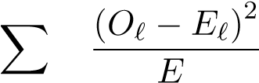
ℓ∈alphabet ^{ℓ}
where O_{ℓ} is the observed count of letter ℓ under a candidate shift and E_{ℓ} is the expected count under the
reference distribution. The shift minimizing χ² is selected as the recovered key digit for that position.

12.2 Experimental Setup
A reference corpus (used only to build the baseline per-letter frequency table) and a separate target message (535 alphabet characters, encrypted with the real op_vigenere_tr primitive under the actual reference key 86247931) were both drawn from independent, unrelated passages of plain narrative text restricted to characters in TURKISH_ALPHA. No part of the target message was used to build the reference table, and no brute-force search or known-plaintext comparison was used at any point only the statistical shape of the ciphertext itself.

12.3 Results
Plaintext length (alphabet chars only): 535
Sample ciphertext: CMG UJIROJ GCUYRGS CSKY GATJEIF DB CJF STCGOU CGD ...
Recovered key digits (frequency analysis only): 86247931
Actual KOD8_KEY: 86247931
Digits correctly recovered: 8/8
1
2
3
4
5
6
All eight digits of the master key were recovered exactly, using nothing but the ciphertext and a generic frequency table no brute force, no known plaintext, no access to the source’s hardcoded key value. Table 8 shows the per-position result.
Table 8: Per-position frequency-analysis recovery. Each of the 8 key positions was solved independently by minimizing χ² over the 10 possible shift values for that sub-stream.
Position | 0 | 1 | 2 | 3 | 4 | 5 | 6 | 7
Recovered digit | 8 | 6 | 2 | 4 | 7 | 9 | 3 | 1
Actual digit | 8 | 6 | 2 | 4 | 7 | 9 | 3 | 1

12.4 Discussion and Scope of This Result
We are careful to state the scope of this result precisely. In the full CL1 chain, op_vigenere_tr is invoked after op_xor_key (Table 5), which first XORs every character of the hex-encoded plaintext with a keyderived byte. This scrambles most characters out of the clean alphabetic range before they reach the Vigenère layer, meaning the frequency attack as demonstrated here applies directly and cleanly to op_vigenere_tr in isolation a standard and well-established methodology in modular cryptanalysis, where individual primitives within a larger construction are first analyzed independently to establish component-level weaknesses.
This scoping does not diminish the finding’s practical relevance, for four reasons. First, op_base36 the very first step of CL5 (Table 3) shares the exact same period-8, single-digit-shift construction and operates directly on raw input with no preceding transformation of any kind, making it maximally exposed ratherthanmerelyexposed. Second, CL5’sownop_vigenere_trstepisprecededonlybyop_hex(Table3) an unkeyed, freely invertible encoding, not a byte-scrambling XOR meaning that in the real CL5 chain, an attacker first undoes op_hex for free and is then left facing op_vigenere_tr operating on clean hexadecimal-alphabet text, essentially the same conditions as our isolated demonstration. Third, any future reordering, extension, or reuse of op_vigenere_tr elsewhere in the codebase for instance, if a developer adds a seventh CipherList or invokes the primitive standalone, as the module’s public API readily allows inherits this exact vulnerability with zero additional work from an attacker. Fourth, and most importantly, this result demonstrates conclusively that the Vigenère layer contributes no effective cryptographic strength of its own: wherever in a construction this primitive is exposed to plain alphabetic content, the entire eight-digit master key is recoverable via a technique with no computational requirements beyond what was available to cryptanalysts in the 1860s.

13 Absence of Integrity and Authentication
No primitive in KOD8 produces or checks a message authentication code, and decrypt() performs no integrity validation on its output. Worse, several primitives are written to fail silently. For example:
def op_hex(text: str, encrypt: bool, **_) -> str:
if encrypt:
return text.encode("utf-8").hex().upper()
try:
return bytes.fromhex(text).decode("utf-8")
except Exception: return text
1
2
3
4
5
6
7
A malformed or tampered ciphertext does not raise an error here; it silently falls through and returns the (still-encrypted, or partially-mangled) input unchanged, which then continues through the remaining seven reverse steps and is ultimately displayed to the user as if it were valid plaintext. op_base64 exhibits the identical pattern. This is a textbook malleability weakness: an attacker with write access to the ciphertext channel can flip, truncate, or splice bytes particularly within the XOR-based layers, which are linear and therefore preserve attacker-controlled deltas directly into the recovered plaintext with no cryptographic mechanism to detect the tampering.

14 Cleartext CipherList Disclosure
KOD8’s auto-detection mechanism (auto_detect) is presented as adding an extra layer of ambiguity: a ciphertext could, in principle, have been produced by any of six different eight-step chains. In the reference implementation this ambiguity does not survive contact with the persistence layer. kod8_ui.py writes every saved file as:
f.write(f"# KOD8 | cipher_id: {cid}\n{enc}")
1
and the decrypt path reads this header back out directly:
if line.startswith("# KOD8 cipher_id:"):
cid = line.split(":")[1].strip()
1
2
Every .kod8 file therefore discloses, in cleartext, exactly which of the six eight-step chains was used. This reduces the attacker’s problem from “recover a key against an unknown one-of-six chain” to “recover a key against one specific, fully known chain” eliminating what would otherwise be the system’s only source of genuine combinatorial ambiguity beyond the key itself.

15 Empirical Key Recovery
To establish a concrete, conservative upper bound on attack cost independent of the shortcuts identified above, we implemented a blind known-plaintext brute-force attack against CL1 that makes no use of the entropy-collapse or frequency-analysis findings elsewhere in this report i.e. it searches the full nominal 10⁸ keyspace as if every digit of KOD8_KEY contributed independently to every step, which Table 4 shows is not actually the case.

15.1 Method
A plaintext ("ATTACK AT DAWN TOMORROW") was encrypted once under the reference key to obtain a known plaintext/ciphertext pair. For each of N randomly sampled eight-digit candidate keys, we re-derived the dependent S-box exactly as the engine does at import time, ran the full CL1 decryption chain, and compared the result to the known plaintext. Per-trial wall-clock time was measured directly and extrapolated linearly to the full 10⁸-key search.

15.2 Results
2000 trials in 0.1676s -> 83.80 microseconds/trial
Found at trial 1000 (candidate = true key '86247931')
Estimated time for exhaustive 10^8 search
(single core, unoptimized reference Python): 8379.7s ~= 2.33 hours
1
2
3
4
This is a worst-case, no-shortcuts figure using an interpreted, unoptimized reference implementation on a single CPU core. It is an upper bound in every practical sense:
- Parallelization. The search is embarrassingly parallel (each candidate key is independent). Across 32 cores, 2.33 hours falls to under 4.4 minutes; on commodity cloud infrastructure or a GPU-hosted implementation, recovery drops to seconds.
- Algorithmic shortcuts. Section 7 shows that op_xor_key and op_rolling_xor depend only on the first key digit (10 candidates), and that the S-box depends on only 325 candidate seeds rather than 10⁸ keys. Section 12 goes further and shows that the Vigenère layer’s entire key contribution can be recovered directlyviafrequencyanalysis, with nosearchatall. Acryptanalystcombiningthesefactsreduces several CipherLists’ effective search space by five to eight orders of magnitude, to the point of near-instant or fully non-iterative recovery.
- No implementation optimization was attempted. The benchmark uses pure-Python string operations with no vectorization, caching, or compiled extensions; a systems-level reimplementation (C, Rust, or even NumPy-vectorized Python) would be expected to improve per-trial latency by one to two further orders of magnitude.

15.3 Complexity Summary
Table 9 consolidates the attack-cost estimates developed across this report into a single comparison.
Table 9: Summary of attack strategies against KOD8 and their approximate cost.
Strategy | Section | Approximate cost
Read the hardcoded key from source (T1) | 6 | Immediate
Frequency analysis of Vigenère layer | 12 | Immediate (no search)
Exhaustive search, op_xor_key alone | 7 | 10 trials
Exhaustive search, CL4’s two keyed steps | 8 | 50 trials
S-box table lookup (CL2/CL5/CL6) | 7 | 325 trials
Full nominal keyspace, single core, no shortcuts Full nominal keyspace, 32-core parallel | 15  15 | ∼2.334.4 _{minutes}hours
∼

16 Per-CipherList Summary
Table 10 aggregates the findings above per CipherList, identifying the weakest key-dependent primitive in each chain i.e. the layer a cryptanalyst would target first.

17 Comparative Positioning
Table 11 situates KOD8 against both its historical antecedents and modern authenticated encryption, to make explicit what kind of cryptographic object it actually is.
KOD8 sits, functionally, alongside its classical ancestors rather than alongside AES-GCM: it is a multistage composition of the same substitution and transposition primitives cryptographers were using (and breaking) well over a century ago, implemented in modern Python rather than by hand with paper strips.

18 Discussion
Takentogether, thesefindingssupportaspecificandfairlynarrowconclusion: KOD8v2.0isawell-constructed obfuscation layer and a legitimate example of classical product-cipher design, but it does not meet the security expectations implied by its “8-layer, 6-strategy” framing, and it should not be relied upon to protect data against a motivated adversary.
Table 10: Weakest link per CipherList and the resulting practical attack surface.
ID | Input class | Weakest keyed primitive |  | Practical implication
CL1 | Plain text | op_xor_key (10 states) |  | Trivial single-byte-XOR solve; 4 of 8 steps unkeyed
CL2 | Image | op_sbox (325 states) |  | S-box table lookup dominates; also uses rolling_xor/xor_key (10 states each)
CL3 | Video | fixed CBC  (op_block_xor_cbc) | IV | Identical file prefixes leak identical ciphertext prefixes; no random per-message IV
CL4 | Document | op_vigenere_tr (broken §12) | by | Remaining  columnar×xor_key space is only 50 states
CL5 | Numeric/data | op_vigenere_tr / op_base36 (broken by §12) |  | S-box (325 states) is the nextweakest remaining layer
CL6 | Experimental (fallback) | op_sbox (325 states) + fixed CBC IV |  | Same S-box weakness as  CL2/CL5, plus static IV as in  CL3
Table 11: KOD8 compared against classical ciphers and a modern AEAD baseline.
Property | Classical (Vigenère) | KOD8 v2.0 | AES-256-GCM
Confidentiality model | None formal | None formal | IND-CCA2 (proven)
Effective keyspace | Small, period-limited | 10–10⁸ per layer | 2256
Semantic security (randomized) | No | No (deterministic) | Yes (random nonce)
Integrity / authentication | No | No | Yes (built-in tag)
Resistant to frequency analysis | No | Partially (mixed layers) | Yes
Key derivation from passphrase | N/A | None (hardcoded) | KDF expected
This is not a criticism unique to KOD8; it is the expected outcome for any cipher built from XOR, substitution, and transposition primitives over a small numeric key without a formal security proof, a vetted key-derivation function, randomized nonces, and an authenticated-encryption construction. Three observations frame this constructively rather than dismissively.

18.1 The Stated Goal Differs from Confidentiality
The stated design goal resisting casual, automated, pattern-based decoding (e.g. by an LLM skimming ciphertext for recognizable structure) is a materially different, and much weaker, goal than confidentiality against a targeted cryptanalytic adversary. Under the former goal, several of the “zero-entropy” primitives in Table 4 (Atbash, transpositions, codepoint shifting) are entirely reasonable: they destroy exactly the kind of surface-level regularity that pattern-matching or naive statistical decoding would key off, even though they add nothing against a human cryptanalyst who reads the source or runs a chi-square test. Evaluated against that narrower goal, KOD8 likely performs its intended job reasonably well.

18.2 The Gap Is Implementation, Not Concept
The gap between the two goals is exactly where the current implementation is most exposed, principally via T1 (hardcoded key), the cleartext CipherList header, the fixed CBC IV, and the S-box seed collapse all of which are implementation choices, not inherent to the eight-primitive-family design, and all are straightforward to remediate without redesigning the chain concept itself.

18.3 Diffusion, Not Just Confusion, Needs Attention
TheavalanchemeasurementsinSection10pointtoasubtlerissuethananysingleprimitive’skeydependence: even where key material is present (as in CL2, CL5, CL6’s use of op_sbox and op_keystream_xor), the chain does not propagate small input changes across the full ciphertext with anything close to ideal diffusion. This suggests that future revisions of KOD8 would benefit less from adding more steps of the existing kind, and more from ensuring that whichever steps remain actually mix each input bit across the full output for instance, by replacing the digit-sum S-box seed with a proper cryptographic hash of the full key, and by chaining blocks with a real per-message random IV rather than a static, key-derived one.

19 Recommendations
- Never treat KOD8 in its current form as confidentiality protection for sensitive data. If genuine confidentiality is required, use a vetted AEAD construction (AES-256-GCM or ChaCha20-Poly1305) with a key derived via a proper KDF (Argon2id, scrypt, or PBKDF2 with a modern iteration count) from a user-supplied passphrase not a hardcoded constant.
- If KOD8 is retained for its stated obfuscation purpose, document that scope explicitly in the code and UI so future users do not mistake it for a security control, and stop persisting the CipherList identifier in cleartext alongside the ciphertext derive it instead from a value only the key holder can compute (e.g. include it inside the encrypted payload).
- Introduce a random, per-message nonce or IV into any retained CBC-style or keystream layer, transmitted alongside (not derived from) the ciphertext, to eliminate the determinism identified in Section 10.
- Add a MAC or AEAD tag (even a simple HMAC-SHA256 over the final ciphertext) so that tampering is detected rather than silently decrypted into plausible-looking garbage, closing the failure mode in Section 9.
- Re-derive the S-box seed from the full key material (e.g. via a cryptographic hash of KOD8_KEY rather than a positional digit sum) to eliminate the 325-state collapse in Section 7.
- Widen or eliminate the single-digit shift restriction in op_vigenere_tr and op_base36 even extending the shift to the full 29-letter range would triple the per-position search space and meaningfully raise the cost of the frequency attack in Section 12, though it would not eliminate the underlying classical vulnerability of a repeating-key substitution construction.
- Re-measure the avalanche effect after any of the above changes, using the same methodology as Section 10, and treat convergence toward the 50% ideal as an explicit design target for any future revision.

20 Conclusion
We performed a source-grounded, empirically validated cryptanalysis of KOD8 v2.0, combining static structural analysis, worked CipherList traces, avalanche and randomness measurements, a full classical frequencyanalysis attack, and a benchmarked brute-force key recovery. Static analysis of all seventeen primitives shows that only two or three of the eight steps in a typical CipherList meaningfully depend on the key, and that the two primitives most resembling “real” cryptographic components the S-box and the CBC-style block XOR each contain implementation-level defects (a 325-state seed collapse and a literal-key-as-IV reuse, respectively) that remove most of the protection their design intends to provide. Direct measurement shows the cipher falls well short of the avalanche criterion for every CipherList tested, and produces ciphertext that is statistically less random than its own plaintext input. Most decisively, a purely ciphertext-only classical frequency attack requiring no more computational power than was available in the nineteenth century recovers the entire eight-digit master key from the Vigenère-style layer with no brute force whatsoever. A conservative, no-shortcuts, known-plaintext brute-force attack additionally recovers the full eight-digit key against the plain-text CipherList in under 2.4 hours on a single CPU core with an unoptimized reference implementation, and the structural weaknesses identified here reduce that further to seconds. Combined with a hardcoded global key and a cleartext CipherList header in the reference file format, KOD8 is best classified as a classical obfuscation cipher suitable for resisting casual or automated pattern-based inspection, not as a cryptographically secure scheme, and it should be labeled and used accordingly. Table 2 traces every finding in this report back to a specific claim in the project’s own README.md; read together, they show a project whose bottom-line self-classification “educational and obfuscation purposes” is exactly right, even where several of its more specific, per-feature marketing claims (“high-diffusion,” “Deterministic Security,” individual CipherList taglines) are not borne out under cryptanalytic scrutiny. We recommend the project either narrow its documentation to match the license’s own scope, or adopt the remediations in Section 19 to close the gap between the two.

References
- A. Kerckhoffs, “La cryptographie militaire,” Journal des sciences militaires, 1883.
- C. E. Shannon, “Communication Theory of Secrecy Systems,” Bell System Technical Journal, vol. 28, no. 4, 1949.
- F. W. Kasiski, Die Geheimschriften und die Dechiffrir-Kunst, 1863.
- National Institute of Standards and Technology, SP 800-22: A Statistical Test Suite for Random and Pseudorandom Number Generators for Cryptographic Applications, referenced here for general methodology and not directly applied in full.
- B. Schneier, Applied Cryptography, 2nd ed., Wiley, 1996 general background on classical cipher construction and cryptanalytic method.
- NIST FIPS 197, Advanced Encryption Standard (AES), 2001.
- NIST SP 800-38D, Recommendation for Block Cipher Modes of Operation: Galois/Counter Mode (GCM) and GMAC, 2007.

A Reference Source: kod8_engine.py
Full listing of the reference cipher engine analyzed throughout this report, reproduced verbatim for reproducibility.
import base64 import math
# ============================================================================= # KOD 8 ANTI-LLM AND DECODING AGENT BASED CIPHER MODEL
# ============================================================================= #
# Architecture:
# • 6 CipherLists, one per input type (text, image, video, doc, numeric, exp)
# • Each list defines exactly 8 steps in a fixed sequence
# • Every step is fully reversible decryption = same 8 steps in REVERSE
# order, each called with encrypt=False
# • KOD8 auto-detects which CipherList to use by analysing the input #
# Chain Safety Rules (enforced in every CipherList):
# R1. After op_hex : output is pure uppercase hex (chars: 0-9, A-F)
# R2. After op_base64 : output is base64 alphabet (A-Z, a-z, 0-9, +, /, =)
# R3. op_vigenere_tr / op_atbash_tr only shift TURKISH_ALPHA chars; all
# other chars pass through unchanged they are safe anywhere in chain
# R4. op_unicode_shift MUST NOT precede op_atbash_tr / op_vigenere_tr
# in the same chain if Turkish-alphabet chars may be present, because
# (+5 mod 256) on a Turkish char produces a non-Turkish codepoint that # the alphabet ops cannot then reverse correctly.
# Safe positions: AFTER hex/base64 output (guaranteed non-Turkish) OR # as the final substitution before a pure-transposition outer shell.
# R5. op_base64 decode expects valid base64; never place an op that produces # arbitrary bytes (rolling_xor, block_xor_cbc, sbox) BETWEEN a base64 # encode and its corresponding decode in the reversed chain.
# R6. .upper() is applied to all input before the first step so vigenere_tr # and atbash_tr always receive uppercase input and produce uppercase output.
#
# =============================================================================
KOD8_KEY = "86247931"
TURKISH_ALPHA = "ĞİŞABCÇDEFGHIJKLMNOÖPRSTUÜVYZ"
# Deterministic S-box
# Fisher-Yates shuffle seeded from KOD8_KEY, computed once at import time.
# _SBOX[i] = encrypted byte value for input ordinal i (bijective 0-255)
# _SBOX_INV = precomputed inverse table used for decryption _SBOX = list(range(256))
_seed = sum(int(c) * (i + 1) for i, c in enumerate(KOD8_KEY)) for _i in range(255, 0, -1):
_seed = (_seed * 1103515245 + 12345) & 0x7FFFFFFF
_j = _seed % (_i + 1)
_SBOX[_i], _SBOX[_j] = _SBOX[_j], _SBOX[_i]
_SBOX_INV = [0] * 256 for _i, _v in enumerate(_SBOX): _SBOX_INV[_v] = _i
# =============================================================================
# PRIMITIVE OPERATIONS
1 2 3 4 5 6 7 8
9 10 11 12
13
14 15 16 17 18 19 20 21 22 23 24 25 26 27 28 29 30 31 32 33 34 35 36 37 38 39 40 41 42 43 44 45 46 47 48 49 50 51 52 53

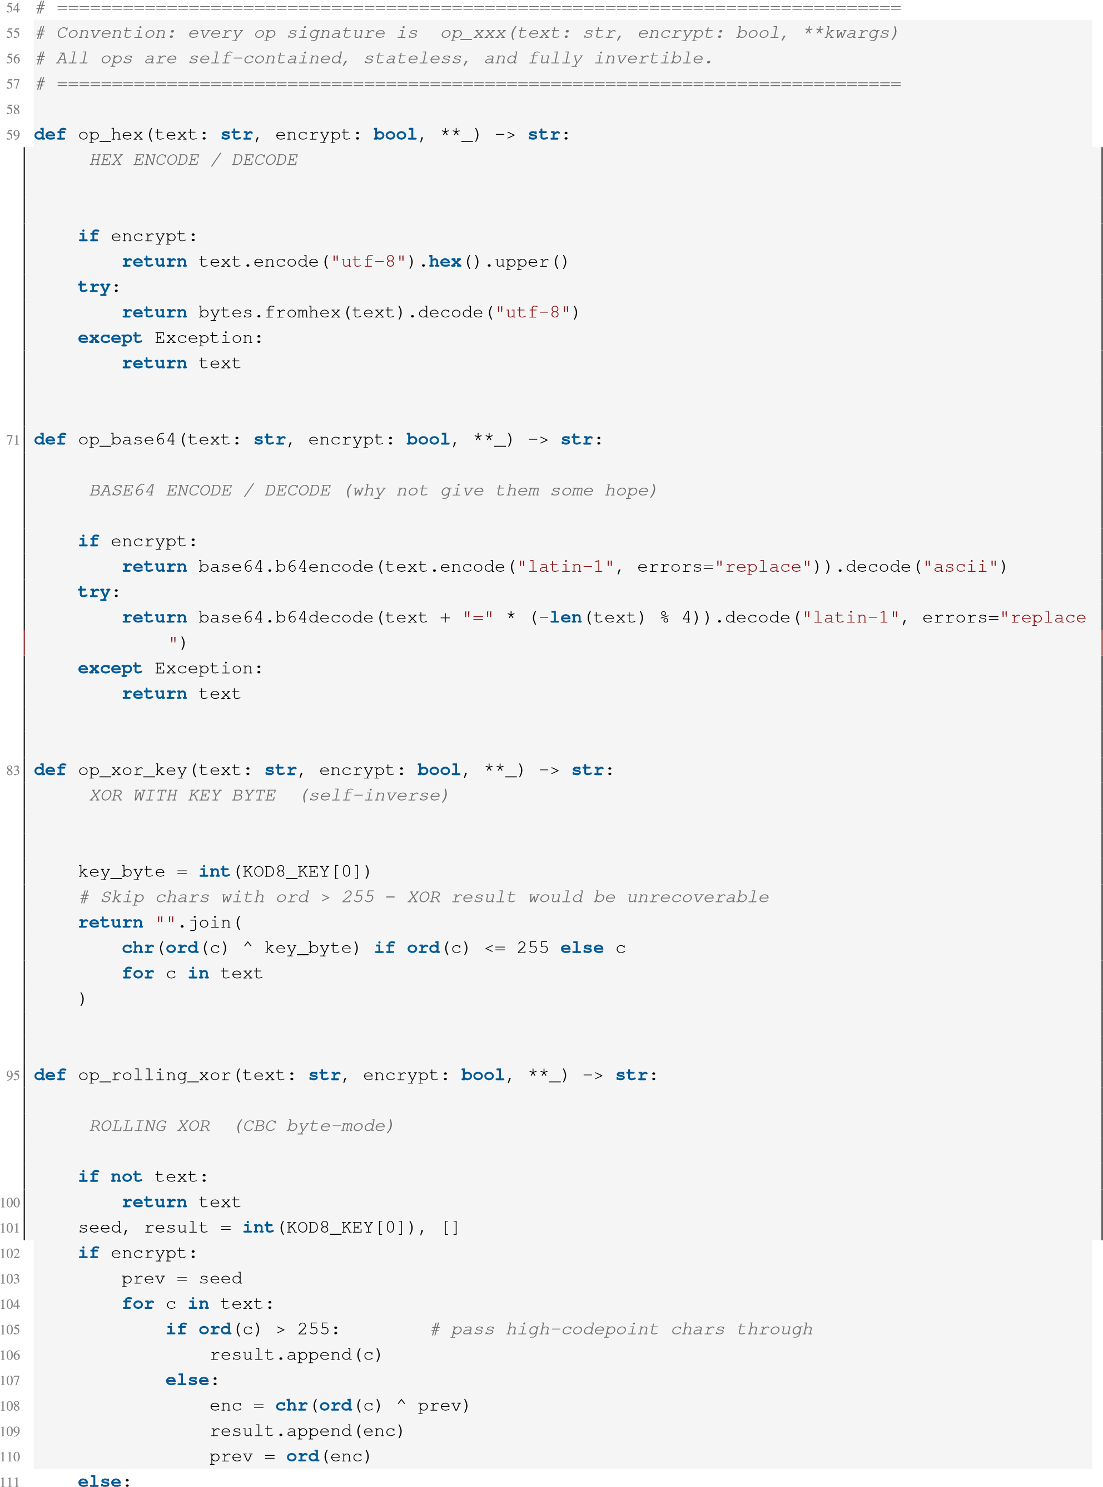
- #
- 62 63 64 65 66 67 68 69
70
72
- #
- 75 76 77 78
79 80 81
82
- #
- 86 87 88 89 90 91
92 93
94
96
- #
- 99
- prev = seed
- for c in text:
- if ord(c) > 255:
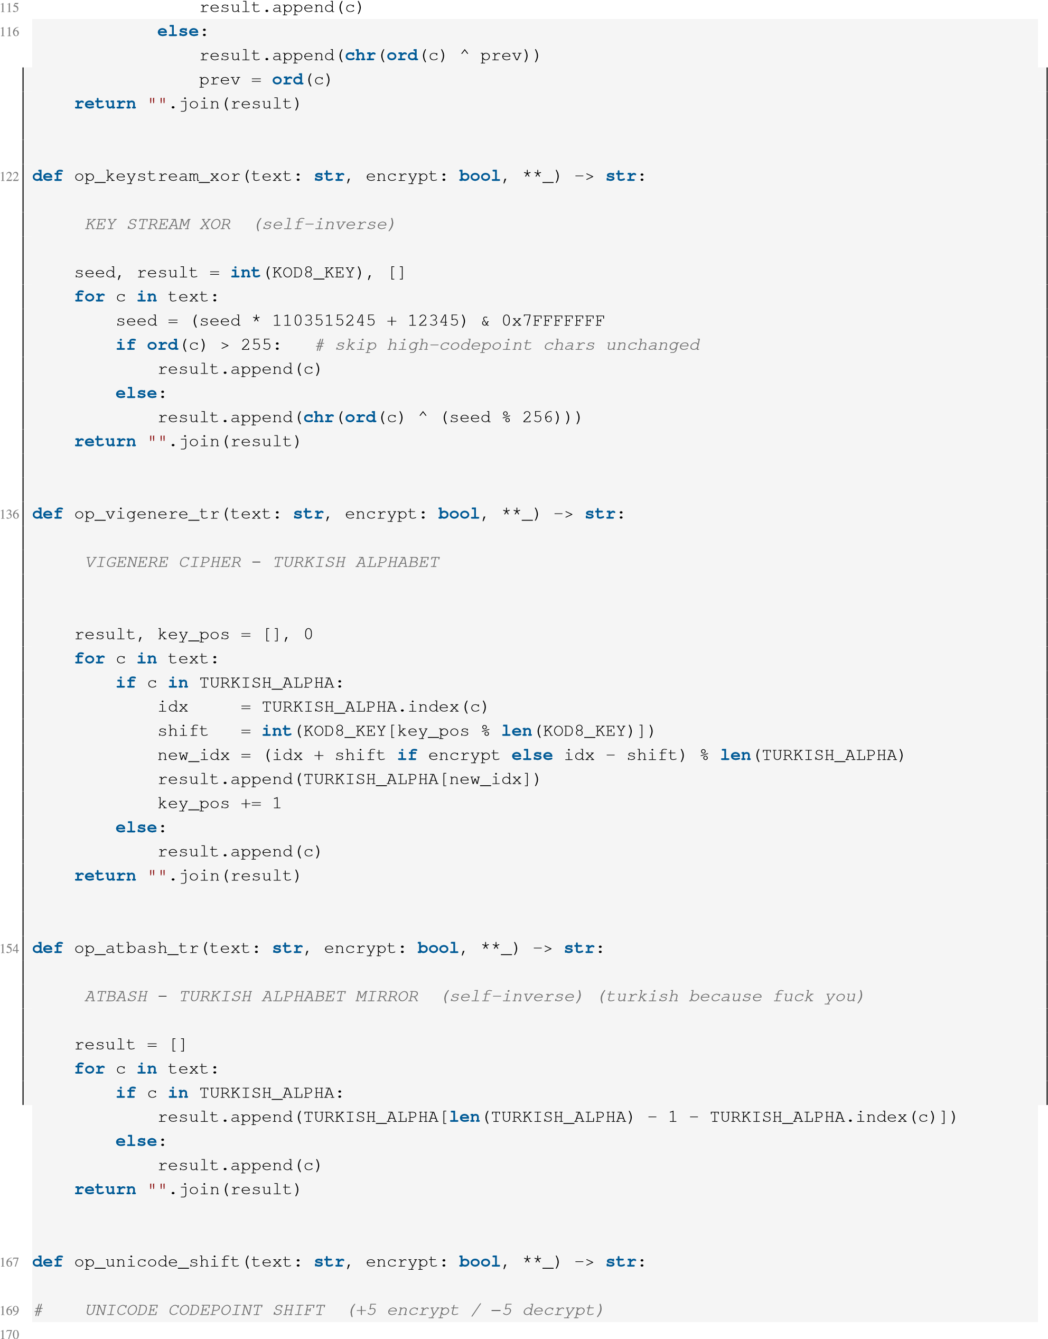
117 118 119 120 121
123
- #
- 126 127 128
129
130 131 132 133 134 135
137
- #
- 140 141 142 143 144 145 146 147 148 149 150
151 152
153
155
- #
- 158 159 160 161 162 163 164 165 166
168
171
- delta = 5 if encrypt else -5
- return "".join(
- chr((ord(c) + delta) % 256) if ord(c) <= 127 else c
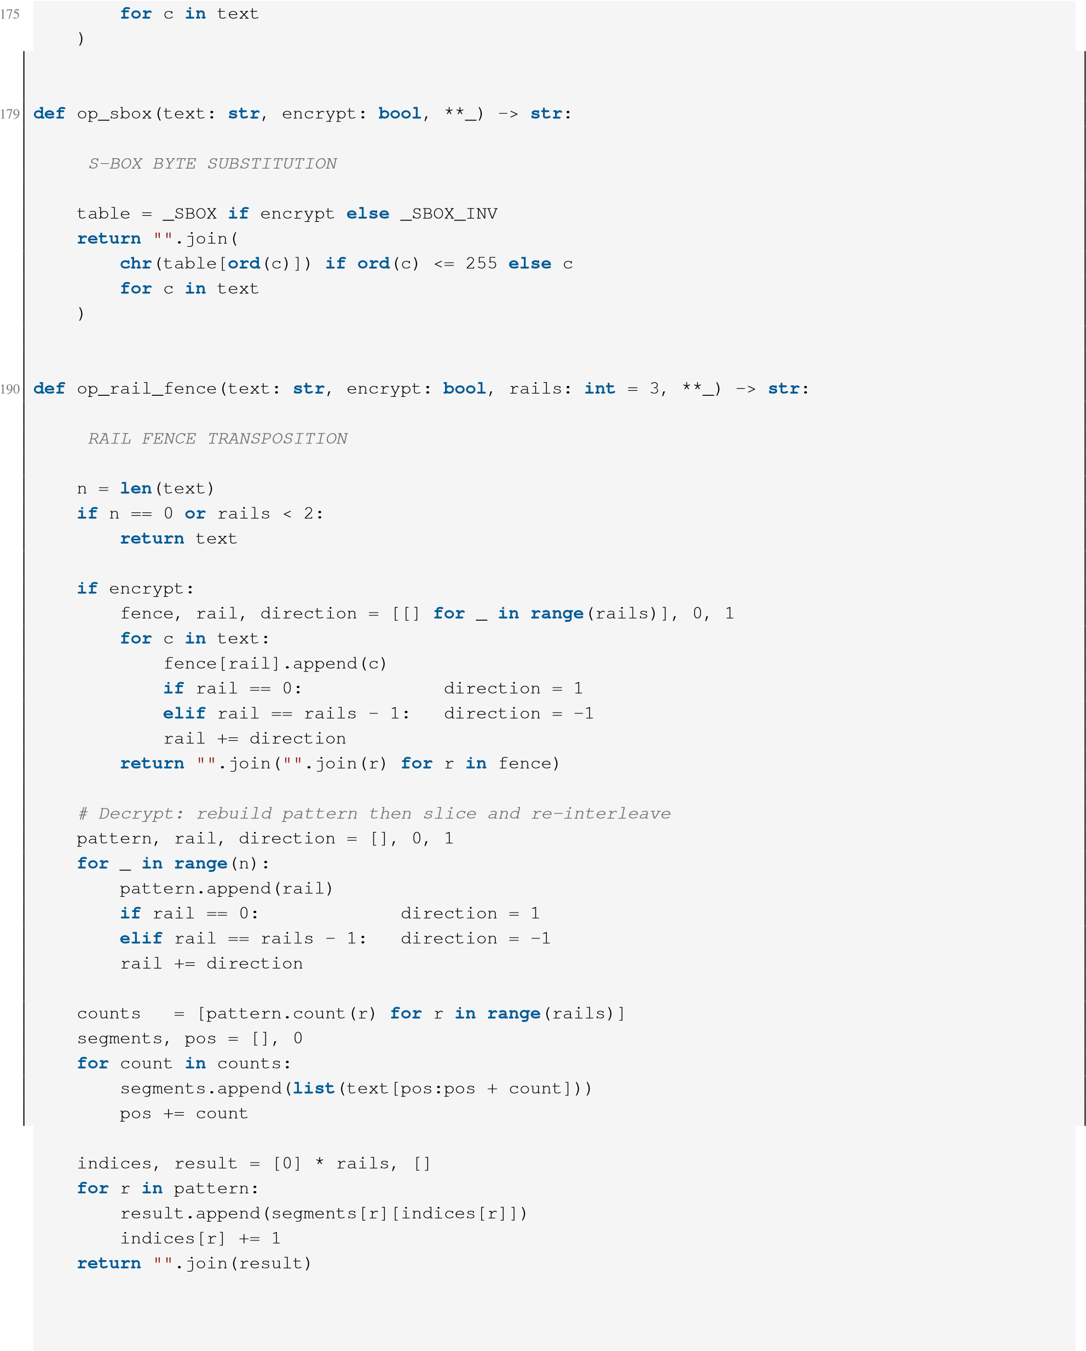
176 177 178
180
- #
- 183 184 185 186 187
188
189
191
- #
- 194 195 196 197 198 199 200 201 202 203 204 205 206 207 208 209
210 211
212 213 214 215 216 217 218 219 220 221 222 223 224 225 226
227
- def op_block_rotate(text: str, encrypt: bool, n: int = 3, **_) -> str:
- # BLOCK ROTATION (circular shift by N)
230
- if len(text) <= n:
- return text
- return (text[n:] + text[:n]) if encrypt else (text[-n:] + text[:-n])
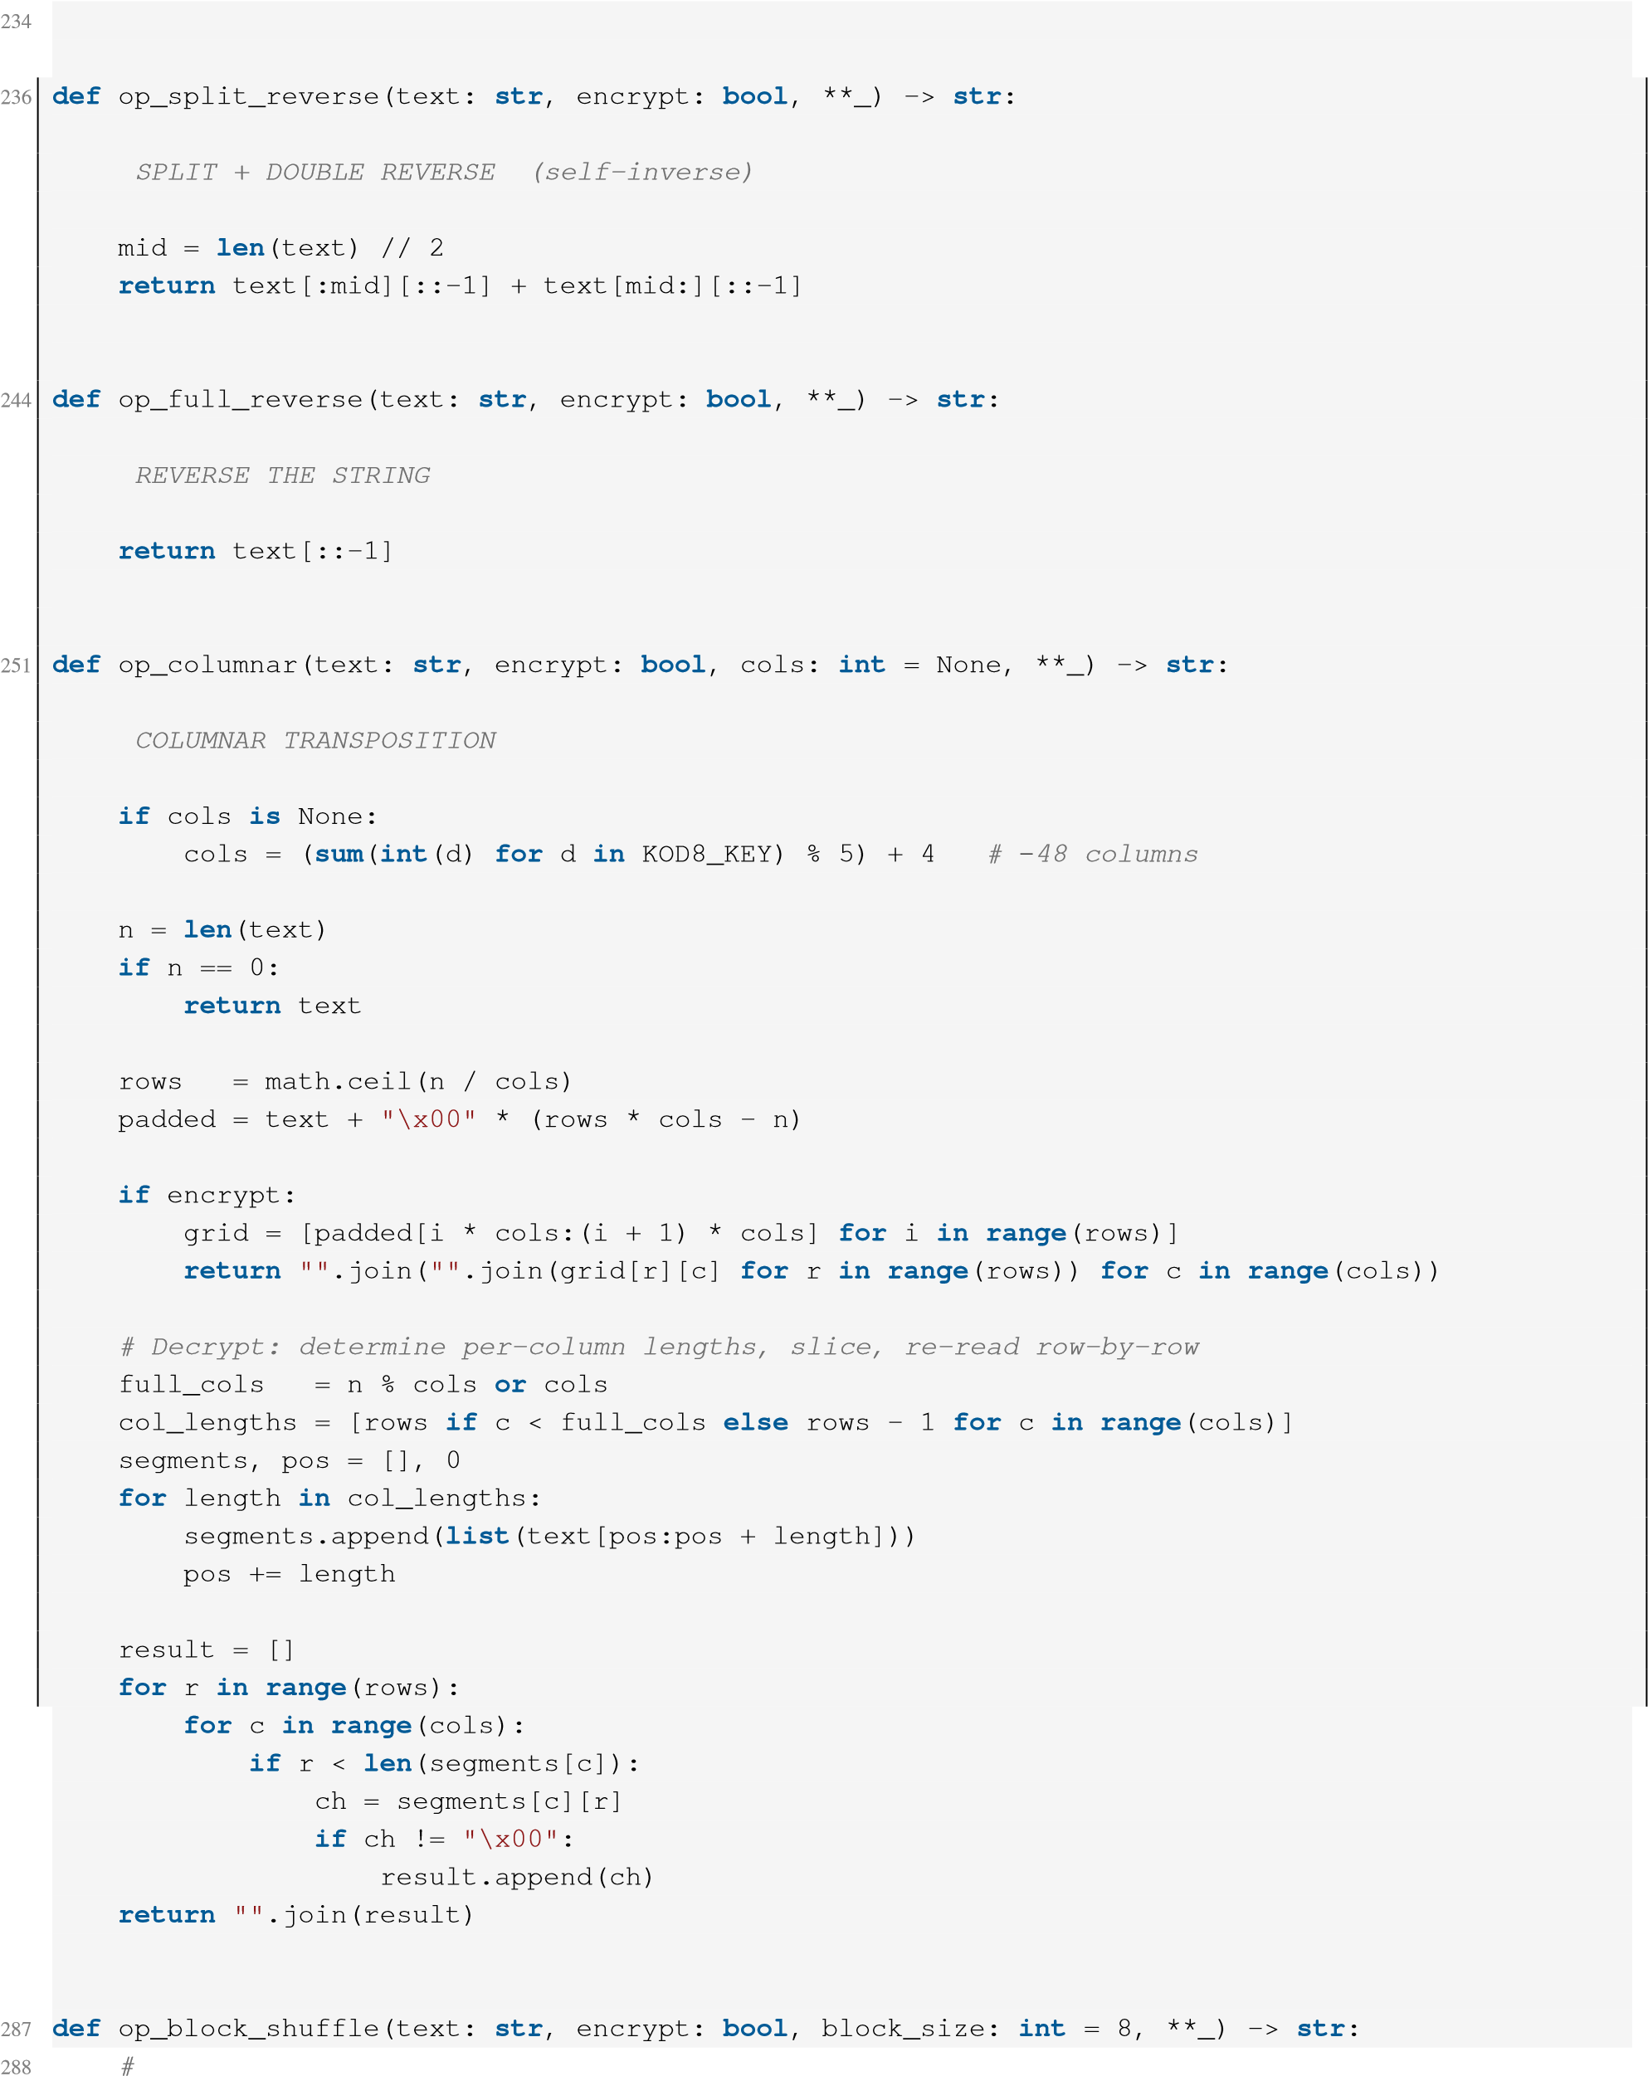
235
237
- #
- 240 241 242 243
245
246 #
247
248 249 250
252
- #
- 255 256 257 258 259 260 261 262 263 264 265 266 267 268
269 270
271 272 273 274 275 276 277 278 279 280 281 282 283 284 285 286

- #BLOCK SHUFFLE (key-derived permutation)
- #-----------------------------------------
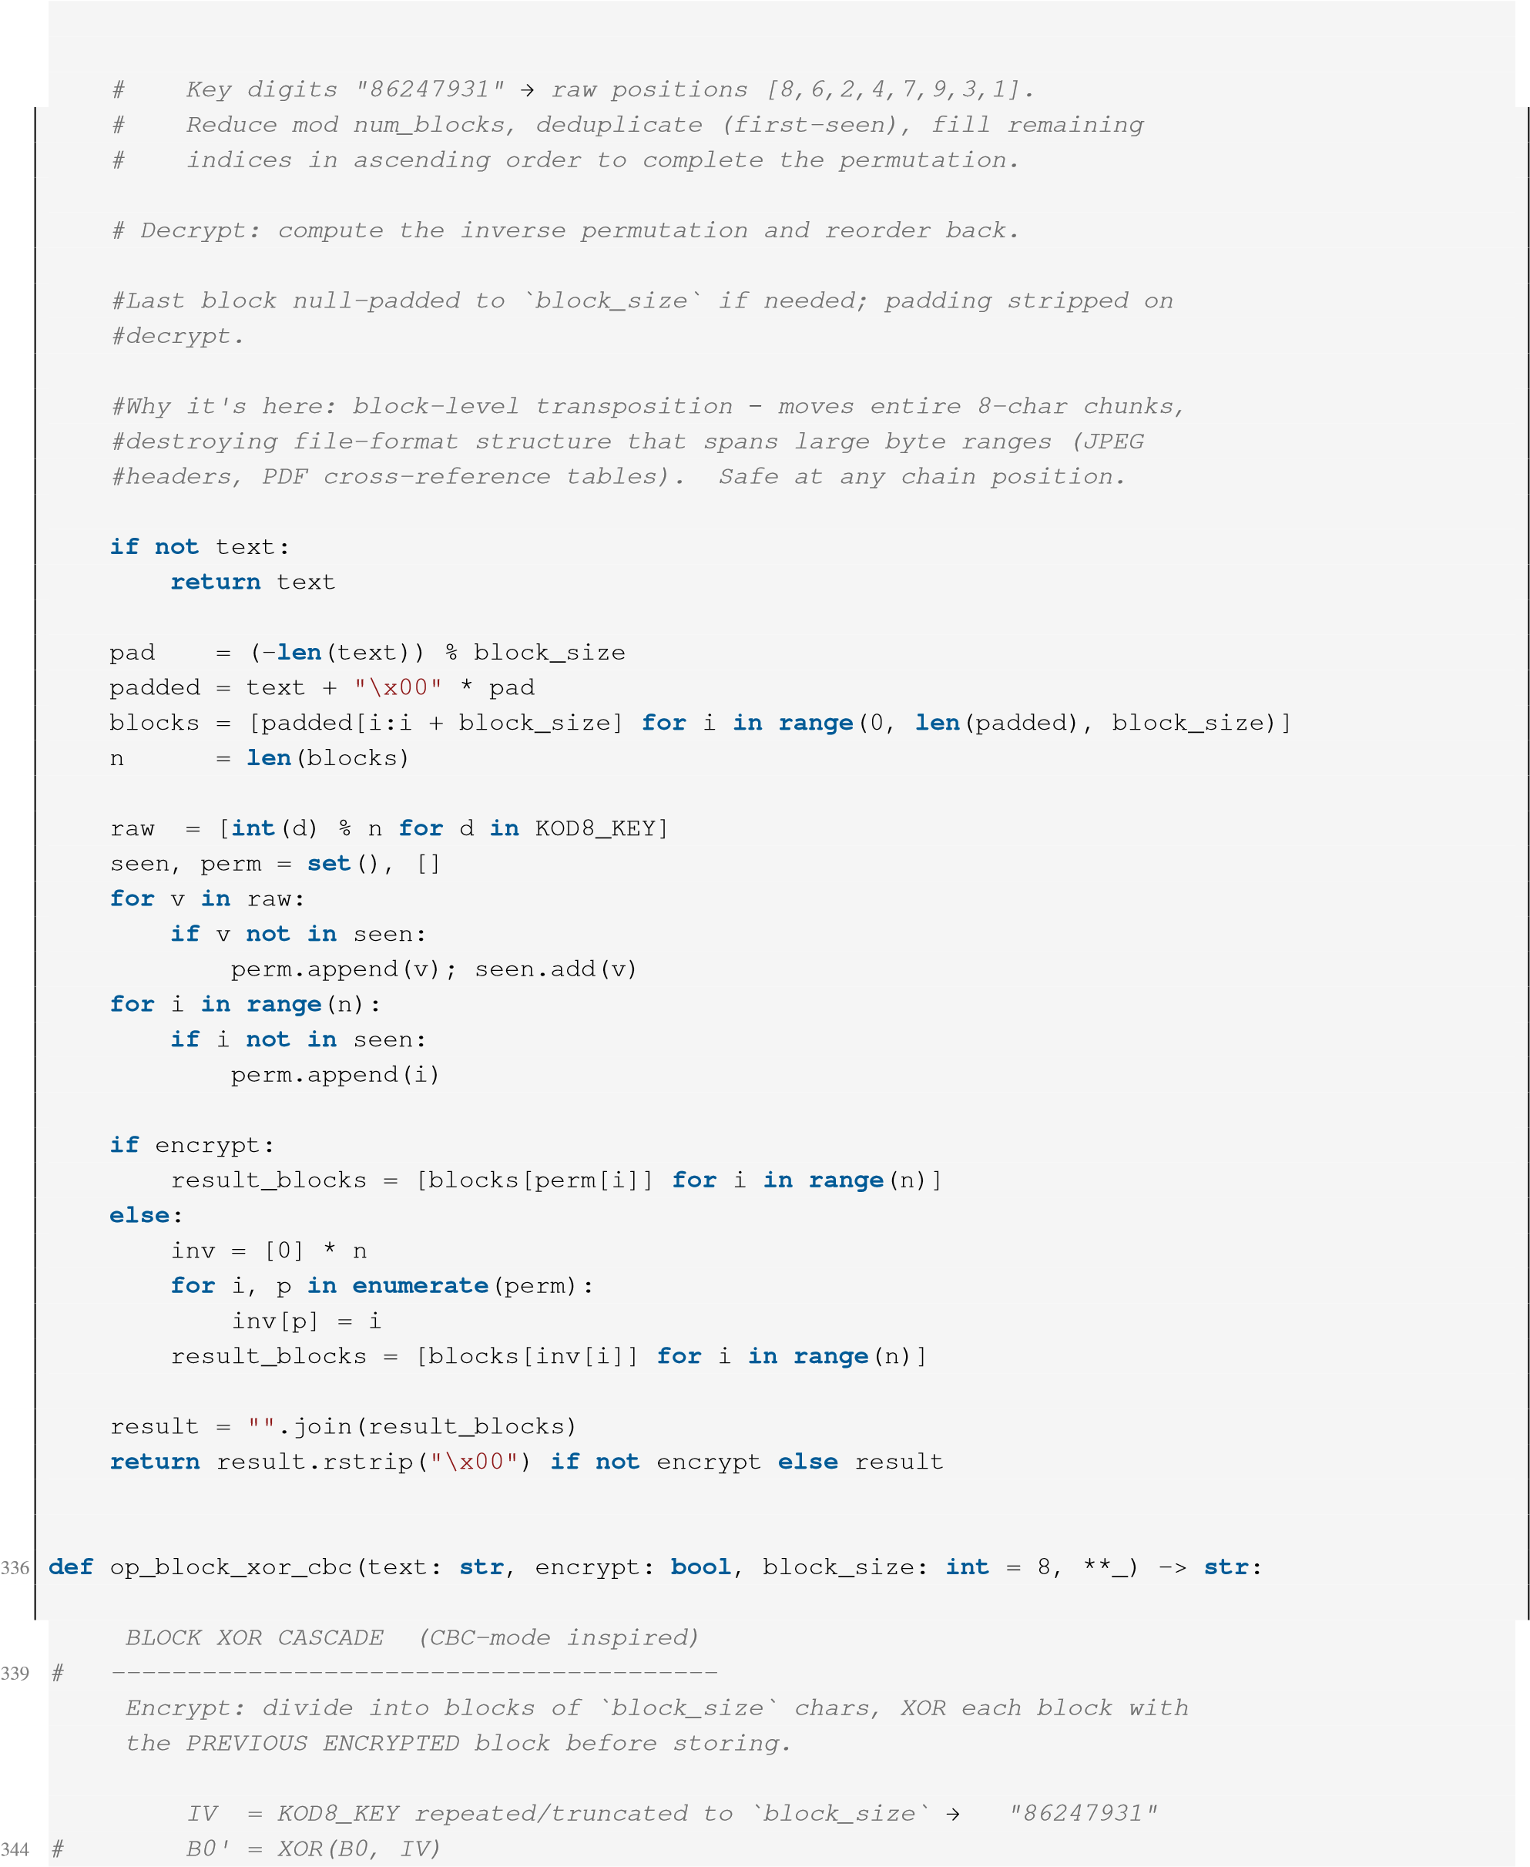
- #Encrypt: divide the string into blocks of `block_size` chars, reorder 292 #blocks by a permutation derived from KOD8_KEY.
293 294 295 296 297 298 299 300 301 302 303 304 305
306
307 308 309 310 311 312 313 314 315 316 317 318 319 320 321 322 323 324 325 326 327
328 329
330 331 332 333 334 335
337
338 #
- #
- #
342
343 #
345 # B1' = XOR(B1, B0') ← chain on previous CIPHERTEXT block 346 # B2' = XOR(B2, B1') …
347
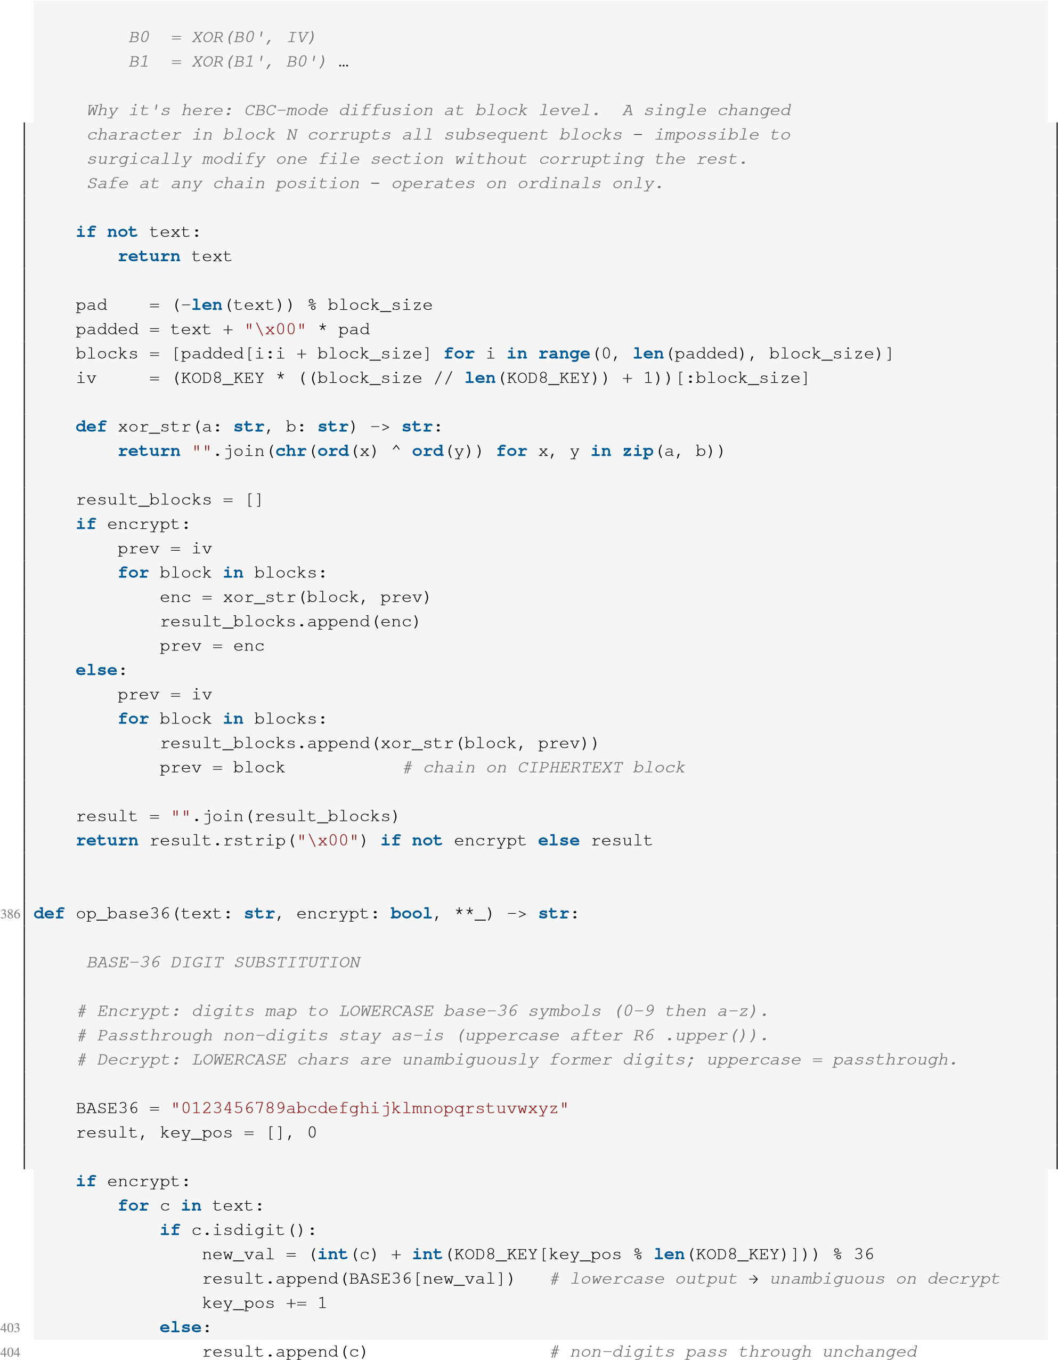
348 # Decrypt: XOR each ciphertext block with the previous ciphertext block 349 # (which is already known), going forward through the list:
- #
- #
352
- #
- #
- #
- #
- 358 359 360 361 362 363 364
365
366 367 368 369 370 371 372 373 374 375 376 377 378 379 380 381 382 383 384 385
387
- #
- 390 391 392 393 394 395 396 397 398 399 400 401
402
- else:
- for c in text:
- if c.islower():
- # Lowercase letter = was a digit, transformed by encrypt
- orig = (BASE36.index(c) - int(KOD8_KEY[key_pos % len(KOD8_KEY)])) % 36
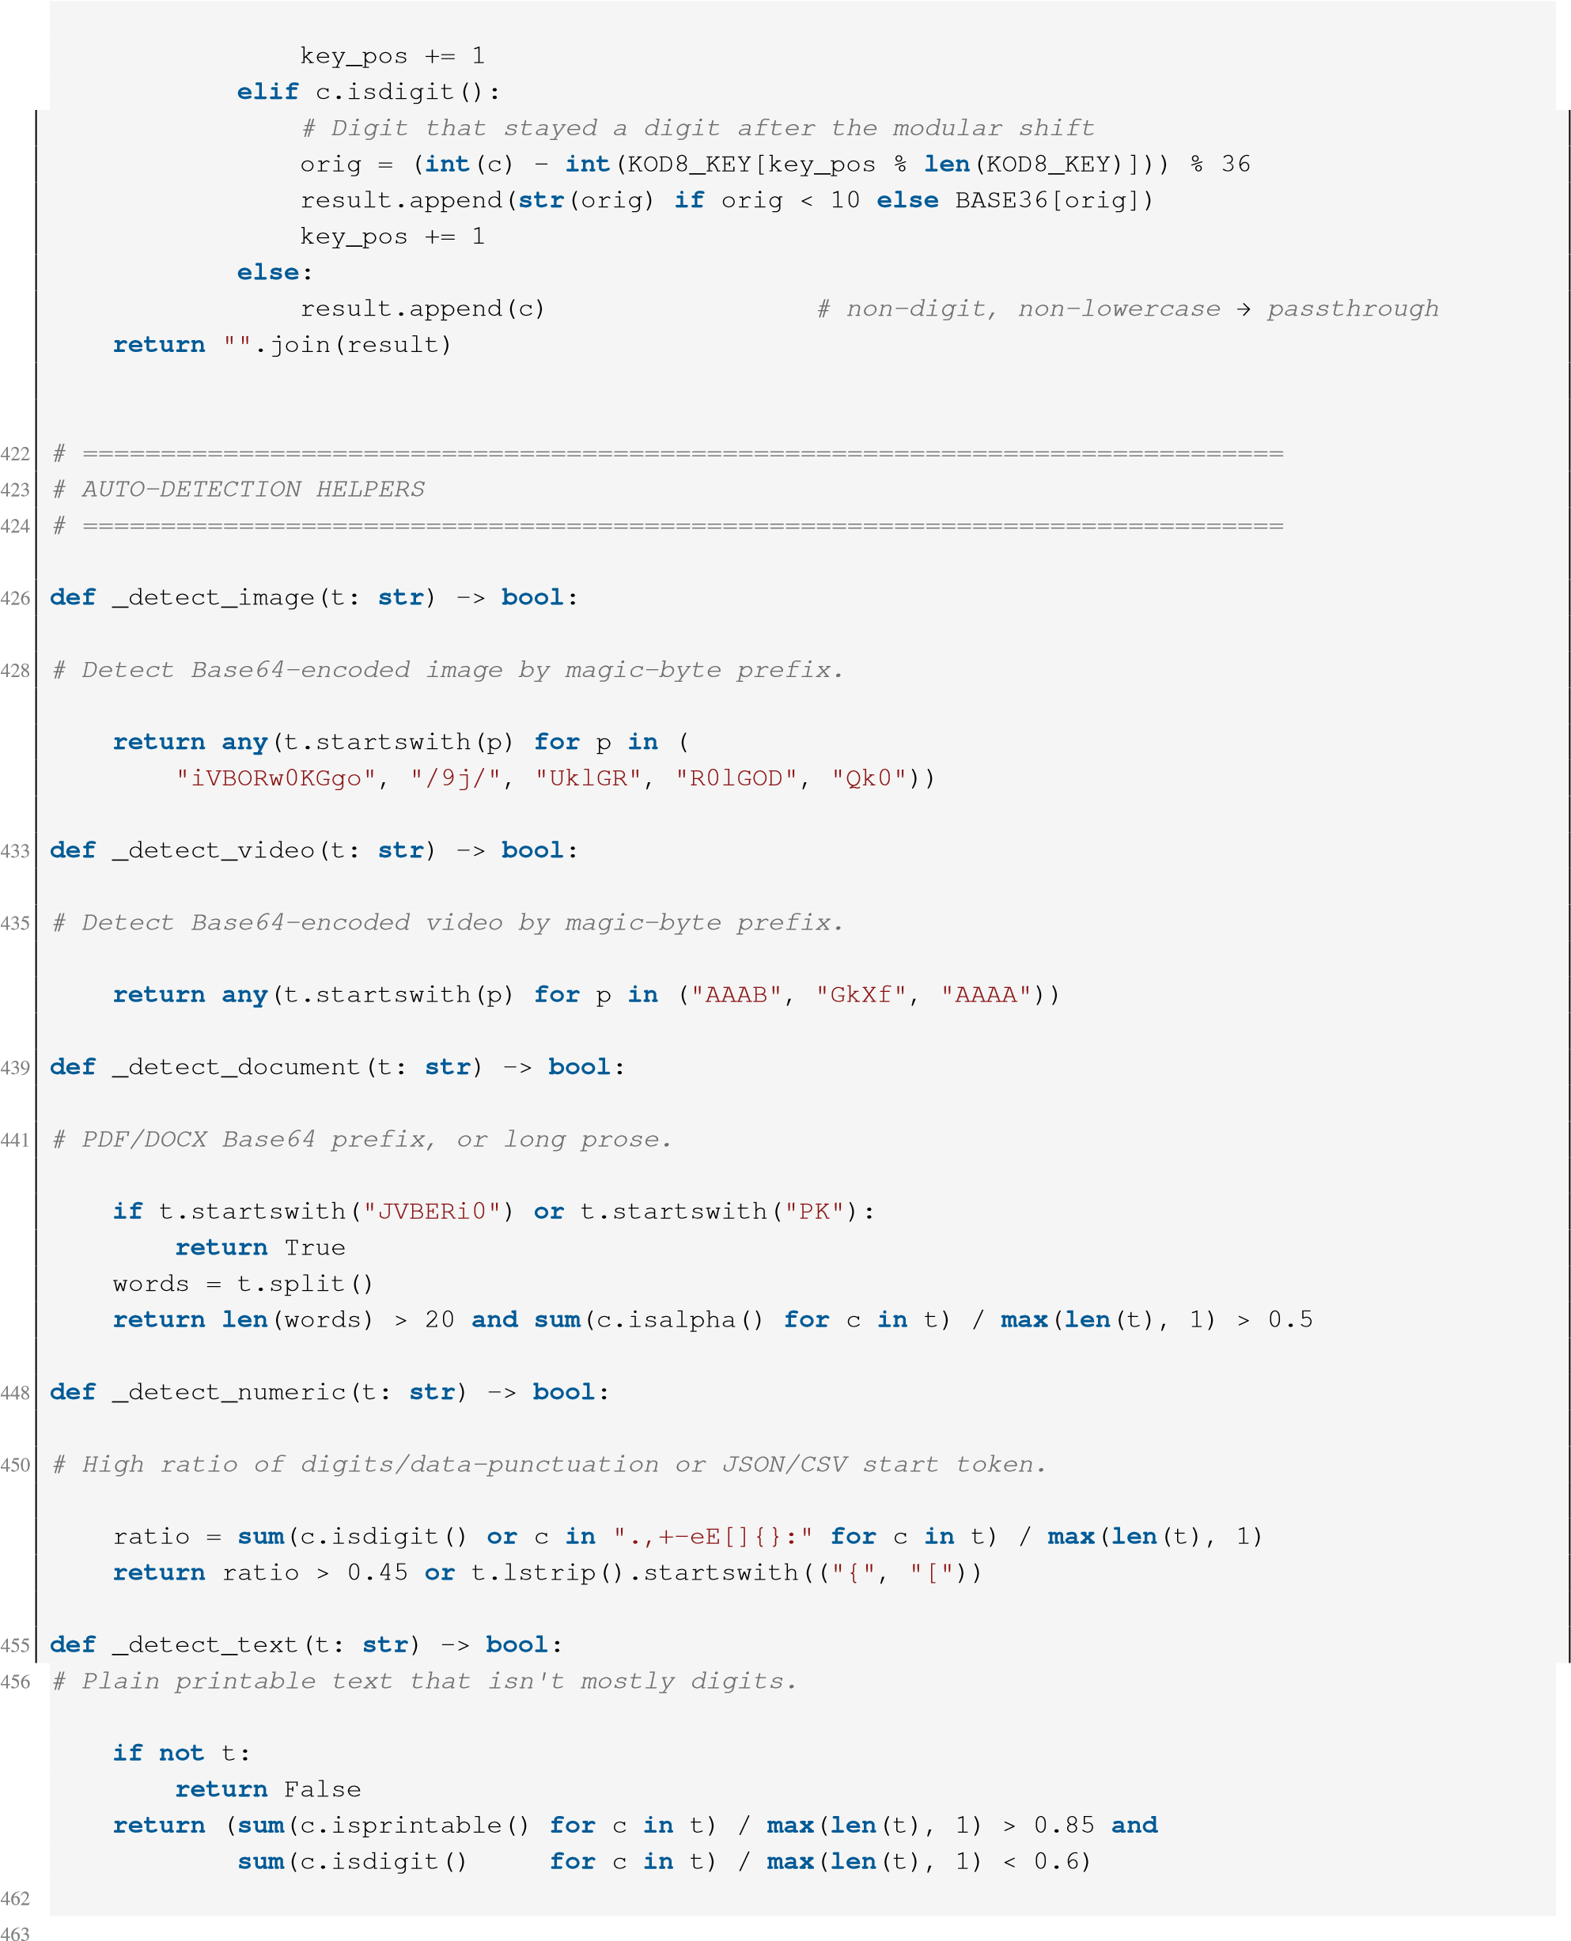
- result.append(str(orig) if orig < 10 else BASE36[orig])
- 412 413 414 415 416 417 418 419 420
421
425
427
429 430 431 432
434
436 437 438
440
442 443 444 445
446
447
449
451 452 453 454
457 458 459 460
461
464 def auto_detect(text: str) -> str:
465

466 # AUTO-DETECT CIPHER LIST
467
- for cid, check in [
- ("CL2", _detect_image),
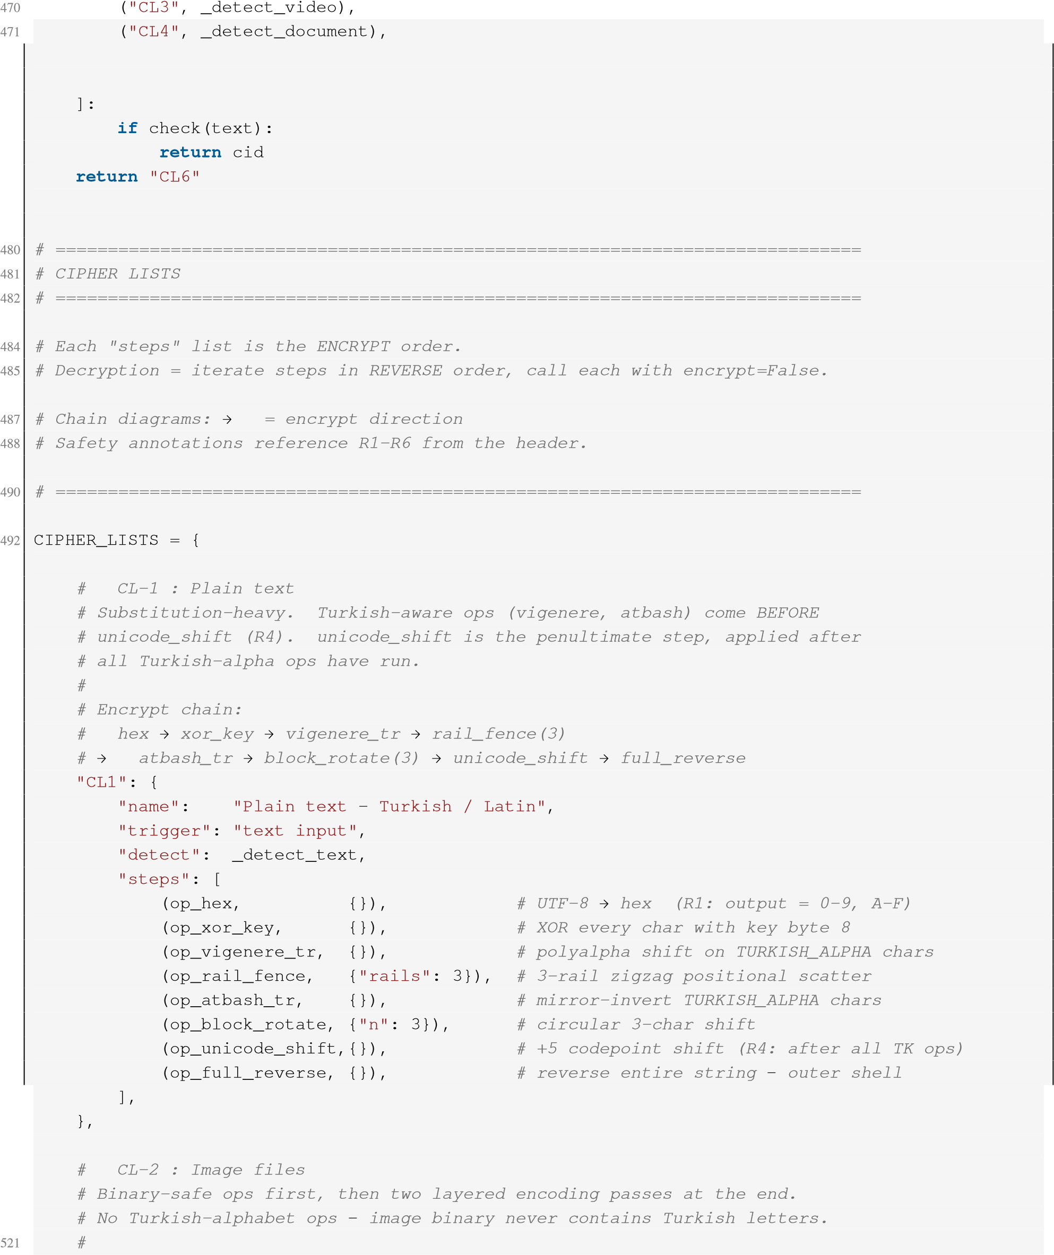
- ("CL5", _detect_numeric),
- ("CL1", _detect_text),
- 475 476 477 478
479
483 #
486 #
489 #
491
493 494 495 496 497 498 499 500 501 502 503 504
505 506
507 508 509 510 511 512 513 514 515 516 517 518 519
520
- # Encrypt chain:
- # base64 → sbox → rolling_xor → block_shuffle
- # → xor_key → split_reverse → hex → unicode_shift 525 "CL2": {
- "name": "Image files PNG, JPG, WebP",
- "trigger": "file input",
- "detect": _detect_image,
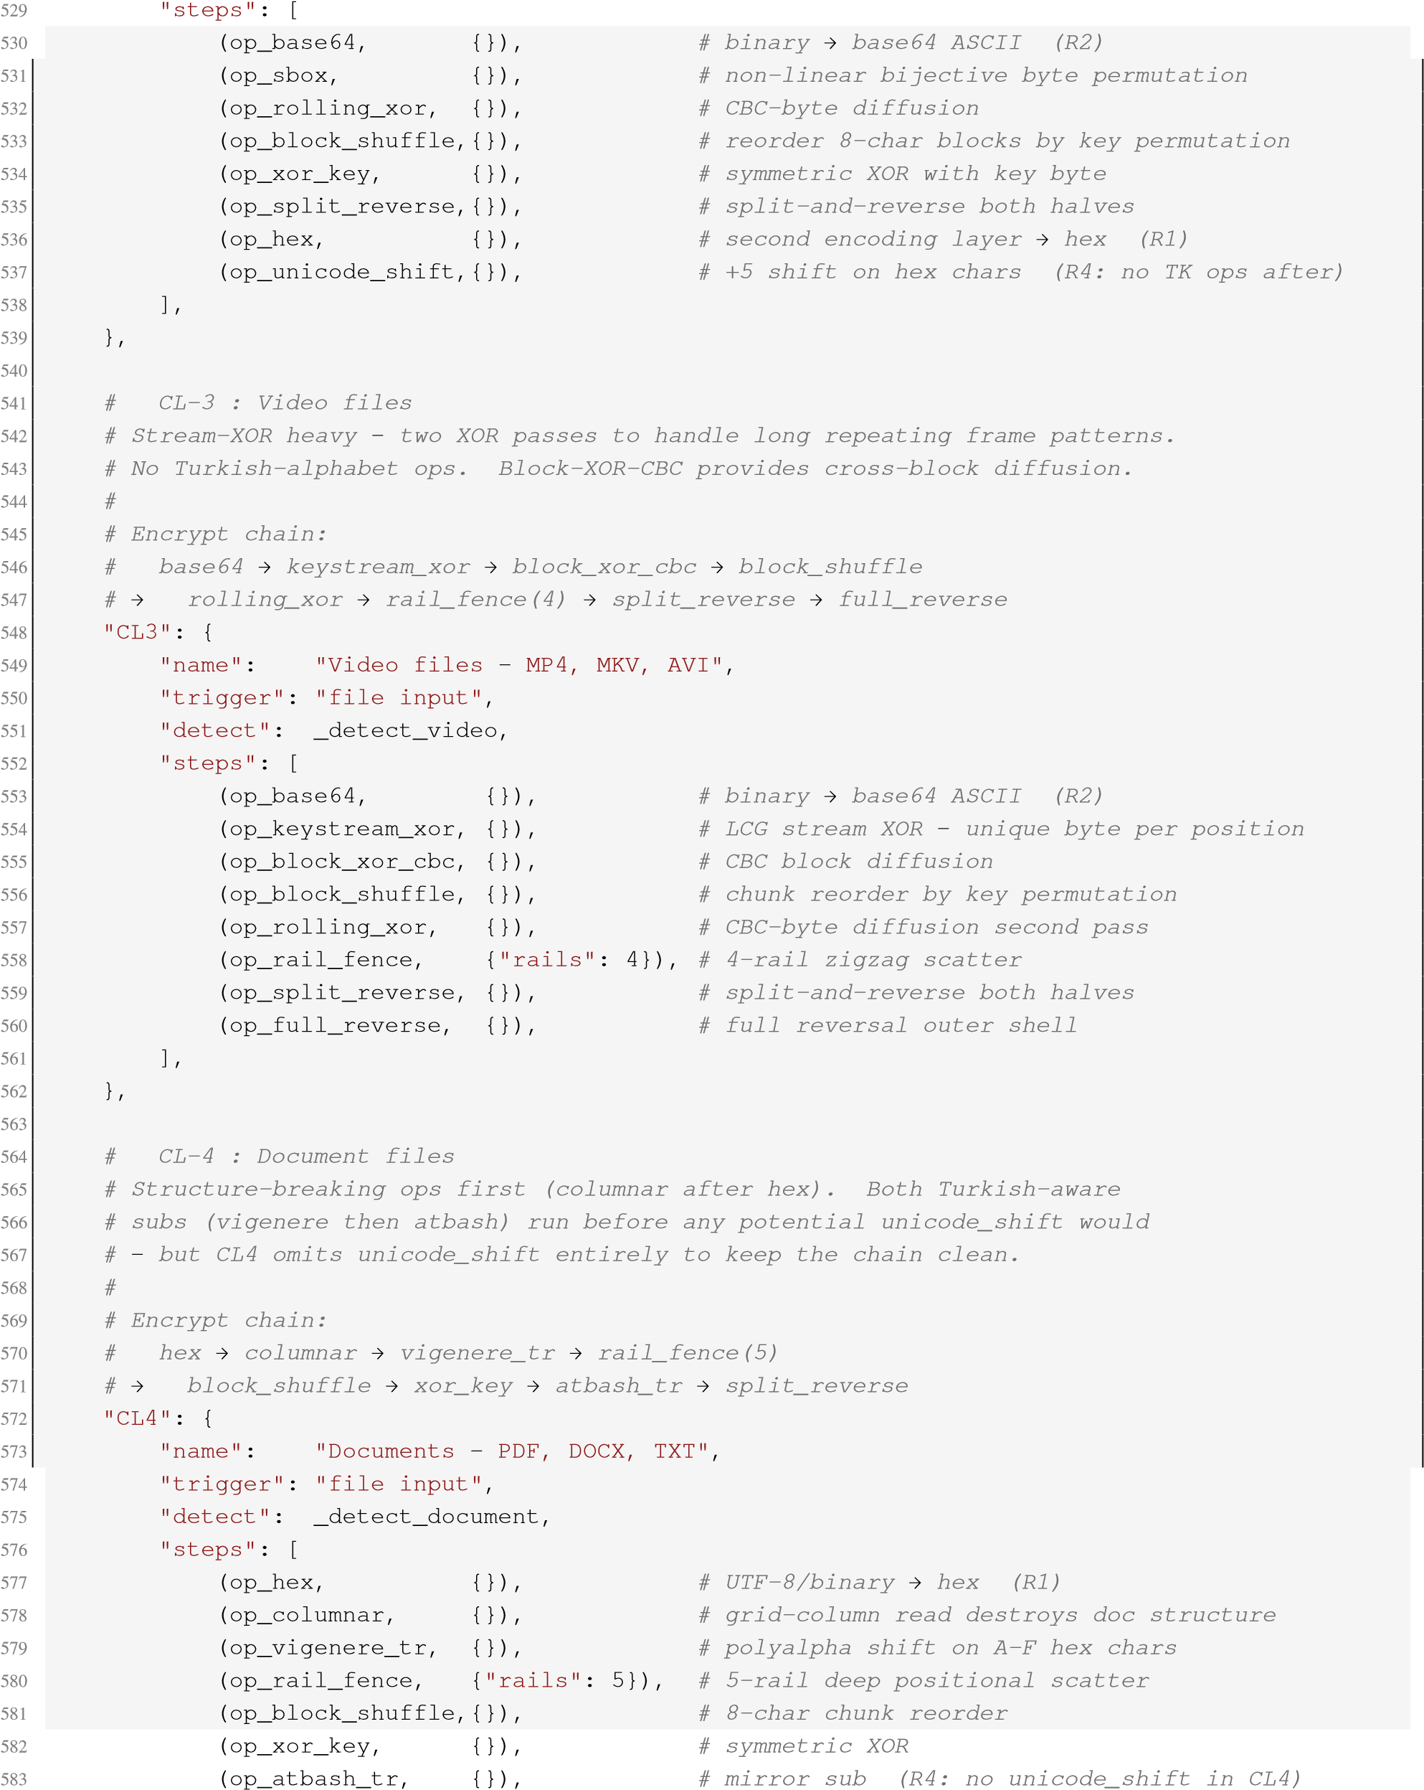
- (op_split_reverse,{}), # split-and-reverse outer shell
- ],
- },
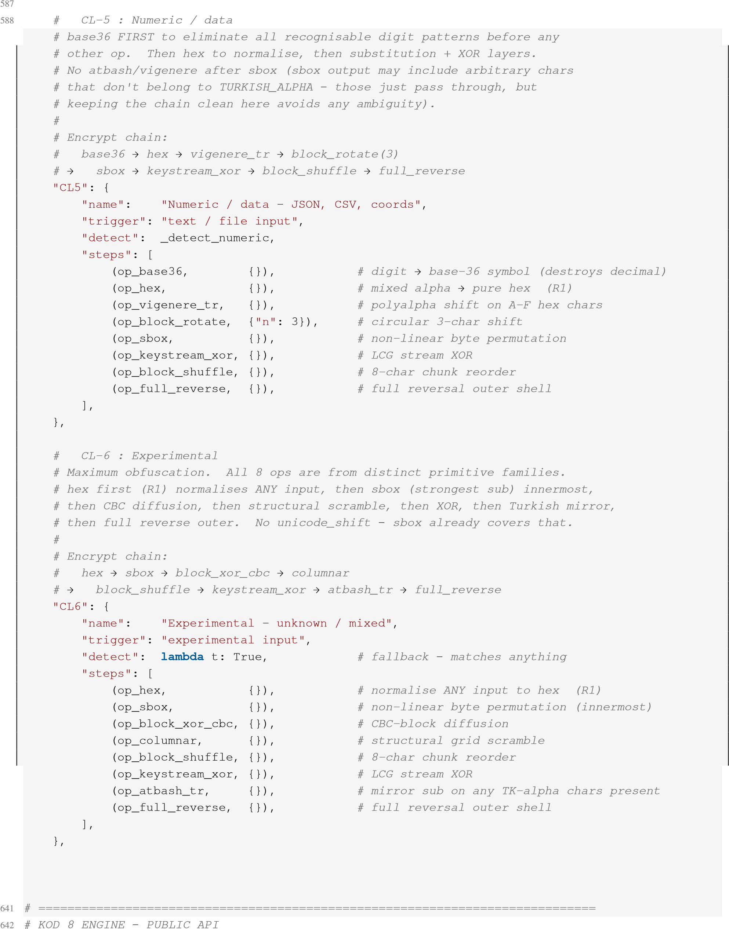
589 590 591 592 593 594 595 596 597 598 599 600
601
602 603 604 605 606 607 608 609 610 611 612 613 614 615 616 617 618 619 620 621 622
623 624
625 626 627 628 629 630 631 632 633 634 635 636
637
- }
- 640

643 # =============================================================================
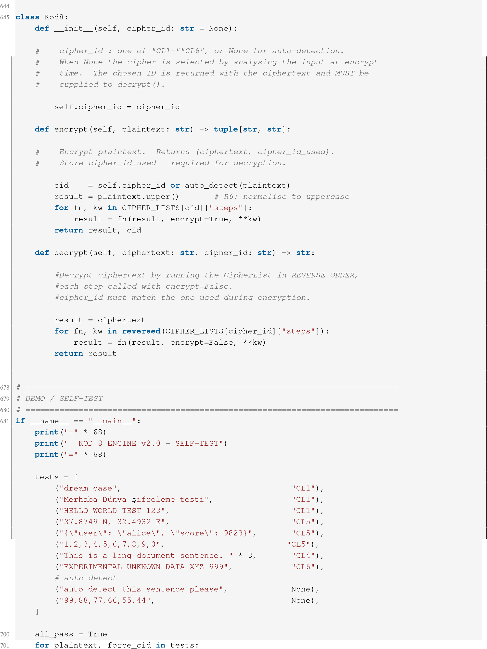
646 647 648 649 650 651 652 653 654 655 656 657 658 659
660
661 662 663 664 665 666 667 668 669 670 671 672 673 674 675 676 677
682 683
684 685 686 687 688 689 690 691 692 693 694 695 696 697 698 699
engine = Kod8(cipher_id=force_cid) enc, cid = engine.encrypt(plaintext) dec = engine.decrypt(enc, cid) expected = plaintext.upper() match = dec.strip("\x00") == expected.strip("\x00") if not match:
all_pass = False
tag = "" if match else "" print(f"\n {tag} [{cid}] {CIPHER_LISTS[cid]['name']}") print(f" Input : {plaintext[:62]}") print(f" Encrypted : {enc…[:62]}{'' if len(enc) > 62 else ''}") print(f" Decrypted : {dec[:62]}")
print("\n" + "=" * 68) print(f" {'ALL TESTS PASSED ' if all_pass else 'SOME TESTS FAILED '}") print("=" * 68)
702 703 704 705 706 707 708 709 710 711 712 713 714 715 716 717

B Reference Source: kod8_ui.py
Full listing of the reference Tkinter front end analyzed in Section 14 for the cleartext CipherList disclosure finding.
#!/usr/bin/env python3
# ============================================================================= # KOD 8 ANTI-LLM AND DECODING AGENT BASED CIPHER MODEL
# =============================================================================
import tkinter as tk from tkinter import filedialog, messagebox import threading import os import sys import base64 import time
# engine
#sys.path.insert(0, os.path.dirname(os.path.abspath(%insertthepath%))) if you want to put the engine elsewhere please indicate its location
#from kod8_engine import Kod8, CIPHER_LISTS, auto_detect, KOD8_KEY
sys.path.insert(0, os.path.dirname(os.path.abspath(__file__))) from kod8_engine import Kod8, CIPHER_LISTS, auto_detect, KOD8_KEY
#
# PALETTE
#
BG_WINDOW = "#1e2128" BG_PANEL = "#2b2f38"
BG_INPUT = "#23272e" BG_HEADER = "#23272e" BTN_UPLOAD = "#3d7ebf" BTN_UPLOAD_H = "#4a8ecf" BTN_ENC = "#2e7d32" BTN_ENC_H = "#388e3c" BTN_DEC = "#1a4fa0" BTN_DEC_H = "#1e5bb5" FG_WHITE = "#e8eaf0" FG_DIM = "#6a7080" FG_GREEN = "#4caf50" FG_CYAN = "#4db6ff" FG_YELLOW = "#f0c060" FG_RED = "#ef5350"
FG_SELECTED = "#4db6ff"
SEPARATOR = "#33373f"
FONT_MONO = ("Consolas", 11)
FONT_MONO_B = ("Consolas", 11, "bold") FONT_MONO_SM = ("Consolas", 10)
FONT_TITLE = ("Consolas", 16, "bold") FONT_PROG_NUM = ("Consolas", 24, "bold")
FONT_PROG_LBL = ("Consolas", 11, "bold") FONT_BTN = ("Consolas", 12, "bold")
FONT_STEP = ("Consolas", 11)
1 2 3 4 5 6 7 8
9 10 11 12
13
14 15 16
17 18 19 20 21 22 23 24 25 26 27 28 29 30 31 32 33 34 35 36 37 38 39 40 41 42 43 44 45 46 47 48 49 50 51 52

53 CL_STRATEGY = {
54 | "CL1" | : | "STRATEGY\nPLAIN TEXT",
55 | "CL2" | : | "STRATEGY\nIMAGE FILE",
56 | "CL3" | : | "STRATEGY\nVIDEO",
57 | "CL4" | : | "STRATEGY\nDOCUMENT",
58 | "CL5" | : | "STRATEGY\nNUMERIC DATA",
"CL6" : "STRATEGY\nEXPERIMENTAL",
}
STEP_META = {
"op_hex" : "HEX Encoding",
"op_base64" : "Base64 Encoding",
"op_xor_key" : "XOR Key Byte [8]",
"op_rolling_xor" : "Rolling XOR (CBC)",
"op_keystream_xor" : "Key-Stream XOR (LCG)",
"op_vigenere_tr" : "Vigenere Turkish Alpha",
"op_atbash_tr" : "Atbash Mirror",
"op_unicode_shift" : "Unicode Codepoint +5",
"op_sbox" : "S-Box Permutation",
"op_rail_fence" : "Rail-Fence Transposition",
"op_block_rotate" : "Block Rotation",
"op_split_reverse" : "Split & Reverse",
"op_reverse" : "Reverse",
"op_columnar" : "Columnar Transposition",
"op_block_shuffle" : "Block Shuffle",
"op_block_xor_cbc" : "Block XOR (CBC Mode)",
"op_base36" : "Base-36 Digit Sub",
}
#
# HOVER BUTTON
#
class HoverButton(tk.Button):
def __init__(self, master, bg_normal, bg_hover, **kw):
super().__init__(master, bg=bg_normal, activebackground=bg_hover, activeforeground=kw.get("fg", FG_WHITE), **kw)
self.bind("<Enter>", lambda _: self.configure(bg=bg_hover)) self.bind("<Leave>", lambda _: self.configure(bg=bg_normal))
#
# APPLICATION
#
class Kod8enc(tk.Tk):
59 60 61 62 63 64 65 66 67 68 69
70
71 72 73 74 75 76 77 78 79 80 81 82 83 84 85 86 87 88 89 90 91
92 93
94 95 96 97 98 99
100 101
102
- def __init__(self):
- super().__init__()
- self.title("KOD 8 - Multi Layer Based Cipher")
- self.configure(bg=BG_WINDOW)
- self.geometry("1120x960")
- self.minsize(860, 780)
109
- self._file_path = None
- self._file_bytes = None
- self._file_is_bin = False
- self._enc_result = None 114 self._enc_cid = None
115 self._busy = False
116
- self._build()
#
# UI BUILD
#
def _build(self):
# 1. Upload / Browse bar
top_bar = tk.Frame(self, bg=BG_HEADER, pady=10) top_bar.pack(fill="x")
HoverButton( top_bar, BTN_UPLOAD, BTN_UPLOAD_H, text="UPLOAD / BROWSE", font=FONT_BTN, fg=FG_WHITE, relief="flat", bd=0, padx=18, pady=8, cursor="hand2", command=self._browse,
).pack(side="left", padx=(16, 14))
self._selected_var = tk.StringVar(value="No file selected.") tk.Label( top_bar, textvariable=self._selected_var, font=FONT_MONO_SM, fg=FG_SELECTED, bg=BG_HEADER, anchor="w",
).pack(side="left", fill="x", expand=True, padx=(0, 16))
# 2. Data display / text input data_frame = tk.Frame(self, bg=BG_INPUT) data_frame.pack(fill="both", expand=True, padx=16, pady=(8, 8))
self._data_text = tk.Text( data_frame, bg=BG_INPUT, fg=FG_WHITE, font=FONT_MONO, relief="flat", bd=0, wrap="word", padx=10, pady=10, insertbackground=FG_CYAN, selectbackground=BG_PANEL, height=8,
) self._data_text.pack(side="left", fill="both", expand=True)
- 119 120 121 122 123 124 125 126 127 128
129
130 131 132 133 134 135 136 137 138 139 140 141 142 143 144 145 146 147 148 149 150
151 152
153 154 155 156 157 158 159
160
- sb = tk.Scrollbar(data_frame, orient="vertical",
- command=self._data_text.yview,
- bg=BG_PANEL, troughcolor=BG_WINDOW,
relief="flat", bd=0, width=10)
sb.pack(side="right", fill="y") self._data_text.configure(yscrollcommand=sb.set)
self._placeholder_active = True self._set_data_text("[NO FILE LOADED]", FG_DIM)
- 165 166 167 168
169
170 self._data_text.bind("<FocusIn>", self._data_focus_in)
171
- # 3. Strategy / Progress row
- sp = tk.Frame(self, bg=BG_WINDOW)
- sp.pack(fill="x", padx=16, pady=(0, 8))
- sp.columnconfigure(0, weight=1, uniform="half")
- sp.columnconfigure(1, weight=1, uniform="half")
strat_card = tk.Frame(sp, bg=BG_PANEL) strat_card.grid(row=0, column=0, sticky="nsew", padx=(0, 6), ipady=16) self._strategy_var = tk.StringVar(value="STRATEGY\nAUTO DETECT") tk.Label( strat_card, textvariable=self._strategy_var, font=FONT_TITLE, fg=FG_WHITE, bg=BG_PANEL, justify="center",
).pack(expand=True)
prog_card = tk.Frame(sp, bg=BG_PANEL) prog_card.grid(row=0, column=1, sticky="nsew", padx=(6, 0), ipady=16) tk.Label(prog_card, text="PROGRESS", font=FONT_PROG_LBL, fg=FG_WHITE, bg=BG_PANEL).pack()
self._progress_var = tk.StringVar(value="0 / 8") tk.Label(prog_card, textvariable=self._progress_var, font=FONT_PROG_NUM, fg=FG_WHITE, bg=BG_PANEL).pack()
# 4. Step-by-step verification
verif = tk.Frame(self, bg=BG_PANEL) verif.pack(fill="both", expand=True, padx=16, pady=(0, 10))
hdr = tk.Frame(verif, bg=SEPARATOR) hdr.pack(fill="x") tk.Label(hdr, text="STEP-BY-STEP VERIFICATION",
font=FONT_MONO_B, fg=FG_WHITE, bg=SEPARATOR, pady=8).pack()
# canvas + scrollbar for the 8 step rows list_wrap = tk.Frame(verif, bg=BG_PANEL) list_wrap.pack(fill="both", expand=True)
self._canvas = tk.Canvas(list_wrap, bg=BG_PANEL, highlightthickness=0, bd=0)
self._canvas.pack(side="left", fill="both", expand=True)
vsb = tk.Scrollbar(list_wrap, orient="vertical",
command=self._canvas.yview, bg=BG_PANEL, troughcolor=BG_WINDOW,
- 178 179 180 181 182 183 184 185 186 187
188
189 190 191 192 193 194 195 196 197 198 199 200 201 202 203 204 205 206 207 208 209
210 211
212 213 214 215 216 217 218
219
- relief="flat", bd=0, width=10)
- vsb.pack(side="right", fill="y")
- self._canvas.configure(yscrollcommand=vsb.set)
223
- self._steps_frame = tk.Frame(self._canvas, bg=BG_PANEL)
- self._steps_win = self._canvas.create_window(
- (0, 0), window=self._steps_frame, anchor="nw")
227
- self._steps_frame.bind(
- "<Configure>",

- lambda e: self._canvas.configure(
- scrollregion=self._canvas.bbox("all")))
- self._canvas.bind( 233 "<Configure>",
- lambda e: self._canvas.itemconfig(
- self._steps_win, width=e.width))
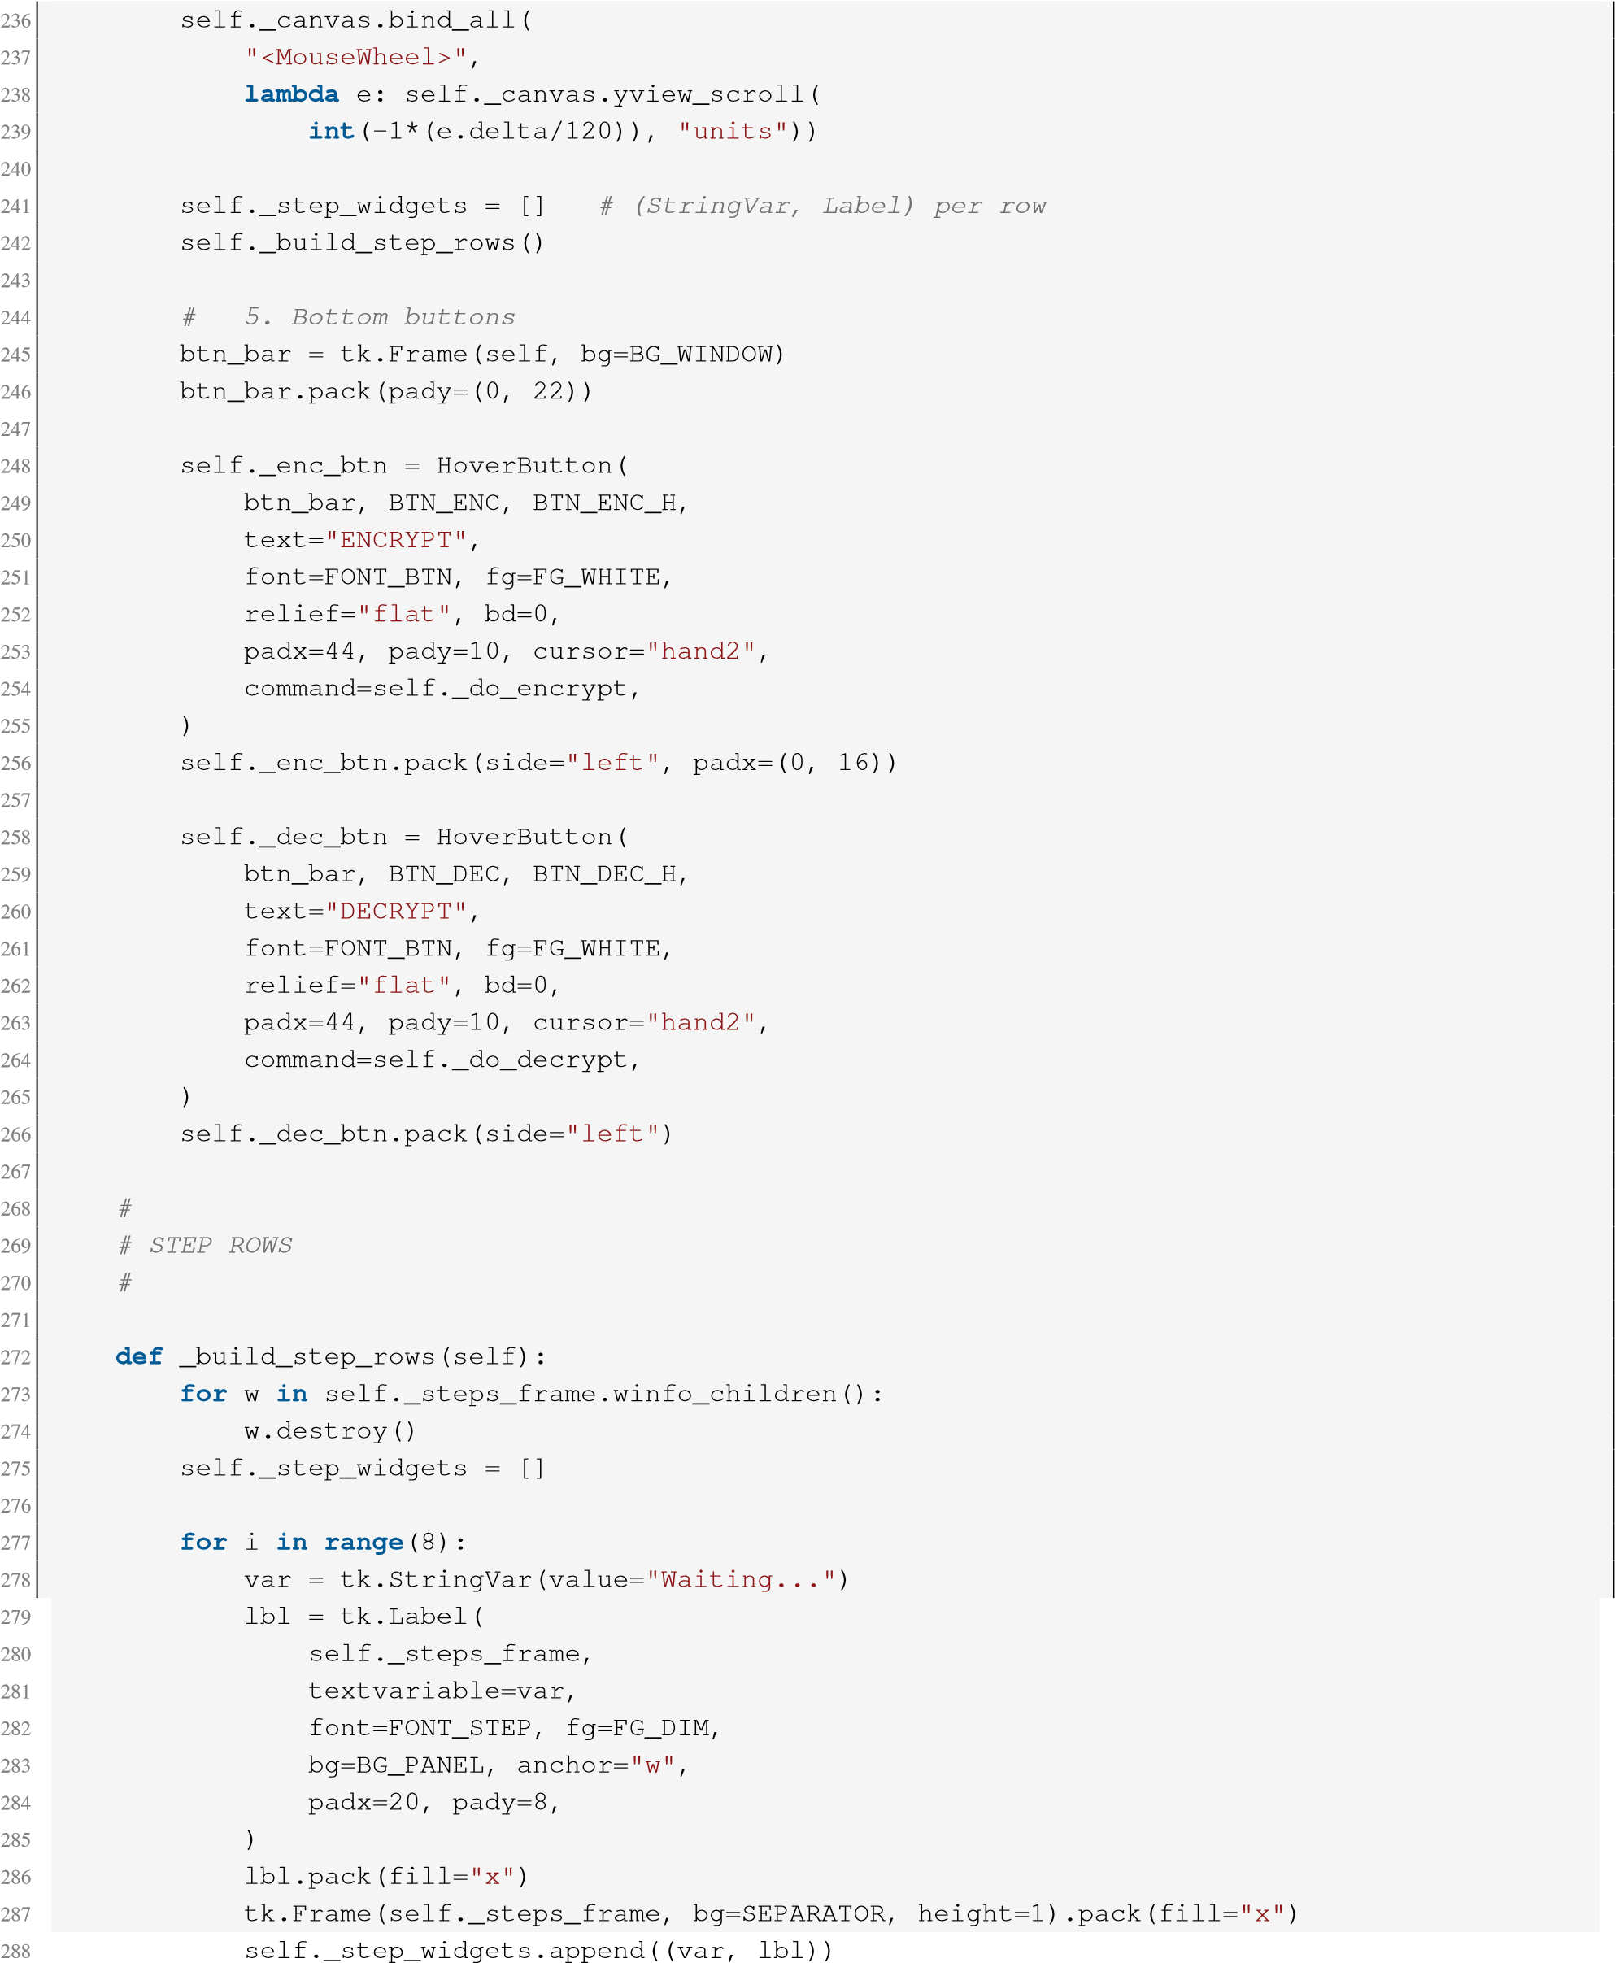
289
- def _reset_steps(self):
- for var, lbl in self._step_widgets:
- var.set("Waiting...")
- lbl.configure(fg=FG_DIM)
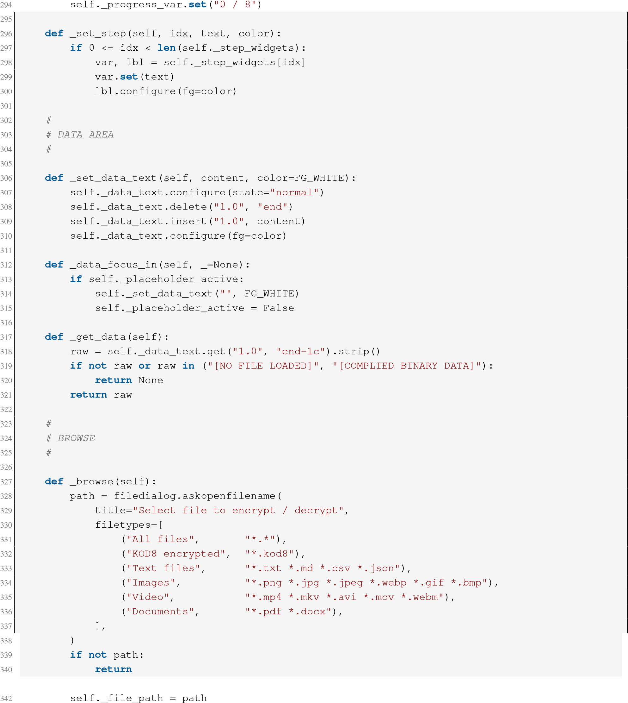341
- self._enc_result = None
- fname = os.path.basename(path)
- self._selected_var.set(f"Selected: {fname}")
346
- try:
- try:
- with open(path, "r", encoding="utf-8") as f:
- content = f.read()
- self._file_bytes = content.encode("utf-8")
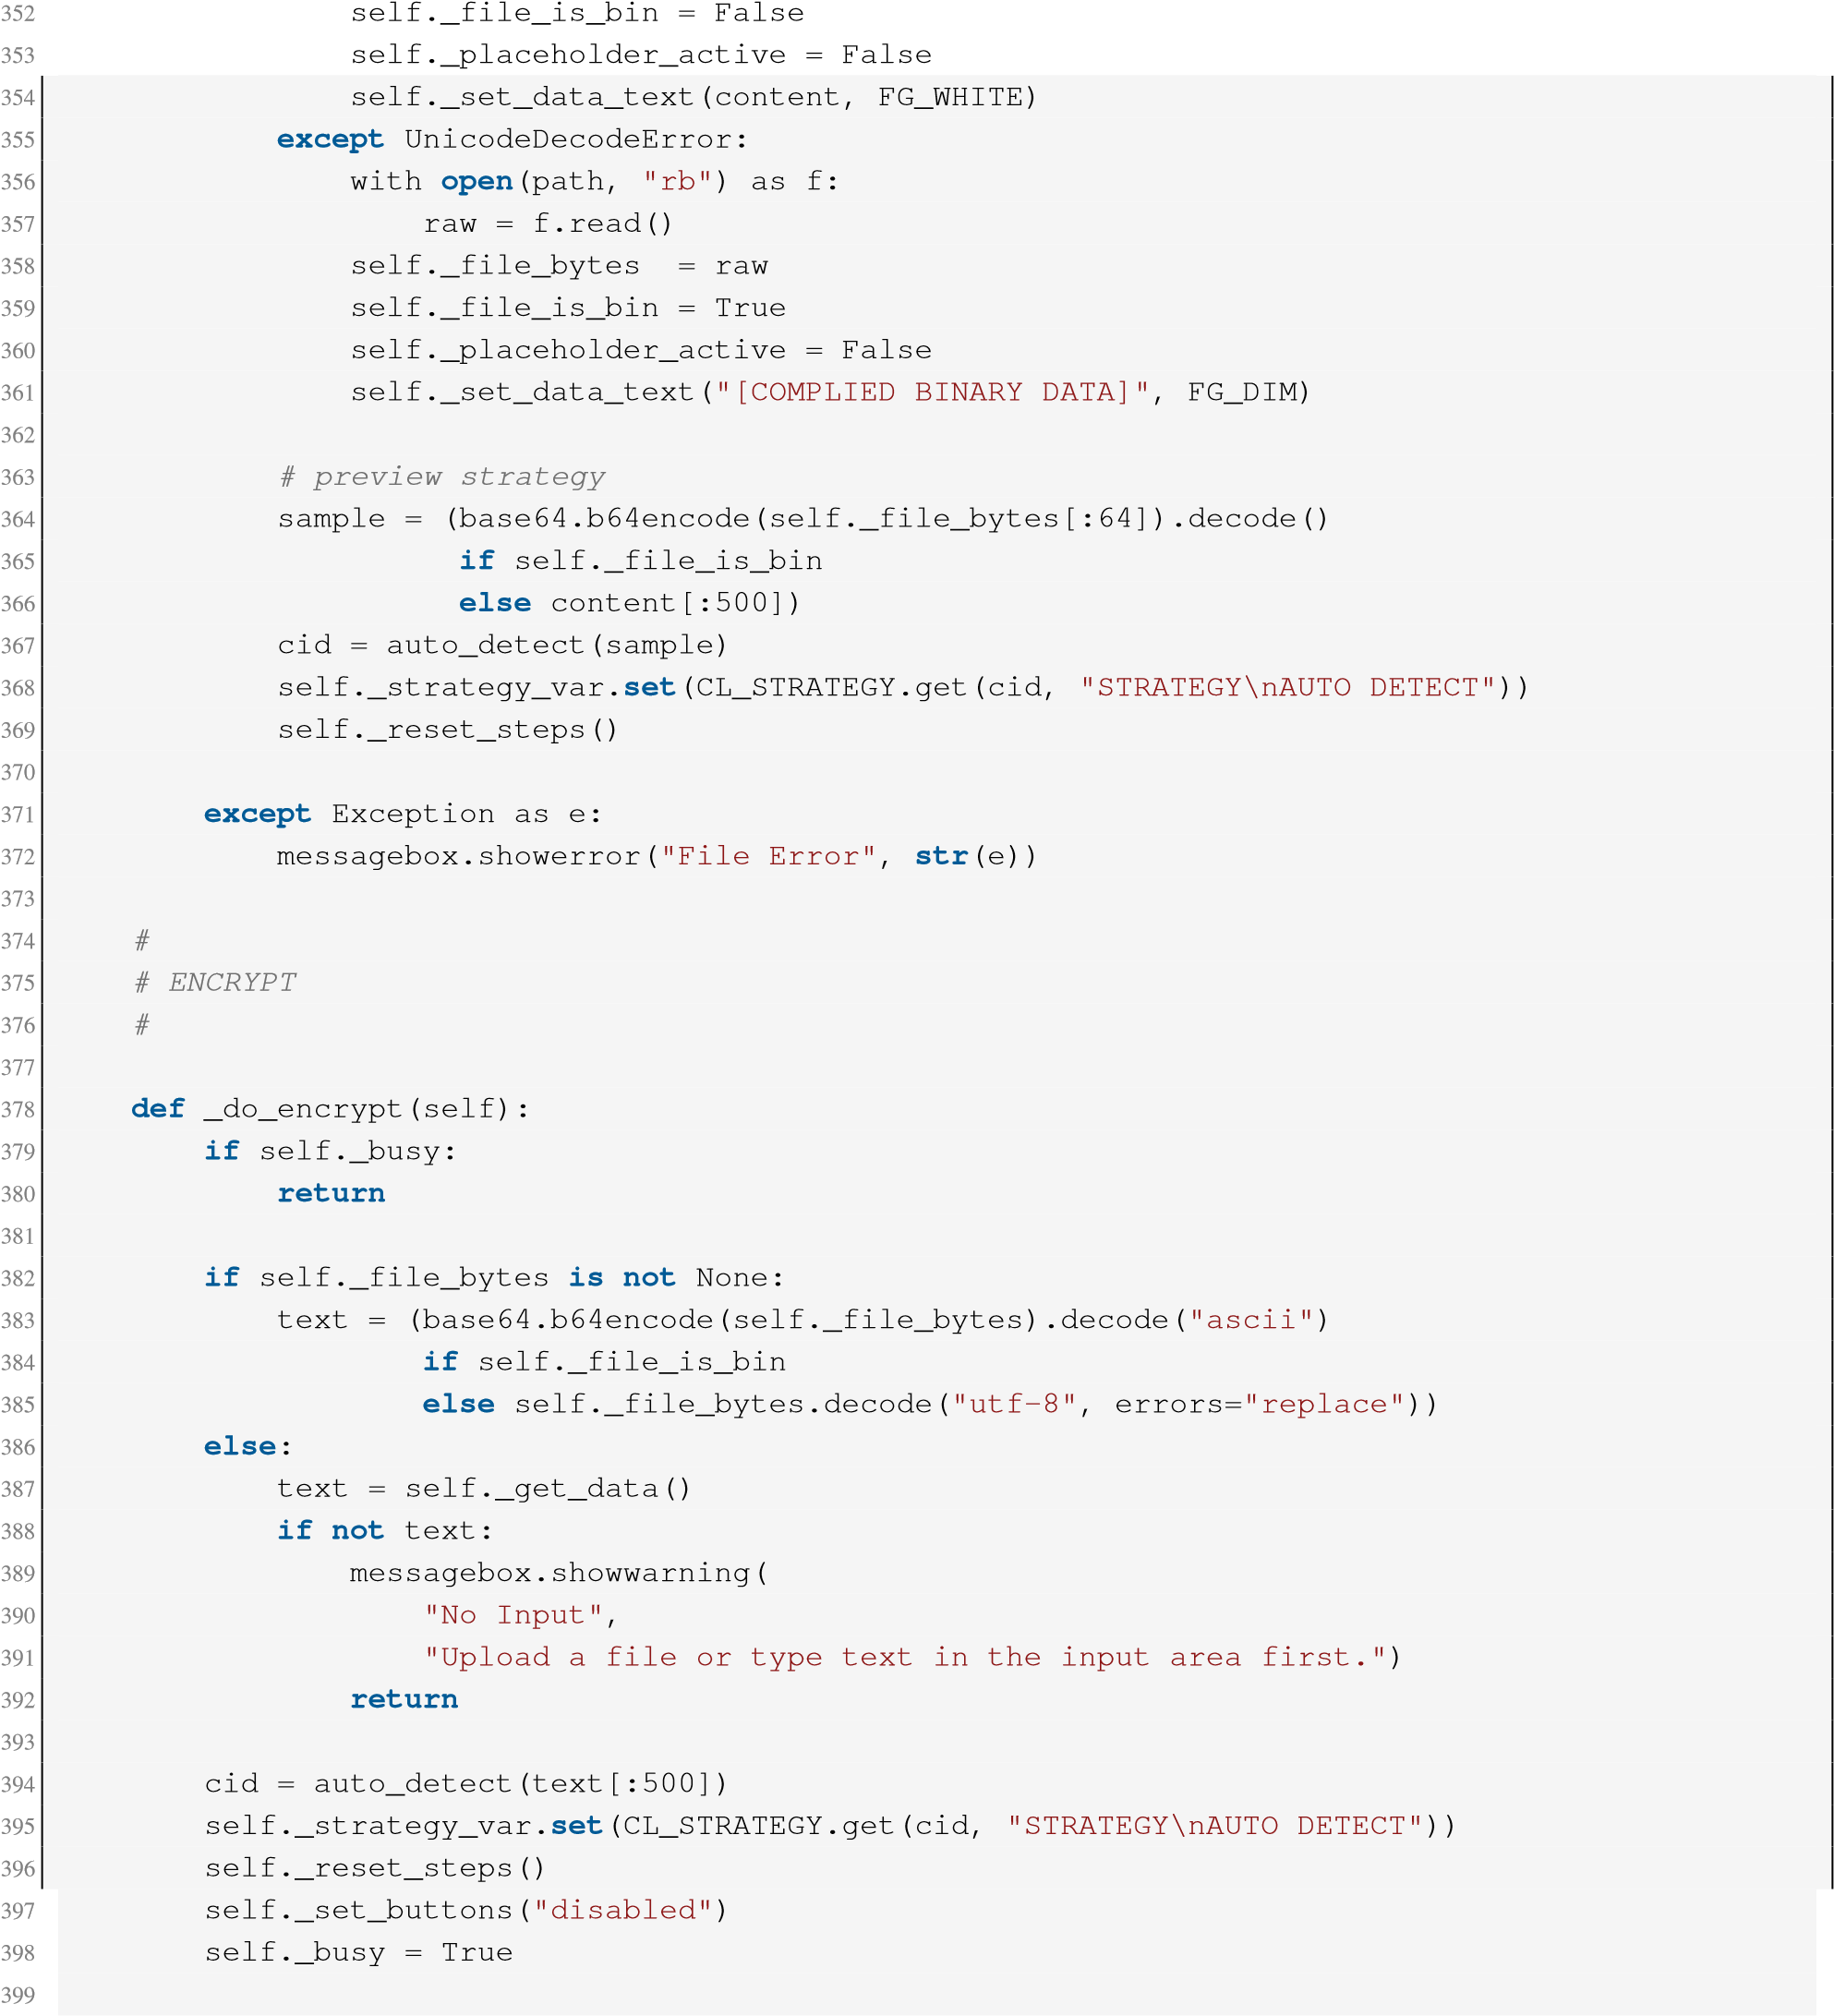
- steps_names = [STEP_META.get(fn.__name__, fn.__name__)
- for fn, _ in CIPHER_LISTS[cid]["steps"]]
402
- def _worker():
- try:
- k = Kod8()
- enc, used_cid = k.encrypt(text)
- n = len(steps_names)
- for i, name in enumerate(steps_names):
- self.after(0, self._set_step, i,
- f"Step {i+1}: Layer {name} [", FG_DIM)
- time.sleep(0.10) 412 self.after(0, self._set_step, i,
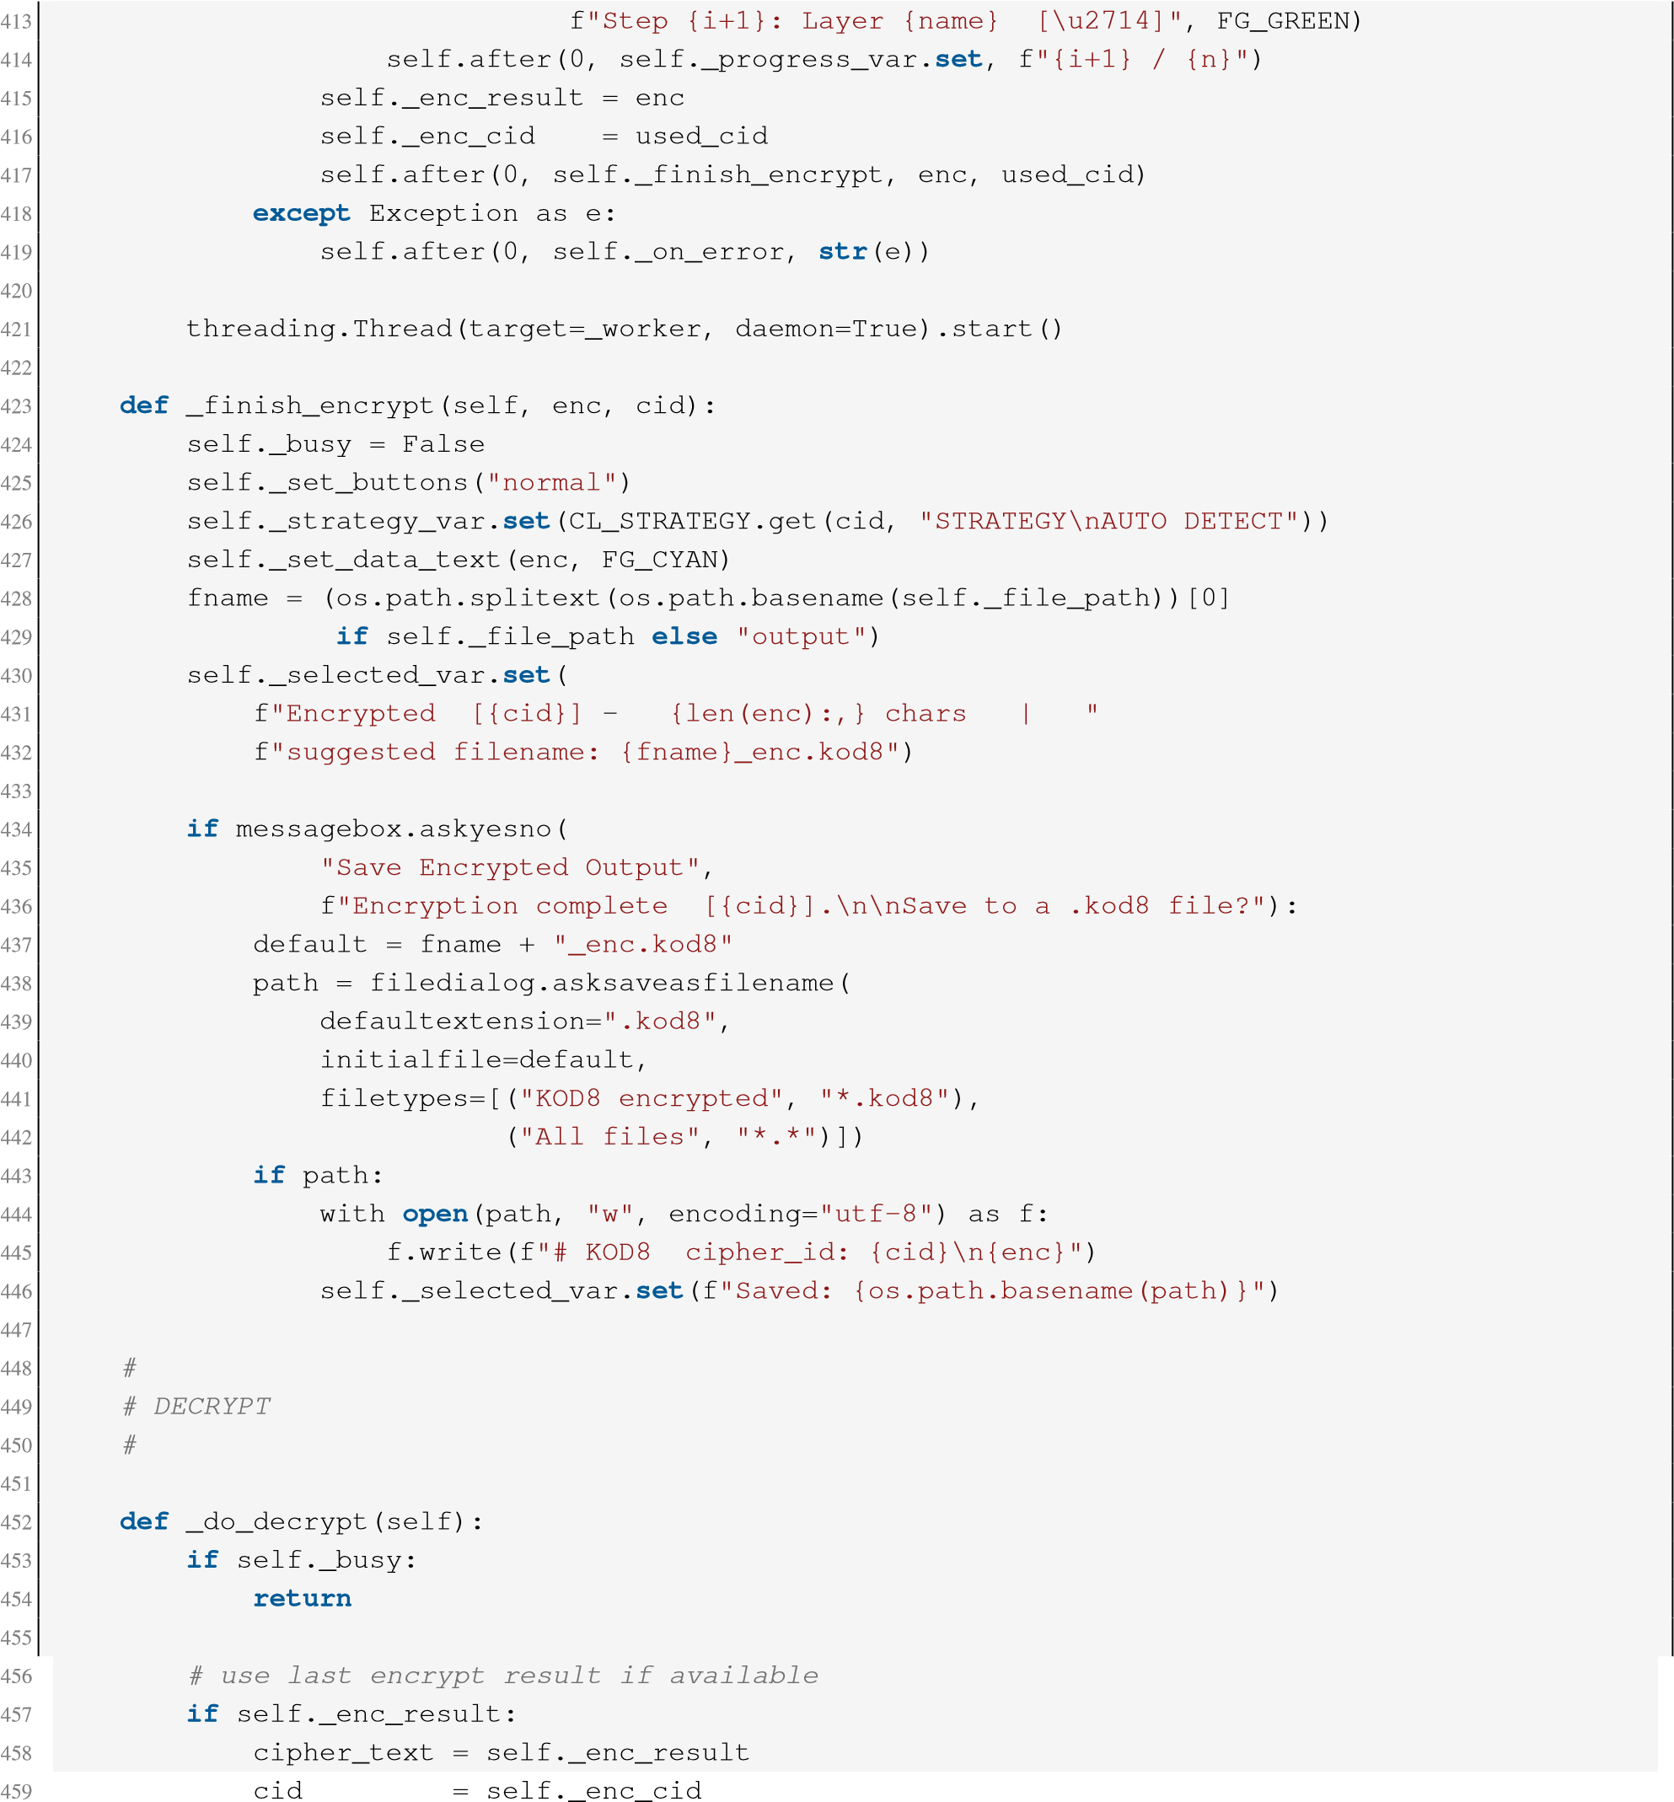
- else:
- raw = self._get_data()
- if not raw:
- messagebox.showwarning(
- "No Input",
- "Load a .kod8 file or encrypt something first.")

- return
- lines = raw.splitlines()
- cid = None
- body_lines = []
- for line in lines:
- if line.startswith("# KOD8 cipher_id:"):
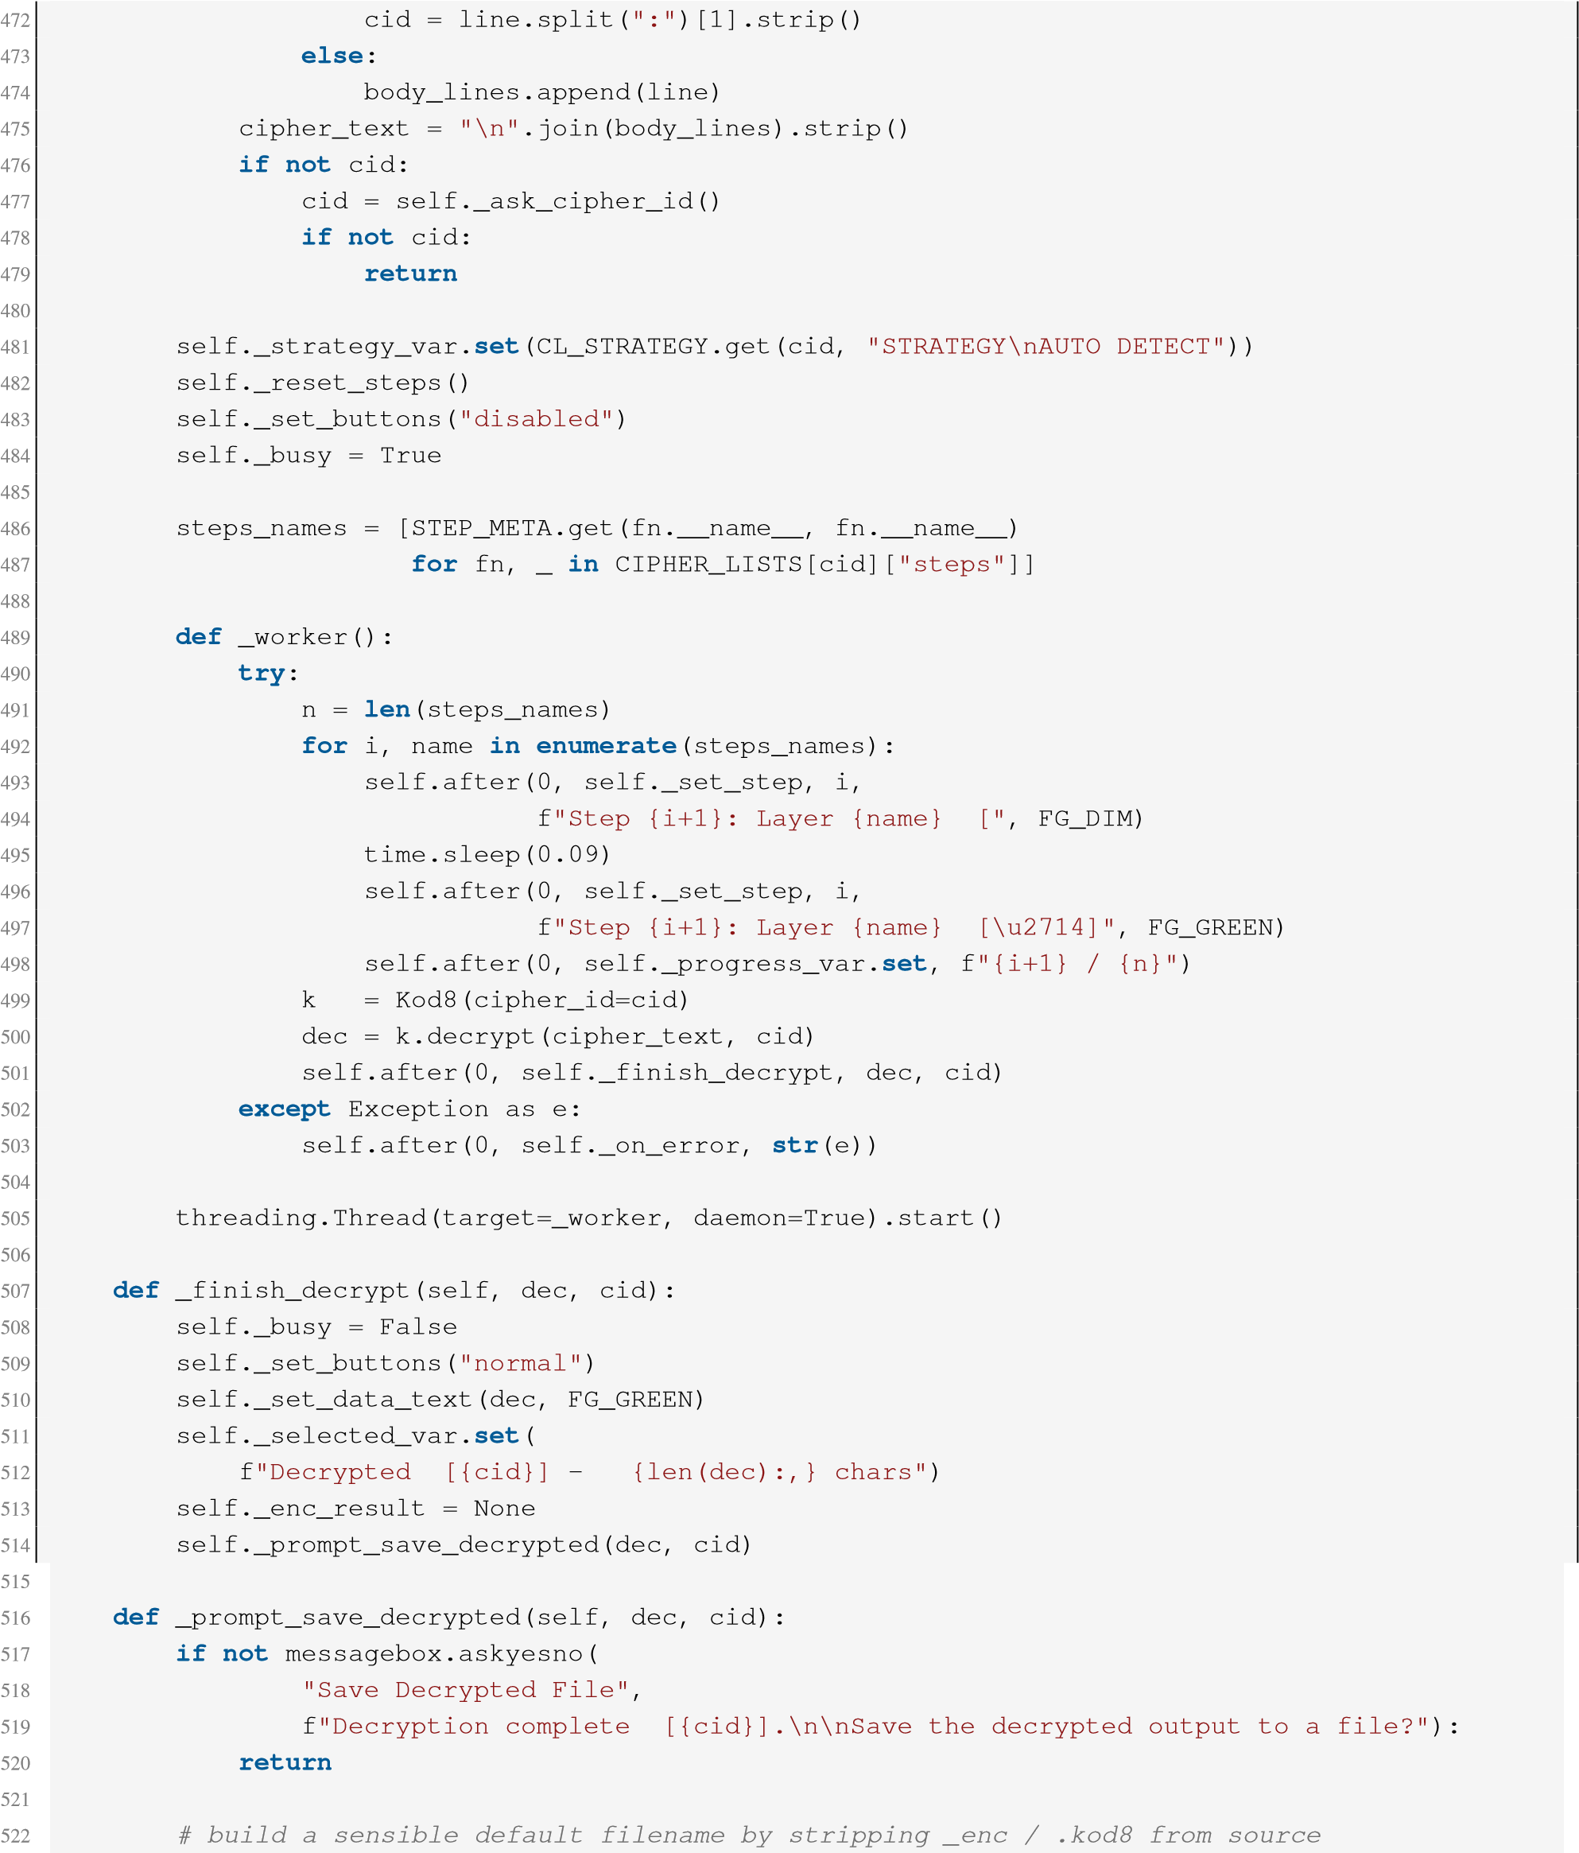
- if self._file_path:
- base = os.path.basename(self._file_path)
- # strip known suffixes
- for suffix in ("_enc.kod8", ".kod8", "_enc"):
- if base.endswith(suffix):
- base = base[: -len(suffix)]
- break
- default_name = base if base else "decrypted_output"
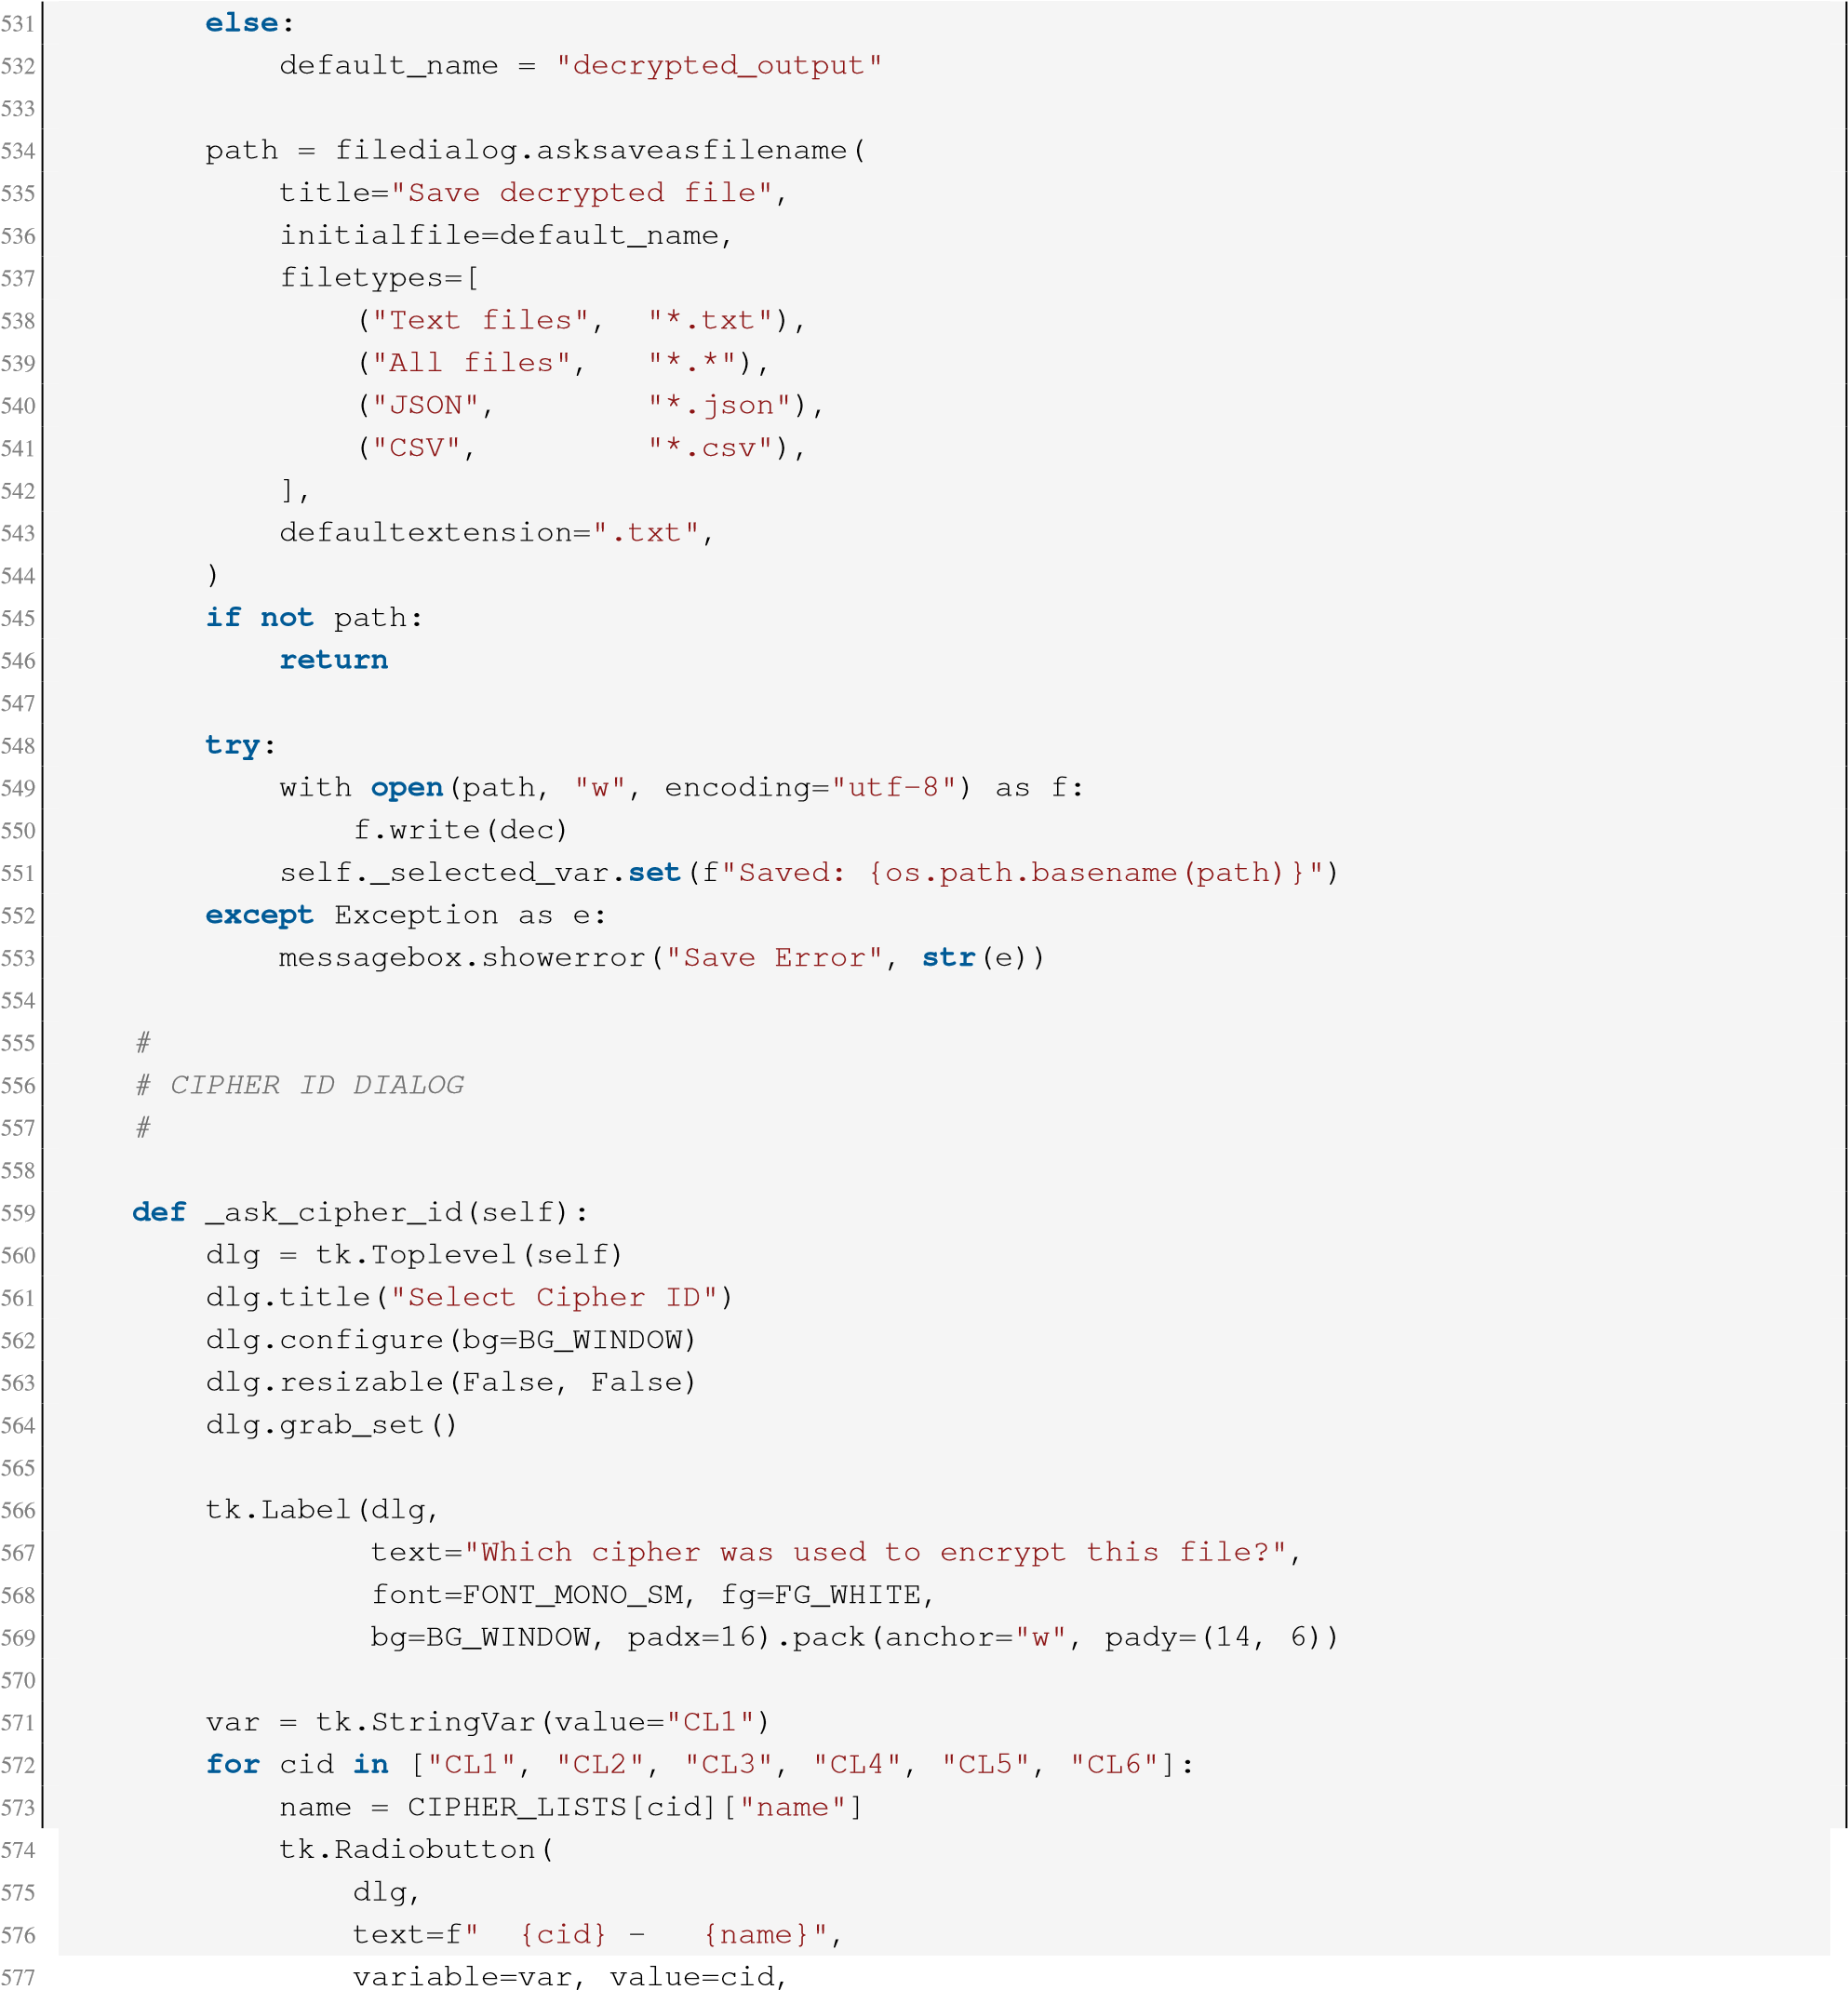
- font=FONT_MONO_SM, fg=FG_WHITE,
- bg=BG_PANEL, selectcolor=BG_WINDOW,
- activebackground=BG_PANEL, 581 relief="flat", anchor="w",
- padx=16, pady=5,
- ).pack(fill="x", padx=12, pady=1)
result = [None]
def _ok():
result[0] = var.get() dlg.destroy()
row = tk.Frame(dlg, bg=BG_WINDOW) row.pack(pady=14)
HoverButton(row, BTN_DEC, BTN_DEC_H, text="Confirm", font=FONT_BTN, fg=FG_WHITE, relief="flat", bd=0, padx=22, pady=6, cursor="hand2", command=_ok).pack(side="left", padx=6)
HoverButton(row, BG_PANEL, SEPARATOR, text="Cancel", font=FONT_BTN, fg=FG_DIM, relief="flat", bd=0, padx=22, pady=6, cursor="hand2", command=dlg.destroy).pack(side="left", padx=6)
dlg.wait_window() return result[0]
#
# HELPERS
#
def _set_buttons(self, state):
self._enc_btn.configure(state=state) self._dec_btn.configure(state=state)
def _on_error(self, msg):
self._busy = False self._set_buttons("normal") messagebox.showerror("KOD8 Error", msg)
#
# ENTRY POINT
#
if __name__ == "__main__":
app = Kod8enc() app.mainloop()
- 585 586 587 588 589 590 591 592 593 594 595 596 597 598 599 600
601
602 603 604 605 606 607 608 609 610 611 612 613 614 615 616 617 618 619 620 621 622
623 624
625 626 627

C Experiment Scripts
The following scripts were executed directly against the reference engine to produce the empirical results reported in Sections 7, 10, 11, 12, and 15.

C.1 S-box Seed Collapse (Section 7)
import kod8_engine as k weighted_sum = sum(int(c)*(i+1) for i,c in enumerate(k.KOD8_KEY)) print('S-box seed =', weighted_sum, '/ max =', 9*sum(range(1,9)))
seeds = set() import random random.seed(2) for _ in range(200000):
key = f'{random.randint(0,99999999):08d}' s = sum(int(c)*(i+1) for i,c in enumerate(key)) seeds.add(s)
print('Distinct seeds observed:', len(seeds), '/ theoretical max 325')
1
2
3
4
5
6
7
8
9
10
11
12

C.2 Avalanche Effect (Section 10)
import kod8_engine as k
def hamming_bits(a: bytes, b: bytes):
n = max(len(a), len(b)) a = a + b'\x00'*(n-len(a)); b = b + b'\x00'*(n-len(b)) return sum(bin(x ^ y).count('1') for x, y in zip(a, b)), n*8
def flip_bit(s: str, bit_index=0):
b = bytearray(s.encode('utf-8')) byte_i, bit_i = bit_index // 8, bit_index % 8 b[byte_i] ^= (1 << bit_i) return b.decode('utf-8', errors='replace')
pt = "THE QUICK BROWN FOX JUMPS OVER THE LAZY DOG NEAR THE RIVER BANK TODAY" for cl in ['CL1', 'CL2', 'CL3', 'CL4', 'CL5', 'CL6']:
enc1, _ = k.Kod8(cipher_id=cl).encrypt(pt) enc2, _ = k.Kod8(cipher_id=cl).encrypt(flip_bit(pt, 3)) diff, total = hamming_bits(enc1.encode('utf-8', 'replace'), enc2.encode('utf-8', 'replace'))
print(cl, diff, '/', total, f'({100*diff/total:.1f}%)')
1
2
3
4
5
6
7
8
9
10
11
12
13
14
15
16
17
18
19
20

C.3 Ciphertext Entropy and Chi-Square (Section 11)
import math from collections import Counter import kod8_engine as k pt = ("THE QUICK BROWN FOX JUMPS OVER THE LAZY DOG..." ) * 3
1
2
3
4
5
enc, _ = k.Kod8(cipher_id='CL1').encrypt(pt) data = enc.encode('utf-8', errors='replace')
counts = Counter(data) n = len(data) entropy = -sum((c/n) * math.log2(c/n) for c in counts.values()) expected = n / 256 chi2 = sum((counts.get(b, 0) - expected)**2 / expected for b in range(256)) print('entropy:', entropy, 'chi2:', chi2)
6
7
8
9
10
11
12
13
14

C.4 Frequency Cryptanalysis of op_vigenere_tr (Section 12)
import kod8_engine as k from collections import Counter
ALPHA = k.TURKISH_ALPHA PERIOD = len(k.KOD8_KEY)
def chi_square(letters, ref_dist):
n = len(letters) obs = Counter(letters) return sum((obs.get(l, 0) - ref_dist[l]*n)**2 / (ref_dist[l]*n) for l in ALPHA if ref_dist[l] > 0)
# ref_dist built from an independent reference corpus (see Experimental Setup) ciphertext = k.op_vigenere_tr(target_plaintext, encrypt=True) streams = [[] for _ in range(PERIOD)] pos = 0 for c in ciphertext:
if c in ALPHA: streams[pos % PERIOD].append(c) pos += 1
recovered = [] for stream in streams:
best_shift, best_score = None, float('inf') for shift in range(10): # shift restricted to a single digit decoded = [ALPHA[(ALPHA.index(c) - shift) % len(ALPHA)] for c in stream] score = chi_square(decoded, ref_dist) if score < best_score: best_score, best_shift = score, shift
recovered.append(best_shift) print("Recovered key:", "".join(map(str, recovered)))
1
2
3
4
5
6
7
8
9
10
11
12
13
14
15
16
17
18
19
20
21
22
23
24
25
26
27
28
29
30
31
32

C.5 Known-Plaintext Brute Force (Section 15)
import kod8_engine as k import time, random def try_key(key_str, ciphertext, cipher_id):
1
2
3
4
k.KOD8_KEY = key_str
_SBOX = list(range(256))
_seed = sum(int(c) * (i + 1) for i, c in enumerate(key_str)) for _i in range(255, 0, -1):
_seed = (_seed * 1103515245 + 12345) & 0x7FFFFFFF
_j = _seed % (_i + 1)
_SBOX[_i], _SBOX[_j] = _SBOX[_j], _SBOX[_i]
k._SBOX = _SBOX
k._SBOX_INV = [0]*256 for _i, _v in enumerate(_SBOX):
k._SBOX_INV[_v] = _i
eng = k.Kod8(cipher_id=cipher_id) return eng.decrypt(ciphertext, cipher_id)
plaintext = "ATTACK AT DAWN TOMORROW" enc, cid = k.Kod8(cipher_id="CL1").encrypt(plaintext)
random.seed(1)
N = 2000 trial_keys = [f"{random.randint(0, 99999999):08d}" for _ in range(N)] trial_keys[N // 2] = "86247931" # true key, inserted to confirm detection
t0 = time.perf_counter() found = None for i, cand in enumerate(trial_keys):
if try_key(cand, enc, "CL1").strip("\x00") == plaintext.upper():
found = (i, cand) t1 = time.perf_counter()
per_trial = (t1 - t0) / N
print(f"{per_trial*1e6:.2f} us/trial, found at {found}") print(f"Full 10^8 search estimate: {per_trial * 10**8 / 3600:.2f} hours")
5
6
7
8
9
10
11
12
13
14
15
16
17
18
19
20
21
22
23
24
25
26
27
28
29
30
31
32
33
34
35
36

