Multi-Object Detection & Persistent ID Tracking
Technical Report — FA Cup 2024 | YOLOv8m + DeepSORT
Praveen V

1. Introduction
This project implements an end-to-end computer vision pipeline for multi-object detection and persistent ID tracking in broadcast football footage. The system detects all on-field players, assigns unique and stable IDs across the full video duration, classifies players into teams based on jersey color, and handles real-world challenges including occlusion, camera motion, scene changes, and crowd interference.
2. Model / Detector Used
YOLOv8
YOLOv8m (Ultralytics) was used for person detection. Pretrained on COCO (class 0 = person), it provides fast and accurate bounding boxes at 1920×1080 resolution. The medium variant balances accuracy and speed. GPU inference via CUDA (RTX 3050) achieves 7–11 FPS.
Detection filters applied:
- Confidence threshold: 0.5
- Min box height: 5% of frame (54px)
- Max box area: 15% of frame
- ratio: width/height < 1.2 Reasons for selection:
- Real-time performance
- High detection accuracy
- Pretrained weights available
- Easy integration with Python pipeline

3. Tracking Algorithm Used
DeepSORT
DeepSORT was used for multi-object tracking. It combines:
- Kalman Filter (motion prediction) with a deep appearance Re-ID embedding.
- Hungarian Algorithm (data association)
- Appearance embeddings (ReID)
Parameter:
- max_age=60 frames
- n_init=5 frames
- cosine_dist=0.2
- nn_budget=100
This allows the tracker to maintain consistent IDs even under occlusion and motion.

4. Why YOLOv8 + DeepSORT
YOLOv8m + DeepSORT was selected because:
- both have stable, well-documented Python APIs with minimal setup;
- DeepSORT's appearance embeddings handle Re-ID in dense scenes where pure motion trackers (SORT, ByteTrack) fail;
- the modular pipeline allows swapping components independently — the detector can be upgraded to YOLOv8x or a sports-fine-tuned model without changing the tracker logic.

5. ID Consistency Maintenance
Within a camera angle, IDs are maintained through two mechanisms working together:
- Kalman Filter — predicts each player's next position based on velocity. Covers brief occlusions (up to 60 frames / 2.4 sec) without losing the track.
- Appearance Re-ID — cosine distance on embedding vectors matches detections to existing tracks by jersey appearance, handling player crossings.
- Scene change reset — frame-diff threshold (35.0) detects camera cuts and resets the tracker, preventing stale Kalman predictions from corrupting the new view. Additionally, scene change detection resets the tracker to avoid ID corruption.

6. Team Classification Approach
A color-based classification method was implemented:
- Torso region extracted from bounding box
- Converted to HSV color space
- Grass pixels removed using hue filtering
- KMeans clustering used to find dominant color
- Teams classified based on HSV thresholds

7. Challenges Faced
- Occlusion between players
- Camera cuts every 3–8 sec reset all player positions
- Motion blur during fast movement
- Similar jersey colors
- Camera zoom and pan
- Crowd interference (spectators misclassified as players)

8. Visual Results (Before vs After)
Crowd Misclassification
Initially, the model incorrectly detected spectators as players due to similar visual features.
Before Filtering:
- Crowd members classified as players
- Incorrect team assignments
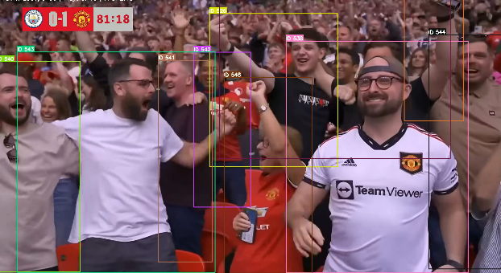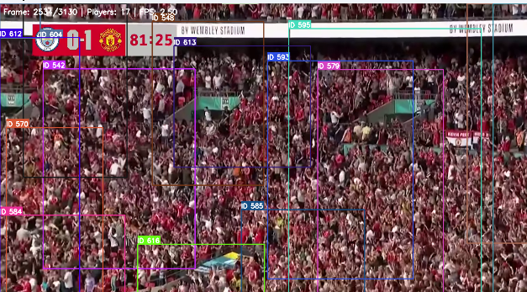

To address this, spatial and size-based filtering was introduced:
- Removed large bounding boxes (close-up spectators)
- Ignored detections in upper frame regions
After Filtering:
- Only on-field players retained
- Significant reduction in false positives
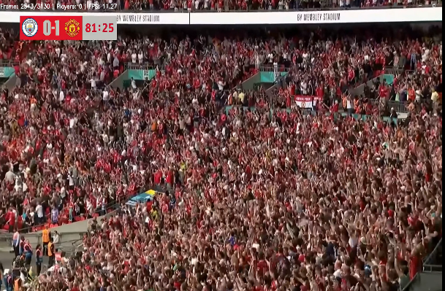

Team Classification Improvement
Initial color-based classification using RGB was sensitive to lighting variations.
Before Improvement:
- Many players classified as "Other"
- Inconsistent labeling
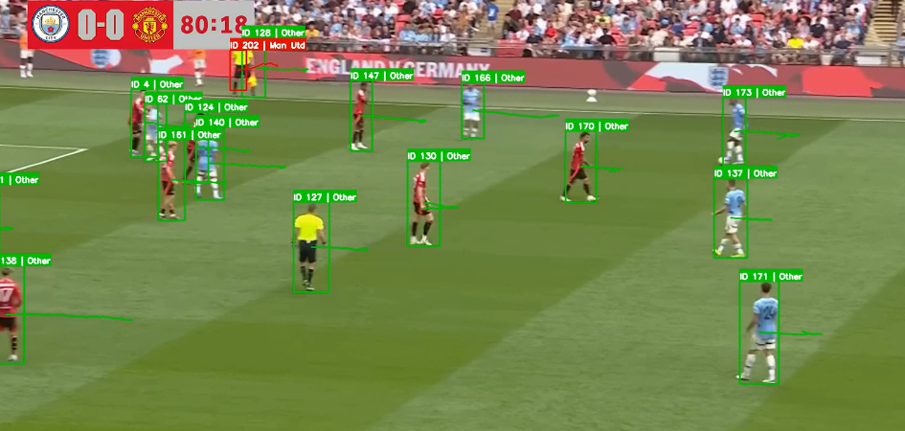

After switching to HSV color space with dominant color extraction:
After Improvement:
- Accurate team identification
- Robust to lighting and shadows
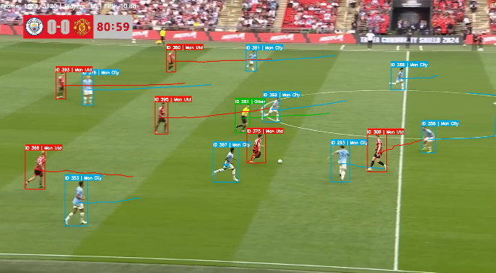

Tracking Visualization
The final system demonstrates:
- Stable ID assignment
- Smooth trajectory visualization
- Consistent tracking across frames
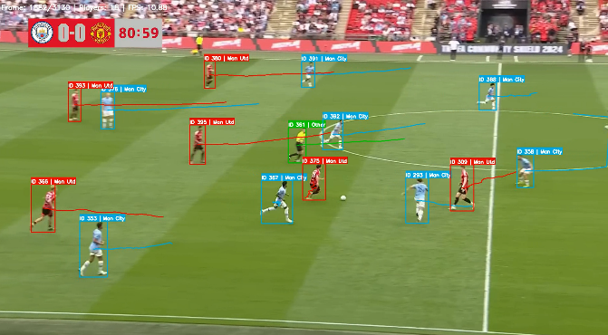

9. Failure Cases
- Distant players not classified correctly
- ID reset on cuts — IDs restart after every broadcast camera change
- Celebration huddles — boxes merge, IDs swap between nearby players
- Temporary ID switches during heavy occlusion
- Incorrect classification under poor lighting
- Team misclassification — referee and ball boys with partial red clothing
- Crowd members incorrectly classified before filtering

10. Solutions Implemented
- Scene change detection to reset tracker
- HSV-based color classification (robust to lighting)
- Spatial + size filtering to remove crowd
- Trajectory visualization for debugging tracking quality

11. Possible Improvements
- Use pose estimation to better isolate players
- Train a custom team classification model
- Add homography for top-view tracking
- Improve ReID model for better ID consistency
- Incorporate temporal smoothing for classification
- StrongSORT / BoTrack with sports Re-ID model - Better ID stability across occlusions.
- Jersey number OCR for hard Re-ID constraint - Cross-cut ID persistence

12. Conclusion
The system successfully detects and tracks multiple players while assigning persistent IDs and classifying teams. It demonstrates strong performance in real-world conditions and handles multiple challenges effectively.

