COURSEWORK 2
SARA TESFAYE
M00949835
CST3340

Introduction
This study analyses the U.S.-based Superstore dataset, a widely used retail dataset that represents the transactional and operational records of a fictitious large retailer. Each record corresponds to an individual customer order and includes information on product sales, profit, discounting, customer segments, shipping modes, and geographic regions. The dataset was sourced from Tableau Public and closely mirrors the type of structured sales data used by retail organisations to support pricing, profitability, and operational decision-making.
The primary business intelligence objective of this analysis is to address the following research question: how do discounting behaviour, product mix, and sales performance influence profitability, and how can these relationships be used to support managerial decisions such as discount control, category prioritisation, and regional strategy?. Retail managers frequently face trade-offs between driving sales volume through discounting and protecting profit margins. The Superstore dataset is well suited to exploring these trade-offs because it contains both revenue related variables (Sales, Quantity) and margin related variables (Profit, Discount), alongside descriptive attributes that allow performance to be compared across categories, customer segments, and regions.

The dataset includes a mixture of categorical, numerical, and temporal variables. Categorical variables such as Category, Sub-Category, Segment, Region, and Ship Mode describe qualitative business characteristics and enable comparative analysis across different parts of the organisation. Numerical variables including Sales, Profit, Quantity, and Discount support quantitative assessment of financial performance and pricing behaviour, while temporal variables such as Order Date and Ship Date enable trend and seasonality analysis over time. Together, these variables support both exploratory visualisation using Tableau and predictive modelling using data mining techniques.

Initial inspection of the dataset indicated that it was largely clean, with no missing values or major inconsistencies. As a result, no extensive data cleaning was required prior to analysis. However, to demonstrate awareness of good data preparation practice, potential preprocessing steps are considered. These include removing duplicate records, handling missing or anomalous values, standardising categorical text fields, and ensuring numerical and date variables are stored in appropriate formats. Additionally, non-analytical identifiers such as Order ID and Customer ID can be removed where they do not contribute to decision-making. Discussing these potential steps is important, as data quality issues are common in real world retail environments and can significantly affect the reliability of business intelligence outcomes.
Data Analysis and Visualisation
These are Tableau visualisations designed to explore sales, profit, discounting, and regional performance within the Superstore dataset. Each visualisation is followed by a discussion of observed patterns and their relevance for business intelligence.

Visualisation 1 – Sales by Category (Vertical Bar Chart)
This visualisation shows total sales across the three main product categories: Technology, Office Supplies, and Furniture. Technology generates the highest sales, indicating strong demand, while Office Supplies follow with steady, recurring purchases. In contrast, Furniture records the lowest sales, likely due to higher prices and longer replacement cycles. Overall, the chart highlights uneven revenue contribution, with Technology acting as the primary sales driver and providing a foundation for subsequent profitability analysis.
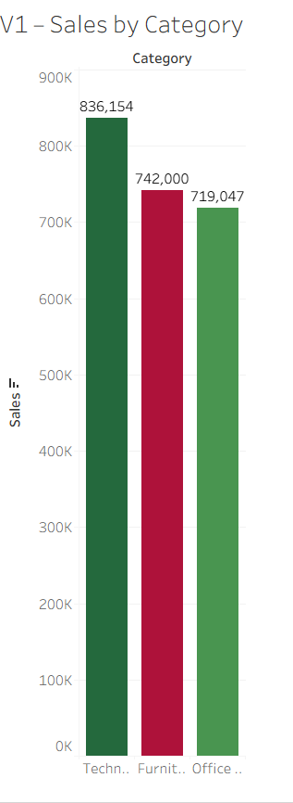

Visualisation 2 – Sales by Sub-Category (Horizontal Bar Chart)
This compares total sales with total profit for each sub-category, allowing performance to be evaluated in terms of both revenue generation and financial return.
The results show that some sub-categories with high sales, such as Phones, also deliver strong profit, indicating healthy margins. However, other sub-categories display high sales but relatively weak or inconsistent profit performance. This suggests that sales volume alone does not guarantee profitability and that discounting or cost structures may significantly impact margins.
Analysing sales and profit together, can reveal sub-categories where revenue growth may be achieved at the expense of profitability.

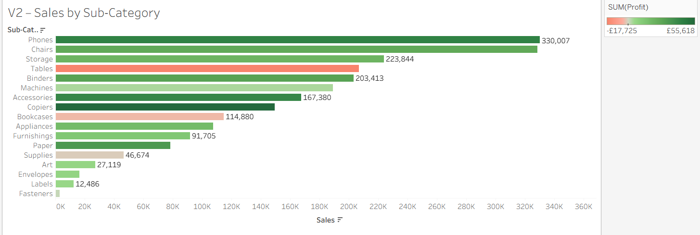
Visualisation 3 – Profit by Category (Vertical Bar Chart with Colour Encoding)
Ranked clearly to highlight relative profitability.
Technology emerges as the most profitable category, confirming its strategic importance to the business. Office Supplies continue to show moderate but stable profitability. Furniture, however, produces the lowest profit among the categories, reinforcing concerns raised in the previous visualisation.
This chart reveals that profitability is highly concentrated, with Technology generating a disproportionate share of total profit. Furniture’s weak performance suggests potential structural issues, such as inefficient pricing or excessive discounting. From a decision-making perspective, this visualisation identifies areas where margin optimisation efforts should be prioritised.

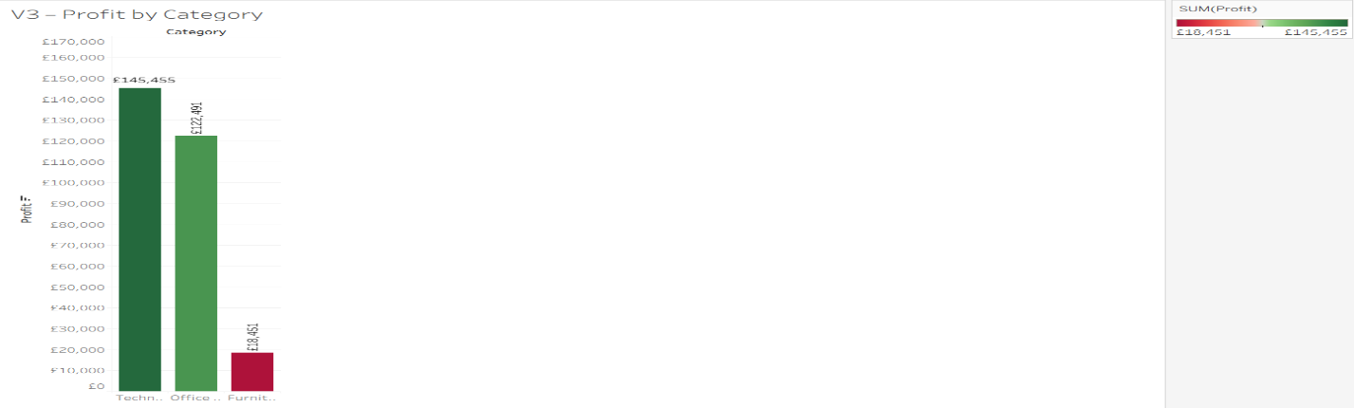
Visualisation 4 – Monthly Sales Trend (Line Chart)
This visualisation examines monthly sales over multiple years to identify seasonal and long-term trends. Sales follow a consistent annual pattern, peaking in the final quarter (Q4) and declining in the early months of the year, particularly January. This reflects typical retail behaviour driven by year-end demand and post-holiday slowdowns.
Beyond seasonality, the chart shows a gradual upward trend over time, indicating sustained business growth rather than volatile demand. The forecast projects a short-term dip in early 2018 but from a higher baseline than in previous years, suggesting that seasonal fluctuations are predictable and structural. These insights support inventory planning and resource allocation by enabling managers to anticipate recurring demand cycles while accounting for underlying growth.
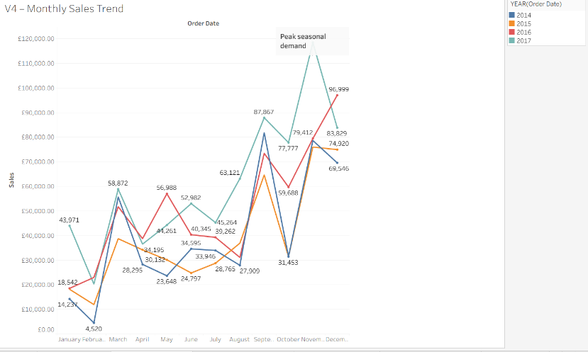
Visualisation 5 – Sales by Region and Segment (Stacked Vertical Bar Chart)
Sales are distributed across regions and customer segments, revealing clear geographic and segment-level concentration. The West region generates the highest total sales, followed by the East, indicating stronger and more consistent demand in these markets. In contrast, the Central and South regions contribute substantially less revenue, highlighting uneven regional performance.
Across all regions, the Consumer segment is the dominant contributor to sales, while Corporate customers provide a secondary but meaningful share. The Home Office segment consistently underperforms, suggesting limited demand or lower purchasing frequency. The key finding is that overall sales performance is driven primarily by consumer demand in a small number of high-performing regions. From a business intelligence perspective, this suggests that regional strategies should prioritise consumer-focused marketing and resource allocation in the West and East, while underperforming regions may require targeted interventions to stimulate demand or reassess market potential.

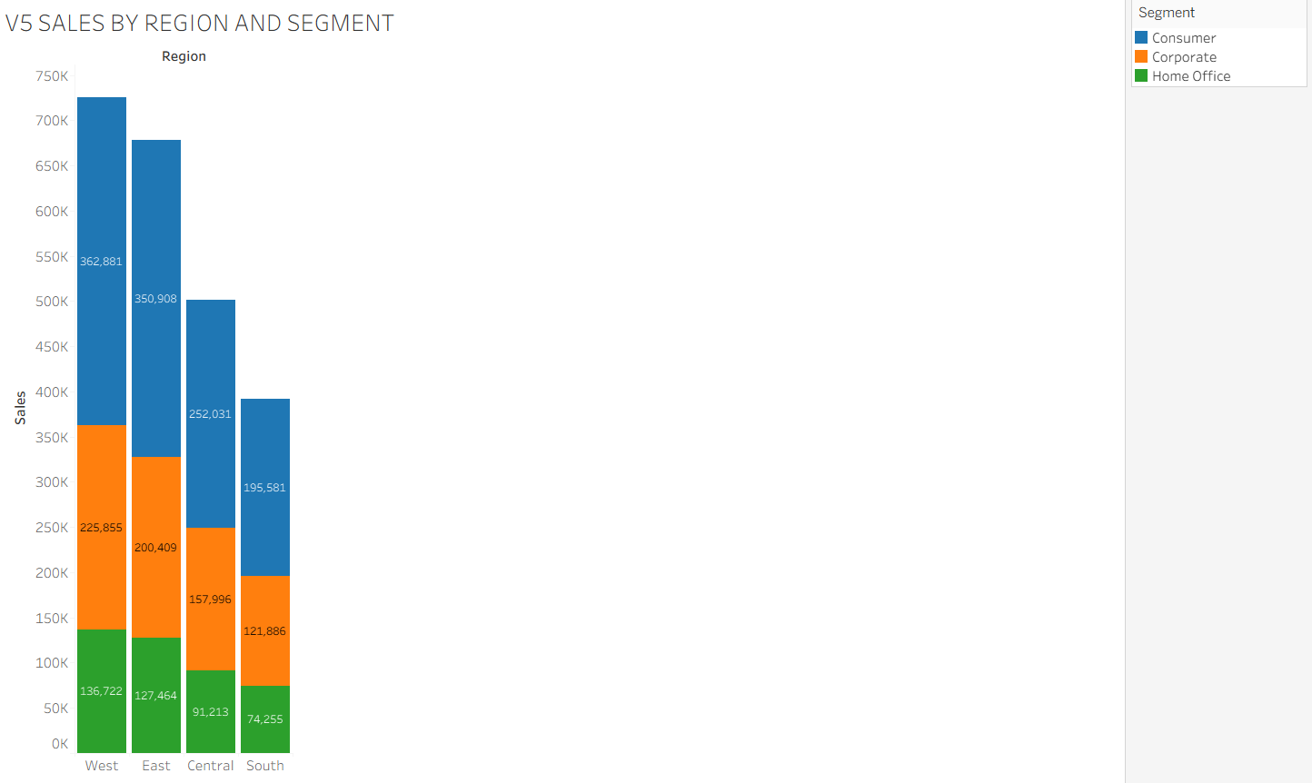

Visualisation 6 – Top 10 Cities by Sales (Horizontal Bar Chart)
Reveals a clear trend in which revenue is concentrated within a small number of urban markets. The results highlight uneven geographic performance, with a few cities contributing a disproportionately large share of total sales. From a business intelligence perspective, these cities represent priority areas for targeted marketing and promotional activity, as investment here is likely to deliver higher returns. Inventory and distribution can also be optimised reducing stock-out risk and logistics costs. Additionally, top-performing cities can be used as benchmarks to improve strategies in underperforming locations and inform future expansion decisions.
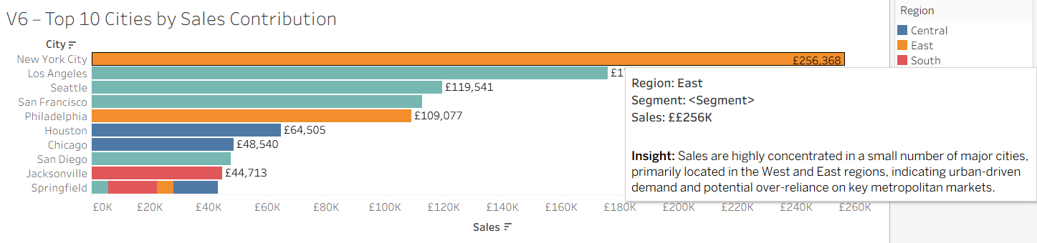
Visualisation 7 – Average Discount by Category (Coloured Bar Chart)
This visualisation shows the average discount applied across product categories and their sub-categories, highlighting clear differences in discounting strategy. Office Supplies exhibits the highest average discounts overall, particularly for sub-categories such as Binders, indicating aggressive price reductions. Furniture also shows relatively high discount levels in sub-categories such as Tables and Bookcases, while Technology generally receives lower average discounts, with the exception of Machines. The overall pattern suggests that discounting is applied unevenly across categories, potentially reflecting differences in demand sensitivity, competition, or inventory pressure. From a business intelligence perspective, this insight helps identify categories where discounting is most heavily relied upon and flags areas where high discounts may require closer monitoring due to their potential impact on profit margins.
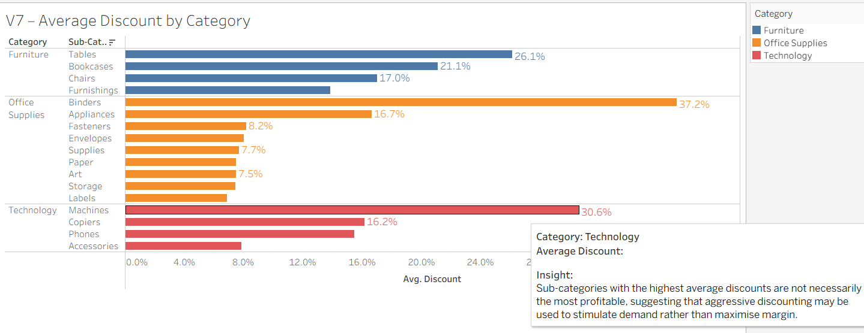
Visualisation 8 – Profit Ratio by Sub-Category (Highlight Table)
This visualisation shows the profit ratio across product sub-categories, revealing substantial variation in profitability. Sub-categories such as Labels, Paper, Envelopes, and Copiers achieve strong positive margins, while Tables, Bookcases, Appliances, and Binders record negative profit ratios, indicating loss-making sales. The key finding is that high sales volume does not guarantee profitability. From a business intelligence perspective, this highlights which sub-categories drive margin growth and which require corrective action through pricing, discount, or cost-structure review.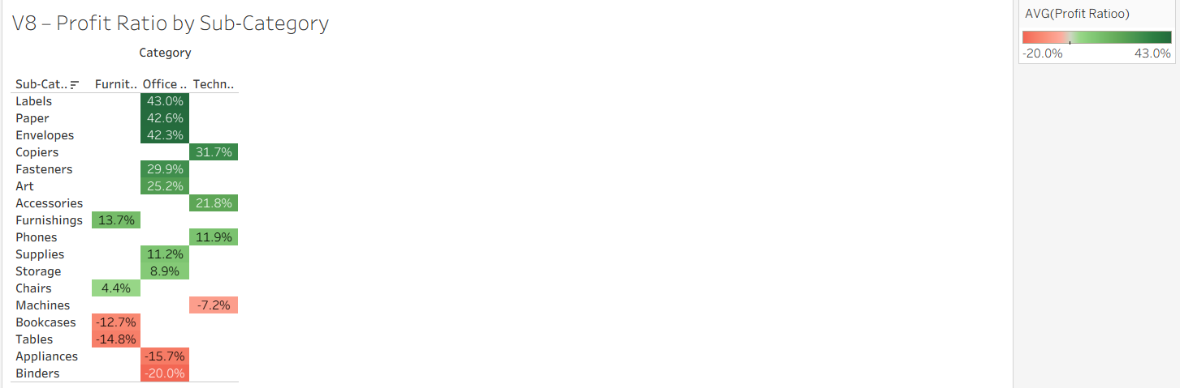
Visualisation 9 – Monthly Sales vs Profit (Dual-Axis Trend Line)
This visualisation compares monthly sales and profit using a dual-axis trend, revealing how revenue growth does not always translate into proportional profitability. Sales increase steadily toward the end of the year, peaking in November and December, reflecting strong seasonal demand. However, profit does not rise at the same rate during these peak months. November records the highest sales volume, yet profit growth is relatively modest compared to other months.
This divergence indicates margin compression during peak sales periods, likely caused by heavy discounting, promotional campaigns, and increased operational costs associated with high order volumes. Earlier months such as March and September show more balanced sales-to-profit relationships, suggesting healthier margins when demand is less promotion-driven. Overall sales growth alone is not a sufficient indicator of financial performance.

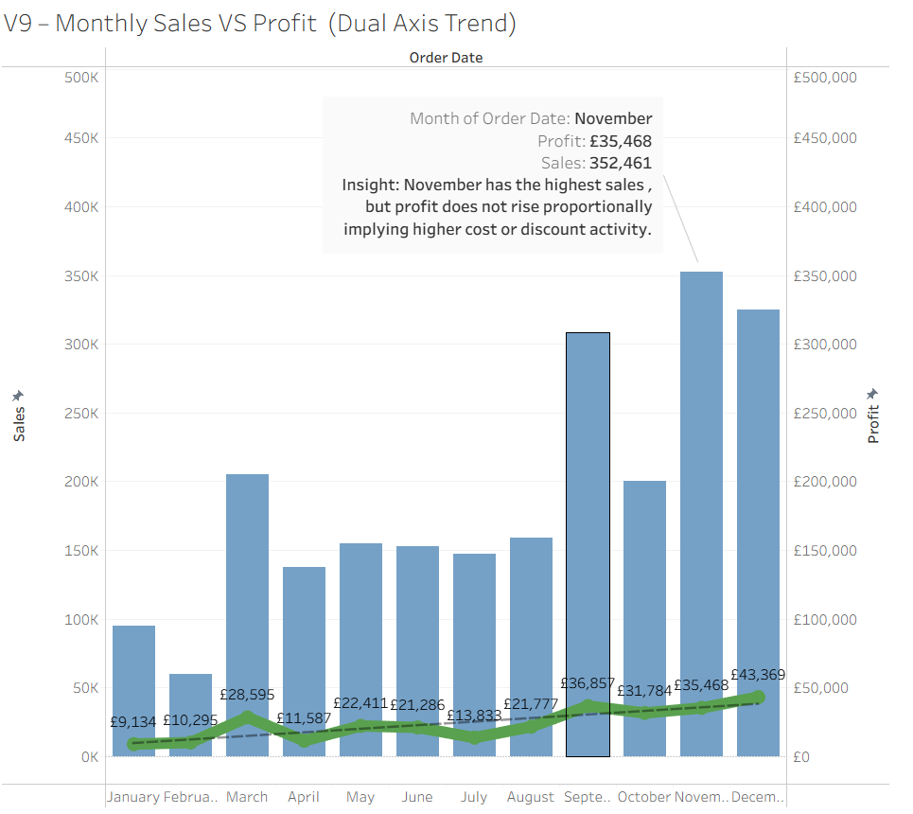
Visualisation 10 – Sales Forecast (Line Chart with Tableau Forecast)
This visualisation presents a time-series sales forecast based on historical monthly data. A clear and recurring seasonal pattern is evident, with sales peaking in Q4 and declining in Q1, reflecting predictable year-end demand and post-holiday slowdowns.
Although the forecast captures the expected January dip in early 2018, projected sales remain higher than Q1 levels in previous years due to the strong upward trend observed in 2017. This indicates that seasonal declines occur from a higher baseline, reflecting sustained growth rather than weakening demand.
For stakeholders, this suggests that sales fluctuations are structural and predictable. Planning should therefore focus on managing seasonal variability, with confidence in inventory and operational capacity even during early-year slowdowns.

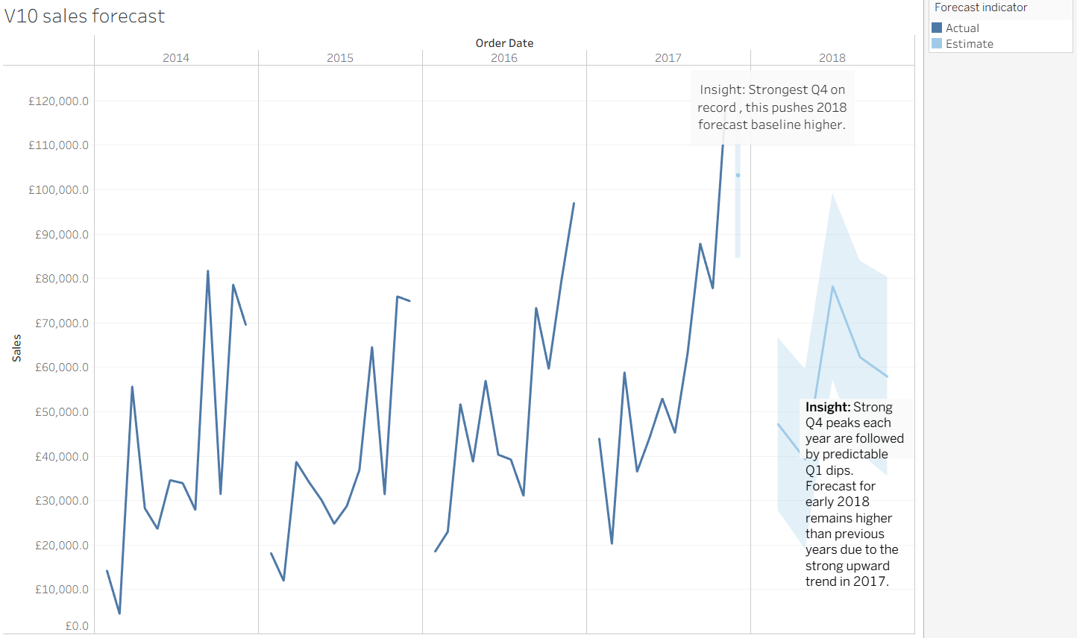
Overall, the visual analysis revealed clear performance patterns within the Superstore dataset. Technology emerged as the strongest revenue contributor, while Furniture consistently underperformed in profitability due to heavy discounting. Sales were unevenly distributed across regions, with the West dominating overall performance, indicating the need for region-specific strategies. Sub-category analysis showed that profitability is concentrated in a limited number of products, while time-based analysis highlighted strong seasonality in sales and profit. Collectively, these findings show how discounting, product mix, and seasonality interact to shape overall business performance.
Selection of Data Mining Algorithm and Data Pre-processing
A J48 Decision Tree classifier was selected for further analysis of the Superstore dataset. This algorithm is well suited to the dataset as it can handle both numerical and categorical variables and produces interpretable decision rules, which is important for business decision-making. The choice of J48 is directly informed by the Tableau visualisation analysis, which revealed clear threshold-based relationships between variables such as discount levels, sales values, and profitability.
The J48 algorithm works by repeatedly splitting the dataset into branches based on the attribute that provides the highest information gain. This process continues until terminal nodes (leaves) are reached, resulting in a tree structure that represents classification rules. In this analysis, the algorithm was used to classify profit outcomes into categories, enabling identification of conditions that lead to high profit, low profit, or losses.
J48 is suitable for this dataset because the visualisations showed that high discounts frequently correspond to low or negative profit, indicating non-linear and rule-based relationships. These patterns are effectively captured by decision trees. The main variables used in the model include Discount, Sales, Category, and Segment, with Profit Class used as the target variable.
The dataset was found to contain no missing values. However, pre-processing steps were still applied to improve model performance and interpretability. Non-analytical identifiers such as Order ID and Customer ID were removed, and Profit was transformed into a categorical variable. Additional attribute reduction was performed across iterations to simplify the model while maintaining accuracy.

Data Mining
I applied the J48 decision tree classifier in Weka to the pre-processed Superstore dataset to predict Profit_Class (Low / High / Loss). J48 is appropriate because it produces interpretable “if–then” rules. Three iterations were run using different subsets of variables, with the aim of balancing predictive performance and model simplicity for business interpretation.
Iteration 1 – Full feature set (baseline)
In the first iteration, J48 was trained on 9,994 instances using 9 attributes (Ship Mode, Segment, Region, Category, Sub-Category, Sales, Quantity, Discount, and Profit_Class). Standard J48 pruning settings (-C 0.25, -M 2) were applied, and the model achieved 95.46% accuracy (9,540 correctly classified), with a Kappa value of 0.8746, indicating strong agreement beyond chance. The confusion matrix shows strong performance for Low (7,541) and Loss (1,606) classes, although some Loss cases were misclassified as Low (264), which is a business-relevant error as it underestimates risk.
The dominant pattern in Iteration 1 is that Discount is the primary split variable, with the root node at Discount ≤ 0.2. Very high discounts (e.g. > 0.4) overwhelmingly predict Loss, strongly supporting the earlier visualisation findings that heavy discounting is closely associated with weak profitability. However, despite its high accuracy, this iteration produced a highly complex tree (183 leaves; size 260), reducing interpretability and increasing the risk of overfitting. In addition, evaluation was conducted on the training set only, meaning the reported accuracy likely overestimates real world predictive performance.

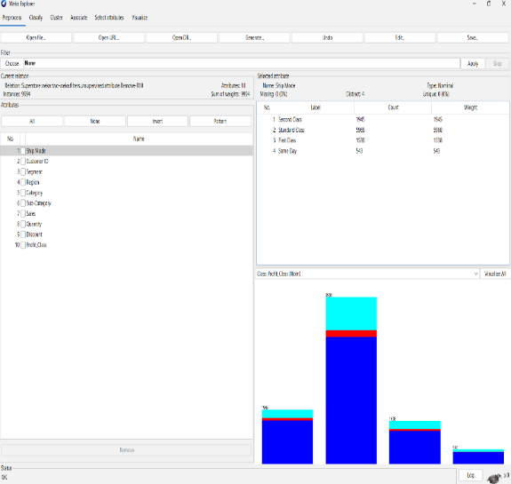
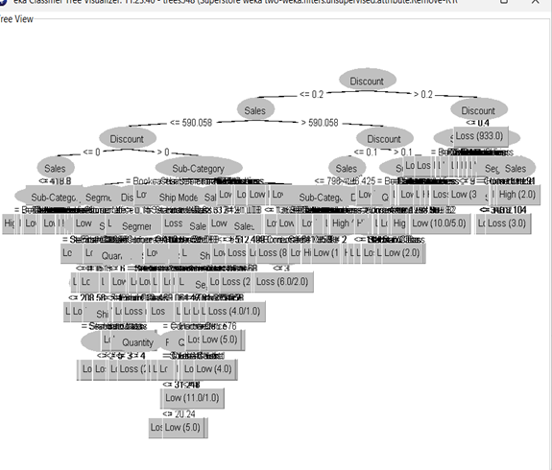

Iteration 2
For Iteration 2, the attribute set was reduced to seven variables (Segment, Region, Category, Sales, Quantity, Discount, and Profit_Class) by removing Ship Mode and Sub-Category. This reduction was justified by Iteration 1, which showed that Discount and Sales thresholds dominated most splits, while detailed operational variables added complexity with limited explanatory benefit. The resulting tree was substantially smaller (26 leaves; size 45), making it easier to interpret and more suitable for managerial use.
Accuracy decreased to 93.06% (9,300 correctly classified), which is expected when reducing predictive detail. Performance for the Low class remained strong (7,608 correctly classified), and the model continued to identify a large proportion of Loss cases (1,359). The key rule remained consistent: Discount > 0.2 strongly predicts Loss, reinforcing discounting as the primary driver of unprofitable transactions. Importantly, retaining Region allows the model to reflect geographic differences observed in the Tableau analysis.

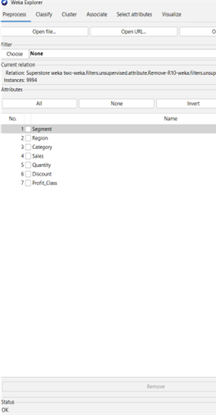
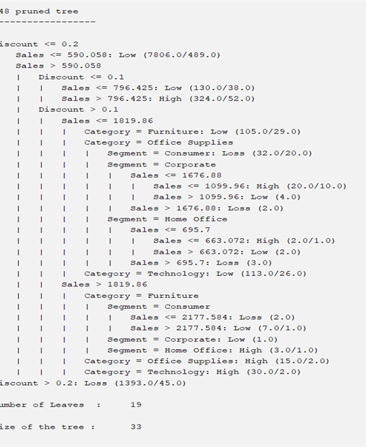
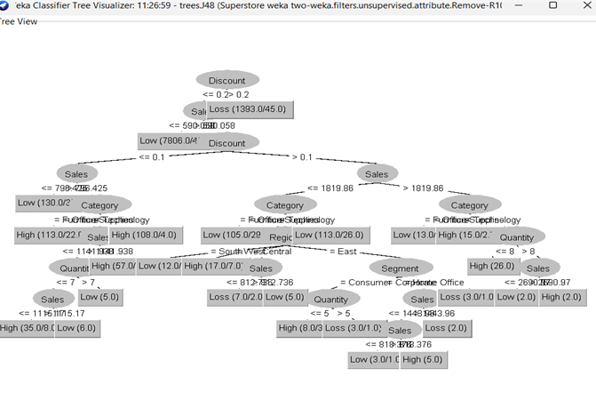

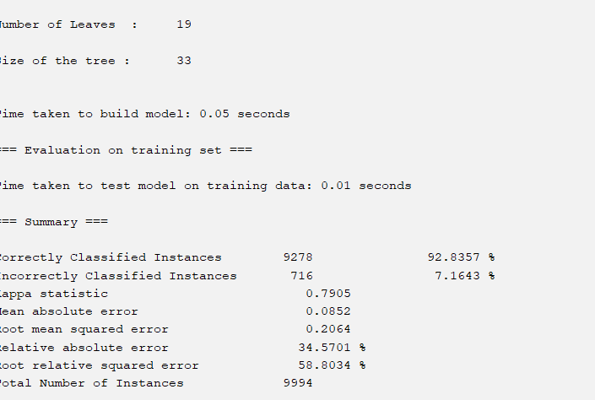

Iteration 3 – Further reduction
In Iteration 3, the dataset was reduced further to five attributes (Segment, Category, Sales, Discount, and Profit_Class), producing the simplest model (19 leaves; size 33). Accuracy fell slightly to 92.84% (9,278 correctly classified), while predictions for Low (7,585) and Loss (1,367) remained reasonable. However, removing Region reduces alignment with earlier regional findings and limits the model’s usefulness for location-specific decision-making.
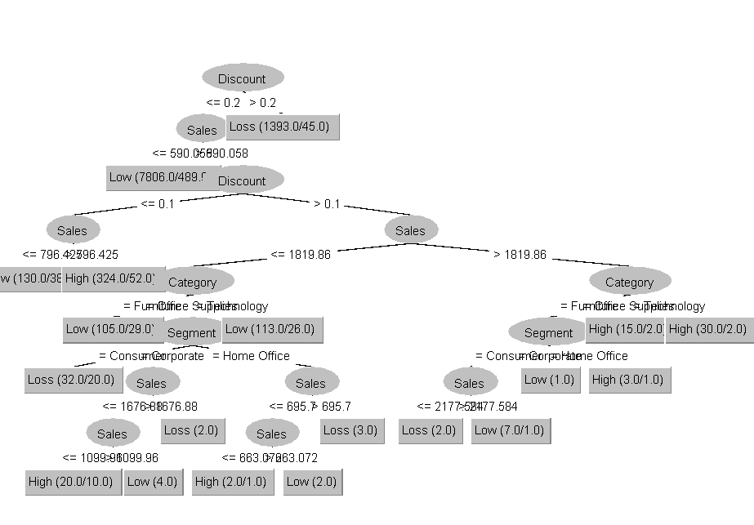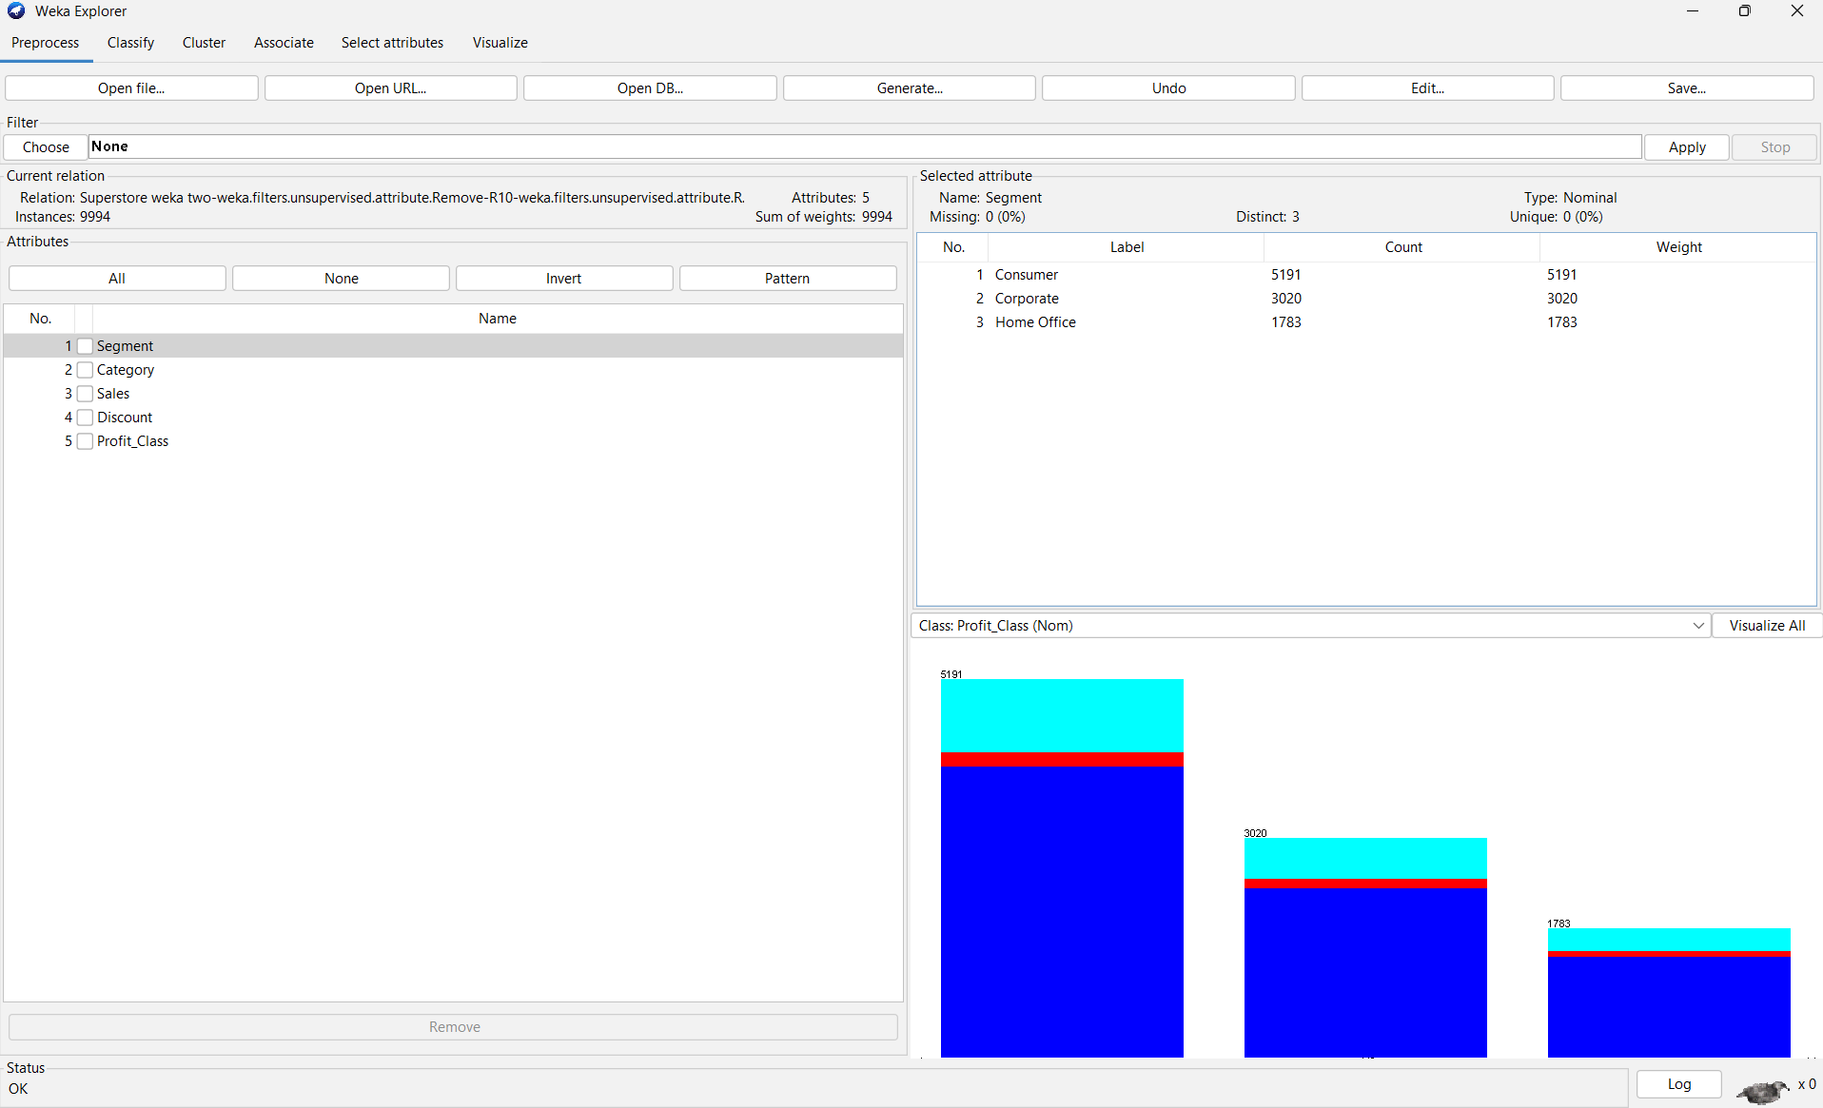
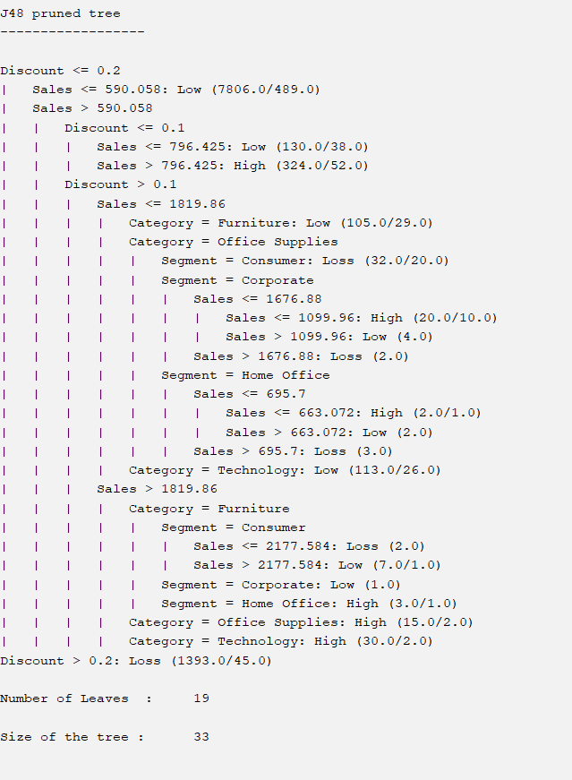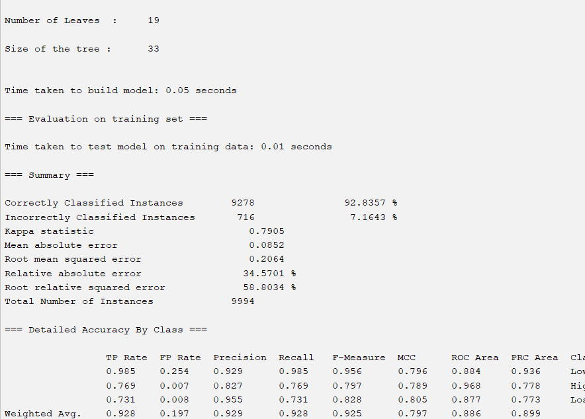
Although Iteration 1 achieved the highest training accuracy, its complexity and lack of validation limit its practical value. Iteration 3 offers maximum simplicity but removes Region, weakening business relevance. Iteration 2 provides the best balance between accuracy (93.06%), interpretability, and alignment with the visual analysis. While the model was evaluated on training data only, the consistency of results across iterations strengthens confidence in the core finding: higher discount levels substantially increase the likelihood of Loss. From a business intelligence perspective, this supports clear recommendations to tighten discount controls (particularly above 20%), review loss-prone category and segment combinations, and apply region-specific strategies where performance differs.
Data Ethics
The analysis of business data raises important ethical, legal, and professional considerations, particularly when datasets contain customer level attributes. Ethical data analysis requires that data is used responsibly, fairly, and without causing harm to individuals. Retail datasets often include identifiers such as Customer ID, customer names, and location details, which, if misused, could enable intrusive profiling or the re-identification of individuals. Ethical practice therefore requires limiting analysis to attributes relevant to decision-making and avoiding unnecessary use of personally identifiable information.
Legal considerations are governed by data protection legislation, most notably the UK General Data Protection Regulation. GDPR requires personal data to be processed lawfully, for a specific purpose, and in a manner that ensures confidentiality and security. In the Superstore dataset, although customer names and identifiers are present, they are not required for analytical objectives such as sales performance or profitability analysis. As a result, these attributes should be excluded, anonymised, or aggregated to comply with the principles of data minimisation and purpose limitation. Removing such fields reduces privacy risk and aligns the analysis with legal requirements.
Professional considerations emphasise the responsibility of analysts to act with integrity and transparency. As highlighted in the data ethics lecture, analysts must ensure that data is interpreted correctly and that models are not used beyond their intended purpose. This includes acknowledging limitations, such as the use of training data for model evaluation, and avoiding biased or misleading conclusions. By excluding unnecessary personal attributes and clearly communicating analytical constraints, data professionals support ethical decision-making and maintain trust in data-driven business practices.
Conclusion :
This study combined Tableau visualisation and decision tree data mining to explore patterns in the Superstore dataset and support data driven decision making. The visualisation analysis revealed several consistent trends across sales, profit, and discounting behaviour. Sales performance varied significantly by category, region, and city, with Technology emerging as the strongest revenue contributor, while Furniture consistently underperformed in profitability due to heavy discounting. Regional analysis showed uneven performance, with sales concentrated in specific regions and cities, highlighting the importance of targeted regional strategies. Temporal analysis further identified clear seasonality, with strong sales peaks in Q4 followed by predictable declines in Q1, reinforcing the need for effective demand forecasting and inventory planning.
The data mining phase applied the J48 decision tree algorithm to classify profit outcomes. Across three iterations, model complexity was progressively reduced by removing less influential attributes, improving interpretability while maintaining strong predictive performance. The final model achieved 92.8% classification accuracy, indicating a strong fit to the available data while remaining interpretable, although performance may be optimistic due to training-set evaluation. The decision tree consistently identified discount level as the most influential factor in determining profitability, with discounts above 20% strongly associated with loss-making transactions. This finding aligns closely with the visualisation results, strengthening confidence in the analytical conclusions.
From a business intelligence perspective, these findings provide clear and actionable value. Senior management, pricing teams, and supply chain planners can use these insights to implement profit-focused discount strategies, control excessive discounting, and prioritise high-performing categories and regions. Forecasting insights support improved inventory allocation and capacity planning during peak periods, while decision tree rules offer managers transparent guidelines for evaluating sales and discount decisions. Overall, the integration of visual analytics and data mining provides a robust analytical framework that can support strategic planning, operational efficiency, and more informed profitability decisions

